NATIONAL INSTITUTE FOR HEALTH

AND CARE EXCELLENCE
CONSULTANCY AGREEMENT FOR
SPECIFIC PROJECT SERVICES

1 BASIC DETAILS

 | 2 NAME AND ADDRESS OF CONTRACTOR (including Company Registration Number if relevant) | Binley’s (Wilmington Healthcare Ltd)  Beechwood House  2 - 3 Commercial Way  Southfields  Basildon  SS15 6EF
 | 3 DESCRIPTION OF CONTRACTOR | Mailing List and Database Provider
 | 4 DESCRIPTION OF PROJECT SERVICES | British National Formulary Publications Distribution
 | 5 NICE BUDGET HOLDER
 | 6 NICE PROJECT MANAGER
 | 7 NOMINATED MANAGER OF CONTRACTOR
 | 8 CONTRACTOR AUTHORISED SIGNATORY
 | 9 DATE AGREEMENT SIGNED | 30 | 12 | 2015
 | 10 DATE AGREEMENT COMES INTO EFFECT (IF DIFFERENT FROM ABOVE)
 | 11 DATE AGREEMENT ENDS (IF FIXED DATE) | 31 | 12 | 2018
 | 1.11. CONTRACT NUMBER | NICE 1027
 | 1.12 PROJECT NUMBER | 740758

IT IS AGREED AS FOLLOWS

2. DEFINITIONS

"Agreement" | this Agreement and any Annexes attached to it.
“Beneficiary” | To be defined
"the Contractor"  Data  Database  NICE Personal Data  Intellectual Property | the person in 1.1 or any partner, employee, agent, sub-contractor or other lawful representative of the person in 1.1.  Data means all information stored in the Database, including but not limited to; titles; names; full postal addresses; entity; organisation name and type; email addresses; telephone numbers; role, position and job type; access and activation status; eligibility status expiry dates; acceptance and approval terms and conditions.  Database means the rights in or to the content and database schema of the databases developed and supplied by the Contractor to NICE in accordance with the terms of this Agreement (excluding all database Third Party Software).  NICE Personal Data means any personal data supplied by NICE, or data for which NICE is the Data Controller.  Intellectual Property means patents, trademarks, service marks, domain names, registered designs, utility models, applications for and the right to make applications for any of such rights, inventions, know-how, unregistered trademarks and service marks, trade and business names, including rights in any get-up or trade dress, copyrights (including rights in computer software), unregistered design rights and other rights in designs and copyright in databases; the sui generis right for the maker of a database to prevent extraction or re-utilisation or both of the whole or a substantial part of the content of that database, as described in the Copyright and Rights in Databases Regulations 1997 (S.I. 1997 No. 3032); and rights of the same or similar effect or nature as or to those in paragraphs above.
“the Location” | “ NICE premises London” or “NICE premises Manchester”
"NICE" | the National Institute for Health and Care Excellence of 10 Spring Gardens, London, SW1A 2BU
"the Milestones" | the milestones as set out in Annex 2.
“the Party” | either “NICE” or the “Contractor”
“the Parties” | both “NICE and the Contractor”
"the Project Services" | the Project Services set out in 1.3 as more fully described in Annex 1.

3. AGREEMENT

3.1. In consideration of NICE making certain payments to the Contractor, the Contractor has agreed to provide the Project Services to NICE on the terms and conditions of this Agreement

3.2. The payments for the Project Services are fixed and no further payments shall be made by NICE, except where a formal variation has been agreed as in clause 19.3.

4. OBLIGATIONS OF THE CONTRACTOR

4.1. The Project Services

4.1.1. The Contractor shall carry out the Project Services in accordance with Annex 1 and to a quality acceptable to NICE.

4.1.2. No material changes to the Project Services shall be permitted without the written consent of NICE Project Manager.

4.1.3. The Contractor shall use its best endeavours to achieve the milestones set out in Annex 2 ("the Milestones").

4.2. Sub-Contractors

4.2.1. The Contractor shall agree with NICE the use of any sub-contractor to carry out any part of the Project Services.

4.2.2. The Contractor shall ensure that any sub-contractor it uses adheres to the obligations of this Agreement as if the sub-contractor were the Contractor.

4.3. Instructions

4.3.1. The Contractor shall comply fully with the instructions of the Project Manager and, if the Contractor is working in NICE, with the office rules of NICE.

4.4. Financial Control

4.4.1. The Contractor shall keep accurate books and accounts in respect of the Project Services and, if requested in writing by NICE, shall (at its own expense) have them certified by a professional firm of auditors.

4.4.2. The Contractor shall permit NICE to inspect and take copies (at NICE's expense) of any financial information or records NICE requires which relate to this Agreement.

4.5. Communication

4.5.1. The Contractor shall ensure that all communications with NICE concerning the Project Services shall only be between the nominated representatives of both Parties, that is, NICE Project Manager who shall be the Manager nominated by NICE from its own staff or such other person as NICE shall nominate in writing, and the nominated manager of the Contractor.

4.6. Laws and Regulation

4.6.1 The Contractor shall adhere to all laws and regulations relating to the provision of the Project Services.

4..6.2 The Contractor shall comply in all material respects with applicable environmental laws and regulations in force from time to time in relation to the Services. Where the provisions of any such legislation are implemented by the use of voluntary agreements or codes of practice, the Contractor shall comply with such agreements or codes of practices as if they were incorporated into English law subject to those voluntary agreements being cited in tender documentation.

4.6.3 While at the Location, the Contractor shall comply, and shall ensure that its employees comply with, the requirements of relevant Health and Safety and other relevant legislation, including regulations and codes of practice issued thereunder, and with NICE’s and any Beneficiary’s own policies and procedures.

4.6.4 The Contractor shall at all times maintain a specific Health and Safety at Work policy relating to the employment of his own staff whilst carrying out their duties in relation to the Contract on the NICE’s or any Beneficiary’s premises. The Contractor shall ensure the co-operation of its employees in all prevention measures designed against fire, or any other hazards, and shall notify NICE’s of any change in the Contractor's working practices or other occurrences likely to increase such risks or to cause new hazards.

5. OBLIGATIONS OF NICE

5.1. Monitoring

NICE shall monitor the provision of the Project Services at its discretion. To assist in this, the Contractor shall provide such written reports as NICE shall reasonably request.

6. TERM

6.1. Except for those clauses 10, 12 and 16 which shall continue after this Agreement terminates, this Agreement shall begin on the date set out in clauses 1.8 or 1.9 and end on the date set out in clause 1.10. If there is no date in clause 1.10 then this Agreement shall continue until the Project Services are completed to the satisfaction of NICE or such other time as shall be notified by NICE to the Contractor.

7. PAYMENT
  - Subject to the due performance of the Contractor’s obligations, NICE will pay all invoices submitted by the Contractor in accordance with Annex 4 within 30 days of their receipt.

7.2. The Contractor shall send all invoices to NICE, clearly quoting the contract number.

7.3. Invoices sent to NICE shall be accurate and correct in all respects. NICE reserves the right to return incorrect or inaccurate invoices to the Contractor for rectification and re-issuance..

7.4. NICE reserves the unconditional right to withhold payment of the final invoice or invoices until the Project Services are successfully concluded to the satisfaction of NICE and NICE receives a copy of any relevant work created as a result of the Project Services in a form acceptable to the NICE.

8. STAFF AND RESOURCES

8.1. The Contractor shall be fully responsible in every way for all its staff and all consultants (whether part-time or full-time).

8.2. The Contractor shall ensure that it complies with all current employment legislation and in particular, does not unlawfully discriminate within the meaning of the Equality Act 2010 (as amended) the Part Time Workers (Prevention of Less Favourable Treatment) Regulations 2000, the Fixed Term Employees (Prevention of Less Favourable Treatment) Regulations 2002, or any other relevant legislation relating to discrimination in the employment of employees for the purpose of providing the Services. The Contractor shall take all reasonable steps (at its own expense) to ensure that any employees employed in the provision of the Services do not unlawfully discriminate within the meaning of this Clause 8.2 and shall impose on any sub-contractor obligations substantially similar to those imposed on the Contractor by this Clause 8.2; and

8.3 in the management of its affairs and the development of its equality and diversity policies, the Contractor shall co-operate with NICE in respect of NICE’s obligations to comply with statutory equality duties. The Contractor shall take such steps as NICE considers appropriate to promote equality and diversity, including race equality, equality of opportunity for disabled people, gender equality, and equality relating to religion and belief, sexual orientation and age in the provision of the Services.

8.4 The Contractor shall notify NICE immediately of any investigation of or proceedings against the Contractor under the Equality Act 2010 and shall cooperate fully and promptly with any requests of the person or body conducting such investigation or proceedings, including allowing access to any documents or data required, attending any meetings and providing any information requested.

8.7 The Contractor shall indemnify NICE against all costs, claims, charges, demands, liabilities, damages, losses and expenses incurred or suffered by NICE arising out of or in connection with any investigation conducted or any proceedings brought under the 2010 Act due directly or indirectly to any act or omission by the Contractor, its agents, employees or sub-contractors.

8.8 The Contractor shall impose on any sub-contractor obligations substantially similar to those imposed on the Contractor by this Clause 8.

8.9 NICE shall have the right to be consulted on what staff will be appointed to provide the Project Services.

8.10 The Contractor undertakes to NICE that any person assigned to NICE to supply the Project Services is an employee of the Contractor and that employee(s) shall not be transferred from this assignment without the prior written consent of NICE.

9. INSURANCE

9.1. The Contractor shall maintain an appropriate insurance policy to cover its liabilities to NICE under this Agreement for the duration of the Agreement.

9.2. The Contractor shall supply a copy of any relevant insurance policy to NICE together with proof of payments of all premiums if required.

10. INTELLECTUAL PROPERTY AND COPYRIGHT

10.1. All Intellectual Property owned by or licensed to either Party prior to the commencement of this Agreement will remain the property of that Party or the licensor to that Party as appropriate.

10.2. NICE’s IPR
10.2.1 NICE shall own:
10.2.1.1. NICE’s Background IPR;
10.2.1.2. NICE’s Personal Data

10.3. Contractors IPR
10.3.1 The Contractor shall own:
10.3.1.1. The Contractor’s Background IPR;
10.3.1.2. The Contractor’s Software
10.3.1.3. The Database;
10.3.1.4. The Data

10.4. NICE’s Licence
10.4.1. NICE hereby grants to the Contractor for the term of the Agreement a non-exclusive, non-transferable licence to use NICE’s Personal Data solely as contemplated hereunder for the purposes of the Project Services.

10.5. Contractor’s Licence
10.5.1. The Contactor hereby grants to NICE for the term of the Agreement a non-exclusive, non-transferable licence to use the Data and the Database solely as contemplated hereunder for the purposes of the Project Services.

10.6. The Contractor warrants to NICE that in relation to any work created by itself, its servants, agents, consultants or independent contractors, as a result of the Project Services, that:-

10.3.1. such work is not a violation of any existing copyright anywhere;

10.3.2. such work does not contain anything objectionable, obscene or libellous;

10.3.3. all statements contained in any such work which purport to be facts are true.

10.7. If the Contractor incorporates any copyrightable work in any work it produces or has produced on its behalf then it shall ensure that appropriate permissions to use that work are obtained in writing. The NICE Project Manager shall have the right to see such permissions.

10.8. The Contractor shall procure that any independent author or part-author of any copyrightable material created as a result of the Project Services, assigns the copyright with full title guarantee to NICE and waives any moral rights under the Copyright, Designs and Patents Acts 1988. Any assignment and/or waiver under this sub-clause shall be on NICE's standard terms set out in Annex 3. The Contractor shall do this as soon as reasonably possible after the creation of any such work.

10.9. It is the policy of NICE to associate authors with their works. However, there may be exceptional circumstances where this would be to the detriment of the NICE. In an exceptional circumstance NICE, as copyright owner, would reserve the right to disassociate the author from the work.

11. PUBLIC REPUTATION OF THE PARTIES

11.1. Both Parties recognise the other Party's public reputation and legal responsibilities. Each Party shall use all reasonable endeavours not to harm or compromise these.

12. CONFIDENTIALITY

12.1. In respect of any Confidential Information it may receive from the other party (“the Discloser”) and subject always to the remainder of this clause 12, each party (“the Recipient”) undertakes to keep secret and strictly confidential and shall not disclose any such Confidential Information to any third party, without the Discloser’s prior written consent provided that:

12.2 the Recipient shall not be prevented from using any general knowledge, experience or skills which were in its possession prior to the commencement of the Contract;

12.3 except in respect of the Data, the provisions of this clause 12 shall not apply to any Confidential Information which is in or enters the public domain other than by breach of the Contract or other act or omissions of the Recipient. However, where NICE has independently compiled information which is in the public domain without otherwise breaching this agreement, such information even if it be part of the Data will not be regarded as Confidential Information hereunder.;
12.4 the provisions of this clause 12 shall not apply to any Confidential information which:
(a) is obtained by a third party who is lawfully authorised to disclose such information; or
(b) is authorised for release by the prior written consent of the Discloser; or

(c) the disclosure of which is required to ensure the compliance of the Institute with the Freedom of Information Act 2000 (the FOIA).12.5 Nothing in this clause 12 shall prevent the Recipient from disclosing Confidential Information where it is required to do so by judicial, administrative, governmental or regulatory process in connection with any action, suit, proceedings or claim or otherwise by applicable law or, where the Contractor is the Recipient, to the Contractor's immediate or ultimate holding company provided that the Contractor procures that such holding company complies with this clause 12 as if any reference to the Contractor in this clause 12 were a reference to such holding company.

12.6 The Contractor authorises NICE to disclose the Confidential Information to such person(s) as may be notified to the Contractor in writing by NICE from time to time to the extent only as is necessary for the purposes of auditing and collating information so as to ascertain a realistic market price for the goods supplied in accordance with the Contract, such exercise being commonly referred to as "benchmarking". NICE shall use all reasonable endeavours to ensure that such person(s) keeps the Confidential Information confidential and does not make use of the Confidential Information except for the purpose for which the disclosure is made. NICE shall not without good reason claim that the lowest price available in the market is the realistic market price.

12.7 The Contractor acknowledges that NICE is or may be subject to the Freedom Of Information Act (FOIA). The Contractor notes and acknowledges the FOIA and both the respective Codes of Practice on the Discharge of Public Authorities' Functions and on the Management of Records (which are issued under section 45 and 46 of the FOIA respectively) and the Environmental Information Regulations 2004 as may be amended, updated or replaced from time to time. The Contractor will act in accordance with the FOIA, these Codes of Practice and these Regulations (and any other applicable codes of practice or guidance notified to the Contractor from time to time) to the extent that they apply to the Contractor's performance under the Contract.

12.8 The Contractor agrees that:

12.8.1 Without prejudice to the generality of clause 12.2, the provisions of this clause 12 are subject to the respective obligations and commitments of NICE under the FOIA and both the respective Codes of Practice on the Discharge of Public Authorities' Functions and on the Management of Records (which are issued under section 45 and 46 of the FOIA respectively) and the Environmental Information Regulations 2004;

12.8.2 subject to clause 12.7.3, the decision on whether any exemption applies to a request for disclosure of recorded information is a decision solely for NICE;

12.8.3 where NICE is managing a request as referred to in clause 12.7.2, the Contractor shall co-operate with NICE and shall respond within five (5) working days of any request by it for assistance in determining how to respond to a request for disclosure.

12.9 The Contractor shall and shall procure that its sub-contractors shall:

12.9.1 transfer the any request for information, as defined under section 8 of the FOIA, to NICE as soon as practicable after receipt and in any event within five (5) working days of receiving a request for information;

12.9.2 provide NICE with a copy of all information in its possession or power in the form that NICE requires within five (5) working days (or such other period as NICE or a Beneficiary may specify) of the Institute or a Beneficiary requesting that Information; and

12.9.3 provide all necessary assistance as reasonably requested by the Institute to enable NICE to respond to a request for information within the time for compliance set out in section 10 of the FOIA.

12.10 NICE may consult the Contractor in relation to any request for disclosure of the Contractor's Confidential Information in accordance with all applicable guidance.

12.11 This clause 12 shall remain in force without limit in time in respect of Confidential Information which comprises Personal Data or which relates to a patient, his or her treatment and/or medical records. Save as aforesaid and unless otherwise expressly set out in the Contract, this clause 12 shall remain in force for a period of 3 years after the termination or expiry of this Contract.

12.12 In the event that the Contractor fails to comply with this clause 12, NICE reserves the right to terminate the Contract by notice in writing with immediate effect.

13. Data Protection

13.1 The Contractor shall comply with the Data Protection Act 1998 ("the 1998 Act") and any other applicable data protection legislation. In particular the Contractor agrees to comply with the obligations placed on the Authority and any Beneficiary by the seventh and eighth data protection principles ("the Seventh Principle") and (“the Eighth Principle”) set out in the 1998 Act, namely:

13.1.1 to maintain technical and organisational security measures sufficient to comply at least with the obligations imposed on NICE and any Beneficiary by the Seventh Principle;
13.1.1.1to ensure that data is not transferred to any other country without adequate data protection in place and to comply with the obligations imposed on NICE and any Beneficiary by the Eighth Principle.

13.1.2 only to process Personal Data for and on behalf of NICE and any Beneficiary, in accordance with the instructions of NICE or such Beneficiary and for the purpose of performing the Services in accordance with the Contract and to ensure compliance with the 1998 Act;

13.1.3 to allow NICE to audit the Contractor's compliance with the requirements of this Clause 13 on reasonable notice and/or to provide NICE with evidence of its compliance with the obligations set out in this Clause 13

13.2 The Contractor agrees to indemnify and keep indemnified NICE and any Beneficiary against all claims and proceedings and all liability, loss, costs and expenses incurred in connection therewith by NICE and any Beneficiary as a result of any claim made or brought by any individual or other legal person in respect of any loss, damage or distress caused to that individual or other legal person as a result of the Contractor's unauthorised processing, unlawful processing, destruction of and/or damage to any Personal Data processed by the Contractor, its employees or agents in the Contractor's performance of the Contract or as otherwise agreed between the Parties.

13.3 Both Parties agree to use all reasonable efforts to assist each other to comply with the 1998 Act. For the avoidance of doubt, this includes the Contractor providing NICE and any Beneficiary with reasonable assistance in complying with subject access requests served on NICE and any Beneficiary under Section 7 of the 1998 Act and the Contractor consulting with NICE and any Beneficiary prior to the disclosure by the Contractor of any Personal Data in relation to such requests.

14. GIFTS AND PAYMENTS OF COMMISSION

14.1. The Contractor shall not offer or give to any member of staff of NICE or a member of their family any gift or consideration of any kind (including the payment of commission) as an inducement or reward for doing something or not doing something or for having done something or having not done something in relation to the obtaining of or execution of this Agreement or any Agreement with NICE. This prohibition specifically includes the payment of any fee or other consideration for any work in respect of or in connection with the Project Services carried out by a member of staff of NICE to that member of staff or to a member of their family.

14.2. Any breach of this condition by the Contractor or anyone employed by the Contractor (with or without the knowledge of the Contractor) or the commission of any offence under the Bribery Act (2010) shall entitle NICE to terminate this Agreement immediately and/or to recover from the Contractor any payment made to the Contractor.

15. INDEMNITY
15.1. Neither Party excludes or limits liability to the other Party for:
15.1.1.death or personal injury caused by its negligence; or
15.1.2.fraud; or
15.1.3.fraudulent misrepresentation;

15.2 If the Contractor shall breach this Agreement in any way then it shall indemnify NICE from any direct losses, costs, damages or expenses of any kind, which arise out of or are connected with that breach..

16. LIMITATION OF LIABILITY

16.1. Neither party shall be liable to the other party for any indirect or consequential loss, damage, injury or costs whatsoever which arise out of or are connected with the party’s adherence or non-adherence to the terms and conditions of this Agreement. Except in the case of death or personal injury caused by negligence, and fraudulent misrepresentation or in other circumstances where liability may not be so limited under any applicable law..

17. TERMINATION

This Agreement shall terminate in the following circumstances -

17.1. Breach

17.1.1. In the event that either Party fails to observe or perform any of its obligations under this Agreement in any way then the other Party may end this Agreement on 30 days written notice; but

17.1.2. If the breach complained of by a Party, cannot be remedied to the satisfaction of that Party, then this Agreement shall end immediately on the service of such notice on the other Party;

17.1.3. In every other case if the breach complained of is remedied to the satisfaction of a Party within the notice period this Agreement shall not end;

17.2. Repeat of Breach

17.2.1.Either Party reserves the right to end this Agreement immediately by written notice if a Party repeats any breach of this Agreement after receiving a written notice from the other Party warning that repetition of the breach shall or may lead to termination (whether or not the repeated breach is remedied within 30 days);

17.3. Insolvency

17.3.1.This Agreement shall end immediately if the Contractor goes into liquidation or suffers a receiver or administrator to be appointed to it or to any of its assets or makes a composition with any of its creditors, or is in any other way unable to pay its debts;

17.4. Change of Management Control

17.4.1.NICE reserves the right to immediately end this Agreement upon any change of the Contractor's management or control within 28 days of NICE finding out of such change. The Contractor shall promptly notify NICE in writing of any such change of management or control.

17.5. Unsatisfactory Evaluation of the Project Services

17.5.1. In the event that the outcome of any evaluation of the Project Services carried out by NICE under this Agreement is unsatisfactory NICE may terminate this Agreement on 30 days' written notice.

17.6 In addition to its rights under any other provision of the contract NICE may terminate the contract at any time by giving the contractor three months’ written notice
18. CONSEQUANCES OF TERMINATION
18.1 Copies or reproductions of the Data shall not be made except to the extent reasonably necessary for the Project Services and all copies made shall be the property of the Contractor.
18.2 Following the expiry of the Term or at the request of the Contractor, NICE shall destroy or return copies of the Data, to the Contractor, shall erase all copies of the Data from its computer systems and NICE undertakes to derive no commercial use or advantage from any information gathered for the Purpose using any of the Data.

19. MISCELLANEOUS
It is further agreed between the Parties:

19.1. Waiver

19.1.1. No waiver or delay in acting upon or by NICE of any of the requirements of this Agreement shall release the Contractor from full performance of its remaining obligations in this Agreement.

19.2. Whole Agreement

19.2.1. The Parties acknowledge that this Agreement contains the whole Agreement between the Parties and supersedes all previous agreements whether express or implied.
19.3 Variation of Specification
19.3.1 NICE and the Contractor may at any time propose any reasonable variation or addition to the Specification. If such variation is agreed then it shall be 5recorded in the form of the template variation letter in Annex 4. Any variation is subject to (a) both Parties agreeing the variation and (b) that such variation or addition can be achieved without need for additional funding; or (c) that NICE provides any additional funding reasonably required by the Contractor in respect of such variation or addition. The proposal shall give details of the variation or addition and the date on which it is to take effect.
19.3.2 No such variation or addition shall affect the continuation of the Agreement or the Agreement Period.
19.3.3 Both Parties acknowledge that any variation to the volume of physical goods will be addressed in accordance with Annex 5 and subject to the procedure detailed there.

19.4 Governing Law

18.4.1 This Agreement shall be governed in all respects by English Law.

Signed for and on behalf
of NICE
 | Signature | Name and title | Date
Associate director of Procurement and IT  Barney Wilkinson |  | Associate director of Procurement and IT
Contract Manager |  | Commissioning Manager
Budget Holder |  | Programme Director
Signed for and on behalf
of the Provider
 | Signature | Name and title | Date
Project Supervisor |  | Sales Manager
Authorised Signatory: |  | Managing Director
This contract is not valid until all Signatures have been completed

ANNEX 1
The Services Specification
- Mailing database
  - The contractor will develop and manage a mailing database which includes all health care professionals who are eligible to receive a hard copy of the BNF, BNFc or NPF (see Annex 8 for eligibility criteria). The database will include the following information regarding each individual. This information must be provided as a minimum in order to validate each individual’s entry on the database:
- Salutation;
- Initials;
- Surname;
- job title;
- location;
- department;
- speciality and directorate, and
- the individual’s professional registration number (GMC, GPhC etc).
  - The database should be as current as possible at all times.
  - The database will be flexible, allowing for specific delivery arrangements to be set up for certain locations if requested. It will also allow for home addresses to be included for staff such as GP Locums who do not have a permanent work base.
  - The contractor will respond to changes to the eligibility criteria (Annex 8) which may be made by NICE if required. These changes may be the addition/removal of staff in a particular professional group, or staff based at a new organisation. The contractor will respond to such changes by collecting any new data required, and making the necessary amendments to the database. This process should be completed within reasonable timescales agreed with NICE.
- Delivery of counts and mailing lists
  - The contractor will deliver counts for each forthcoming distribution of a new BNF publication. The counts will be used by NICE to ensure enough copies are ordered. The counts will be delivered to NICE electronically approximately 3 months in advance of each forthcoming distribution, at the request of NICE. The counts will be broken down to show the number of copies required for each professional group. Hospitals will be provided with a surplus on their order quantity. The level of the surplus will be provided by NICE approximately 4 months in advance of each distribution. This should be included within the count.
  - The contractor will deliver electronic mailing lists for the BNF Publications to NICEs distribution partner. These will be delivered 3 weeks in advance of bulk distribution start dates, which will be provided by NICE. The lists will be constructed so as to ensure the most accurate and cost effective delivery methods across different professional groups and working locations. It is a priority to ensure that recipients receive their copies.
  - The contractor will deliver mailing lists to NICEs distribution partner on a monthly basis for validated requests received during periods between monthly distributions.
  - The default delivery recipient at all Trusts should the Chief Pharmacist or Head of Medicines Management, unless they specifically nominate another individual. In such cases the other individuals name should be added to the database as a preferred delivery recipient for that Trust, and all deliveries directed to them in future until amended by them or the Trusts Chief Pharmacist or Head of Medicines Management.
  - The default delivery recipient at all GP Surgeries should be the Practice Manager.
  - Individuals who are registered at multiple locations must only be sent a single copy.
  - Mailing lists will up loaded to the Hard Copy Distributors secure FTP site.
  - Mailing lists will be encrypted using software such as PGP and delivered in a format, such as csv. which is can be easily exported into the Hard Copy Distributors system
  - The contractor will deliver additional mailing lists and provide emailing services as required by NICE on an ad-hoc basis as a call off service under this contract, see Annexes 5 and 6
- Pro-active engagement
  - The contractor will deliver an email to each NHS Trusts Chief Pharmacist/Head of Medicines Management or nominated alternative. The emails will be sent 2 months before the date of delivery of final mailing lists for each bulk distribution to NICEs Hard Copy Distribution partner. A Microsoft Excel based mailing list which includes all names and details (as per standard criteria for the mailing database) of all the Healthcare Professionals who are eligible to receive a copy of the forthcoming BNF publication within the Trust will be attached to the email. These mailing lists should be presented and formatted so as to make them simple and easy to update and manipulate. The email will inform the recipient of the impending distribution of a BNF/BNFC or NPF and request that they review the attached mailing list, make any amendments which are necessary, and return it to the contractor by email within a month.
  - The email will also offer NHS Trusts the option to reduce allocations of copies below the quantity stated in the mailing list. It will state that any organisations which request reductions must provide reasoning, so that NICE can ensure the reduction is being made appropriately. If approved by NICE the organisation will be required to provide the quantity of copies of BNF or BNFC it requires only, and will not be required to provide any information regarding eligible members of staff. If the contractor subsequently receives requests for individual copies from staff at Trusts which have already requested a reduction, they should be referred to that Trusts Chief Pharmacist/Head of Medicines Management or nominated alternative.
  - If NHS Trusts return their respective lists in a different format, for example tabulated in a word document, or in a slightly different table format within Microsoft Excel, the contractor will be expected to take reasonable steps to use it, rather than request the list in the pre-provided format. If the list returned is in a totally different format the contractor will be expected to advise the Trust that they are unable to use it and request the it be supplied using the pre-provided format.
  - The contractor will send a second email to each NHS Trusts Chief Pharmacist/Head of Medicines Management or nominated alternative 1 week in advance of the date of delivery of final mailing lists to NICEs Hard Copy Distribution partner. A Microsoft Excel based mailing list which includes all names and details (as per standard criteria for the mailing database) of all the Healthcare Professionals who are eligible to receive a copy of the forthcoming BNF publication within the Trust will be attached to the email. This list should reflect all amendments received in the preceding 2 months which followed the initial email.
  - Text for any such bulk emails, and the format of Excel based mailing lists are to be agreed with NICE.
  - The contractor may be required to send out other emails to NHS staff as requested by NICE.
  - The contractor will deliver a project plan for each bulk distribution to NICE for approval, 3 weeks in advance of the project start date.
- Enquiry handling and updating the database
  - The contractor will set up an enquiry management team who will undertake the following tasks:
    - Responding to telephone and email enquiries, referencing the database and eligibility criteria and where appropriate arranging delivery of further copy(s) with distribution company and updating the database.
    - All email enquiries will receive an automatic email reply acknowledging receipt and providing timescales for a response. Expected response times can be found in section 8.3.
    - Take a pro-active approach to encouraging NHS staff to keep their mailing information up to date, so as to ensure that they receive an adequate number of copies.
    - If an enquiry relates to a professional group or individual who is outside the eligibility critieria, it should be referred to the contact at NICE.
    - If a complaint is received where possible it should be resolved within the enquiry management timescales and forwarded to NICE.
    - Ensure that 95% of enquiries receive a human response within 1 working day and 80% of enquiries to be resolved within 5 working days.
  - The Contractor shall identify and check postal returns and misdirected deliveries and liaise with the NICEs Distribution supplier to redirect the delivery to the correct address where required. The database shall be validated and updated as a result of this exercise.
  - The Contractor will deliver monthly reports detailing monthly database activity and enquiries received. Enquiries will be categorised to identify trends.

ANNEX 2
Service Level Agreement, Key Performance Indicators (KPI) and Reporting
KPI 1:
- Timeliness of initial email request to Information Providers.
- 95% of initial email requests to be issued in the period 59 to 61 working days before the due date for delivery of the final mailing lists for the BNF Publication concerned.
Measured by: Monitoring of email dates by Project Manager
KPI 2:
- Accuracy of database
- 99% of eligible Health Care Professionals to be sent a copy of the publication they are eligible to receive
Measured by: Monitoring of complaints via the help desk
KPI 3:
- Enquiries to be dealt with promptly
- 99% of enquiries to receive a response within 48 hours and 80% of enquiries to be resolved within 5 working days
Measured by: Monitoring and analysis of enquiry response and resolution times
In the event that of prolonged non-compliance with any one of the SLA criteria, Binley’s will
- Provide a written plan for resolution of the non-compliance
- Supply at no cost, all required resources to resolve the specified non- compliance
- Review the resolution and seek a sign off from NICE confirming satisfactory resolution of the non-compliant issue(s)

2.1 Key Performance Indicators (KPI) and Reporting
Refer to the Microsoft Excel Workbook, Annex 2.1, Key Performance Indicators (KPI), Service Credits and Reporting.
The Contractor must complete the KPI and Reporting template as provided by the Authority in the format required by the Authority, as detailed in Annex 2.1 – KPI Reporting Microsoft Excel Workbook.
All requested fields must be completed by the Contractor.
The KPI Reporting Microsoft Excel Workbook, shall be issued to the Authority no later than ten (10) working days before the scheduled quarterly review meeting, to summarise performance against the key KPI’s as detailed in clause.
- 95% of initial email requests to be issued in the period 59 to 61 working days before the due date for delivery of the final mailing lists for the BNF Publication concerned
- 95% of eligible Health Care Professionals to be sent a copy of the publication they are eligible to receive
- 95% of enquiries to receive a human response within 1 working day and 80% of enquiries to be resolved within 5 working days
Period Month 1 2015 – Month 3 2015 – Achieved

2.2 Monthly Reporting
The Contractor shall provide the following information, monthly to the Authority as detailed in clause 18:
2.3 Quarterly Reporting
The Contractor shall provide the information as required in clause 18, quarterly to the Authority.

1. Service Deliverables
- To obtain information on all healthcare professionals eligible to receive a copy of the BNF Publications in line with the criteria provided by NICE
- Collation of information received into BNF database from a variety of sources and prepare distribution files for NICE mailing partner (Prolog)
- Service in-bound enquiries and respond within SLA guidelines
- Production of regular activity reporting
- Production of project plans for each edition

2. SLA Standards
- 95% of initial email requests to be issued in the period 59 to 61 working days before the due date for delivery of the final mailing lists for the BNF Publication concerned
- 99% of eligible Health Care Professionals to be sent a copy of the publication they are eligible to receive
- 99% of enquiries to receive a human response within 1 working day and 80% of enquiries to be resolved within 5 working days
Period [date] – [Date] – Achieved

3. Milestones 2015
Jan Activity
Feb Activity
March Activity
April Activity
May Activity
June Activity
July Activity
August Activity
September Activity
October Activity
November Activity
December Activity

4. Invoice Schedule Update
- Date Invoiced
- Date Invoiced
- Date Invoiced
- Date Invoiced

3. Risk Management
Details of any risk issues identified within this period
None identified

4. Service Incidents
Details of any service incidents or enquiry issues, their resolution and response times
None identified for this period

5. Enquiry Statistics
Details of General Enquiries
xx general enquiries received during the period of this report (xx% increase on previous 3 months), of which;

- xx (xx%) were general customer service enquiries (a xx% increase when compared to the previous 3-month period)
- xx (xx%) related specifically to delivery, NICE mailing partner (a xx% increase when compared to the previous 3-month period)
- xx(xx%) related specifically to delivery, general (a xx% increase when compared to the previous 3-month period)
- xx (xx%) related specifically to eligibility (a xx% increase when compared to the previous 3-month period)
- xx (xx%) related specifically to ‘extra’ allowance (a xx% decrease when compared to the previous 3-month period)

5. Annual Enquiry Charts
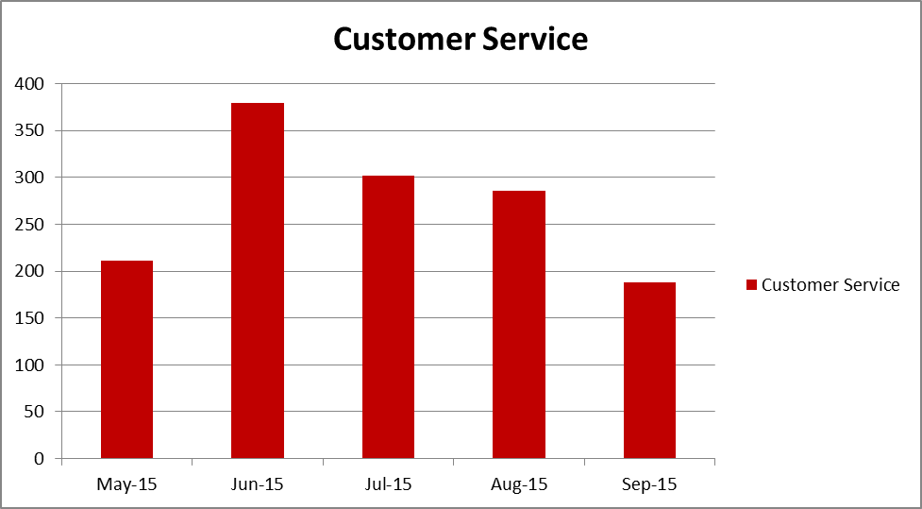

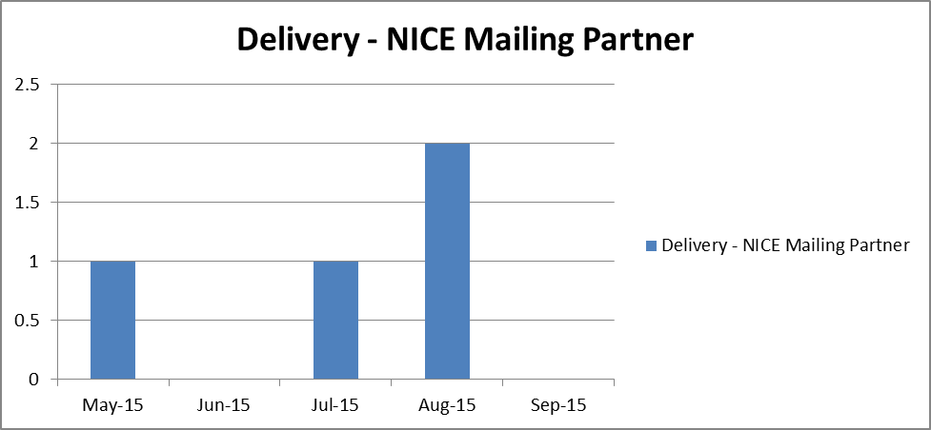

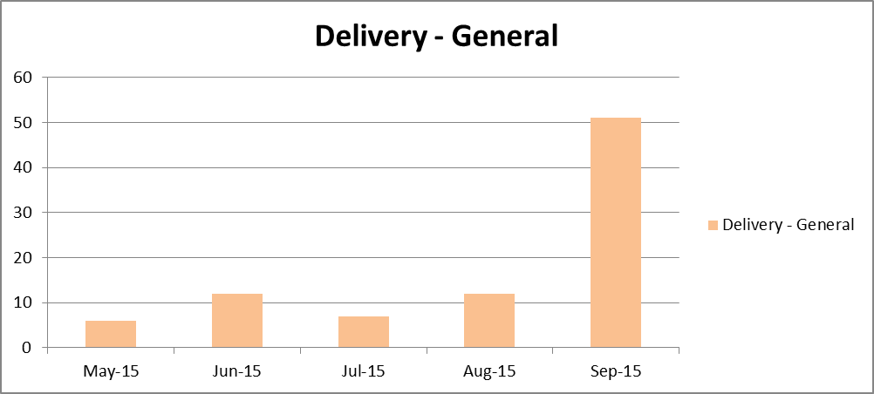
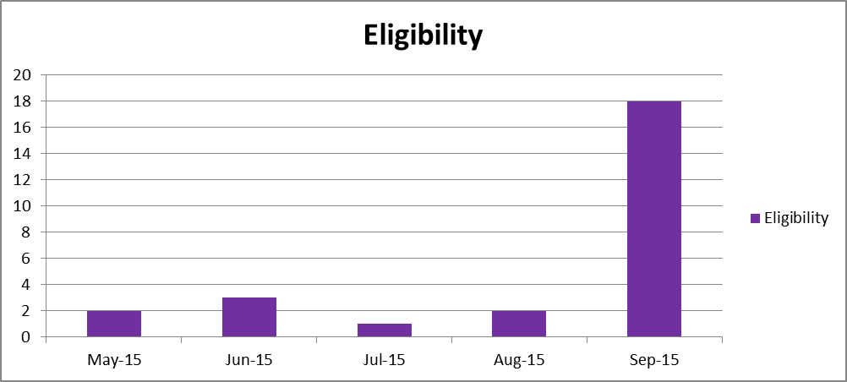c
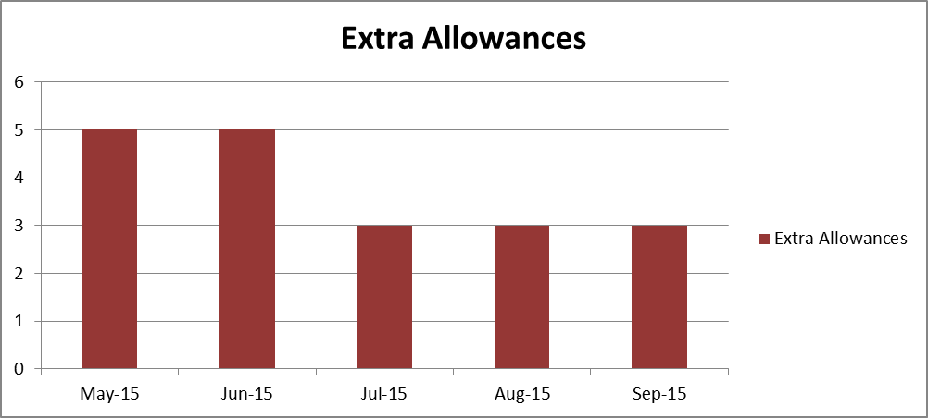

ANNEX 3
Payment Schedule
The Contractor will invoice NICE quarterly in arrears according to the schedule below.

Amount of Funding | Financial Year 1 | Date(s) for Submission of Invoice(s)

AGREEMENT TOTAL (2yrs) Excluding VAT | 144,375

Annex 4
Key Dates

Publication/Edition | NICE will request counts
BNF 72 | May 2016
BNFC 2016 | May 2016
BNF 74 | May 2016
BNFC 2017 | May 2017
NPF 2017 | May 2017
BNF 76 | May 2018
BNFC 2018 | May 2018

Annex 5
Pricing Structure for Call off Orders

Annex 6
Call off Services Order
The following call of order shall be an additional to the Agreement between National NICE for Health and Clinical Excellence and the Contractor of on the Day of 20xx (“the Agreement”).
For the purposes of this Call off Agreement:
NICE’s Commissioning Manager | means the individual from time to time appointed by the NICE and notified to the Contractor in writing responsible for the co-ordination of the development specified below;
This Call off order, pertains to the services of XXX (the “Services and Supply”) to be undertaken by the Contractor and is agreed by the Contractor and the NICE as a current addition to Annex 1 to the Agreement.
The Services and Supply will:
- be developed by the Contractor in compliance with the specifications contained in this Call off Agreement, and
- be developed and delivered in accordance with the terms and conditions of the Agreement.
This Services and Supply consists of:
[To be completed]

The Scope and this Call off order may only be varied with the prior written agreement of the NICE, such agreement (if given) not to be unreasonably delayed.
The Milestones for deliverables which are required by the NICE are detailed in this Memorandum. The NICE requires, and the Contractor will deliver quarterly a Monitoring Report in the form and by the times set out within clause 18.
Milestones
Due Date | Milestone

The Contractor shall be deemed to have completed a Milestone by the Due Date notwithstanding any delay beyond the Due Date if such delay would not have occurred but for any act or omission of the NICE, anything done or omitted to be done on the NICE’s instructions or any other act or omission of a third party which was beyond the reasonable control of the Contractor (for the avoidance of doubt such third parties do not include the Contractor’s sub-Contractors,).
Call off Pricing Schedule
The Contractor will invoice NICE quarterly in arrears according to the schedule below.
Amount of Funding |  | Financial Year 1 | Date(s) for Submission of Invoice(s)
1st Quarter
2nd Quarter
3rd Quarter
4th Quarter
Total
VAT (at prevailing rate)
CALL OFF AGREEMENT TOTAL | £

This Call off order shall be pursuant to the Agreement and all terms and conditions herein.

______________________________  Signature on behalf of the Contractor  Name  Title  Date | ______________________________  Signature on behalf of the NICE  Name  Title  Date

Annex 7
Variation to Agreement
Annex 9 to Agreement between National NICE for Health and Clinical Excellence and the Contractor of on the Day of 20xx (“the Agreement”).
For the purposes of this Memorandum of Agreement:
NICE’s Commissioning Manager | means the individual from time to time appointed by the NICE and notified to the Contractor in writing responsible for the co-ordination of the development specified below;
This Memorandum of Agreement, pertain to the development of XXX (the “Services and Supply”) to be undertaken by the Contractor and is agreed by the Contractor and the NICE as a current addition to Annex 1 to the Agreement.
The Development Services and Supply will:
- be developed by the Contractor in compliance with the specifications contained in this Memorandum, and
- be developed and delivered in accordance with the terms and conditions of the Agreement.
This Development Services and Supply consists of:
[To be completed]

The Scope and this Memorandum may only be varied with the prior written agreement of the NICE, such agreement (if given) not to be unreasonably delayed.
The Milestones for deliverables which are required by the NICE are detailed in this Memorandum. The NICE requires, and the Contractor will deliver quarterly a Monitoring Report in the form and by the times set out within clause 18.
Milestones
Due Date | Milestone

The Contractor shall be deemed to have completed a Milestone by the Due Date notwithstanding any delay beyond the Due Date if such delay would not have occurred but for any act or omission of the NICE, anything done or omitted to be done on the NICE’s instructions or any other act or omission of a third party which was beyond the reasonable control of the Contractor (for the avoidance of doubt such third parties do not include the Contractor’s sub-Contractors,).
Terms defined in the Agreement shall bear the same meanings in this Memorandum of Agreement, unless otherwise stated, or the context otherwise requires.

______________________________  Signature on behalf of the Contractor  Name  Title  Date | ______________________________  Signature on behalf of the NICE  Name  Title  Date

Annex 8
- Eligibility criteria for BNF Publications
  - The current eligibility criteria are shown below. These may be changed during the contract period. They currently apply to staff employed directly by the NHS, or staff employed by organisations who are commissioned by the NHS.
Role | BNF | BNFC
Hospital-based doctors or pharmacists who have a paediatric or accident & emergency speciality | ✓ | ✓
Hospital-based doctors or pharmacists who do not have a paediatric or accident & emergency speciality | ✓
NHS Dentists | ✓
Non-medical prescribers: independent and/or supplementary prescribers who hold a V200 or V300 qualification employed by an acute Trust | ✓ | ✓
Non-medical prescribers: independent and/or supplementary prescribers who hold a V200 or V300 qualification employed by social enterprises, community interest companies or private companies who are commissioned to provide NHS services | ✓ | ✓
Doctors employed by social enterprises, community interest companies or private companies who are commissioned to provide NHS services | ✓
Doctors who have a paediatric or accident & emergency speciality employed by social enterprises, community interest companies or private companies who are commissioned to provide NHS services | ✓ | ✓
General practitioners, community/retail pharmacists and prescribing advisors (Not including pharmacy technicians) | ✓ | ✓
Students studying pharmacy or for a non-medical prescribing V200 or V300 qualification | ✓ | ✓

  - NPF:
    - NICE supplies print copies of the NPF to community practitioner nurse prescribers who hold a V100 or V150 qualification, employed by the NHS and other organisations that provide NHS-commissioned care in England.
    - NPFs should also be provided for all student nurses attending V100 and V150 Nurse Prescribing Programmes at Universities.

