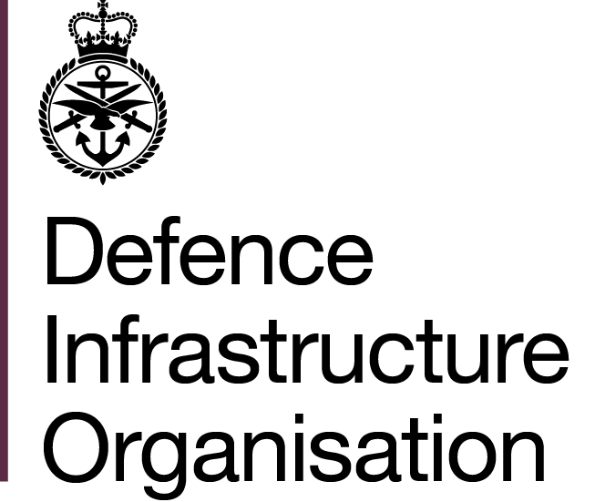  Reference: DIOECAM/SE/002  Contract number: 710396379 | Ministry of Defence  DIO Commercial  Rm 2.1.02, Level 2  Kentigern House  65 Brown Street  Glasgow G2 8EX
 | Telephone:  Email: | +447929763231

Steve Dixon  Arcadis LLP  34 York Way  London, N1 9AB | Date: 18th December 2020

Dear Martin Rance,

ENHANCED COMMISSIONING AND ASSURANCE MODEL (ECAM), TECHNICAL SUPPORT PROVIDER (TSP) TO THE RE-PROVISION OF LONDON TRANSIT ACCOMODATION (LTA) AND ALTERNATIVE LONDON MILITARY OPERATIONS CENTRE (LMOC) AS PROJECT

Standard Notice of Contract Award Decision

1. Thank you for your proposal dated 25th November 2020, and revised programme dated 11th December 2020, for the Enhanced Commissioning and Assurance Model (ECAM) Technical Support Provider (TSP) in support of the Re-Provision of London Transit Accommodation (LTA) and Alternative London Military Operations Centre (LMOC) AS Project.

2. This letter notifies you of the Employer’s decision to award the TSP support works for the Project to your company.

3. The Employer is not invoking a standstill period. This means that this notification of the contract award decision is also the date of the contract award.

4. The resultant contract is attached for your convenience. It comprises of:

the call off terms RM3741, including the completed contract data part 1 and 2,
Schedule of Services (SoS),
Technical Statement of Requirement (TSOR),
Contract Key Performance Indicators,
Pricing Schedule,
Security Aspects Letter (SAL),
Supplier Cyber Protection,
Supplier Assurance Questionnaire,
and your TSP proposal.

5. Your acknowledgement of receipt of this award letter would be appreciated.

Yours sincerely,

Senior Commercial Officer
For and behalf of DIO Commercial

