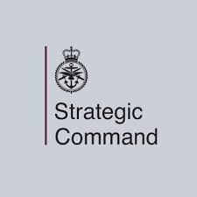

Defence Digital IT Services Commercial

Contract Number: 701415373

Contract Description: DD/IT/SVCS/012 – Atlas Exit, RAID Manager
Award to: i3Works Limited



G-Cloud 12 Call-Off Contract

This Call-Off Contract for the G-Cloud 12 Framework Agreement (RM1557.12) includes:
G-Cloud 12 Call-Off Contract 2
Part A: Order Form 3
Schedule 1: Services 12
Schedule 2: Call-Off Contract charges 12
Part B: Terms and conditions 13
Schedule 3: Collaboration agreement Error! Bookmark not defined.
Schedule 4: Alternative clauses Error! Bookmark not defined.
Schedule 5: Guarantee Error! Bookmark not defined.
Schedule 6: Glossary and interpretations 37
Schedule 7: GDPR Information 51

