Work Order Ref. PSGW01501
Provision of Project Delivery Digital E-Learning Enterprise Licences
This Work Order is made on the [DD/MM/YYYY] between Capita Business Services and ILX Group Plc (the Parties).
This Work Order is a Work Order as referred to in, and incorporates and is governed by, the Knowledgepool Supplier Agreement between the Parties dated [DD/MM/YYYY] of Supplier Agreement and sets forth the specific terms and conditions relating to the provision of the Services described in this Work Order. The combination of the terms of the Knowledgepool Supplier Agreement, subject to any agreed alterations contained within Section 3 Variations to the Terms and Conditions contained within this Work Order, and the provisions of this Work Order shall together constitute the call-off contract between the parties in respect of the Services outlined in this Work Order.
This call-off contract offers no volume guarantees nor does it place any restriction on Knowledgepool to book/buy any service(s) solely from the Supplier. Any work booked before the contract expires will be delivered even if the date for delivery is after the contract end date.
- Order Details:
Client: | MOD
Work Order Effective Date: | [DD/MM/YYYY]
Contract End Date: | 30/042022
Extension period in months | 2 possible 12 months extensions at Knowledgepool’s discretion

- Supplier details:
Supplier: | ILX Group Plc
Contact(s) Name(s): | Booking Enquiries: Claire Heesom  Account/Project: Claire Hessom
Contact details: | Booking Enquiries: claire.heesom@ilxgroup.com | +44 (0) 7964 271 545  Account/Project: claire.heesom@ilxgroup.com | +44 (0) 7964 271 545

- Variations to the Terms and Conditions:
The Parties agree to the following variations to the referenced Terms and Conditions for this Work Order:
- No variations

- Work/Service Description:
Part B
Bidder’s proposed methodology for delivering the contract
ILX offers a broad range of fully accredited eLearning courses, covering Project, Programme and Portfolio Management, as well as IT Service and Finance Management. Our online courses are accredited multimedia eLearning packages providing content which traditionally has been delivered as a 2 or 3 day classroom event.
Our on-demand, digital learning provides a flexible and efficient way to train your entire team. Each eLearning course is derived from the official syllabus and converted into an interactive, multimedia, content-rich training package and gained accreditation from the official bodies. The combination of interactive visuals and audio explanation delivers information in an easily understood format. The one-on-one nature of the ILX eLearning systems help learners take greater control and hence responsibility for their own learning process.
An ILX Enterprise Licence provides 12 months access to our entire eLearning portfolio which includes the accredited courses below:
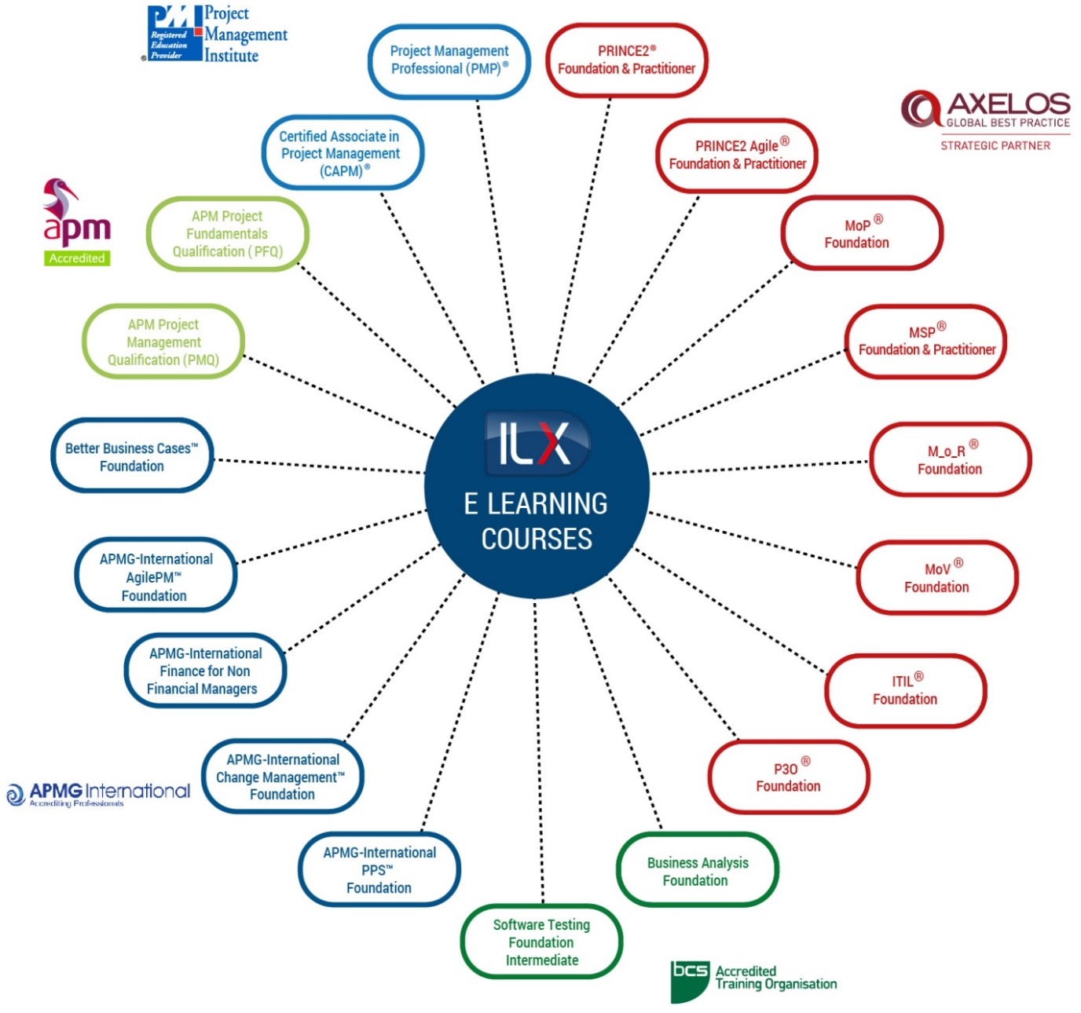
The full suite of ILX courses are mapped to the government competency assessment model, PDCF. Following completion of the GOST, individuals will be provided with tailored learning plan.
Delegates are then able to prove and plan effective progress in a modular fashion, able to pinpoint the learning elements to drive project management efficiency without the need to complete entire training courses. This saves time and cost, and allows delegates to nail-out and undertake full accredited courses required to achieve the qualification.
The ILX Connect team provides close support at every stage of this process, to successfully manage the roll out of your learning programme. In this way, obstacles that might negatively impact the learner’s progress are removed, driving up the organisation’s ROI.
What’s Included?
An Unlimited Enterprise Licence is available for any number of users who work for the MoD, and includes the following elements:
- 12 months access to our entire eLearning portfolio, equivalent to over 250 hours of learning available to each individual user
- Full support from the ILX Tutor panel
- Access to ILX CONNECT – GOLD LEVEL which includes:
  - Access to eLearning portal
  - Tailored quarterly reporting, to maximise ROI and to accurately monitor and plot learner progress
  - Dashboards that allow the training administrators to define and deliver streamlined internal training processes
  - Exam administration support
  - Company-specific launch webinars
  - Monthly progress reporting
  - Personalised portal pages
  - Bespoke reporting
  - Tailored webinars
CVs/Bios of resources that would be involved in design and/or delivery of the contract
Claire Heesom – Account Director
ILX will provide a dedicated Account Director, Claire Heesom, who will be responsible for the overall service provided. Claire has considerable experience of account management of major projects within ILX’s key central government and public sector vertical including P3M3 assessments, PPM Leadership Programmes, and all related PPM learning and development activities. As ILX Group’s Public Sector Director, Claire is responsible for strategic planning and management of the public sector vertical and internal team.
David Wall - ILX Connect
David will manage the ILX Learning Portal, guide learners through the learning and provide support where necessary, produce management information reports, maintain communication with learners keeping them engaged and focused on the course examination (if required).
Glyn Davies – Head of Product Development
A professional developer and project manager with a wealth of experience in the project management training field. Glyn has been responsible for the design and development of ILX’s extensive portfolio of project and service management eLearning courses. He has been instrumental in the design of ILX’s award winning eLearning products and has responsibility for technical innovation.
Proposed Course Outline/Content if applicable
We work with a wide range of accrediting bodies to develop our best practice eLearning courses, including PeopleCert (on behalf of AXELOS), APM, APMG International, PMI and BCS. Please use the links below for full course outlines for our eLearning courses, as well as classroom and blended options:
Course | Course Outline
 | https://www.ilxgroup.com/uk/individual/training/prince2
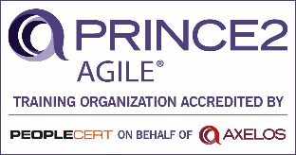 | https://www.ilxgroup.com/uk/individual/training/prince2-agile
 | https://www.ilxgroup.com/uk/individual/training/msp
 | https://www.ilxgroup.com/uk/individual/training/mop
 | https://www.ilxgroup.com/uk/individual/training/p3o
 | https://www.ilxgroup.com/uk/individual/training/m-o-r
 | https://www.ilxgroup.com/uk/individual/training/mov
 | https://www.ilxgroup.com/uk/individual/training/itil
Certified Associate in Project Management (CAPM)
https://www.ilxgroup.com/uk/individual/training/certified-associate-in-project-management-capm
Project Management Professional (PMP)
https://www.ilxgroup.com/uk/individual/training/project-management-professional-pmp
 | https://www.ilxgroup.com/uk/individual/training/apmg-international-agilepm
 | https://www.ilxgroup.com/uk/individual/training/apmg-international-better-business-cases
 | https://www.ilxgroup.com/uk/individual/training/apmg-international-finance-for-non-financial-managers
 | https://www.ilxgroup.com/uk/individual/training/apmg-international-change-management
 | https://www.ilxgroup.com/uk/individual/training/apmg-international-pps
 | https://www.ilxgroup.com/uk/individual/training/apm
Business Analysis (BCS) Foundation
https://www.ilxgroup.com/uk/individual/training/business-analysis
Software Testing
https://www.ilxgroup.com/uk/individual/training/software-testing

Sample course materials
Please use the links below to view our online eLearning demo content:
Course | Online Demo
PRINCE2 Foundation: http://content-eu.ilxportal.com/demos/prince2f_html5_demo/index.html
PRINCE2 Practitioner: http://content-eu.ilxportal.com/demos/prince2p_html5_demo/index.html
 | http://content-eu.ilxportal.com/demos/p2a_demo/index.html
MSP Foundation: http://content-eu.ilxportal.com/demos/msp_html5_demo/index.html
MSP Practitioner: http://content-eu.ilxportal.com/demos/mspp_html5_demo/index.html
 | http://content-eu.ilxportal.com/demos/mopf_html5_demo/index.html
 | http://content-eu.ilxportal.com/demos/p3of_html5_demo/index.html
 | http://content-eu.ilxportal.com/demos/morf_html5_demo/index.html
 | http://content-eu.ilxportal.com/demos/mov_html5_demo/index.html
 | http://content-eu.ilxportal.com/demos/itil_v4_f_demo/index.html
Certified Associate in Project Management (CAPM)
http://content-eu.ilxportal.com/demos/capm_html5_demo/index.html
Project Management Professional (PMP)
http://content-eu.ilxportal.com/demos/pmp_html5_demo/index.html
 | http://content-eu.ilxportal.com/demos/agile_pm_html5_demo/index.html
 | http://content-eu.ilxportal.com/demos/bbc_demo/index.html
 | http://content-eu.ilxportal.com/demos/fnfm_html5_demo/index.html
 | http://content-eu.ilxportal.com/demos/change_f_html5_demo/index.html
 | http://content-eu.ilxportal.com/demos/pps_html5_demo/index.html
APM Project Fundamentals Qualification (PFQ)
http://content-eu.ilxportal.com/demos/apmpf_html5_demo/index.html
APM Project Management Qualification (PMQ)
http://content-eu.ilxportal.com/demos/apmpmq_html5_demo/index.html

Quality Assurance
How the Bidder will ensure the quality of the contract
ILX Group operates a Quality Management System which is accredited to the ISO 9001 standard by the BSI. Quality of product is controlled through our design procedures and key features of these procedures are the clarification of requirement and control and regular reviews of product conformity. A copy of our ISO 9001 certificate is available on request.
ILX’s eLearning products are developed inhouse by our own Development Team. Issue and problem solving is supported by our ISO 9001 development processes. Issues are formally documented and handled by our team of subject and technical experts. We are able to respond quickly and effectively should any content or functionality issues arise. We maintain full control of our change and release processes which provides efficient and timely delivery of new releases and updates to our customers.
Include evidence of relevant accreditations/certifications held
ILX is an Accredited Training and Consulting Organisation (ATO & ACO) offering a full suite of best practice training courses, materials and systems, all accredited (as appropriate) by the APM Group, the Association for Project Management (APM), PeopleCert (on behalf of AXELOS), BCS, The Chartered Institute for IT (formerly ISEB), the British Standards Institute (BSI) and the UK Accreditation Service (UKAS).
ILX is an Accredited Training Organisation for courses including PRINCE2®, PRINCE2 Agile®, MSP®, M_o_R®, MoP®, MoV®, P3O®, ITIL®, PPS™, AgilePM®, Change Management™, Managing Benefits™, Better Business Cases™, Finance for Non Financial Managers, APM Project Management Qualification (PMQ) and APM Project Fundamentals Qualification (PFQ). Copies of our ATO certificates are available by request.
Business continuity and exit plan (if applicable)
Our accredited eLearning is available 24/7 and offers maximum learning flexibility. The ILX eLearning Portal is a secure web-based site that is accessible through the internet, so each learner can log in from home, office or anywhere that they have internet access.
The ILX Portal Platform is hosted using Amazon Web Services (AWS) infrastructure with all servers and data storage hosted within AWS’s EU Region. For its database backend, the portal uses Amazon’s Relational Database Service (RDS) with automatic failover server in separate availability zone, automatic software patching and automated backups.
Our system has a 99.9% uptime. No downtime is required as we have a full UAT environment with replication centres, so there is no need for the system to be taken offline.

- Commercials:
*All costs are inclusive of expenses and exclude VAT.

Payment Terms:
  - Delivery: Successful provider to invoice Knowledgepool monthly in arrears of successful delivery per cohort
  - Licences / Online Learning / Professional Qualifications:
    - Provider to invoice Knowledgepool at registration,

- Please note these payment terms are non-negotiable

Ensure that all invoices are emailed directly to finance@knowledgepool.com
Invoices must be addressed to the business address stated in the invoicing guide and template. However, do not send invoices to this address.
- Next Steps
Next steps upon contract agreement are:
1. A Knowledgepool Learning Coordinator or Project Manager will contact you to organise delivery.
2. Event references will be sent prior to delivery dates.
Note:
- Delivery should not commence until you have been contacted by the Knowledgepool Learning Coordinator/Project Manager and you have been issued with an event reference (Booking)
- Knowledgepool will not be liable for any work undertaken without the above being satisfied.
- Any amendment to this work order without approval by Knowledgepool Supplier Management is void.

- Declaration
Document Agreed by Supplier
I declare that to the best of my knowledge the detail submitted in this document are correct.
Name:
Date:
Signature:
Title:
On behalf of:

Document Agreed by Customer
I declare that to the best of my knowledge the detail submitted in this document are correct.
Name: | Dorne Carter
Date: | 2 April 2010
Signature: | Dorne Carter
Title: | Defence Project Delivery Centre of Excellence Training Authority1
On behalf of: | Capita Business Services Ltd

A Booking has occurred when the Supplier receives an event reference from Knowledgepool
Any work Booked before the contract expires will be delivered even if the date for delivery is after the contract end date.
Except otherwise stated in this WO, the pricing quoted in the Commercials section of this WO shall apply to the extension period should Knowledgepool trigger the contract extension.

