Mrs. L.A. Ruff, Clerk of the Council, Street Parish Rooms, 6 Leigh Road, Street, Somerset BA16 0HA Tel. (01458) 440588
Email street.parish@street-pc.gov.uk Website www.street-pc.gov.uk

2nd June, 2020
SUBJECT TO CONTRACT

Dear Derek,

Tender – Street Parish Rooms

I write with reference to your tender document dated 20th December, 2019 and additional information and pricing detailed in the email from Orme dated 16th January 2020 on fire detection and additional stone and mortar repair for external facades – walls noted as A to E and not measured. This gave a total value of £177,408.15 + VAT which has been agreed by the Council with all documents submitted as part of the tender. I write to inform you that the Council wishes to proceed with the start date of 29th June 2020. The intermediate JCT contract for the works is being prepared.

Yours sincerely,

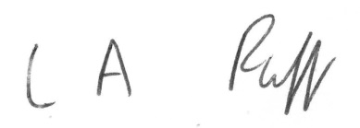

Clerk of the Council

D.J. Thyer,
Estimator/Quantity Surveyor,
Melhuish and Saunders Ltd.,
8/9 Landmark House,
Wirral Park Road,
Glastonbury.
BA6 9FR.

