
Town Hall, Market Square
Witney, OX28 6AG

Tel: 01993 704379
E-mail: info@witney-tc.gov.uk

Mrs Sharon Groth FSLCC fCMgr
Town Clerk

Cllr Owen Collins
Mayor of Witney

LITE Limited 26th July 2023
Unit 2, Farrington Place
Rossendale Road Ind. Est.
Burnley
Lancashire
BB11 5TY

Our ref: R11/24/01

Dear Paul Taylor

Tender for Witney Christmas Lights 2024-2027 Contract

I am very pleased to confirm that the tender offer which was submitted by LITE Ltd. for the total contract sum of £133,467 excluding VAT has been accepted by Witney Town Council.

The tender scored highly on all elements of the design and quality criteria. The Council was also particularly impressed with your company’s experience in providing similar local authority schemes and social value offer.

I would be grateful if you would confirm acceptance of this offer of award of tender as soon as possible to enable the formal award process to be completed following the expiration of the mandatory standstill period on 23rd June 2024, as required by the Public Contracts Regulations 2015.

The Council looks forward to working in partnership with your company and I trust that all associated matters will now progress satisfactorily.

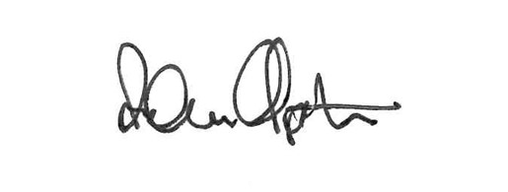
Yours sincerely

Adam Clapton
Deputy Town Clerk

