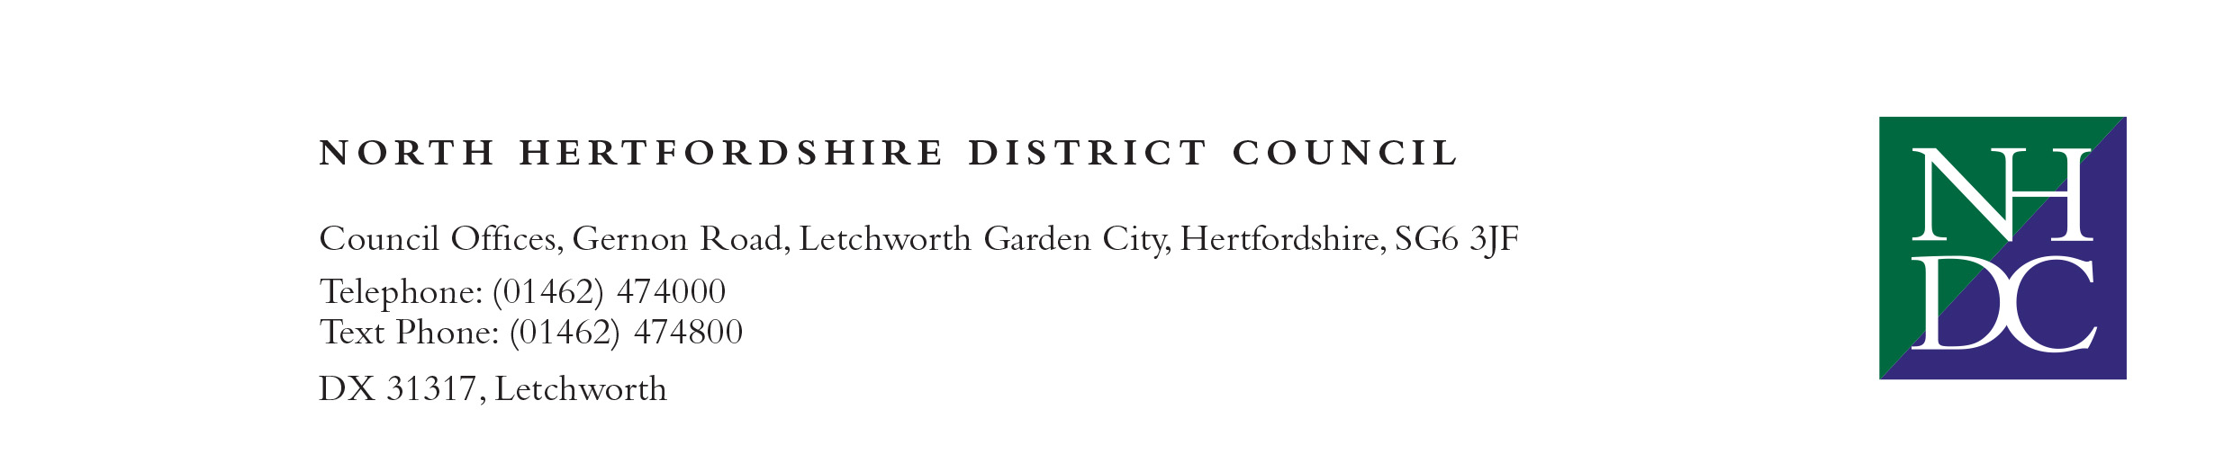
Floorteq Limited  Market House  21 Lenten Street  Alton  Hampshire  GU34 1HG | Our Ref: LL14352  Contact Officer: Robert Orchard  Direct Line: 01462 474287  Email: robert.orchard@north-herts.gov.uk  Date: 18th November 2021

Dear Sirs,

Re: Hitchin Town Hall Flooring

Thank you for submitting a tender in respect of the above contract. We have now completed our evaluation process and are pleased to advise you of our notification of intention to award you the contract, subject to the requirements of regulation 87 of the Public Contracts Regulation 2015 and the Authority’s reserved rights as declared in the ITT and also the ability to fulfil the contract within the dates of 26th December 2021 to 26th January 2022. The table below shows the individual scores given based on quality and price in respect of your submission.

The reason for the Authority’s decision is that Floorteq Limited’s tender meets all the Authority’s requirements, namely proof of competency when dealing with historic sprung floors along with knowledge of materials used, plans for the works and health and safety considerations. Its overall score provides the Authority with the best value.

AWARD CRITERIA | YOUR SCORE
Quality | 32
Price | 60
OVERALL SCORE | 92

Yours faithfully,

Robert Orchard
Culture and Facilities Service Manager
North Herts Council

