

Call-Off Order Form
Contract Reference: CCIH20A48
NFC128 IT Hardware Aggregation Autumn 2020

Framework Schedule 6 (Order Form Template and Call-Off Schedules)

Order Form

CALL-OFF REFERENCE: GDC-2020-061

THE BUYER: General Dental Council

BUYER ADDRESS 1 Colmore Square (6th Floor), Birmingham, B4 6AJ

THE SUPPLIER: Incredible Computers Limited
SUPPLIER ADDRESS: 386 Upper Ballynahinch Road, Lisburn, Northern Ireland, BT27 6XL

REGISTRATION NUMBER: NI632640
DUNS NUMBER: 221020655
SID4GOV ID: Unknown

APPLICABLE FRAMEWORK CONTRACT

This Order Form is for the provision of the Call-Off Deliverables and dated as per Supplier Signature Date.
It’s issued under the Framework Contract with the reference number RM6068 for the provision of Technology Products and Associated Services.

CALL-OFF LOT(S):

- Lot 2 Hardware & Associated Services

CALL-OFF INCORPORATED TERMS
The following documents are incorporated into this Call-Off Contract. Where numbers are missing we are not using those schedules. If the documents conflict, the following order of precedence applies:
- This Order Form including: Order Form Attachment 2, Order Form Attachment 3, Order Form Attachment 4, and Call-Off Special Terms.
- Joint Schedule 1 (Definitions and Interpretation) RM6068
- The following Schedules in equal order of precedence:

- Joint Schedules for RM6068
  - Joint Schedule 2 (Variation Form)
  - Joint Schedule 3 (Insurance Requirements)
  - Joint Schedule 4 (Commercially Sensitive Information)
  - Joint Schedule 6 (Key Subcontractors) – if applicable
  - Joint Schedule 10 (Rectification Plan)
  - Joint Schedule 11 (Processing Data)
- Call-Off Schedules for this Call-Off Contract:
  - Call-Off Schedule 5 (Pricing Details)
- CCS Core Terms (version 3.0.6) (including paragraph 10 of Framework Award Form)
- Joint Schedule 5 (Corporate Social Responsibility) RM6068
- Call-Off Schedule 4 (Call-Off Tender) which shall comprise of Attachment 2 – Supplier Tender Response and Attachment 4 – Price Schedule

No other Supplier terms are part of the Call-Off Contract. That includes any terms written on the back of, added to this Order Form, or presented at the time of delivery.

CALL-OFF SPECIAL TERMS
The following Special Terms are incorporated into this Call-Off Contract:

Special Term A:
In the event that the Goods become genuinely unavailable after the Supplier has accepted and/or confirmed the Buyer’s Order and is contractually bound, the Supplier shall offer the Buyer a replacement model or equivalent substitute goods at no additional cost to the Buyer. The equivalent substitute goods shall be of an equivalent or higher specification and provide the same or additional functionality than the Goods they replace. It shall be the Buyer’s sole decision whether to accept the replacement model or equivalent substitute goods. In the event that the Buyer rejects the replacement model or equivalent substitute goods, the Supplier’s failure to Deliver in accordance with the Call-Off Contract shall be deemed a material Default entitling the Buyer to terminate the Call-Off Contract.

Special Term B:
Warranty shall commence on Acceptance.

Special Term C (for Buyers with Storage requirements managed by the Supplier ONLY):
Risk shall pass on receipt of delivery at the Buyer’s goods in reception.
Title of the Goods shall pass on delivery to a secure storage facility and issue of a satisfactory vesting certificate.

Special Term D (for Buyers with Storage requirements managed by the Supplier ONLY):
The Buyer has specifically requested storage of Goods. The Supplier shall ensure:
- Goods are stored in a UK warehouse;
- that once the Goods are delivered to the storage facility they are not moved without prior agreement from the Buyer, save for delivery in line with the Implementation Plan
- Goods are clearly allocated as belonging to the Buyer
- adequate insurance is included to cover damage or loss to any or all of the Goods
- the Buyer has right and access to inspect the Goods at any point, given reasonable notice
- a vesting certificate is provided to the Buyer within 2 Working Days of delivery to the storage facility. Vesting certificates must be dated from the date the delivery to the storage facility was made
- an invoice for the stored Goods is issued along with the vesting certificate. For the avoidance of doubt, this invoice must cover the Charges of the Goods only, Charges for storing Goods should be invoiced monthly in arrears (reflecting actual pallets and weeks in storage).

CALL-OFF START DATE: Date Supplier Signed the Order Form

CALL-OFF EXPIRY DATE: Earlier of: All Deliverables Paid For or six (6) Months

CALL-OFF INITIAL PERIOD: Maximum of six (6) Months

CALL-OFF OPTIONAL EXTENSION None
PERIOD

CALL-OFF DELIVERABLES
See Attachment 3 – Statement of Requirements and Attachment 4 – Price Schedule

LOCATION FOR DELIVERY
See Attachment 3 – Statement of Requirements and Attachment 4 – Price Schedule

DATES FOR DELIVERY OF THE DELIVERABLES
See Implementation Plan in Attachment 3 – Statement of Requirements and Attachment 4 – Price Schedule

TESTING OF DELIVERABLES

Acceptance Test Criteria below:
a) For each delivery, the correct quantity of device types has arrived;
b) All boxes are delivered with the packaging intact;
c) No boxes have evidence of damage prior to stock checking in the Buyer’s goods in area;
d) No devices have any cosmetic damage;
e) Each device successfully loads the Buyer’s image (where applicable);
g) Each device connects successfully to the Buyer’s network (where applicable);

The Goods shall be deemed as Accepted twenty-eight (28) Calendar Days following delivery at the Buyer’s goods in reception unless otherwise notified by the Buyer.

WARRANTY PERIOD
The warranty period for the purposes of Clause 3.1.2 of the Core Terms shall be a minimum of 90 days.

MAXIMUM LIABILITY
The limitation of liability for this Call-Off Contract is stated in Clause 11.2 of the Core Terms.

The Estimated Year 1 Charges used to calculate liability in the first Contract Year is set out in Attachment 4 – Price Schedule

CALL-OFF CHARGES
As set out in Attachment 4 – Price Schedule

The Charges will not be impacted by any change to the Framework Prices. Charges are subject to the terms set out in Call-Off Schedule 5 (Pricing Schedule)

REIMBURSABLE EXPENSES
None

PAYMENT METHOD
See Attachment 3 – Statement of Requirements

BUYER’S INVOICE ADDRESS:
See Attachment 3 – Statement of Requirements

BUYER’S AUTHORISED REPRESENTATIVE
See Attachment 3 – Statement of Requirements

BUYER’S DATA PROTECTION OFFICER:
[LWhiting@gdc-uk.org]

BUYER’S ENVIRONMENTAL POLICY
Not Applicable

BUYER’S SECURITY POLICY
Not Applicable

SUPPLIER’S AUTHORISED REPRESENTATIVE
Aaron Kanengoni
CEO
aaronk@incrediblecomputers.co.uk
Incredible Computers
386 Upper Ballynahinch Road,
Lisburn
Northern Ireland
BT27 6XL

SUPPLIER’S DATA PROTECTION OFFICER:
Aaron Kanengoni
CEO
aaronk@incrediblecomputers.co.uk
Incredible Computers
386 Upper Ballynahinch Road,
Lisburn
Northern Ireland
BT27 6XL

SUPPLIER’S CONTRACT MANAGER
Aaron Kanengoni
CEO
aaronk@incrediblecomputers.co.uk
Incredible Computers
386 Upper Ballynahinch Road,
Lisburn
Northern Ireland
BT27 6XL

PROGRESS REPORT FREQUENCY
Shall be requested by Crown Commercial Service and Ad Hoc as required by Buyer.

PROGRESS MEETING FREQUENCY
Ad Hoc as required by Buyer.

KEY STAFF
None

KEY SUBCONTRACTOR(S)
None

COMMERCIALLY SENSITIVE INFORMATION
All pricing information, address, personal employee names, part numbers included in the procurement, total value of the contract

SERVICE CREDITS
Not applicable

ADDITIONAL INSURANCES
Not applicable

GUARANTEE
Not applicable

SOCIAL VALUE COMMITMENT
Not applicable

For and on behalf of the Supplier: |  | For and on behalf of the Buyer:
Signature: | 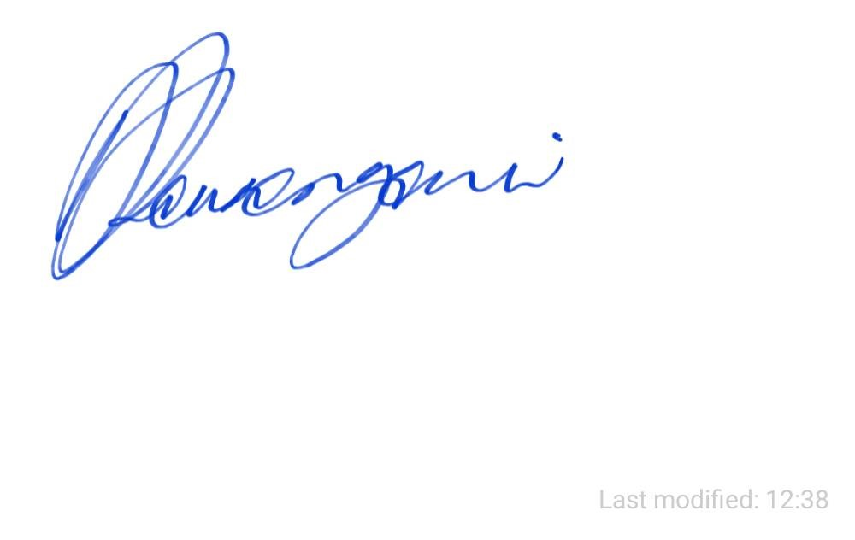 | Signature: | E J REED
Name: | Aaron Kanengoni | Name: | ED REED
Role: | CEO | Role: | Head of IT
Date: | 11/12/2020 | Date: | 12/11/2020

Attachment 1 – Terms and Conditions
Attachment 2 – Supplier Tender Response
Attachment 3 – Statement of Requirements
Attachment 4 – Price Schedule

