CONFIRMATION OF AWARD

Laundry (including Specialist Firefighters PPE) REF NO 000929

To be completed by the Customer: I confirm the details of the following award of contract under the Laundry Framework Agreement, reference number 000929
Name of Organisation: | West Midlands Fire Service Headquarters
Address: | 99 Vauxhall Road , Nechells  Birmingham B7 4HW
Name of person signing this form: | Ms Geraldine Turner
Signature: | 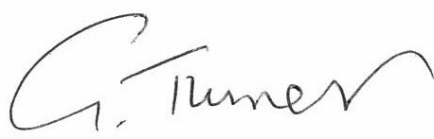
Date: | 10/10/2022
Position: | Con tract Manager
Telephone: | 0121 380 6174
E-mail: | Gerri.turner@wmfs.net
Description of service procured: | Provision of Laundry & Rental Service  Provision of Corporate Workwear Rental & laundering service
Value of award; | £32.5k pa ie: TCV £97.5 ( 3yrs )
Details of spend forecasting: | N/A
Date of award: | 1st October 2022 ( followed by Vol Standstill period)
Length of call off period (or one-off purchase): | N/A
Awarded provider name: | ELIS UK Ltd
Savings achieved: | £21k over 3yrs contract award period
Benefits you gained by using the framework: | Opportunity to source available contractors which is difficult in this type of service provision  Assistance with the Tender process – use of the Framework e-tendering portal –  Achievable savings
Are you happy to be contacted by YPO to discuss your experience of using the Framework? (please tick) | YES | NO
 | X

To return this form, please email it to laura.megson@ypo.co.uk

