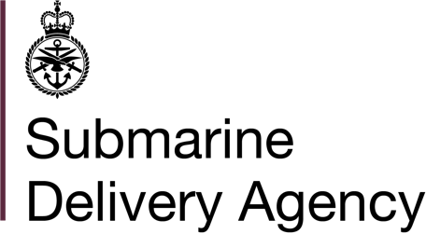 | Susan McGowan  Clyde Commercial Manager 2
 | 0300 1623924 | 
 | susan.mcgowan288@mod.gov.uk
Gareloch Support Services (Plant) Ltd  Silverhills  Rosneath  Helenburgh  G84 0RW | Defence Equipment & Support  HMNB Clyde. Faslane  Helensburgh, G84 8HL  Reference: 700032343  Date: 9 February 2021

Dear Jamie

Contract Number: 700032343 for the Maintenance and Repair of the Counter Seaborne Intruder Device (CSID) at HMNB Clyde

- The Authority hereby accepts your Tender Reference: 700032343 dated 20 August 2020 as clarified by your e-mails dated:

- 2 October 2020
- 19 November 2020
- 16 December 2020
- 14 January 2021

for the supply of the Maintenance and Repair of the Counter Seaborne Intruder Device (CSID) at HMNB Clyde.

- For your convenience, the Terms and Conditions of the Contract which will result from this acceptance are attached.

- Instructions are being sent to the authorised demander telling them that they may proceed to place orders for items shown in the Schedule of Requirements with the effect from the contract start date, Monday 15 February 2021.

- Payment will be made in accordance with the attached Terms and Conditions. If your company has not already provided its banking details to the Defence Business Services (DBS) Finance Branch, please complete the Form BX177, which is available from the website (https://www.gov.uk/government/organisations/ministry-of-defence/about/procurement) (search for DBS Finance payments: nominate a bank form) and forward to DBS Finance, Walker House, Exchange Flags, Liverpool, L2 3YL.

- Please acknowledge this by completing sections B and C in the table attached and return to me at the e-mail address above.

Yours sincerely

Susan McGowan

Offer and Acceptance
Section A) Acceptance  Acceptance of Tender No 700032343 constitutes acceptance by the Authority of your company’s tender for the supply of the Deliverables. | Section B) Confirmation of Receipt  I acknowledge receipt of the Authority’s Contract Letter No. 700032343
Signed by:  Name (Block Capitals): SUSAN MCGOWAN  Position: COMMERCIAL MANGER 2  For and on behalf of the Authority  Authorised Signatory: Susan McGowan  Date: 9 February 2021 | Signed by:  Name (Block Capitals):  Position:  For and on behalf of  Authorised Signatory …………………………….  Date:

Section C) Tier 1 Sub-Contractor data:
Name ………………….. value of work (£ ex VAT) ………… Location Of work….. SME …Yes / No
Name ………………….. value of work (£ ex VAT) ………… Location Of work….. SME …Yes / No
Name ………………….. value of work (£ ex VAT) ………… Location Of work….. SME …Yes / No
Name ………………….. value of work (£ ex VAT) ………… Location Of work….. SME …Yes / No

Name ………………….. value of work (£ ex VAT) ………… Location Of work….. SME …Yes / No

The date of unqualified acceptance by signature is the effective date of the Contract
The MOD is required to report to the Government any spend with Small and Medium-sized Enterprises (SMEs) including sub-contractors (Tier 1). SMEs are defined by the EU on http://ec.europa.eu/enterprise/policies/sme/facts-figures-analysis/sme-definition/index_en.htm

