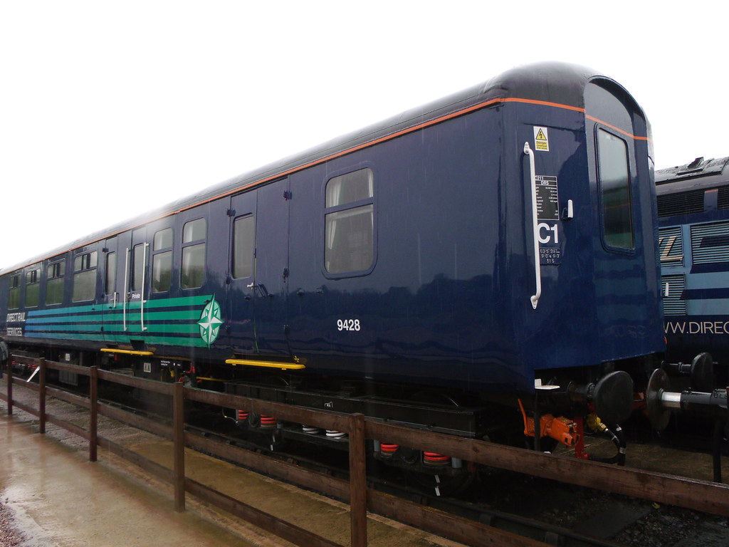

To Provide expert services required to C4 services and refurbishment of two (2) MK2 ABSO Coaches.

Prior Information Notice (PIN)

**Request for Information**

**CTM DRS Ref:**

Date: 5th May 2021

Service: Escort Coach Maintenance

Dear Sirs,

**RE: Request for Information (RFI)**

This RFI has been published on behalf of Direct Rail Services

We would like to thank you for taking the time to download this RFI document in relation to the expert services required for the C4 and C6 services and refurbishment of two (2) MK2A BSO Coaches.

We are currently developing the sourcing strategy and want to test some of our assumptions and understanding with the market to ensure that we offer an opportunity that is of interest and one that you may be interested in responding to in the near future.

The responses you provide are not binding and will be used to inform our strategy. We may also seek to hold follow up calls on the information provided to further test your response and our understanding.

We would be grateful if you could provide your responses by **16:00hrs GMT on the 25/05/2021.**

Kind Regards,

Leslie Hopcroft

1. About Direct Rail Services Limited (DRS)

Something about NTS and DRS

1. The Nuclear Decommissioning Authority (NDA) is bringing together International Nuclear Services (INS), Direct Rail Services (DRS), and the INS subsidiary Pacific Nuclear Transport Ltd (PNTL) to create a single nuclear transport division, Nuclear Transport Solutions (NTS).
   1. DRS is a wholly owned subsidiary of the Nuclear Decommissioning Authority (NDA). The company was established in 1995 as a lynch pin supplier of transport and associated services to the nuclear industry.
   2. Today DRS is a profitable and dynamic business that is achieving sustained growth with current turnover levels running at around £80 million a year and employing more than 450 staff.
   3. Further information can be found on our website here [**https://www.directrailservices.com/**](https://www.directrailservices.com/)
2. **Our requirements**
   1. Direct Rail Services Ltd (DRSL) have a requirement to carry out C4, C6 and modification on 2 x MK2 BSO vehicles.
   2. Activities include removal & installation of major equipment, corrosion repairs and repaint, full supply chain and materials management, internal modifications to the passenger environment and provision of additional work based on C4 specifications.
3. **RFI Process**
   1. This RFI has been issued on the 5th of May 2021
   2. The deadline for responses will be 25th May 2021 at 16:00pm
   3. You should return your responses Via [Procurement@ntsglobal.uk](mailto:Procurement@ntsglobal.uk)
   4. If you have any queries relating to this RFI, please email Leslie.hopcroft@nts.global.uk.
   5. Please note: Participation in this RFI exercise is not a pre-requisite for the future procurement process nor does it guarantee selection in a future procurement process.
   6. It is our aim to issue additional information, dependant on Covid-19, either via a physical Pre-market Engagement Day or more likely a virtual session with 1:1 session with all interested parties.
4. **Questionnaire**
   1. All participants are asked to complete the questionnaire at Appendix 1. (Note: This section has no editing restrictions.)

**Appendix 1: Questionnaire**

**Company Name:**

**Company Background/ core activities:**

|  |  |
| --- | --- |
| **Question 1** | **Response 1** |
| Would your organisation be able to self-deliver the full scope of work as detailed in this PIN or individual elements?  (Please provide details of elements the scope your organisation delivers |  |
| **Question 2** | **Response 2** |
| Can you confirm an expected mobilisation period required to successfully deliver this scope from contract award? |  |
| **Question 3** | **Response 3** |
| Does your organisation have capacity and capability to deliver the requirement highlighted in section 2 of this PIN? |  |
| **Question 4** | **Response 4** |
| Have you successfully delivered a similar scope previously and if so, please could you confirm when and with whom? |  |
| **Question 5** | **Response 5** |
| Can you confirm how Covid-19 has impacted and is impacting your ability to deliver a scope similar to that detailed in this PIN? |  |
| **Question 6** | **Response 6** |
| Can you confirm, if we issue the procurement in early to mid-July, whether you will be in a position to bid for the work with your current view of any disruption caused by Covid-19 (Coronavirus)? |  |
| **Question 7** | **Response 7** |
| What would you expect the additional work referred to in section 2.2 of this PIN to be, based on your experience? |  |
| **Question 8** | **Response 8** |
| Please provide any additional information you wish us to consider in drafting the strategy and tender pack for this scope of work. |  |
| **Question 10** | **Response 9** |
| Can you confirm what pricing model you would expect to see covering the scope |  |
| **Question 11** | **Response 10** |
| Please can you confirm the timescales to carry out C4, C6 and modification on 2 x MK2 vehicles. |  |
| **Question 12** | **Response 11** |
| Please can you explain if required your relationships with the supply chain to source MK2 Coach spares needed to complete the overhaul? |  |
| **Question 13** | **Response 13** |
| If you don’t have relationships built with the supply chain to provide Coach spares can you explain how you would go about this process to deliver on this scope? |  |