INVITATION TO QUOTE: BIDDER INSTRUCTIONS

FOR THE PROVISION OF QUALITATIVE ANALYTICS TRAINING TO HELP DEVELOP A NHS QUALITATIVE APPROACH FOR BABIES, CHILDREN AND YOUNG PEOPLE HEALTH SERVICES

ON BEHALF OF

NHS NORTH WEST LONDON INTEGRATED CARE BOARD (‘THE CONTRACTING AUTHORITY’)

DEADLINE FOR SUBMITTING BID RESPONSES:
12 NOON WEDNESDY 19TH APRIL 2023

ATAMIS REFERENCE NUMBER:: C162587

11/04/2023

- Overview
North West London Integrated Care System (NWL ICS) is seeking training, learning, and development support, against defined deliverables and wishes to explore creative and best value approaches to delivery, at pace. .
The ICB are seeking a proposal that offers best value for money, and a flexible deployment of skills and capacity, with delivery support able to start as soon as possible.
Responses to this ITQ must be made through the Atamis portal (reference C162587).
The ICB reserves the right to cancel or revise this procurement process at any time and to not award a contract for any reason.

2. Information about the Authority
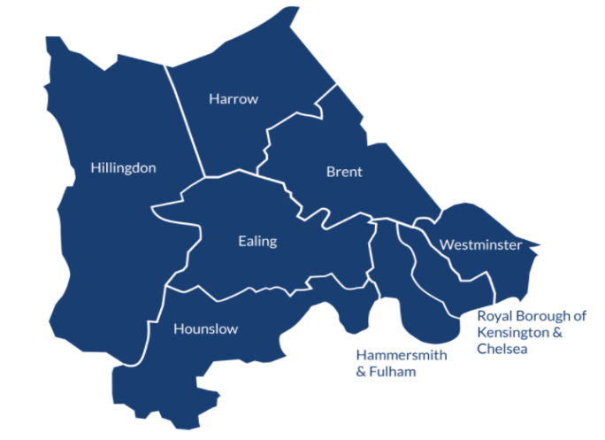
The NWL ICB covers the 8 boroughs of Brent, Ealing, Hammersmith & Fulham, Harrow, Hillingdon, Hounslow, Kensington & Chelsea and Westminster.

Whole Systems Integrated Care (WSIC) is a linked quantitative dataset between GPs, NHS providers, and Local Authorities in NWL ICS. It allows de-identified population health analysis, case-finding, and longitudinal impact monitoring, as well as identifiable patient data to support personalization of care.

A logical model of changes is one of the most impactful elements of a service improvement plan. NWL ICB has adopted a consistent logical model to guide service improvement: FOCUS-On. This places importance on engagement with residents to help make sense of data we hold about inequalities.
- FIND INEQUALITY. A review of data (NHS and LA) across different population segments can help identify and prioritise communities were diagnosis rates may be significantly lower than expected for core20plus5 conditions.
- OPEN CONVERSATIONS. Engagement with those communities and residents can add qualitative evidence about the socio-economic and practical barriers that prevent timely access to care, or cause residents to leave treatment before it is complete.
- COPRODUCE & UNITE. Coproduction between residents and multi-agency partners can unite stakeholders behind key changes to the way clinically effective care is offered and sustained. This is supported by more detailed reviews of quantitative and qualitative evidence.
- STUDY IMPACT & ON-GOING MEASUREMENT. Health economic analysis can allow prototyped changes in the way services are offered to become part of the ‘business as usual’ multi-agency offer of care to our residents. This may require changes to contract incentives, and a change to the balance of contracted professional hours spent delivering reactive care and proactive care.

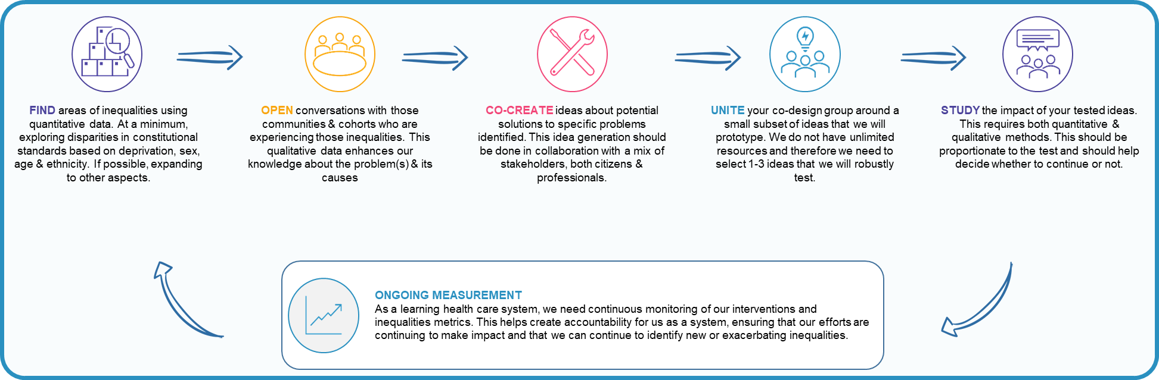
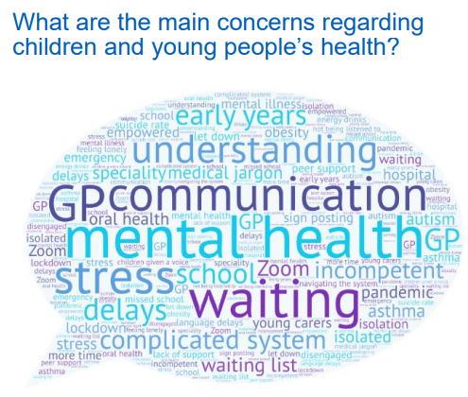
Some examples of themes from NWL engagement with young people

2. Service Specification
See Appendix D – Specification.

3. Contract Term
The term of this contract is unspecified at this moment, NWL ICB has suggested the work is delivered over an approximate three (3) month period but has opted to wait for the proposals to define the exact contract term. However, work must commence by w/c 1st May 2023 and finish no later than 31st October 2023.

4. The Contract Terms & Conditions
The form of contract will be the NHS Terms and Conditions for the Provision of Services, which will apply to a Purchase Order (PO), to be raised with the Provider following this procurement process.
A copy of the terms and conditions are available at:
https://www.england.nhs.uk/wp-content/uploads/2022/09/nhs-terms-and-conditions-for-the-provision-of-services-po-version.docx

6. The Budget
For a Bid price to be compliant, this must be within the upper affordability limit. There will be no further funding available for any additional costs, expenses and/or liabilities incurred. Any additional costs shall be the responsibility of the Recommended Bidder. Further, it is the Bidder’s responsibility to obtain for themselves, at their own expense, any additional information necessary for the preparation of their quotation.
An affordability threshold of £32,500 (excl. VAT) been allocated for this contract and for a Bid price to be deemed compliant, it must be equal or less than this value.
The affordability threshold will be scored as pass/fail criteria.

7. Timetable
Milestone | Date
Invitation to Quote (ITQ) issued | Monday 11th April 2023
Deadline for receipt of Clarification Questions | 12 noon Friday 14th April 2023
Deadline for receipt of ITQ Bids | 12 noon, Wednesday 19th April 2023
Evaluation of the Bids | April 2023
Bidders notified of the outcome of the ITQ | April 2023
Expected Service commencement | w/c 1st May 2023

8. Clarification Questions
Bidders should submit clarifications via the Atamis messaging function.
To ensure equal treatment of Bidders, anonymised details of all clarification questions and the Contracting Authority’s respective responses will be shared with all Bidders.

9. Bid Submission
Bidders are invited to prepare and submit a sufficiently detailed, yet succinct written response to provide the ICB with a high level of confidence that:
- Your organisation has appropriate and sufficient and relevant experience, understanding and capability; and
- You can develop and deliver the intended outcomes, having regard to the requirements specified within this ITQ, in a timely manner.
Responses must be in English, in MS Word format and adhere to a maximum overall word limit of 4000 words across all criteria, as set out below. Excluded from the word count is; biographies, testimonials, case Studies and appendices.
Please also complete and submit the following documents:
- Appendix B: “ITQ Bidder Details & Declaration Form”
- Appendix C: “Financial Model Template”.
Please refrain from including general documentation including marketing information and only supply relevant material in support of your ITQ response.
The Contracting Authority reserves the right to reject bids received after the stated deadline above and/or not being submitted through the designated Portal.

Award Criteria
To offer a confidence that your organisation is able to deliver the intended outcomes, as specified, your response should address each of the following award criteria, noting the evaluation weighting against each that will be applied.
Ref | Award Criteria | Weighting
AC1 | Demonstrate your proposed approach to delivering the requirements set out within the specification, specifically touching on the three (3) individual training outputs. | 60%
AC2 | Detail your proposed project/delivery team members (supported by up to 5 biographies), the organisations previous experience of delivery requirements of this kind (supported by a case study from a previous piece of work and testimonial from a previous client). The requested additional supporting information (biographies, case study and testimonial) is excluded from the word count. | 30%
AC3 | Provide an overview of how you will evaluate the success/effectiveness of the training during and after the project, as well any risks and how you will mitigate these. | 10%
AC4 | Confirmation of delivery against all deliverables within the affordability threshold of £32,500 exclusive of VAT. This must include a breakdown of the pricing within the template that is provided (FMT). | Pass/Fail
AC5 | Confirmation of acceptance of the Terms and Conditions set out within section 4 of this document. | Pass/Fail

Your attention is drawn to the “Important Notes to Bidders” within Appendix A.
11. Bid Evaluation
Bidders are invited to submit a response no later than the deadline as indicated in the timetable above.
The written response to this ITQ will be evaluated in accordance with the scoring criteria as detailed below:
Definitions for Pass/Fail Questions | Grade
Meets all the criteria set out in the question | Pass
Does not meet all the criteria set out in the question | Fail

Grade Label | Definition of Scored Questions | Grade
Superior | The response supports an excellent degree of confidence in the Bidder’s ability to deliver and/or exceed the Contracting Authority’s specified requirements and/or expectations. Where appropriate, the response is well evidenced, and/or of a quality and/or level of detail, and understanding that provides either a very high certainty of delivery or is considered likely to offer added value, likely to result in improved: quality and/or; performance and/or; efficiency and/or; outcomes. | 4
Comprehensive | A comprehensive response submitted in terms of relevance, detail and evidence; and able to meet in full the requirements of the Contracting Authority. A high degree of confidence in the Bidder’s ability to do what is being requested. | 3
Acceptable | An acceptable response submitted in terms of the level of detail and relevance. There is reasonable confidence that the Bidder will be able to deliver in line with expectations and the requirements of the Contracting Authority as detailed in the Service Specification. | 2
Limited | Limited information provided and/or a response that is inadequate. Fails to meet expectations/requirements in many ways and provides insufficient confidence of delivery. | 1
Deficient | Response to the question and/or an implicit requirement is deficient, or no response received. Provides no confidence that the issues will be addressed and managed at all in line with the Contracting Authority’s requirements and/or expectations. | 0
The final grade will then be factored against the relevant weighting for each of the award criteria to calculate a weighted evaluation score, with the maximum weighted score available for AC1 to AC3 being 100.

12. Identification of the Recommended Bidder
The Contracting Authority will evaluate the responses against each of the award criteria to determine the bid that offers best value for money and is able to deliver the specified outcomes.
The Recommended Bidder will be the Bidder achieving the highest weighted evaluation score.

13. Contract Award and Due Diligence:
The Contracting Authority reserves the right to undertake due diligence as it considers appropriate at any point throughout and/or after the ITQ process to seek the necessary reassurances in regard to the Bidder’s bid response and overall ability to deliver the requirements of the Contracting Authority.
As part of its due diligence, the Contracting Authority may wish to more fully assess and consider the information provided by the Bidder to determine the extent to which a Bidder presents any risks which the Contracting Authority may deem to be unacceptable, in its sole discretion, to the delivery of the Services. Where such risk is identified, the Contracting Authority may invite the Bidder to agree how the risk can be mitigated to an extent considered by the Contracting Authority to be sufficient. Where mitigation cannot be agreed to the satisfaction of the Contracting Authority, such satisfaction being at the sole discretion of the Contracting Authority, the Contracting Authority reserves the right to award a Contract to one of the other Bidders, such award to be decided on the basis of ranking of the highest scoring Bids. Alternatively, it may decide to re-run part or all of the ITQ process or cancel the ITQ process completely.
Bidders should note that the Contracting Authority may require additional documents or information from the Bidders as part of a due diligence process prior to deciding upon the Recommended Bidder and/or contract signature.
Timely responses for any due diligence are required from the Recommended Bidder to facilitate timely progression towards contract signature. In the event that the required information is not provided by the Bidder, or the information provided is not satisfactory or it comes to light that information supplied and relied on to arrive at the decision regarding the choice of Recommended Bidder is incorrect, the Contracting Authority reserves the right in its absolute discretion not to enter into a Contract. Under such circumstances, the Contracting Authority reserves the right to award a Contract to one of the other Bidders, such award to be decided based on the ranking of the highest scoring Bids. Alternatively, it may decide to re-run part or all of the ITQ process or cancel the ITQ process completely.
Without prejudice to any other actions which the Contracting Authority may wish to take, findings from the due diligence undertaken may identify the need for specific Conditions Precedents to the Contract.

Appendix A - Important Notices for Bidders

Appendix B – Bidder Details & Declarations
Please complete and return Appendix B along with your ITQ response.

Appendix C – Financial Model Template
Please complete and return Appendix C along with your ITQ response.

Appendix D – Specification (Original Contracting Authority document)

