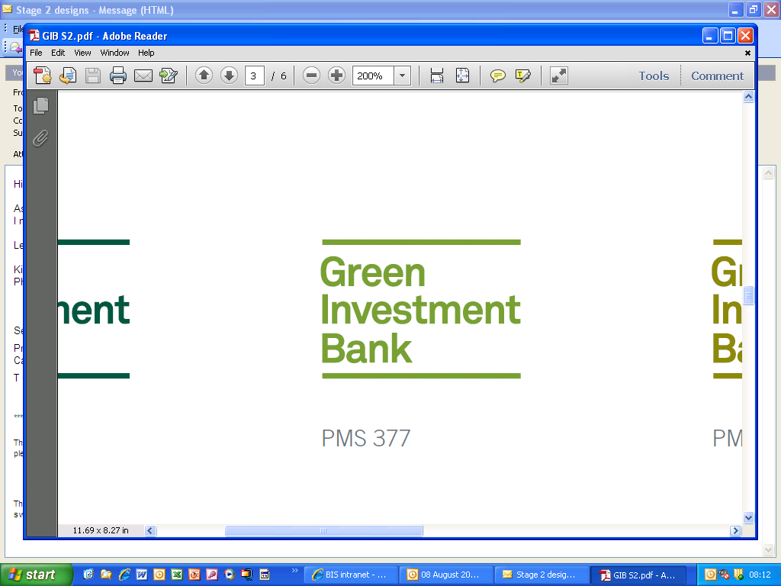

**UK Green Investment Bank plc**

**Request for Proposal (RFP) Review of Employee Value Proposition GIB032**

Issue Date: 14th December 2015

Closing Date and Time:

8th January, 2015

22nd December, 2015

Request for Proposal (RFP) Review of Employee Value Proposition GIB 032

Dear Sir or Madam,

Green Investment Bank plc (“GIB”) invites you to bid to in accordance with the specification detail shown below and GIB Terms and Conditions of contract.

As GIB operates a sealed bid process, tenders should be sent by email to:

Doug.craig@greeninvestmentbank.com

The **tender submission deadline** is 17:00hrs on **8th January, 2016.**

Please include the GIB032 reference number in the subject line of your e-mailed tender submission.

Please do not send a copy of your tender response directly to any individual within GIB.

Subject to the Freedom of Information Act 2000, all information exchanged between the client and your company in connection with this bid shall be regarded as confidential.

Yours faithfully

**Doug Craig**

**Procurement Manager**

**SUPPLIER INSTRUCTIONS**

**Introduction**

These instructions are designed to ensure that all bids are given equal and fair consideration. Please read the information provided carefully and ensure your response includes all the information requested as your company will be initially evaluated solely on the evidence supplied in response to this invitation to tender.

If having read the specification you wish to submit a tender and have any clarification questions then please advise Doug Craig ([Doug.Craig@greeninvestmentbank.com](mailto:Doug.Craig@greeninvestmentbank.com)) by no later than **17:00hrs 29th December.**

Please aggregate any clarification questions as a list rather than sending them through individually.

Details of any clarification questions and answers relating to this RFP will then be circulated to all potential tenderers by email accordingly (without revealing the identity of the bidder that put forward a particular question).

Requests received after this deadline will not receive the information.

**Timetable of Events**

Please note that GIB may revise this timetable as necessary.

|  |  |
| --- | --- |
| **Stage** | **Date** |
| RFP document published | 22 December 2015 |
| Submit any clarification questions | 29 December, 2015 |
| Responses to clarification queries circulated to all potential bidders | 30 December, 2015 |
| **Deadline for submission of proposals from bidders** | **17:00hrs 8th January, 2016** |
| Estimated contract start date | tbc |

**Conflict of Interest**

The services procured through this RFP are not considered to raise conflict of interest issues given their nature. However bidders are asked to consider any potential conflicts and where applicable detail them for our consideration. Conflicts of interest will be checked for pre-selected bidders following receipt of the proposals.

We reserve the right to reject any bids where we consider the risks associated with a potential conflict of interest to be too great or the proposed mitigation actions to be inadequate.

**Commercials**

GIB’s standard Terms and Conditions of Contract will apply to this contract a copy of which are attached to this RFP, unless already agreed in an existing Framework Agreement. **In considering your response to this RFP, please note that no material changes to our standard Terms and Conditions of Contract are possible and there will be very limited scope for re-negotiating.**

Prices quoted shall be fixed (or provided as capped fees) including all reasonable expenses.

Bidders are advised that we require task based approach to this engagement and we expect bidders to price all of the tasks identified.

All prices quoted shall be exclusive of VAT.

Payment terms – the successful supplier shall invoice monthly in arrears of the work being completed and accepted. Correctly presented invoices will be paid within 30 days.

Your tender should be valid for acceptance for 90 days from the tender submission deadline stated above. The receipt of the enclosed bid documents shall be regarded as adequate consideration for maintaining the validity of your response for the period requested.

**Procurement Process**

The procurement is based on awarding the contract to the Most Economically Advantageous Tender (MEAT) by assessing both quality and cost using the evaluation criteria and weightings shown below.

**Scope of Work for GIB Employee Value Proposition**

Green Investment Bank (GIB) is seeking Requests for Proposal for a partner to develop our Employee Value Proposition (EVP). This RFP focuses on the analysis, architecture and design our EVP. Your proposal should include the steps and outputs you would take.

1. **Analysis and Recommendation**

You will be required to conduct research and analysis on the current aspects of GIB’s EVP to identify employee and prospective employee perceptions and preferences. From this analysis, aspects that are critical to successful business outcomes should be prioritized.

Existing GIB internal data is available to conduct the internal analysis. The awarded vendor would receive the following data:

* Outcome of a culture audit, undertaken during 2014 and 2015
* Analysis of exit interviews
* A report on our existing employee communication approach and activity

You should specify any additional information and resources that you would require GIB to provide to complete this phase.

**Your RFP should price to include the following**

:

* Provision of an overview of the Project Work Plan that your organisation would use to complete this phase of the project, including the resources that you would use to gauge market trends, assess the external market and best practice.
* Carrying out of interviews with key leadership stakeholders
* Undertaking two staff focus groups (one in Edinburgh, one in London)
* Bringing together various data points and provide synthesized information
* Uncovering the key elements that drive employees to greater performance
* Provision of a comparative analysis of GIB’s EVP with best-in-class EVP organisation's including identifying GIB’s EVP strengths and gaps

Key deliverables:

* EVP statements for GIB should be proposed based on the analysis in the report.
* An explanation of EVP elements that are predicted to change over time based on industry and social trends.

Work on this phase must be completed by 12th February 2016 unless another timeline is agreed to by GIB

1. **EVP Architecture and Design – to be completed by 28th February 2016**

Using the outcomes and deliverables from Phase 1 the supplier will develop a proposed EVP statement, develop a proposed EVP brands and prepare a roadmap for implementing the EVP, including determining quick wins for GIB. The selected vendor will work with GIB’s external Brand team on this. The final report will include recommendations on:

* Brand positioning
* Brand collateral for internal and external use
* Additional service proposal, including the utilization of the current intranet

Please specify any additional information and resources that you would require GIB to provide to complete this phase.

Enter cost by Key Deliverable and Total

General

Please provide additional information on your company’s experience and expertise in defining and implementing EVP.

Please indicate and explain any additional services that you feel would be beneficial for GIB to consider as part of this process. List each additional (optional) service and explain why it would benefit GIB and the cost for each.

Please include in your proposal

## Company Background

* Please provide a brief company profile, including size, location and staff. If you are not the pension provider, please outline the process you will follow to assess the market and work to find a provider
* What do you consider your competitive advantages?
* Please provide 2 case studies of clients of similar size

1. ***Detailed Response should include***

* The Successful bidder will work to produce areport that will be issued on an agreed date,
* GIB expects the following deliverables to be included in the report as a minimum:
  + A condensed main body that will provide i) a summary and ii) a short list of key considerations in relation to each the sections and sub-sections described in the scope of works;
  + Detailed appendices providing in-depth review and analysis of each topics in the scope of works (and covered in the main body) and any additional information that you assume to be relevant.
* Bidders should provide a fixed cost for the market review and options appraisal work covered under section 1
* Detailed charging structure should be provided for all other elements.

1. ***Due Diligence***

* Please complete the due diligence questionnaire included in Appendix B of this RFP.
* Bidders are requested to include evidence to support their responses in this section

## 4. Contract

* GIB Ltd intends to award a contract for this requirement commencing on the 7th April 2016
* All completed RFQ’s will be considered and evaluated against the Evaluation Criteria as detailed in Appendix A. Suppliers may be invited to give presentations to fully demonstrate their understanding of the requirement and to outline their particular strengths.

***Appendix A: Tender Evaluation***

Bids will be evaluated solely on the evidence provided in the submission and will be evaluated against the following main and sub criteria headings and weightings:

|  |  |  |
| --- | --- | --- |
| **Section** | **Weighting** | **Detail** |
| ***Project Plan & Timescales*** | 35% | Please provide details of your proposed project plan to provide the market overview and meet to have a new Pension plan in place for April 2016. This should include summary details of who will be working on the various items. |
| ***Delivery*** | 35% | Evidence a proven track record of projects in relation to our requirement, including evidence of relevant experience |
| ***Cost*** | 30% | Please quote fixed lump sum (or capped fee), but providing a cost breakdown of rates in the attached form. **Please provide separate quotes for Stage 1 and Stage 2.** |

***Evaluation Scoring***

All scoring will be done on a scale of 0-10 as follows. For example a section which has a weighting of 10% and scores 5/10 will receive 5 marks.

|  |  |
| --- | --- |
| **Score** | **Evaluation response** |
| 0 | Question is not answered or the response is completely unacceptable |
| 1 | Extremely poor response - they have completely missed the point of the question |
| 2-3 | Very poor response and not wholly acceptable fails to meet the minimum requirement/standard, requires major revision to the proposal to make it acceptable. Only partially answers the requirement with major issues and RFP detail proposed |
| 4-5 | Poor response only partial acceptable with deficiencies apparent. Some useful evidence provided but response falls well short of providing full confidence in the approach / solution described. Low probability of success. |
| 6-7 | Response is acceptable and meets the minimum requirement but remains basic and could have been expanded upon. Response is sufficient but does not inspire. Good probability of success, weaknesses can be readily corrected. |
| 8-9 | Good response which describes in detail an approach / solution which provides high levels of assurance consistent with a quality provider. Great probability of success, no significant weaknesses noted. |
| 10 | Excellent response - comprehensive and useful, demonstrating a detailed understanding of the requirement. High probably of success, no weaknesses noted. The response includes a full description of techniques and measurements to be employed, providing full assurance consistent with a quality provider. |

***Scoring Price***

Each Bidder’s price is used to identify their relative positions on a 0-10 price scale. This is done by allocating the lowest priced bid 10 points and calculating the remaining Bidders’ scores in relation to this scale. However bids that exceed the lowest bid by more than 100% will receive 0 price points.

**Please note:**

* Poor quality bids receiving scores less than half the available marks for any section may be rejected.
* We reserve the right to reject bids which are priced abnormally low, however if such a situation arises bidders will be asked to first explain their pricing before we reject the bid.

The lowest bid may not necessarily be accepted. We shall be under no obligation to accept the lowest or any bid.

***Appendix B: Due Diligence***

1. GIB is required to assess the Environment credentials of suppliers that we work with, can you provide detail how your company monitors its impact on the environment. Supporting evidence should be supplied, for example Sustainability Policy.
2. What is the legal entity GIB will be contracting with? Please include company registration number.
3. What is your overall corporate structure? Please detail any parent company and subsidiaries.
4. Has anything happened recently that would impact on our decision to enter into a contract with your company (e.g. Press interest in the company, parent company, subsidiary or key member of staff)?
5. Have any of the key individuals within the organisation (e.g. Director/Potential Partner/Proprietor etc.) been convicted of any offence involving fraud or dishonesty?
6. Have any of the key individuals within the organisation (e.g. Director/Potential Partner/Proprietor etc.) been the subject of any civil proceedings, including judgement debts or bankruptcy proceedings or entered into any arrangements with creditors?
7. Have any of the key individuals within the organisation (e.g. Director/Potential Partner/Proprietor etc.) been the subject of any investigations into allegations of misconduct or malpractice in connection with any business activity?
8. Have any of the key individuals within the organisation (e.g. Director/Potential Partner/Proprietor etc.) been refused, had revoked, restricted or terminated any Regulatory licence or membership of a professional body?
9. Do you have a Data Protection policy and appropriate processes and controls in place to ensure compliance with the Data Protection Act? If so, please provide a copy of the policy.
10. Do you have an Information Security Policy in place to a recognised standard (such as ISO27001/27002)?
11. Provide brief overview of the Information Security policy in force. Please attach a copy of the policy.
12. Which role in the organisation owns the policy?
13. Are security compliance audits conducted at least annually?
14. Can you explain your proposed approach to business continuity and disaster recovery as this is not detailed in your proposal
15. What investment do you make in your local community – through sponsorship, donations, pro-bono work, community projects, etc?
16. Physical building security controls must be in place to prevent/detect unauthorised access to the IT Data Centre and IT Development Centre. Please describe such controls.
17. What physical access controls do you have to buildings during normal working hours?
18. What physical access controls do you have for sensitive areas?
19. Do you have system access controls on all systems?
20. What processes and systems do you have for monitoring and managing user accounts?
21. Do you perform regular audits on user access, failed attempts etc.?
22. What user identification policy do you implement on the systems? Include details of access levels, mechanisms and frequency of change.
23. What policies do you enforce regarding passwords (length, construction, ageing, etc)?