CASTLE DONINGTON PARISH COUNCIL
The Community Hub, 101 Bondgate, Castle Donington. DE74 2NR

Telephone: (01332) 810432
Email: clerk@castledonington-pc.gov.uk

Clerk: Fiona M. Palmer

Tender for Grounds Maintenance Contract

The Contractor is required to maintain the grounds listed below throughout the period of the contract.

The Contract has been reviewed to include a trial period of one year initially of less weed treatment versus more strimming, and the creation of wildflower areas. Contractors should consider this amendment when quoting for year 1 and years 2-4 as this will be a set price contract once agreed.

The Contractor is to provide all plant, labour and materials including marking out and fuel to carry out the operations detailed in the tender specification.

In carrying out such work the Contractor will ensure that his staff conduct themselves in an appropriate manner, this is especially important in the Cemetery and Churchyard.

The Contractor shall hold and provide copies of the required insurance and public liability cover to a minimum of £10,000 Million.

The Contractor shall comply with the latest Health and Safety at Work Act and shall hold the relevant Health and Safety certificates, including those specific to the job – pesticide control, tree maintenance, etc.

The Contractor shall hold in place a relevant written Health and Safety Policy and shall complete risk assessment for each individual task undertaken. Supplying a copy of each to the Parish Council.

The Contractor shall comply with Control of Waste regulations and hold a valid Certificate of registration under the control of Pollution Act 1989.

The Contract will be for a period of four years, subject to an annual review, to include a rate of inflation rise each year to be agreed with the Clerk and Contractor.

All Tenders are to be sent to the Clerk to the Council, in a sealed envelope, marked private and confidential, be exclusive of VAT.

Areas:

Description | Area  (Sq. Mtrs) | Activity | Picture
Queensway and Bentley Rd  DE74 2UL | 2580 | Mow – no collection  Clean footpath  18 cuts (fortnightly)  Strim round trees, perimeter, street signs and bank | 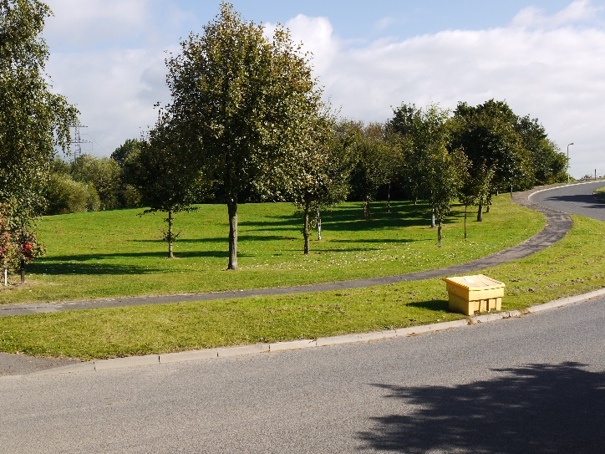
Queensway and Bentley Rd  DE74 2UL | 2580 | Mow – no collection  Clean footpath  18 cuts (fortnightly)  Strim carefully round trees, perimeter, street signs and bank | 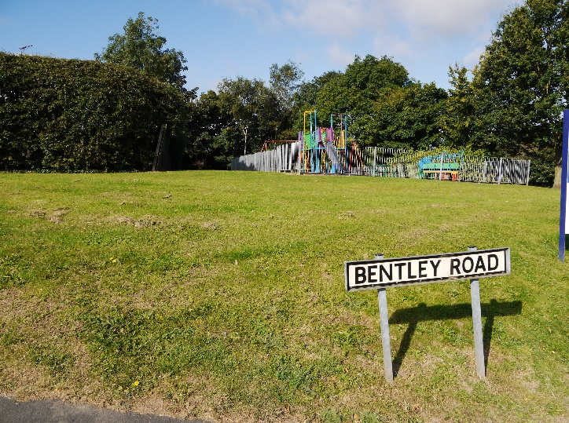
Fox Road  DE74 2UN | 630 | Mow – No collection,  Clean footpaths  18 cuts (fortnightly)  Strim around perimeter, street signs and carefully around trees | 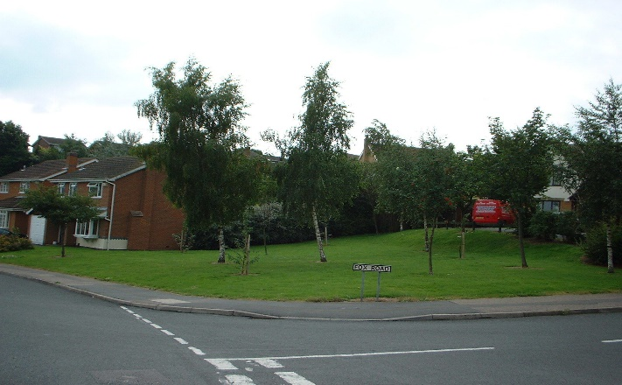
Roby Lea  DE74 2UR |  | Mow – No collection,  Clean footpaths  18 cuts (fortnightly)  Strim around perimeter, street signs and carefully around trees | 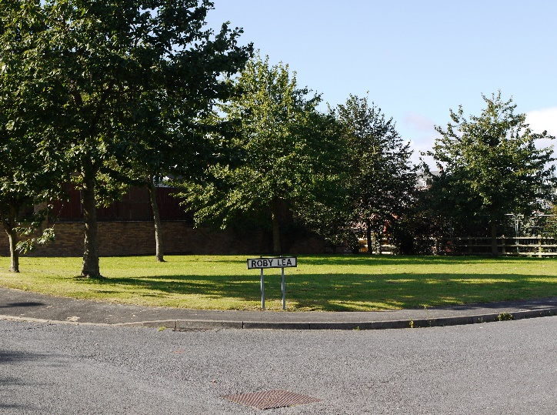
The Spital  Hillside  (Accessible only from  The Spittal road)  DE74 2NQ | 16000 | Mow - no collection  18 cuts (fortnightly)  Strim around trees and difficult areas | 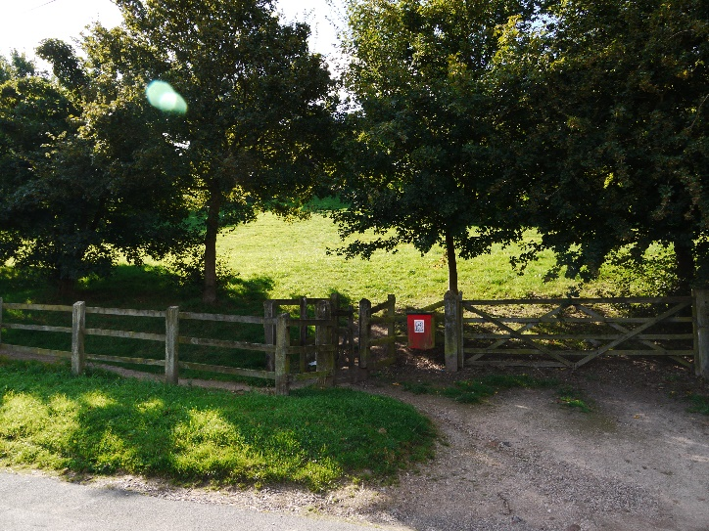
Spital Park - Total  DE74 2NQ  1 Orchard  2 Tanyard end  3 Main Area  4 Bank (up to  training area)  5 Flat (Training  area)  6 Around buildings  and track | 64131  1024  5200  41062  1420  10640  4785 | Mow - no collection  Strim after bluebell/daffodils have died off  18 cuts (fortnightly)  Weed control perimeter, trees and shrubs  18 cuts (fortnightly)  Weed control perimeter, trees and shrubs  18 cuts (fortnightly)  Weed control perimeter, trees and shrubs  18 cuts (fortnightly)  Weed control perimeter, trees and shrubs  18 cuts (fortnightly)  Weed control perimeter, trees and shrubs | 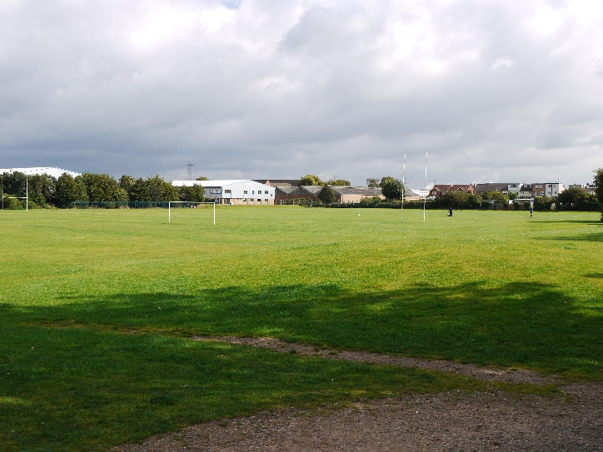
Spital Park – Playground  DE74 2NQ |  | Mow – No collection,  Clean footpaths  18 cuts (fortnightly)  Weed control perimeter | 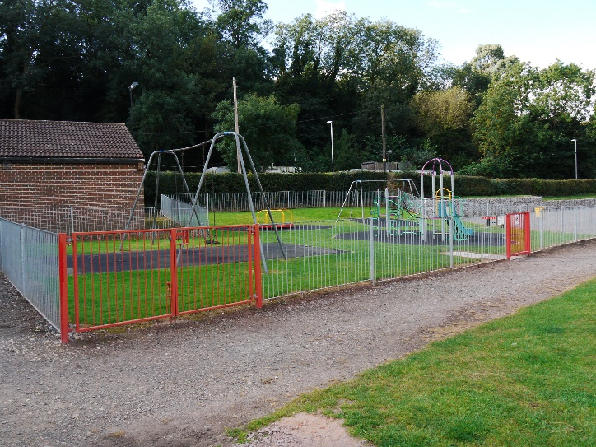

Darsway  DE74 2RZ | 3530  in four areas | Mow – No collection,  Clean footpaths  18 cuts (fortnightly)  Strim daffodils when died back and around trees and street signs | 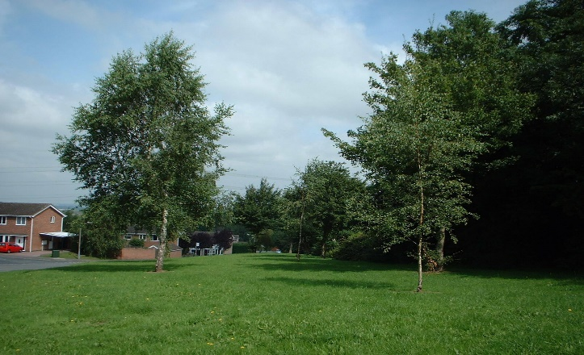
Hazelrigg  DE74 2XE | 2600 | Mow – No collection,  Clean footpaths  18 cuts (fortnightly)  Strim perimeter signs and dog bin areas | 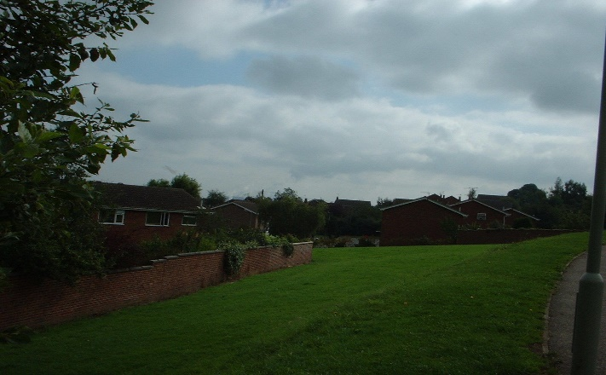
Campion Hill - Large  DE74 2XH | 2170 total | Mow – No collection,  Clean footpaths  18 cuts (fortnightly)  Strim perimeter and carefully around trees. | 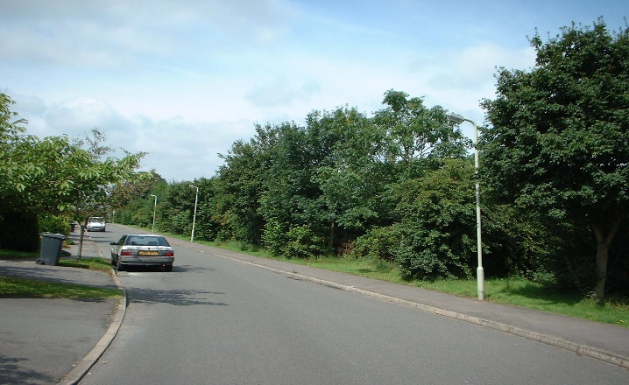
Campion Hill - Small  DE74 2XH | 312 | Mow – No collection,  Clean footpaths  18 cuts (fortnightly)  Strim perimeter and carefully around trees. | 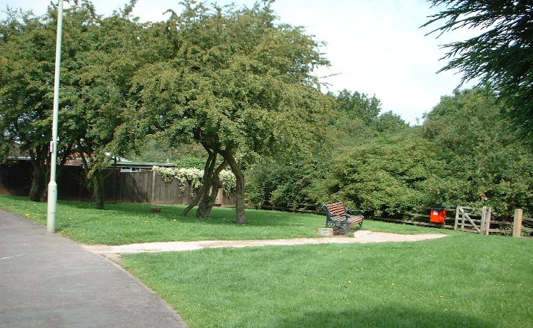

Gasny Avenue  DE74 2HZ | 400 | Mow – No collection,  Clean footpaths  18 cuts (fortnightly)  Strim perimeter | 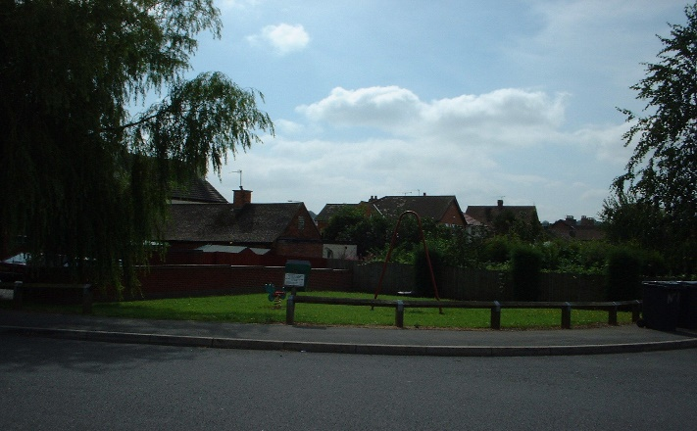
Glover Road play area  DE74 2GL |  | Mow – No collection,  Clean footpaths  18 cuts (fortnightly)  Strim perimeter | 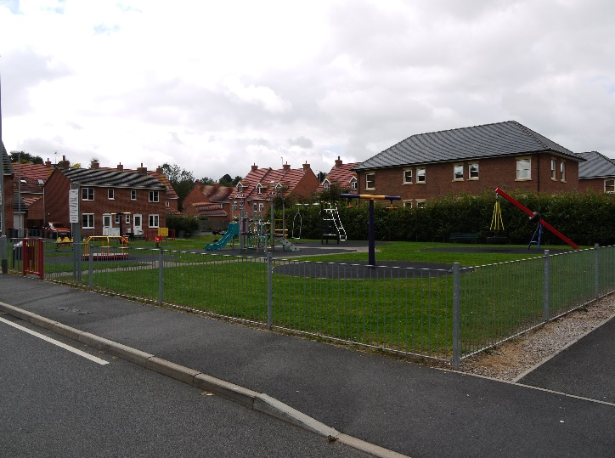
Ferrers Close  DE74 2QW | 608 | Mow – No collection,  Clean footpaths  18 cuts (fortnightly)  Strim around perimeter and equipment | 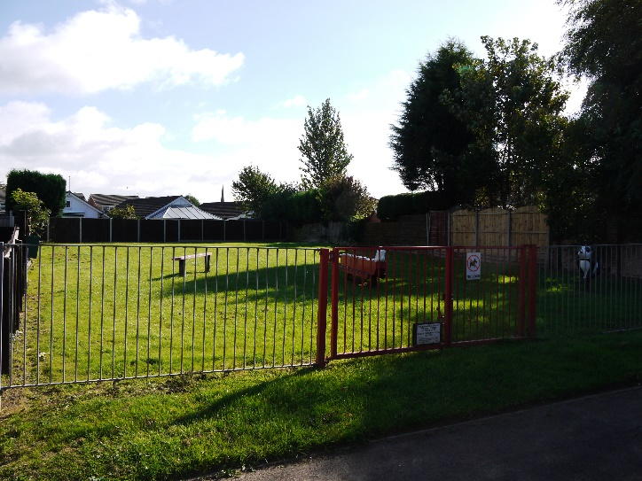
Kirkland Close  DE74 2QY | 279 | Mow – No collection,  Clean footpaths  18 cuts (fortnightly)  Strim around perimeter and equipment | 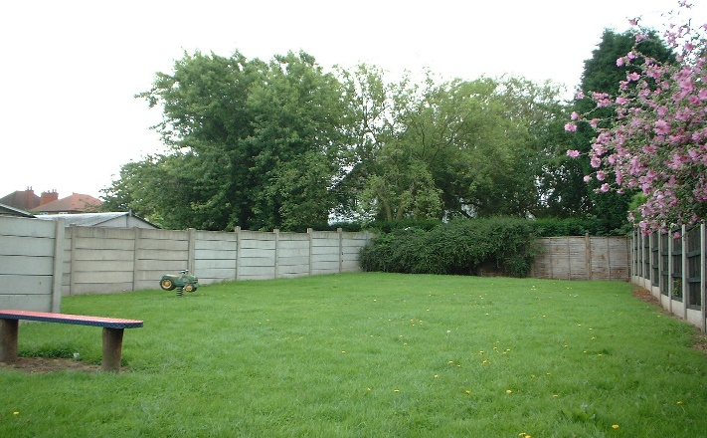
Peartree Close  DE74 2JJ | 325 | Mow – No collection,  Clean footpaths  18 cuts (fortnightly)  Strim around perimeter one side, street signs and carefully around trees | 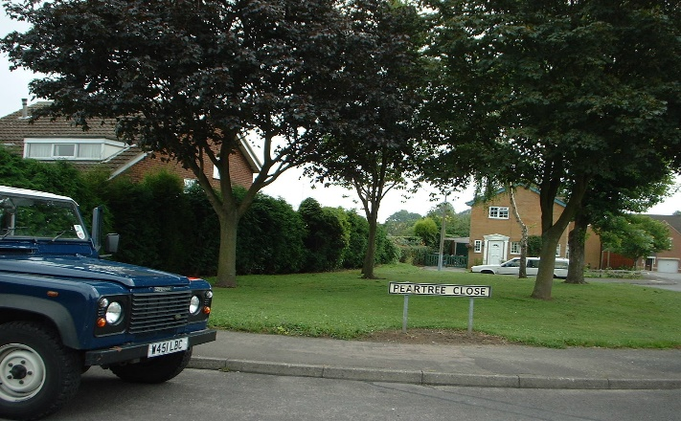
Grange Drive  DE74 2QU | 500 | Mow – No collection,  Clean footpaths  18 cuts (fortnightly)  Strim around perimeter and adjacent jitty | 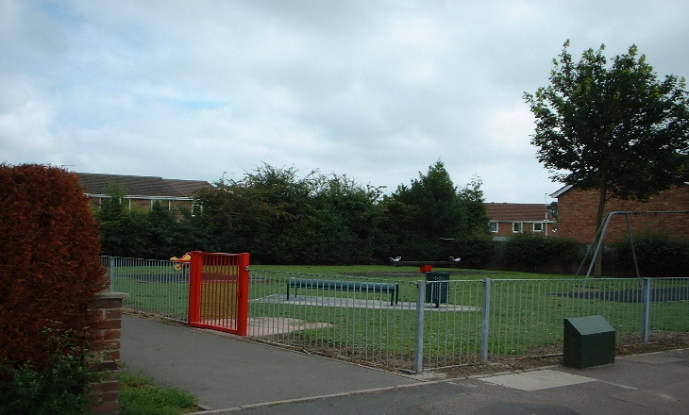
Pinfold Gardens  DE74 2NS | 656 | Box mow, collect and  clean footpaths  18 cuts (fortnightly)  Weekly cuts during height of season.  This is an area which requires special attention.  Strim around perimeter | 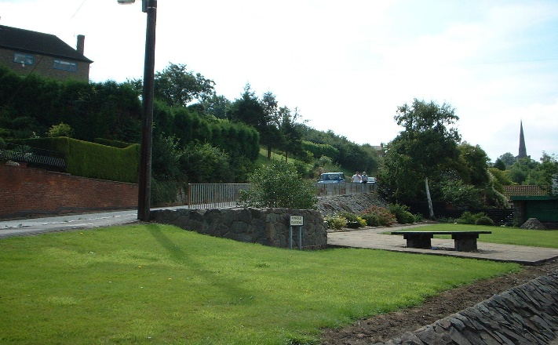
Community Hub  101 Bondgate  DE74 2NR  (Front garden and grass verge by bollards of car park) |  | Box mow, collect and  clean footpaths  18 cuts (fortnightly)  Weekly cuts during height of season.  This is an area which requires special attention.  Strim around perimeter.  Move tables to mow under, then move back
Closed Churchyard  DE74 2LA | 7725 | Mow, collect and clean all round  18 cuts (fortnightly)  Strim with careful  attention and care  Clean all paths and other areas  Cutting of shoots from around the Lime trees – twice yearly | 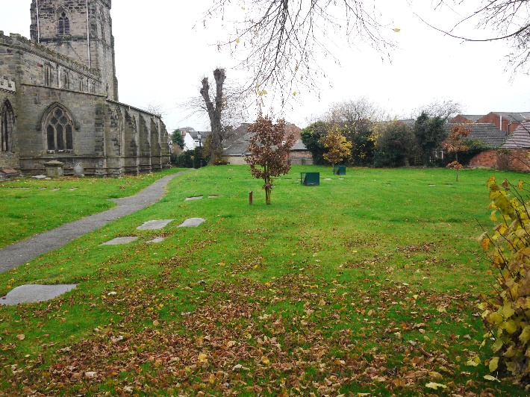
Bondgate  DE74 2NS | 380 | 18 cuts (fortnightly) | 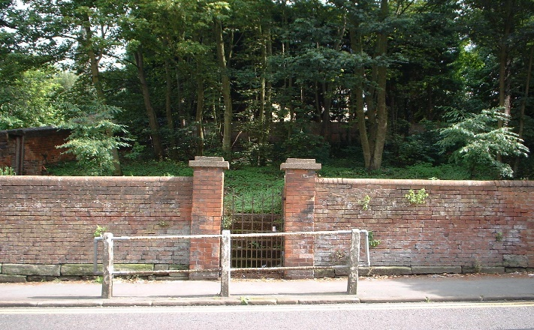
Cemetery  DE74 2PF |  | Box mow all grass areas and collect 18 times per year.  Strim with very careful attention around graves.  Strim path edges  Clean all paths and other areas  Weed / moss control to paths and hedge bottoms only | 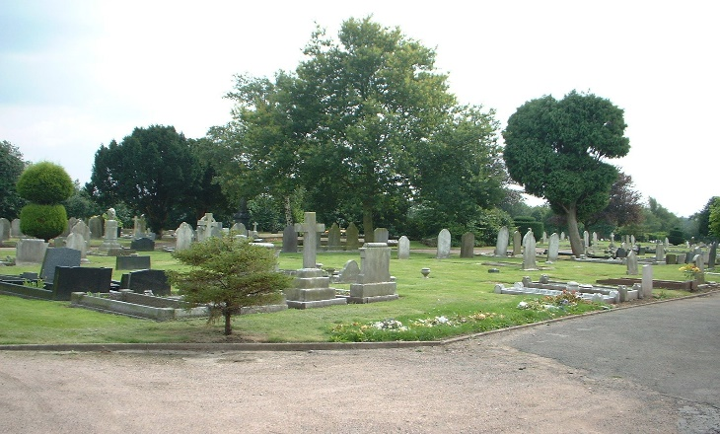
Moira Dale  DE74 2PJ  1 Main Field (football pitches)  2 Field perimeter (outside of main field), car park and behind screens  3 Play area | 690 | Note: cricket club responsible for wickets and outfield  Mow – No collection 18 cuts (fortnightly)  Mow – No collection  18 cuts (fortnightly)  Weed control perimeter, trees and shrubs  Mow – No collection,  18 cuts (fortnightly)  Strim around perimeter, signs, bins and play equipment | 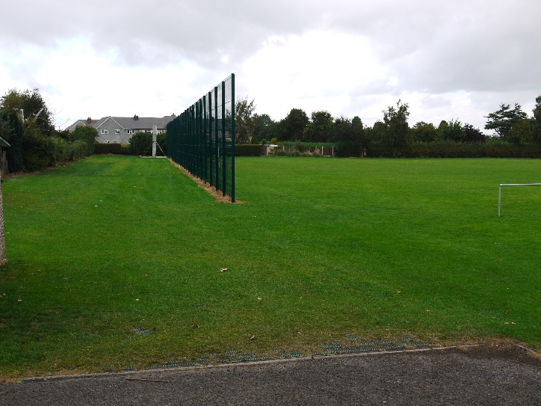

Bosworth Road  DE74 2JQ | 6955 | Mow – No collection  18 cuts (fortnightly)  Weed control perimeter, trees, and shrubs  Strim around bin and play equipment | 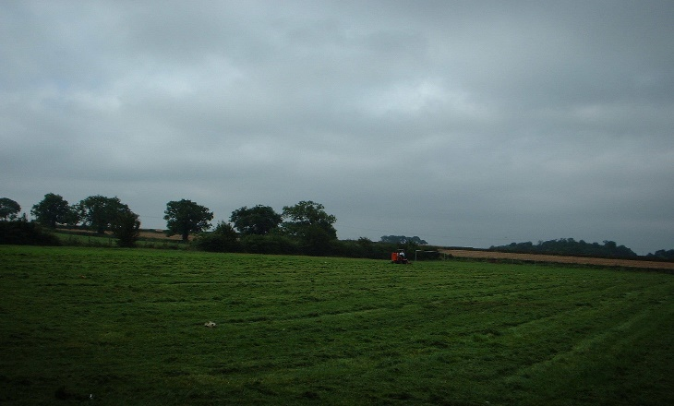

Cooks drive  DE74 2SW | 494 | Mow – No collection,  18 cuts (fortnightly)  Strim around perimeter, signs, bins, play equipment and trees | 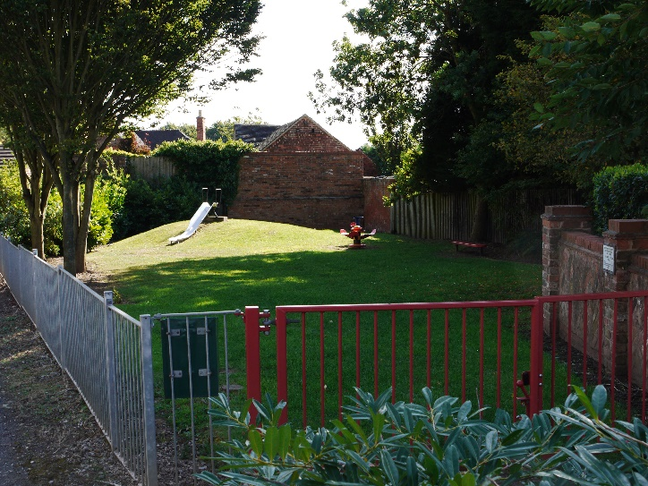
Towles Pastures  DE74 2RX | 700 | Mow – No collection,  Clean footpaths  18 cuts (fortnightly)  Strim around perimeter and carefully around trees | 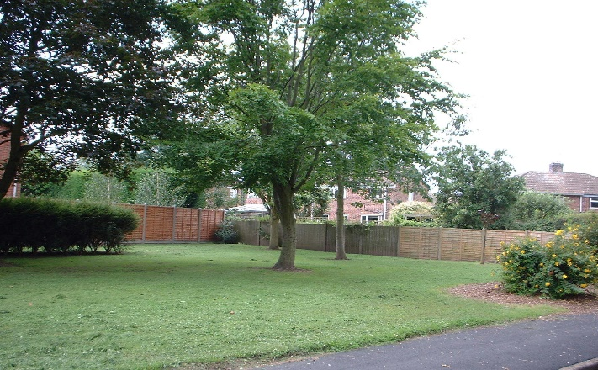
Stonehill Fields  DE74 2LZ  1 Play area  2 Main field | 462  Not known | Mow – No collection,  18 cuts (fortnightly)  Mow – No collection,  18 cuts (fortnightly)  Weed control perimeter, trees and shrubs  Strim around bins and play equipment | 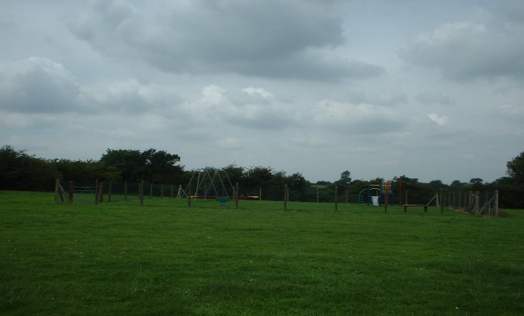

Bus Station  DE74 2PP |  | Box mow and collect  18 cuts (fortnightly)  Strim around perimeter, signs, bins and trees | 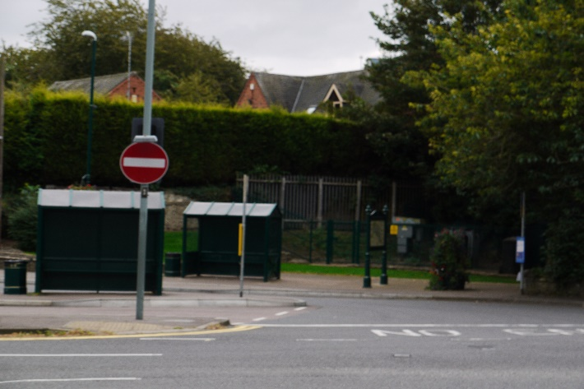
Stonehill Small  DE74 2LZ  1 Verges | 1348 | Mow – No collection,  Clean footpaths  18 cuts (fortnightly)  Strim daffodils when died back  Strim around perimeter, signs, bins and trees | 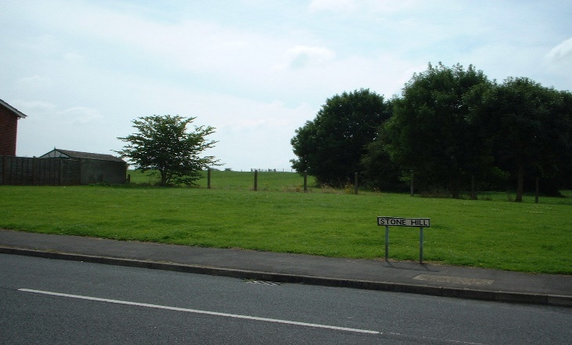

Allotments  DE74 2LN  1 Entrance &  Driveway  2 Tracks x 3  3 Empty plots  4 Car parks x 3 | 520  1224  Unknown  360 | Mow – No collection,  18 cuts (fortnightly)  Mow – No collection,  18 cuts (fortnightly)  As directed by Grounds man  As directed by the Grounds man | 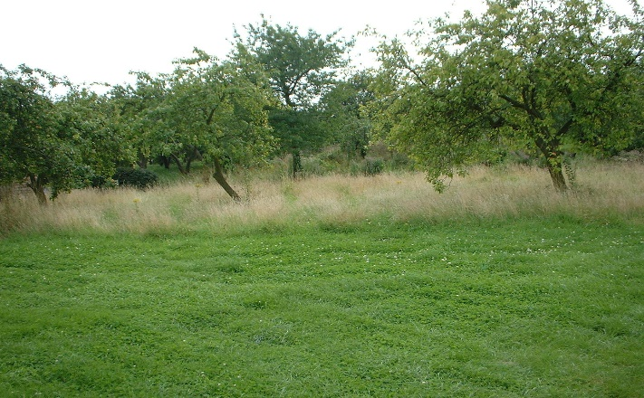
Station Road over railway bridge  DE74 2NJ |  | Mow – No collection,  18 cuts (fortnightly)  Strim around perimeter hedges | 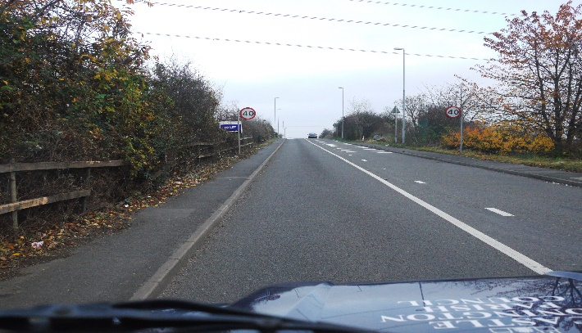
Junction of Station Road and Trent Lane, opposite  Co-op  DE74 2NJ |  | Mow – No collection,  18 cuts (fortnightly)  Strim around perimeter and tree | 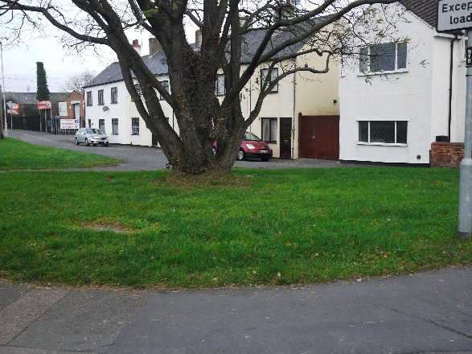
Long Well  Behind and two areas either side  DE74 2PP |  | Mow/strim and collect  18 Cuts  No weed control, strim only | 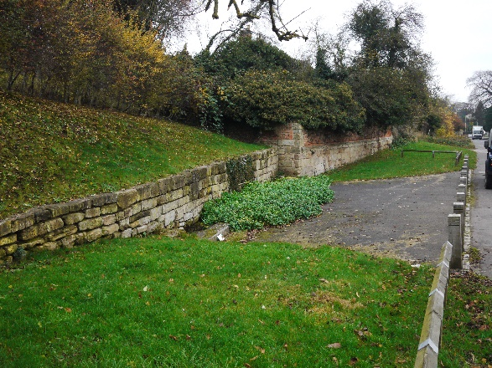
DHL, Hilltop and Willow Farm Islands  DE74 2PR  Plus new roundabouts as below |  | Mow – No collection,  18 cuts (fortnightly)  Strim around perimeter, signs and shrubs | 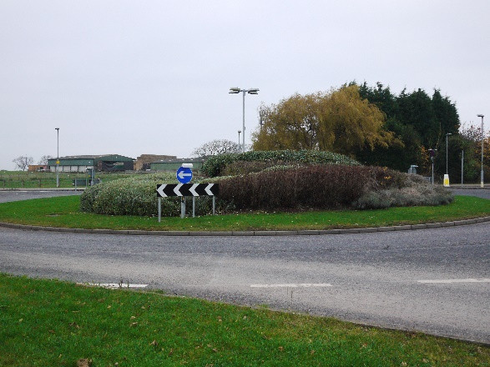
Village entrances – A50 and Donington Park  This is from Hilltop roundabout through and including new roundabout to the end of the raised banks. Both sides. |  | Mow – No collection,  18 cuts  Strim around perimeter, signs and shrubs | 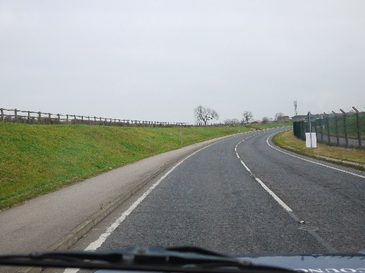
Spitfire Road/Robey Lea  DE74 2AP/DE74 2UR |  | Mow – No collection,  18 cuts (fortnightly  Strim around perimeter, signs and shrubs | 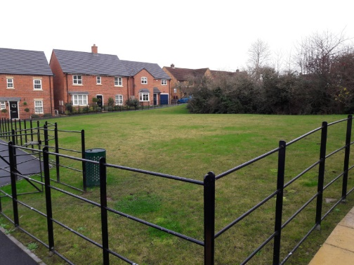  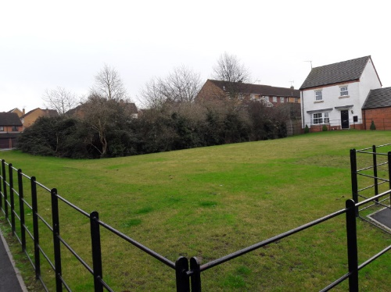
Spitfire Road  DE74 2AP |  | Mow – No collection,  18 cuts (fortnightly)  Strim around perimeter, signs and shrubs | 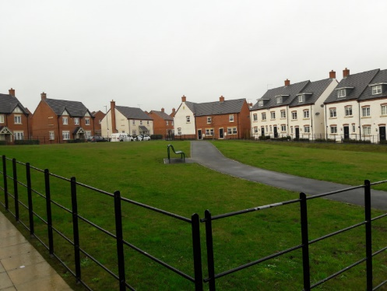  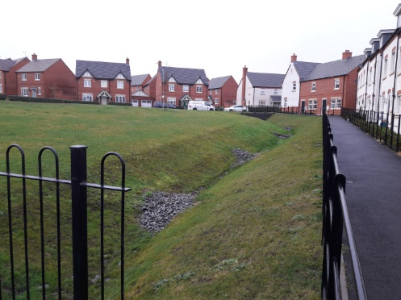
Bentley Road/Spitfire Road  DE74 2UL/ DE74 2AP |  | Mow – No collection,  Clean footpaths  18 cuts (fortnightly)  Strim around perimeter, signs and shrubs | 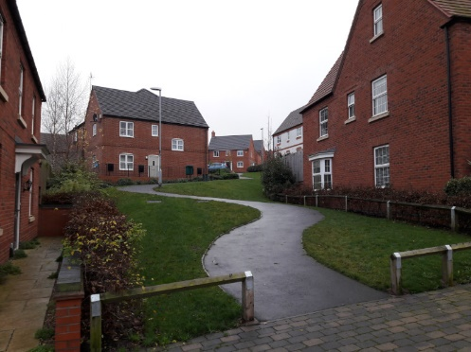
Merchantman Mews Playground  DE74 2UY |  | Mow – No collection,  18 cuts (fortnightly)  Strim around perimeter, play equipment, signs and shrubs | 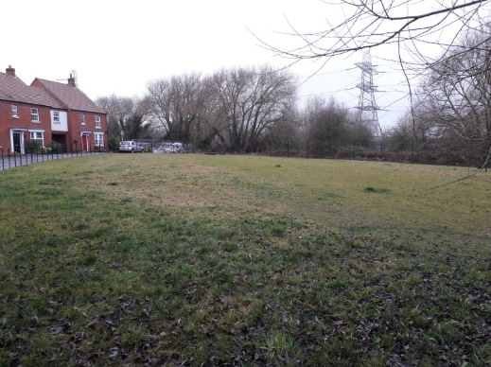  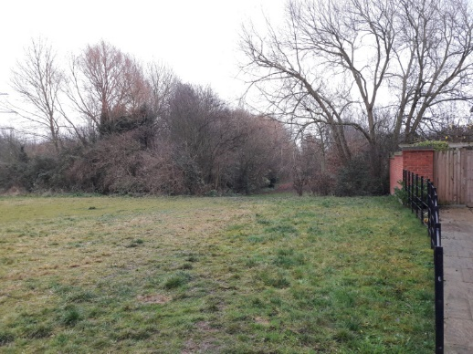
All grass verges as per the LCC urban plan |  | Mow – No collection,  18 cuts (fortnightly)  Weed control arounds street signs | Map supplied
Trent Lane (from the junction of Maple Road) and Back Lane  (Both sides, new roundabout up to Spittal Hill) |  | Mow – No collection,  18 cuts (fortnightly)  Strim around perimeter, edges, and signs
Common Land (Priest House hotel) |  | Mow – No collection,  18 cuts (fortnightly)  Strim around perimeter, edges, and signs
Mowing

The Contractor will carry out the regular cutting of all listed areas.

As it is not possible to accurately predict the number of cuts per season that may be required, an anticipated number of 18 (fortnightly) is given for most areas. All cuts are to maintain a short, neat and tidy standard for the area (maximum growth 50mm/cut height 20-25mm.

Mowing of Spital Park and Moira Dale must be to a standard acceptable to the Rugby and Football Club tenants.

Extent of Mowing

Mowing will cover a total area of grass at the site as close as possible to any obstacle without causing damage to said obstacle.

Mowing method

The Contractor will keep to an approved route for the areas, in particular, around an area such as the Cemetery. The grass shall be mown in an orderly manner to ensure no area is missed. Any cuttings that fly onto pathways, against headstones, play equipment, etc. shall be swept/blown off and removed to the Contractors own tip.

Weed Control

Weed treatment to be kept to a minimum. Strimming is preferred method and strimmers should be fitted with a guard to ensure no damage to trees and headstones, etc.

Under no circumstance should herbicide be use to manage growth around trees, plants and shrubs. In the interest of health and safety of the users (dogs/kids), ALL high usage areas, ie playing fields to be weed control, but only to the perimeters otherwise to be strimmed.

The application for the purposes of weed control should be by an approved herbicide applied to a maximum of 200mm.

Cemetery – Grass edges to footways, roadways, borders and gravestones will be strimmed.
Weed/moss treatment to paths and hedge perimeters only.

Churchyard – No weed killing, only strimming allowed. Moss treatment to paths allowed.
Clapgun Street embankment – Spray as appropriate to allow the shrubs and plants to thrive.

Other areas – Grass edges to footpaths, roadways and borders will be strimmed, no weed treatment.

Selective weed treatments for all areas, other than those of the LCC rural specified map. – Budget cost to be provided.
Cemetery, Churchyard and all pitches are to be included in contract price.

Removal of Rubbish and Arisings

The Contractor will arrange for the removal and disposal of all incidental rubbish including branches, leaves, twigs, stones, litter, cans, bottles, etc. prior to mowing operations.
Litter on all areas should be cleared (picked if necessary) before mowing (and not mown over).
All grass cuttings, trimmings, weeds, moss, prunings, plant growth and other materials to be removed from site to Contractors own tip.
Leaf clearance in the Cemetery to be included in the contract. Twice in the Autumn. All leaf debri to be removed from site to Contractors own tip.

Hedging

The contractor is to price for two cuts to all hedges (early (after bird nesting) and late season). As above all rubbish and arisings to be removed from site.
Flail cutting should have debris removed in a timely matter, maximum of 36 hours.

Location | Linear Metres | Activity
Spital Park (inside perimeter) | 652 | One side and top – flail
Spital Park (outside perimeter) |  | One side and top – flail
Moira Dale (Play area) (privet) | 46 | One side and top – hedge cutter
Moira Dale field (all perimeters including behind houses) | 150 | One side and top - flail
Bosworth Road including pedestrian jitty | 344 | One side and top – flail
Kirkland Close | 6 | One side and top – hedge cutter
Peartree Close | 25 | One side and top – hedge cutter
Towles Pastures | 20 | Both sides and top – hedge cutter
Campion Hill | 217 | One side and top – hedge cutter
Grange Drive | 48 | One side and top – hedge cutter
Darsway – 3 areas (except section nearest to Shirley Close) | 223 | One side and top – flail
Darsway (bottom triangle) |  | Prune and trim trees and shrubs
Bentley Road – Inside perimeter |  | One side and top flail
Stonehill field |  | One side flail
Fox Road | 14 | One side and top – hedge cutter
Roby Lea | 20 | One side and top – hedge cutter
Spitfire Road (both areas) |  | One side and top – hedge cutter
Spitfire Road to Bentley Road |  | One side and top – hedge cutter
Merchantmen Mews |  | One side and top – hedge cutter
Station Road Bridge |  | One side and top – flail
Bowls Club jitty |  | One side and top – hedge cutter
Village entrance from Willow Farm roundabout to next one towards A50 |  | Strim around trees shrubs  Cut back (flail/hedge cutter) one side and top
Churchyard  Yew trees  Single Commemorative Yew tree  Hedge to the rear of Borough Street properties  Lime and Yew trees |  | Hedge cutter top and sides, retain shape  No pruning or trimming whatsoever, allow to mature to a full grown tree  Hedge cutter top and sides  Cut bottom shoots off
Cemetery | 700 | One side and top – hedge cutter
Cemetery Topiary | - | 10 Shaped bushes – hedge cutter
Spital Hillside – Road side | 200 | Both sides and top – hedge cutter / chainsaw
Spital Park (including the main field, hillside and woodland) |  | One side – flail / chainsaw
Long Well |  | Side and top – hedge cutter
Entrance roundabouts, including new verge area on Back Lane |  | Prune twice a year
Allotment’s perimeter  (main garden) | 965 | One side and top – flail and hedge cutter
Allotments entrance  (Not track to main gardens) |  | One side and top – flail and hedge cutter  Prune trees
Pinfold Gardens |  | Shaped bushes. Prune and shape twice a year
Bus Station  Shrubs/hedge |  | One side, top and shape as necessary – hedge cutter
Clapgun street carpark |  | Hedges – both sides with hedge cutter. Shaped bushes. Prune and shape twice a year
Common Land |  | Young trees – Attention as required.
Community Hub |  | Hedge to Bondgate/Spittal Road side. Shrubs to Bondgate/Tanyard one side top and shape as necessary

Football/rugby pitch maintenance

Slitting of all pitches at Spital Park, Moira Dale and College twice a year to be included in contract.
Annual pitch repairs to goal mouths, centre circles, etc to be included in the contract price.
Application of fertilizer to pitches – to be included in contract.
Selective weed treatment to be included in contract.

Football / rugby pitch marking – Approximately 20 pitches

Spital Park, Moira Dale and College sites.

Pitches are a mixture of mini, full size and junior. To include some over marking (in blue) of adult pitches with mini and junior pitches.
To be undertaken fortnightly (occasional weekly) marking from late August/September through to the end of April/June.

There is also a requirement to mark the field permitter during the closed season, to allow the enforcement of the Dog Control orders if necessary.

Training area is required to be marked out to approved grid system during the winter months.

All marking to be included in pricing of contract.

Additional markings – Price per marking required.

Additional mowing of pitches – Price per pitch required

New areas

The Parish Council is looking to take-on two new areas during the next year 2025-26.
I am looking for guide prices for this work and for it to be separated at this stage form the main part of the contract.

Land behind Moira Dale – It is uncertain exactly what work will be needed, but the area is 14 acres. Once landscaped, I think it will probably be a mow/strim twice a year, as the intention is to leave this a natural environment. There are likely to be grass paths that will require mowing to ensure they can be walked.

Foxbridge Park This is an area of land that is being gifted by the developers. It has been landscaped to an approved design. It is uncertain exactly what work will be needed, but the area is 14 acres.
The play area and immediate area around it will need fortnightly mowing as with all the other play areas the Parish Council has.
There is a level sports pitch area that will require fortnightly mowing.
The rest of the site is to be left as a natural environment and only mown/strim twice a year.

Job sheets – Are required to handed to the Clerk or Groundsman after every mow and other works

