

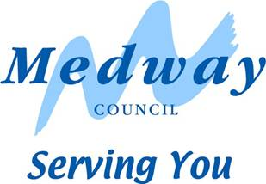

Intermediate Care and Reablement Services Market Engagement Event

Thursday 26th November 2015

St Georges Centre

9.30 Introduction

9.45 The Medway Intermediate Care and Reablement Services to be provided to vulnerable people of Medway

10.30 Coffee Break

10.45 Table Discussions

- What do you think will be the opportunities in delivering this service in Medway?
- What do you think are the challenges in providing the service in Medway?

11.30 Questions and Answers and Feedback

12.00 Way Forward

12.30 Close

