Request for Proposals

Company number: 11810533

25 April 2024

Proposal request: Board CEO and Non Executive recruitment
Fair4All Finance is seeking a provider to lead and manage recruitment of board members, including the CEO, a Non Executive Board member and a Non Executive sub committee member. We are looking for provider(s) who can demonstrate a track record of sourcing a diverse range of candidates with relevant experience for roles and who can also design and deliver a suitable selection/development programme for internal candidates for the CEO role.

About Fair4All Finance
Fair4All Finance is a not for profit organisation founded in early 2019 to increase the financial wellbeing of people in vulnerable circumstances through increasing access to fair and affordable financial products and services. It is a unique organisation currently funded predominantly through Dormant Assets to effect long term system change through its activities. The Impact report [link to add] sets out the overall approach to system change and impact.
To effect change we use a range of activities:
- We support and invest in organisations already doing a good job of serving this customer group to help them grow and share best practice
- We research and gather evidence to show what works well when serving people in vulnerable circumstances
- We partner with others to develop, test and fund new products, services and technologies that meet gaps in the market
- We bring people together to deliver policy and regulation change needed to create a sustainable financial services market that works for everyone in the country
The team consists of around 50 people with remaining funding from existing allocations of £10m to deploy. The announcement on the next phase of funding is imminent with the Secretary of State having already set out an intention for £87.5m to be allocated to financial inclusion and capability over the period from 2025 – 2028, albeit we will are awaiting formal spending direction as to what funding will be made available to us in that context.

Introduction
Our overall mission is to change the financial services system so it works for everyone.
We set out clear phases of development for the organisation. The first phase was building foundations, initiating delivery and innovating, testing and enhancing delivery. Starting from just four employees we have grown to a team with deep insight into the market and customer dynamics of people in financially vulnerable circumstances, expertise in investing, co developing and scaling propositions and in developing well evidenced policy regulations.
We are now transitioning to the next phase of our work. We’re clear that we cannot change the financial system on our own. We know it will take the combined skills of the whole industry, government and regulators. The focus over the next five years will be on scaling and embedding policy and practice.
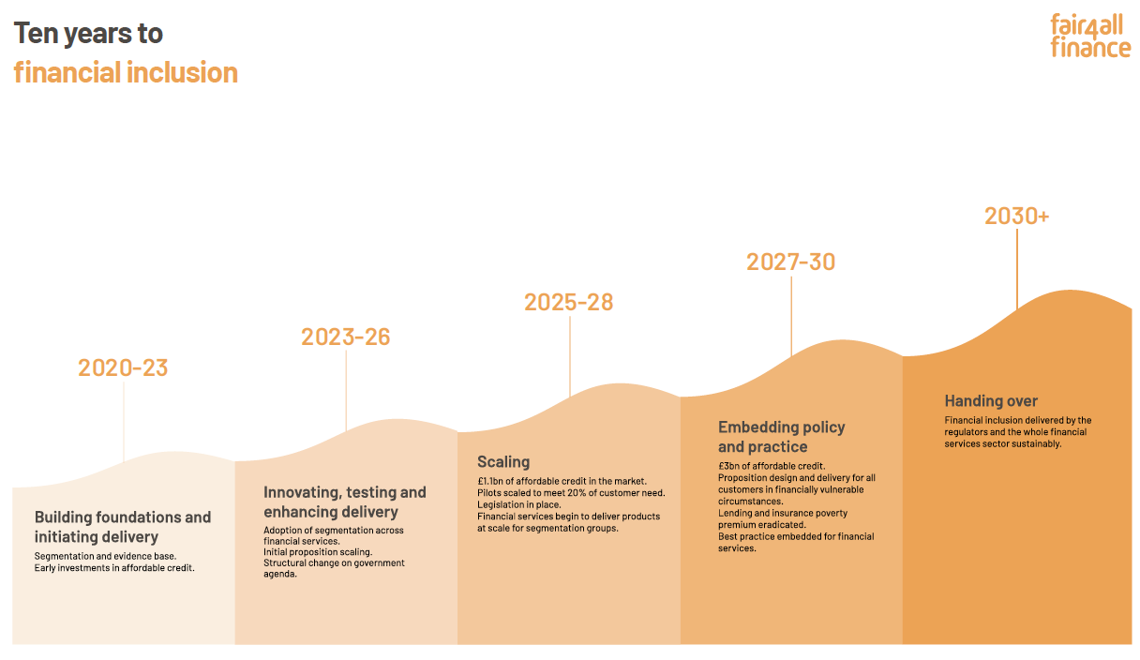

The specification
The requirement is for a provider to support the board in the appointment of board members as part of ongoing board succession planning. In the first phase of work we are looking to appoint three roles:
- CEO to succeed the current CEO
A full non executive board member who brings personal experience of what it is like to not be able to access services and support from the financial system operating in the UK. We believe that individuals who have faced financial challenges firsthand bring invaluable insights to decision-making. No previous Board experience is required as we will provide the induction and ongoing support required for this important role
- A non executive member of the Finance, Grants and Investment Committee with specific unsecured lending experience to people in financially vulnerable circumstances (also known as the non prime lending population)
The role specifications for the two board roles are available to providers on request to linda@fair4allfinance.org.uk.
It is important to the board that:
- The approach supports refining the essential criteria for assessment and selection of candidates
- The approach provides for development/consideration of internal candidates for executive roles
- A diverse range of candidates is sourced, reflecting the organisation’s mission and values
- Key stakeholders are engaged appropriately in the process to support smooth appointment process
Providers may choose to submit a proposal for any or all of the roles; please set out clearly in your response whether you feel you have the credentials to support all roles or specific roles noting the different talent pools that may need to be explored.

Outputs/deliverables
Key deliverables will be:
- Overall recruitment strategy to include proposed assessment and development process for internal candidates and overall selection process
- Comprehensive briefing sessions with key stakeholders to support a smooth appointment process
- Prepare candidate briefing and recruitment copy to reach a diverse range of candidates
- Agree search targets and headhunting approach for each of the roles
- Shortlist of potential candidates
- Manage ongoing assessment/development process for internal candidates
- Feedback to candidates throughout the process
- Input into final selection interview process
- Verify qualifications and take up references

Contracts
All successful suppliers will be contracted under our standard Terms and Conditions which can be found on our website. By submitting your bid, you are agreeing to be contracted under these Terms and Conditions. Where there are specific additional terms appropriate to this engagement please submit these with your proposal.

Timings
Timetable for proposal requests:
Stage | Dates
Request for proposals published | Friday 26 April 2024
Online meeting for provider Q&A | Wednesday 8 May 2024
Proposals due | Friday 10 May 2024
Assessment of proposals | Monday 13 May 2024
Follow up Interviews with providers if required | Monday 13 May 2024
Decisions made to appoint provider(s) | Monday 20 May 2024
Finalise terms of engagement with providers | Tuesday 21 May 2024
Engagement with key stakeholders | Week commencing 20 May 2024
Role descriptions and process finalised, advertising and internal process starts | 27 May 2024
Deadline for applications | 12 June 2024
Shortlist committee/board appointments | Wednesday 12 June
Shortlisted applications for CEO for review and commence psychometrics | Friday 14 June
Interviews board/committee roles | Monday 17 June plus another date that week.
First CEO interviews | Monday/Tuesday 24/25 June in person
Final CEO interviews | Third week of July
Board meeting to ratify CEO appointment | Late July 2024

Your response
To respond to this proposal request, please provide a proposal for how you would deliver the required specification for the scope of services as outlined above. The proposal assessment criteria and requirements are set out below.
Clarification questions on this proposal request may be addressed to Ria Bailes via contracts finder.
Any question responses which are relevant to all will be shared with all applying parties. If you intend to submit a proposal please advise us at your earliest convenience so that question responses can be shared. Questions will be anonymised before responses are shared with respondents.
- Budget and Pricing
- The total budget for the three roles is anticipated to fall in the envelope of £50,000 to £70,000 excluding VAT
- Given the not for profit nature of Fair4All Finance, and our founding and funding through government, please indicate where you have given a discount on commercial rates
- We would welcome proposals which identify a way to deliver the requirements for under the identified budget on a fixed price basis
- Please outline any VAT and or expenses which may be payable clearly and separately
- Proposal submission and scoring criteria
Please email a proposal of no more than 10 pages long to Linda Stevens at Linda@fair4allfinance.org.uk by 5pm on Friday 10 May.
Proposals submitted will be assessed by Fair4All Finance against the following criteria:
1 Understanding of requirements.  Please explain what you understand Fair4All finance is aiming to achieve in commissioning this work.  To what extent does the proposal demonstrate an understanding of the issues related to this brief? | 10%
2 Please set out your proposed methodology/approach by stage  To what extent are the methodology and methods appropriate to the requirements set out in this brief? | 30%
3 Relevant experience  Please set out your experience of delivering high quality candidates for each of the three roles and ability to reach into candidate markets you anticipate needing to operate within.  Please set out the expertise you have to support internal candidates through strengths assessment, coaching and preparing for post-interview feedback.  Please provide the name of two references we can contact in confidence, and at our sole discretion to confirm the work you undertook and its relevance.  What degree of experience does the bidder demonstrate in order to successfully complete the work? | 30%
4 Appropriate resourcing  Please set out your resourcing plan and assumptions about the time commitments you plan to make by grade and resource type.  Please make it explicitly clear who will be accountable for the work and who our day to day contact will be.  How well has the bidder structured a team in order to successfully manage the contract and deliver the required work to the budget and timetable required? | 10%
5 Value for money  To what extent does the proposal represent good value for money? | 20%

- Notes
- Proposal request responses not received by the deadline will not be considered
- Quotations shall be valid for 90 days
- All bidders are solely responsible for all their costs and expenses incurred in connection with this procurement process at all stages
- Fair4All Finance reserves the right to amend or cancel the procurement exercise at any point. Fair4All Finance will accept no liability for any losses caused by any change or cancellation of this procurement exercise nor any decision not to award a Contract
- Any information submitted to Fair4All Finance may need to be disclosed and/or published by Fair4All Finance. Fair4All Finance may disclose information in compliance with the Freedom of Information Act 2000, any other law, or, as a consequence of judicial order, or order by any court or tribunal with Fair4All Finance to order disclosure
- Data Protection Act 2018 - Any awarded Contract will be subject to the Data Protection Act (DPA) 2018. Fair4All Finance reserve the right to request additional evidence to undertake sufficient due diligence of any Tenderer to ensure they have implemented the appropriate technical and organisational measures to comply with the act
- Fair4All Finance is committed to greater transparency and may publish its tender documents, contracts and data from invoices received and may at its discretion redact all or part of such information prior to publication
- Bidders shall not (and shall procure that their subcontractors and representatives do not) do any of the following without obtaining the prior written consent of Fair4All Finance:
  - make a public statement or communicate in any form with the media in connection with this procurement
  - use any trademarks, logos or other intellectual property rights associated with Fair4All Finance and/or its stakeholders
  - represent that the Bidder is directly or indirectly associated in any way with Fair4All Finance and/or its stakeholders or that its or their respective products and/or services are in any way endorsed by Fair4All Finance and/or its stakeholders
  - do anything or refrain from doing anything which would have an adverse effect on or embarrass Fair4All Finance and/or its stakeholders.
- Tenders with abnormally low prices may be rejected by Fair4All Finance. Prices that are suspiciously low in the opinion of Fair4All Finance will be considered further before a decision is taken as to whether the price is abnormally low. This will include clarification with the relevant bidder
- Fair4All Finance will award the Contract to the bidder submitting the offer that best meets scoring criteria from the point of view of Fair4All Finance
- Fair4All Finance will notify all bidders of its contract award decision

