GOAR KNAP TRACKWAY REPAIR
The allotment at Goar Knap has 2 ways of entry, the principle entry is that by the Royal Marine pub and the other is a trackway off St Michael’s Avenue.
The trackway of St Michael’s Avenue has at least 2 natural springs (fig 1). The trackway through Goar Knap runs on a slow with the St Michael’s Avenue entrance sitting higher than the Royal Marine pub entrance. When there are significant downpours of rain, the rain runs down the trackway (fig 2).
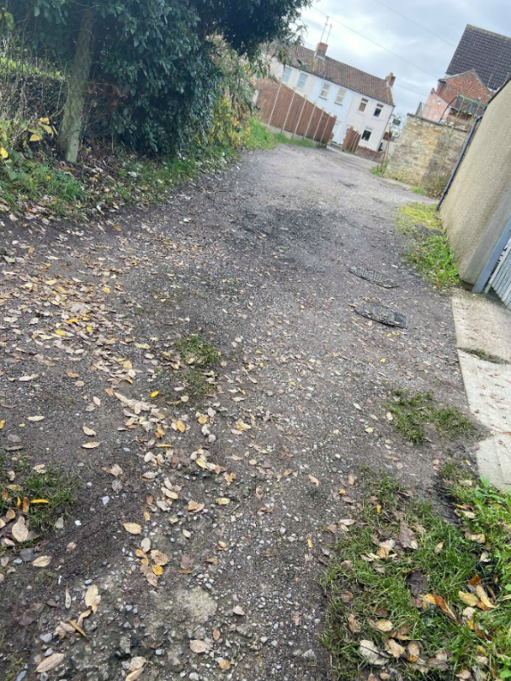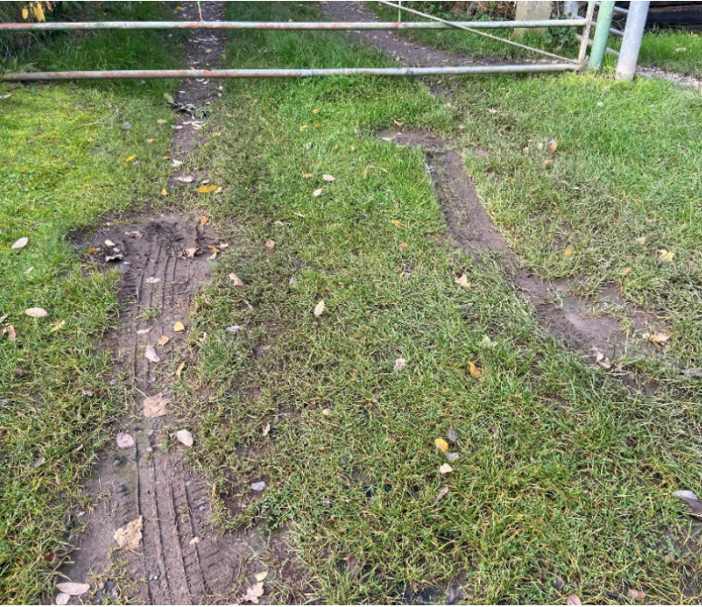
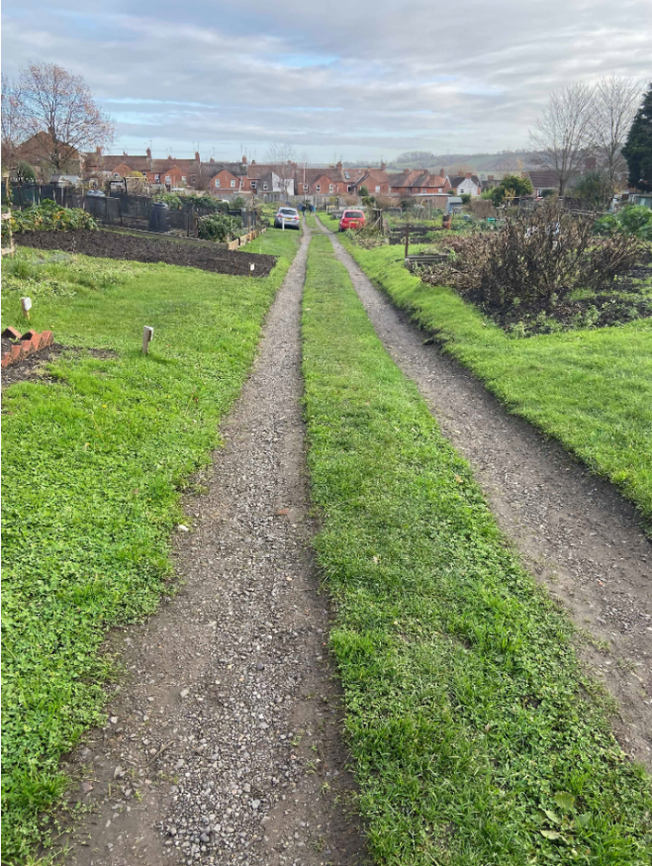
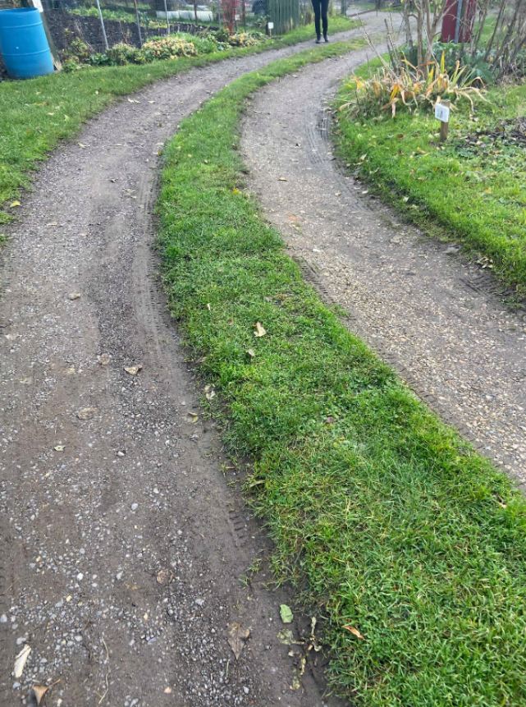
Figure 1: Entrance via St Michael's Avenue Figure 2: Trackway from St Michael's Avenue entrance

Figure 3: View from St Michael’s Ave – looking down Figure 4: Bend near Royal Marine entrance

As cars drive up and down the trackway, the trackway has embedded further partially caused by the rainwater saturating the track as it runs down and partially due to natural erosion. The grass mound in the middle of the track has got deeper and is now scuffing the bottom of cars driving up and down the track. Having carried out a site visit (see fig 3 and 4), the mound in the middle of the trackway is very prominent.
Please quote for the insertion of a land drain, removal of the centre grass mound and laying and compacting scalpings where required to improve the structure of the trackway.

