**North Somerset - Business Support Service Specification** 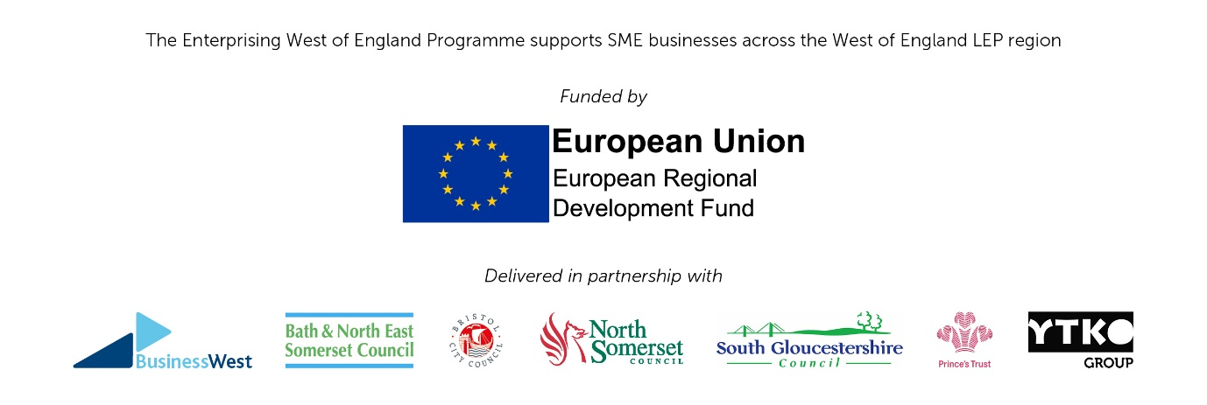

**1. Introduction**

North Somerset has a diverse and growing economy with the number of active enterprises having expanded by 10.2% since 2009 which is higher than the rate of growth for England.

North Somerset has a relatively strong economy, its businesses exhibit productivity levels similar to the national average, which is rare outside of London and the South East. Similarly, its employment levels and activity levels are above average and its workforce is well qualified. It benefits from a strong strategic location in the UK, with local businesses able to connect to markets in the UK and beyond, through the strategic transport network and international ports and airports.

A part of this growth is the number of new enterprises, which year on year averages more than 1,000 annually, although this is countered by a steady 800 annual business closures (ONS 2017). This provides a challenge to ensure as many new start-ups have access to support and advice to ensure they have as strong a start as possible and that they have access to ongoing to support to ensure they can increase their chances of survival in their early years as they establish themselves.

North Somerset is currently updating its Local Economy Plan (2017-2030) and identifies key Objectives and themes that pick up on the need to grow and strengthen business in the area for longer term benefit.

Specifically in relation to start up and business support, the draft plan identifies the following:

**2. Strategic Objective**: To grow and enhance the competitiveness of our businesses base – to address the productivity challenge

**3. Investment Theme**

Theme 3: Competitive Businesses & Enterprise

* Developing niche clusters and supply chains
* Encouraging innovation and collaboration
* Supporting business start-up, self-employment, SMEs and growth

North Somerset Council’s Economic Development Service provides a range of business support services and is looking to secure ongoing business start-up advice to local residents to build on previous work to increase survival chances for new businesses in the area.

The Council has as part of a consortium of unitary authorities and support agencies, secured additional funding to expand current provision in the area and through additional support from a number of partners across the West of England.

The EWOE Programme is part funded by EU Structural Investment Fund (EUSIF), under European Regional Development Fund (ERDF). Priority Axis 3 – Enhancing the Competitiveness of Small and Medium Enterprises.

Each Local Authority in the West of England is procuring its own business support service as part of this overall project. This invitation to tender relates to the North Somerset element of the overall programme, although the delivery will be closely linked to other parts of the programme and delivery partners.

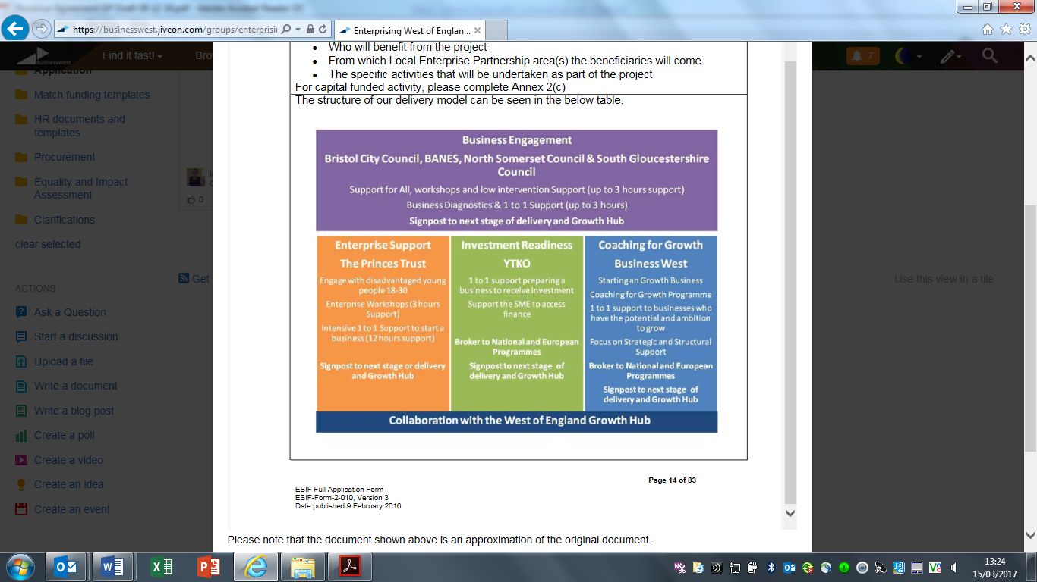

**4. Scope of Service**

The support that will be available through this programme will provide impartial advice to those considering starting up a business and early stage businesses as a way of improving their survival chances over 12 and 36 months. Experience has shown that business survival improves when start up support has been accessed. In some cases businesses are able to achieve objectives and targets faster when they have been helped through initial development.

The purpose of this service will be to provide advice and general support to new start businesses, covering all needs for starting up a business and developing beyond initial start-up. This service will provide advice and guidance to those seeking to set up a business or social enterprise. This will be responsive to specific needs of those individuals and groups of people and will include general advice and early support on such matters as business planning, sources of finance, and getting started.

The Contractor and advisors are also expected to refer the client group to other sources of appropriate advice, support and training, particularly the other Enterprising West of England (EWoE) partners, assistance to social enterprises, women’s enterprises and to provide support for innovation.

The service will need to link to other business support activity in the area including FoodWorksSW .

**5. The Service Requirements**

5.1 Pre start support

* Provision of pre – start advice, guidance and support to individuals or groups who are seeking help in developing their business ideas and requirements for setting up and running a business.
* Required to provide access to business advice through surgeries, 1-1 contact at the local base, with phone and email contact available.
* Initial advice at least to be through face to face diagnostics surgeries between advisor (s) and interested parties in North Somerset.

5.2 Early stage and established SMEs

* Advice to cover all aspects of supporting further development growth of the business providing ongoing support and advice as new businesses develop through their first year.
* Advice to cover all aspects of supporting further development growth of small businesses providing support and advice as businesses continue to develop post 12 months.

5.3 Events and workshops

* Develop and deliver a well promoted programme of events for different business stages covering a wide range of topics that meet need and demand. This may be delivered through a mix of contractor and specialists as appropriate.
* To develop and deliver a monthly Start in Business course that will cover a wide range of topics to help those considering establishing a business understand all the requirements. This will be in addition to the advice clinics and 1-1s and topic specific events.

5.4 Promotions and Marketing

* Promotion and marketing to raise awareness of the service through website and social media and other mediums. A communications plan will developed and maintained through the duration of the programme.
* All marketing and publications must clearly state North Somerset Council and ERDF funded, brand usage guidelines will be provided.

5.5 Specific requirements

* Requirement to have a physical fixed presence in the area through a staffed and accessible office base open at least 9am – 5pm Monday to Friday. The events and workshops will be available in a range of locations to ensure support is accessible across North Somerset.
* Signposting to other organisations and services, including North Somerset Council Services, WoE Growth Hub and EWOE partners.
* Support is to be open to any North Somerset resident or existing North Somerset SME.
* Support available to all eligible sectors and industries unless specifically referred to under ERDF non eligibility rules.
* The contractor will be responsible for effective monitoring and reporting against all Programme outputs and desired outcomes.

**6. Contract duration to confirm**

Start: 1st January 2018

End: 31st December 2019

**7. Finance**

The project is being funded by North Somerset Council (NSC) and European Structural Funds, particularly ERDF.

Total funding available for the Service is £89,600 over the contract period. It is expected the full amount will be utilised to deliver at least the minimum output requirements.

**8 Applicable service standards**

The Contractor/ consultant will provide information about the quality standards of the service as detailed in the requirements of the Service as detailed, but also provided a list of accredited counsellors and trainers who will be providing the support and training.

Where business advice is provided consultants should be SFEDI accredited or to similar agreed quality standards.

**9. Performance and Monitoring**

Key performance indicators, targets and monitoring for North Somerset Council and ERDF funding are identified below:

Table 1 – Required Outputs and Outcomes

|  |  |  |
| --- | --- | --- |
| **Output Indicator** | **Description** | **Targets** |
| ERDF (P11) & NSC | Number of potential entrepreneurs assisted to be enterprise ready | 280 |
| ERDF (P13) & NSC | Number of enterprises receiving information, diagnostics and brokerage support | 76 |
| ERDF (C1) | Number of business receiving support | 16 |
| ERDF (C4 | Number of business receiving non-financial support | 16 |
| ERDF (C5) | Number of new enterprises supported | 8 |
| ERDF (C8) | Employment increase in supported enterprises | 7 |
|  |  |  |
| NSC | Business start ups – new registrations supported | 240 |
| NSC | Jobs created through new start up | 256 |
| NSC | 12 month survival rate | 80% |
| NSC | 36 month survival rate | 55% |
| NSC | Communication Plan | Annual |

Further information on the elements of each indicator can be found at

<https://www.gov.uk/government/uploads/system/uploads/attachment_data/file/601630/ESIF-GN-1-002_ERDF_Output_Indicators_Definition_Guidance_v4.pdf>

Monitoring meetings will take place quarterly to review progress against the agreed targets and to identify any issues arising in respect to the service being provided and if necessary any remedial action required to improve activity.

Bidders will need to be able to confirm that they are able to collect, record, store and provide to North Somerset Council all relevant information needed to fully respond to monitoring requirements, this will be a specific requirement to satisfy forecasting and claims under the Enterprising West of England funding, this includes ability to provide monthly reports.

9.1 Supporting information to be reported.

In addition to ERDF monitoring, the following will be required:

* Number of individuals and group assisted to be business ready, including enterprises receiving information, diagnostic and brokerage support
  + Number of overall enquiries received, even if the enquirer does not go on to receive detailed advice. This information should include nature of enquiry, location, type of business (where available), a brief description of any action taken and follow up and time spent with the client.
  + Number of unique enquiries received for advice and support including what type of support provided and time spent on the enquiry,
  + Feedback/evaluation those who have received support under the programme, particularly attendees on all courses and events.
* Number of businesses started
  + New start businesses (including details of the company name including when registered, nature of business (using SIC codes), and location).
  + Survival rate for new start businesses after 12 months and 3 years (including details of the company name, nature of business (using SIC codes) and location)

Number of jobs in supported start ups and business

* + Jobs created (including details of the company name, nature of business (using SIC codes) and location)
* Start up in Business Course and events
  + Number of individual businesses attending. Including company name, nature of business (using SIC codes) and location, also whether they have received pre start up advice or not.
  + Promotion of the courses across the district – details to be reported quarterly.
  + Individual business feedback/evaluation from those on the course.
  + Number of business starting up following attendance on the courses.
* Promotion of the service across the district – (quarterly)
  + Information on all marketing and promotions undertaken including press releases