

STATEMENT OF SERVICE REQUIREMENT FOR
THE PROVISION OF SUPPORT TO REVIEW THE EFFECTIVENESS OF
ONR’s SECURITY COMMITTEE (PHASE ONE) &
REMUNERATION AND NOMINATIONS COMMITTEES (PHASE TWO)

1 BACKGROUND TO THE PROJECT
1.1 ONR vested as a statutory corporation in 2014. The Energy Act 2013 established the ONR Board, which is responsible for setting and delivering ONR’s strategic aims and objectives and for ensuring that effective arrangements are in place at ONR to provide assurance on governance, risk management and internal control.

1.2 Below the Board, sit four Committees - Audit and Risk Assurance, Security, Remuneration and Nominations. The Audit and Risk Assurance Committee was subject to external review in 2016 and is outside the scope of this project.

1.3 The Security Committee provides assurance to the Board that ONR is efficient and effective in its regulation of the nuclear industry with respect to risk and malicious intent and is chaired by a Non-Executive Director recruited specifically for their expertise in matters relevant to ONR’s nuclear security purposes. The requirement for a security NED to provide a particular focus on assurance of ONR’s security regulation is enshrined in legislation and is outside the scope of the review.

1.4 The Remuneration Committee has oversight of all matters relating to the remuneration and performance of Executive Members of the ONR Board along with oversight of remuneration and performance for all others who hold senior civil servant equivalent roles (Director cadre).

1.5 The Nominations Committee makes recommendations for the appointment of new Board members (Non-Executives, Chief Executive and Chief Nuclear Inspector). The Committee also advises on Board training and development matters.

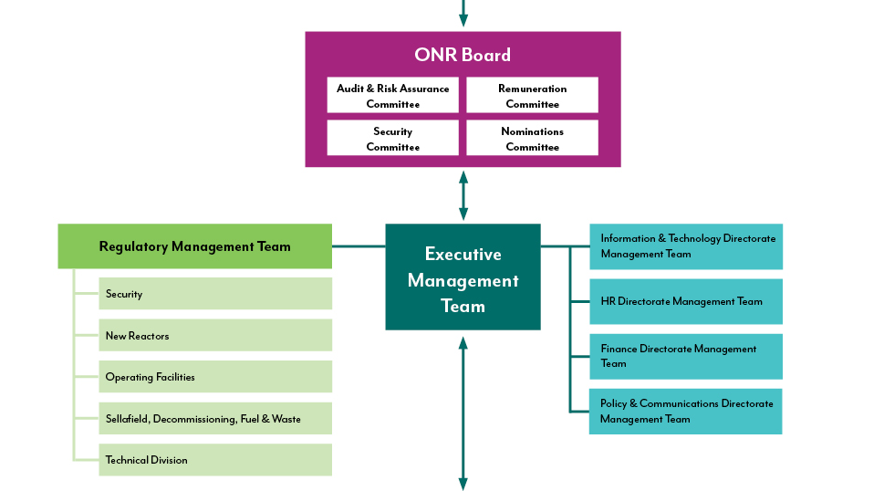

1.6 The role and responsibilities of the Committees, together with their terms of reference, are specified in ONR’s Arrangements for Corporate Governance (http://www.onr.org.uk/documents/2014/corporate-governance.pdf).

1.7 Our relationship with our sponsoring department, the Department for Work and Pensions is described in the Framework Agreement which can be found on our website (www.onr.org.uk/documents/2014/onr-dwp-framework.pdf)

2 SCOPE OF THE SERVICES REQUIRED
2.1 Regular review of governance arrangements is recognised as good practice across all sectors and is incorporated within the UK Corporate Governance Code. ONR conducts annual effectiveness reviews and is now seeking an externally facilitated review in line with good practice. The review will be conducted in two phases.
Overall Objectives:
- To understand how effective and efficient the current arrangements are, within the ONR governance model, in meeting recognised standards e.g. UK Corporate Governance Code and relevant wider public sector practice.
- To understand how efficient and effective the Committees operate compared to best practice.
2.2 Phase One:
To carry out a fundamental review of the way in which security assurance can be provided to the Board, currently delivered through the Security Committee.
During the review, the following matters will need to be considered:

- Do the original requirements that led to the need to establish the ONR Security Committee remain valid? – This context for this will be provided during kickstart and introductory meetings.
- How effective is the Committee in providing assurance to the Board that ONR’s regulation of civil nuclear security is efficient and effective.
- Is the Committee the most effective and efficient structure to do this and if so can it be strengthened in anyway.
- Explore other models in similar environments and whether they offer a better, optimised approach for providing Board assurance
The broad timeline for this, envisaged programme and estimated resource are listed below:
Before 27 July | Initial kick start meeting (due to staff availability)  Venue: Bootle, Merseyside (Head Office) if face-to-face  Estimated Time: 1 Day inc. travel
Late August/Early September | Desktop Review of Previous Report Packs and Associated Documentation  Venue: Bootle, Merseyside (Head Office)  Estimated Time: 1 Day inc. travel
TBC | Pre-meet/introductory chat with the Chair of Committee and Chair of Board  Venue: Central London (if face-to-face)  Estimated Time: 0.5 Day
18th September | Observe meeting of Security Committee – Venue: Central London
Interviews with 9 people (3x Committee Members, ONR Chief Inspector and Deputy Chief Inspector, 4x attendees)
Venues – Telephone, Bootle or London
Estimated Time: 2 Days inc. write up
Timing of interviews to be determined we would suggest they would have the greatest impact after observing a Committee meeting. Depending on availability of interviewees, these could be scheduled before the SC meeting
15th October | Draft report to be available for comments with staff and Committee members (Face-to-face meeting if required)
14th November | Finalised Report for Board Deadline
26th November | Board Meeting to present findings – Venue – Sellafield Nuclear Site, Cumbria  Estimated Time: 1 Day inc. travel

2.3 Phase Two
The aim of the second phase is to obtain an independent evaluation of the effectiveness of the Remuneration and Nominations Committees.
The starting point for the review will be to evaluate whether the Remuneration and Nominations Committee operate more effectively as a single Committee given the synergies between the two, and, if so, what changes would be required in terms of membership, terms of reference and frequency of meetings.

2.4 Following the settlement of this aspect of the review, the matters below will need to be considered in regard to the effectiveness of the Committee(s):

- How effective are the Committees against their Terms of Reference;
- Are the Committees compliant with the UK Corporate Governance Code;
- How do current arrangements compare with best practice elsewhere in the public sector and other regulators;
- Do the arrangements within ONR fit with best practice in the wider public sector for remuneration of senior staff. Is the remit too narrow or too wide?
- Do the Committees have sufficient expertise, support, time, and access to key staff and information to discharge their functions effectively;
- Do the Committees operate effectively;
- Are the Committees cohesive and do they provide appropriate challenge.

Mid/Late September | Initial kick start meeting  Venue: Bootle, Merseyside (Head Office) if face-to-face  Estimated Time: 1 Day inc. travel
25th September | Desktop Review of Previous Report Packs and Associated Documentation  Venue: Windsor House, Central London  Estimated Time: 1 Day inc. travel
25th September  (after Board meeting) | Pre-meet/introductory chat with the Chair -  Venue: Windsor House – Central London  Estimated Time: 0.5 Day
TBC – Mid November | Observe meeting of Remuneration Committee – Venue: Central London
Interviews with 6 people (3x Committee Members, ONR Chief Executive, ONR HR Director, 1x Nominations Committee Member)
Venues – Telephone, Bootle or London
Estimated Time: 2 Days inc. write up
Depending on availability of interviewees, these could be scheduled before the Committee meeting
Friday 14 December | Draft report to be available for comments with staff and Committee members (Face-to-face meeting if required)
9 January 2019 | Finalised Report for Board Deadline
24 January 2019 | Board Meeting to present findings – Venue – Bootle  Estimated Time: 1 Day inc. travel

3 EXPECTED OUTPUTS
3.1 ONR will require one report for each phase detailing the context and findings from any fieldwork and how these have influenced any recommendations for improvement. An action plan agreed with ONR should also be included when the findings are presented to the Board.
3.2 Invoice production must be accompanied by reports detailing progress against agreed deliverables.
4 CONSTRAINTS
4.1 Scheduling of Meetings/Finalisation of Reports: As detailed in the draft timelines, the timeframe for delivering the review will allow the contractor/s the opportunity to observe at least one meeting of each Committee. Phase one will report to Board in November 2018 (Security Committee), followed by phase two in January 2019 (Nominations and Remuneration).
4.2 Experience: It is essential that the contractor who carries out the Security Review has an appreciation of the regulatory environment within which ONR operates. To this end, ONR is open to splitting the work between two contractors.
4.3 Conflicts of interest: all potential conflicts of interest must be declared.
4.4 Security Clearance: the contractor will have access to information marked OFFICIAL-SENSITIVE relating to our work on security regulation of the civil nuclear industry and remuneration of senior executives. For this reason any member of staff from the contractor will require appropriate security clearance (baseline personnel security standard as a minimum). Ideally, we would like this to be in place before commencement of fieldwork.
4.5 The identified financial envelope for the reviews is up to £15k.
5 TENDER SUBMISSIONS
5.1 Bidders will be expected to provide the information listed below by completing the Tender Submission Form in Schedule B in order to demonstrate how they propose to meet ONR’s requirements:
- a description of how they will deliver the work and the resources they will use;
- the CVs and other relevant details of experience and skills of all staff who will be undertaking the work;
- their arrangements for managing delivery of the work and dealing with disputes (including details of who will act as the liaison point between the contractor and ONR);
- a proven track record of undertaking similar work for other customers (tender proposals should include two case studies of similar work undertaken previously);
- details of any and all costs associated with undertaking the required work, including a breakdown of the time that will be required by each individual involved and the appropriate day rates for those individuals together with any sundry costs and an indication of the likely impact of their activities on ONR personnel / resources;
- a description of your arrangements for securing baseline personnel security standard clearance.

6 CONTRACT MANAGEMENT
6.1 ONR expects to be kept updated about progress and delivery of the required work via regular discussion, including a contract start-up meeting which can be carried out by telephone. Subsequent progress meetings should be arranged with the ONR Project Officer.
7 EVALUATION
7.1 Tender submissions will be evaluated by ONR staff in line with the Evaluation Criteria at Schedule B. The contract will be awarded to the contractor that best satisfies compliance, quality and value for money criteria.
8 TIMETABLE
Invitation to Tender (ITT) issued | 07 June 2018
Deadline for Tender Questions | 15 June 2018
Publication of Questions and Answers | 19 June 2018
Deadline for Receipt of Tenders | 22 June 2018

