Supporting Photographs – Tender for Redevelopment of Osprey Park Play Area
Existing Play Equipment at Osprey Park Play Area

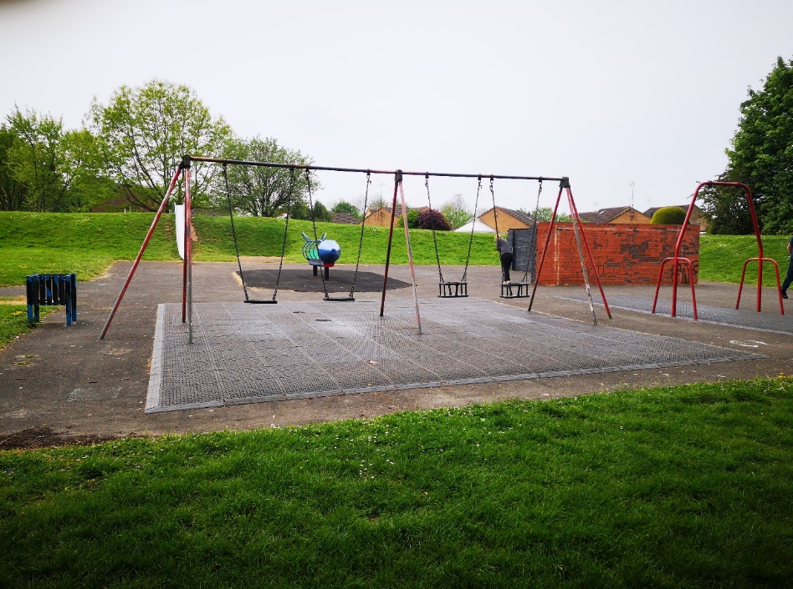

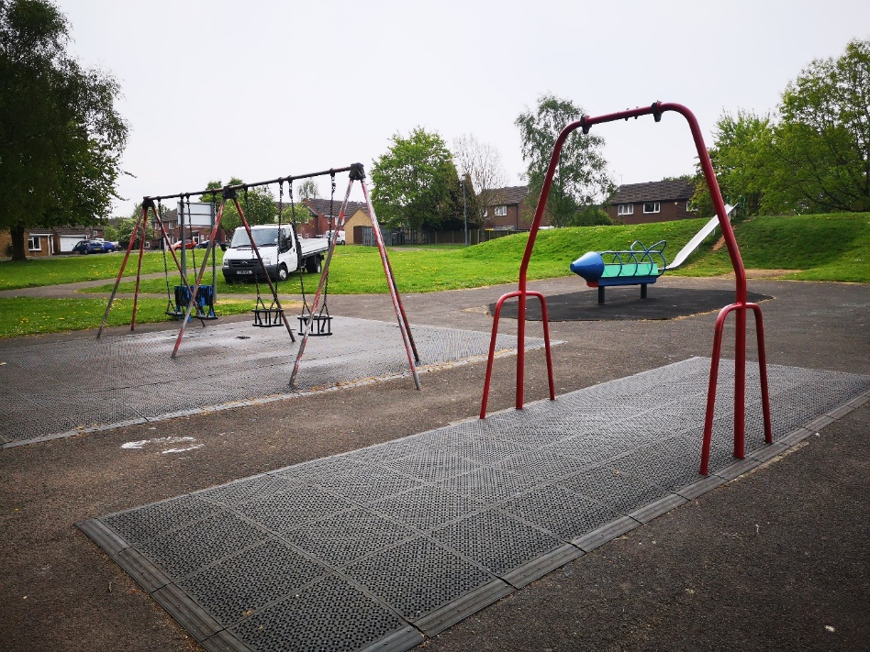

Ariel View of Osprey Park Play Area
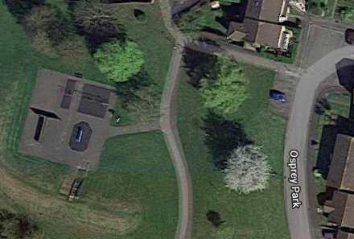

Existing “Kick Wall” – To Be Removed
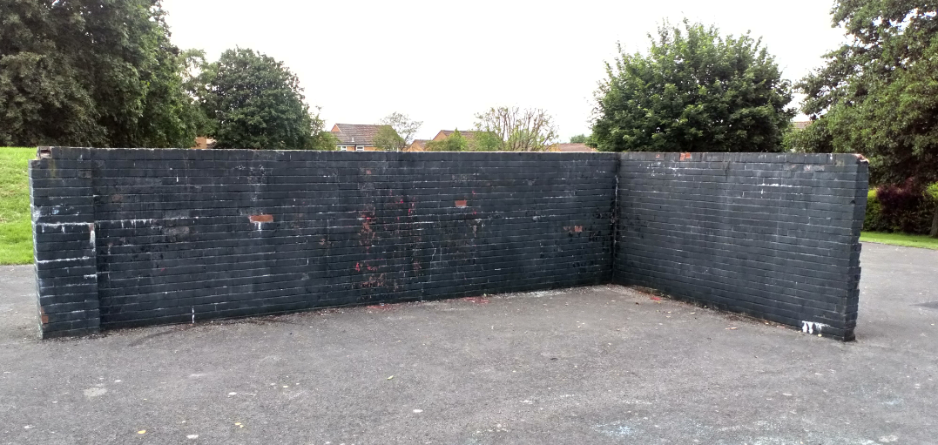

Existing Slide – To Be Replaced

