Slough Borough Council
Dynamic Purchasing System for the Provision of Adult Social Care Services for Slough Resident

- Register with the SE Shared Services Portal - www.sesharedservices.org.uk

- Find the Council’s opportunity called SBC Dynamic Purchasing System for the Provision of Adult Social Care Services for Slough Resident

- Express an interest
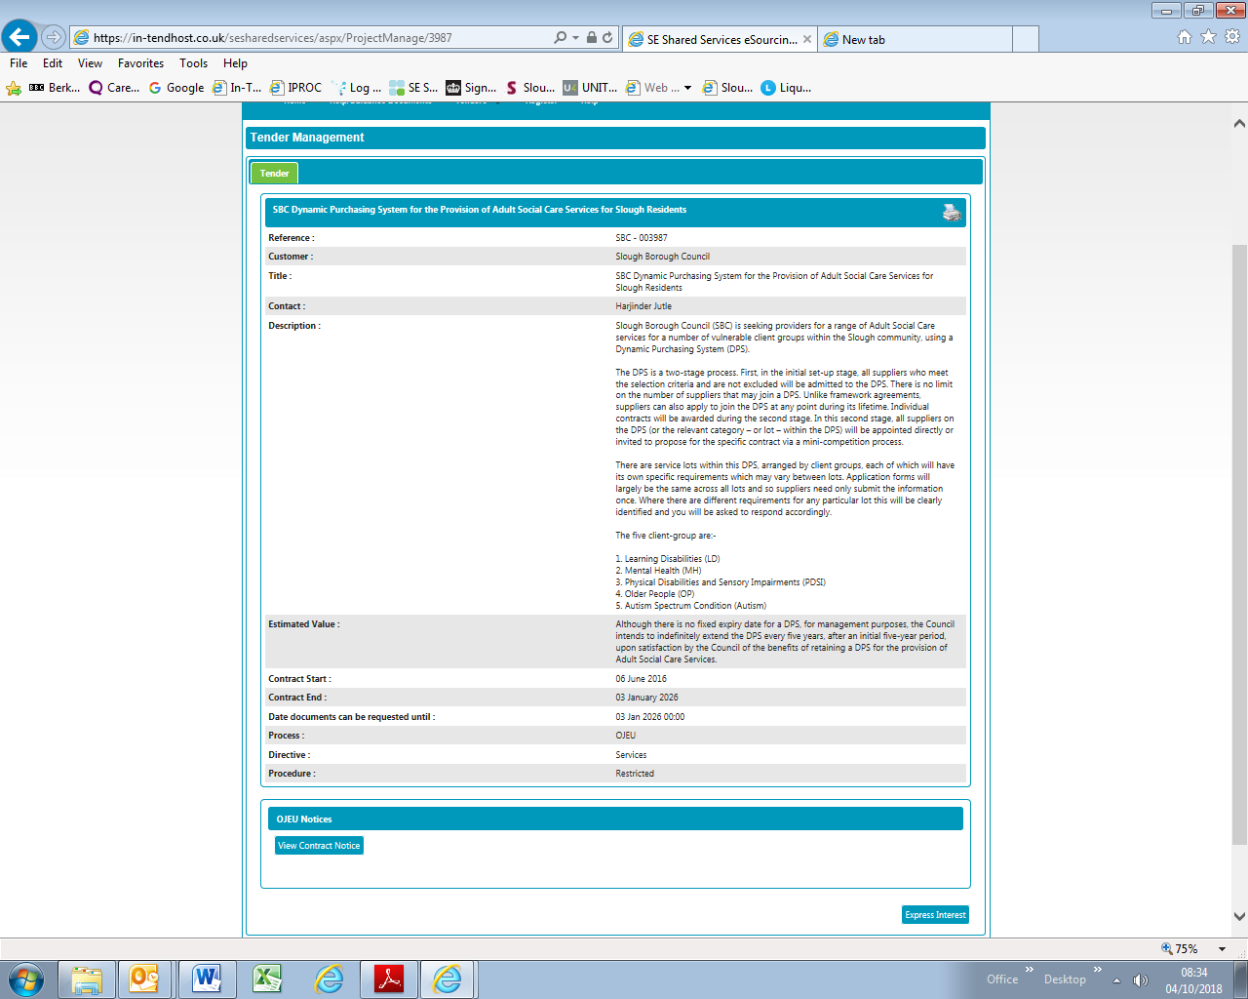

- Click on DPS Application stage, scroll down the webpage, and download the documents for completion. Once completed, upload your completed documents and other required documents for assessment and approval.

