Mission Net Zero Open Market Day tender information

SHORT VERSION
Mission Net Zero aims to create an Enabling Environment for investment of approximately £1bn for a Just Transition to Net Zero in the West of England. A structured process of engagement and capacity building is planned to accelerate the transition and address the three key non-technical barriers of climate finance, consumer engagement and capacity development. It’s a collaboration between Bristol City Council, West of England Combined Authority (WECA), Bristol and North East Somerset (BANES), North Somerset and South Gloucestershire Councils, Bristol Climate and Nature Partnership, Bristol City Leap Partnership, the Centre for Sustainable Energy, Bristol Energy Network, Bristol and Bath Regional Capital and National Grid Electricity Distribution (NGED) South West.

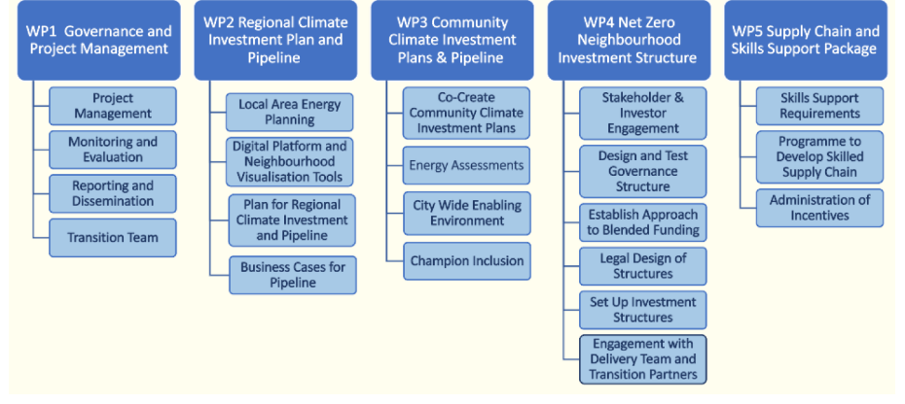

Objectives
The open market day aims to introduce potential bidders to the forthcoming opportunity and to identify areas for consideration when developing our specification. For the tender at present (subject to change following the open market day) we require a consultant(s) to provide services to achieve the following objectives:
- Broaden the regional partners understanding of how to decarbonise the area and build support for project delivery
- Consult with key stakeholder groups to understand their needs around energy planning and investment decisions and barriers to achieving these
- / Produce a regional climate investment plan to support decarbonisation of the region, taking a place-based approach
- Build on emerging best practice to ensure an energy planning process that results in a deliverable project pipeline
- Design a process to prioritise net zero projects including governance arrangements (Pipeline development). Balancing considerations etc
- Deliver a digital platform and/or combination of digital tools to host data and/or provide data modelling or analysis capabilities to support energy planning activities
- Understand how non-technical barriers are considered in the development of plans to ensure they are embedded in stakeholder wants and needs

Activities to be delivered are anticipated to include:
- Background onboarding to understand partner requirements
- Proposed definition of a regional climate investment plan and associated investment pipeline process – how these should be structured and the methodology through which they will be developed
- Stakeholder engagement to inform opportunities and challenges, taking into account the findings of stakeholder engagement and needs analysis already undertaken
- Energy scenario modelling to understand the current state of play and opportunities
- Business case development to aid realisation of decarbonisation projects
- Structuring and population of a pipeline of investable projects, and design of a robust process to prioritise opportunities in line with agreed criteria
- Delivery of a digital energy data platform and/or combination of digital tools to provide a dynamic system to inform investment pipeline development
- Quality assurance through third party technical review
- Project management to ensure timely delivery of intended deliverables
Timings
Seeking to appoint by end October 2024 TBC
Contract delivery October 24- October 25

Budget
£700-950k TBC

