**Procurement of the Contractor to provide the High Commissioner’s Residence Redevelopment in Abuja, Nigeria Market Engagement**

**Contract Ref ESND-11039-2024**

We invite you to register your interest for the High Commissioner’s Residence Redevelopment in Abuja, Nigeria via the Procurement Portal, e-Bravo/Jaggaer.

**BACKGROUND INFORMATION**

The project is for the redevelopment of the High Commissioner’s Residence, Gana Street, Abuja, Nigeria.

The works briefly comprise:

• Residence for the High Commissioner (approx. GIFA 930m2)

• Residential accommodation for staff (20nr x 2 bedroom flats, approx. GIFA 2,745m2)

• Shared swimming pool

• Gatehouse (approx. GIFA 231m2)

• Associated external works and security related works

The main development objectives are:

• Produce a concept which showcases the best of British design, whilst being sympathetic to the local environment and design standards

• Create a Residence suitable for social and official functions, VIP stays and family living

• Create modern residential properties which maximise living space given in the FCDO design standards

• Consolidate the estate in Abuja

• Provide a sustainable compound, keeping ongoing maintenance to a minimum and reducing the average running cost of FCDO residential properties in Abuja

• Provide safe fit for purpose properties in line with the security threat

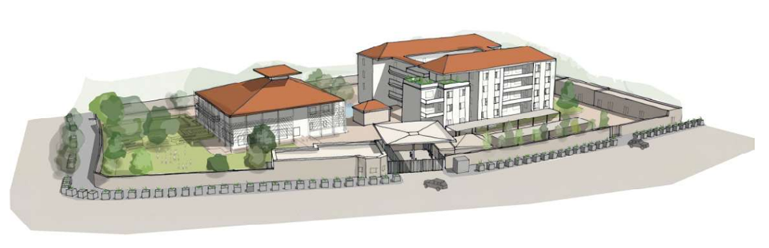

**Project 11039, PQQ 1624: the High Commissioner’s Residence Redevelopment in Abuja, Nigeria**

**How to Register Your Company/Express Interest in this Project**:

1. Register your company on the eSourcing portal (this is only required once) - Browse to the eSourcing Portal: **https://fcdo.bravosolution.co.uk** and click the link to register. - Accept the terms and conditions and click "continue" - Enter your correct business and user details - Note the username you chose and click "Save" when complete - you will shortly receive an e-mail with your unique password (please keep this secure).

2. Login to the portal with the username/password - Click on the relevant Selection Questionnaire (SQ) - You can now access any attachments by clicking the "Settings and Buyer Attachments" in the "Actions" box;

Responding to the SQ - You can choose to "Reply" or "Reject" (please give a reason if rejecting) - You can now use the 'Messages' function to communicate with the buyer and seek clarification - Note the deadline for completion, - There may be a mixture of online & offline actions for you to perform (there is detailed online help available), You must then publish your reply using the publish button in the "Actions" box on the left-hand side of the page. If you require any further assistance please consult the the online help or contact the eTendering help desk.

Potential Providers should answer all questions as accurately and concisely as possible in the same order as the questions are presented. Where a question is not relevant to the Potential Provider’s

organisation, this should be indicated, with an explanation. Where attachments are requested to be submitted within the electronic SQ, these shall be submitted in a PDF format (Adobe or similar).

SQ or Bids not submitted via the FCDO’s eProcurement portal will not be considered.

**Return Date: 17:00hrs – Friday 10th May 2024 (BST) – Please note that any returns submitted after the deadline has closed will be considered ‘late’ and may not be accepted for shortlisting.**