

Request for Quotation

LIFE18NAT/UK/000039 – LIFE Recreation ReMEDIES: Reducing and Mitigating Erosion and Disturbance Impacts affecting the Seabed

# Installation and Maintenance of Voluntary No Anchor Zone (VNAZ) Markers at Osborne Bay, Isle of Wight



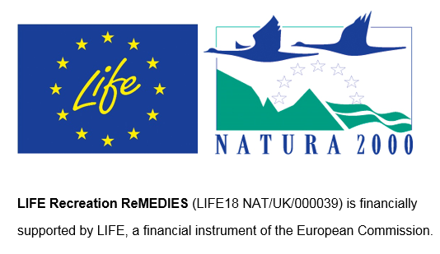

28/07/2023

Contents

Installation and Maintenance of Voluntary No Anchor Zone (VNAZ) Markers at Osborne Bay, Isle of Wight 1

Request for Quotation 1

Section 1: General Information 2

Glossary 2

Conditions applying to the RFQ 3

Acceptance of Quotations 3

Costs 3

Self-Declaration and Mandatory Requirements 3

Clarifications 3

Amendments 4

Conditions of Contract 4

Prices 5

Disclosure 5

Disclaimers 5

Protection of Personal Data 6

General Data Protection Regulations 2018 6

Equality, Diversity & Inclusion (EDI) 7

Sustainable Procurement 7

Conflicts of Interest 8

Section 2: The Invitation 8

Specification 8

Sustainability 16

Payment 16

Award Stage 17

Annex 1 21

# Request for Quotation

### LIFE18NAT/UK/000039 - LIFE Recreation ReMEDIES: Reducing and Mitigating Erosion and Disturbance Impacts affecting the Seabed

### Installation and maintenance of Voluntary No Anchor Zone (VNAZ) markers at Osborne Bay, Isle of Wight

You are invited to submit a quotation for the requirement described in the specification, Section 2.

Please confirm by email, receipt of these documents and whether you intend to submit a quote or not.

Your response should be returned to the following email address by:

Email: [Caitlin.Napleton@naturalengland.org.uk](mailto:Caitlin.Napleton@naturalengland.org.uk)

Date: 18/08/2023

Time: 12 noon

Ensure you include the name of the quotation and ‘Final Submission’ in the subject field to make it clear that it is your response.

Contact Details and Timetable

Caitlin Napleton will be your contact for any questions linked to the content of the quote or the process. Please submit any clarification questions via email and note that, unless commercially sensitive, both the question and the response will be circulated to all tenderers.

|  |  |
| --- | --- |
| Action | Date |
| Date of issue of RFQ | 28th July 2023 |
| Deadline for clarification questions | 12 noon on 11th August 2023 |
| Deadline for receipt of Quotation | 12 noon on 18th August 2023 |
| Evaluation of bids | Week commencing 21st August |
| Intended date of Contract Award | 23rd August 2023 |
| Intended Contract Start Date | 25th August 2023 |
| Intended Installation Delivery Date | 6 – 13th September 2023 |
| Intended Maintenance of Markers | May 2024 |

Section 1: General Information

## Glossary

Unless the context otherwise requires the following words and expressions used within this Request for Quotation shall have the following meanings (to be interpreted in the singular or plural as the context requires).

|  |  |
| --- | --- |
| Words/Expression | Meaning |
| “Authority” | Means Natural England who is the Contracting Authority |
| “Contract” | Means the contract to be entered into by the Authority and the successful supplier |
| “Response” | Means the information submitted by a supplier in response to the RFQ |
| “RFQ” | Means this Request for Quotation and all related documents published by the Authority and made available to suppliers |

## Conditions applying to the RFQ

You should examine your Response to the RFQ and related documents ensuring it is complete and in accordance with the stated instructions prior to submission.

Your Response must contain sufficient information to enable the Authority to evaluate it fairly and effectively. You should ensure that you have prepared your Response fully and accurately and that prices quoted are arithmetically correct for the units stated.

By submitting a Response, you, the supplier, are deemed to accept the terms and conditions provided in the RFQ. Confirmation of this is required in Annex 2.

Failure to comply with the instructions set out in the RFQ may result in the supplier’s exclusion from this quotation process.

## Acceptance of Quotations

By issuing this RFQ the Authority does not bind itself to accept any quotation and reserves the right not to award a contract to any supplier who submits a quotation.

## Costs

The Authority will not reimburse you for any costs and expenses which you incur preparing and submitting your quotation, even if the Authority amends or terminates the procurement process.

## Self-Declaration and Mandatory Requirements

The RFQ includes a self-declaration response (Annex 1) which covers basic information about the supplier, as well as any grounds for exclusion. If you do not comply with them, your quotation will not be evaluated.

Any mandatory requirements will be set out in Section 2, Specification of Requirements and, if you do not comply with them, your quotation will not be evaluated.

## Clarifications

Any request for clarification regarding the RFQ and supporting documentation must be submitted via email no later than the deadline for clarifications set out in the Timetable. The Authority shall be under no obligation to respond to queries raised after the clarification deadline.

The Authority will respond to all reasonable clarifications as soon as possible but cannot guarantee a minimum response time. The Authority will publish all clarifications and its responses to all suppliers via email unless deemed commercially sensitive.

If a supplier believes that a request for clarification is commercially sensitive, it should clearly state this when submitting the clarification request. However, if the Authority considers either that:

* the clarification and response are not commercially sensitive; and
* all suppliers may benefit from its disclosure,

then the Authority will notify the supplier (via email), and the supplier will have an opportunity to withdraw the request for clarification by sending a further message requesting the withdrawal of the clarification request. If not withdrawn by the supplier within 2 working days of the Authority’s notification, the Authority may publish the clarification request and its response to all suppliers and the Authority shall not be liable to the supplier for any consequences of such publication.

The Authority reserves the right to seek clarification of any aspect of a quotation and/or provide additional information during the evaluation phase to carry out a fair evaluation. Where the Authority seeks clarification on any aspect of the quotation, the supplier must respond within the timeframe requested by the Authority.

## Amendments

The Authority may amend the RFQ at any time prior to the deadline for receipt. If it amends the RFQ the Authority will notify you via email.

Suppliers may modify their quotation prior to the deadline for Responses. No Responses may be modified after the deadline for Responses.

Suppliers may withdraw their quotations at any time by submitting a notice via the email to the named contact.

## Conditions of Contract

The Authority’s standard [Condensed Terms and Conditions](https://www.gov.uk/government/organisations/natural-england/about/procurement) provided as part of the RFQ will be included in any contract awarded as a result of this quotation process. The Authority will not accept any changes to these terms and conditions proposed by a supplier.

Suppliers should note that the quotation provided by the successful bidder will form part of the Contract.

## Prices

Prices must be submitted in £ sterling, inclusive of VAT.

## Disclosure

All Central Government Departments, their Executive Agencies and Non Departmental Public Bodies are subject to control and reporting within Government. In particular, they report to the Cabinet Office and HM Treasury for all expenditure. Further the Cabinet Office has a cross-Government role delivering overall Government policy on public procurement, including ensuring value for money and related aspects of good procurement practice. For these purposes, the Authority may disclose within Government any details contained in your quotation. The information will not be disclosed outside Government during the procurement.

In addition, the Authority is subject to the Freedom of Information Act 2000 and the Environmental Information Regulations 2004, which provide a public right of access to information held by public bodies. In accordance with these two statutes, the Authority may be required to disclose information contained in your quotation to any person who submits a request for information pursuant to those statutes.

Further to the Government’s transparency agenda, all UK Government organisations must advertise on Contract Finder in accordance with the following publication thresholds:

* Central Contracting Authority’s: £12,000
* Sub Central Contracting Authority’s and NHS Trusts: £30,000

For the purpose of this RFQ the Authority is classified as a Central Contracting Authority with a publication threshold of £12,000 inclusive of VAT.

If this opportunity is advertised via Contracts Finder, we are obliged to publish details of the awarded contract including who has won the contract, the contract value, and indicate whether the winning supplier is a small and medium-sized enterprise (“SMEs”) or voluntary organisation or charity. A copy of the contract must also be published with confidential information redacted.

By submitting a Response, you consent to these terms as part of the procurement.

## Disclaimers

Whilst the information in this RFQ and any supporting information referred to herein or provided to you by the Authority have been prepared in good faith the Authority does not warrant that this information is comprehensive or that it has been independently verified.

The Authority does not:

* make any representation or warranty (express or implied) as to the accuracy, reasonableness or completeness of the RFQ;
* accept any liability for the information contained in the RFQ or for the fairness, accuracy or completeness of that information; or
* accept any liability for any loss or damage (other than in respect of fraudulent misrepresentation or any other liability which cannot lawfully be excluded) arising as a result of reliance on such information or any subsequent communication.

Any supplier considering entering into contractual relationships with the Authority following receipt of the RFQ should make its own investigations and independent assessment of the Authority and its requirements for the goods and/or services and should seek its own professional financial and legal advice.

## Protection of Personal Data

In order to comply with the General Data Protection Regulations 2018 the supplier must agree to the following:

* You must only process any personal data in strict accordance with instructions from the Authority.
* You must ensure that all the personal data that we disclose to you or you collect on our behalf under this agreement are kept confidential.
* You must take reasonable steps to ensure the reliability of employees who have access to personal data.
* Only employees who may be required to assist in meeting the obligations under this agreement may have access to the personal data.
* Any disclosure of personal data must be made in confidence and extend only so far as that which is specifically necessary for the purposes of this agreement.
* You must ensure that there are appropriate security measures in place to safeguard against any unauthorised access or unlawful processing or accidental loss, destruction or damage or disclosure of the personal data.
* On termination of this agreement, for whatever reason, the personal data must be returned to us promptly and safely, together with all copies in your possession or control.

## General Data Protection Regulations 2018

For the purposes of the Regulations the Authority is the data processor.

The personal information that we have asked you provide on individuals (data subjects) that will be working for you on this contract will be used in compiling the tender list and in assessing your offer. If you are unsuccessful the information will be held and destroyed within two years of the award of contracts. If you are awarded a contract it will be retained for the duration of the contract and destroyed within seven years of the contract’s expiry.

We may monitor the performance of the individuals during the execution of the contract, and the results of our monitoring, together with the information that you have provided, will be used in determining what work is allocated under the contract, and in any renewal of the contract or in the award of future contracts of a similar nature. The information will not be disclosed to anyone outside the Authority without the consent of the data subject, unless the Authority is required by law to make such disclosures.

## Equality, Diversity & Inclusion (EDI)

The Client is striving to create a diverse and inclusive working environment where every individual has equality of opportunity to progress and to apply their unique insights to making the UK a great place for living. The Service Provider is expected to respect this commitment in all dealings with Natural England staff and service users.

Suppliers are expected to;

* support Defra group to achieve its Public Sector Equality Duty as defined by the Equality Act 2010, and to support delivery of [Defra group’s Equality & Diversity Strategy](https://www.gov.uk/government/publications/defra-group-equality-diversity-and-inclusion-strategy-2020-to-2024/defra-group-equality-diversity-and-inclusion-strategy-2020-to-2024).
* meet the standards set out in the [Government’s Supplier Code of Conduct](https://www.gov.uk/government/publications/supplier-code-of-conduct)
* work with Defra group to ensure equality, diversity and inclusion impacts are addressed (positive and negative) in the goods, services and works we procure, barriers are removed and opportunities realised.

## Sustainable Procurement

Addressing global sustainability impacts and realising additional community benefits within commercial activity is core to Defra group’s approach, working with its supply chain is key to achieving sustainable outcomes. In addition to supporting Defra group to meet its outcomes we look to understand and reduce negative sustainability impacts associated with our commercial activity and realise benefits.

The Client encourages its suppliers to share these values, work to address negative impacts and realise opportunities, measure performance and success.

Suppliers are expected to have an understanding of the Sustainable Development Goals, the interconnections between them and the relevance to the Goods, Services and works procured on the Client’s behalf

## Conflicts of Interest

The concept of a conflict of interest includes but is not limited to any situation where an Involved Person or Relevant Body has directly or indirectly, a financial, economic or other personal interest which might be perceived to compromise their impartiality and independence in the context of the procurement procedure and/or affect the integrity of the contract award.

We expect suppliers to mitigate appropriately against any real or perceived conflict of interest through their work with government. A supplier with a position of influence gained through a contract should not use that position to unfairly disadvantage any other supplier or reduce the potential for future competition

Where the supplier is aware of any circumstances giving rise to a conflict of interest or has any indication that a conflict of interest exists or may arise you should inform the Authority of this as soon as possible (whether before or after they have submitted a quotation). Tenderers should remain alert to the possibility of conflicts of interest arising at all stages of the procurement and should update the Authority if any new circumstances or information arises, or there are any changes to information already provided to the Authority. Failure to do so, and/or to properly manage any conflicts of interest may result in a quotation being rejected.

Provided that it has been carried out in an open, fair and transparent manner, routine pre-market engagement carried out by the Authority should not represent a conflict of interest for the supplier.

Section 2: The Invitation

## Specification

1. **Background**
   1. **Background to Natural England**

Natural England (NE) is the government’s advisor on the natural environment. We provide practical advice, grounded in science, on how best to safeguard England’s natural wealth for the benefit of everyone.

NEs remit is to ensure sustainable stewardship of the land and sea so that people and nature can thrive. It is NEs responsibility to see that England’s rich natural environment can adapt and survive intact for future generations to enjoy.

Further information on the Authority can be found at: [Natural England](http://www.naturalengland.org.uk/)

* 1. **Background to the specific work area relevant to this purchase**

The LIFE Recreation ReMEDIES: ‘Reducing and Mitigating Erosion and Disturbance Impacts affecting the Seabed’ project (LIFE 18 NAT/UK/000039) runs from July 2019 - Oct 2024 and will improve the condition of seagrass beds in five Special Areas of Conservation (SACs) between Essex and Isles of Scilly. This will be achieved by restoration, demonstration and reducing recreational pressures. Promoting awareness, communications and inspiring better care of sensitive seabed habitats will be key. Natural England (lead partner) is working with the Marine Conservation Society, Ocean Conservation Trust, Plymouth City Council/Tamar Estuaries Consultative Forum, Royal Yachting Association and the Green Blue. The project is financially supported by LIFE, a financial instrument of the European Commission. More about the project can be seen at www.saveourseabed.co.uk

* 1. **Background to the site**

LIFE Recreation ReMEDIES focuses on five Special Areas of Conservation (SACs), on site of which is the Solent Maritime SAC (fig. 1). This Marine Protected Area (MPA) is a complex site encompassing a major estuarine system and has a tight cluster of small estuaries. It lies in one of the only major sheltered channels in Europe. The SAC includes extensive areas of mudflats and sandbanks, supporting seagrass habitats.

*Figure 1. Map of Solent Maritime SAC*

* 1. **Survey Area**

Osborne Bay sits within the Solent Maritime SAC and hosts one of the largest continuous seagrass beds in the Solent (fig. 2). As part of the LIFE Recreation ReMEDIES project, recreational activity surveys have been undertaken over 8 weeks in the summer of 2021 and 2022 with more planned for 2023 and 2024. The results of these has highlighted Osborne Bay as a hotspot for recreational activity interacting with seagrass.

The current management in place consists of 4 swim marker buoys (fig. 3) which aim to restric anchoring to outside of the marked off area. However, these are not always adhered to and do not cover the bay sufficiently. The ReMEDIES project has hosted 3 open forum events with local recreational users to propose the placement of a Voluntary No Anchor Zone (VNAZ). Throughout this process questions, feedback and discussion were encouraged with the results overwhelmingly in favour of the VNAZ in Osborne Bay. A survey of the seagrass is being done in order to accuratley map the edge of the seagrass bed and update the currnet data (fig. 2).

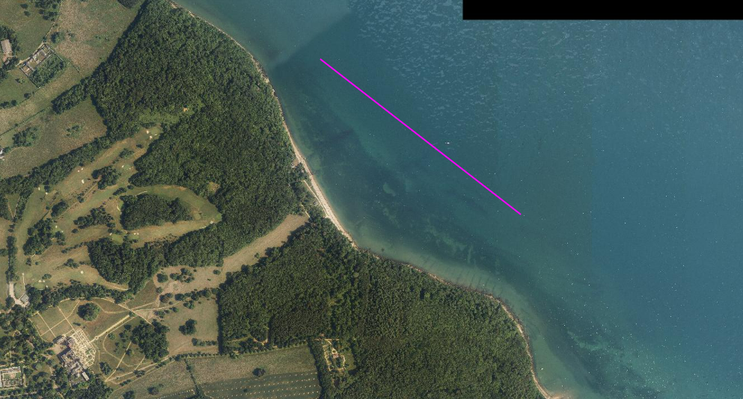

*Figure 2: Line marking the edge of the seagrass bed based on current data*

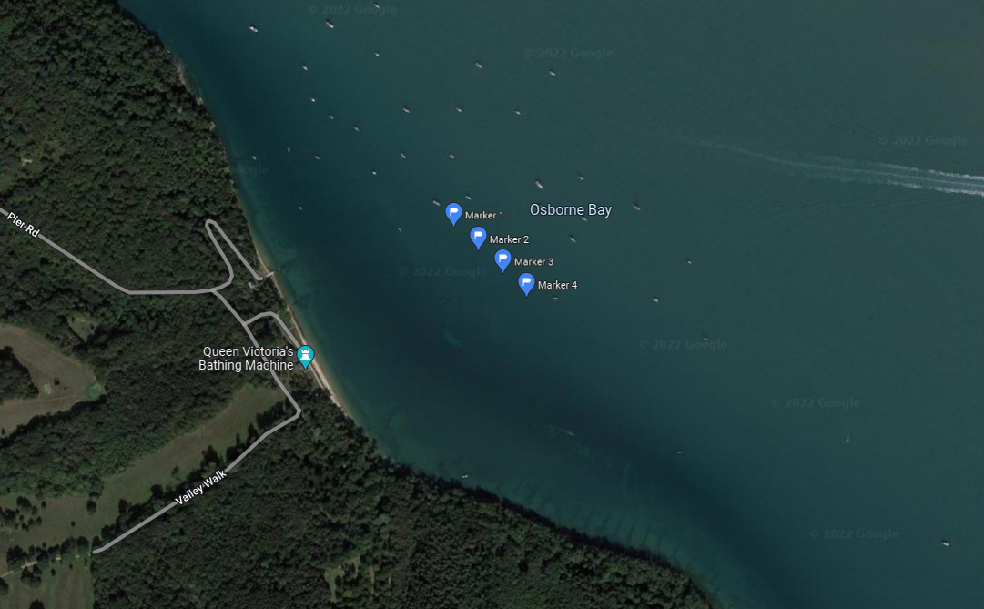

*Figure 3: Osborne Bay with current swim marker buoys*

**Aims and Objectives**

* 1. **Aims**

Natural England wishes to commission the purchase, installation and maintenance of 8 VNAZ marker buoys for Osborne Bay

**Please note, this invitation to tender covers purchase, installation and maintenance. The maintenance can be awarded separately, tenderers should therefore cost for these elements separately but indicate where cost savings could be made if both elements were awarded to a single tenderer.**

Should tenders identify limitations or positive improvements within the plan these suggestions should be indicated. In doing so tenderers should consider the costs and benefits offered by an alternative design. **You should indicate any cost savings in your tender bid.**

The tender should achieve the following aims:

* Purchase of 8 VNAZ marker buoys and VNAZ signs
* Removal of marker buoys currently in place in Osborne Bay
* Installation of buoys at the seaward edge of the seagrass bed in Osborne Bay
* Annual maintenance of buoys in 2024
  1. **Objectives**

The specific objectives of this contract are to, in collaboration with Natural England, plan, purchase, install and maintain the marker buoys for a VNAZ to protect the seagrass bed in Osborne Bay from further anchoring damage as part of the LIFE Recreation ReMEDIES project.

Under this specification tenderers must:

* Source and recommend the best specification for the VNAZ marker buoys
* Agree the final specification with Natural England
* Place required orders for, and purchase all required components
* Ensure warrantees are in place for the duration of the LIFE Recreation ReMEDIES project (until October 2024)
* Remove the current marker buoys in place in Osborne Bay
* Carry out the installation of all components of the VNAZ marker buoys, completing installation in line with manufacturers requirements
* Provide an annual maintenance check on the VNAZ buoys in 2024
* Provide a written report with photos after the installation and maintenance

1. **Methods**
   1. **Purchase**

Provide recommended specification for the VNAZ markers and an estimate of costs of the different components to include both options of anchor, riser, shackles, buoys and metal plate for signage (fig. 4). Note that Stickers for signage will be purchased separately. Based on the best available data, Natural England recommends the use of a helical screw anchor (fig. 5) and rope riser.

The final specification will be agreed by Natural England prior to purchasing. Natural England will require copies of invoice for final product or service provided.

Place required orders for, and purchase all required components. For helical screws, these should be sourced from [ABC Anchors ABC Anchors - Screw Piles and Installation Equipment](https://www.abcanchors.co.uk/). Please contact Richard Robinson for information about current designs appropriate for VNAZ markers [richard@autoguide.co.uk](mailto:richard@autoguide.co.uk). Ensure warrantees are in place for the duration of LIFE Recreation ReMEDIES, which is until October 2024.

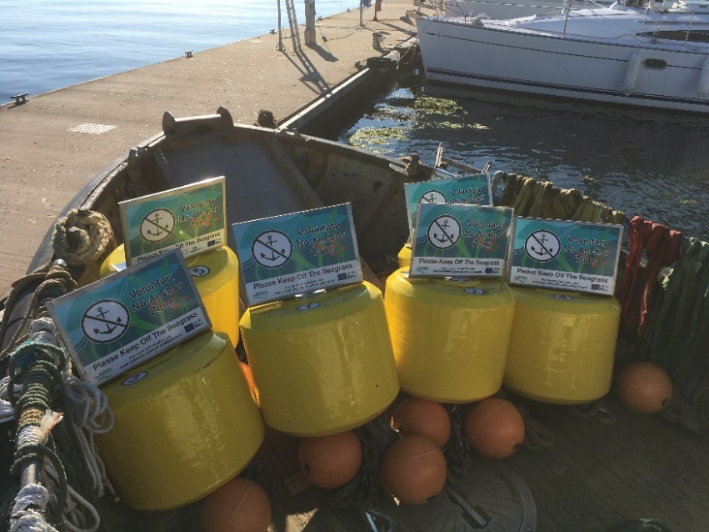

*Figure 4: Photo of example marker buoys used for a VNAZ in Plymouth as part of ReMEDIES*

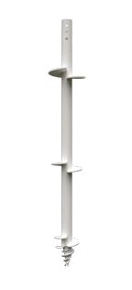

*Figure 5: Photo of helical screw from ABC Anchors*

* 1. **Installation**

Remove the current marker buoys currently in place in Osborne Bay. Carry out all installation of the VNAZ components (anchor, riser, shackles, top buoy, screw and metal plate for signage). For helical screw anchors please contact Richard Robinson (details above) for information about installation process. This would likely require divers, but there are current trials underway to allow installation from barge. Please install in line with manufacturers requirements. Hire of all the kit required (Annex 1) for helical screw anchor installation.

**If diving is selected as the preferred method, the winning contractor must comply with the Diving at Work Regulations (1997) and appropriate Health and Safety Executive Approved Code of Practice. Prior to diving operations commencing, the contractor must supply the Natural England Dive Officer with a Diving Project Plan and diving risk assessment. Copies of qualifications, medical certificates and first aid certificates should also be provided to the Natural England Diving Officer. Post operation, the diving report is required to be shared with the Natural England Dive Officer.**

Provide a report to NE about the installation process and photographs of the installed VNAZs both above and below water (if visibility allows). Prior to departure from site, arrange a debrief with Customer (NE).

* 1. **Maintenance**

Provide an annual maintenance check of the VNAZ markers in 2024. Conduct a thorough inspection of all mooring components from seabed to surface. Please provide a maintenance schedule in response to this tender. This will likely require divers, please see the above for diving requirements.

Provide written reports for the inspection and photos if available.

* 1. **Out of Scope**

The following are outside of the requirements for this tender:

* The sticker signage for the VNAZs will be purchased and supplied separately in time for installation and out of scope for this contract.
* Any licence requirements, authorisations, and communications about the VNAZs (e.g. Notice to Mariners) are the responsibility of Natural England and out of scope for this contract.
* If maintenance activities require removal of any parts e.g. replacement of parts, they should be replaced to the standard of the original specification. The costs of replacement parts and works to install are outside the scope of this contract and would be subject to a future additional contract.
* Installation works will be subject to Marine Management Organisation/Crown Estate licence which will be obtained by Natural England.
  1. **Invasive Non-Native Species**

Invasive Non-Native Species (INNS) are considered to be one of the top five pressures directly driving biodiversity loss globally. Prevention is the key focus, particularly in marine environments. The contractor needs to be aware of and work in accordance with standard good practice biosecurity measures to avoid spread of INNS:

* Equipment, clothes and boots should be clean before carrying out any work on site
* When on or near water it is important that equipment is drained after use and as far as possible dried
* Dry all clothes and boots thoroughly
* Boats or other watercraft (e.g. hovercraft) to be used in survey work should have their hulls cleaned on a regular basis. Best practice guidelines should be followed as outlined by The Green Blue

A statement of biosecurity measures that the successful Contractor will undertake is required with the tender.

The successful Contractor shall report any records of INNS observed on site to the Marine Biological Association <http://www.mba.ac.uk/recording> and to the Natural England project officer. More information and guidance including ID guides can be found at [www.nonnativespecies.org](http://www.nonnativespecies.org) and the [Marine Aliens Project](http://www.marlin.ac.uk/marine_aliens/).

* 1. **Risk Assessments**

All risk assessments need to be seen and signed off by the Natural England project officer (ideally presented with the project plan), as part of the contract management process.

1. **Outputs**
   1. **Timeline for Project Delivery**

|  |  |
| --- | --- |
| **Event** | **Date** |
| Contract Award Date | 23rd August 2023 |
| Finalise method and plan by | 4th September 2023 |
| Purchase by | 8th September 2023 |
| Installation by | 13th September 2023 |
| Draft report to be provided by | 20th September 2023 |
| Final report to be delivered | 26th September 2023 |
| Annual Maintenance | May 2024 |
| Brief field report following maintenance | Mid-June 2024 |

Any delays should be discussed with the Natural England project officer.

1. **Other**

In support of this contract Natural England will provide the successful Contractor with:

* Project support from dedicated project lead
* Opportunity to feedback and discuss progress and the project

The intellectual property rights and copyright for all products (including photographs) will lie with Natural England. All data will be made available by Natural England under the Open Government Licence at the end of the project via MESH and the MEDIN Data Archiving Centres.

As part of this contract the successful Contractor will provide a pre-survey planning meeting with Natural England.

## Sustainability

Natural England protects and improves the environment and is committed to reducing the sustainability impacts of its activities directly and through its supply chains. We expect he Contractor to share this commitment and adopt a sound, proactive sustainable approach in keeping with the 2 yr environmental plan/our commitments compliant with all applicable legislation. This includes understanding and reducing direct and indirect sustainability impacts and realising opportunities, including but not restricted to; resilience to climate change, reducing greenhouse gas emissions, water use and quality, biosecurity, resource efficiency and waste, reducing the risk of pollution, biodiversity, modern slavery and equality, diversity & inclusion, negative community impacts.

As a delivery partner, the successful Contractor is expected to pursue sustainability in their operations, thereby ensuring the Contracting Authority is not contracting with a supplier whose operational outputs run contrary to the Contracting Authority’s objectives. The successful Contractor will need to approach the project with a focus on the entire life cycle of the project.

## Payment

The Authority will raise purchase orders to cover the cost of the services and will issue to the awarded supplier following contract award.

The Authority’s preference is for all invoices to be sent electronically, quoting a valid Purchase Order number.

It is anticipated that this contract will be awarded for a period 1 month to end no later than 29/09/23. Prices will remain fixed for the duration of the contract award period. We may at our sole discretion extend this contract to include related or further work. Any extension shall be agreed in writing in advance of any work commencing and may be subject to further competition.

If successful, all invoices must include the following reference: LIFE Recreation ReMEDIES (LIFE18NAT/UK/000039).

*“Contractors shall make no financial investment in the project and, therefore, shall not benefit from any intellectual property rights arising from the project.”*

## Award Stage

**Evaluation: Award Stage (Stages 3 to 4)**

Evaluation comprises the stages set out in the table below.

|  |  |  |  |
| --- | --- | --- | --- |
| **Stage** | **Section Reference** | **Evaluation Criteria** | **Question Scoring/Weighting (%)** |
| 1 | Complete quotation | Responses have been provided to all of the questions | Pass/Fail |
| 3 | Technical & Professional Ability – Project Specific Requirements (Technical Requirements) | This stage will be evaluated in accordance with the criteria set out in the Technical Questionnaire | Technical Requirements will make up 70% the total marks available.  Overall technical score will be formed from the following breakdown:  E01 – Quality of proposal and sampling Strategy (weighting 55%)  E02 – Experience (20% weighting)  E03 – Ability to mobilise a survey team (weighting 20%)  E04 – GDPR (5% weighting) |
| 4 | Pricing Schedule | Prices will be evaluated in accordance with the criteria set out in the Pricing Schedule | Commercial score will make up 30% of the total marks available |
| 5 | Final score | If you pass stages 1 to 2 your Tender will be evaluated in stages 3 to 4  The final score is calculated as follows:  70 % is made up of the total of Stage 3  30 % is made up from Stage 4  The most economically advantageous Tender will be the Tender with the highest final score. | |

Tenders will be evaluated on quality and price using the evaluation criteria set out in Bravo

to determine which Tender is the most economically advantageous. The Authority will

award the Contract to the Tenderer which submits the most economically advantageous

tender which will be the highest scoring Tender after the weightings below are applied.

Each question will be scored separately, and no reference will be made between the

questions.

To ensure that the relative importance of both sets of criteria is correctly reflected in the

Overall score, a weighting system will be applied to the evaluation:

The total quality scores awarded will form 70% of the final score;

The score awarded for price will form 30% of the final score.

Each scoring question in the quality evaluation is given a weighting to indicate the relative

importance of that question in the overall quality score. Weightings for quality scores are

provided with the evaluation criteria and are detailed in the response form. The evaluation criteria for price are set out in the Pricing Schedule.

Evaluation of Tenders will be undertaken by the two selected case officers. Each officer will first undertake an independent evaluation of the Tenders applying the Relevant evaluation criteria for each question. Then the two case officers will agree on the winning Tenderer.

**Questions E01 – E04 will be assessed using the following scoring criteria**:

|  |  |
| --- | --- |
| **Score** | **Justification** |
| For a score of hundred  (100): | Excellent - Response is completely relevant and excellent overall. The response is comprehensive, unambiguous and demonstrates a thorough understanding of the requirement and provides details of how the requirement will be met in full. |
| For a score of seventy  (70): | Good - Response is relevant and good. The response demonstrates a good understanding and provides details on how the requirements will be fulfilled. |
| For a score of fifty (50): | Acceptable - Response is relevant and acceptable. The response provides sufficient evidence to fulfil basic requirements. |
| For a score of twenty  (20): | Poor - Response is partially relevant and/or poor. The response addresses some elements of the requirements but contains insufficient / limited detail or explanation to demonstrate how the requirement will be fulfilled. |
| For a score of zero (0): | Unacceptable - Nil or inadequate response. Fails to demonstrate an ability to meet the requirement. |

If a bidder scores 20 (twenty) or below for any of the technical evaluation questions (E01 – E03), they will be eliminated from the procurement.

For avoidance of doubt please note: no half marks or a score other than those whole

numbers above will be awarded to responses.

Tenders are required to complete Appendix D: Pricing Schedule and submit this within their

Tender response. This document is for information purposes only and will be used by the

Authority to understand how the submitted price is calculated. The information provided

may be used to inform the Pricing Schedule of the final Contract.

The appendices will include several worksheets which the Tenderer is requested to complete

for information purposes in order for the Authority to understand how the Tenderer’s costs

are calculated. This information may be used to inform the Pricing Schedule of the

Contract. The weighting and maximum marks available for the price will be 30% and will

be awarded to the Tenderer with the lowest Tender Price. The remaining Tenderers will

receive marks on a pro rata basis from the lowest to the highest price. The calculation

used is the following:

Score = Lowest Tender Price x 30% (Maximum available marks)

Tender Price

For example, if three Tender Responses are received and Tenderer A has quoted £30,000 as their total price, Tenderer B has quoted £50,000 and Tenderer C has quoted £60,000 then the calculation will be as follows:

Tenderer A Score = £30,000/£30,000 x 30% (Maximum available marks) = 30%

Tenderer B Score = £30,000/£50,000 x 30% = 18%

Tenderer C Score = £30,000/£60,000 x 30% = 15%

# Annex 1

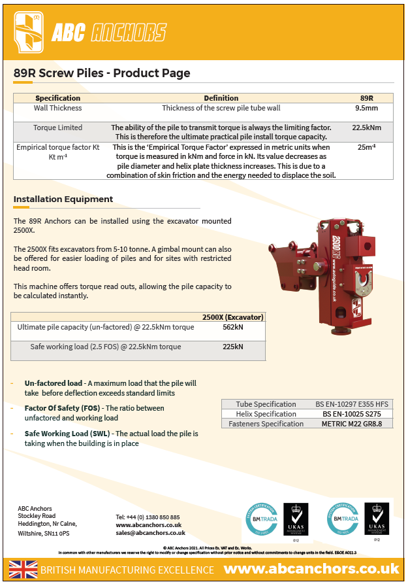

**Appendices**

**APPENDIX A**

**FORM OF TENDER**

To be returned by 12:00 noon (BST) on

TENDER FOR: **LIFE Recreation ReMEDIES Osborne Bay VNAZ Marker Buoys Installation**

Tender Ref:

1. We have examined the invitation to tender and its schedules set out below (the **ITT**) and do hereby offer to provide the services specified in the ITT and in accordance with the attached documents to the Authority commencing xxx for the period specified in the ITT.

* Specification of Requirements
* Evaluation
* Form of Tender (Appendix A)
* Authority’s Conditions of Contract (Appendix B)
* Technical Questions (Appendix C)
* Pricing Schedule (Appendix D)
* Conflict of Interest declaration form (Appendix E)

1. If this tender is accepted, we will execute the Contract and any other documents required by the Authority within 10 days of being asked to do so.
2. We agree that:
3. before executing the Contract substantially in the form set out in the ITT, the formal acceptance of this tender in writing by this Authority or such parts as may be specified, together with the documents attached shall comprise a binding contract between the Authority and us;
4. pursuant to EU Directive 1999/93/EC (Community Framework for Electronic Signatures) and the Electronic Communications Act 2000, the Contract may be executed electronically using the Authority’s electronic tendering and contract management system, Bravo;
5. we are legally bound to comply with the confidentiality provisions set out in the ITT;
6. any other terms or conditions or any general reservation which may be provided in any correspondence sent by the Authority in connection with this procurement shall not form part of this tender without the prior written consent of the Authority;

1. this tender shall remain valid for 120 days from the closing date for tenders specified in the ITT; and
2. the Authority may disclose our information and documents (submitted to the Authority during the procurement) more widely within Government for the purpose of ensuring effective cross-Government procurement processes, including value for money and related purposes.

4. We confirm that:

* 1. there are no circumstances affecting our organisation which could give rise to an actual or potential conflict of interest that would affect the integrity of the Authority’s decision making in relation to the award of the Contract; or
  2. if there are, or may be such circumstances giving rise to an actual or potential conflict of interest we have disclosed this in full to the Authority.

5. We undertake and it shall be a condition of the Contract that:

1. the amount of our tender has not been calculated by agreement or arrangement with any person other than the Authority and that the amount of our tender has not been communicated to any person until after the closing date for the submission of tenders and in any event not without the consent of the Authority;
2. we have not canvassed and will not, before the evaluation process, canvass or solicit any member or officer, employee or agent of the Authority or other contracting authority in connection with the award of the Contract and that no person employed by us has done or will do any such act; and
3. made arrangements with any other party about whether or not they may submit a tender except for the purposes of forming a joint venture.

6. I warrant that I am authorised to sign this tender and confirm that we have complied with all the requirements of the ITT.

**Signed _____________________________________________________________**

**Date _____________________________________________________________**

**In the capacity of _________________________________________________________**

**Authorised to sign**

**Tender for and on**

**behalf of _____________________________________________________________**

**Postal Address __________________________________________________________**

**Post Code _____________________________________________________________**

**Telephone No. ___________________________________________________________**

**Email Address ___________________________________________________________**

**APPENDIX B**

*Authority’s Conditions of Contract*

Please visit the following link and download ‘Standard Condensed Terms and Conditions’ -<https://www.gov.uk/government/organisations/natural-england/about/procurement>. These terms and conditions are non-negotiable.

**APPENDIX C**

*Technical Questions*

The questions below are those which you will be scored against.

If a bidder scores twenty (20) or below for any of the evaluation questions (E01 – E04), they will be eliminated from the procurement.

Technical Evaluation Questions

**E01 – Quality of proposal and strategy (weighting 55%)**

Your response will be marked against the quality of the proposal based on the method design meeting the requirements of the proposal, mooring specification and installation method.

Please submit a document with the filename: “E01_Your Organisation Name”.

Your response must not exceed a maximum of three sides of A4, font size 11.

**E02 – Experience (20% weighting)**

Please provide details of your experience operating within Marine Protected Areas and identification of marine species and habitats.

Your response should include any accreditations, e.g. NMBAQC Scheme accreditation, that the processing laboratory holds.

Please submit a document with the filename: “E02_Your Organisation Name”.

Your response must not exceed a maximum of two sides of A4, font size 11.

**E03 – Ability to mobilise a team (weighting 20%)**

Please provide details to demonstrate that you can mobilise a team and complete the work specified according to the timetable in this ITT.

Please submit a document with the filename: “E03_Your Organisation Name”.

Your response must not exceed a maximum of two sides of A4, font size 11.

**E04 – GDPR (weighting 5%)**

Please provide details of the technical facilities and measures (including systems and processes) you have in place, or will have in place by contract award, to ensure compliance with the General Data Protection Regulation and to ensure the protection of the rights of data subjects.

Your response should include, but should not be limited to facilities and measures:

* to ensure ongoing confidentiality, integrity, availability and resilience of processing systems and services;
* to comply with the rights of data subjects in respect of receiving privacy information, and access, rectification, deletion and portability of personal data;
* to ensure that any consent based processing meets standards of active, informed consent, and that such consents are recorded and auditable;
* to ensure legal safeguards are in place to legitimise transfers of personal data outside the EU (if such transfers will take place);
* to maintain records of personal data processing activities; and
* to regularly test, assess and evaluate the effectiveness of the above measures.

Responses should not exceed three sides of A4, font size 11.

Please upload your response to this question with the filename: E04_Your Organisation Name

**APPENDIX D**

*Pricing Schedule*

|  |  |  |  |  |  |
| --- | --- | --- | --- | --- | --- |
| **Costs** | | | | | |
| **ITEM** | **SPECIFICATION TITLE** | **Staff to deliver work** | **No. of days** | **UNIT PRICE (ex. VAT) £** | **TOTAL PRICE**  **(ex.VAT) £** |
| **1** | Project set up/design and review |  |  |  |  |
| **2** | Pre planning and design |  |  |  |  |
| **3** | Initial project meeting (to be held by phone) |  |  |  |  |
| **4** | Purchase (itemized equipment and staff time) |  |  |  |  |
| **5** | Installation (staff time, equipment, fuel costs etc) |  |  |  |  |
| **6** | Maintenance (staff time, equipment, fuel costs etc) |  |  |  |  |
| **7** | Travel and subsistence |  |  |  |  |
| **8** | Customer support / contract management |  |  |  |  |
| **9** | Please detail any assumptions made during pricing |  |  |  |  |
| **10** | Other – please detail, including contingency planning for weather downtime/equipment failure etc. a separate costing for any additional elements/effort that may be required). |  |  |  |  |

**Prices**

Prices must be submitted in £ sterling, exclusive of VAT.

**Quotation Submission**

Details of the Qualification, Technical and Commercial requirements can be located through the Governments Procurement with Natural England Portal: [Procurement at Natural England - Natural England - GOV.UK (www.gov.uk)](https://www.gov.uk/government/organisations/natural-england/about/procurement)

**Disclosure**

All Central Government Departments, their Executive Agencies and Non Departmental Public Bodies are subject to control and reporting within Government. They report to the Cabinet Office and HM Treasury for all expenditure. Further the Cabinet Office has a cross-Government role delivering overall Government policy on public procurement, including ensuring value for money and related aspects of good procurement practice.

For these purposes, the Authority may disclose within Government any details contained in your quotation. The information will not be disclosed outside Government during the procurement.

In addition, the Authority is subject to the Freedom of Information Act 2000 and the Environmental Information Regulations 2004, which provide a public right of access to information held by public bodies. In accordance with these two statutes, the Authority may be required to disclose information contained in your quotation to any person who submits a request for information pursuant to those statutes.

You should also note that the Authority will publish the RFQ and the Contract on the Contracts Finder Website.

By submitting a quotation, you consent to these terms as part of the procurement.

**Disclaimers**

Whilst the information in this RFQ and any supporting information referred to herein or provided to you by the Authority have been prepared in good faith the Authority does not warrant that this information is comprehensive or that it has been independently verified.

The Authority does not:

* make any representation or warranty (express or implied) as to the accuracy, reasonableness or completeness of the RFQ;
* accept any liability for the information contained in the RFQ or for the fairness, accuracy or completeness of that information; or
* accept any liability for any loss or damage (other than in respect of fraudulent misrepresentation or any other liability which cannot lawfully be excluded) arising as a result of reliance on such information or any subsequent communication.

Any supplier considering entering into contractual relationships with the Authority following receipt of the RFQ should make its own investigations and independent assessment of the Authority and its requirements for the goods and/or services and should seek its own professional financial and legal advice.

**Protection of Personal Data**

In order to comply with the General Data Protection Regulations 2018 the contractor must agree to the following:

* You must only process any personal data in strict accordance with instructions from the Authority
* You must ensure that all the personal data that we disclose to you or you collect on our behalf under this agreement are kept confidential.
* You must take reasonable steps to ensure the reliability of employees who have access to personal data.
* Only employees who may be required to assist in meeting the obligations under this agreement may have access to the personal data.
* Any disclosure of personal data must be made in confidence and extend only so far as that which is specifically necessary for the purposes of this agreement.
* You must ensure that there are appropriate security measures in place to safeguard against any unauthorised access or unlawful processing or accidental loss, destruction or damage or disclosure of the personal data.
* On termination of this agreement, for whatever reason, the personal data must be returned to us promptly and safely, together with all copies in your possession or control.

**General Data Protection Regulations 2018**

For the purposes of the Regulations the Authority is the data processor.

The personal information that we have asked you provide on individuals (data subjects) that will be working for you on this contract will be used in compiling the tender list and in assessing your offer. If you are unsuccessful the information will be **held and destroyed within two years** of the award of contracts. If you are awarded a contract it will be retained for the duration of the contract and destroyed within **seven years** of the contract’s expiry.

We may monitor the performance of the individuals during the execution of the contract, and the results of our monitoring, together with the information that you have provided, will be used in determining what work is allocated under the contract, and in any renewal of the contract or in the award of future contracts of a similar nature. The information will not be disclosed to anyone outside the Authority without the consent of the data subject unless the Authority is required by law to make such disclosures.

**Appendix E**

*Conflict of Interest Form*

[Guidance Note:

This Conflict of Interest declaration template aligns with the published template included within Procurement Policy Note Guidance 04/21: Applying Exclusions in Public Procurement, Managing Conflicts of Interest and Whistleblowing published by the Cabinet Office. By using this form DgC is consistent with the standard required by the procurement policy across government.

This form places greater expectation on individuals to highlight their own potential, perceived, or actual conflicts of interest during the lifecycle of any procurement activity. An individual is best placed to make this assessment for themselves, rather than a central procurement or contract manager. But DgC personnel, along with guidance published, can provide support to individuals when considering their situation.

Please read this document before using and follow the instructions below, prior to use.

* Select “Open in Desktop App”
* Save a copy of this form in your procurement or project folders.
* The requester needs to ensure that this form is completed, to aid the easy completion by individuals who are required to undertake this due to their involvement with a commercial activity.
* For procurement or contract management activities led by DgC, please ensure that the highlighted text within the square brackets is completed prior to being sent to the customer or stakeholder.
* Also prior to sending, it is recommended to delete these guidance notes.
* If the use of wet or electronic signatures is difficult for users to apply, then the complete form can be emailed back from the individual’s email account and this may be accepted as ‘signed off’. In that case, the associated email should be retained with the completed form.]

**Conflicts of Interest Declaration**

Please complete the declaration for the [ insert title of procurement, commercial, or relevant activity that the potential for conflicts must be checked for. select appropriate route for procurement, e.g. Single Tender Action/competed opportunity] [insert project reference and name].

(For a Grant Competition, where the term ‘procurement’ appears in this document, you can extend the meaning to include grants).

Introduction

This Declaration Form is intended to capture conflicts of interest relating to individuals involved in the aforementioned procurement in order to avoid any distortion of competition and to ensure equal treatment of all companies seeking to do business with the Contracting Authority.

For a procurement, involvement, in the context of conflicts of interest, may relate to any stage in the Commercial Lifecycle including preparation and planning, publication, selection and award and contract implementation.

For a grant, involvement in the context of conflicts of interest, may relate to any stage in the Grant Lifecycle including design and development – market engagement, application assessment, award, performance monitoring and final evaluation.

Individuals must avoid placing themselves in a position where there is a conflict between their personal and/or outside interest and their official duties in a procurement and must comply with internal policy relating to gifts, hospitality and conflicts of interest at all times.

Examples of conflicts of interest may include, but are not restricted to:

• if you are a current or previous employee of an organisation, or have a member of your family, your partner (married, civil partnership or not), your siblings, your children, or any close personal or professional relationships that are an employee of an organisation, that is seeking to do business with the Contracting Authority.

• if you, or a member of your family/friends (as set out above), has a financial interest in an organisation that is seeking to do business with the Contracting Authority.

• if you, or a member of your family/friends (as set out above), has a financial relationship of any kind with an organisation seeking to do business with a Contracting Authority.

This is a non-exhaustive list of examples and it is your responsibility to ensure that any and all actual, potential or perceived conflicts are disclosed prior to you being involved in the procurement.

If you are unsure whether your current or previous relationship or involvement with an organisation that is seeking to do business with the Contracting Authority constitutes a conflict of interest, you should seek advice from an Authorised Individual / DgC commercial contact.

stated below.

This Form also includes a requirement for individuals involved in the procurement to treat information (including but not restricted to bid documents, bidder / organisation evaluations etc.) with the appropriate level of confidentiality, and not make any unauthorised disclosures of this information.

32

All individuals with access to procurement information must sign this Form.

This COI declaration does not change the Conflicts of Interest Declaration process you must follow within your organisations.

Authorised Individuals

Authorised Individuals are responsible for managing the disclosure of procurement information and conflicts of interest. The Authorised Individuals for the procurement are:

[insert name and title of accountable officer and any person(s) to whom management has been delegated]

If conflicts of interest arise at any time during the commercial lifecycle, an Authorised Individual must be notified. Any disclosure of procurement information must also be approved by an Authorised Individual prior to disclosure.

Statements

1. I acknowledge that my official duties cause me to have access to documents or data pertaining to the above procurement. I am aware that unauthorised disclosure of information could damage the integrity of the procurement and that transmission or revelation of such information to unauthorised persons will subject me to disciplinary action.

2. I will not divulge, publish or reveal by word, conduct, or any other means such information or knowledge, except as necessary to do so in the performance of my official duties related to this procurement and in accordance with the laws of the United Kingdom, unless specially authorised in writing in each and every case by an Authorised Individual of the Contracting Authority.

3. I acknowledge that the information I receive will be given only to persons specifically granted access to the procurement, and it may not be further divulged without specific prior written approval from an Authorised Individual.

4. If at any time during the procurement my participation might result in an actual, potential or perceived conflict of interest, I will immediately report the circumstances to the appropriate Authorised Individual.

33

Declaration Guidance

Declaration A should be signed if there are no actual, potential or perceived conflicts of interest.

Declaration B should be signed if there are actual, potential or perceived conflicts of interest. The conflicts of interest and mitigation must be stated in Appendix 1 below, as must the role that the individual will be carrying out (where appropriate) within the procurement. An Authorised Individual must also sign Declaration B to confirm that they accept that appropriate mitigations have been put in place.

Declaration A (if no conflicts of interest)

By signing this Form, I declare that I have read and accept the Statements above, and that there are no conflicts of interest of any nature which would prevent me from participating in the aforementioned procurement.

If any actual, potential or perceived conflicts of interest arise in the future, I will inform an Authorised Individual immediately.

Name:

Job Title: Organisation / Department:

Signature: Date:

Declaration B (if actual, potential of perceived conflicts of interest)

By signing this Form, I confirm that the conflicts of interest in Appendix 1 have been mitigated appropriately to allow me to participate in a suitable role within the procurement.

If any other actual, potential or perceived conflicts of interest arise in the future, I will inform an Authorised Individual immediately.

Name:

Job Title: Organisation / Department:

34

Signature: Date:

35

Appendix 1

My conflict(s) of interest, including mitigations, is/are:

Conflict of interest [insert text]

Mitigation [insert text]

[Delete as appropriate]

Therefore, my role in the procurement will be [briefly describe role]

OR

Therefore, I will not have a role in the procurement.

Authorised Individual

By signing this Form, I confirm that the conflicts of interest in Appendix 1 have been mitigated appropriately, and therefore the individual’s role in the procurement, also stated in Appendix 1, is appropriate.

Name:

Job Title: Organisation / Department:

Signature: Date: