Biggleswade Town Council
Play Areas Project - Tender Invitation Request

Franklins Recreation Ground
June 2022

As part of its wider programme of improvements, Biggleswade Town Council (BTC) has resolved to launch an exciting major project to regenerate the Franklins Recreation Ground area. Franklins is located 150 yards from the town centre and is part of the town’s Green Wheel, an area of landscaped beauty surrounding Biggleswade offering the opportunity to residents and visitors to walk and undertake leisure activities around Biggleswade on a dedicated green space. A link to an online map and satellite view of the space can be viewed here.

BTC is launching a tender exercise and all expressions of interest from suppliers are invited to be submitted to enquiries@biggleswadetowncouncil.gov.uk by close of business on Monday 25th July 2022. As part of the process to submit your expression of interest, please read in full this document and collate your company’s costs into the equipment specification table with the requested information.

Corporate Aspirations for Biggleswade 2021-2025

The Town Council has several strategic aspirations for improving the town to help it to become a positive beacon to both residents, business and visitors as well as its surrounding areas. These aspirations are set out in the Corporate Aspirations Statement on the Town Council’s website, which can be viewed here.

Play Areas Project

We are seeking to turn in 2022-2023 the Franklins play area into a flagship play area for the community. All existing play equipment in Franklins has recently passed its safety checks and is fully compliant with current health and safety regulations. Even so, the project is focused on regenerating the Franklins play area to ensure that the space is fully inclusive to all users and becomes an enhanced open space with exciting equipment to help promote physical and mental health and wellbeing for all generations.

Franklins Maps

The Franklins Recreation Ground features distinct age-related play areas for toddlers, for older children, and for teenagers. The Town Council’s intention is for the project to sympathetically regenerate the existing play areas using sustainable methods and add a new fully inclusive open-air gymnasium. The BTC Public Realm team will monitor all work and facilitate landscaping. One map and two renderings are included below to provide some context and understating of the Franklins space.
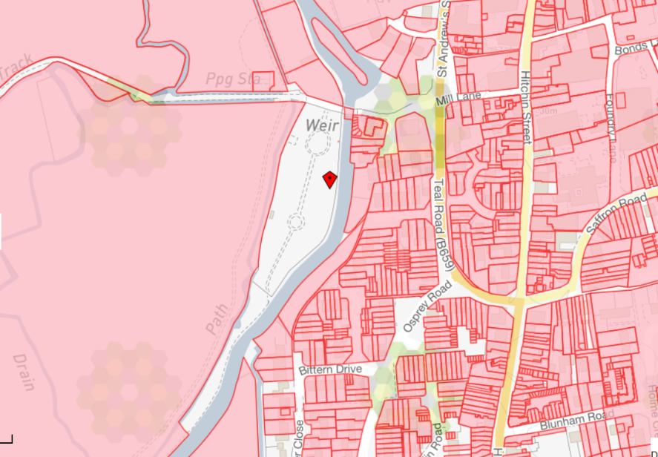
Play Equipment Specification List

 | FRANKLINS RECREATION GROUND
Equipment Type | Quantity | Cost
Junior Area Seesaw animal | 1
Multi Play equipment piece | 1
Flat Swing 2 bay with 4 seats hang and rotating glider | 1
Multi use goal area | 1
Toddlers’ area Multi Play set piece equipment | 1
Springer Player piece | 1
Cradle Swing 1 bay 2 seats | 1
Fully Inclusive Open-Air Gymnasium, 5 units, single or double | 5  (Various type/configuration)
Subtotal

The Town Council looks forward to receiving your expression of interest and associated quote in keeping with the above specification.

