Applicants must register on the EastMids Tender Portal (if they have not already done so) at https://www.eastmidstenders.org (click on 'Register) and complete the registration process.

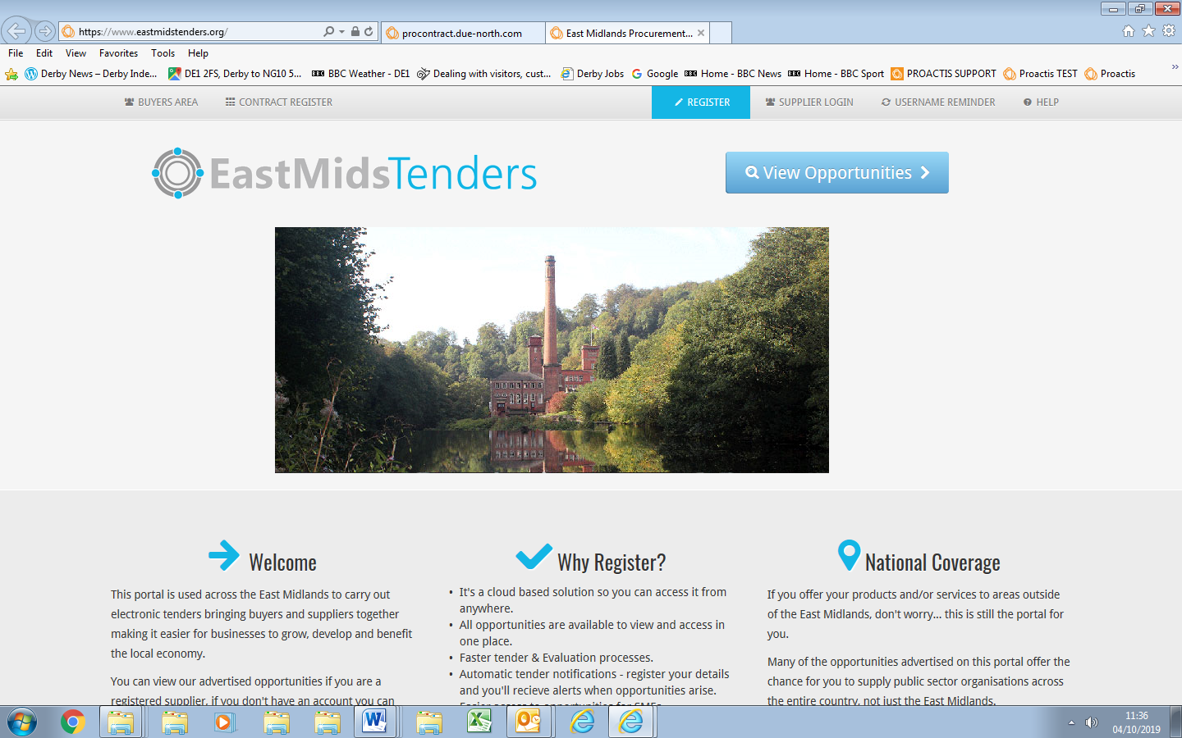

The portal provider will then confirm registration within two working days.

If you have any issues regarding registration then you must contact the supplier help desk via email. This operates from 08:30am to 17:30 (local time) Monday to Friday, excluding Bank Holidays. ProContractSuppliers@proactis.com

The Council is unable to help with the registration process as it does not control this or have any access to this part of the process

