Specification Template
The following template is a useful basis for drafting specifications for general goods and services. It should be amended to suit your specific requirements.
To try and identify some changes that might occur during the lifetime of a contract, Appendix 1 lists some questions that you may wish to consider.

Contents
Specification Template 1
1. Introduction 1
2. Background 1
3. Scope of Contract 1
4. Detailed Requirements 1
5. Service Levels and Key Performance Indicators (KPIs) 2
6. Contract Management and Review 3
7. Sustainability 3
8. General Data Protection Regulations (GDPR) and Privacy Impact Assessments (PIA) 3
9. Contract Period 3

Introduction
Our purpose as part of the NHS, is to work with partners to plan, recruit, educate and train the health workforce.
Health Education England exists for one reason and one reason only: our vision is to help improve the quality of life and health and care services for the people of England by ensuring the workforce of today and tomorrow has the right skills, values and behaviours, in the right numbers, at the right time and in the right place.
We are people centred, committed to the NHS Constitution, and driven by our values of responsibility, inclusiveness, fairness, and confidence.
Our goals are to deliver and reform education to produce the best possible future workforce; to transform the current workforce to meet tomorrow's health and care needs; and ensure the quality of our education and training system.
We serve;
- Patients and population
- Partners and stakeholders
- Students, trainees and learners
Within this the Nursing and Midwifery directorate has a role in ensuring the current and future nursing and midwifery workforce have the skills, competencies and values needed to meet the needs of patients, their families and carers.

We aim to deliver a workforce that works responsively, with compassion, delivering high quality patient care, including prevention, whilst working across boundaries. We will support these aims by delivering actions to ensure we maximise the numbers of staff in our nursing and midwifery workforce who have the right skills and attitudes to deliver safe sustainable patient care. This includes reflecting the 10 commitments ‘NHS England - Leading change, adding value (1)’, reflecting ‘Shape of caring, raising the bar (2)’ and the HEE response ‘Raising the Bar: Shape of Caring’: Health Education England’s response (3)’.

Background

This piece of work was instigated due to work undertaken as part of the development of the Baroness Mary Watkins of Tavistock review of Mental Health Nursing, England (2022) This review was initiated due to ongoing concerns about the mental health nursing profession, and the fact that we not only do not currently have sufficient numbers of such nurses to meet demand. We are also experiencing high numbers of mental health nurses leaving the profession, which means that the increase in student mental health nurses is not sufficient to meet demand in the future. This review was therefore commissioned in order to identify ways to address these and other challenges facing the mental health nursing profession.

As part of developing this review we undertook a number of listening exercise with people with lived experience as well as with mental health nurses.

These listening exercise helped us not only to clearly identify and articulate key recommendations of the report, two of which linked to this work are outlined below. They also helped us to identify and prioritise key areas of work that needed progressing form the outset of the implementation of the review. In this instance this piece of work was prioritised as it was felt by both people with lived experience and mental health nurses, that this was an area of need that required swift attention, as it would make a quick and long lasting impact on improving care delivery.

This piece of work will help achieve the recommendations made as part of the Baroness of Watkins report as below::

Recommendation 2: Mental health nurses must enhance the therapeutic relationship, valuing experiential knowledge, while acknowledging and overcoming the power differentials between staff and service users.
Recommendation 3: Mental health nurses must place a renewed focus on identifying and promoting the core skills of mental health nurses, across the lifespan, within all practice settings and in direct response to the needs of our local populations.

The key areas of work which link both the recommendations listed above and also the areas that were deemed high priority by both people with lived experience and mental health nurses where:

The need for mental health nurses to develop high-quality, person-centred communication skills and techniques.

The need for mental health nurses to use their personal qualities, experiences and interpersonal skills to develop and maintain therapeutic, recovery-focused relationships with people and therapeutic groups. They must be aware of their own mental health, and know when to share aspects.

Consistently shows ability to communicate safely and effectively with people providing guidance for others.

Communicates effectively and sensitively in different settings, using a range of methods and skills.

Once we had identified these as core areas of need in relation to the profession, we spent time reviewing the current offers for mental health nurses to see if any of these would meet need, we found no existing courses that could meet these needs. However, we did find a course that had been developed in 1992 and which had these areas of needs are core elements of the training offer. This is a course that was known at the time as the Thorne initiative or PSI, it has a large body of evidence to support its efficacy and which also demonstrates the positive impact this training has on mental health nurse development, as well as patient outcomes. In order to address theses gaps in knowledge and skills in relation to communication and

Additionally the course has a core value of which placed focus on mental health nurses working with people in a way that values, respects and explores the meaning of their individual lived experiences of mental health problems, to provide person-centred and recovery-focused practice’ principles and values that still hold true today
We were also aware that the IP for this course and all its constituent parts resides with the RCN, hence why we are working with the RCN to refresh and redeliver this course.

Scope of Contract
The scope of this contract is to refresh and redeliver the Thorne initiative/PSI in a way that is fit for the current mental health nurse, whilst broadening this training offer to include other fields and areas of nursing.

This will be a national offer that will take the form of an online training resource, developed in this way to ensure optimal accessibility for all.

People with lived experience and mental health nurses will remain core to the development and delivery of this training package, to ensure that their voices continue to be heard throughout this work.

We expect this product carer be offered to mental health and other nurses working in all sectors and areas of health and social care, and not to be limited to NHS workforce

Detailed Requirements
The requirements of the programme are as set out below, whilst the final product may differ from this model, this is the outline which initial planning will be based on.

The reason for allowing some variation away from this structure means that we can ensure that whilst the programme will retain the core elements of the thorne/PSI work, we retain flexibility to amend this structure to ensure it meets the needs of nurses and nursing.

It also ensures that as we start to build this product, if we need to make any changes to ensure the final product meets need we can do so. However, any material changes to this structure will need to be agree with and by the commissioner.
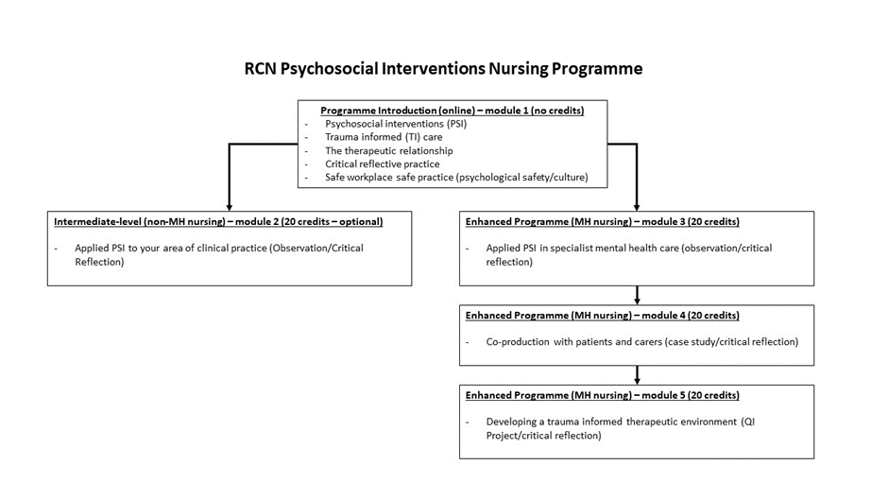

.

Service Levels and Key Performance Indicators (KPIs)
At the outset of this work the commissioner and provider will agree a project plan which will detail key timelines for each piece of the development of this programme.
As part of this project plan development we will build in key milestones and link those milestones to KPI’s which will be jointly agreed at the outset of the work.
The key KPI will be the development, hosting and implementation of a 5 module on line training package.

Contract Management and Review
Regular meetings will be held with the RCN to ensure that delivery of the work is on track.
These meetings will use the project plan which will be jointly agreed as a tool to measure that work is on track within expected timelines.

Contract Period
The contract period will run from 2023- 2025 with an option to extend at the end of this period.

Appendix 1

Changes that can occur during the lifetime of a contract.
To try and identify some changes that might occur during the lifetime of a contract here are some questions you may wish to consider:

1. Careful thought should be given to the duration of the contract.
Is there a possibility the contract may need to be extended because of a legal challenge which delays the award of a new contract (in order that the supplies/services can continue to be supplied/provided)? There is a clause in the standard Conditions of Contract to cater for this eventuality. In construction professional services contracts, it may sometimes be desirable to retain the professionals for a short period following completion of the building, and this needs to be taken account of in the period of the contract that is specified.

2. Is there a possibility the value of the contract will either increase or decrease (eg more money becomes available in a monitoring round or new users come online which results in a greater than anticipated spend or budget reductions result in a lower than anticipated spend)?
3. Will the contract prices need to be adjusted in line with a price index such as the Consumer Price Index (CPI)? There are clauses in the Standard Conditions of Contract which cater for this. The applicable index should be detailed in the Specification.
4. Is there a likelihood government legislation or policy will change during the lifetime of the contract? There are clauses in the standard Conditions of Contract which cater for changes in law.
5. How can the contract be future proofed to cater for changes to technology? Have you considered hardware and software refresh needs (eg future releases and developments and interoperability with other IT systems)? Pre-market engagement might help identify new technologies which may become available further down the line.

6. How, during the lifetime of the contract, can innovation and continuous improvement be encouraged to identify better ways of doing things (eg through gain/profit share). Pre-market engagement might assist with this. The contract could include a requirement that during year X there will be a meeting between the contractor and the client to identify cost savings across the remainder of the period.
7. Is there a probability of industrial action? There is a Disruption clause in the standard Conditions of Contract dealing with this eventuality.
8. Have all the potential bodies that may wish to avail of the contract during its lifetime been identified?

Total Contractual Costs

 | Development costs |  | Delivery costs
 | 2023 | 2024 | 2024 | 2025
RCN staff (including review, audit, evaluation and programme development and delivery | £93,988.00 | £34,929.00 | £59,976.00 | £59,976.00
Programme promotion | £3,350.00
Programme development (Modules 1-5) | £118,260.00 | £30,240.00
2 x Module 2 (Non MH Nurses): income after expenditure |  |  | -£5,740.00 | -£5,740.00
4 x Module 3, 4 and 5 (MH Nurses: income after expenditure |  |  | -£51,780.00 | -£60,180.00
Total year spend | £215,598.00 | £65,169.00 | £2,456.00 | -£5,944.00
Total | £277,279.00

