**JNCC/Cefas Partnership Video & Stills Processing Protocol - Haig Fras/East of Haig Fras Monitoring Survey**

1. Video and stills processing protocol for Monitoring surveys

The purpose of the analysis of the video/stills is to identify which seabed habitats are present in a video record/still image, provide quantitative (where possible) or semi-quantitative data on the observed physical habitat and biological assemblages (species records) and to note where one substrate/habitat type changes to another. The contractor may also be made aware of additional specific requirements relating to a particular survey/dataset which may require completing at the same time. Contractors should note that video analysis is to be undertaken based on distance rather than time. It is therefore important for the contractor to understand the average speed that each camera transect was run at (which can be calculated using the positional data and time), so that the time taken to run set distances (such as 5m specified in this document) can be calculated.

Video Analysis

* 1. An initial quality check of the video footage for each transect should be performed. If the contractor feels that any transect videos contain footage too poor for analysis to be undertaken, this should be flagged with the project officer immediately (see Annex 9 for video quality guidance). It is recommended that the video record is initially viewed rapidly (at approximately 4x normal speed) in order to gain an overview of the habitat types visible in the complete camera tow. Then, at normal speed, the video can be viewed again and the start and end points (time as well as the spatial positions in Lats/Longs) of each segment are logged; each of these segments will then be subjected to more detailed analysis. It should be specified on the video analysis log whether the spatial positions relate to the Central Reference Point (CRP = GPS antenna), Side/Stern Gantry or HiPAP/USBL. Brief changes in substrate type covering **less than 5 meters** of the seabed are considered as incidental patches and are not logged – however, these should be recorded as part of the habitat description.

**Figure 1 Illustration of video segment and stills crossing three different substrates**

* 1. Note that for this survey (CEND0915) both standard definition (SD) and high definition (HD) video streams were recorded simultaneously. As the field of view between the two formats varies, during the analysis process, both video streams should be replayed, although the HD footage should be the primary media for analysis, with SD being used to obtain metadata from the overlay.
  2. As noted in 3a above, record the start and end times and positions of each segment from the information provided (by Cefas). As stated above, it should also be specified on the video analysis log whether the spatial positions relate to the Central Reference Point (CRP = GPS antenna), Side/Stern Gantry or HiPAP/USBL.
  3. View each segment at a slower than normal speed, recording the physical habitat (substrate type, seabed character/morphology) and biological components (organisms to the lowest taxa/taxon at which ID can be certain) as detailed on the recording form. Record the analyses on the video pro-forma; detailed instructions of how to fill this in can be found below.
  4. For each identifiable taxon record an actual abundance or percentage cover **and** a semi quantitative SACFOR abundance score (Annex 1).
  5. When each segment has been analysed, review all the information recorded and assign the segment to the most relevant level of the JNCC marine habitat classification and the EUNIS habitat classification system as per the guidance provided by Parry (2015).
  6. A Video_Sample_Ref by species matrix should be completed for each survey.

Stills analysis

1. Still images should be analysed separately, to supplement and validate the video analysis, and provide more detailed (i.e. higher resolution) information than can be extracted from a moving video image.
2. Analyse all stills and assign them to their parent segment (see Stills analysis proforma instructions below). For each image, note the time and position it was taken, using information from the metadata provided by Cefas.
3. View the image at normal or greater than normal magnification, noting the physical and biological characteristics, such as substrate type (according to ‘Modified folk’, seabed character, species and life forms present.
4. If enough information on depth (biological zone), vegetation, faunal composition or energy (for rock biotopes) is available then allocate a lower level EUNIS code.
5. Record the analysis on the stills proforma; detailed instructions of how to fill this in can be found below.
6. Assign each still to the relevant habitat classification as described above for video analysis. This does not have to be the same as its ‘parent’ segment in the video. A comment should be added where there is discrepancy between the still and the 'parent' video segment.
7. For each taxon, record an actual abundance (where appropriate) or percentage cover for encrusting/turf/colonial organisms and a SACFOR (semi-quantitative) score. (Annex 1).
8. A Still_Sample_Ref by species matrix should be completed for each survey.

Taxon ID

In all analyses, the identification of taxa should be limited to a level that can be confidently achieved from the available image. Hence, taxon ID could range from the ‘life form’ level (e.g. sponge, hydroid, anemone) to the species level (e.g. *Asterias rubens*, *Alcyonium digitatum*). Avoid the temptation to guess the species ID if it can not be determined positively from the image. For example, *Spirobranchus* sp(p). would be acceptable, but *Spirobranchus triqueter* would not, as the specific ID normally requires the specimen to be inspected under a microscope. A list of life forms to be used is provided in Annex 8 to aid in consistency.

In addition to taxon ID, sponge morphologies should be divided into appropriate pre-defined categories (Figure 2) i.e. Arborescent, Encrusting, Flabellate, Globular, Massive, Papillate, Pedunculate, Repent, and Tubular, following Bell & Barnes, (2001). Sponges should be captured using counts for erect, percentage cover for colonial/encrusting and SACFOR for both.

If any difficulties distinguishing between types is found, a set method should be followed based on the Thesaurus of Sponge Morphology (Boury-Esnault and Rutzler 1997). For example, massive and encrusting sponges should be determined based on elevation from substrate.

Please note that some sponge species can display plasticity (i.e. have multiple morphology types). For example, some adults species are likely to show environmental induced morphological variation such as the *Haliclona* species (e.g. from cushions to fistulae) and *Halichondria* species (from cushions to fistulate seasonally) (see Bell and Barnes, 2001).

**When assigning morphologies, a note should be made of species showing morphological variation where possible.**

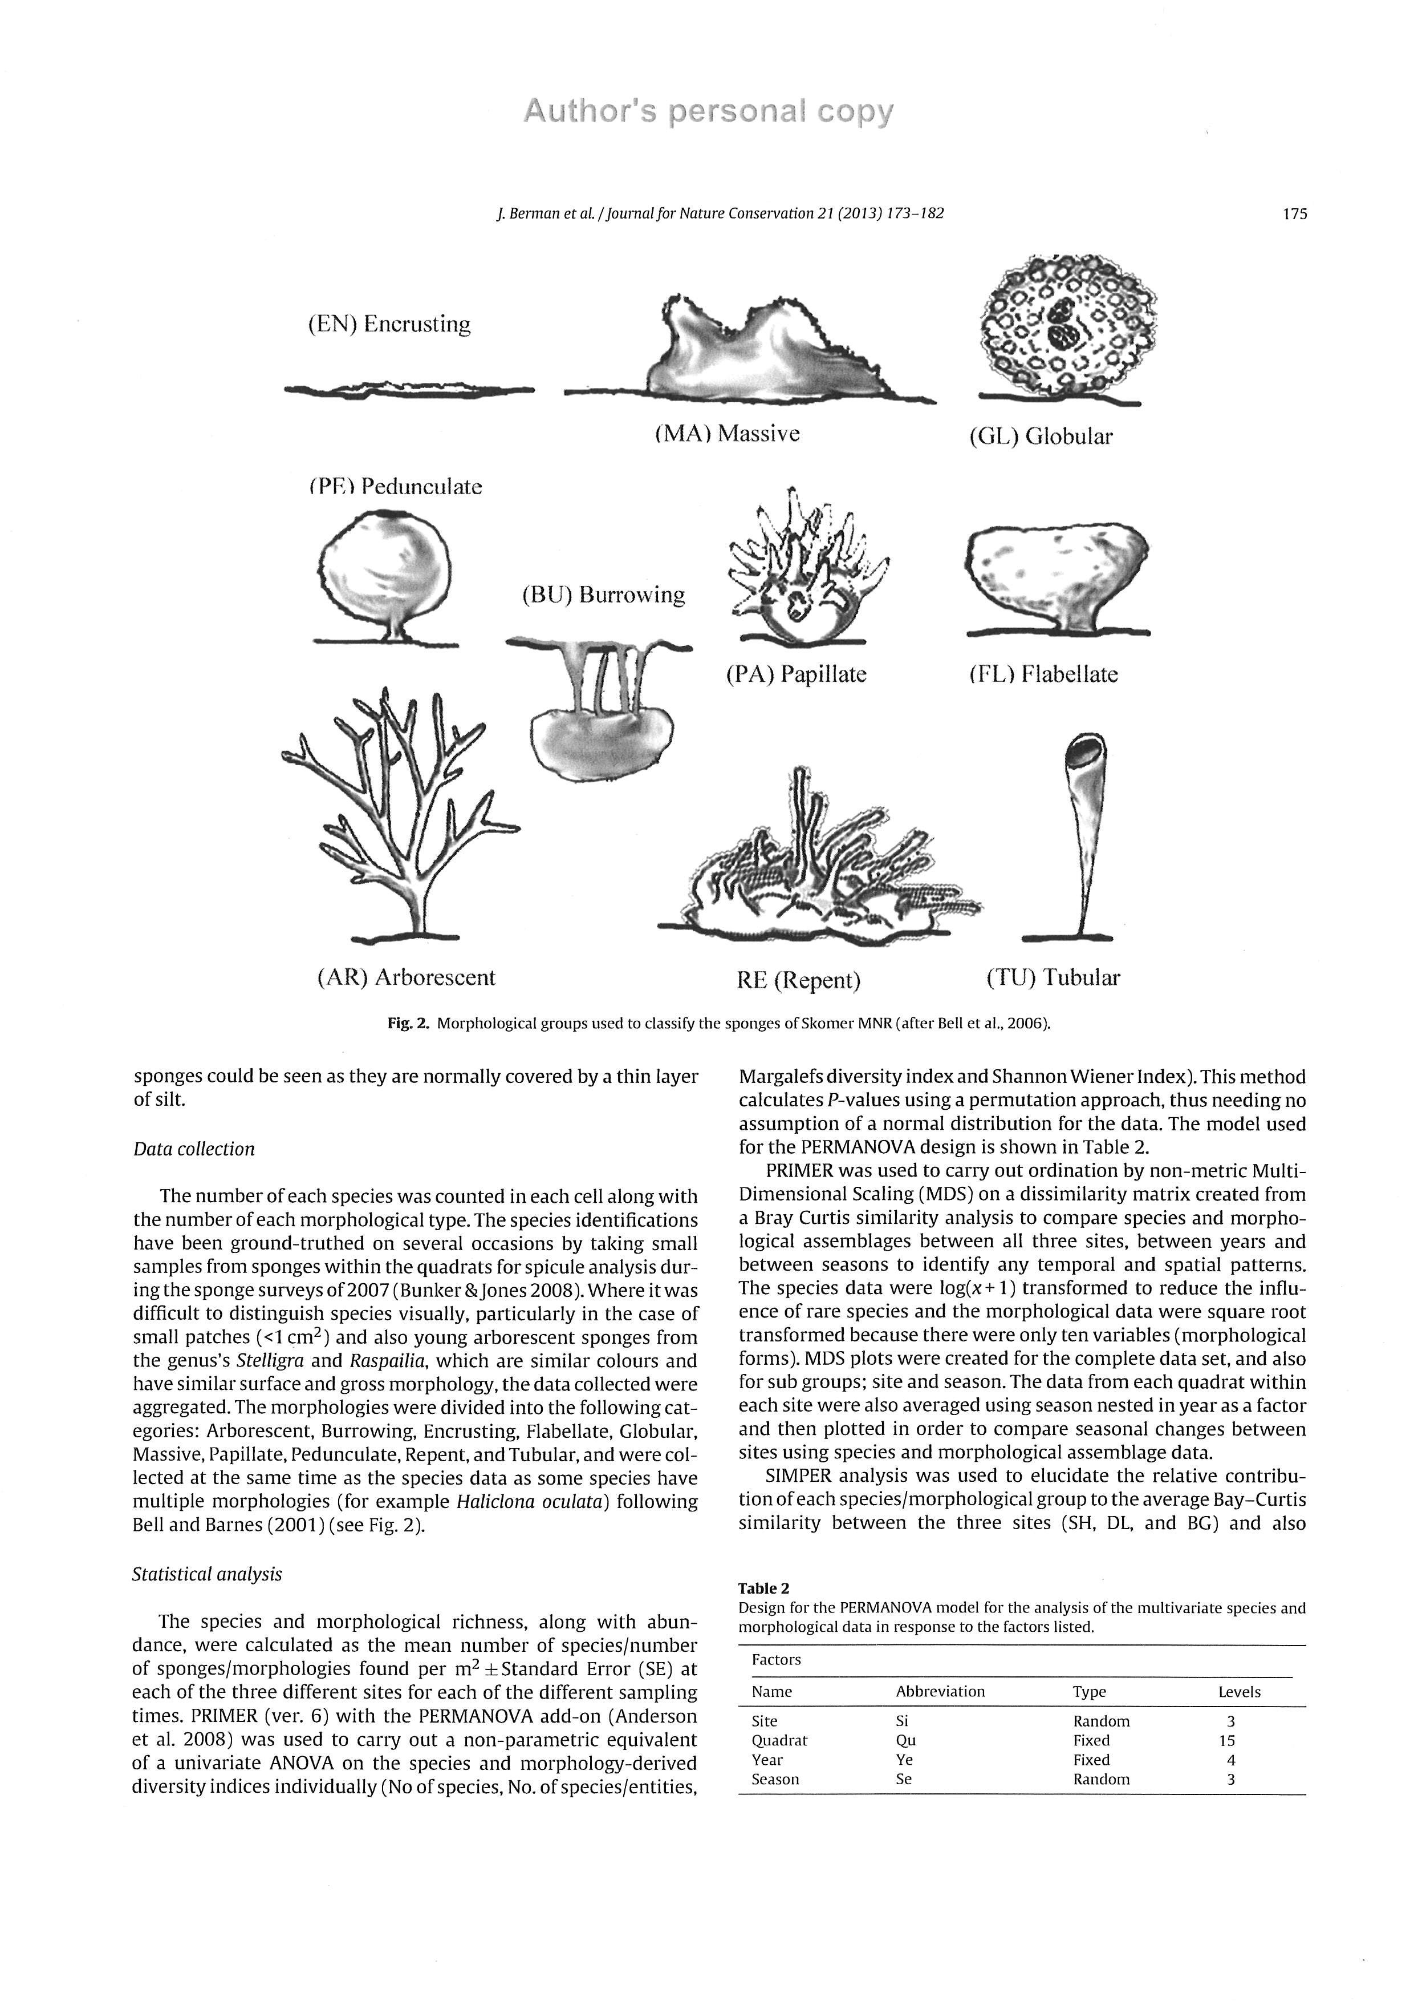

Figure 2 Sponge morphological types (Berman et al, 2012, after Bell et al, 2006)

1. Quality Assurance (QA)

Internal QA

Cefas will require contractors to provide quality assured products under this contract. Contractors should also supply a quality plan as part of the contract. All products supplied will be subject to quality checks by Cefas to ensure they meet the agreed standards.

Contractors should clearly describe their data management facilities and procedures in proposals related to this work.

Documentation

The following documents must be provided by the contractor upon the request of the contract manager. Contractors must also ensure they have a document control system in place to manage these documents (i.e. documents are kept electronically live and there is version control of hard copies to prevent the inadvertent use of obsolete documents).

Standard Operating Procedure

The contractor must provide copies of all relevant Standard Operating Procedures (SOPs) for the contracted work. An SOP should include:

1. A clear statement of the qualitative and quantitative goals of the contract work, which demonstrates that the specified methods are fit for purpose.
2. Methodological details of all steps performed.
3. Details of the procedures related to the analysis of data.
4. Details of the quality assurance system in place.

Quality Manual

The contractor should be able to provide on request a quality manual which details an organisation’s quality assurance system/policy (i.e. all aspects of quality assurance described in this document), which allows systematic audits of a monitoring programme to ensure that all aspects of quality assurance are being met. This should include details of the contractor’s Quality Manager, who is deemed responsible for overseeing the entire QA within the contracted organisation.

Quality Management System

It is recommended that the contractor should have the following Quality Management System (QMS) documentation (or alternative documentation proposed by the contractor which is demonstrated to be equivalent) to demonstrate there is a working QA system in place:

Quality Control Audit

Examination of in-house QC data, check of appropriate control limits, and corrective action is documented where QC data has breached control limits.

Vertical Audit

A random selection of data points, where each data point is traced to the Method, Instrument/Equipment, Calibration and internal and external QC.

Method Witnessing

Comparison of written procedure to observed procedure under real conditions. Any differences must be resolved through corrective action where needed.

Training Manual

Criteria stating the minimum competency (education, training, work experience and/or other demonstrated skills) necessary for staff to undertake different types of marine monitoring work must be defined in the Training Manual. The competency of each staff member must be signed off initially against all criteria and evidence of ongoing competency must be maintained on a regular basis in a document such as a Training Log (or individual staff member’s Curriculum Vitae’s).

Adherence to standardised methods

The contractor must adhere to relevant national, European or international standardised methods. The [NMBAQC website](http://www.nmbaqcs.org/qa-standards.aspx) gives the current list of all British Standards (BSi), International Organization for Standardisation (ISO) standards and European Committee for Standardisation (CEN) standards which currently exist for marine biological monitoring.

The contractor must provide details of any additional standard methods which they adhere to if these are not explicitly stated in the SOP (e.g. UK government agencies protocols and standards for marine monitoring programmes, ICES or NMBAQC standard methods).

Documentary evidence must be provided if the contractor is certified or accredited to a standard method (or their own method) through an accreditation scheme such as Good Laboratory Practice (GLP) or United Kingdom Accreditation Service (UKAS).

Adherence to data standards and guidelines

The contractor must adhere to the relevant data standards and guidelines.

1. Species lists which are compliant with current taxonomic names and synonyms (e.g. World Register of Marine Species (WoRMS), which is now endorsed by the Healthy and Biologically Diverse Seas Evidence Group (HBDSEG)).
2. Data and metadata guidelines relevant to the contracted work, which define data and metadata formats (e.g. Marine Environmental Data and Information Network (MEDIN) data guidelines and Mapping European Seabed Habitats (MESH) standards).

Taxonomic resources

The contractor must use the taxon dictionary supplied within Marine Recorder (which is the WoRMS dictionary) to aid in the identification of marine biological taxa.

Staff competency

Staff involved in identifying marine species should have a relevant degree level qualification (or equivalent) in a relevant discipline, plus 3 years relevant work experience. If less experienced staff are proposed to conduct species identification, this must be under the direct supervision of a fully trained staff member. Staff should also have substantial experience of field recognition of marine biotopes.

The up-to-date competency of each contracted staff member must be demonstrated via a list of the most up to date and relevant contracted marine work (along with client contact details) and proof of continual professional development of staff through:

* Participation in workshops (run internally or externally through universities, museums or marine organisations/associations),
* Participation in proficiency tests (Interlaboratory Comparisons) and/or external quality control tests run through an external quality assurance scheme
* Proof of tertiary qualifications and other qualifications (e.g. Identification Qualification awarded by a professionally recognised institute).

Stated project personnel

The names of proposed project personnel and their role in the contracted work must be specified. Only those staff proposed in the tender submission will be expected to undertake the work. Changes to contracted staff (including subcontractors) will only be accepted following written approval from the contract manager.

Internal Quality Control

The contractors must demonstrate their internal Quality Control (QC) system (which is demonstrated in the Quality Control Audit), which includes routine checks of data and analysis.

QC of data and analysis is where samples are re-checked and compared against the original and compared to an expected standard/limit of error/deviation from the original. It is also where electronic records (in spreadsheets or databases) are checked against the data on the original field/laboratory datasheets. This measures the repeatability of the method of analysis and data entry, and highlights factors such as inter-worker variability. QC must also include details of remedial action in cases where expected standards/limits are not met.

* The contractors should demonstrate their internal system of validation for 10% of the samples analysed (identification and enumeration of species and biotopes from photographs and videos).
* The contractor should also be able to demonstrate their internal system of validation for 10% of the electronic records (in spreadsheets or databases) of biological/environmental data.
* The above 10% should include samples across the range of habitats recorded/observed.

Internal QC must be undertaken by a staff member other than the staff member who conducted the original sample analysis.

1. External Quality Assurance

External Training, Qualifications and Proficiency Tests

The contractor should provide evidence (Certificates or Statement of Performance) of their up-to-date expertise through active participation in:

External training (e.g. workshops run through universities, museums, marine organisations/associations),

Qualification schemes (e.g. Identification Qualification awarded by a professionally recognised institute)

Participation in proficiency tests (Interlaboratory Comparisons) and/or external quality control tests run through an external quality assurance scheme

External Quality Control

JNCC subscribes to the NMBAQC ‘own sample’ scheme (<http://www.nmbaqcs.org/scheme-components/invertebrates.aspx> ). The contractor shall facilitate the completion of these independent QA/QC checks. In all cases, if the products do not meet the relevant quality standard the contractor will be required to undertake appropriate remedial action and then re-supply the product. All costs associated with such remedial action will be borne by the contractor and will not be charged to Cefas/JNCC.

1. Suggested Report Outline

**Introduction**: Brief details on the work undertaken, including number of videos and stills analysed.

**Methods**: Brief details on the methodology followed for the video and stills analysis and the QA followed

**Results**: Table of results for each video station segment and notes on any features of interest observed. Also note any evidence of human activities seen at each station.

**QA**: Details on which stations were reanalysed and by whom and a table detailing the QA’d results against the originals.

1. Survey image reference collections

Species/taxon reference collection

* A reference image is required for each species/taxon from the combined video and stills species list for each survey, including those where positive ID was difficult/not possible
* At least one image per species/taxon, either from the video (snapshot/screen grab) or the stills with the preference being the stills due to image resolution.
* Highlight the species/taxon on the image (e.g. box or circle) and save the image with the relevant species/taxon name and video/still file name
* Fill in a new row in the SpeciesBiotopeRefCollection.xlsx spreadsheet
* See examples below

**Video screen shot Still image**

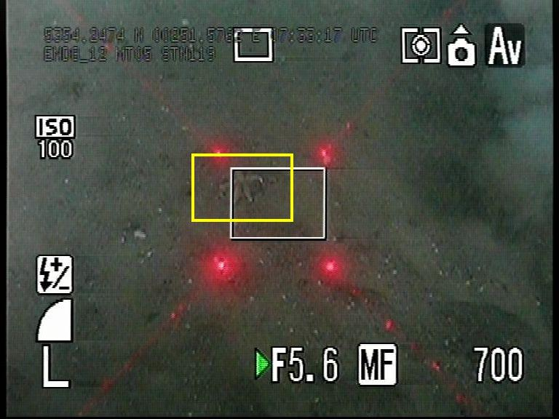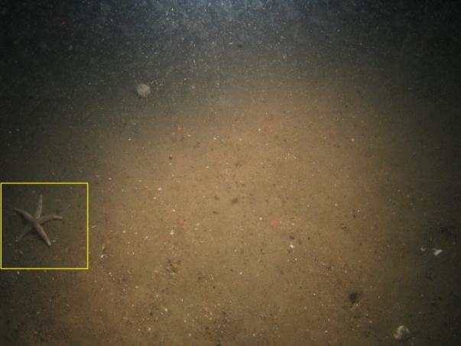

Example file names: Video Still

Asterias rubens_Video_MRTR_CEND08a12_MT05_STN_119.jpg Asterias rubens_Still_MRTR_CEND08a12_MT05_STN_119_005.JPG

Biotope reference collection

* A reference image is required for each biotope recorded within the survey
* At least 1 image per biotope, either from the video (snapshot/screen grab) or the stills with the preference being the stills due to image resolution. In addition, a short (30 second/1 minute) video clip showing examples of habitats/biotopes identified should be included. This may be better than a video screen shot and could accompany a still image to highlight possible variation within the habitat.
* Save the image with the relevant biotope code, both the EUNIS and MNCR, and video/still file name. See examples below.
* Fill in a new row in the SpeciesBiotopeRefCollection.xlsx spreadsheet

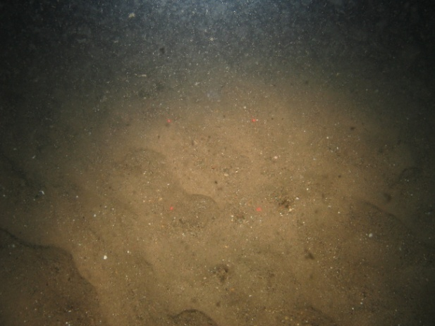

Example file names: Biotope_A5.25_SS.SSa.CFiSa_Still_MRTR_CEND08a12_MT05_STN_119_003.JPG

Video Analysis Proforma

The following is a detailed description of how to fill out the Video Analysis Proforma.

* **SURVEY NAME**: Enter the name of the rMCZ and the year of the survey
* **Station code**: Enter the station code for the video being analysed
* **Date**: Enter the date the video was taken
* **Video Sample Ref**: This should be the station code along with the segment number. E.g. if the video is separated into 3 segments due to change in substrate type or biological community (communities identifiable by different biotope codes) the first sample ref would be StnCode_S1 (subsequent segments would be StnCode_S2, StnCode_S3 etc.). If, for example, the first and third segments contain the same habitat they should still be labelled _S1 and _S3 and not both labelled _S1. See example on the video analysis proforma.
* **BriefHabitatDescription**: Give a brief description of the physical and biological features visible in the appropriate video segment
* **Method**: Enter drop camera or camera sledge depending on the gear used from drop-down menu
* **StartTime**: This should be taken from video overlay at the start of the segment.
* **EndTime**: This should be taken from video overlay at the end of the segment.
* **Duration**: This should automatically calculate when the two above rows are filled in.
* **SurveyRunBy**: Enter the name of the company that undertook the survey (e.g. Cefas, EA etc)
* **Start – Latitude**: Enter the start latitude for the video segment. This should be taken preferentially from the nearest still position or video overlay (converted from degrees and decimal minutes to decimal degrees) if no still position available.
* **Start – Longitude**: Enter the start Longitude for the video segment. This should be taken preferentially from the nearest still position or video overlay (converted from degrees and decimal minutes to decimal degrees) if no still position available. Note that longitudes west of the meridian are negative, e.g. -1.00 for 1° 00’ W.
* **End - Latitude**: Enter the end latitude for the video segment. This should be taken preferentially from the nearest still position or video overlay (converted from degrees and decimal minutes to decimal degrees) if no still position available.
* **End - Longitude**: Enter the end Longitude for the video segment. This should be taken preferentially from the nearest still position or video overlay (converted from degrees and decimal minutes to decimal degrees) if no still position available. Note that longitudes west of the meridian are negative, e.g. -1.00 for 1° 00’ W.
* **SeaLevelUpper**: Enter upper depth if known
* **SeaLevelLower**: Enter lower depth if known
* **Substratum%**: Under this section enter the % of each observed substrate. Make sure that when combined they add to 100%.
* **Broadscale Habitat**: Enter the relevant broadscale habitat from the drop-down menu for each segment. For sediments, use the modified Folk trigon in Annex 2 to differentiate between Coarse Sediment, Sand, Mud, Mixed Sediment. Note that a mixture of sand and gravel (incl. granules, pebbles and unstable cobbles) is to be classified as Coarse Sediment in the absence of significant amounts of mud.
* **Habitat FOCI**: Enter a Habitat FOCI from the drop-down menu for each segment if relevant (MCZ Only).
* **Annex 1 Habitats:** Enter an Annex 1 habitat from the drop-down menu for each segment if relevant (SAC Only).
* **Scottish MPA Search Features:** Enter a SMPA search feature from the drop-down menu for each segment if relevant (SMPA Only).
* **EUNIS code**: If enough information on depth (biological zone), vegetation, faunal composition or energy (for rock biotopes) is available then use this space to allocate a higher level biotope code.
* **MNCR code**: As above
* **Classification**: Exact copy of MNCR descriptor.
* **DeterminedBy**: Name of analyst for this video segment
* **Visual quality of sample**: E.g. Good, adequate, poor.
* **COMMENTS**: Any other information or comments about the video segment should be entered here. Especially any evidence of human activities seen on the video tow.
* **COMPLETED BY**: Name of person who completed the spreadsheet

Stills Analysis Proforma

The following is a detailed description of how to fill out the Stills Analysis Proforma. The results for the stills analysis for each station should be entered in separate tabs in the proforma.

* **SURVEY NAME**: Enter the name of the rMCZ and the year of the survey
* **Station code**: Enter the ‘parent’ / ‘segment’ code for the still being analysed. E.g. StnCode_S1
* **Date**: Enter the date the still was taken
* **Still Sample Ref**: This should be the same as station code with the name of the still added. E.g. StnCode_S1_Img001.
* **BriefHabitatDescription**: Give a brief description of the physical and biological features visible in the still.
* **Method**: Enter drop camera or camera sledge depending on the gear used from drop-down menu
* **Fix Time (hh:mm:ss)**: Enter the time the still was taken. This can either be taken from the video overlay or from metadata provided by Cefas.
* **SurveyRunBy**: Enter the name of the company that undertook the survey (e.g. Cefas, EA etc)
* **Latitude (DecDeg)**: This should be taken from metadata provided by Cefas.
* **Longitude (DecDeg)**: This should be taken from metadata provided by Cefas. Note that longitudes west of the meridian are negative, e.g. -1.00 for 1° 00’ W
* **SeaLevelUpper**: Enter the water depth
* **Substratum%**: Under this section enter the % of each observed substrate. Make sure that when combined they add to 100%.
* **Broadscale Habitat**: Enter the relevant broadscale habitat from the drop-down menu for each segment. For sediments, use the ‘Modified’ Folk trigon in Annex 2 to differentiate between Coarse Sediment, Sand, Mud, Mixed Sediment.
* **Habitat FOCI**: Enter a Habitat FOCI from the drop-down menu for each segment if relevant (MCZ Only).
* **Annex 1 Habitats:** Enter an Annex 1 habitat from the drop-down menu for each segment if relevant (SAC Only).
* **Scottish MPA Search Features:** Enter a SMPA search feature from the drop-down menu for each segment if relevant (SMPA Only).
* **EUNIS code**: This does not need to be thee same as the parent segment
* **MNCR code**: This does not need to be thee same as the parent segment
* **Classification**: Exact copy of MNCR descriptor.
* **DeterminedBy**: Name of analyst for this video segment
* **Visual quality of sample**: E.g. Good, adequate, poor.
* **COMMENTS**: Any other information or comments about the video segment should be entered here. Especially any evidence of human activities seen on the video tow.
* **COMPLETED BY**: Name of person who completed the spreadsheet

1. References

BELL, J.J. & BARNES, D.K.A. 2001. Sponge morphological diversity: a qualitative predictor of species diversity? *Aquatic Conservation: Marine and Freshwater Ecosystems*, **11**(2): 109–121.

BELL, J. J., BURTON, M., BULLIMORE, B., NEWMAN, P., & LOCK, K. 2006. Morphological monitoring of subtidal sponge assemblages. *Marine Ecology Progress Series*, **311:** 79–91.

BERMAN, J., BURTON, M., GIBBS, R., LOCK, K., NEWMAN, P., JONES, J., & BELL, J. J. 2013. Testing the suitability of a morphological monitoring approach for identifying temporal variability in a temperate sponge assemblage. *Journal for Nature Conservation*, **21**(3): 173-182.

BOURY-ESNAULT, N. & RUTZLER, K. 1997. Thesaurus of sponge morphology. Smithsonian contributions to zoology 596. Smithsonian Institute Press, Washington, DC

PARRY, M.E.V. 2015. Guidance on Assigning Benthic Biotopes using EUNIS or the Marine Habitat Classification of Britain and Ireland JNCC report No. 546

1. Version Control

BUILD STATUS:

|  |  |  |  |
| --- | --- | --- | --- |
| Version | Date | Author | Reason/Comments |
| 0.1 | 15/7/15 | MN | Updated for analysis of seabed imagery from Haig Fras/East of Haig Fras Monitoring survey |
| 0.2 | 17/7/15 | MN | Updated following internal coments |

DISTRIBUTION:

|  |  |  |  |
| --- | --- | --- | --- |
| Copy | Version | Issue Date | Issued To |
| Electronic/ Paper/Link | 0.1 | 15/7/15 | JNCC Monitoring Leads |
| Electronic/ Paper/Link | 0.2 | 17/7/15 | Cefas |

# Annex 1. SACFOR

|  |  |  |  |  |  |  |  |  |  |  |  |  |
| --- | --- | --- | --- | --- | --- | --- | --- | --- | --- | --- | --- | --- |
|  | **Growth form** | | **Size of individuals or colonies** | | | | **Density measures** | | | | | |
| % cover | Crust or Meadow | Massive or Turf | <1cm | 1-3 cm | 3-15 cm | >15 cm | No per unit area | Nos per m² | Nos per 0.5m² image | Nos per 0.4m² image | Nos per 0.3m² image | Nos per 0.2m² image |
| >80% | **S** |  | **S** |  |  |  | >1/ 0.001 m2 | >10,000 / m² | 50,000 | 40,000 | 30,000 | 20,000 |
| 40-79% | **A** | **S** | **A** | **S** |  |  | 1-9/ 0.001 m2 (1x1 cm) | 1000-999 / m² | 5,000 | 4,000 | 3,000 | 2,000 |
| 20-39% | **C** | **A** | **C** | **A** | **S** |  | 1-9 / 0.01 m2 (10 x 10 cm) | 100-999 /m² | 500 | 400 | 300 | 200 |
| 10-19% | **F** | **C** | **F** | **C** | **A** | **S** | 1-9 / 0.1 m2 (0.316 x 0.316 m) | 10-99 m² | 50 | 40 | 30 | 20 |
| 5-9% | **O** | **F** | **O** | **F** | **C** | **A** | 1-9 / m2 (1 x 1 m) | 1-9 / m² | 5 | 4 | 3 | 2 |
| 1-5% or density | **R** | **O** | **R** | **O** | **F** | **C** | 1-9 / 10m2 (3.16 x 3.16 m) | 1-9 / 10m² | 1 | 1 | 1 | 1 |
| <1% or density |  | **R** |  | **R** | **O** | **F** | 1-9 / 100m2 (10 x 10 m) | 1-9 / 100m² | - | - | - | - |
|  |  |  |  |  | **R** | **O** | 1-9 / 1000m2 (31.6 x 31.6 m) | 1-9 / 1000m² | - | - | - | - |
|  |  |  |  |  |  | **R** | 1<1/1000 m2 | 1<1/1000 m² | - | - | - | - |

**MNCR Notes**

* Whenever an attached species covers the substratum and percentage cover can be estimated, that scale should be used in preference to the density scale.
* Use the massive/turf percentage cover scale for all species, excepting those given under crust/meadow.
* Where two or more layers exist, for instance foliose algae overgrowing crustose algae, total percentage cover can be over 100% and abundance grade will reflect this
* Percentage cover of littoral species, particularly the fucoid algae, must be estimated when the tide is out.
* Use quadrats as reference frames for counting, particularly when density is borderline between two of the scale.
* Some extrapolation of the scales may be necessary to estimate abundance for restricted habitats such as rockpools.
* The species (as listed above) take precedence over their actual size in deciding which scale to use.
* When species (such as those associated with algae, hydroid and bryozoan turf or on rocks and shells) are incidentally collected (i.e. collected with other species that were superficially collected for identification) and no meaningful abundance can be assigned to them, they should be noted as present (P)

**Cefas notes**

* As the count for individual taxa can never be less than 1 per photo, those in size range >15 cm (e.g. Asterias) can never be scored less than Common in a photo.
* Similarly, size range 3-15 cm (e.g. Echinus) can never be scored less than Frequent and size range 1-3 cm (e.g. Ebalia) can not be scored less than Occasional.

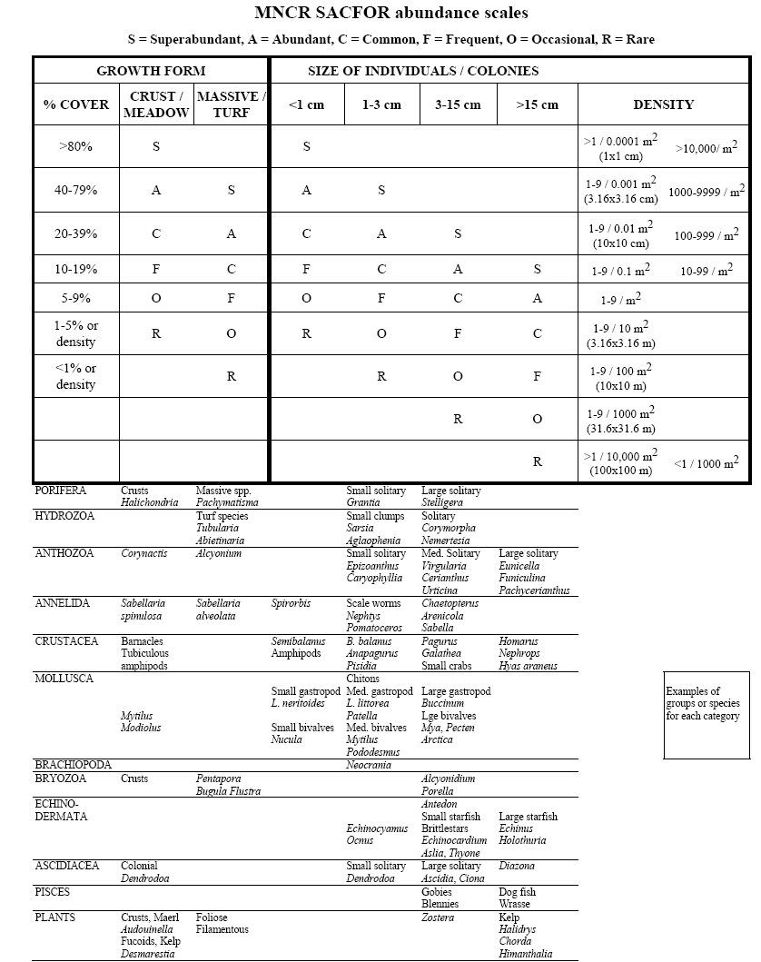

# Annex 2. ‘Modified’ Folk Trigon

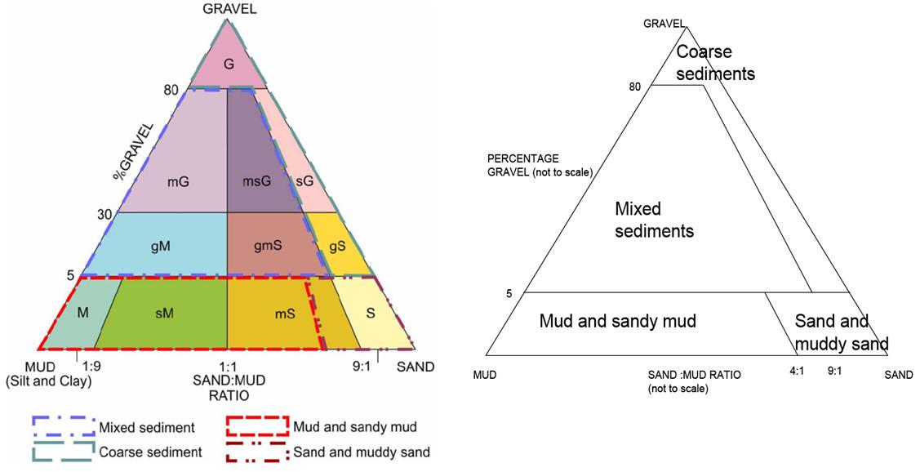

* ‘Modified’ Folk trigon (left) showing the classification used by the UK SeaMap and MESH projects to assign Folk sediment classes to the four broader sediment classes used in the EUNIS habitat classification scheme (after Long, 2006)

# Annex 3. Broadscale habitat features listed in the ENG.

|  |  |
| --- | --- |
| **Broadscale Habitat Type** | **EUNIS Level 3 Code** |
| High Energy Intertidal Rock | A1.1 |
| Moderate Energy Intertidal Rock | A1.2 |
| Low Energy Intertidal Rock | A1.3 |
| Intertidal Coarse Sediment | A2.1 |
| Intertidal Sand and Muddy Sand | A2.2 |
| Intertidal Mud | A2.3 |
| Intertidal Mixed Sediments | A2.4 |
| Coastal Saltmarshes and Saline Reed Beds | A2.5 |
| Intertidal Sediments Dominated by Aquatic Angiosperms | A2.6 |
| Intertidal Biogenic Reefs | A2.7 |
| High Energy Infralittoral Rock* | A3.1 |
| Moderate Energy Infralittoral Rock* | A3.2 |
| Low Energy Infralittoral Rock* | A3.3 |
| High Energy Circalittoral Rock** | A4.1 |
| Moderate Energy Circalittoral Rock** | A4.2 |
| Low Energy Circalittoral Rock** | A4.3 |
| Subtidal Coarse Sediment | A5.1 |
| Subtidal Sand | A5.2 |
| Subtidal Mud | A5.3 |
| Subtidal Mixed Sediment | A5.4 |
| Subtidal Macrophyte Dominated Sediment | A5.5 |
| Subtidal Biogenic Reef | A5.6 |
| Deep Seabed*** | A6 |

* *Infralittoral rock includes habitats of bedrock, boulders and cobble which occur in the shallow subtidal zone and typically support seaweed communities
* **Circalittoral rock includes habitats of bedrock, boulders and cobble characterised by animal dominated communities, rather than seaweed dominated communities
* ***The deep seabed broadscale habitat encompasses several different habitat sub-types, all of which should be protected within the MPA network. The broadscale habitat deep seabed habitat is found only in the southwest of the MCZ project area and MCZs identified for this broadscale habitat should seek to protect the variety of sub-types known to occur in the region.

# Annex 4. Habitat FOCI listed in the ENG.

|  |
| --- |
| **Habitat Features of Conservation Importance (FOCI)** |
| Blue Mussel Beds (including intertidal beds on mixed and sandy sediments)** |
| Coldwater Coral Reefs *** |
| Coral Gardens*** |
| Deepsea Sponge Aggregations*** |
| Estuarine Rocky Habitats |
| File Shell Beds*** |
| Fragile Sponge and Anthozoan Communities on Subtidal Rocky Habitats |
| Intertidal Underboulder Communities |
| Littoral Chalk Communities |
| Maerl Beds |
| Horse Mussel (*Modiolus modiolus*) Beds |
| Mud Habitats in Deepwater |
| Sea Pen and Burrowing Megafauna Communities |
| Native Oyster (*Ostrea edulis*) Beds |
| Peat and Clay Exposures |
| Honeycomb Worm (*Sabellaria alveolata*) reefs |
| Ross Worm (*Sabellaria spinulosa*) reefs |
| Seagrass Beds |
| Sheltered Muddy Gravels |
| Subtidal Chalk |
| Subtidal Sands and Gravels |
| Tide-Swept Channels |

* * Habitat FOCI have been identified from the ‘OSPAR List of Threatened and/or Declining Species and Habitats’ and the ‘UK List of Priority Species and Habitats (UK BAP)’.
* **Only includes ‘natural’ beds on a variety of sediment types. Excludes artificially created mussel beds and those which occur on rocks and boulders.
* ***Coldwater coral reefs, coral gardens, deep sea sponge aggregations and file shell beds currently do not have distributional data which demonstrate their presence within the MCZ project area.

# Annex 5. Annex I Habitats

|  |
| --- |
| **Annex I Habitats** |
| Atlantic salt meadows |
| Estuaries |
| Lagoons |
| Large shallow inlets and bays |
| Mediterranean and thermo-Atlantic halophilious scrubs |
| Mudflats and sandflats not covered by seawater at low tide |
| Reefs |
| Salicornia and other annuals colonising mud and sand |
| Sandbanks which are slightly covered by seawater all the time |
| Spartina swards |
| Submerged or partially submerged caves |

# Annex 6: Scottish Marine Protected Area (SMPA) Search Features

|  |
| --- |
| **SMPA Search Features** |
| Blue mussel beds |
| Burrowed mud |
| Carbonate mound communities |
| Coral gardens |
| Deep sea sponge aggregations |
| Flame shell beds |
| Horse mussel beds |
| Inshore deep mud with burrowing heart urchins |
| Kelp and seaweed communities on sublittoral sediment |
| Low or variable salinity habitats |
| Maerl beds |
| Maerl or coarse shell gravel with burrowing sea cucumbers |
| Native oysters |
| Northern sea fan and sponge communities |
| Offshore deep sea muds |
| Offshore subtidal sands and gravels |
| Seagrass beds |
| Sea loch egg wrack beds |
| Seamount communities |
| Shallow tide-swept coarse sands with burrowing bivalves |
| Tide-swept algal communities |
| Burrowing sea anemone aggregations |
| Northern feather star aggregations |
| Fan mussel aggregations |
| Heart cockle aggregations |
| Ocean quahog aggregations |

# Annex 7. Low or limited mobility species FOCI listed in the ENG.

|  |  |  |
| --- | --- | --- |
| **Group** | **Scientific name** | **Common Name** |
| Brown Algae | *Padina pavonica* | Peacock’s Tail |
| Red Algae | *Cruoria cruoriaeformis*  *Grateloupia montagnei*  *Lithothamnion corallioides*  *Phymatolithon calcareum* | Burgundy Maerl Paint Weed  Grateloup’s little-Lobed Weed  Coral Maerl  Common Maerl |
| Annelida | *Alkmaria romijni\*\**  *Armandia cirrhosa\*\** | Tentacled Lagoon Worm**  Lagoon Sand Worm** |
| Teleostei | *Gobius cobitis*  *Gobius couchi*  *Hippocampus guttulatus*  *Hippocampus hippocampus* | Giant Goby  Couch’s Goby  Long Snouted Seahorse  Short Snouted Seahorse |
| Bryozoa | *Victorella pavida* | Trembling Sea Mat |
| Cnidaria | *Amphianthus dohrnii*  *Eunicella verrucosa*  *Haliclystus auricular*  *Leptosammia pruvoti*  *Lucernariopsis campanulata*  *Lucernariopsis cruxmelitensis*  *Nematostella vectensis* | Sea Fan Anemone  Pink Sea Fan  Stalked jellyfish  Sunset Cup Coral  Stalked Jellyfish  Stalked Jellyfish  Starlet Sea Anemone |
| Crustacea | *Gammarus insensibilis\*\**  *Gitanopsis bispinosa*  *Pollicipes pollicipes*  *Palinurus elephas* | Lagoon Sand Shrimp**  Amphipod  Gooseneck Barnacle  Spiny Lobster |
| Mollusca | *Arctica islandica*  *Atrina pectinata*  *Caecum armoricum\*\**  *Ostrea edulis*  *Paludinella littorina*  *Tenellia adspersa\*\** | Ocean Quahog  Fan Mussel  Defolin’s Lagoon Snail**  Native Oyster  Sea Snail  Lagoon Sea Slug** |

* *Species FOCI have been identified from the ‘OSPAR List of Threatened and/or Declining Species and Habitats’, the ‘UK List of Priority Species and Habitats (UK BAP)’ and Schedule 5 of the Wildlife and Countryside Act.
* **Those lagoonal species FOCI may be afforded sufficient protection through coastal lagoons designated as SACs under the EC Habitats Directive. However, this needs to be assessed by individual regional projects.

# Annex 8. Life Form list

Faunal_Turf

U. brown algae_filamentous

U. brown algae_foliose

U. green algae_filamentous

U. green algae_foliose

U. red algae_encrusting

U. red algae_foliose

U. red algae_filamentous

U. anemone

U. anemone_white

U. ascidian_solitary

U. ascidian_colonial

U. bryozoan_encrusting

U. bryozoan_massive

U. bryozoan_foliaceous

U. bryozoan_dendroid

U. bryozoan_fenestrate

U. bryozoan_plumose

U. faunal turf

U. holothurian_burrowing

U. hydroid

U. hydroid turf

U. hydroid crust

U. gastropod

U. sponge_encrusting

U. sponge_cushion

U. sponge_massive

U. sponge_globular

U. sponge_pedunculate

U. sponge_papillate

U. sponge_flabellate

U. sponge_arborescent

U. sponge_cuplike

U. sponge_columnar

# Annex 9. Video Quality Guidance

* + A number of criteria can be used to determine video quality including:
    - Camera distance to seabed
    - Angle of the field of view of the camera
    - Speed of camera over ground
    - Level of turbidity
    - Presence or absence of scale
    - Lighting quality
  + Example categories can include:
    - *Excellent* - Water is clear, perfect illumination, colour is excellent, camera moving at ideal speed and at a constant angle, sea bed is visible at all times.  There may be very occasional issues with viewing the seabed but these occurances last for <5% of the tow. All levels of analysis are expected to be possible;
    - *Good* - Seabed easily observed, small amounts of suspended matter but this does not effect the visibility, speed may occasionally vary, lighting is sufficient to appropriately illuminate organisms.  There may be occasional issues with viewing the seabed but these occurances last for 5-20% of the tow. This level of quality is not expected to affect analysis;
    - *Poor* - Suspended matter, dense fauna or flora (e.g. Kelp beds) or disturbed sediment results in a partially obscured view of the seabed. Camera speed and distance to the seabed is consistently variable throughout the tow.   The constant stop-start, particularly in the case of sledge systems on sediments, can often result in reduced visibility.  Uncertain if all target objects can be accounted for. These problems are present for 20-50% of the tow.  High level taxonomic identification will be difficult from this point.  Quantification of organisms may still be possible but it is recommended that a qualitative assessment of abundance is used.  Broadscale habitat mapping (EUNIS Level 3) is still possible;
    - *Very Poor* - Suspended matter, dense fauna or flora (e.g. Kelp beds) or disturbed sediment obscures most of the seabed.  Camera is often moving too fast resulting in constant blurring of organisms.  Camera often moves too far from the seabed resulting in a lack of illumination and visibility.  These problems are likely to be present for 50-80% of the tow.  Quantitative or qualitative estimates of abundance of organisms is not recommended.  It may still be possible to determine broadscale habitats;
    - *Zero* - For whatever reason (camera too far from the seabed, camera moving too quickly, lack of illumination, sediment disturbance, dense gathering of fauna or flora (e.g. Kelp beds), etc) there is no view of the seabed at all for >80% of the tow. Data is not usable.
  + If the quality is deemed very poor or zero then it is recommended that the video **should** not be analysed further, or in cases where it is necessary for it to be analysed, that caveats are placed on the data.