OFFICIAL

Provision of Resource Management

Contract Reference:
CCSO21A28
-
2

CHANGE CONTROL NOTICE (CCN)

Contract Title: | Contract for the Provision of RESOURCE MANAGEMENT (The Contract)
Contract Reference: | CCSO21A28 | Contract Change Number: | 2
Date CCN issued: | 16/12/2022 | Date Change Effective from: | 01/01/2023
Between: Government Internal Audit Agency (Customer) and Insight Direct (UK) Ltd (The Supplier)

- The Contract is varied as follows:
- Increase in contract value by £15,670.82 (excluding VAT) (£18,804.98 including VAT). This makes the total contract value £316,169.82 (excluding VAT) for four years with the fourth year an optional extension.
- This increase is for 75 additional internal audit Tempus Resource user licences.
- Words and expressions in this Change Control Notice shall have the meanings given to them in the Contract.
- The Contract, including any previous Contract changes, authorised in writing by both Parties, shall remain effective and unaltered except as amended by this Change Control Notice.

REDACTED | REDACTED | 16 December 2022
Change authorised to proceed by: (Customer’s representative):

Signature
Print Name and Job Title
Date
Insight Direct (UK) Ltd REDACTED | REDACTED

Authorised for and on behalf of the Supplier:

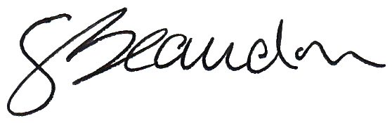
Signature Print Name and Job Title Date Jan 3, 2023

OFFICIAL
Contract Change Notice
© Crown copyright 2018

V1.0 27/10/2022

REDACTED | REDACTED | 16 December 2022

Authorised for and on behalf of the Customer:

Signature Print Name and Job Title Date

OFFICIAL

Provision of Resource Management

Contract Reference:
CCSO21A28
-
2

OFFICIAL
Contract Change Notice
© Crown copyright 2018

V1.0 27/10/2022

14022 - Signed Customer CCN001 Government Internal Audit Agency Prosymmetry LLC
Final Audit Report 2023-01-03
Created: | 2023-01-03
By: | shuaib solkar (Shuaib.Solkar@insight.com)
Status: | Signed
Transaction ID: | CBJCHBCAABAAoU1J4OOYrKI-w1IZV8Qi7srKQyfFvcMg
"14022 - Signed Customer CCN001 - Government Internal Audit Agency - Prosymmetry LLC" History
- Document created by shuaib solkar (Shuaib.Solkar@insight.com)
2023-01-03 - 11:46:20 AM GMT
Document emailed to guy beaudin (guy.beaudin@insight.com) for signature 2023-01-03 - 11:47:38 AM GMT
- Email viewed by guy beaudin (guy.beaudin@insight.com)
2023-01-03 - 1:16:34 PM GMT
Document e-signed by guy beaudin (guy.beaudin@insight.com)
Signature Date: 2023-01-03 - 1:17:39 PM GMT - Time Source: server
Agreement completed.
2023-01-03 - 1:17:39 PM GMT

