Offer of Contract


Our Reference: 707475451

Date: 7 June 2023
XXX
Def Comrcl BP3

Kentigern House
Glasgow
G2 8EX

Email: Jonathan.mcniven101@mod.gov.uk

XXX
SafeLives
5203237
Suite 2a
Whitefriars
Lewins Mead
Bristol
BS1 2NT
Dear XXX,
“)

Offer of Contract 707475451 for Domestic Abuse (“DA”) Matters between the parties who are:

- Ministry of Defence (“MoD”), Whitehall, London SW1A 2HB; and,

- Safelives (“the Contractor”), a charity registered under Charity No. 5203237 whose registered office is at Suite 2a, Whitefriars, Lewins Mead, Bristol, BS1 2NT.

- As you are aware, the Authority intends to enter into the above contract with Safelives (together referred to as “the Parties”).
- Please sign and return the enclosed final version of the Contract within 10 working days of the date of this letter to acknowledge your acceptance of the Terms and Conditions.
- Please note that no Contract will come into force until both parties have signed it. The Authority will countersign the Contract and return a copy of the same to you.
- Payment will be made in accordance with the attached Terms and Conditions. If your company has not already provided its banking details to the Defence Business Services (DBS) Finance Branch, please complete the Form CX723, which is available from the Gov.uk (https://www.gov.uk/government/publications/dbs-finance-payments-nominate-a-bank-form) and forward to DBS Finance, Walker House, Exchange Flags, Liverpool, L2 3YL.
- The Authority may publish notification of the Contract and shall publish Contract documents under the FOI Act except where publishing such information would hinder law enforcement; would otherwise be contrary to the public interest; would prejudice the legitimate commercial interest of any person or might prejudice fair competition in the supply chain.
- If you wish to make a similar announcement you must seek approval from the named Commercial Officer.
- Under no circumstances should you confirm to any third party that you are entering into a legally binding contract for DA Matters prior to both parties signing the Terms and Conditions, or ahead of the Authority's announcement of the Contract award.

Yours sincerely,
XXX

XXX
Commercial Officer

Offer and Acceptance
Section A) Offer  Contract 707475451 constitutes an offer by the Authority for the supplier to supply / provide the Contractor Deliverables.  By signing this DEFFORM 10B the Contractor agrees to be bound by the attached contract amendment, and they acknowledge that all other terms and conditions remain unchanged. | Section B) Acceptance of Offer  I acknowledge receipt of the Departments Contract,  I confirm that I accept the Offer it contains and agree to be bound by its terms and I acknowledge that all other terms and conditions of the Contract remain unchanged.
Signed by: ….XXX  Name (Block Capitals): XXX  Position: Higher Executive Officer  BUSINESS PARTNER 3  For and on behalf of the Authority  Authorised Signatory  Date: 8/6/23 | Signed by:  Name (Block Capitals): XXX  Position: Director of External Relations  For and on behalf of the Contractor  Authorised Signatory  Date¹: 7 June 2023

Schedule 1

STATEMENT OF REQUIREMENT FOR SAFELIVES TO DELIVER DOMESTIC ABUSE (“DA”) MATTERS TRAINING TO SERVICE POLICE.

- Introduction

DA Matters is a training package which links directly with the professionalisation of Service Police within the DSCC and GPD area of business. This is linked and relevant to achieve the strategic goal of aligning the Service Police and professional accreditation with College of Policing (CoP). This is a clear direction from several reports published that state we must deliver this strategic aim, including HMICFRS.
The course is the only approach that can be taken in these circumstances. The rules and guidance are set by College of Policing nationally regarding the content of the course and at this time and in order to ensure the relevant training is delivered Service Police wide an external delivery is the only option.

- Background

The overarching aim of the DA Matters Change programme is to provide a programme of events which builds on and enhances the policing response to those experiencing domestic abuse and those responsible for domestic abuse. Its aim is to assist Police to act before someone harms or is harmed, identify and stop harmful behaviour, increase safety for those at risk and support people to live the lives they want after harm occurs. DA Matters is one of Safe Lives Responding Well programmes, which facilitate improvement in all services when responding to domestic abuse.

- Objectives
The objectives of the training shall include those defined in the Safelives document at Annex A to this Schedule 1 as well as the requirement as specified elsewhere in this Schedule 1.

- Scope of Requirement

The scoping of this relates links directly not only with the DSCC staff but also GPD staff and then the embedding of this course as business as usual for all service police courses in the future. This will support the strategic aim and delivery to safeguard and support victims of domestic abuse.

Programme - The change programme entitled Domestic Abuse Matters which consists of:

1 Critical friend Health check and report
3 day Train the Trainer course for up to 25 learners
40 days training for First Responders co-delivered by SafeLives and MOD for up to 25 learners per session, and an additional 4 days training for DA Matters Champions co-delivered by SafeLives and MOD for up to 25 learners per session
1 Senior Leaders Sustaining the Change workshop for up to 25 attendees

MOD to provide trainers for 25% of the training delivery schedule from their local area as agreed in 4.1 (f). This equates to 11 training days, 2 trainers per training day which equates to 22 trainer slots across the delivery schedule.

Where 25% of training is not met by trainers provided by the authority, SafeLives will provide trainers at an additional cost to the authority. Where trainers are not approved by SafeLives an additional fee of £800 per day, per trainer will be charged.

Post-Training Support

Following delivery of the Programme by SafeLives, the following support is available to the Authority from SafeLives free of charge except where otherwise stated:

• Trainer approval events organised by SafeLives to allow the Authority to keep a pool of Approved Trainers meeting local need (to be paid for by the Authority where required under the terms of a separate agreement)
• Update webinar and other events for Approved Trainers to allow Approved Trainers to keep up to date with any changes to the trainer guidance scripts
• A Community platform for Approved Trainers and Champions/Mentors to communicate nationally with approved trainers and champions/mentors from other organisations and obtain continuous performance development opportunities
• National organisational leads events to ensure networking opportunities between adopter organisations

- Scope of Training

The overarching aim of the DA Matters Change programme is to provide a programme of events which builds on and enhances the policing response to those experiencing domestic abuse and those responsible for domestic abuse. Its aim is to assist Police to act before someone harms or is harmed, identify and stop harmful behaviour, increase safety for those at risk and support people to live the lives they want after harm occurs. DA Matters is one of Safe Lives Responding Well programmes, which facilitate improvement in all services when responding to domestic abuse.

This case also includes:
- Train the Trainer funding to ensure the future proofing of the DSPG and delivery of training: to provide the learners with suitable skills and knowledge to be competent in delivery of the training elements of the DA Matters Change programme for Police
- Critical Friend Health Check: To work alongside a police force to prepare for delivery of the DA Matters Change programme and for the resultant practice and attitudinal change to be sustained.
- First Responder Training: To provide police officers and staff with knowledge and understanding of the dynamics of domestic abuse, the reality of domestic abuse and how to respond consistently and effectively to reports of domestic abuse
- DA Matters Champion Training: To provide learners with an introduction to the role of a DA Matters Champion and the confidence to practice in the role.
- Sustaining the change for Senior Leaders: To provide strategic leads with an insight into the DA Matters First Responder and Champions training events and look at ways their force can sustain the change achieved by the training and health check elements of the programme

- Delivery
- SafeLives Evaluation
- Train the Trainer (3-day event)
- First Responder & Champions training
- Health Check and Report
- Senior Leaders Sustaining the Change workshop
A SafeLives evaluation:
This is a two-phase evaluation, used to measure how the training has been received and to understand additional learning and barriers for frontline officers.
Phase one is carried out on the training day through a discussion exercise and completion of survey included some open-ended questions for detailed feedback.
Phase two is carried out six months post training with a questionnaire sent to all officers who provided their email address at the end of training. It focuses on how the training has impacted their practice, and any positives and barriers to implementation. The force receives a full report detailing the breakdown of responses as well as an analysis of these qualitative elements. If there is an area of specific interest for a force, then the Authority may request the supplier to add an additional question to the follow up evaluation.
A Critical Friend Health Check:
Following a 3-day review of practice and attitudes, there will be provision of an evidence-based document summarising the outcomes from which will enable discussion and action planning within a local strategic forum covering the following:
· Areas of development identified within the force to ensure that the training elements of the DA Matters Change programme have the best chance of meeting their objectives.
· Findings and suggested actions in relation to the three specific deep dive areas of review chosen by the force.
· Findings and suggested actions in relation to any additional areas of concern identified during the Health Check
A Senior Leaders Sustaining the Change Day
A 1-day workshop which provides strategic leads with an insight into the DA Matters First Responder and Champions training events, the evaluation outcomes, feedback from the frontline staff on their needs and concerns and a look at the ways the force can sustain the change achieved by the training and health check elements of the programme. Additionally, the workshop explores the level of domestic abuse experienced by officers and staff themselves and how to use these experiences safely to co-create a DA response by the force both internally and externally, thus making the best use of authentic voice.
The delivery of the DA Matters change programme for Police (DA Matters) usually requires a 3-month mobilisation period. The 3 months begins from when the contract is signed. During this time SafeLives will support the Police force to be ready to make the most of the programme.
- Health and Safety

Training instruction should be delivered in compliance with health and safety Legislation and any specific health and safety provisions identified
- In particular:

  - Risk assessments have been carried out in accordance with health and safety policy for the training environment (displayed in the training delivery suite).

  - Trainees will be made familiar with health and safety issues concerning the equipment and content of the training and environment.

  - The Trainer will identify any temporary hazards prevalent in the training environment (e.g., trip hazards), take steps to remove the hazard where possible, and brief the trainees accordingly.

- Training delivery will be conducted in accordance with the following standards:

  - The Health & Safety at Work Act 1974.

  - JSP 375, MOD Health and Safety Handbook.

  - The Management of Health & Safety at Work Regulations.

- Quality Assurance (“QA”) Requirements/Monitoring

The QA of the product, delivery and the training is overseen by College of Policing (“CoP”). There will be an evaluation report by Safelives post the delivery and this will support the evaluation of the quality of the learning from the training delivered.
- Key Personnel
  - The Authority’s Key Personnel for the purpose of ‘Demanding Officer’ which for this contract will be confined to day to day instructions issued on behalf of the MoD that are within the scope of the contract shall be:
XXXX
Provost Marshall Serious Crime on behalf of CDP
Project manager
XXXX
Head of Continuous Improvement and Development DSCC
  - Only the Authority’s authorised Commercial Officer, for this contract Jonathan McNiven at the outset and thereafter any authorised Commercial Officer, may amend the contract including any contemplated change of scope or Total Contract Value (“TCV”).
Annex A – Objectives


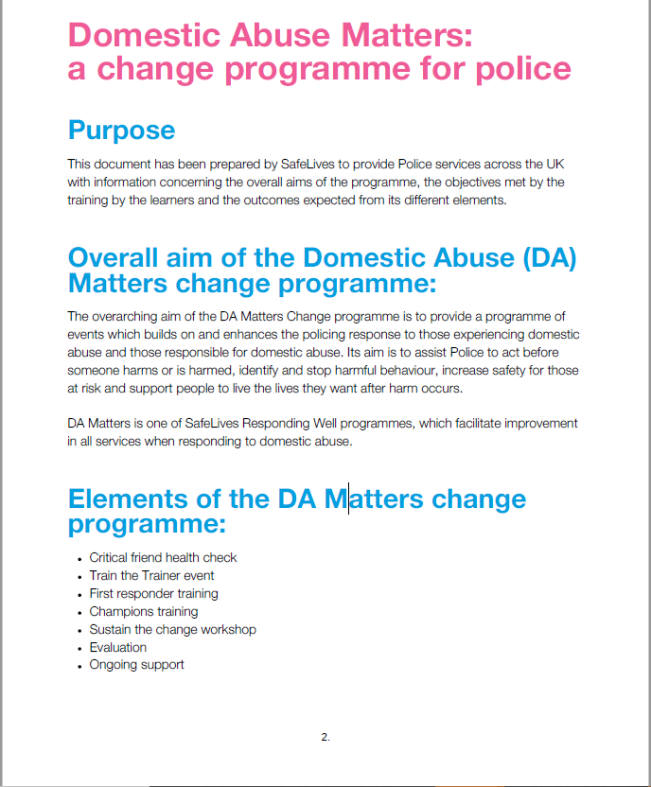
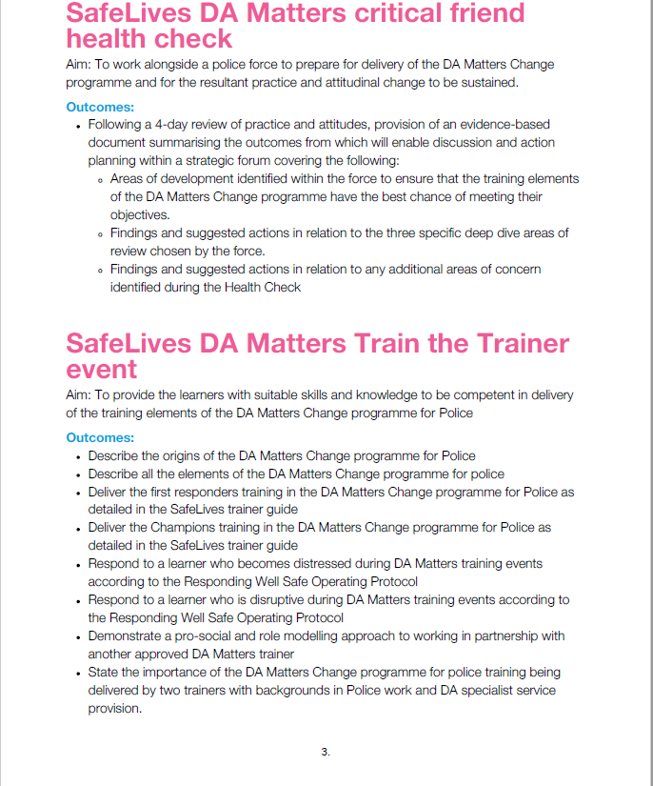

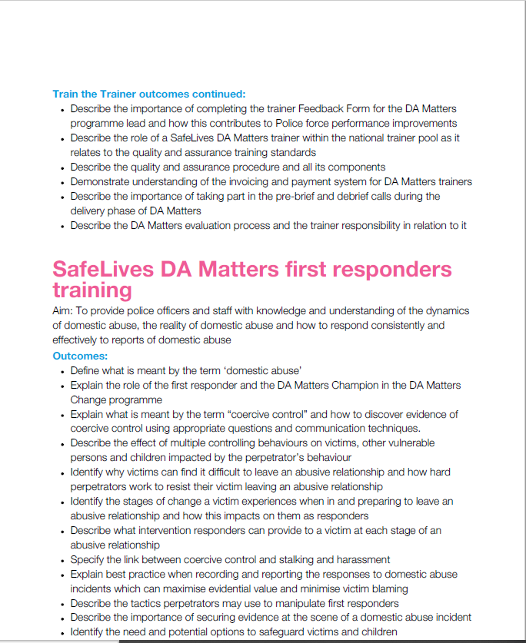

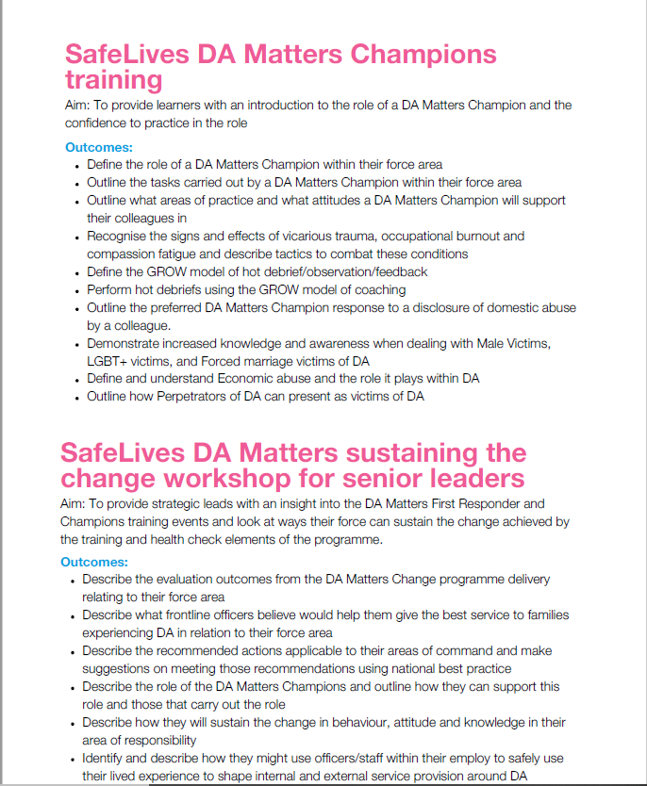

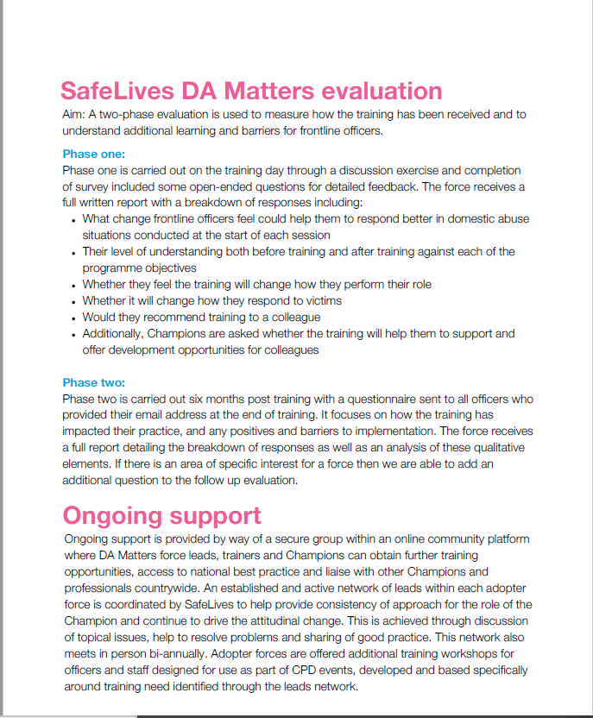

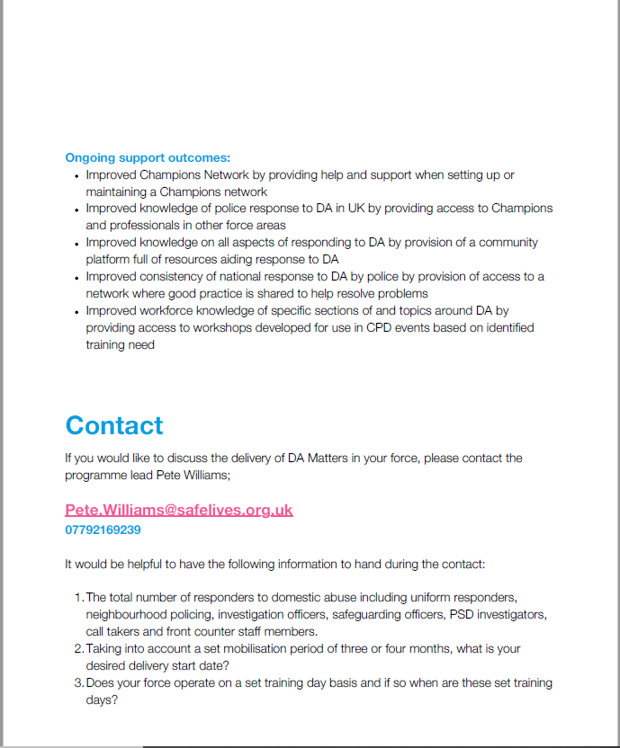


Schedule 2

Pricing Schedule

- Total price for delivery of the contract (for up to 25 learners per session) shall be £96,561.75 (VAT exempt) and this is a Firm Price, meaning it is not subject to any form of indexation or inflation.
- The Firm Price shall include delivery of the statement of requirement articulated in Schedule 1 and training for 1,000 learners and Senior Leaders and all other supplier costs.
- The contractor may submit its invoices for payment as follows:

a. 50% of the Firm Price on contract signature; £48,280.87
b. 25% of the Firm Price upon completion of mobilisation period and completion of first training delivery 2023; £24,140.44
c. 25% of the Firm Price 30 days following delivery of sessions as agreed within delivery schedule (if there are outstanding sessions over 30 days after the originally agreed dates due to the force rearranging sessions, the monies will need to be paid before these take place) £24,140.44

Serial | Description | Duration | Firm Price  (£)
1. | DA Matters programme - Health Check, Train-the-Trainer course, First Responders &  Champions training for 1000 learners, Senior Leaders Sustaining the Change  workshop, inc. CoP royalties. | 18 months 7/6/23-6/12/24 | £96,561.75 (VAT Exempt)

- The Firm Price includes delivery of the training outlined in Schedule 1, the provision of highly skilled, expert trainers and all expenses for SafeLives provided trainers.
- The Firm Price includes the health check includes a critical friend review of 22 areas which support the delivery of the DA Matters programme and the resultant attitudinal and behavioural change, and 3 additional areas chosen by the force connected to domestic abuse service provision. This is delivered by trainers with domestic abuse expertise and policing experience with the appropriate level of security vetting.
- The Firm Price includes the SafeLives Research, Evaluation and Analysis team providing a data report that reflects the feedback and learning captured through the SafeLives learner matrix provided by those attending the training. This captures the knowledge, understanding and comparative findings based on the areas identified within the learner matrix.
- Any variation to the original proposal as set out in the Special Conditions must be agreed in writing and in advance by the parties in accordance with clause 6 and may incur an additional fee.
- The Fee does not cover inclusion of training venue costs, refreshments and lunch, nor does it include the provision of projector and training equipment (flipchart stands, projector screen, laptop/desktop in training room). The responsibility for this lies with the Authority.
- Day rate applicable charges under 550 per day

Schedule 3- Standard Terms and Conditions



MOD Terms and Conditions for Less
Complex Requirements

1 Definitions - In the Contract:

Article means, in relation to Clause 9 only, an object which during production is given a special shape, surface or design which determines its function to a greater degree than does its chemical composition;
The Authority means the Secretary of State for Defence of the United Kingdom of Great Britain and Northern Ireland, (referred to in this document as "the Authority"), acting as part of the Crown;
Business Day means 09:00 to 17:00 Monday to Friday, excluding public and statutory holidays;
Contract means the agreement concluded between the Authority and the Contractor, including all terms and conditions, associated purchase order, specifications, plans, drawings, schedules and other documentation, expressly made part of the agreement in accordance with Clause 2.c;
Contractor means the person, firm or company specified as such in the purchase order. Where the Contractor is an individual or a partnership, the expression shall include the personal representatives of the individual or of the partners, as the case may be;
Contractor Deliverables means the goods and / or services including packaging (and supplied in accordance with any QA requirements if specified) which the Contractor is required to provide under the Contract in accordance with the schedule to the purchase order;
Effective Date of Contract means the date stated on the purchase order or, if there is no such date stated, the date upon which both Parties have signed the Contract;
Firm Price means a price excluding Value Added Tax (VAT) which is not subject to variation;
Government Furnished Assets (GFA) is a generic term for any MOD asset such as equipment, information or resources issued or made available to the Contractor in connection with the Contract by or on behalf of the Authority;
Hazardous Contractor Deliverable means a Contractor Deliverable or a component of a Contractor Deliverable that is itself a hazardous material or substance or that may in the course of its use, maintenance, disposal, or in the event of an accident, release one or more hazardous materials or substances and each material or substance that may be so released;
Issued Property means any item of Government Furnished Assets (GFA), including any materiel issued or otherwise furnished to the Contractor in connection with the Contract by or on behalf of the Authority;
Legislation means in relation to the United Kingdom any Act of Parliament, any subordinate legislation within the meaning of section 21 of the Interpretation Act 1978, any exercise of Royal Prerogative or any enforceable community right within the meaning of Section 2 of the European Communities Act 1972.
Mixture means a mixture or solution composed of two or more substances;
Notices means all notices, orders, or other forms of communication required to be given in writing under or in connection with the Contract;
Parties means the Contractor and the Authority, and Party shall be construed accordingly;
PPT means a tax called “plastic packaging tax” charged in accordance with Part 2 of the Finance Act 2021;
PPT Legislation means the legislative provisions set out in Part 2 and Schedules 9-15 of the Finance Act 2021 together with any secondary legislation made under powers contained in Part 2 of the Finance Act 2021. This includes, but is not limited to, The Plastic Packaging Tax (Descriptions of Products) Regulations 2021 and The Plastic Packaging Tax (General) Regulations 2022;
Plastic Packaging Component(s) shall have the same meaning as set out in Part 2 of the Finance Act 2021 together with any associated secondary legislation;
Sensitive Information means the information listed as such in the purchase order, being information notified by the Contractor to the Authority, which is acknowledged by the Authority as being sensitive, at the point at which the Contract is entered into or amended (as relevant) and remains sensitive information at the time of publication;
Substance means a chemical element and its compounds in the natural state or obtained by any manufacturing process, including any additive necessary to preserve its stability and any impurity deriving from the process used, but excluding any solvent which may be separated without affecting the stability of the substance or changing its composition;
Transparency Information means the content of this Contract in its entirety, including from time to time agreed changes to the Contract,except for (i) any information which is exempt from disclosure in accordance with the Freedom of Information Act 2000 (FOIA) or the Environmental Information Regulations Act 2004 (EIR), which shall be determined by the Authority, and (ii) any Sensitive Information.
2 General
a. The Contractor shall comply with all applicable Legislation, whether specifically referenced in this Contract or not.
b. Any variation to the Contract shall have no effect unless expressly agreed in writing and signed by both Parties.
c. If there is any inconsistency between these terms and conditions and the purchase order or the documents expressly referred to therein, the conflict shall be resolved according to the following descending order of priority:
(1) the terms and conditions;
(2) the purchase order; and
(3) the documents expressly referred to in the purchase order.
d. Neither Party shall be entitled to assign the Contract (or any part thereof) without the prior written consent of the other Party.
e. Failure or delay by either Party in enforcing or partially enforcing any provision of the Contract shall not be construed as a waiver of its rights or remedies. No waiver in respect of any right or remedy shall operate as a waiver in respect of any other right or remedy.
f. The Parties to the Contract do not intend that any term of the Contract shall be enforceable by virtue of the Contracts (Rights of Third Parties) Act 1999 by any person that is not a Party to it.
g. The Contract and any non-contractual obligations arising out of or in connection with it shall be governed by and construed in accordance with English Law, and subject to Clause 16 and without prejudice to the dispute resolution procedure set out therein, the Parties submit to the exclusive jurisdiction of the English courts. Other jurisdictions may apply solely for the purpose of giving effect to this Clause 2.g and for enforcement of any judgement, order or award given under English jurisdiction.
3 Application of Conditions
a. The purchase order, these terms and conditions and the specification govern the Contract to the entire exclusion of all other terms and conditions. No other terms or conditions are implied.
b. The Contract constitutes the entire agreement and understanding and supersedes any previous agreement between the Parties relating to the subject matter of the Contract.
4 Disclosure of Information
Disclosure of information under the Contract shall be managed in accordance with DEFCON 531 (SC1)
5 Transparency
a. Notwithstanding any other condition of this Contract, and in particular Clause 4, the Contractor understands that the Authority may publish the Transparency Information to the general public.
b. Subject to Clause 5.c, the Authority shall publish and maintain an up-to-date version of the Transparency Information in a format readily accessible and reusable by the general public under an open licence where applicable.
c. If, in the Authority's reasonable opinion, publication of any element of the Transparency Information would be contrary to the public interest, the Authority shall be entitled to exclude such information from publication. The Authority acknowledges that it would expect the public interest by default to be best served by publication of the Transparency Information in its entirety. Accordingly, the Authority acknowledges that it shall only exclude Transparency Information from publication in exceptional circumstances and agrees that where it decides to exclude information from publication on that basis, it will provide a clear statement to the general public explaining the categories of information that have been excluded from publication and reasons for withholding that information.
c. The Contractor shall assist and co-operate with the Authority as reasonably required to enable the Authority to publish the Transparency Information, in accordance with the principles set out above. Where the Authority publishes Transparency Information, it shall:
(1) before publishing redact any information that would be exempt from disclosure if it was the subject of a request for information under the FOIA and/or the EIR , for the avoidance of doubt, including Sensitive Information;
(2) taking into account the Sensitive Information set out in the purchase order, consult with the Contractor where the Authority intends to publish information which has been identified as Sensitive Information. For the avoidance of doubt the Authority, acting reasonably, shall have absolute discretion to decide what information shall be published or be exempt from disclosure in accordance with the FOIA
and/or EIR; and
(3) present information in a format that assists the general public in understanding the relevance and completeness of the information being published to ensure the public obtain a fair view on how this Contract is being performed.
6 Notices
a. A Notice served under the Contract shall be:
(1) in writing in the English language;
(2) authenticated by signature or such other method as may be agreed between the Parties;
(3) sent for the attention of the other Party’s representative, and to the address set out in the purchase order;
(4) marked with the number of the Contract; and
(5) delivered by hand, prepaid post (or airmail), facsimile transmission or, if agreed in the purchase order, by electronic mail.
b. Notices shall be deemed to have been received:
(1) if delivered by hand, on the day of delivery if it is the receipient’s Business Day and otherwise on the first Business of the recipient
immediately following the day of delivery;
(2) if sent by prepaid post, on the fourth Business Day (or the tenth Business Day in the case of airmail) after the day of posting;
(3) if sent by facsimile or electronic means:
(a) if transmitted between 09:00 and 17:00 hours on a Business Day (recipient’s time) on completion of receipt by the sender of verification of the transmission from the receiving instrument; or
(b) if transmitted at any other time, at 09:00 on the first Business Day (recipient’s time) following the completion of receipt by the sender of verification of transmission from the receiving instrument.
7 Intellectual Property
a. The Contractor shall as its sole liability keep the Authority fully indemnified against an infringement or alleged infringement of any intellectual property rights or a claim for Crown use of a UK patent or registered design caused by the use, manufacture or supply of the Contractor Deliverables.
b. The Authority shall promptly notify the Contractor of any infringement claim made against it relating to any Contractor Deliverable and, subject to any statutory obligation requiring the Authority to respond, shall permit the Contractor to have the right, at its sole discretion to assume, defend, settle or otherwise dispose of such claim. The Authority shall give the Contractor such assistance as it may reasonably
require to dispose of the claim and will not make any statement which might be prejudicial to the settlement or defence of the claim.
c. Notwithstanding any other provisions of the Contract and for the avoidance of doubt, award of the Contract by the Authority and placement of any contract task under it does not constitute an authorisation by the Crown under Sections 55 and 56 of the Patents Act 1977 or Section 12 of the Registered Designs Act 1949. The Contractor acknowledges that any such authorisation by the Authority under its statutory powers must be expressly provided in writing, with reference to the acts authorised and the specific intellectual property involved. Notification of Intellectual Property Rights (IPR) Restrictions
d. Where any of the Conditions listed below (1 to 3) have been added to these Conditions of the Contract as Project Specific DEFCONs at Clause 21, the Contractor warrants and confirms that all Intellectual Property Rights restrictions and associated export restrictions relating to the use or disclosure of the Contractor Deliverables that are notifiable under those Conditions, or of which the Contractor is or should reasonably be aware as at Effective Date of Contract, are disclosed in Schedule 5 (Notification of Intellectual Property Rights (IPR) Restrictions):
(1) DEFCON 15 - including notification of any self-standing background Intellectual Property;
(2) DEFCON 90 - including copyright material supplied under clause 5;
(3) DEFCON 91 - limitations of Deliverable Software under clause 3b;
e. The Contractor shall promptly notify the Authority in writing if they become aware during the performance of the Contract of any required additions, inaccuracies or omissions in Schedule 2.
f. Any amendment to Schedule 2 shall be made in accordance with DEFCON 503 (SC1).
8 Supply of Contractor Deliverables and Quality Assurance
a. This Contract comes into effect on the Effective Date of Contract.
b. The Contractor shall supply the Contractor Deliverables to the Authority at the Firm Price stated in the Schedule to the purchase order.
c. The Contractor shall ensure that the Contractor Deliverables:
(1) correspond with the specification;
(2) are of satisfactory quality (within the meaning of the Sale of Goods Act 1979, as amended) except that fitness for purpose shall be limited to the goods being fit for the particular purpose held out expressly by or made known expressly to the Contractor and in this respect the Authority relies on the Contractor’s skill and judgement; and
(3) comply with any applicable Quality Assurance Requirements specified in the purchase order.
d. The Contractor shall apply for and obtain any licences required to import any material required for the performance of the Contract in the UK. The Authority shall provide to the Contractor reasonable assistance with regard to any relevant defence or security matter arising
in the application for any such licence.
9 Supply of Data for Hazardous Substances, Mixtures and Articles in Contractor Deliverables
a. Nothing in this Clause 9 shall reduce or limit any statutory duty or legal obligation of the Authority or the Contractor.
b. As soon as possible and in any event within the period specified in the purchase order (or if no such period is specified no later than one month prior to the delivery date), the Contractor shall provide to the Authority’s representatives in the manner and format prescribed in the purchase order:
(1) confirmation as to whether or not to the best of its knowledge any of the Contractor Deliverables contain Hazardous Substances, Mixtures or Articles; and
(2) for each Substance, Mixture or Article supplied in meeting the criteria of classification as hazardous in accordance with the GB Classification, Labelling and Packaging (GB CLP) a UK REACH compliant Safety Data Sheet (SDS);
(3) where Mixtures supplied do not meet the criteria for classification as hazardous according to GB CLP but contain a hazardous Substance an SDS is to be made available on request; and
(4) for each Article whether supplied on its own or part of an assembly that contains a Substance on the UK REACH Authorisation List, Restriction List and / or the Candidate List of Substances of Very High Concern (SVHC) in a proportion greater than 0.1% w/w of the Article, sufficient information, available to the supplier, to allow safe use of the Article including, as a minimum, the name of that Substance at the time of supply.
c. For substances, Mixtures or Articles that meet the criteria list in clause 9.b above:
(1) if the Contractor becomes aware of new information which may affect the risk management measures or new information on the hazard, the Contractor shall update the SDS/safety Information and forward it to the Authority and to the address listed in the purchase
order; and
(2) if the Authority becomes aware of new information that might call into question the appropriateness of the risk management measures identified in the safety information supplied, shall report this information in writing to the Contractor.
d. If the Substances, Mixtures or Articles in Contractor Deliverables are Ordnance, Munitions or Explosives (OME), in addition to the requirements of the GB CLP and UK REACH the Contractor shall comply with hazard reporting requirements of DEF STAN 07-085 Design Requirements for Weapons and Associated Systems.
e. If the Substances, Mixtures or Articles in Contractor Deliverables, are or contain or embody a radioactive substance as defined in the Ionising Radiation Regulations SI 2017/1075, the Contractor shall additionally provide details on DEFFORM 68 of:
(1) activity; and
(2) the substance and form (including any isotope).
f. If the Substances, Mixtures and Articles in Contractor Deliverables have magnetic properties which emit a magnetic field, the Contractor shall additionally provide details on DEFFORM 68 of the magnetic flux density at a defined distance, for the condition in which it is packed.
g. Failure by the Contractor to comply with the requirements of this Condition shall be grounds for rejecting the affected Substances, Mixtures and Articles in Contractor Deliverables. Any withholding of information concerning hazardous Substance, Mixtures or Articles in Contractor Deliverables shall be regarded as a material breach of Contract under Condition 18 (Material Breach) for which the Authority reserves the right to require the Contractor to rectify the breach immediately at no additional cost to the Authority or to terminate the Contract in accordance with Condition 18.h. Where delivery is made to the Defence Fulfilment Centre (DFC) and / or other Team Leidos location / building, the Contractor must comply with the Logistic Commodities and Services Transformation (LCST) Supplier Manual.
10 Delivery / Collection
a. The purchase order shall specify whether the Contractor Deliverables are to be delivered to the consignee by the Contractor or collected from the consignor by the Authority.
b. Title and risk in the Contractor Deliverables shall pass from the Contractor to the Authority on delivery or on collection in accordance
with Clause 10.a.
c. The Authority shall be deemed to have accepted the Contractor Deliverables within a reasonable time after title and risk has passed to the Authority unless it has rejected the Contractor Deliverables within the same period.
11. Marking of Contractor Deliverables
a. Each Contractor Deliverable shall be marked in accordance with the requirements specified in the purchase order or if no such
requirement is specified, the Contractor shall mark each Contractor Deliverable clearly and indelibly in accordance with the requirements of the relevant DEF-STAN 05-132 as specified in the contract or specification. In the absence of such requirements, the Contractor Deliverables shall be marked with the MOD stock reference, NATO Stock Number (NSN) or alternative reference number shown in the
Contract.
b. Any marking method used shall not have a detrimental effect on the strength, serviceability or corrosion resistance of the Contractor Deliverables.
c. The marking shall include any serial numbers allocated to the Contractor Deliverable.
d. Where because of its size or nature it is not possible to mark a Contractor Deliverable with the required particulars, the required
information should be included on the package or carton in which the Contractor Deliverable is packed, in accordance with condition 12 (Packaging and Labelling (excluding Contractor Deliverables containing Ammunition or Explosives)).
12 Packaging and Labelling of Contractor Deliverables (Excluding Contractor Deliverables Containing Ammunition or
Explosives)
a. The Contractor shall pack or have packed the Contractor Deliverables in accordance with any requirements specified in the purchase order and Def Stan 81-041 (Part 1 and Part 6).
b. The Contractor shall establish if the Contractor Deliverables are, or contain, Dangerous Goods as defined in the Regulations set out in this Clause 12. Any that do shall be packaged for UK or worldwide shipment by all modes of transport in accordance with the following unless otherwise specified in the Schedule to the purchase order:
(1) the Technical Instructions for the Safe Transport of Dangerous Goods by Air (ICAO), IATA Dangerous Goods Regulations;
(2) the International Maritime Dangerous Goods (IMDG) Code;
(3) the Regulations Concerning the International Carriage of Dangerous Goods by Rail (RID); and
(4) the European Agreement Concerning the International Carriage of Dangerous Goods by Road (ADR).
c. Certification markings, incorporating the UN logo, the package code and other prescribed information indicating that the package corresponds to the successfully designed type shall be marked on the packaging in accordance with the relevant regulation.
13 Plastic Packaging Tax
a. The Contractor shall ensure that any PPT due in relation to this Contract is paid in accordance with the PPT Legislation.
b. The Contract Price includes any PPT that may be payable by the Contractor in relation to the Contract.
c. On reasonable notice being provided by the Authority, the Contractor shall provide and make available to the Authority details of any
PPT they have paid that relates to the Contract.
d. The Contractor shall notify the Authority, in writing, in the event that there is any adjustment required to the Contract Price in accordance with section 70 of the Finance Act 2021 and, on reasonable notice being provided by the Authority, the Contractor shall provide any such information that the Authority requires in relation to any such adjustment.
e. In accordance with DEFCON 609 (SC1) the Contractor (and their sub-contractors) shall maintain all records relating to PPT and make
them available to the Authority when requested on reasonable notice for reasons related to the Contract.
f. Where the Contractor manufactures, purchases or imports into the UK any Plastic Packaging Component in relation to the Contract the Contractor shall, on reasonable notice being given, provide the Authority with such information and documentation that it requires to enable the Authority to carry out due diligence checks and satisfy itself that the Contractor has complied with the requirements of the PPT Legislation. This shall include, but is not limited to the Contractor providing:
(1) confirmation of the tax status of any Plastic Packaging Component;
(2) documents to confirm that PPT has been properly accounted for;
(3) product specifications for the packaging components, including, but not limited to, the weight and composition of the products and any other product specifications that may be required; and
(4) copies of any certifications or audits that have been obtained or conducted in relation to the provision of Plastic Packaging
Components.
g. The Authority shall have the right, on providing reasonable notice, to physically inspect or conduct an audit on the Contractor, to ensure
any information that has been provided in accordance with clause 13.f above is accurate.
h. In the event the Contractor is not required to register for PPT they (and to the extent applicable, their sub-contractors) shall provide the Authority with a statement to this effect and, to the extent reasonably required by the Authority on reasonable notice, supporting evidence for that statement.
i. The Contractor shall provide, on the Authority providing reasonable notice, any information that the Authority may require from the Contractor for the Authority to comply with any obligations it may have under the PPT Legislation.
14. Progress Monitoring, Meetings and Reports
The Contractor shall attend progress meetings and deliver reports at the frequency or times (if any) specified in the purchase order and shall ensure that its Contractor’s representatives are suitably qualified to attend such meetings. Any additional meetings reasonably required shall be at no cost to the Authority.
15 Payment
a. Payment for Contractor Deliverables will be made by electronic transfer and prior to submitting any claims for payment under clause 15b the Contractor will be required to register their details (Supplier on-boarding) on the Contracting, Purchasing and Finance (CP&F) electronic procurement tool.
b. Where the Contractor submits an invoice to the Authority in accordance with clause 15a, the Authority will consider and verify that invoice in a timely fashion.
c. The Authority shall pay the Contractor any sums due under such an invoice no later than a period of 30 days from the date on which the Authority has determined that the invoice is valid and undisputed.
d. Where the Authority fails to comply with clause 15b and there is undue delay in considering and verifying the invoice, the invoice shall be regarded as valid and undisputed for the purpose of clause 15c after a reasonable time has passed.
e. The approval for payment of a valid and undisputed invoice by the Authority shall not be construed as acceptance by the Authority of the performance of the Contractor’s obligations nor as a waiver of its rights and remedies under this Contract.
f. Without prejudice to any other right or remedy, the Authority reserves the right to set off any amount owing at any time from the Contractor to the Authority against any amount payable by the Authority to the Contractor under the Contract or under any other contract with the Authority, or with any other Government Department.
16 Dispute Resolution
a. The Parties will attempt in good faith to resolve any dispute or claim arising out of or relating to the Contract through negotiations between the respective representatives of the Parties having authority to settle the matter, which attempts may include the use of any alternative dispute resolution procedure on which the Parties may agree.
b. In the event that the dispute or claim is not resolved pursuant to Clause 16.a the dispute shall be referred to arbitration and shall be governed by the Arbitration Act 1996. For the purposes of the arbitration, the arbitrator shall have the power to make provisional awards
pursuant to Section 39 of the Arbitration Act 1996.
c. For the avoidance of doubt it is agreed between the Parties that the arbitration process and anything said, done or produced in or in relation to the arbitration process (including any awards) shall be confidential as between the Parties, except as may be lawfully required in judicial proceedings relating to the arbitration or otherwise. No report relating to anything said, done or produced in or in relation to the arbitration process may be made beyond the tribunal, the Parties, their legal representatives and any person necessary to the conduct of the proceedings, without the concurrence of all the Parties to the arbitration.
17 Termination for Corrupt Gifts
The Authority may terminate the Contract with immediate effect, without compensation, by giving written notice to the Contractor at any time after any of the following events:
a. where the Authority becomes aware that the Contractor, its employees, agents or any sub-contractor (or anyone acting on its behalf or any of its or their employees):
(1) has offered, promised or given to any Crown servant any gift or financial or other advantage of any kind as an inducement or reward;
(2) commits or has committed any prohibited act or any offence under the Bribery Act 2010 with or without the knowledge or authority of the Contractor in relation to this Contract or any other contract with the Crown;
(3) has entered into this or any other contract with the Crown in connection with which commission has been paid or has been agreed
to be paid by it or on its behalf, or to its knowledge, unless before the contract is made particulars of any such commission and of the terms and conditions of any such agreement for the payment thereof have been disclosed in writing to the Authority.
b. In exercising its rights or remedies to terminate the Contract under Clause 17.a. the Authority shall:
(1) act in a reasonable and proportionate manner having regard to such matters as the gravity of, and the identity of the person committing the prohibited act;
(2) give due consideration, where appropriate, to action other than termination of the Contract, including (without being limited to):
(a) requiring the Contractor to procure the termination of a subcontract where the prohibited act is that of a Subcontractor or anyone acting on its or their behalf;
(b) requiring the Contractor to procure the dismissal of an employee (whether its own or that of a Subcontractor or anyone acting on its behalf) where the prohibited act is that of such employee.
c. Where the Contract has been terminated under Clause 17.a.the Authority shall be entitled to purchase substitute Contractor Deliverables from elsewhere and recover from the Contractor any costs and expenses incurred by the Authority in obtaining the Contractor Deliverables in substitution from another supplier.
18 Material Breach
In addition to any other rights and remedies, the Authority shall have the right to terminate the Contract (in whole or in part) with immediate effect by giving written notice to the Contractor where the Contractor is in material breach of their obligations under the Contract. Where the Authority has terminated the Contract under Clause 18 the Authority shall have the right to claim such damages as may have been
sustained as a result of the Contractor’s material breach of the Contract.
19 Insolvency
The Authority shall have the right to terminate the contract if the Contractor is declared bankrupt or goes into liquidation or administration. This is without prejudice to any other rights or remedies under this Contract.
20 Limitation of Contractor’s Liability
a. Subject to Clause 20.b the Contractor's liability to the Authority in connection with this Contract shall be limited to £5m (five million pounds).
b. Nothing in this Contract shall operate to limit or exclude the Contractor's liability:
(1) for:
a. any liquidated damages (to the extent expressly provided for under this Contract);
b. any amount(s) which the Authority is entitled to claim, retain or withhold in relation to the Contractor’s failure to perform or underperform its obligations under this Contract, including service credits or other deductions (to the extent expressly provided for under this Contract);
c. any interest payable in relation to the late payment of any sum due and payable by the Contractor to the Authority under this Contract;
d. any amount payable by the Contractor to the Authority in relation to TUPE or pensions to the extent expressly provided for under this Contract;
(2) under Condition 7 of the Contract (Intellectual Property), and DEFCONs 91 or 638 (SC1) where specified in the contract;
(3) for death or personal injury caused by the Contractor’s negligence or the negligence of any of its personnel, agents, consultants or sub-contractors;
(4) for fraud, fraudulent misrepresentation, wilful misconduct or negligence;
(5) in relation to the termination of this Contract on the basis of abandonment by the Contractor;
(6) for breach of the terms implied by Section 2 of the Supply of Goods and Services Act 1982; or
(7) for any other liability which cannot be limited or excluded under general (including statute and common) law.
c. The rights of the Authority under this Contract are in addition to, and not exclusive of, any rights or remedies provided by general (including
statute and common) law.
21 The project specific DEFCONs and DEFCON SC variants that apply to this Contract are:
DEFCON 532
DEFCON 532B
DEFCON 658 (SC1)
DEFCON 660

22 The special conditions that apply to this Contract are:

AUTHORITY'S OBLIGATIONS

22.1 The Authority shall:
(a) co-operate with SafeLives in all matters relating to the Services;
(b) provide for SafeLives, its agents, subcontractors, consultants and employees, in a timely manner and at no charge, access to the Authority's premises, office accommodation, data and other facilities if required by SafeLives or any of them for the purposes of providing the Services;
(c) provide, in a timely manner, such any information or other input as SafeLives may require from the Authority in order to enable the provision of the Services, and ensure that it is accurate in all material respects;
(d) provide trainers for the delivery schedule for the Programme as set out in Special Conditions Clause 22 who are suitably qualified and skilled and have passed SafeLives’ Train the Trainer event. These trainers will be assessed by SafeLives and, where they are not approved by SafeLives to deliver the training, the Authority agrees to pay for additional SafeLives staff;
(e) ensure that all learners are service police, or personnel employed in a policing capacity by the Authority and that no more than 25 learners attend any training session;
(f) ensure that all learners arrive at the training event on time and in casual clothing and not police uniform;
(g) provide a suitable training room: a room large enough to comfortably accommodate 25 learners, two trainers and 2 observers in horseshoe style as well as I.T provisions;
(h) ensure that all access requirements of learners are met by providing a suitably accessible training room and making any reasonable adjustments required by any of the learners in accordance with the Equality Act 2010; and
(i) ensure that all learners complete and return to SafeLives’ on completion of each training session SafeLives’ Programme evaluation survey.

22.2 Following delivery of the Programme by SafeLives, the Authority shall in relation to the continued adoption of the Programme by the Authority:
(a) ensure that any additional training sessions required by the Authority are delivered only by Approved Trainers and in accordance with clause 22.1(f) to (i) (inclusive);
(b) apply to the Programme the same quality assurance programme that it applies to other types of training that the Authority provides to its employees and shall provide SafeLives with any information in relation to its quality assurance programme that SafeLives may reasonably request from time to time;
(c) ensure that each delivery of a “Responders Day” or a “Champions/Mentors Day by the Authority is delivered by two Approved Trainers, one being a police specialist trainer and the other being a domestic abuse specialist trainer as described in the then trainer guidance scripts included in the Products and approved by SafeLives via their train the trainer process; and
(d) participate in SafeLives’ Revisit and Review process and, on reasonable notice at a time to be mutually agreed between the parties, will allow SafeLives to return to the Authority’s premises at no cost to the Authority in order to allow SafeLives to check that the Authority is complying with the terms of this Agreement and has implemented any recommendations provided by SafeLives from the free health check and Sustaining the Change Workshop delivered as part of the Programme. This process will also provide an opportunity to discuss any further support, consultation or workshops that the Authority may require.

22.3 If SafeLives’ performance of its obligations under this Agreement is prevented or delayed by any act or omission of the Authority, its agents, subcontractors, consultants or employees, SafeLives shall not be liable for any costs, charges or losses sustained or incurred by the Authority that arise directly or indirectly from such prevention or delay.

22.4 The Authority shall indemnify SafeLives against all reasonable costs, charges and/or losses sustained or incurred by SafeLives that arise directly from the Authority's fraud, negligence, failure to perform or delay in the performance of any of its obligations under this Agreement.

INTELLECTUAL PROPERTY RIGHTS AND USE OF PRODUCTS

22.5 All Intellectual Property Rights in the Programme are owned by and shall be retained by the College of Policing and SafeLives. SafeLives acts as a delivery agent for the Responders and Champions Training Days and has been granted the right to deliver these elements of the package under an agreement between SafeLives and the College of Policing (the COP Licence).
22.6 SafeLives hereby grants to the Authority a non-exclusive licence to use and make copies of the Products solely to the extent necessary to enable the Approved Trainers to deliver training sessions to police officers employed by the Authority from time to time in accordance with this Agreement.
22.7 SafeLives will provide hard copies of the Products for use during the delivery of the Programme by SafeLives and will take back these copies on completion of the Programme.
22.8 Following completion of the Programme, Safe Lives will deliver to the Authority an encrypted memory stick containing the Products. The Authority may print out copies of the Products from this stick for use solely in accordance with clause 22.6.
22.9 SafeLives will from time-to-time issue updates to the Products to the Head of Continuous Improvement and development (the Authority) and the Authority shall be responsible for implementing the updates promptly (including the immediate withdrawal of any survivor videos, testimonies, police video footage or other evidence within the Products for which permission has been withdrawn) and ensuring that only the latest versions of the Products are used by the Approved Trainers. The Authority will securely delete and/or destroy any out-of-date versions of the Products promptly upon receiving any such update and will certify to SafeLives that it has complied with this clause 22.9.
22.10 The Authority shall not edit, cut or make any changes to the Products except for making updates to the Products in accordance with clause 22.9 and shall not remove any copyright notices appearing on the Products.
22.11 The Authority shall use the Products solely in the form provided by SafeLives (as updated from time to time in accordance with clause 22.9) and shall ensure that whenever the Approved Trainers deliver training in accordance with this Agreement they use the Products in their entirety and do not separate any materials from the Products or deliver the training or use the Products in part only.

TERMINATION AND CANCELLATION

22.12 Without prejudice to any other rights or remedies which the parties may have, the party not in default may terminate this Agreement without liability to the other immediately on giving notice to the other if:
(a) the other party fails to pay any amount due under this Agreement on the due date for payment and remains in default for more than 30 days after being notified in writing to make such payment; or
(b) the other party commits a breach of any of the material terms of this Agreement and (if such a breach is remediable) fails to remedy that breach within 10 days of that party being notified in writing of the breach; or In addition to any other rights and remedies, the Authority shall have the right to terminate the Contract (in whole or in part) with immediate
effect by giving written notice to the Contractor where the Contractor is in material breach of their obligations under the Contract. Where the Authority has terminated the Contract under the Authority shall have the right to claim such damages as may have been sustained as a result of the Contractor’s material breach of the Contract.
(c) the other party suspends, or threatens to suspend, payment of its debts, is unable to pay its debts as they fall due, admits inability to pay its debts or (being a company) is deemed unable to pay its debts within the meaning of section 123 of the Insolvency Act 1986 as if the words “it is proved to the satisfaction of the court” did not appear in sections 123(1)(e) or 123(2) of the Insolvency Act 1986; or
(d) the other party commences negotiations with all, or any class of, its creditors with a view to rescheduling any of its debts, or makes a proposal for, or enters into any compromise or arrangement with, its creditors other than for the sole purpose of a scheme for a solvent amalgamation of that other party with one or more other companies, or the solvent reconstruction of that other party; or
(e) the other party applies to court for, or obtains, a moratorium under Part A1 of the Insolvency Act 1986;
(f) a petition is filed, a notice is given, a resolution is passed, or an order is made, for or on connection with the winding up of that other party other than for the sole purpose of a scheme for a solvent amalgamation of that other party with one or more other companies, or the solvent reconstruction of that other party; or
(g) an application is made to court, or an order is made, for the appointment of an administrator, a notice of intention to appoint an administrator is given or if an administrator is appointed over the other party; or
(h) a floating charge holder over the assets of that other party has become entitled to appoint, or has appointed, an administrative receiver; or
(i) a person becomes entitled to appoint a receiver over the assets of the other party, or a receiver is appointed over the assets of the other party; or
(j) a creditor or encumbrancer of the other party attaches or takes possession of, or a distress, execution, sequestration or other such process is levied or enforced on or sued against, the whole or any part of its assets and such attachment or process is not discharged within 14 days; or
(k) any event occurs, or proceeding is taken, with respect to the other party in any jurisdiction to which it is subject that has an effect equivalent or similar to any of the events mentioned in clause 22.12(c) to (j) inclusive; or
(l) the other party suspends or ceases, or threatens to suspend or cease, to carry on all or a substantial part of its business; or
(m) there is a change of control of the other party (within the meaning of section 1124 of the Corporation Tax Act 2010).
22.13 This Agreement shall terminate in the event that the licence awarded to SafeLives by College of Policing is terminated following the breach of a material term of the licence, if such breach cannot be remedied or, if capable of remedy, it is not remedied within 30 days of a request by the Party that the breach be remedied.
22.14 On termination of this Agreement for any reason:
(a) the Authority shall immediately pay to SafeLives all of SafeLives’ outstanding unpaid invoices and interest and, in respect of Services supplied but for which no invoice has been submitted, SafeLives may submit an invoice, which shall be payable immediately on receipt;
(b) the Authority shall promptly return to SafeLives and/or permanently delete all copies of the Products which are the property of SafeLives and certify to SafeLives in writing that it has done so;
(c) the accrued rights, remedies, obligations and liabilities of the parties as at termination shall not be affected, including the right to claim damages in respect of any breach of the Agreement which existed at or before the date of termination; and
(d) clauses which expressly or by implication have effect after termination shall continue in full force and effect, including Special Conditions Clause 22
22.15 The Authority may not reschedule, cancel or make amendments (trainer or location) to a scheduled training session on less than 30 calendar days’ notice.
22.16 Where a training session is rescheduled, cancelled or amended by the Authority with less than 30 calendar days’ notice, SafeLives will invoice for the costs of the training session that has been rescheduled, cancelled or amended which it has incurred and committed to and which cannot otherwise be avoided. SafeLives will take all reasonable steps to minimise these associated costs.
FORCE MAJEURE
22.17 A party, provided that it has complied with the provisions of clause 22.19 , shall not be in breach of this Agreement, nor liable for any failure or delay in performance of any obligations under this Agreement (and, the time for performance of such obligations shall be extended accordingly) arising from or attributable to acts, events, omissions or accidents beyond its reasonable control that affect the ability of either party to deliver the training (Force Majeure Event), including but not limited to any of the following:
(a) acts of nature, including but not limited to fire, flood, earthquake, windstorm or other natural disaster;
(b) war, threat of or preparation for war, armed conflict, imposition of sanctions, embargo, breaking off of diplomatic relations or similar actions;
(c) terrorist attack, civil war, civil commotion or riots;
(d) nuclear, chemical or biological contamination or sonic boom;
(e) epidemic or pandemic;
(f) compliance with any law;
(g) fire, explosion or accidental damage;
(h) loss at sea;
(i) adverse weather conditions;
(j) collapse of building structures, failure of plant machinery, machinery, computers or vehicles;
(k) any labour dispute, including but not limited to strikes, industrial action or lockouts;
(l) non-performance by that party’s subcontractors; and
(m) interruption or failure of utility service, including but not limited to electric power, gas or water.

22.18 The corresponding obligations of the other party will be suspended to the same extent.

22.19 A party that is subject to a Force Majeure Event shall not be in breach of this Agreement provided that:

(a) it promptly notifies the other party in writing of the nature and extent of the Force Majeure Event causing its failure or delay in performance;

(b) it has used all reasonable endeavours to mitigate the effect of the Force Majeure Event, to carry out its obligations under this Agreement in any way that is reasonably practicable and to resume the performance of its obligations as soon as reasonably possible.

22.20 If the Force Majeure Event prevails for a continuous period of more than 6 months, either party may terminate this Agreement by giving 7 days' written notice to the other party. On the expiry of this notice period, this Agreement will terminate. Such termination shall be without prejudice to the rights of the parties in respect of any breach of this Agreement occurring prior to such termination.
Schedule 4 - Data Processing by the Authority

Scope, Nature and Purpose of Processing

The Products include the following Personal Data:

• Video testimonies that feature the images and voices of survivors and perpetrators who have provided their consent to COP/SafeLives for the use of their testimonies in the Products.
• Written testimonies of survivors and perpetrators which contain personal data that may identify them. These individuals have provided their consent to COP/SafeLives for their testimonies to be used in the Products.
• Police evidence videos provided by the police to COP/SafeLives for use in the Products, which include the images and voices of individuals.
• Criminal convictions data relating to certain individuals whose cases are featured in the Products.

The Authority’s officers attending training sessions will be provided with copies of the Products (including the above Personal Data) for the purposes of receiving training in the Programme and when receiving ‘Trainer the Trainer’ sessions. The Authority will have the right to use the Products (including the above Personal Data) following delivery of the Programme strictly in accordance with Special Conditions clause 22 of the main body of this Agreement for the purposes set out in that clause.

Duration of Processing

The processing will continue during the Term but is subject to clause 22.9 which requires the Authority to withdraw any of the above materials from the Products should the individuals withdraw their consent to their Personal Data being used or should the Police notify COP/SafeLives that materials are to be withdrawn for this or any other reason.

Types of Personal Data

Images and voices of Data Subjects as described above.
Other Personal Data contained in the testimonies which may identify Data Subjects.

Categories of Data Subject

Survivors of domestic abuse
Perpetrators of domestic abuse
Police officers
Individuals featuring in the Police evidence videos.

Schedule 5 – Notification of Intellectual Property Rights (IPR) Restrictions (i.a.w. Clause 7 of Schedule 3) for Contract No. PART A – Notification of IPR Restrictions

DEFFORM 711

1. ITT/Contract Number
2. ID# | 3. Unique Technical Data Reference Number/ Label | 4. Unique Article Identification Number/Label | 5. Statement Describing IPR Restriction | 6. Ownership of the Intellectual Property Rights
1
2
3
4
5
6
7
8
9
10

* Article(s), for the purpose of this form only, means part or the whole of any item, component or process which the Contractor is required under the Contract to supply or in connection with which it is required under the Contract to carry out any service and any other article or part thereof to the same design as that article.

PART B – System / Product Breakdown Structure (PBS) The Contractor should insert their PBS here. For software, please provide a Modular Breakdown Structure.

(Please see the DEFFORM 711 Completion Notes for guidance on completing Schedule 5)
DEFFORM 711 Narrative Condition

1. Where any of the conditions listed below (a-d) form part of the terms and conditions of the Contract or where other similar notification obligations exist, the Contractor warrants and confirms that all Intellectual Property Rights restrictions and associated export restrictions relating to the use or disclosure of the Contractor Deliverables that are notifiable under those conditions, or of which the Contractor is or should reasonably be aware as at the date of the Contract, are disclosed in DEFFORM 711 annexed to the Contract.

a) DEFCON 15 - (including notification of any self-standing background Intellectual Property).

b) DEFCON 90 - including copyright material supplied under clause 5.

c) DEFCON 91 - Limitations of Deliverable Software under Clause 3b.

d) DEFCON 632 - Notifications under clause 1.

2. The Contractor shall promptly notify the Authority in writing if it becomes aware during the performance of the Contract of any required additions, inaccuracies or omissions in DEFFORM 711.

3. Any amendment to DEFFORM 711 shall be made in accordance with DEFCON 503.

