Request for Quotation

Allonby Bay candidate HPMA intertidal survey: feature extent and seabed character assessment

19/06/2023

Request for Quotation

Allonby Bay candidate HPMA intertidal survey: feature extent and seabed character assessment
You are invited to submit a quotation for the requirement described in the specification, Section 2.
Please confirm by email, receipt of these documents and whether you intend to submit a quote or not.
Your response should be returned to the following email address by:
Email: sarah.meek@naturalengland.org.uk
Date: 12/07/2023
Time: 12pm
Ensure you include the name of the quotation and ‘Final Submission’ in the subject field to make it clear that it is your response.
Contact Details and Timetable
Sarah Meek will be your contact for any questions linked to the content of the quote or the process. Please submit any clarification questions via email and note that, unless commercially sensitive, both the question and the response will be circulated to all tenderers.
Action |  | Date
Date of issue of RFQ | 21/07/2023 at 12:00 BST
Deadline for clarifications questions | 14/07/2023 at 12:00 BST
Deadline for receipt of Quotation | 21/07/2023 at 12:00 BST
Intended date of Contract Award | 24/07/2023
Intended Contract Start Date | 26/07/2023
Intended Delivery Date / Contract Duration | 26/07/2023 to 01/03/2024

Section 1: General Information
Glossary
Unless the context otherwise requires, the following words and expressions used within this Request for Quotation shall have the following meanings (to be interpreted in the singular or plural as the context requires):
“Authority” | Means Natural England who is the Contracting Authority.
“Contract” | means the contract to be entered into by the Authority and the successful supplier.
“Response” | means the information submitted by a supplier in response to the RFQ.
“RFQ” | means this Request for Quotation and all related documents published by the Authority and made available to suppliers.

Conditions applying to the RFQ
You should examine your Response and related documents ensuring it is complete and in accordance with the stated instructions prior to submission.
Your Response must contain sufficient information to enable the Authority to evaluate it fairly and effectively. You should ensure that you have prepared your Response fully and accurately and that prices quoted are arithmetically correct for the units stated.
By submitting a Response, you, the supplier, are deemed to accept the terms and conditions provided in the RFQ. Confirmation of this is required in Annex 2.
Failure to comply with the instructions set out in the RFQ may result in the supplier’s exclusion from this quotation process.
Acceptance of Quotations
By issuing this RFQ the Authority does not bind itself to accept any quotation and reserves the right not to award a contract to any supplier who submits a quotation.
Costs
The Authority will not reimburse you for any costs and expenses which you incur preparing and submitting your quotation, even if the Authority amends or terminates the procurement process.
Self-Declaration and Mandatory Requirements
The RFQ includes a self-declaration response (Annex 1) which covers basic information about the supplier, as well as any grounds for exclusion. If you do not comply with them, your quotation will not be evaluated.
Any mandatory requirements will be set out in Section 2, Specification of Requirements and, if you do not comply with them, your quotation will not be evaluated.
Clarifications
Any request for clarification regarding the RFQ and supporting documentation must be submitted via email no later than the deadline for clarifications set out in the Timetable. The Authority shall be under no obligation to respond to queries raised after the clarification deadline.
The Authority will respond to all reasonable clarifications as soon as possible but cannot guarantee a minimum response time. The Authority will publish all clarifications and its responses to all suppliers via email unless deemed commercially sensitive.
If a supplier believes that a request for clarification is commercially sensitive, it should clearly state this when submitting the clarification request. However, if the Authority considers either that:
- the clarification and response are not commercially sensitive; and
- all suppliers may benefit from its disclosure,

then the Authority will notify the supplier (via email), and the supplier will have an opportunity to withdraw the request for clarification by sending a further message requesting the withdrawal of the clarification request. If not withdrawn by the supplier within 2 working days of the Authority’s notification, the Authority may publish the clarification request and its response to all suppliers and the Authority shall not be liable to the supplier for any consequences of such publication.
The Authority reserves the right to seek clarification of any aspect of a quotation and/or provide additional information during the evaluation phase to carry out a fair evaluation. Where the Authority seeks clarification on any aspect of the quotation, the supplier must respond within the timeframe requested by the Authority.
Amendments
The Authority may amend the RFQ at any time prior to the deadline for receipt. If it amends the RFQ the Authority will notify you via email.
Suppliers may modify their quotation prior to the deadline for Responses. No Responses may be modified after the deadline for Responses.
Suppliers may withdraw their quotations at any time by submitting a notice via the email to the named contact.
Conditions of Contract
The Authority’s standard Condensed Terms and Conditions provided as part of the RFQ will be included in any contract awarded as a result of this quotation process. The Authority will not accept any changes to these terms and conditions proposed by a supplier.
Suppliers should note that the quotation provided by the successful bidder will form part of the Contract.
Prices
Prices must be submitted in £ sterling, inclusive of VAT.
Disclosure
All Central Government Departments, their Executive Agencies and Non Departmental Public Bodies are subject to control and reporting within Government. In particular, they report to the Cabinet Office and HM Treasury for all expenditure. Further the Cabinet Office has a cross-Government role delivering overall Government policy on public procurement, including ensuring value for money and related aspects of good procurement practice. For these purposes, the Authority may disclose within Government any details contained in your quotation. The information will not be disclosed outside Government during the procurement.
In addition, the Authority is subject to the Freedom of Information Act 2000 and the Environmental Information Regulations 2004, which provide a public right of access to information held by public bodies. In accordance with these two statutes, the Authority may be required to disclose information contained in your quotation to any person who submits a request for information pursuant to those statutes.
Further to the Government’s transparency agenda, all UK Government organisations must advertise on Contract Finder in accordance with the following publication thresholds:
- Central Contracting Authority’s: £12,000
- Sub Central Contracting Authority’s and NHS Trusts: £30,000

For the purpose of this RFQ the Authority is classified as a Central Contracting Authority with a publication threshold of £12,000 inclusive of VAT.
If this opportunity is advertised via Contracts Finder, we are obliged to publish details of the awarded contract including who has won the contract, the contract value, and indicate whether the winning supplier is a small and medium-sized enterprise (“SMEs”) or voluntary organisation or charity. A copy of the contract must also be published with confidential information redacted.
By submitting a Response, you consent to these terms as part of the procurement.
Disclaimers
Whilst the information in this RFQ and any supporting information referred to herein or provided to you by the Authority have been prepared in good faith the Authority does not warrant that this information is comprehensive or that it has been independently verified.
The Authority does not:
- make any representation or warranty (express or implied) as to the accuracy, reasonableness or completeness of the RFQ;
- accept any liability for the information contained in the RFQ or for the fairness, accuracy or completeness of that information; or
- accept any liability for any loss or damage (other than in respect of fraudulent misrepresentation or any other liability which cannot lawfully be excluded) arising as a result of reliance on such information or any subsequent communication.

Any supplier considering entering into contractual relationships with the Authority following receipt of the RFQ should make its own investigations and independent assessment of the Authority and its requirements for the goods and/or services and should seek its own professional financial and legal advice.
Protection of Personal Data
In order to comply with the General Data Protection Regulations 2018 the supplier must agree to the following:
You must only process any personal data in strict accordance with instructions from the Authority.
- You must ensure that all the personal data that we disclose to you or you collect on our behalf under this agreement are kept confidential.
- You must take reasonable steps to ensure the reliability of employees who have access to personal data.
- Only employees who may be required to assist in meeting the obligations under this agreement may have access to the personal data.
- Any disclosure of personal data must be made in confidence and extend only so far as that which is specifically necessary for the purposes of this agreement.
- You must ensure that there are appropriate security measures in place to safeguard against any unauthorised access or unlawful processing or accidental loss, destruction or damage or disclosure of the personal data.
- On termination of this agreement, for whatever reason, the personal data must be returned to us promptly and safely, together with all copies in your possession or control.

General Data Protection Regulations 2018
For the purposes of the Regulations the Authority is the data processor.
The personal information that we have asked you provide on individuals (data subjects) that will be working for you on this contract will be used in compiling the tender list and in assessing your offer. If you are unsuccessful the information will be held and destroyed within two years of the award of contracts. If you are awarded a contract it will be retained for the duration of the contract and destroyed within seven years of the contract’s expiry.
We may monitor the performance of the individuals during the execution of the contract, and the results of our monitoring, together with the information that you have provided, will be used in determining what work is allocated under the contract, and in any renewal of the contract or in the award of future contracts of a similar nature. The information will not be disclosed to anyone outside the Authority without the consent of the data subject, unless the Authority is required by law to make such disclosures.
Equality, Diversity & Inclusion (EDI)
The Client is striving to create a diverse and inclusive working environment where every individual has equality of opportunity to progress and to apply their unique insights to making the UK a great place for living. The Service Provider is expected to respect this commitment in all dealings with Natural England staff and service users.
Suppliers are expected to;
- support Defra group to achieve its Public Sector Equality Duty as defined by the Equality Act 2010, and to support delivery of Defra group’s Equality & Diversity Strategy.
- meet the standards set out in the Government’s Supplier Code of Conduct
- work with Defra group to ensure equality, diversity and inclusion impacts are addressed (positive and negative) in the goods, services and works we procure, barriers are removed and opportunities realised.
Sustainable Procurement
Addressing global sustainability impacts and realising additional community benefits within commercial activity is core to Defra group’s approach, working with its supply chain is key to achieving sustainable outcomes. In addition to supporting Defra group to meet its outcomes we look to understand and reduce negative sustainability impacts associated with our commercial activity and realise benefits.
The Client encourages its suppliers to share these values, work to address negative impacts and realise opportunities, measure performance and success.
Suppliers are expected to have an understanding of the Sustainable Development Goals, the interconnections between them and the relevance to the Goods, Services and works procured on the Client’s behalf
Conflicts of Interest
The concept of a conflict of interest includes but is not limited to any situation where an Involved Person or Relevant Body has directly or indirectly, a financial, economic or other personal interest which might be perceived to compromise their impartiality and independence in the context of the procurement procedure and/or affect the integrity of the contract award.
We expect suppliers to mitigate appropriately against any real or perceived conflict of interest through their work with government. A supplier with a position of influence gained through a contract should not use that position to unfairly disadvantage any other supplier or reduce the potential for future competition
Where the supplier is aware of any circumstances giving rise to a conflict of interest or has any indication that a conflict of interest exists or may arise you should inform the Authority of this as soon as possible (whether before or after they have submitted a quotation). Tenderers should remain alert to the possibility of conflicts of interest arising at all stages of the procurement and should update the Authority if any new circumstances or information arises, or there are any changes to information already provided to the Authority. Failure to do so, and/or to properly manage any conflicts of interest may result in a quotation being rejected.
Provided that it has been carried out in an open, fair and transparent manner, routine pre-market engagement carried out by the Authority should not represent a conflict of interest for the supplier.

Section 2: The Invitation
Specification of Requirements

Introduction
This survey will contribute to evidence gathering in year one of the Highly Protected Marine Areas (HPMAs) pilot project.
HPMAs are areas of the sea that allow for the protection and full recovery of marine ecosystems. By designating areas of sea with high levels of protection, HPMAs will allow nature to fully recover to a more natural state, allowing the ecosystem to thrive. They prohibit extractive, destructive and depositional uses, allowing only non-damaging levels of other activities to the extent permitted by international law. HPMAs will protect all species and habitats and associated ecosystem processes within the site boundary, including the seabed and water column. This means gathering comprehensive evidence of the effectiveness of the HPMA in delivering biodiversity recovery will be critical.
The ecological monitoring of this Defra-funded programme will be led by Natural England and JNCC. Natural England’s marine remit includes biodiversity extending from the intertidal zone out to 12 nautical miles. Natural England will therefore gather baseline data and continue to monitor the inshore HPMA site Allonby Bay throughout the pilot project.

1.2 Survey Area

Allonby Bay candidate HPMA covers 27.6 km² of the southern region at the mouth of the Solway Firth (Figure 1). The boundary follows the Mean High Water line along the shore from the western most building of Bank End Farm, Maryport to Christ Church south of Allonby and then extends seaward to approximately 5.6 km off the shore at its maximum width. The site has a maximum depth of 6.6m at lowest chart datum (Figure 2). The area is located within the 12 nm territorial sea limit of the Irish Sea region. It overlaps with Allonby Bay MCZ and the Solway Firth SPA and there is a very small overlap with the Solway Firth SAC and Upper Solway Flats and Marshes SSSI along the northeastern boundary.

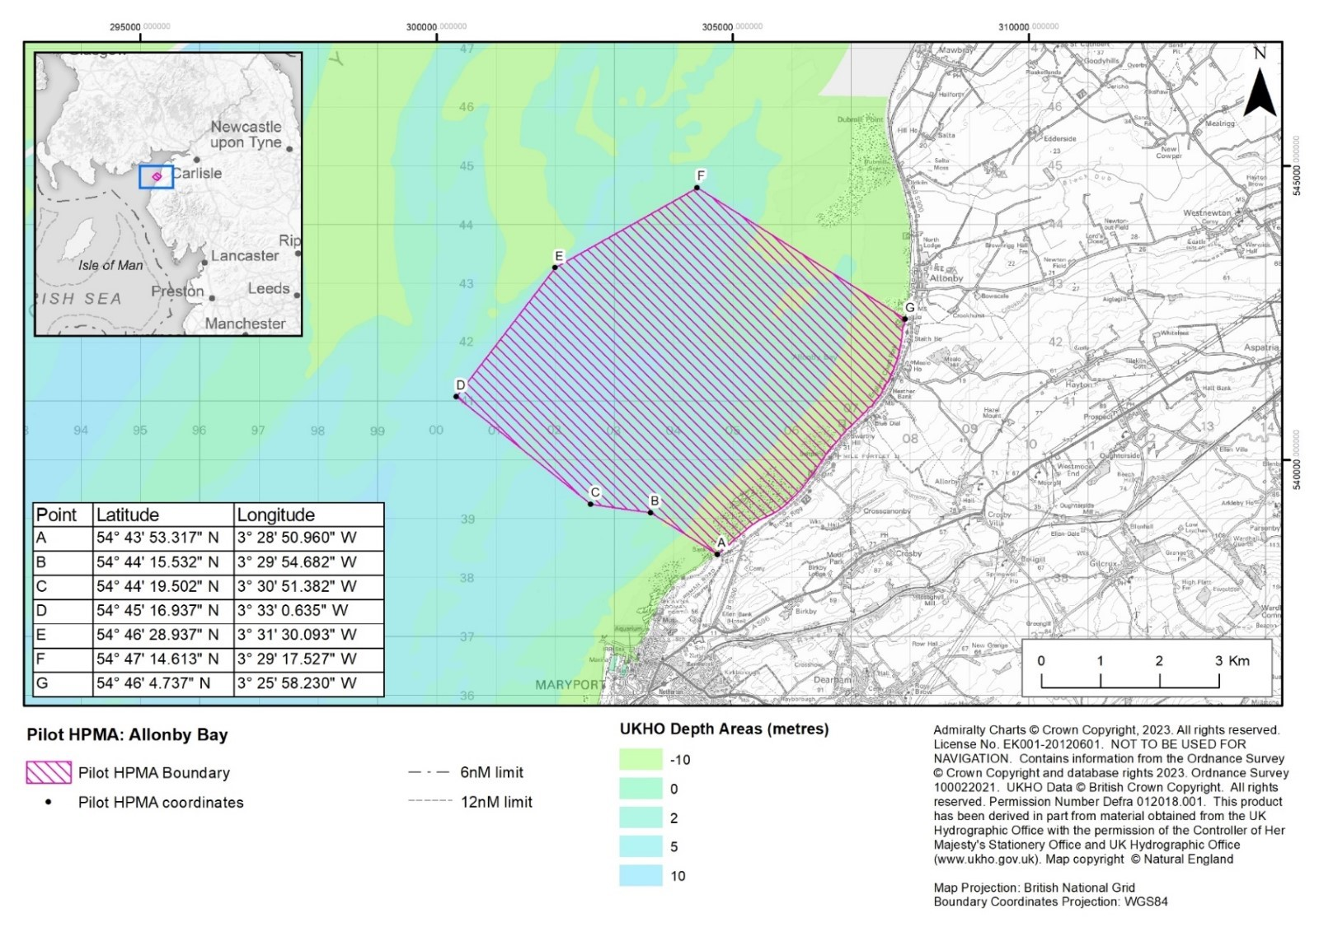
Figure 1. Candidate HPMA Allonby Bay proposed boundary and coordinates.
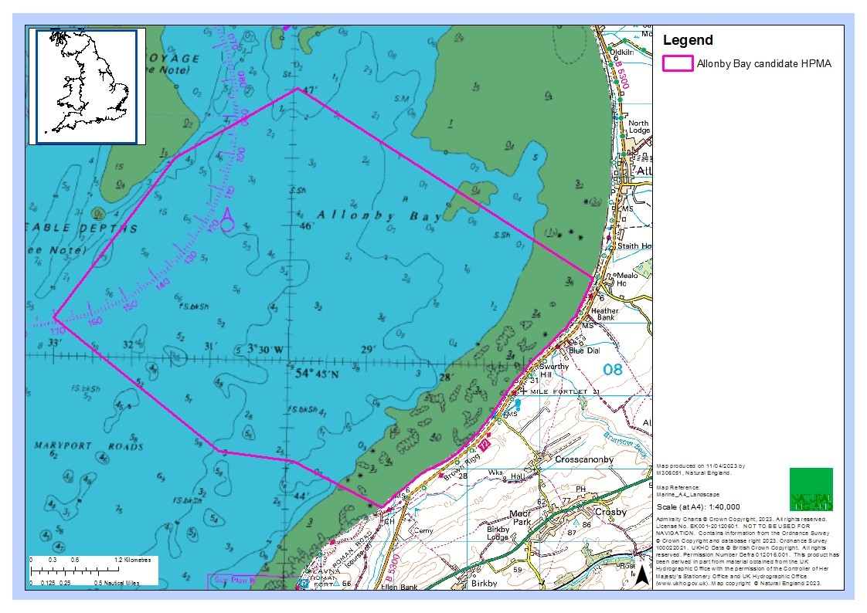
Figure 2. Candidate HPMA Allonby Bay chart datum.

Allonby Bay consists of a mix of habitats, characteristic of an environment that is subject to dramatic currents and tides. The seabed consists of a range of rocky habitats and sediment dominated habitats, including mudflats, sandbanks, reefs, peat and clay exposures, and biogenic reefs (Figure 3).

The nutrient-rich sediments, dense mussel beds and intertidal rocky habitats in this area attract large densities of shore birds including species such as curlew and oystercatcher. The biodiverse subtidal habitats here provide a food source for fish species, such as flat fish and nursery areas for other species such as bass, cod and herring. In turn, these fish species attract diving, foraging seabirds including guillemots, gannets and razorbills. There is also one of the best examples of honeycomb Sabellaria alveolata reefs in the UK within the site, creating a complex sediment network of tubes attached to rock creating vital habitat for crustacea and molluscs.

Previously recorded habitats in the Allonby Bay MCZ include:
- Blue mussel (Mytilus edulis) beds
- Honeycomb worm (Sabellaria alveolata) reefs
- Moderate energy littoral rock
- Low energy littoral rock
- Features of littoral rock (rockpools/ ephemeral algae)
- Littoral sand and muddy sand
- Littoral biogenic reefs
- Features of littoral sediment (ephemeral algae)
- High energy infralittoral rock
- Moderate energy infralittoral rock
- Moderate energy circalittoral rock
- Sublittoral coarse sediment
- Sublittoral sand
- Sublittoral mud
- Sublittoral mixed sediments
- Sublittoral biogenic reefs

For full site details please see: Highly Protected Marine Areas (HPMAs) - GOV.UK (www.gov.uk).

A designation order covering a HPMA will set out the protected features and the conservation objectives applicable within the HPMA site boundary. The protected feature is: “The marine ecosystem, habitats and species of flora and fauna, abiotic elements, and their supporting ecosystem function and processes, including the seabed, water column and sea surface, within the site boundary.” The proposed conservation objective for all pilot HPMAs, including Allonby Bay is: “To achieve full natural recovery of the structure and functions, features, qualities and composition of characteristic biological communities present within HPMAs and prevent further degradation and damage to the marine ecosystem subject to natural change.”

Natural England and JNCC advise within an HPMA:
    - The ecosystem is allowed to fully recover in the absence of damaging activities such that:
• The ecosystem structure consists of a diverse range of benthic and pelagic communities, habitats and species, including biotic and abiotic components of the ecosystem. These fulfil a variety of functional roles, including supporting key life cycle stages and/or behaviours of marine species.
• The physical, biological and chemical ecosystem processes and functions proceed unhindered, so that the site realises its full ecological potential to deliver goods and services, including habitats and species considered important to the long-term storage of carbon, and habitats and species important for flood and erosion protection.
• The ecosystem is resilient to change and stressors.

    - Any ecosystem changes brought about by the process of removing anthropogenic pressures should be considered in the context of a naturally recovering ecosystem.

3. The HPMA supports our understanding of how marine ecosystems change and recover in the absence of impacting activities

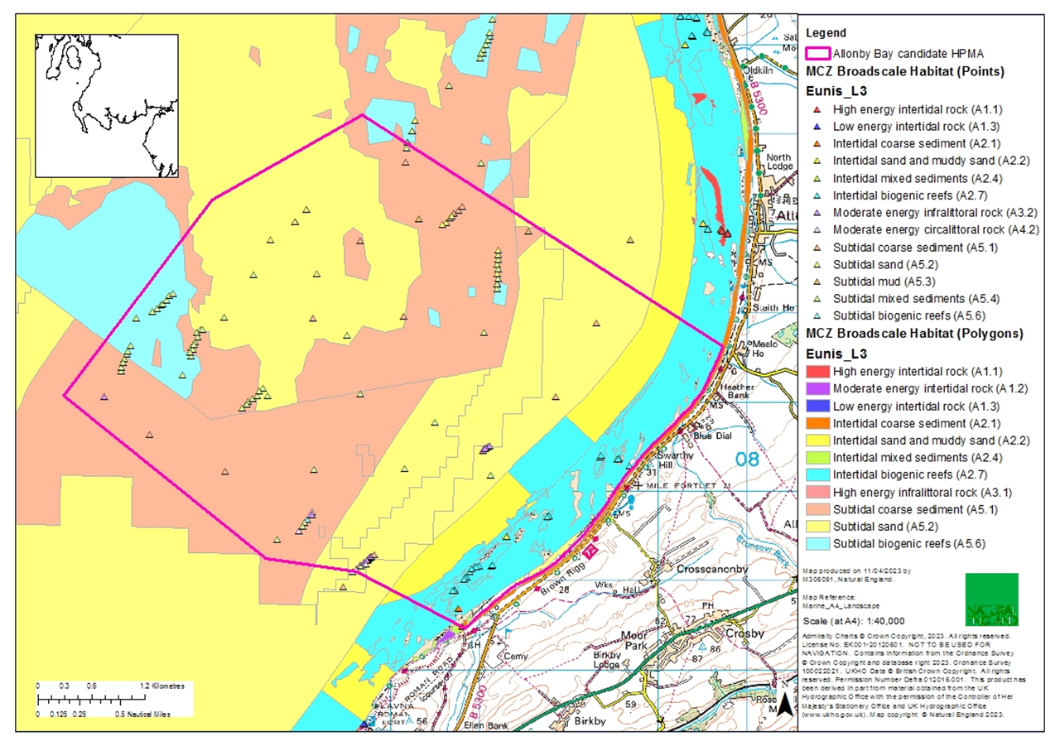
Figure 3. Current map of the broadscale habitats in Allonby Bay with the candidate HPMA boundary.
1.2 Previous Surveys

Previous intertidal surveys include the 2008 and 2012 shore surveys by the North Western Inshore Fisheries Commission Authority and the 2013 verification survey of intertidal rocky shore features (APEM, 2013) during designation of the Allonby Bay MCZ. The aim of the verification survey was to determine the presence and extent of broad scale habitats (BSH) and habitats of conservation interest (HOCI), the presence of species of conservation interest (SOCI), and to provide a baseline to inform future condition assessment (figure 4).

Earnshaw, S. (2013). Verification survey of intertidal rocky shore features in the Allonby Bay rMCZ, 2014. APEM Scientific Report 412902. RP0103 Natural England. Verification survey of intertidal rocky shore features in the Allonby Bay recommended MCZ 2013 - RP01603 (naturalengland.org.uk)

A GI package from the Natural England Marine Evidence database will be provided to the successful contractor. The datasets shown in Figure 4 should be incorporated into the current report, and the contractor is invited to suggest an integrated survey plan taking methodology from previous surveys into account.

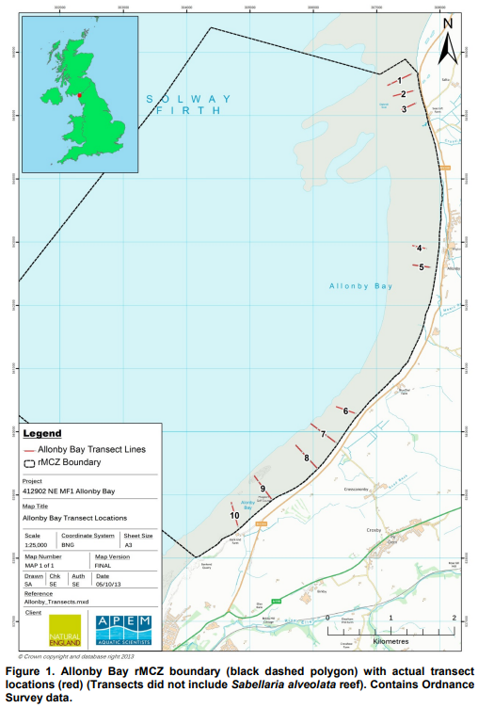

Figure 4. Allonby Bay rMCZ boundary (black dashed polygon) with actual transect locations (red) from the 2013 verification survey (Transects did not include Sabellaria alveolata reef). Contains Ordnance Survey data.

Aims & Objectives

2.1 Aims

Natural England is commissioning ecological survey work in summer 2023 to understand the extent and distribution of intertidal broad-scale habitats in Allonby Bay candidate HPMA. This project will include Phase I and Phase II intertidal survey work during the Summer of 2023 (July to October) in order to gather robust evidence on the distribution, extent and quality of intertidal habitats and features of intertidal habitats (sediments, rock, biogenic reef).

The survey design should achieve the following:
- Acquire high quality data to establish a baseline of the extent and distribution of the following habitats: Littoral rock and sediment habitats and biogenic reef.
- Acquire high quality data where the abundance of species present in the different biotopes is recorded.
- Acquire high quality biological data of suitable resolution to allow key attributes of condition to be assessed according to Common Standards Monitoring guidance for the intertidal habitats. This data should be sufficient as to provide detailed baseline information.
- Specify how the survey work will be carried out, including equipment to be used, improvements to previous methodologies (Godsell & Fraser, 2013), and how challenging conditions that occur within Allonby Bay cHPMA will be accounted for.

Survey work should be scheduled to be completed between July – October 2023.

This project will deliver a detailed map of features at a range of EUNIS levels. Natural England will interrogate and analyse the detailed evidence collected (as part of a separate exercise) to inform the baseline for which the recovery can be evaluated against during the duration of the HPMA pilot project. In addition, this data will provide the latest evidence on the extent and distribution of MCZ designated features which NE can use for MCZ condition assessment reporting in subsequent projects.

2.2 Objectives
The main objectives for this contract are to, in collaboration with Natural England, plan, undertake and report on Phase I and Phase II intertidal survey work in the summer of 2023 collect baseline data and inform future assessment of the recovery of intertidal habitats in Allonby Bay candidate HPMA. Surveys should determine the presence and extent of intertidal habitats both inside the HPMA boundary and north of the HPMA boundary (within Allonby Bay MCZ) to allow for comparison between condition inside and outside the HPMA which will be referred to as a control site. In addition, under this contract cores samples will be collected, and Particle Sample Analysis carried out to help characterise sediments and conduct contaminant testing.
Environmental indicators have been identified to measure change and assess recovery over time in HPMAs. Biotic and abiotic attributes are set out for each indicator and consider a whole-site management approach (Annex 1).

Primary indicators to monitor in this survey:
- Benthic habitats (extent and distribution)
- Benthic species (distribution, abundance, diversity)
- Invasive species
- Sediment biota (biomass)
Secondary indicators to monitor:
- Shellfish

Under this specification the successful Contractor(s) must:
- Develop, agree and implement, in collaboration with Natural England, a survey plan to collect data suitable for undertaking assessment of the direction of ecological change within the communities/habitats identified under this specification, integrating and interrogating previously obtained relevant data in the analysis.
- Where possible, ensure that newly collected data is compatible (analytically) with historical survey data, but at the very least will make reference to and utilise such historical data.
- In agreement with Natural England, implement a statistically robust survey design to enable future collection of compatible data, permitting quantitative long-term analysis. This should seek to build on any previous work listed (please refer to section 1.2 above) and, where possible, enable temporal comparisons to be made with previous datasets overall objective is to provide an ecosystem asset map comprising the location and quality of intertidal habitats.
- Ensure anthropogenic influences, potentially impacting intertidal features, are identified, and where possible quantified, allowing analysis to focus on investigation of the potential impacts of these pressures (e.g. bait digging, fishing activities, coastal defence works, and damaging activities). These should be mapped where possible in accordance with the methods outlined in the CCW Phase I Biotope Handbook and should include damaging or potentially damaging activities.
- Provide an evidence based preliminary assessment of the condition of intertidal benthic habitats in Allonby Bay candidate HPMA, clearly stating out how the assessment is supported by the analysis of data collected. This should note any difference in observed condition between similar communities which are subject to varying degrees of anthropogenic pressures to focus analysis on investigating particular impacts.
- Provide fully detailed methodology for the work undertaken to ensure that methods can be repeated in the future.
- PSA and contaminant analysis will be undertaken as part of this contract. Please note, whilst this invitation to tender covers both the survey and analysis elements, these elements could be awarded separately. Tenderers should therefore cost for these elements separately but indicate where cost savings could be made if both elements were awarded to a single tenderer.
- Infaunal analysis will be undertaken by a third-party contractor under a separate NE/EA framework (Infaunal sample analysis is therefore not required in the costing). However, the contractor will be expected to prepare samples for transport to the laboratory (e.g. sieve and fix samples in formaldehyde, package ready for transport in similar pots used by the EA’s National Laboratory Service, and arrange courier). The successful Contractor(s) must liaise with the successful lab and ensure samples are couriered to the lab for analysis. Where Samples cannot be sent immediately; this must be stored by the Contractor in a safe refrigerated facility prior to postage. Please ensure that the postage is included in the costing.
- Produce a concise field report.
- Provide all data to the relevant standards including GI and Marine Recorder data (see details below).

Methods
3.1 Development of a Suitable Sampling Design

A sampling design needs to be developed for this work. This should seek to build on any previous work listed in section 1.2 and enable temporal comparisons to be made with previous datasets (where data has been collected at the same time of year).
In developing an appropriate sampling strategy, it is not necessary for contractors to simply repeat previous methodologies undertaken; rather they should seek to implement an improved approach which enables a comparison with existing data but at the same time delivers Natural England’s requirements for a whole site approach to collecting data. It is important to ensure the sampling design includes enough sampling effort to provide a sufficient baseline to detect change over time with future monitoring.

3.2 Pre-survey Deskwork

Before the survey is carried out, the successful Contractor will discuss any pre-survey work with the Natural England contract manager, including:
- Clarification of roles, responsibilities and expectations
- Acquisition and checking of sources of relevant information and gathering of local advice in preparation of a project plan
- Review existing information provided by Natural England or any datasets known to the contractor.
- Ways of working and close collaboration with NE in developing project plan, particularly selection of survey sites, and finalising survey design and methodologies. For example, intertidal surveys will need to consider the use of hovercrafts and/or quad bikes to conduct surveys, which will require a Habitats Regulations Assessment (HRA).
- Ensure that up to date charts are used to position sample sites away from cables, pipelines or any other coastal infrastructure. Should any coastal infrastructure exist within an area to be sampled then a buffer should be used to ensure that sampling activity does not cause damage and this should be clearly displayed within the survey plan. Should coastal infrastructure be found during fieldwork then any sample sites should be relocated and the Nominated Officer informed.

3.3 Site Access

The Nominated Officer should be contacted prior to commencement of any fieldwork.

Natural England will work with the successful Contractor to obtain permission from seabed owners or leaseholders for survey work on the seabed and will supply a copy of these permissions. Where access is required to privately owned land (e.g. to deploy survey craft), Natural England will provide the contractor with a list of landowners and contact details. This data must be stored securely and all data deleted after completion of the survey. The contractor should ensure any system which holds authority data, including backup data, should be secure and compliant with Defra guidelines. Each member of the survey team must carry a letter from Natural England to confirm that they are doing this work on the behalf of Natural England. Survey work will not be able to begin until access permissions have been obtained by Natural England.
Contractors should allow for the option for inclusion of Natural England staff on surveys wherever feasible. The Natural England contract manager will liaise with the contractor regarding the availability of Natural England staff to join the survey.
Where contractors intend to use either a vessel or hovercraft to access sites this requirement should be made clear in the tender submission and any use of these vehicles will be subject to SSSI consent and Habitats Regulations Assessment (HRA). This should be discussed from the outset with the Nominated Officer and site leads.

The removal of sediment samples from the seabed must meet the terms of a marine licence exemption set out in Article 17 of the Marine Licence (Exempted Activities) Order 2011 (as amended) . The MMO require notification of any exempted activities occurring; Natural England will be responsible for submitting the relevant information to the MMO for this.
Natural England will be responsible for obtaining permissions from the Crown Estate

3.4 Field Survey

3.4.1 Phase I Survey

Natural England envisages that the Phase I survey will cover 100% of the site. This survey should be planned in accordance with the methods detailed in the CSM guidance, JNCC Marine Monitoring Handbook (Davies et al., 2001) and the CCW Handbook for Marine Intertidal Phase I Survey and Mapping (Wyn et al., 2000).

3.4.2 Phase II Survey

This broad-scale “walkover” style survey is to be supported by stratified targeted in-situ survey stations distributed along transects across the site. In-situ sampling at these stations is intended to quantify the species assemblages and corroborate biotope assessment made during the Phase I survey which will also provide in-situ granulometry and faunal descriptions. This survey should be planned in accordance with the methods detailed in the CSM guidance, JNCC Marine Monitoring Handbook (Davies et al., 2001) and the CCW Handbook for Marine Intertidal Phase I Survey and Mapping (Wyn et al., 2000).

A robust sampling strategy for Phase II infaunal sampling of target intertidal habitats (e.g. coverage and other elements such as stoney/cobble reef, biogenic reef (Mytilus and/or Sabellaria and particular shellfish species (i.e. Cerastoderma) etc. should be implemented. The Phase II survey plan should be agreed following the results of the Phase I survey to ensure samples are taken from across representative and target habitats in accordance with the aims and objectives.

Sample locations should be:
- Geographically spread throughout the site
- Representative of the range of target habitats of interest (including a range of sediments for coring samples)
- Proportionate in their split to the overall coverage of the sediment of interest
- Randomly located within the broad intertidal habitat types identified through Phase I
- Distributed across the site as transects with stations at high, mid and low shore (where appropriate)
- If appropriate sampling can be stratified using the sectors described below

Natural England requests that the Contractor conducts phase II surveying along 16 transects within Allonby Bay (8 within the HPMA and 8 north of the HPMA boundary) spread across a range of sediment and rock habitat types. Natural England envisages approximately 64 sampling stations spread across the transects.
Along transects covering sediment single cores should be taken from each station (0.01m² - 15cm core, 0.5mm mesh sieve) for infaunal sampling (abundance). Triplicate samples should also be taken and stored separately at a subset of stations, 1 along each transect (be mindful of previous Water Environment Regulations (WER) samples in the water body and number of triplicates needed for WER monitoring requirements). However, unlike WER methodology, these triplicate samples should be treated as individual samples and not combined. A further 0.01m² core will be collected for PSA analysis at each station. Additionally, sample should be collected for contaminants analysis (1 at each transect). Each station should also have a redox and an interstitial salinity measurement.
Along transects covering rock or biogenic reef quadrats will be taken at each station, paying particular attention to sabellaria reef and blue mussel bed. An indication of reefiness should be given and sufficient data collected on the quality of the reef features to enable change in ephemeral features to be detected, e.g. cast occupancy, size classes of mussel etc.

Faunal sampling should conform to standard methodology ISO 16665:2014, and identification should be carried out in accordance to the NMBAQC quality control guidelines following Standard Operation Procedure ES-04.

Survey work under the contract should be scheduled to be completed by the end of October 2023, however potential contractors should provide contingency dates should the planned survey be affected e.g. by weather downtime.

Surveys will be carried out in accordance with the technical specification provided above. Alternative approaches will be considered if they meet the aims and objectives of the contract, demonstrate efficiencies and are agreed with NE prior to survey commencing.

3.5 Data analysis

PSA and contaminant sample analysis will be undertaken as part of this contract. Please find details of contaminant analysis required in Annex 2. Infaunal sample analysis will be undertaken through a separate NE/EA framework. Provide fully detailed “standard operating protocols” for the work undertaken to ensure that methods can be repeated in the future.

3.6 Invasive Non-Native Species

Invasive Non-Native Species (INNS) are considered to be one of the top five pressures directly driving biodiversity loss globally. Prevention is the key focus, particularly in marine environments. The contractor shall be aware of and work in accordance with standard good practice biosecurity measures to avoid spread of INNS:
- Equipment, clothes and boots should be clean before carrying out any work on site
- When on or near water it is important that equipment is drained after use and as far as possible dried
- Boats to be used in survey work should have their hulls cleaned on a regular basis. Best practice guidelines should be followed as outlined by The Green Blue.
INNS species previously recorded in this region and/or to particularly look out for during this survey. See GB non-native species secretariat.
The Contractor must report any records of INNS observed on site on Marine Recorder and to the Natural England project officer as part of the survey report. Any species currently listed as ‘alert’ species should be flagged immediately to the GB Non-Native Species Secretariat http://www.nonnativespecies.org/alerts/index.cfm. More information and guidance including ID guides can be found at www.nonnativespecies.org and the Marine Aliens Project.

3.7 H & S Requirements

All risk assessments need to be seen and signed off by the Nominated Officer (ideally when presented with then project plan), as part of the contract management process. Risk assessments need to be provided by the Contractor. Surveys will be done out of season, risks around reduced daylight and poor weather etc. need to be highlighted.

3.8 Weather Downtime & Contingency

Survey windows should be allocated in accordance with the best tides available. Contractors will be expected to check weather regularly (daily) prior to agreed survey windows. If contractors have 48 hours' notice of impending poor weather then they will be expected to make alternative arrangements for the duration of the poor weather and reschedule survey work to be completed at a later date. If contractors have not yet mobilised then Natural England is not expected to be charged for any weather downtime. It is the responsibility of the contractor to contact Natural England in the event that impending poor weather is putting the survey at risk.
Natural England does not envisage paying for downtime or contingency time for intertidal contracts, but in the event of unforeseeable weather events, a maximum of 1 day may be paid.
In the event of uncertainty or other unforeseen events that impact upon the ability of the contractor to undertake the survey, the Natural England Nominated Officer should be contacted immediately.

Survey outputs
This contract shall be managed on behalf of the Authority by Camille Burton

  - Reporting requirements

The successful contractor should produce a field report and brief report outlining

- The survey methodology used,
- A timeline of events and actions
- Any difficulties encountered
- A brief discussion and interpretation of the data i.e. obvious features, areas of similar sediment type, areas of sediment change, identification of seabed features.
- Inclusion of infaunal and sediment data analysed by third party
- Maps of habitats identified at biotope level (level 4/5) where possible and higher.

Draft reports should be provided in electronic MS Office Word *.DOCX format for comment. A template and guidance exists for writing Natural England commissioned reports and will be sent to the contractor upon award of the tender. All reports should retain a clear suggested citation stating that it is a ‘Report to Natural England.’

  - Data requirements
Appropriate survey level metadata should be supplied in a format acceptable for the corresponding MEDIN Data Archive Centre (DAC). All interpreted products following data analysis should accompany the draft report; these will include:
- All GIS datasets need to be provided in ESRI ArcGIS format compatible with ArcGIS 10.2 and have attached metadata.
- All GIS files containing habitat data for each individual survey need to be produced to the MESH translated habitat Data Exchange Format (DEF) to the most detailed EUNIS habitat level possible. MNCR (v15.03) data should be added to the ORIG_HAB column. The GUI provided by Natural England for each survey will be used, and as much information as possible (e.g. survey name, originally assigned feature/habitat name etc.) from the original dataset, as well as any documentation provided (where available) should be included in the resulting datasets to maintain a useful audit trail. As specified in the MESH DEF, data files must be provided as ESRI Shapefiles or as a feature class data within a geodatabase using the WGS1984 geographic coordinate system and lat/long coordinates. If not included in the GIS data layers listed above all sampling locations, vessels tracks, and links to data obtained should also be included as a single GI layer.
- A MESH data confidence assessment for each habitat map should be calculated and provided in a ‘MESH confidence scoresheet’ *.XLS file. The confidence assessment process is described and a template provided in the following MESH resources The MESH Confidence Assessment Scheme.
- Natural England are a member of the UK Centre For Seabed Mapping and also endorses the MEDIN initiative. Any data gathered/derived as part of this project must be submitted to Natural England in MEDIN data standards through Data Archive Centres (DACs) with metadata meeting the MEDIN metadata discovery standard (MEDIN discovery metadata standard). A MEDIN compliant metadata XML file must be provided for each survey.
- Copies of the original data spreadsheets or databases are to be provided in the appropriate Microsoft Office format
- Stills photographs to be provided in their raw format on CD/DVD or USB compliant external hard drives.
All sample data (e.g. grab sample analyses, video/still photography analyses, PSA analysis and biotope lists, biological taxon data) need to be entered into the latest version of Marine Recorder. NBN data and an exported snapshot file of the data should be provided for QA. Natural England will provide licence keys for Marine Recorder. Natural England will supply a ‘Marine Recorder guidance for contractors’ document to successful contractors.

The Contractor must report any records of Invasive and Non-Native Species observed on site on Marine Recorder and to the Natural England project officer as part of the survey report. Any species currently listed as ‘alert’ species should be flagged immediately to the GB Non-Native Species Secretariat Species alerts. More information and guidance including ID guides can be found at GB non-native species secretariat.

Copies of the original data spreadsheets or databases are to be provided in the appropriate Microsoft Office format. However please be aware that using MEDIN marine biodiversity data guideline spreadsheets (available online under the marine biodiversity tab at MEDIN data guidelines) will ensure that biological taxon data is prepared correctly for entry into Marine Recorder and will facilitate the efficient entry of data into this system and the data archiving process in general. Natural England welcomes and supports the provision of raw data spreadsheets in the MEDIN format and expects that all raw datasheets will contain the mandatory fields in the MEDIN guidelines, regardless of their format.

Standard survey imagery (stills and video) is to be provided in their raw format electronically or on USB compliant external hard drives (to be provided by the contractor).

High quality imagery which has been selected to form part of the image reference collection for the survey need to be labelled appropriately, including the habitat/species which is represented. These should be provided as a separate folder on the storage device to the standard survey imagery.

All data products and electronic files must be appropriately named so they sufficiently describe the contents and are not purely a numerical value. All products should be named appropriately so that they can be clearly linked to the report/project.

Any species lists submitted will be compliant with current taxonomic names and synonyms (e.g. Marine Species of the British Isles and Adjacent Seas (MSBIAS), World Register of Marine Species (WoRMS))

Video and still camera filenames must include the recording start date and time. Position data must be included within the overlay information.

The NE Project Officer will raise purchase orders to cover the cost of the services and will issue to the awarded supplier following contract award. Upon completion of the survey, the first of two staged payments for this contract will be released. Final payment will be issued upon completion of the final report.

Timeline for project delivery
Event | Date
Successful contract awarded | 17/07/2023
Finalise sampling design | 04/08/2023
Produce final project plan | 11/08/2023
Survey to be completed by | 04/09/2023
Submission of brief field/survey report by | 25/09/2023
Draft final report and associated products to be provided by | 30/11/2023
Final report, biotope maps and output to be delivered | 20/12/2023

Any delays to this timetable should be discussed with the Natural England Project Officer and delays not outside the control of the contractor will be penalised.

5 Other

In support of this contract NE will provide the winning supplier with:

- Project support from dedicated Project Officer
- Opportunity to feedback and discuss progress and the project
- Supporting GIS datasets (if required) under licence for use in this contract:
  - Base map data from Ordnance Survey
  - Aerial photography from Next Perspectives
  - S-57 vector data from the UK Hydrographic Office (in ArcGIS format)*
  - Raster charts from Oceanwise*
*(Not to be used for Navigation)

Please see the following site for information on how to obtain access to the GI datasets listed above: https://www.gov.uk/how-to-access-natural-englands-maps-and-data

- Additional reports to help with the analysis and report, such as those listed in Section 1.2

The intellectual property rights and copyright for all products (including photographs) will lie with Natural England. All data will be made available by Natural England under the Open Government Licence at the end of the project via www.data.gov.uk and the MEDIN Data Archiving Centres.

6 References

Davies, J., Baxter, J., Bradley, M., Connor, D., Khan, J., Murray, E., Sanderson, W., Turnbull, C. & Vincent, M., (2001). Marine Monitoring Handbook, 405 pp, ISBN 1 85716 550 0. Available online at: http://jncc.defra.gov.uk/page-2430

Earnshaw, S. (2013). Verification survey of intertidal rocky shore features in the Allonby Bay rMCZ, 2014. APEM Scientific Report 412902. RP0103 Natural England. Verification survey of intertidal rocky shore features in the Allonby Bay recommended MCZ 2013 - RP01603 (naturalengland.org.uk)

JNCC (2004). Common Standards Monitoring Guidance for Marine, Version August 2004, ISSN 1743-8160. Available online at: http://jncc.defra.gov.uk/page-2236
Payment
The Authority will raise purchase orders to cover the cost of the services and will issue to the awarded supplier following contract award.
The Authority’s preference is for all invoices to be sent electronically, quoting a valid Purchase Order number. Invoiced as agreed with the Authority after certain project milestones.
It is anticipated that this contract will be awarded for a period of five months to end no later than 20/12/2023. Prices will remain fixed for the duration of the contract award period. We may at our sole discretion extend this contract to include related or further work. Any extension shall be agreed in writing in advance of any work commencing and may be subject to further competition.
Evaluation Methodology
We will award this contract in line with the most economically advantageous tender (MEAT) as set out in the following award criteria:
Technical – 60%
Commercial – 40%
Evaluation criteria
Evaluation weightings are 60% technical and 40% commercial, the winning tenderer will be the highest scoring combined score.

Award Criteria | Weighting (%) | Evaluation Topic & Weighting | Sub-Criteria | Weighted Question
Technical | 60% | Service / Product Proposal | Methodology | 1 Question  Q1.1 (60% of technical score available)
Technical | 60% | Service / Product Proposal | Key personnel | 1 Question  Q2 (20% of technical score available)
Technical | 60% | Service / Product Proposal | Quality Assurance measures | 2 Questions  Q3.1 (10% of technical score available)
Technical | 60% | Service / Product Proposal | Health & Safety | 1 Question  Q4 (10% of technical score available)
Technical | 60% | Service / Product Proposal | Availability/ capacity | 1 Question  Q5 (Pass/ Fail)
Commercial | 40% | Whole life cost of the proposed Contract | Commercial Model | 1 Question  Q4 (100% of commercial score available)

Technical (60%)
Technical evaluations will be based on responses to specific questions covering key criteria which are outlined below. Scores for questions will be based on the following:
Description | Score | Definition
Very good | 100 | Addresses all the Authority’s requirements with all the relevant supporting information set out in the RFQ. There are no weaknesses and therefore the tender response gives the Authority complete confidence that all the requirements will be met to a high standard.
Good | 70 | Addresses all the Authority’s requirements with all the relevant supporting information set out in the RFQ. The response contains minor weaknesses and therefore the tender response gives the Authority confidence that all the requirements will be met to a good standard.
Moderate | 50 | Addresses most of the requirements with most of the relevant supporting information set out in the RFQ. The response contains moderate weaknesses and therefore the tender response gives the Authority confidence that most of the requirements will be met to a suitable standard.
Weak | 20 | Substantially addresses the requirements but not all and provides supporting information that is of limited or no relevance or a methodology containing significant weaknesses and therefore raises concerns for the Authority that the requirements may not all be met.
Unacceptable | 0 | No response or provides a response that gives the Authority no confidence that the requirement will be met.

Technical evaluation is assessed using the evaluation topics and sub-criteria stated in the Evaluation Criteria section above.
Separate submissions for each technical question should be provided and will be evaluated in isolation. Tenderers should provide answers that meet the criteria of each technical question.

Methodology | Detailed Evaluation Criteria
Q1.1 Provide details of the methodology and approaches proposed to deliver the requirements of this project.  Responses should not exceed four sides of A4, and use Arial font, size 11. | Your response should:  1) Demonstrate a clear understanding of the nature of the requirements.  2) Be a clear, practical, achievable, and cost-effective methodology to deliver these requirements.  3) Have information in sufficient detail to allow a full appraisal of the suitability of the approach to deliver for the project.

Key Personal | Detailed Evaluation Criteria
Q2.1 Please provide evidence of experience of key staff | Could be demonstrated in providing CVs, staff profiles or evidence of completed relevant projects

Quality Assurance | Detailed Evaluation Criteria
Q3.1 Please provide evidence of the quality assurance methods used during the survey and the analysis of samples | The audit trail required and sufficient data for supporting biotope assignments, the QC procedure for samples.

Health and Safety | Detailed Evaluation Criteria
Q4.1 Provide a statement on how you ensure Health Safety requirements are met | Please supply a proposed health and safety plan and how you mitigate the risks of surveying the intertidal tidal area of Allonby Bay.

Availability | Detailed Evaluation Criteria
Q5.1 Provide a statement on your  availability & capacity carry out the work | Please supply a proposed schedule of work, stating the timescales you will be able to execute and deliver the products specified above. See Section 5 Timeline for project delivery

Commercial (40%)
The Contract is to be awarded as a fixed price which will be paid according to the completion of the deliverables stated in the Specification of Requirements.
Suppliers are required to submit a total cost to provide the deliverables stated in the Specification of Requirements. In addition to this the Commercial Response template must be completed to provide a breakdown of the whole life costs against each deliverable used in the delivery of this requirement.
Calculation Method
The method for calculating the weighted scores is as follows:
Commercial
Score = (Lowest Quotation Price / Supplier’s Quotation Price ) x 40% (Maximum available marks)
Technical
Score = (Bidder’s Total Technical Score / Highest Technical Score) x 60% (Maximum available marks)
The total score (weighted) (TWS) is then calculated by adding the total weighted commercial score (WC) to the total weighted technical score (WT): WC + WT = TWS.
Information to be returned
Please note, the following information requested must be provided. Incomplete tender submissions may be discounted.
Please complete and return the following information:
completed Commercial Response template
separate response submission for each technical question (in accordance with the response instructions)
completed Mandatory Requirements (Annex 1)
completed Acceptance of Terms and Conditions (Annex 2)
Award
Once the evaluation of the Response(s) is complete all suppliers will be notified of the outcome via email.
The successful supplier will be issued the contract, incorporating their Response, for signature. The Authority will then counter sign.

Annex 1 Mandatory Requirements
Part 1 Potential Supplier Information
Please answer the following self-declaration questions in full and include this Annex in your quotation response.
Part 1.1 Potential Supplier Information:
Question no. | Question | Response
1.1(a) | Full name of the potential supplier submitting the information
1.1(b) | Registered office address (if applicable)
1.1(c) | Company registration number (if applicable)
1.1(d) | Charity registration number (if applicable)
1.1(e) | Head office DUNS number (if applicable)
1.1(f) | Registered VAT number
1.1(g) | Are you a Small, Medium or Micro Enterprise (SME)? | (Yes / No)
Note: See EU definition of SME https://ec.europa.eu/growth/smes/business-friendly-environment/sme-definition_en
Part 1.2 Contact details and declaration
By submitting a quotation to this RFQ I declare that to the best of my knowledge the answers submitted and information contained in this document are correct and accurate.
I declare that, upon request and without delay you will provide the certificates or documentary evidence referred to in this document.
I understand that the information will be used in the selection process to assess my organisation’s suitability to be invited to participate further in this procurement.
I understand that the authority may reject this submission in its entirety if there is a failure to answer all the relevant questions fully, or if false/misleading information or content is provided in any section.
I am aware of the consequences of serious misrepresentation.

Question no. | Question | Response
1.2(a) | Contact name
1.2(b) | Name of organisation
1.2(c) | Role in organisation
1.2(d) | Phone number
1.2(e) | E-mail address
1.2(f) | Postal address
1.2(g) | Signature (electronic is acceptable)
1.2(h) | Date

Part 2 Exclusion Grounds
Part 2.1 Grounds for mandatory exclusion
Question no. | Question | Response
2.1(a) | Please indicate if, within the past five years you, your organisation or any other person who has powers of representation, decision or control in the organisation been convicted anywhere in the world of any of the offences within the summary below.
 | Participation in a criminal organisation. | (Yes / No)  If yes please provide details at 2.1 (b)
 | Corruption. | ((Yes / No)  If yes please provide details at 2.1 (b)
 | Fraud. | (Yes / No)  If yes please provide details at 2.1 (b)
 | Terrorist offences or offences linked to terrorist activities | (Yes / No)  If yes please provide details at 2.1 (b)
 | Money laundering or terrorist financing | (Yes / No)  If yes please provide details at 2.1 (b)
 | Child labour and other forms of trafficking in human beings | (Yes / No)  If yes please provide details at 2.1 (b)
2.1(b) | If you have answered yes to question 2.1(a), please provide further details.  Date of conviction, specify which of the grounds listed the conviction was for, and the reasons for conviction.  Identity of who has been convicted  If the relevant documentation is available electronically please provide the web address, issuing authority, precise reference of the documents.
2.1 (c) | If you have answered Yes to any of the points above have measures been taken to demonstrate the reliability of the organisation despite the existence of a relevant ground for exclusion? (i.e. Self-Cleaning) | (Yes / No)
2.1(d) | Has it been established, for your organisation by a judicial or administrative decision having final and binding effect in accordance with the legal provisions of any part of the United Kingdom or the legal provisions of the country in which the organisation is established (if outside the UK), that the organisation is in breach of obligations related to the payment of tax or social security contributions? | (Yes / No)
2.1(e) | If you have answered yes to question 2.3(a), please provide further details. Please also confirm you have paid or have entered into a binding arrangement with a view to paying, the outstanding sum including where applicable any accrued interest and/or fines.

Part 2.2 Grounds for discretionary exclusion
Question no. | Question | Response
2.2(a) | The detailed grounds for discretionary exclusion of an organisation are set out on this webpage, which should be referred to before completing these questions.  Please indicate if, within the past three years, anywhere in the world any of the following situations have applied to you, your organisation or any other person who has powers of representation, decision or control in the organisation
2.2(b) | Breach of environmental obligations? | (Yes / No)  If yes please provide details at 2.2 (f)
2.2(c) | Breach of social obligations? | (Yes / No)  If yes please provide details at 2.2 (f)
2.2(d) | Breach of labour law obligations? | (Yes / No)  If yes please provide details at 2.2 (f)
2.2(e) | Shown significant or persistent deficiencies in the performance of a substantive requirement under a prior public contract, a prior contract with a contracting entity, or a prior concession contract, which led to early termination of that prior contract, damages or other comparable sanctions? | (Yes / No)  If yes please provide details at 2.2 (f)
2.2 (f) | If you have answered Yes to any of the above, explain what measures been taken to demonstrate the reliability of the organisation despite the existence of a relevant ground for exclusion? (Self Cleaning)

Annex 2 Acceptance of Terms and Conditions
I/We accept in full the terms and conditions appended to this Request for Quote document.
Company ____________________________________________________
Signature ____________________________________________________
Print Name ____________________________________________________
Position ____________________________________________________
Date ____________________________________________________

http://www.oceannet.org/marine_data_standards/medin_disc_stnd.html

