Manor House External Elevations

Front Elevation 35 M x 7.5 M Total = 262.50 M²
(predominantly south west facing scout garden) including entrance.
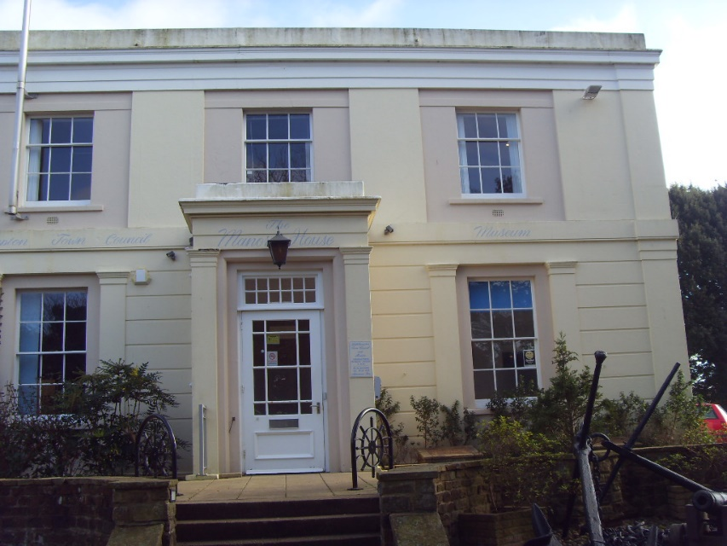

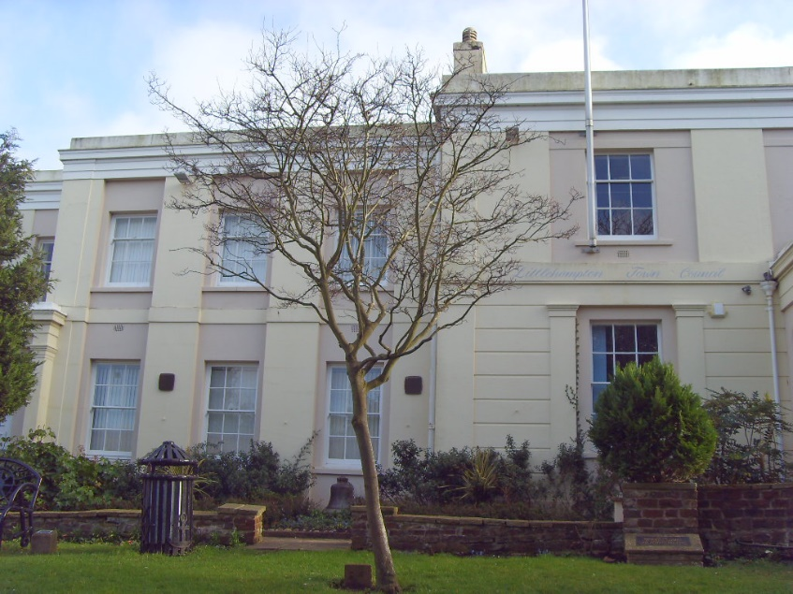

Side Elevation Church Street, 9 M x 7.5 M Total = 67.5 M²
(predominantly North facing).

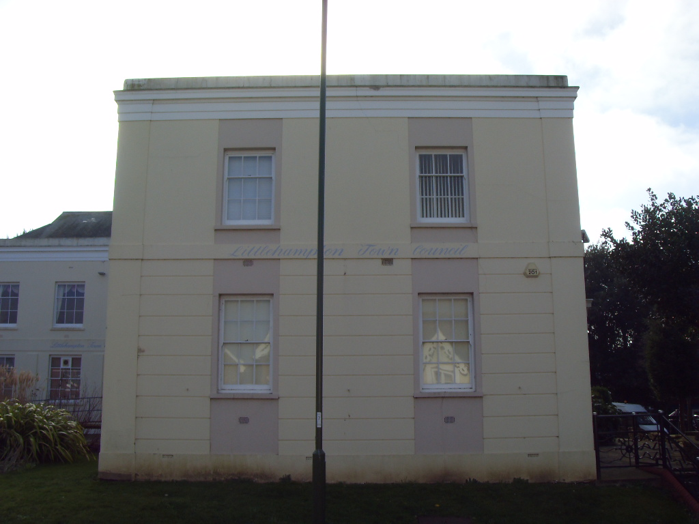

Rear Elevation 16 M x 7.5 M Total = 120 M²
(predominantly East facing). Inc emergency basement exit from boiler room.
Down pipe and rainwater goods: 1

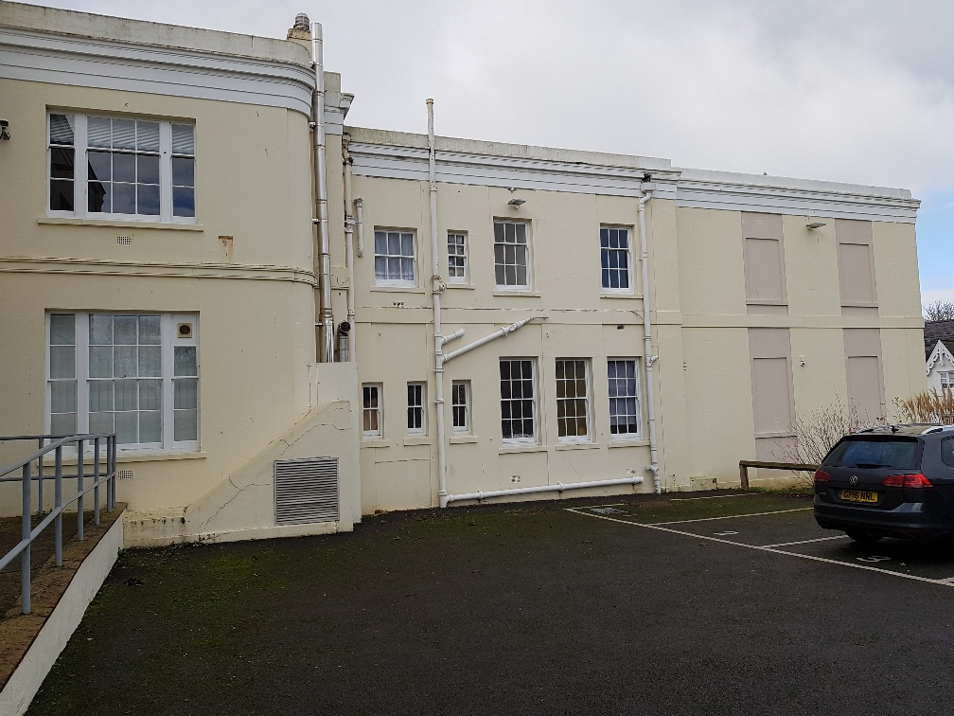

Side Elevation 12M x 7.5 Total = 90 M²
(predominantly North facing) including emergency exit ramp.
Down pipe and rainwater goods. Sign writing to facia

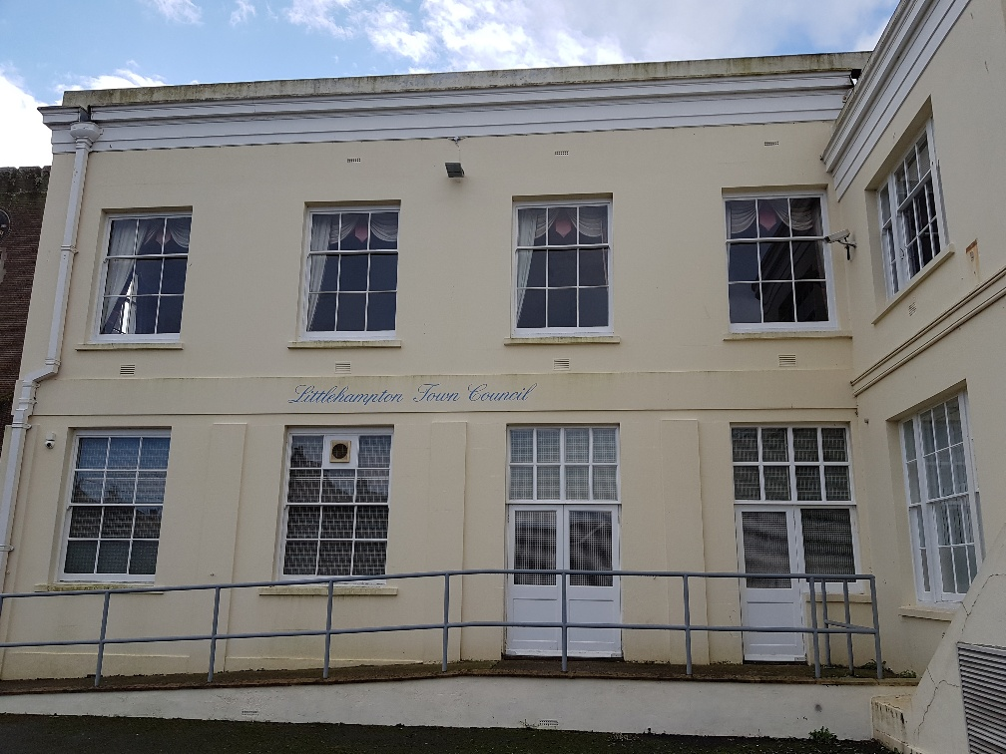

Rear Elevation 15M x 7.5 M Total = 112.5 M²
(predominantly East facing).

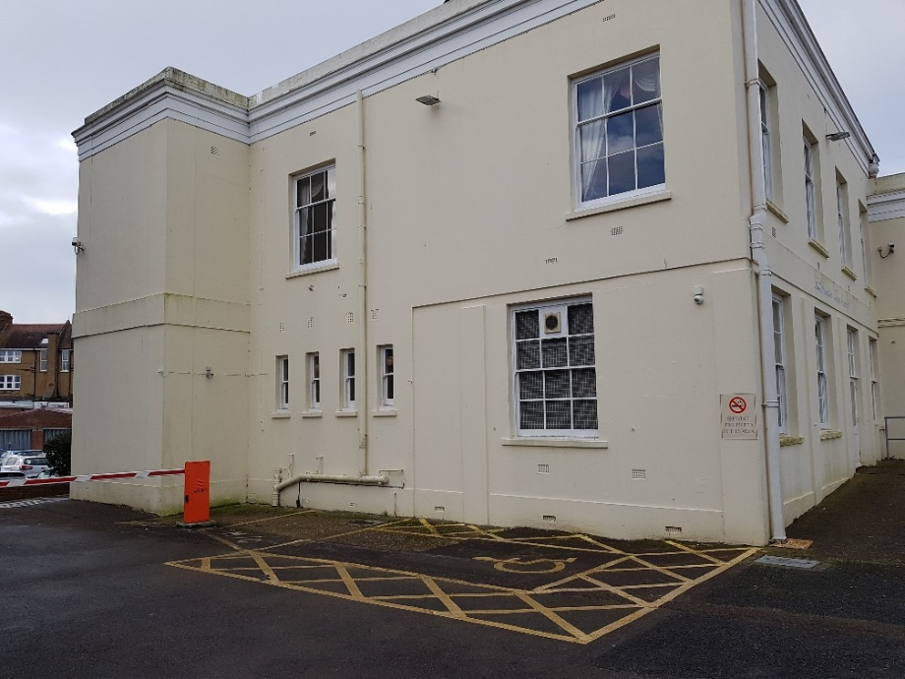

South Elevation 21.5 M x 7.5 M Total = 161M²
(predominantly South facing) including entrance to Millennium Chamber.
Handrails to ramp.

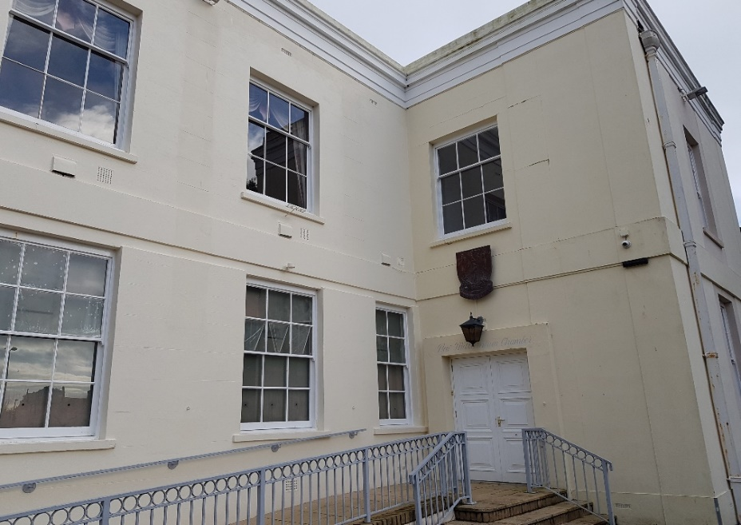

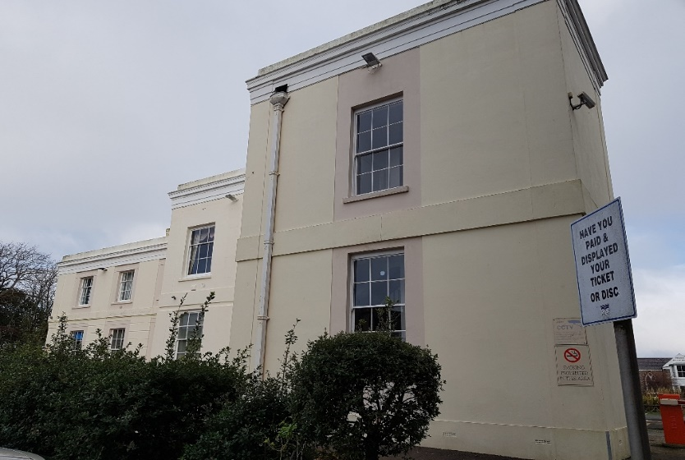
Total 1,076 M²

