PROSPECTIVE SUPPLIER LINK AND SETUP GUIDANCE

Dear Supplier,

In order to quote or tender for contracts with Thurrock Council, you need to register with Thurrock’s Oracle Cloud. Once registered you can view and respond to relevant active competitions.

Click on the following link Oracle Prospective Supplier Link which will take you to the front page registration screen and follow the directions below:

_________________________________________________________________________

Enter company name and choose “corporation” from the drop down list and enter your 9 digit DUNS number in the box. If you don’t know this now, any 9 digit number will be allowed – you will need to amend with the correct details if you are awarded a contract.

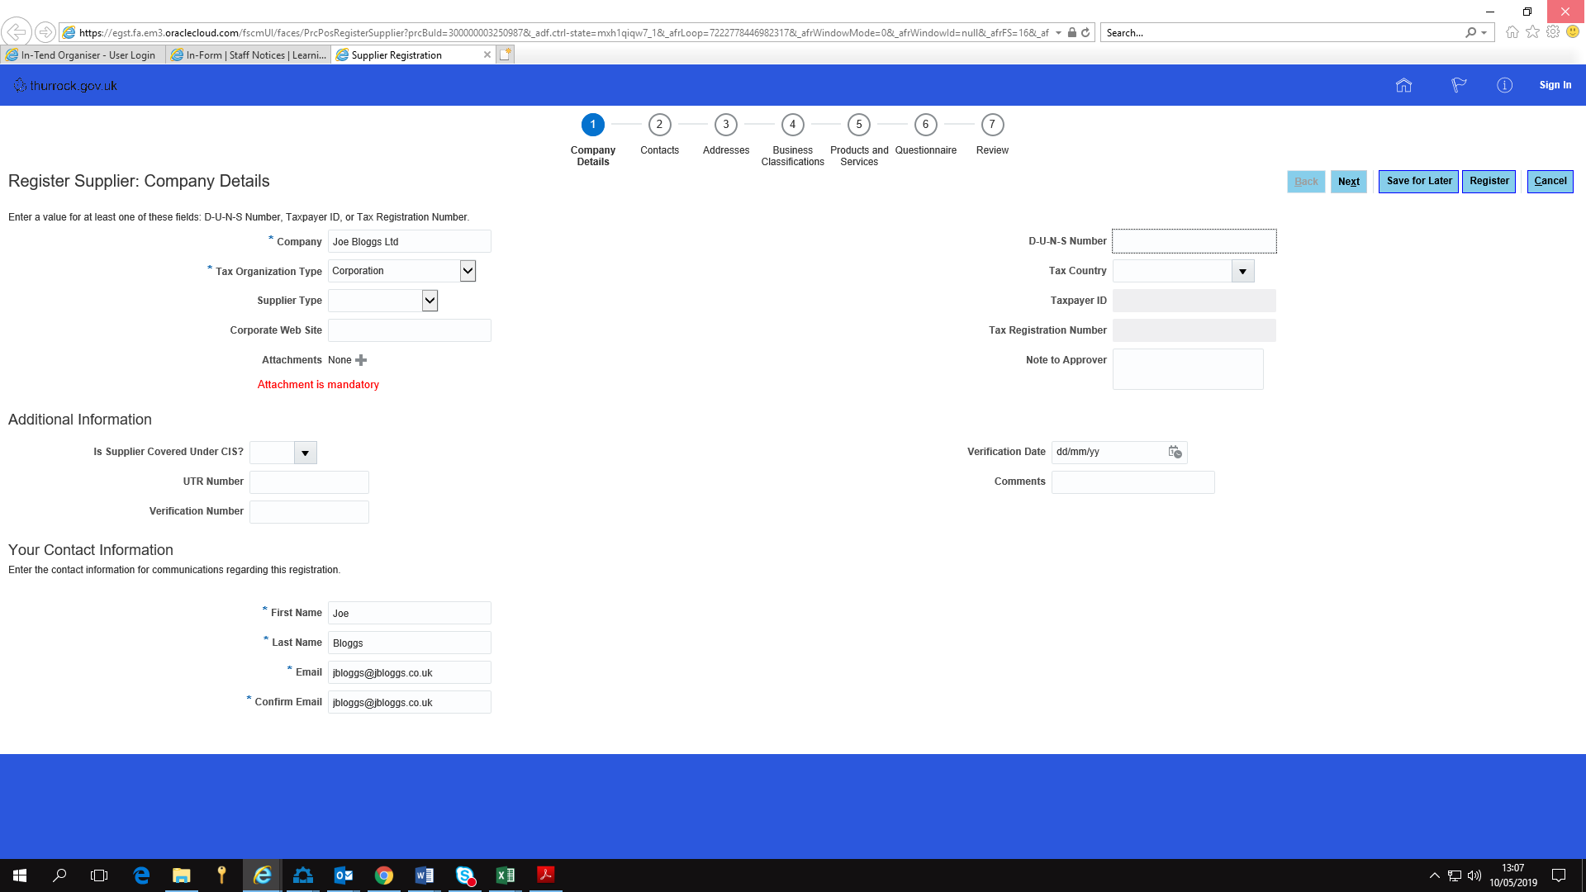

Then provide your name and email contact details.

The click “Next” at the top.

Your contact details will be confirmed on the next page. You can add another contact if you wish (eg. If you have a general Tenders@Jbloggs.co.uk email for example).

Then click “Next”. At this point you can add an address for your company, but it isn’t essential. The next step (Business Classifications) is optional too. Moving on, you reach the “Products and Services” Point.

Click on “Select and Add” and the following screen pops up.
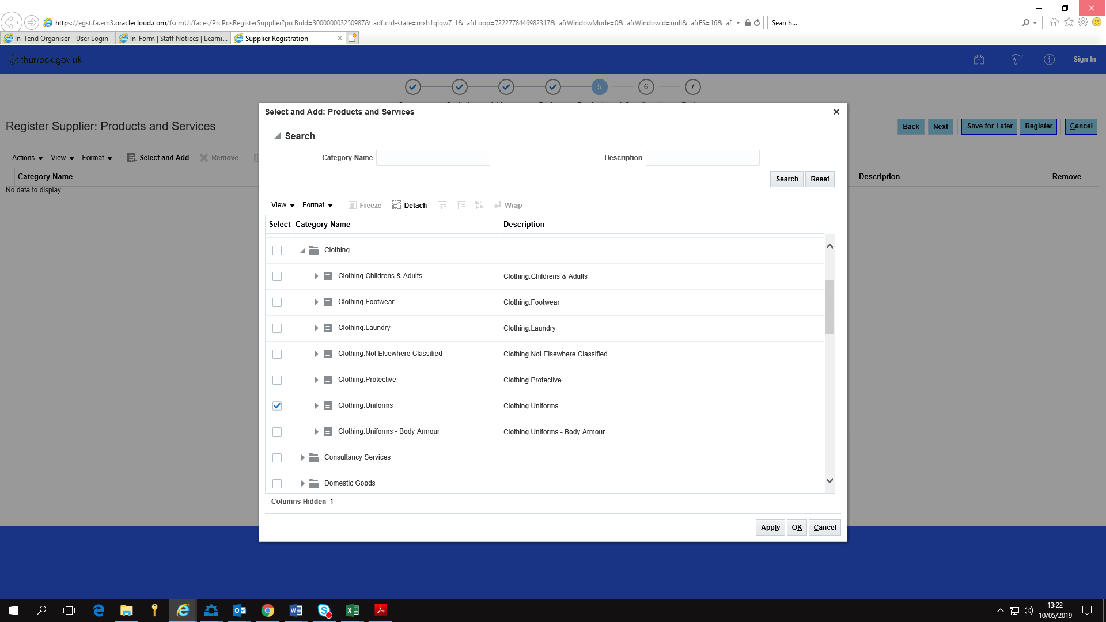

The example here, J Bloggs sells uniform so tick the appropriate box. This is very helpful to Thurrock if we are looking for specialist suppliers – so this enables us to search for companies that provide certain services or supplies, so we can invite them to bid.

Then click “Apply” and “OK”.

The next point is the “Questionnaire”

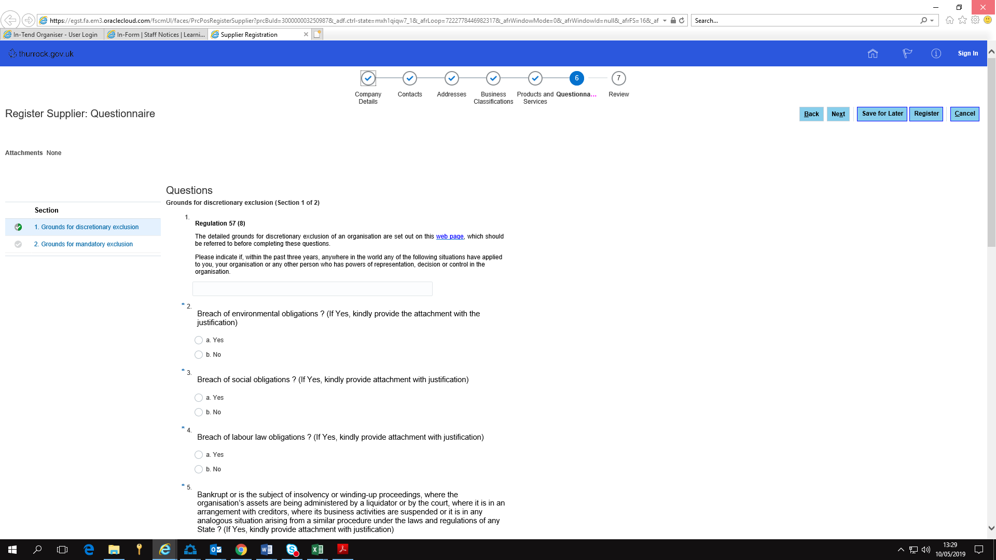

These are the standard grounds for mandatory and discretionary exclusion that public sector needs to check for all suppliers. Previously we had asked these as part of every tender exercise regardless of how many tenders you bid for each year. This questionnaire is asked on registration and then you are reminded to update it annually.

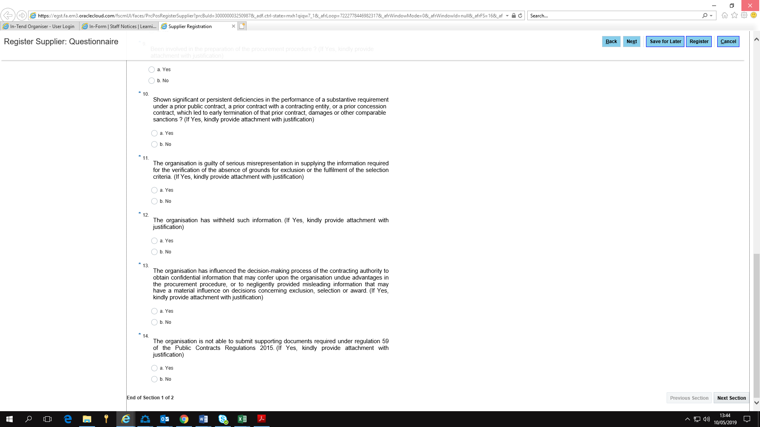

The questionnaire is tick box only, so click in the appropriate box and move on. At the bottom right hand side of the screen, click “Next Section” and one further page of questions will appear.

Then you are done. You can review if you want. You can also “Save for Later “ at any point in the process if you need to come back.

Finally, click on “Register” and your registration is submitted for approval. Approval is automatic unless the completion of the questionnaire raises a serious question about your company, in which case you will be contacted for further details.

The Oracle System then will send you an email to confirm you’ve been registered with a link to log in and reset your password.

Once complete, you’re good to go.

10/5/19

