REQUEST FOR TENDER (RFT)

BIDDERS MUST COMPLETE ALL THE AREAS SHADED IN YELLOW TO ENSURE THEIR BID IS PRESENTED IN A COMPLIANT FORMAT

SECTION ONE – LEOMINSTER TOWN COUNCIL’S CONTACT DETAILS

RFT Title | Old Priory Boiler Replacements
Department | Property
Originator telephone number | 01568 611734
RFT clarifications email address | e.womack@leominstertowncouncil.gov.uk
RFT response address | boilerprocurement@leominstertowncouncil.gov.uk
Leominster Town Council’s originator of RFT | Liz Womack/Julie Debbage

SECTION TWO – TIMESCALES

Date RFT Developed | 28th November 2024
Date/time RFT questions should be received by email to the Leominster Town Council originator as identified in Section One | Monday 9th December 2024 at 5pm.
Date/time RFT response to be received by email to the Leominster Town Council originator as identified in Section One | Sunday 15th December 2024 at midnight.
RFT Validity Period (calendar days) | 90 days
Planned notification of the result to bidders | 19th December 2024
Estimated Contract Award Date | 19th December 2024
Contract Duration | Works must be completed by 01/03/25
Payment Terms | Payment will be on completion of the contract and will be no longer than 30 days from receipt of invoice.  Interim payments can be arranged subject to a scoping meeting following the award of the contract.

SECTION THREE – SCOPE OF WORKS

Description of the Scope of Works
SITE
The Old Priory, Leominster, Herefordshire, HR6 8EQ. Scheduled Ancient Monument list entry number 1005529.

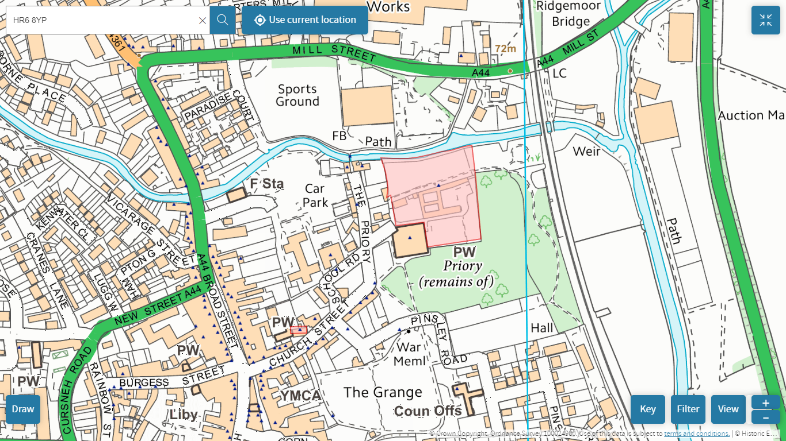

BACKGROUND

Located in the centre of the rural market town of Leominster, the Old Priory building is a large (1740m²) grade 2 listed building and scheduled ancient monument within walking distance of Leominster’s High St. Ownership of the Old Priory building was transferred to Leominster Town Council from Herefordshire Council in September 2022 via Community Asset Transfer.

The Old Priory has played an important role in Leominster’s community life for over 900 years. The building currently accommodates a number of essential organisations that sustain our community, providing vital support and representation to many of Leominster’s residents. Tenants include:
- Leominster Foodbank (www.leominsterfoodbank.org): providing emergency food support, debt advice and signposting to those in need. Also a Talk Community (Herefordshire-wide community support network) Hub.
- Leominster Meeting Centre (www.leominstermeetingcentre.co.uk): provides activities, advice, discussion groups and one-to-one support for people affected by dementia.
- ECHO (www.echoherefordshire.org.uk): a leading provider of services for people with disabilities living in Herefordshire.
- Leominster Youth Hostel (www.yha.org.uk/hostel/yha-leominster)
- Hereford Diocese (https://www.hereford.anglican.org/) – rental of storage space to support children and families ministry
Approximately 30% of the Old Priory building is currently vacant.

Leominster Town Council has worked in collaboration with the building’s current tenants and other local organisations to ensure that the Old Priory remains at the heart of Leominster’s community life as a sustainable and economically viable multi-use community asset. One that will:
- be financially sustainable, generating sufficient income to cover the costs of ongoing building management, maintenance and conservation.
- utilise the full potential of the Old Priory as a community resource.
- respect, preserve and celebrate the historical value of the Old Priory building and its significance within Leominster’s heritage.
- support community organisations and services by offering affordable, versatile and accessible office, meeting and outreach space.
- support the town economy by encouraging business development, innovation and diversification.
- support the town’s tourism by providing high quality accommodation and enhancing heritage.
- be environmentally responsible, in line with a climate and ecological emergency declaration made by Leominster Town Council.
- complement existing town services and businesses, while minimising competition.
Specifically, our vision for the Old Priory Centre incorporates:
- Community Support: the Old Priory already accommodates a number of essential community services that provide vital support and representation. By offering shared office and meeting space that can be rented on a long-term or flexible short-term basis, the Old Priory will become an outreach hub for a wide variety of county-wide support organisations - helping to improve local access to services, supporting the well-being and quality-of-life of Leominster residents, and assisting with community recovery and resilience following the recent cost of living crisis.
- Incubation Hub & Office Space Rentals: sections of the Old Priory premises will be converted into a purpose-designed facility for supporting the start-up of local services and businesses that need low-cost office space/hot desks, shared meeting rooms and other support. The facility will be the first of its kind in Leominster, offering business services that complement, rather than compete with, those available at Grange Court and the Leominster Community Centre.
- Accommodation: sections of the Old Priory building will be converted into self-catering accommodation that complements the current offer available at the Leominster Youth Hostel, while responding to a local need for additional visitor accommodation.
- Heritage: There is significant potential to preserve, enhance and celebrate the Old Priory’s rich heritage by providing opportunities for interpretation and education, while also adding to Leominster’s tourism offer.
Much of the Old Priory building is not currently in use and no sizeable investment in the property has been made in a number of years. Since taking on the asset in September 2022, Leominster Town Council has addressed urgent repair needs at the site, however significant investment is required to preserve and rejuvenate existing tenant spaces and bring unused areas back into use, ensuring that the Old Priory centre remains architecturally sound, economically sustainable and of maximum benefit to residents, businesses and community groups in the town for the long-term future. Grants from the Leominster High Street Heritage Action Zone Scheme in 2022 enabled Leominster Town Council to commission a condition report, heritage statement, architectural drawings and a feasibility study, assessing and confirming the viability of our plans to develop the building for community use.
In March 2024, Leominster Town Council was offered a grant from Central Government’s Community Ownership Fund to enable the implementation of phase 1 of the Old Priory Centre development plans. The funded works will focus on making much needed repairs and improvements to areas of the building currently occupied by essential local support services and community groups, in addition to renovating unoccupied areas in order to provide additional office suites, incubation and co-working spaces, self-catering accommodation units and several small/medium size meeting rooms. The Old Priory is a very large site, so replacement and repair of items that are essential to the safe and effective running of the building (e.g. wiring, fire alarm systems, window replacements, heating provision) are significant costs.
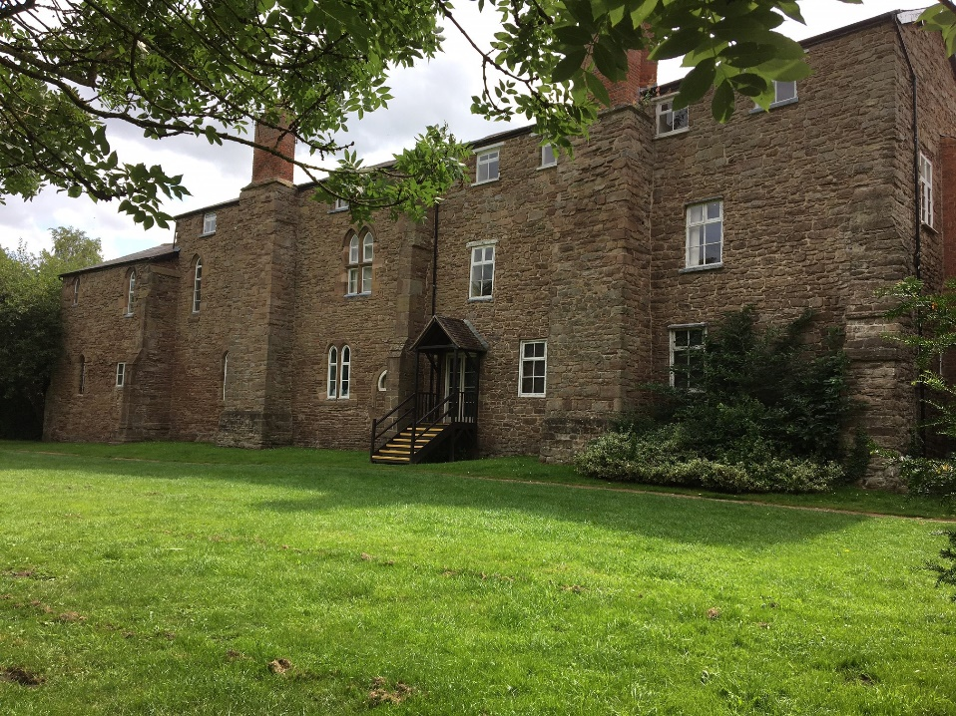

THE BRIEF
Leominster Town Council wishes to procure an appropriately qualified and accredited plumbing and heating engineer to replace existing plant room boilers, associated ancillary equipment, accompanying pipe work, and controls at the Old Priory site.

Specifically, this work will include:
- Isolating gas and electric supplies, taking them back to localised isolation points and testing for soundness.
- Fully draining the existing heating system.
- Removal of all redundant equipment, boilers, flues, pipework, pumps etc.
- Installation of 2 x 70kw gas condensing boilers, with flues and air ducts according to the manufacturer’s specifications.
- Provision of new pumped primary boiler circuit (from boiler shunt pumps to the plate heat exchanger)
- Provision of new secondary distribution circuits within the plant room.
- Provision of one new automatic system pressurization unit (one to be retained)
- Installation of new BMS controls for the boilers and heating system, including zoning and thermostatic time controls.
- Installation of new electrical control panel.
- Flushing and recharging the heating system, including corrosion inhibitor.
- Commissioning of new boilers and instructing staff on use of controls.
- 2 years of servicing and system support
- 5 year minimum guarantee (to cover boiler hardware and software) The
- boilers MUST be commissioned by the manufacturer to obtain this warranty.

Works must:
- Include appropriate lighting, signing and guarding to protect members of the public for the duration of the works.
- Include issuing of all industry standard certificates for the works
- Comply with all Scheduled Monument Consent requirements communicated by the client
- Leave the site clean, tidy and ready for use.
Note: public toilets are located at the site, so no additional temporary facilities will be required. Disposal of waste, including old boiler units and redundant pipework, will be managed by Leominster Town Council.

Tenderers are:
- required to inspect and examine the site and its surroundings before submitting their tenders
- advised to obtain all necessary information which they feel is necessary to submit their tender.
It will be a condition of the invitation to tender that the tenderer should not at any time prior to notification of the award of the contract disclose to or otherwise discuss with any other tenderer or any other third party its actual or intended tender price or any approximation of that price. Your indication that you wish to submit a tender will be taken as acceptance of that condition. The client offers no guarantee that the lowest or any tender will be recommended for acceptance or accepted. The client will not be responsible for any cost incurred in the preparation of any tender.

All tenderers are to complete sections 4-12 and return their submission by Sunday 15th December 2024 at midnight to: boilerprocurement@leominstertowncouncil.gov.uk

DESCRIPTION OF PROPOSED WORKS
General
The works described below are to be read in conjunction with the equipment schedules which form Annex 4 of the specification and the proposed drawings in Annex 3.
Scaffolding for all works will be procured separately and is not required as part of this tender.

Boilers and Flues
The existing gas fired boilers are to be isolated, dismantled and removed from site.
The new boiler installation shall comprise of 2 Hamworthy Stratton mk3 S3-70 frame mounted condensing boilers providing a total output of 140kW complete with pipe and header kits and shunt pumps, as detailed on the equipment schedule.
The boilers shall be installed using manufacturer’s frame and pipe kit. The frame and pipe kit shall comprise boiler support frames, headers for flow, return, gas and condense services with all interconnecting pipes, individual boiler module pumps and non-return valves. The frame shall be firmly bolted to the wall.

The primary and secondary heating system shall be hydraulically separated using a brazed plate heat exchanger by Hamworthy, as detailed in the equipment schedule.
There shall be 2 new pumped secondary VT circuits in the boiler room serving the 2 zones within the main building. Each circuit shall be controlled 3-port blending valves of equal size to the pipework as shown on the schematic and be controlled via the BMS.
Both primary and secondary circuits will be sealed and equipped with dedicated pressurisation units and expansion vessels.

Condensate from the boilers and flue is to be piped via a common header to the existing drain.

The boiler flues shall be by Hamworthy and shall be their C13 80/125 concentric horizontal system.

Boiler Room Ventilation
The contractor shall supply and install new low level air inlet louvre and new high level air outlet louvre to the boiler room to meet IGEM/UP/10 requirements.
Heating Pumps
New pumps are to be provided details of which are provided within the equipment schedules in section 5 of this document. All the existing heating pumps and pipework in the boiler house are to be disconnected and removed from site.

Pressurisation Units
Mains fed pressurisation units and expansion facilities are to be provided for the primary and secondary circuits within the boiler plant room. The existing Mikrofill 3 unit is to be retained and re-used.

Air/Dirt separation & dosing pots
The contractor shall allow for a line size combined magnetic air and dirt separator as manufactured by Fabricated Products on the heating return circuit, as shown on the schematic drawing, and will be fitted with the correct insulation jacket.
Both primary and secondary circuits shall be fitted with chemical dosing pots with a minimum volume of 3.5 litres each. The dosing pots shall be made of stainless steel.
Plant Room Heating, Domestic Water and Gas Pipework
The existing heating, cold water and gas service pipework within the plant room shall be replaced, other than distribution pipework services which pass through.

All existing heating pipe work within the main plant area, other than services passing through, shall be replaced up to and including new isolation valves at the exit points of the plant room with either stainless steel pipe & press fittings (Mapress or equal) or heavy grade steel pipe with screwed fittings. Where the drawing states DN65 for pipework 76mm will be used if pipework is stainless Mapress.

The contractor shall run a new mains water supply in copper utilising ‘Mapress’ fittings (or equal) from the existing mains water entry point to the plant room to the pressurisation units.

All new main distribution heating pipework and domestic cold pipework within the plant room and shall be fully insulated / reinsulated with a CFC free phenolic foam with a foil face finish and to a minimum thickness of 20mm on pipework up to 50mm, 25mm thick 50mm and above to BS 5422: 2009.

All pipework shall be provided with a suitable range of identification bands and flow arrows.

The Contractor shall extend the gas main within the plant room from the existing gas pipe entry point to the building in 50dia pipe and install a new isolation valve and emergency gas solenoid shut off valve.
Chemical Clean of Heating System
The contractor shall allow for a full "non-aggressive" chemical clean, flush and inhibitor/biocide dosing of the entire heating only system. (both primary and secondary)

The exact methodology for chemically cleaning the heating system shall be provided by the contractor and/or their chemical treatment specialist.

A final water sample and analysis shall be provided to demonstrate the overall effectiveness of this treatment and levels of inhibitor.

Automatic Control
The existing controls and all associated controls serving the main plant are to be isolated and removed from site.
A new wall-mounted cabinet style BMS control panel shall be provided to control and monitor the main plant located in the plant room.
The controls system shall be a Trend Building Management System, designed, manufactured, supplied and installed by a Trend controls specialist approved by Trend Control Systems Ltd. The Trend control system will be microprocessor based with a Trend IQ View 4 microprocessor, with the IQ4 controller being panel mounted.

The panel shall be provided with all necessary power equipment and safety devices, hand/off/auto switches for all plant, together with run and trip lamps and a lamp test facility. The panel facia shall also incorporate 1 no. 13 amp switched socket outlets for general power use within the plant room.

The control system shall be capable of sequencing and modulating the boilers and shunt pumps, control of the heating circuits, provision of heating compensation control etc.

The VT Heating circuits shall be fitted with a flow and return temperature and outside temperature sensors. The outside temperature sensor is to be located on a north wall away from any direct sunlight.

Associated Electrical Works
The existing plant room is to be provided with power from the existing electrical supply, subject to electrical integrity testing.

All new power supplies to equipment with the plant room are to emanate from the new wall mounted BMS control panel unless otherwise instructed or agreed.

All new wiring within the plant room shall be carried out in accordance with BS:7671.

New cable containment within the boiler plant room shall be carried out using galvanised steel trunking and/or conduits. Final connections to all electrical equipment shall be carried out using flexible conduits from local isolators. All local isolators are to be suitably labelled.

The contractor shall allow for providing new LED luminaires complete with new wiring within the plant room. Power supplies are to be taken from the existing lighting circuit. The luminaires shall be fitted where necessary to provide the optimum light level within the plant room.

The contractor shall allow for a new emergency stop button adjacent to the boiler room entrance door, together with heat detectors over each boiler module and a gas / CO detector. All are to be linked to the new gas solenoid valve within the plant room.

The standalone fire protection/gas safety system described above shall be provided with a link to the main building fire alarm system for possible future connection.

Associated Builders Work
Any existing main plant bases within the heating plant room no longer required shall be removed and floor finish made good.

New concrete bases/plinths will be required for the boiler rig and floor standing expansion vessel.

The boiler plant room floor is to be painted with a propriety floor paint – 2 coats. Hazard tape or yellow paint is to be fixed to all plant-based edges.

The internal walls and ceiling of the boiler plant room are to be decorated with a PVA emulsion paint – 1 wash coat and 1 topcoat. This paint finish is to be applied prior to the installation of new services and then touched in as necessary at completion of the works.

The contractor shall install a new weathering where the air inlet and new flues pass through the boiler plant room wall. Any openings will be made good using brickwork to a similar style and colour. Replacement bricks for infilling will need to match those in the surrounding fabric for their dimensions, colour and texture.
The infilling bricks will need to be keyed into the surrounding fabric so that the original coursing and bond is restored. This will require some bricks around the current grills to be removed where they have been cut by the original installation (see Annex 6 for further illustration). Mortar used must match historic mortars on the structure.

New plant room doors will be supplied separately, with weathered external high- and low-level louvres sufficient to meet combustion and plant room cooling requirements. Works to the plant room doors do not form part of this brief.

The contractor shall provide all builders work in connection with the M&E services to enable the installation and completion of the building services described here in.
Testing and Commissioning
The contractor shall ensure that the heating system is adequately cleaned, dosed, and air vented prior to any commissioning works taking place.

The contractor shall allow for all necessary Gas Safety Certification for the new boiler plant in accordance with Gas Safety Regulations.

The control panel shall be fully tested and commissioned prior to any demonstrations that take place to the Client. The contractor shall provide a schedule of default set points for the control system for approval by the Client.

The contractor shall provide all necessary certificates for system testing and commissioning of the works including laboratory sample analysis reports for the heating system.

The boilers will be commissioned and certified by the manufacturer. This is necessary to obtain the 5-year warranty.

Handover Documentation and Client Training
The contractor shall allow for providing 1 hard bound copy and 1 electric copy of the Operating and Maintenance (O&M) Manual and record drawings for the works at completion of the contract.

The Operating and Maintenance Manuals shall consist of, but not be limited to, the following: -
- Description of building systems.
- Description of methods and materials used.
- Description of client operation.
- Product details and manufacturers maintenance literature.
- Record drawings.
- Guarantees and warranties etc.
- Information regarding preventative maintenance.
- Emergency procedures.
- Testing and commissioning certification.
- Residual health and safety issues.

Also required to be provided is a simple user-friendly operating guide for scheme personnel which shall be utilised as a menu for the system demonstration and client training exercise.

SUPPORTING DOCUMENTS
- Annex 1: Site plans indicating the boiler plant room location.
- Annex 2: Photographs of the existing boiler plant room.
- Annex 3: M01 Proposed boiler room schematic
- Annex 4: Boiler room equipment schedule
- Annex 5: Tender Summary
- Annex 6: Additional Images - Associated Builders Work

SECTION FOUR – QUESTIONNAIRE

Q1 | Service Delivery  Please describe how you will deliver the works outlined within the specification in Section 3. Your answer should:  - Set out a detailed programme and timescales for the delivery of the works.  - Address how you will meet any specific requirements set out in the specification.

Bidder response

Q2 | Experience  Please demonstrate your experience, knowledge and skills relevant to delivering the works outlined within the specification in Section 3. Your answer should:  - Provide evidence of previous experience in working with heritage sites, specifically scheduled monuments and listed buildings.  - Address the company and individual team members’ experience and qualifications.  - Outline any experience in delivering similar works, reflecting the type, nature and scale of the service provision.

Bidder response

SECTION FIVE – PRICE

The Bidder shall confirm the total price (exclusive of VAT) to complete the works outlined in Section 3. The Bidder is also required to submit a completed Tender Summary (Annex 5).

Bidder response

SECTION SIX – REFERENCES

The Bidder shall include reference details of one contract relevant to this particular activity, which is still running or has been completed within the last three years.

The bidder shall support the reference with the following information:
- Reference Company Name
- Description of the work carried out
- Approximate annual contract value (£)
- Contract start and end date

Bidder response | Reference
Company Name
Address
Contact Name
Telephone No.
Email
Description of the work carried out
(word count 200 words)
Approximate annual contract value (£)
Contract start and end date

SECTION SEVEN – EVALUATION MODEL

The evaluation model below shall be used for this RFT, which will be determined to two decimal places.

Pass/Fail Criteria
Failure of any one of the pass/fail questions listed below will mean automatic disqualification from this quotation process.
RFT response received on time:  RFT response in the correct format: | Pass / fail  Pass / fail
Adherence to all areas in Section Eight ‘Legal Compliance’ | Pass / fail
Insurance levels acceptable | Pass / fail
Adherence to all areas in Section Nine ‘Financial Information’ | Pass / fail

Scoring Criteria (out of 100% rounded to two decimal places)
S4: Q1 Service Delivery | 25%
S4: Q2 Experience | 25%
S5: Price | 50%
Total | 100%

Evaluation Criteria
Non-Price elements will be judged on a score from 0 to 10, which shall be subjected to a multiplier – so criteria worth 20% will have a 0-10 score and a multiplier of 2. The 0-10 score shall be based on:
0-1 The Question is not answered or the response is completely unacceptable. It does not meet the minimum requirement or fails to address the point of the question
2-3 Very poor response and not acceptable – fails to meet the minimum requirement/standard. Requires major revision to the proposal to make it acceptable. Only partially answers the requirement, with major deficiencies and little relevant detail proposed.
4-5 Poor response only partially satisfying requirement/standard with deficiencies apparent. Some useful evidence provided but response falls well short of minimum requirements.
6-7 Response is acceptable and meets minimum requirement but remains basic and could have been expanded upon.
8-9 Response meets our expected requirement/standard and exceeds minimum expectations, including a level of detail that adds value to the bid.
10 – Excellent response – comprehensive and useful, which exceeds the specified performance or capability in a beneficial way. The response is innovative and includes a full description of techniques and measurements to be employed.
Price elements will be judged on the following criteria.
The lowest price for a response which meets the pass criteria shall score 10. All other bids shall be scored on a pro rata basis in relation to the lowest price.
For example - Bid 1 £100,000 scores 10, Bid 2 £120,000 differential £20,000 or 20% remove 20% from price scores 8, Bid 3 £150,000 differential £50,000 remove 50% from price scores 5, Bid 4 £175,000 differential £75,000 remove 75% from price scores 2.5. The lowest score possible is 0. All scores are then subjected to a multiplier e.g. if price has a scoring criteria of 55%, the multiplier will be 5.5.

SECTION EIGHT – LEGAL COMPLIANCE

All Bidders must provide an acceptable response to the questions detailed below.

1. Please mark ‘X’ in the relevant box to indicate whether you are: |  | A) Bidding as a Prime Contractor and delivering 100% of the key contract deliverables yourself.
 |  | B) Bidding as a Prime Contractor and will use third parties to deliver some of the contract deliverables.
 |  | C) Bidding as a Prime Contractor but will operate as a Managing Agent and will use third parties to deliver all of the contract deliverables.
 |  | D) Bidding as a consortium
If you have selected B), C) or D) above, please provide further details here:
2. Grounds for Mandatory Exclusion  i) Within the past five years, has your organisation (or any member of your proposed consortium, if applicable), Directors, partners or any other person who has powers of representation, decision or control, been prosecuted under UK or EU law or convicted of any criminal offences; including bribery, corruption, conspiracy, terrorism, fraud and money laundering, theft, and tax evasion? | Yes/No
If you have answered ‘Yes’ to question 2. i), please provide further details here:
3. Grounds for Discretionary Exclusion  i) Within the past five years, has your organisation (or any member of your proposed consortium, if applicable), Directors, partners or any other person who has powers of representation, decision or control, been accused of misconduct, distortion of competition, or breaches of environmental, employment, equity legislation or health and safety law? | Yes/No
If you have answered ‘Yes’ to question 3. i), please provide further details here:
ii) Within the past five years, has your organisation shown significant or persistent deficiencies in performance of a prior contract that have led to early termination of that contract, damages or other sanctions? | Yes/No
If you have answered ‘Yes’ to question 3. ii), please provide further details here:
iii) Are you aware of any legal or financial proceedings currently in progress that might affect the performance of contract obligations?
If you have answered ‘Yes’ to question 3. iii), please provide further details here:
4. Conflicts of Interest  Leominster Town Council may exclude a supplier if there is a conflict of interest that cannot be effectively remedied. A conflict of interest includes any situation where relevant staff members have, directly or indirectly, a financial, economic or other personal interest which might compromise their impartiality or independence in the context of the procurement procedure. | Please declare any potential conflicts of interest here.
5. Health and Safety  i) Does your organisation have a Health and Safety Policy that complies with current legislative requirements? | Yes/No
ii) If you use sub-contractors, do you have processes in place to check whether they have a Health and Safety Policy that complies with current legislative requirements? | Yes/No
6. Employment and Recruitment  i) Does your organisation have policies in place to ensure fair recruitment and adherence to employment law, including right to work obligations? | Yes/No
ii) If you use sub-contractors, do you have processes to check whether they have policies in place to ensure fair recruitment and adherence to employment law, including right to work obligations? | Yes/No

SECTION NINE – INSURANCE

Please confirm that you shall have the following insurance cover:
Public liability (a minimum of) £10,000,000 | Yes/No
Employers liability (a minimum of) £5,000,000 | Yes/No
Professional indemnity (a minimum of) £2,000,000 | Yes/No

SECTION TEN – FINANCIAL INFORMATION

Please provide one of the following to demonstrate your economic/financial standing: | Please indicate with an ‘X’ which document you have provided as an accompanying document (or indicated where records can be accessed online).
A) A copy of audited accounts for the most recent two years.
B) A statement of the turnover, profit & loss account, current liabilities and assets, and cash flow for the most recent year of trading for your organisation.
C) A statement of your organisation’s cash flow forecast for the current year and a bank letter outlining the current cash and credit position.
D) Alternative means of demonstrating financial status, if any of the above are not available.

SECTION ELEVEN - BIDDER DETAILS
Bidder name and registered address

Email address
Phone number
RFT completed by

SECTION TWELVE - DECLARATION
I declare that to the best of my knowledge the answers submitted within sections 4-10 are correct. I understand that the information provided will be used in the selection process to assess my organisation’s suitability to provide services outlined in section 3.

I declare that I have permission to complete and submit answers within sections 4-10 on behalf of the organisation listed in section 11. I understand that Leominster Town Council may reject my submission if there is a failure to answer all relevant questions fully or if I provide false/misleading information.

Declaration made by:
(please print name)

Signature:
Date:

