

Invitation to Tender

Grass Cutting Contract

2023-2026

Middleton Cheney Parish Council

Cemetery
Play Areas
Village Green
Verges
Other Green Areas

Pip Davis
Clerk/ RFO
Parish Meeting Room
Middleton Cheney
OX17 2LR
Tel: 01295 713500
clerk@middletoncheney.org.uk

Contents

A. INVITATION TO TENDER 4
B. STANDARD CONTRACT CONDITIONS 6
Officer 6
Scope of Work 6
Site Details 6
Site Access 6
Workmanship and Equipment 7
Additional Erection/Installation 7
Duration of Contract 7
Payment to Contractor 7
Termination of Contract 7
Insurance 7
Subcontractor/Employee Verification 8
Health and Safety 8
Notes to Tenderers 8
C. SPECIFICATION OF WORKS 9
D. SCHEDULE OF WORKS 11
Cemetery (20 cuts) 11
Play areas and village green (16 cuts) 11
Alleyways (1 seasonal) 12
Verges and other identified green spaces (16 cuts) 12
E. SITE PLANS 14
F. TENDER FORM – To be submitted to the Council 20
G. DECLARATION & COMPANY DETAILS FORM – To be submitted to the Council 22
H. EVALUATION 20

INVITATION TO TENDER

GRASS CUTTING SERVICES 2023-2026

REF: MCPCGCS01

- Middleton Cheney Parish Council ("the Council") hereby invites tenders for the carrying out of the Service of Grass Cutting in accordance with the Contract documents attached, which comprise:

  - Invitation to tender
  - Standard contract conditions
  - Specification of works
  - Schedule of works
  - Site plans
  - Tender form
  - Declaration & Company Details Form
  - Evaluation

- Scope of the contract
  - The contract will include grass cutting and strimming in the parish as specified in Section E and Section F
  - Provision of all suitable protective clothing is the responsibility of the applicant.
  - The Contractor will be required to demonstrate that all insurances, health and safety procedures and risk assessments necessary for the smooth and safe fulfilment of the contract are in place prior to submission of tender response.
- Tender documents
  - This tender includes the following documents to enable you to bid. If you find any documents missing or you are unable to open any, please contact us immediately.
  - Invitation to Tender (this document)
  - Grass cutting site confirmation as specified in Section E and Section F
  - Draft contract
- Your response to this tender invitation must include the following documentation:
  - Your quotation for the 3-year grass cutting contract (Section F – Tender Form)
  - A copy of your 2023/24 Certificate of Public Liability Insurance (up to £5,000,000)
  - A copy of your 2023/24 Certificate of Employers’ Insurance (up to £1,000,000)
  - Details of similar projects/services undertaken including references to clients or links to relevant web pages
  - The prices submitted must indicate the rate for carrying out each element of the Contract
- Prospective contractors must not contact Councilor’s or staff to encourage or support their tender outside the prescribed process.
- How to submit your bid Tenders are to be submitted in hard copy on the attached Form of Tender in a sealed marked envelope clearly marked “Grass Cutting Tender Response” to The Parish Clerk at the above address by 12 Noon, Monday 27th February 2023
- Submissions received after this date and time will not be considered.
- Middleton Cheney Parish Council reserves the right not to award any contract as a result of this tender and will award in line with the award criteria at Section H - Evaluation, and not necessarily in line with the lowest bids.
- Tender bids will be treated as private and confidential. Bids for this contract will be opened 5pm, Monday 27th February 2023.
- Middleton Cheney Parish Council reserves the right to publish the cost of the winning tender.
- The Council will notify applicants of the outcome of their tender by Monday 6th March 2023
- Any responses to queries raised by bidders will be included in a document entitled ‘Additional information for bidders’. This will be found with the tender documentation in the Tenders section of the Parish Council’s website and will be updated regularly.
- The successful tender together with the Council's written acceptance shall form a binding agreement in the terms of the Contract documents.
- Middleton Cheney Parish Council will examine the outputs of the contract and the Contractor may be called upon to correct any errors or answer queries regarding any of the outputs at their own expense.
- For further information, please contact the Clerk at clerk@middletoncheney.org.uk.

STANDARD CONTRACT CONDITIONS

Officer
The Officer will be the Parish Clerk

Scope of Work
The work will comprise of the cutting of grass on three amenity spaces managed by the Council together with some grass verges. (See site plans attached)

Grass Cutting: The height of cut to be appropriate for the use of each space and as agreed with the Officer. To also include strimming around grave markers, head stones, play equipment, outside furniture, path edges, trees, bushes, fences, hedges and all other authorised site fixtures and fittings. To include grass removal from all play safety surfaces as well as footpaths and seating areas by sweeping or blower. Although a specific number of cuts has been set for the tender these may be varied according to seasonal grass growth and by agreement with the Officer Only.

Site Details
The sites are:

Middleton Cheney Cemetery, which requires weekly grass cutting and strimming undertaken with the due care and respect that a site of this nature requires. The cemetery contains the graves and memorial sites of a great many families who still reside in the village and as such is a particularly sensitive location.

Stanwell Park and Astrop play area – a large sized traditional children’s and family play park, containing open spaces, play equipment and skate ramps as well as seating areas. This excludes the playing fields at Astrop road.

Village Main Green – a large rectangle of grass and grass verge on the Main Road in the lower part of the village.
Several other smaller village greens on Main Road, The Washle, Bull Baulk and Stanwell. These do not contain any equipment other than benches.

Other Green Areas/Verges

Before tendering the Contractor is advised, at his/her own discretion, to visit the sites to satisfy themselves as to the full extent of the Contract Specification. No claims arising from failure to do so will be accepted. An accompanied tour of the zones will be available if booked in advance with the Clerk, or the Contractor is welcome to view the zones independently at any time in advance.

Site Access

The Cemetery has restricted opening times. Please contact the Officer for opening times and to arrange a visit to the cemetery. Any tour of the cemetery should be accompanied and prebooked with the Officer, to ensure any site visit does not coincide with a funeral or relative visit.
Stanwell Park is open during the day, the gates are locked at night. Contractors may arrange their own site inspection during the hours of 10 and 2, or contact the Officer for a prebooked accompanied site visit.

All other sites are open public areas and able to be inspected at any time.

The contractor is only permitted to access the sites for the performance of this contract and for no other purpose without seeking prior permission from the Officer.

Workmanship and Equipment
The workmanship must be of the highest standard and shall conform to all relevant British Standards, Specifications and Codes of Practice.

Additional Erection/Installation
The Council may at any time add or remove outside fixtures and fittings (play equipment, benches, planting etc.) during the period of the Contract and no application from the Contractor to adjust the Contract price as a consequence will be considered.

Duration of Contract
The duration of the Contract will be THREE YEARS commencing 13th March 2023 to 31st OCTOBER 2025 inclusive, with annual performance reviews. Tenders are to be priced on a per cut basis. There will be no opportunity to alter the rates tendered during the full term of the contract.

Payment to Contractor
The Contractor will submit a monthly invoice, by the 10th of the following month for it to be paid before the end of that month, throughout the cutting season for all work carried out. Invoices submitted during August will not be paid until September due to there being no Parish Council meeting that month. Invoices submitted after the 10th of the month will not be paid until the following month unless the Officer has sufficient time to include them on the Parish Council Agenda.

Termination of Contract
Either party may, without reason, terminate the Contract, in writing, giving no less than Three Months’ Notice.

Insurance
The Contractor is required to have a minimum of £5,000,000 Public Liability Insurance. A current Certificate of Insurance to this effect for the year must be produced to the Officer prior to commencement of the Contract and annually thereafter. The Contractor shall indemnify the Council against any claim or proceedings for any injury or damage to any property or persons or animals as a result of negligence, poor workmanship or failure to notify the Council of any action likely to cause injury or damage to a third party. Any damage caused to any property during the performance of this contract must be reported to the Officer immediately and any costs involved to rectify the damage will be the responsibility of the contractor.

Subcontractor/Employee Verification
Due to the nature of the locations included within the contract all subcontractors or employees employed in the performance of this contract are required to have a valid Basic DBS check which is not more than 3 years old. A list of names, DBS numbers and date of last check must be produced to the Officer prior to commencement of the Contract and annually thereafter. If new subcontractors/employees are used then it is the Contractor’s responsibility to provide the same details.

Health and Safety
The Contractor shall comply with all relevant statutory requirements (including Health and Safety at Work Legislation) at all times in carrying out the services described in this agreement. All works will be carried out in accordance with the Safety at Street Works and Road Works: Code of Practice 2013.

Notes to Tenderers

- Attention is drawn to the Form of Tender and Standard Contract Conditions. These documents must be read in conjunction with the Specification of Works, Plans and Schedule of Works. Contractors are advised to carefully read all documentation.
- The prices to be included in the Form of Tender are to be the full inclusive value of the work described, including all profit, costs and expenses, and all general risks, liabilities and obligations, but EXCLUDING VAT (if applicable)
- A price shall be inserted against each item on the Form of Tender for each element of the contract tendered for.
- No alteration to the text of the Form of Tender is to be made by the Contractor tendering. Should any alteration, amendment, note or addition be made, the same will not be recognised and the reading of the printed Schedule will be adhered to.
- A regular inspection will be carried out by the Council throughout the period of the Contract to ensure the work is completed in accordance with the Specification of Works.
- Invoices presented for payment must include a schedule of the works completed including the dates of the work.
- Contractors are asked to contact the Officer if any clarification is required.

SPECIFICATION OF WORKS
- Prior to cutting or trimming any area, the Contractor will ensure that the site is free of any significantly large stones and all paper, tins, bottles and other debris on the cutting area.

- The Contractor will also inspect each site for areas of ground sinkage/potholes and areas of potential hazard and will inform the Council immediately of any such potential hazards.

- The Contractor will at all times during the period of the Contract, ensure that all machines engaged in grass cutting operations are sharp and properly set, so as to produce a true and even cut. Any damage or areas of grass not cut to the approval of the Council from such lack of maintenance will be made good by the Contractor at his own expense and to the satisfaction of the Council.

- The Contractor will at all times during the period of the Contract ensure that machines are properly guarded and maintained so as to present no danger to the operator, surrounding structures, vehicles or any person in the vicinity of operations. The Contractor will provide his staff with all safety equipment, (boots, reflective vests etc.), and will ensure that staff use these at all times they are engaged in work for the Council.

- During the period of the Contract no growth regulators of any form will be applied to any area of turf without the Council sanctioning such an operation in writing, in advance.

- All grass will be cut cleanly and evenly without damaging the existing surface and with sufficient overlap between passes of the cutter.

- The Contractor will complete one area of grass cutting before moving onto the next, and immediately after cutting a scheduled area, the Contractor will ensure, where applicable, that all grass clippings and other arising’s are cleared from all paved areas, playground equipment safety surfaces, paths and public footpaths, etc., by sweeping or using a blower.

- Soft vegetative growth, such as clover will be deemed to be part of the Contract where it falls within large areas of grass.

- Since it is not possible to predict accurately the precise number of mowing’s which may be required on any site in any one year, the Schedule of Works includes a minimum number of mowing’s, but the Contractor will be paid on a pro-rata basis for additional cuts, dependent upon the prevailing weather conditions throughout the growing season and at the discretion of the Council.

- Mowing will take place on the full area of grass at the site, up to all path edges, fencing, play equipment, obstacles and any other boundaries.

- Areas not cut to the satisfaction of the Council will be re-cut by the Contractor at the Contractor’s own expense.

- In very wet conditions all operations involving grass cutting shall cease until conditions allow operations to recommence without damaging the surface levels and contours of the ground or grass cutting “divots” from the machine rollers or cutters.

- Should the Contractor cause damage to the surface or levels of the ground, or create divots during grass cutting operations, the Contractor will at his own expense reinstate such damage forthwith to the satisfaction of the Council.

- Mowing will be carried out as close as possible to fixed obstructions. Moveable obstructions can be removed to facilitate cutting, and replaced before the Contractor leaves the site.

- Mowing around obstructions including seats, trees, fence lines, posts, stones and kerbs and the like, and in the proximity of margins, will be undertaken using methods, tools and machines as appropriate to ensure neat edges to paths etc.

- If used, strimmers must not be allowed to damage any trees, shrubs etc. or permanent or removable fittings; particular attention should be paid to the wooden supports for play equipment

- All persons operating grass cutting machinery must be appropriately trained, and the Council reserves the right to ask the Contractor to provide adequate proof that his operators are well trained, conversant with Health and Safety legislation and competent in their operating methods.

- All arising’s from grass cutting, where collection is required, are to be removed from site and correctly disposed of.

NOTE: None of the sites have access to toilets or running water – so contractor will need to make their own arrangements for their staff welfare.

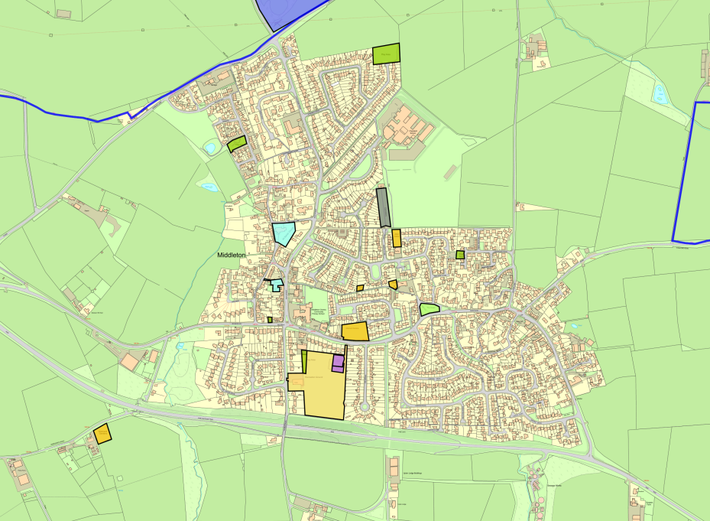
Map of Middleton Cheney

SCHEDULE OF WORKS

Cemetery: Strim, Close Cut and Collect – 20 cuts

    - There are to be a minimum of 20 cuts to the Cemetery.
    - To include damage free strimming around grave markers, head stones, seating areas and other obstructions including trees and all of the various edges of the site (Hedges, Gates & Fences) to obtain a neat and tidy finish.
    - Grave ornaments to be removed prior to strim / cut to avoid damage and to be returned to the relevant grave after strim / cut
    - Dead flowers not on graves to be removed with grass cuttings
    - All other ornamentation and flowers to be returned to the relevant grave
    - All footpaths, seating areas, entrances etc. to be cleaned off by sweeping or blowing after each cut/strim.
    - The first cut being in March then fortnightly until June, weekly until the middle of August then fortnightly with the final cut in October, according to seasonal growth patterns.
    - To include seasonal maintenance of hedges and boundary trees.
    - Grass cuttings to be removed.

Play areas and village green: Strim and remove – 16 cuts

- There are to be a minimum of 16 cuts to the play area and village green.
- The first cut being in March then fortnightly after with the final cut in early October, according to seasonal growth patterns.
- To include strimming around signs and other obstructions including trees and the various edges of the sites.
- All footpaths, seating areas, entrances etc. to be cleaned off by sweeping or blowing after each cut/strim.
- Grass cuttings to be removed.

Alleyways: Spray, strim and remove – 7 cuts

- To include one weed spray in early March and at least one strim to keep weed growth to a minimum.
- To include strimming around signs and other obstructions including trees and the various edges of the footpaths.
- To be cleaned off by sweeping or blowing after each strim.
- Grass cuttings to be removed.

Verges and other identified green spaces
Strim and blowing, Seasonal shrub maintenance – 16 cuts

- There are to be a minimum of 16 cuts of the areas covered.
- The first cut being in March then fortnightly after with the final cut in early October, according to seasonal growth patterns.
- To include strimming around signs and other obstructions including trees and the various edges of the sites.
- All footpaths, seating areas, entrances etc. to be cleaned off by sweeping or blowing after each cut/strim.
- Seasonal shrub maintenance to splays with planting, e.g. Tenlands splay, Memorial Island.
- Grass cuttings from first cut of the season to be collected, thereafter blown back onto the green space.

SITE PLAN
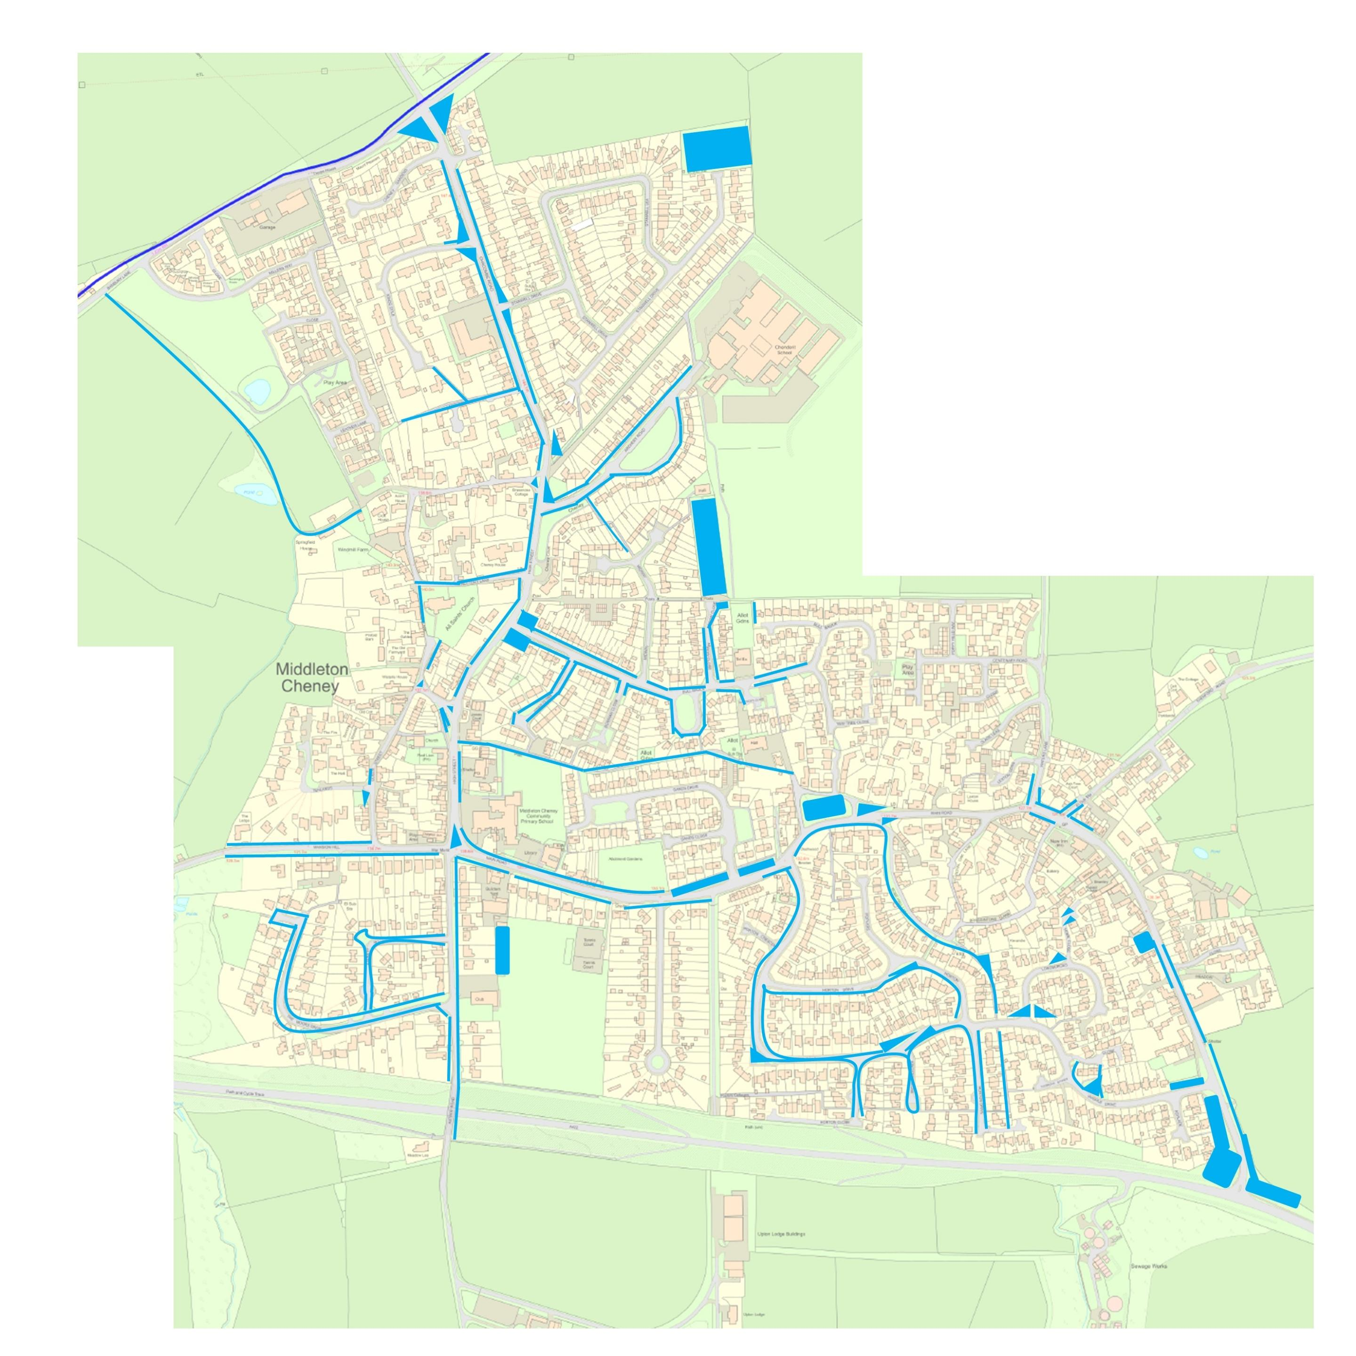

TENDER FORM – To be submitted to the Council

Please complete and sign the Tender Form and Declaration & Company Details Form to the Middleton Cheney Parish Council offices by 12 NOON, MONDAY 27th FEBRUARY 2023 at the latest.

PRICES QUOTED ARE TO BE EXCLUSIVE OF VAT

Contracted Area for 2023-2026 | Number of Cuts (Frequency) Minimum | QUOTED PRICE PER CUT | TOTAL PRICE for the 3 years 2023 - 2026  Based on  Minimum Cuts
Cemetery (Hedges, Strim, Close Cut and Collect – 20 cuts) | 20  (Fortnightly / Weekly) | £ | £
Play areas and village green (Strim & Disperse) | 16  (Fortnightly) | £ | £
Alleyways (Spray, Strim and Remove) | 1  (Seasonal) | £ | £
Verges and other green spaces (Strim, Blowing) | 16  (Fortnightly) | £ | £
TOTAL GRASS CUTTING CONTRACT PRICE FOR 2023/26
£
(assuming no additional cuts)

Please complete if you have not been previously used by Middleton Cheney Parish Council in the performance of a similar contract then please provide details of 2 references who can be contacted to provide support for your application:

Referee 1 Referee 2
Name
Position
Company Name
Contact Number
Contact Email
Annual Contract Value

Name
Position
Company Name
Contact Number
Contact Email
Annual Contract Value

DECLARATION & COMPANY DETAILS FORM – To be submitted to the Council

Please complete and sign the Tender Form and Declaration & Company Details Form to the Middleton Cheney Parish Council offices by MONDAY 27TH FEBRUARY 2023 at the latest.

I/We agree to complete the work in accordance with the Invitation to Tender, Standard Contract Terms, Specification of Works, Schedule of Works and location plans.

I/We understand that Middleton Cheney Parish Council is not bound to accept the lowest or any Tender or part thereof and that the Council will not be responsible for any expense incurred in preparing this Tender.

I/We certify that the amount of the Tender has not been calculated by agreement or arrangement with any other person, firm or company and that the amount of the Tender has not been communicated to any person and will not be communicated to any person until after the closing date for the submission of Tenders.

Company or Business Name:

……………………………………………………………..……………………………………...

Business correspondence address

…………………………………………………………………………………………………….

………………………….………………………………………Postcode: …………..…………...

VAT Reg No. (if applicable) …………………………………………………

Contract Manager : ………………………………………...

Contacts: Landline : ……………………………………….

Mobile : ……………………………………….

Email : …………………………………………………………………..

By signing and submitting this tender form you agree that you fully understand the commitments and requirements contained therein and, if successful are willing to be bound to the contract as expressed therein.

Signed: ……………………………..…….. Print Name: ………………………..……………

Position: ……………………..……………

Dated: …………………………………..….

EVALUATION

Bids will be evaluated in accordance with the Middleton Cheney Parish Council’s Financial Regulations using the following criteria and weighting:

Criteria | Possible Score
Price  The full and final cost over the full term of the contract.  To take into account affordability and the commercial stability of a reasonable return for the supplier. | Max 50 points out of 100
Quality  The supplier’s ability to perform the contract to the highest standards.  Evidence of the supplier’s relevant knowledge and experience through the delivery of previous contracts  Feedback received from References. | Max 25 points out of 100
Compliance  The supplier’s compliance with all Health & Safety and employment laws and regulations | Max 25 points out of 100

