Appendix 1 - Music Quiz

Objective:
The quiz is one of the main interactive elements in the music exhibition and is a fun way for visitors to find out more about some of the content and the people included within the exhibition. To make it fun for all ages and levels of interest, we want visitors to be able choose how they access the quiz by opting for different levels of difficulty.

All the questions/answers will be local, relevant and informative. The answers will be supported by a relevant song and image or music video footage so that the process and content is as engaging as possible.

Technical information:
The quiz will be a free-standing tabletop structure that sits centrally within the Music section of the gallery. The idea is that it can be played by up to 4 - 8 people as individuals or in pairs, who can stand around the quiz easily. The footprint of the quiz should be no bigger than 1.4m in diameter to allow for enough visitor flow around the space. The area around the quiz will have a combination of cased objects, large graphics and other AV elements. (See visual Musicquizlocation.jpg) The quiz will need to be powered from a floor socket, so this needs to be considered within the design.

The design of the quiz shouldn’t be too overpowering in the space, it should be streamlined and clean so not to distract from other displays. It could be delivered through a large tabletop touchscreen or a series of 4 touchscreens, one for each user or pair of users. Any sound should be delivered through the table via speakers. Any equipment needs to be housed within the table and needs to be easily accessible for maintenance. The design must be accessible and adhere to NML’s access guidelines.

The gallery has been designed to have a light colour palette with most walls being white and the flooring a mid-grey tone. The gallery has some natural daylight, so projection is not effective in this area.

Below are some visual reference examples of tabletop interactives to give a look and feel of what NML are looking to produce on the gallery:

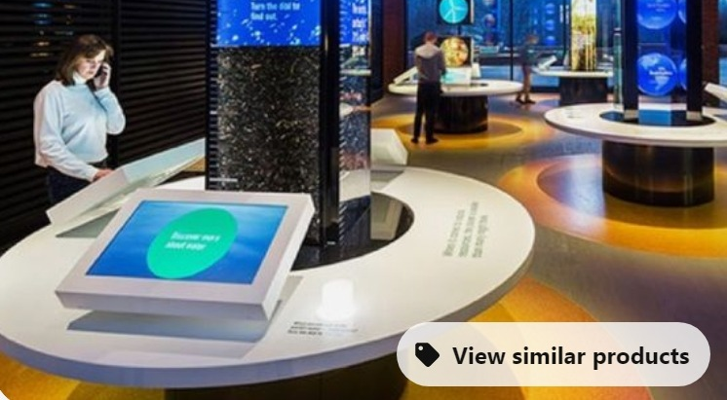
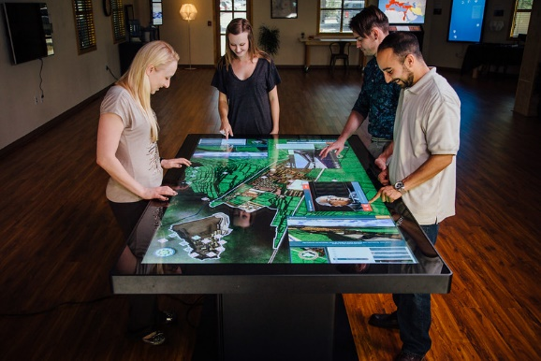
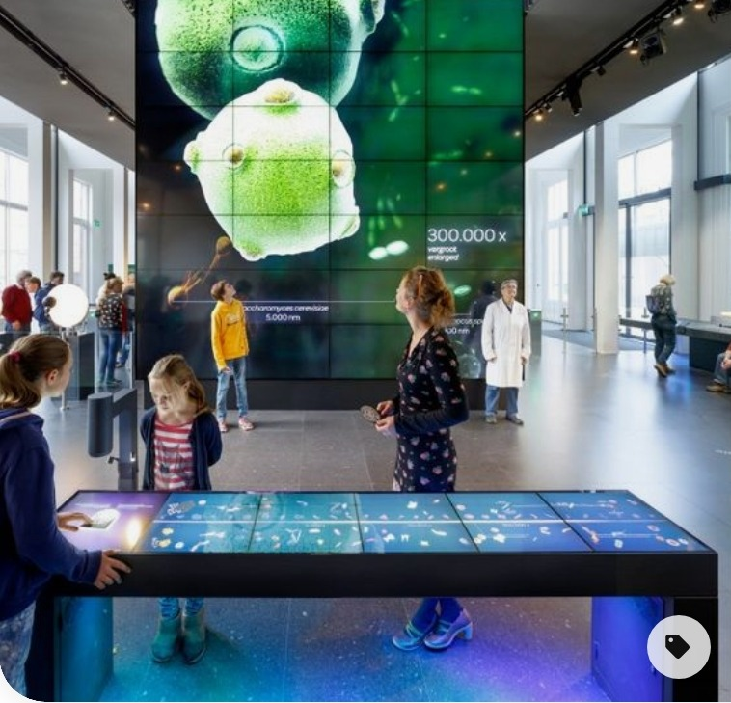

Content Look and Feel:
The quiz will need a screensaver/holding screen that can attract the visitor and advertise the content. It should be bright and playful, but also contain a level of competitiveness with the potential for a leader board embedded into the software. The graphics should match the colours and fonts used in this section of the gallery, information to be supplied by NML.

Content to be included:
Situated centrally in the music exhibition, the quiz will pull content from all areas of the exhibition, covering topics as wide ranging as early jazz and folk influences, the punk scene in Liverpool and contemporary club dance nights. Some of the answers will be found within the displays, some will be basic general knowledge.

The quiz will be divided into three selectable options:

- Easier general knowledge questions
- Harder more niche questions, but still accessible
- Beat the DJ – questions submitted by local radio DJs

The NML content team will deliver a ‘pool’ of questions with associated multiple-choice answers for each section (minimum a pool of 40 x questions per section) for the contractor to animate and develop into engaging content - there is potential to expand the pool of questions if required – the developer will source and deliver supporting sound/images or footage to animate the information.

Audience:
Aimed at a general audience but needs to be accessible for visitors on the autism spectrum and dementia.

Dwell Time:
Our expectation is that approx. 8- 10 x questions will be long enough for the visitors to feel satisfied that they have participated, but short enough that the interaction does not feel laboured - this is open for discussion .The quiz could be played again with different questions being drawn from the pool for each section.

Copyright:
Footage and imagery are the responsibility of the AV Software provider, to research/source and purchase the copyright licenses/rights, under the guidance of the NML content team. NML requires all copyright license clearance to be at least ten year or a lifetime, nothing less. NML will require copies of the project files and media and the content management system / web platform so the AV presentation can be updated if and when necessary by NML.

Handover:
NML will require copies of the project files and media and the content management system / web platform so the quiz can be updated if and when necessary by NML.

