

**Appendix A**

Specification of Services Required

Provision of Serviced Apartment Accommodation for patients and carers of The Christie NHS Foundation Trust

Authority Reference Number: CHRT546-2024-25 DES JC

# Overview of The Christie and service requirements

**Background and Context**

Bidders should note the following high level needs for The Christie’s requirements.

The aim of the service is to allow patients who are receiving treatment at The Christie hospital in Withington, Manchester (The Christie NHS Foundation Trust [The Trust]), but who live more than ~45mins travel away from the hospital, to access the services without placing undue travel burdens upon these patients, their families and care groups.

The Christie, as a Comprehensive Cancer Centre and the largest single-site specialist cancer hospital in the UK, is delivering specialist treatments in greater numbers than before, and is increasing the numbers of such treatments offered at the site.

The result of the Christie’s growth in specialist treatments is a wider geographical catchment area for patient referrals; patients are now being seen from a supra-regional and national footprint, considerably more widely distributed than the cancer network in Greater Manchester.

Relatively few of these patients require admission on an inpatient ward, and can be treated safely on an ambulatory basis where the patient remains at home or a home-like setting and travels to and from the hospital each day to be treated. Patients travelling for specialist treatment are typically accompanied for the duration of their treatment by one or two family members or carers, and in the fewer cases where the patient does require admission, these carers may continue to require accommodation during the period of treatment.

Since the introduction of Proton Beam Therapy at The Christie site in November 2018, The Christie, working in partnership with Royal Manchester Children’s Hospital [RMCH] (Manchester University Hospitals NHS Foundation Trust), has been caring for an increasing number of paediatric cases. The stresses of moving a family with often young, dependent children across the country make it particularly important that the provision is consistent and accessible to these patient groups.

Lengths of patient stays in this accommodation are in line with patient treatment timescales. Some assessments or interventions with the patients may involve a length of stay of only several days, while some of the longer treatment periods may be as long as 6-8 weeks with daily attendances at The Christie.

Given that patients will receive treatment by a combination of appointments at The Christie and RMCH, and that complexities with treatment may occur at any time, it is essential that the accommodation is conveniently located for access to both hospital sites. Nevertheless, it is important to note that that the sought provision is **strictly non-clinical in nature**. Although unwell patients may stay in the apartment, any organisations wishing to express an interest in providing this service are being asked to provide serviced apartments only, and are **not required or expected to provide medical care of any kind**. The provider will not be required take any clinical responsibilities for patients staying at their premises.

**The Christie as a corporate client**

The Christie intends to act at all times as an arm’s length corporate client in its duties regarding serviced apartment accommodation. The Trust intends to bear the responsibility to pay for an agreed rate for hire of a serviced apartment in respect of each patient / patient family / patient and support group for the duration of their stay.

However, the Trust will not take responsibility for funding any other consequential or associated costs that patients may incur during their stay. Costs further to, *e.g.,* parking, transport, catering, room upgrades, additional electronic services, additional cleaning costs incurred voluntarily, or any other items in excess of a “base rate” for the room will *not* be funded by the NHS. The Christie accepts the responsibility for communicating this to patients.

The Christie will, following clinical referral, inform the serviced apartment provider that a patient has been accepted for assessment / treatment, the expected group size, arrival date, stay duration, and a unique identifier for the patient.

Thereafter, it is the patient’s responsibility to contact the provider and make all necessary arrangements, including confirmation of their personal details and other information pertinent to their stay. No data sharing between the serviced apartment and the provider is envisaged, following the guidelines and restrictions of the General Data Protection Regulation (GDPR).

Patients staying as guests will enter their own standard agreement with the provider, without reference to The Trust, other than to provide a basic rate of funding as noted above. The patient / guest will be responsible for all additional charges, including damages either deliberately or accidentally caused to the property in which they are staying.

The provider will invoice The Trust for the costs of stays, and will notify the Trust immediately if, on contact from the patient it becomes apparent that the patient is unable to offer a guaranteed card or other payment in respect of damages and charges accruing to their stay.

**The requirement**

The first call for a service of this type from The Christie began with Proton Beam Therapy in late 2018. Since then, other service areas within the hospital have availed themselves of this type of service with the potential for further expansion. It is considered that demand for serviced apartments will continue to increase, though this cannot be predicted with certainty. The pattern of clinical services is one of peaks and troughs according to demand, flexibility around which is a key factor in the requirements of this tender document.

Patient input and patient co-design are high priorities for all Christie services, which are given effect in this tender process by the allocation of a single (albeit highly weighted) criterion to be evaluated by a patient group. This process is described below and elsewhere in this pack.

Suppliers are invited to submit serviced apartment accommodation solutions to the specification provided.

The proposed solution shall:

* Allow the Christie to access sufficient apartments for its patients and carer groups throughout the year.
* Provide apartments of the appropriate size and with appropriate features for the family groups staying as guests.
* Be conveniently located for access to The Christie and RMCH, and be located in an area with some local amenities and away from areas likely to cause concern for guests.
* Provide value for money as a solution for non-clinical accommodation supporting Trust activities.
* Ensure that the Christie can maintain an appropriate separation from day-to-day operations and fund the provision while not interfering in the primary relationship between the guest and provider.
* Be safe for families and carers at all times.
* Offer a comforting, relaxing and quiet environment for patients exhausted by their treatment.
* Include sufficient facilities and staff to provide a “home away from home” environment during relatively prolonged stays and assist families with problems during their stay not related to their clinical care.
* Be sufficiently well managed and professionally organised to respond to client queries and work alongside the client around guest bookings and financial queries to meet client objectives.
* Be evidenced by high customer and client satisfaction.

**Contents**

|  |  |  |  |
| --- | --- | --- | --- |
| Criteria | Sub-Criteria | Page & Section | Relative Weight |
| SECTION A  Capacity, Location and Layout  (18%) | Available block and allocation | A1 | 5.0% |
| Apartment capacity, Layout, and in-room facilities | A2 | 9.0% |
| Provider site location | A3 | 4.0% |
|  | | | |
| SECTION B  Contract Standards (15%)  Price  (30%) | Block management policy, Cancellations and Flexibility | B1 | 10.0% |
| Invoicing | B3 | 5.0% |
| Price | B2 | 30.0% |
|  | | | |
| SECTION C  Facilities, Staff and Environment  (34%) | Other on-site facilities | C1 | 11.0% |
| Staffing and on-site support | C2 | 5.0% |
| Environmental sustainability | C3 | 10.0% |
| Health & Safety | C4 | 8.0% |
|  | | | |
| SECTION D  Quality and overall impression  (3%) | Interior feel and quality of appointment | D1 | 2.0% |
| Guest satisfaction and user ratings | D2 | 1.0% |

**Section header numbers correspond to the equivalent section of the Scoring Criteria set out in Appendix E(i) and E(ii). Some sections of this document will correspond to more than one section of the Scoring Criteria, e.g. A2.2, A2.3, A2.4 etc..**

**Please see Appendix B(i) and B(ii), which are intended to be read with this document.**

# Outline Serviced accommodation Requirements

1. Capacity, Location and Layout

A1. Available block and allocation

1.1 It is envisaged that The Trust will access apartments by drawing on an apartment allocation composed of “Block Apartments” and “Non-Block” apartments.

* The block is defined as a fixed number of apartments which the Trust has high confidence in allocating to patients every night. This forms the baseline number of rooms that should be made available to the Trust each night, and should not be let to other guests *without prior approval from the Trust.*

1.2 These rooms should therefore be viewed as “opt-out”, i.e. to be handed back to the provider by the Trust if not needed on a given night. The Trust accepts a level of demand risk associated with these apartments where fewer guests are staying than anticipated.

* Non-block are defined as apartments in excess of the block. Due to peaks and troughs in service demand over time, it is possible that, on occasion, The Trust may require additional apartments beyond the block and seek the assistance of the provider in providing a solution. These apartments should therefore be viewed as “opt-in”, i.e. to be allocated to the Trust where available. The Trust accepts a level of demand risk relating to these apartments where demand is above block at a time where there are other pressures on the provider’s stock.

A1.1 – A1.4

1.3 The Christie requires a block of **34 serviced apartments minimum** to be provided under this agreement.

1.4 Although there is no absolute requirement that all 34 apartments will be co-located on the same site, it is preferred. This is to simplify the logistics of moving patients from both principal treatment centres.

* Providers will be asked to provide information on the maximum block of apartments which can be provided under this agreement to take into account future growth in The Trust centre activity.

1.5 Patients will stay in two group types:

* Paediatric patients (aged 0-15) will be accommodated and are permitted two family members or carers each.
* Teenage and Young Adult patients (TYA) (aged 16-24) will be accommodated and are permitted two family members or carers each.
* Adult patients (aged 25 and upwards) will be accommodated and are permitted a single carer each.

1.6 The “Block” may therefore be broken down into two different sections:

A requirement for **11 apartments** capable of sleeping a party size of 2 guests.

A requirement for **23 apartments** capable of sleeping a party size of 3-4 guests.

* It is acceptable (though not required) that different apartment sizes are available for the different group sizes above.

1.7 Apartments of a single size will be acceptable for the entire offer, provided that they can accommodate the larger paediatric patient guest groups, however this may impact the cost competitiveness of the offer.

A1.5

1.8 The majority of patients are expected to remain ambulatory throughout their treatment period, ie. able to travel themselves and not to be sufficiently unwell that access to treatment or carrying out basic functions becomes difficult for them. Nevertheless, the potential requirement for accessible rooms is driven by:

* Patients or carers who have pre-existing mobility restrictions.
* Patients whose treatment-related toxicities require a basic level of adaptation to allow them to continue to live independently.

1.9 For accessible rooms, the Trust requirement is for **a minimum 10 of the apartments** detailed above (i.e. part of the 34 room block) to be identified as accessible.

1.10 Note that in addition to the above, it is possible that some patients may be able to continue in a non-accessible apartment subject to some equipment items loaned from The Christie Occupational Therapy service.

1.11 The minimum requirement is based on meeting the accessible rooms standards and legislation – please see BS 5810: 1979 Code of Practice for Access for the Disabled to Buildings.

1.12 Apartments not meeting this standard will not be considered accessible.

1.13 For the purpose of the procurement, the block size referenced above will be used as the basis for competitive evaluation. This also represents the best current estimate of the Trust requirement for the foreseeable future.

1.14 However, it is possible that the block and additional non-block room requirements of the service may change over time as services develop, with growth possible. It is therefore preferred that the provider has the potential to increase the size of the block beyond that projected in this tender document. The larger the potential block, the more attractive this will be to the Trust.

1.15 It is not a requirement of this exercise that a separate or segregated area be created within the site for the exclusive use of Christie patients. However, any bidder with the ability to create ‘quiet’ or more patient-friendly areas by use of annexes, floors or wings of the proposed site(s) would be preferred, where this is possible.

1.16 The provider will have no right to offer services where any Christie patient is deemed sufficiently unwell or at significant enough risk to require hospital admission, or where the clinical needs of the patient require alternative accommodation arrangements to be made for reasons of clinical proximity or clinical accessibility.

A2. Apartment capacity, layout, and in-room facilities

2.1 As set out above at section 1.5 patients will stay in groups of a single patient and two carers (paediatric and TYA patients) and a single patient (adult patients). The combination of beds in each apartment must be reflective of the fact that these groups may not be nuclear family units and may contain unrelated individuals whose privacy and dignity are important to the Trust.

2.2 It is therefore a requirement that a separate bed is provided for each member of the groups provided above in each apartment.

* In a two-person apartment, 2x single beds, 2x double beds or 1x single and 1x double are acceptable combinations.
* In a three-person apartment, 3x single beds, 3x double beds or any combination of single and double beds are acceptable, provided that three separate beds of either type are available.
* Sofa beds, folding beds, ‘Z’ beds or other adequately physically supportive beds are acceptable as part of the minimum specification and can contribute to the numbers above. However, where these are less comfortable or of lower quality to a conventional bed, this may result in a lower score being awarded.
* Airbeds, foam beds or other non-fixed furniture appointments are not acceptable as part of the minimum specification.

2.3 The distribution of beds does not need to correspond to a separation of different rooms within each apartment, although separate rooms, particularly in the 3-person apartments, would be considered advantageous.

2.4 The availability and room capacity to sleep 2 and 3 guests in each patient category is considered the minimum requirement. The ability to sleep more than 2 and 3 guests is a significant advantage as larger families do occasionally travel together, and the ability to sleep more without the family being required to self-fund additional apartments would facilitate additional support for patients.

2.5 Please note that any patient group that voluntarily choose to travel with larger numbers of carers and family members than can be safely accommodated in a single apartment will be required to self-fund another apartment either at the same site or elsewhere.

2.6 The ability for bidders to support this secondary requirement is not being evaluated in this exercise.

A2.1 – A2.4

2.7 The Trusts’ requirement for in-apartment facilities can be broken down into thematic areas:

* Fully equipped bedroom
* Fully equipped bathroom
* Fully equipped kitchen
* Seating and surfaces
* Television and basic audio-visual equipment
* Wi-Fi internet access
* Electrical supply

A3. Provider site location

A3.1

3.1 All bidders must be current operators of one or more serviced apartment sites within greater Manchester. All sites must be fully operational at the time of bidding.

3.2 It is not medically appropriate for patients to stay long distances remote from either hospital during assessment or treatment - although generally expected to be well, patients may deteriorate and require attendance at one or the other hospital at short notice.

3.4 Furthermore, during treatment, long journeys are unwelcome for patients whose conditions can affect their tolerance for movement, light, noise and other factors.

3.5 On this basis, it has been deemed essential that any and all sites put forward by the bidder must be located within a perimeter determined by the ‘corridor’ between the two hospital sites and arterial roads within the surrounding area.

Please see map

* Sites within the pink “inner” perimeter (an approximate 10 minute travel isochrone from either hospital site) are preferred – such solutions will be considered advantageous and will attract a higher score.
* Sites within the blue “outer” perimeter (an approximate 15 minute travel isochrone) are considered acceptable as a minimum standard, however this constitutes a less advantageous solution and will attract a lower score.
* **Sites outside the blue “outer” perimeter are not acceptable and will not be considered under any circumstances**. Any such submissions will be considered to be non-compliant with this key criterion.

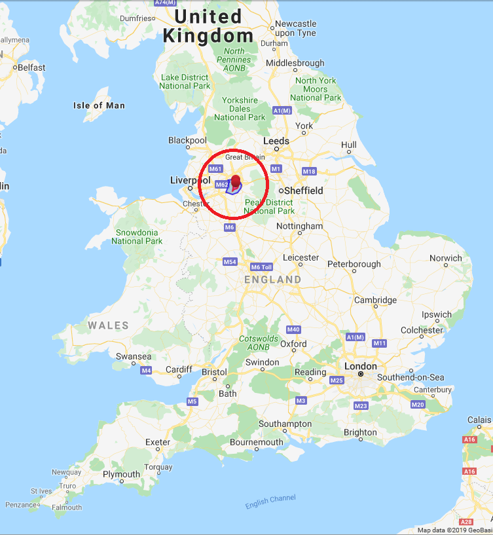

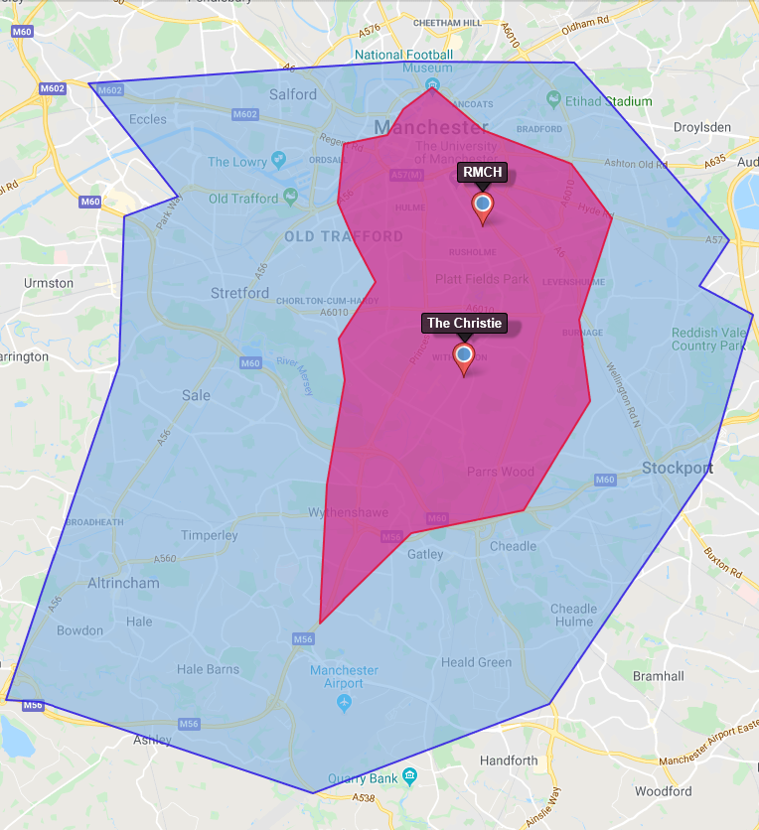

A3.2

3.6 Note that it is not necessary to provide a single site to service the entire requirement, although this is preferred and will be scored accordingly.

3.7 In the case that bidders submit multiple sites for consideration as part of this exercise, *all* properties must obey the above restrictions and meet the proximity requirement.

3.8 Scoring of multiple site submissions will reflect the furthest acceptable property. i.e. Where a bidder submits two properties, one of which in inside the “inner” perimeter while the other is within the outer perimeter, the bid will be scored as if all properties were within the “outer” perimeter.

3.9 If bidders propose multiple sites, they must also explain how they will allocate guests bookings between sites; i.e. If this will entail allocation to one site and then ‘overspill’ to the other, or if the provider intends to split paediatric and adult patient groups between sites etc.

3.10 Bidders using this approach must describe their own approach and the score given will be reflective of the confidence of The Christie that distributed sites will be manageable. Such approaches can be expected to score less than single site proposals, reflecting the additional cost and time taken to operate shuttle buses between accommodation sites.

3.11 All sites to be submitted are to be evaluated for the suitability of their location.

3.12 Families may be staying with young children, or there may be a number of vulnerable members in each patient group. Bids entered bids in respect of poorly lit areas, high crime areas or areas of high socio-economic deprivation are not desirable, as this may adversely impact the reputation of the Trust by exposing patients and their groups to risk due to the surrounding area of the site(s). Any such bids will attract a low score.

3.14 Similarly, old, dilapidated or dangerous buildings are not considered desirable and will also attract a low score. To be considered advantageous, buildings must have been either purpose-built for their current use or extensively converted. Buildings haphazardly or inadequately converted will attract a low score.

3.14 The bidder must describe their legal entitlement to the buildings in the submitted site(s) to allow The Christie to manage its risk in entering into a contract for the service. This element is not evaluated.

A3.3

3.15 The Christie is aware of the practice of overbooking in the serviced apartment sector. As noted in the Invitation to Tender, this practice of overbooking, is expressly prohibited under this tender. The Christie must understand and be assured that NHS allocations under the resulting contract are ring-fenced from outbooking practices that may happen on site.

1. Contract standards and delivery

B1. Block Management Policy, cancellations and flexibility

B1.1

1.1 The Christie is a public service body bound by the GDPR regulations. The nature of the financial and management interactions between the Trust and the contract holder do not meet the necessity threshold for data sharing, therefore there will be no transfer of patient/guest identifiable details between the parties to this agreement.

1.2 The only details that will be shared by The Christie once the patients’ accommodation needs have been identified are:

* Party size
* Check-in and Check-out dates
* A unique reference number generated by The Christie’s hospital systems.

1.3 Bidders warrant as part of the bidding process that they are prepared to work with the Trust in this way, and that they have their own fully functional electronic system for recording guest stays.

1.4 This system must enable both regular, planned information submissions back to The Trust for regular monitoring, but also be responsive should the Trust make ad-hoc information requests or “spot checks” regarding patients staying in the accommodation.

1.5 Although not part of the minimum requirement, a cloud-based booking system that allows real-time monitoring and amendment of guest bookings and details would be of interest and may attract a higher score if such features could be accessible to Christie staff (notwithstanding GDPR restrictions).

B1.2, B1.3

1.5 As described at section A1 above, the basis of the service sought is a number of ‘block rooms’ which form the core of the capacity of the service, with additional ‘non-block’ rooms purchased on an as-needed basis.

* The Christie envisages booking rooms between 6 weeks and 24 hours in advance of any booking. ‘Block’ rooms must be handed back to the provider by prior agreement in order for these rooms to be sold to other, non-Christie, guests, however these rooms will not be handed back more than one week before a stay is due to begin.

1.6 The opportunity cost to the provider of these rooms being handed back at the one-week notice advance point and not being filled by the provider for non-Christie guests should be factored into the bid price.

1.7 These limits represent the minimum requirement. Any provider that was prepared to allow hand-backs of ‘block’ rooms later than 1 week in advance would be viewed favourably.

* For non-block rooms, The Christie will notify the provider as early as possible within the 6-week timeframe that such bookings are likely to be required. These apartments will then exist as a separate supply on top of and beyond the block apartments.
* Bidders are required to honour a single price for all apartments of a given type (see section B2), regardless of whether they are booked in-block or beyond the block, and regardless of the notice period provided for a given booking.

1.8 Bidders are free to determine their own booking forms and booking processes within the parameters described above, however these will be requested to be demonstrated as part of the site visit to be carried out in this evaluation exercise.

B1.4

1.9 Bidders must provide a responsive service to The Christie, including a booking line accessible at minimum between the hours of 8am-6pm weekdays. This service must be available for both Trust and Guests to access for information regarding bookings. 8am-6pm is considered the minimum standard and extended hours would be preferable.

B1.5

1.10 Bidders to have a system for recording bookings and links to accounting systems to track and report on bookings and occupancy over time back to the Trust at the request of the Trust.

B1.6

1.11 Cancellation fees for late cancellation of rooms (either in-block or later cancellation of non-block rooms) are permitted. It will not always be possible for The Christie to be 100% accurate about patient attendance, particularly for patients of more complex interventions where the patient’s attendance may depend on discharge from other hospitals.

1.12 It is in the interests of the Trust to maximise the flexibility around such cancellation charges and would view the minimisation of cancellation fees, in terms of notice periods and charge levels, favourably.

1.13 At a minimum level, the Trust must be notified of all such cancellation charges in each case in which they are applied, and reflect these in all invoicing arrangements so that fees can be identified at the point of payment.

B1.7

1.14 Changes to the block size during the life of the contract are anticipated. Several of the services described in the ITT documentation are either new or growing at the time this tender is being issued, and it is furthermore possible that the block size may contract should services be decommissioned by the NHS.

1.15 Bidders are asked to outline the notice periods involved with amending the block, upward or downward, and to set any limits (in terms of the numbers of available apartments) which they would be prepared to offer on a sustained basis.

1.16 Wider up/down parameters and shorter notice periods are desirable for the Trust.

NB. The Trust *must* be notified of all DNA/’no-show’ patients. A human interface using phone or email is acceptable as a minimum, however, an automatic alert system is preferred.

B1.8

1.17 Bidders must complete any adaptions or modifications to the submitted apartments before commencement of the contract (i.e. converting rooms to a disability standard).

B2. Price

B2.1 – B2.2

2.1 A comprehensive set of prices must be submitted for evaluation.

2.2 Prices must be fixed and cannot vary over the course of the year (i.e. must not change seasonally), from week to week, between block or non-block, or vary depending on the amount of notice given for bookings.

2.3 All fees proposals in this section must be in terms of £GBP per night.

2.4 The only price variation permitted is between apartments of different types in line with those described at section 1.5, i.e. between larger apartments to accommodate 3-4 guests, smaller apartments to accommodate 2 guests, and accessible apartments in either of the above size classes.

2.5 Prices offered in Appendix B(ii) Tab G. Finance Criteria will be taken forward into the contract and will be considered binding.

2.6 Typically the following apartments will be required:

* Apartments to all required quality standards, sleeping 2 guests.
* Apartment to all required quality standards, sleeping 3 guests.
* Accessible apartments to all required quality standards, sleeping 3 guests.
  1. A “sample block” of reserved apartments in respect of a (theoretical) night is as follows:
  + 10x Apartment sleeping 2 people.
  + 15x Apartment sleeping 3 people.
  + 5x Accessible apartment sleeping 3 people.

2.9 Bidders must warrant that the prices submitted in Appendix B(ii) Tab G are also accessible to guests who wish to book additional rooms themselves. Any such bookings will always be associated with guests whose apartments have been booked under this agreement and whose family, carers or relatives wish to access additional apartments at their own cost to facilitate the patients’ stay. Such bookings will also be restricted to run concurrently with their “Christie” stay.

B3. Invoicing

B3.1 – B3.5

3.1 The Christie will only accept invoicing on the basis of a single invoice per month for all costs accruing in that month.

3.2 This should be presented in a manner which is easily interpreted by the Christie operational leads.

3.3 Bidders must warrant that the monthly invoice includes:

* Only costs for guests that have departed their stay within the month. Bidders must not include invoices for guests that are still in residence.
  + Note that The Trust can be invoiced for guests that are in residence at the end of the payment period where these guests have departed in month and have since returned to start a new stay. In such cases, costs may be included for the value of the earlier (i.e. concluded) stay.
* Details of the guest reference number, nightly cost, number of nights, and any costs considered additional to the basic stay, i.e. costs that the guests have paid for themselves.
* A distinction between nightly costs associated with a guest stay, and those attributable to cancellations and charges, must be made.

3.4 The Christie intends to bear no responsibility for damages, theft, or other injurious or prejudicial activities that may be carried out at the bidder’s site.

3.5 The only exception to this policy occurs where a family are unable to provide a credit/debit card or other appropriate security for any events that may occur during their visit. In these circumstances, the provider will notify The Christie that the patient is unable to make such security available (or in some cases The Christie will be aware of this in advance and notify the provider). The Christie will then underwrite the value of any damages.

3.6 Bidders must provide a copy of their damages policy and describe their approach to reclaiming funds from guests that have inflicted damage on site.

1. Facilities, staff and the guest environment

C1. Other on-site facilities

C1.1 – C1.8

1.1 Bidders are invited to submit their car park solutions related to their site(s). This may include the bidders’ own car park facility or a local 3rd party parking supplier with whom a written agreement exists. Bidders must submit their car park prices on a per-night basis.

1.2 As described a shuttle bus is part of The Trust’s service provided to patients staying at sites included in this provision. The proposed sites must be sufficient to allow this shuttle to pick-up and drop-off patients nearby the site and to allow the bus to turn safely within the road access limitations of the site.

1.3 Although the vehicle used since the commencement of the service has been a conventional 16-seater minibus, it is possible that larger vehicles may be used on this route in future years; therefore larger bays and turning spaces are considered to score more highly than small ones.

1.4 Provision of some storage space on-site would be advantageous; however, this is not part of the minimum requirement.

1.5 Provision of some common areas on-site would be advantageous; however, this is not part of the minimum requirement.

1.6 Usage of ‘common’ space would principally be for informal guest networking and activities to allow some joint recreation and mutual support. Flexibility within this space to allow supportive services from the Christie (Social Work, Youth Support Work, Complementary Therapies) to run sessions for the patient group would present a higher score, particularly larger areas equipped with plentiful seating and soft furnishings, televisions, games and distractions for guests.

1.7 Provision of a gymnasium and exercise equipment availability on-site would be advantageous; however this is not part of the minimum requirement.

1.8 This criterion is applicable only where the provider has not included full clothes washing facilities within each apartment). In this case, score will be awarded based on other on-site laundry facilities for guests and how these are accessed and, if applicable, charged for.

1.9 A level of score may be awarded through agreement with a local laundrette or similar to provide such services free of charge, if conveniently located for patient access, or a lesser score for a discounted agreement or more remote location.

1.10 Bidders may include proposals for catering for patients should they wish to do so. This is not part of the minimum requirement.

1.11 A (chargeable) breakfast offer is considered advantageous while a catering offer throughout the day is considered optimal.

1.12 Bidders are required to submit their policies and/or procedures for the cleaning guest apartments and other guest spaces within the sites(s), both before/after a guest stay, and during a guest stay where applicable.

1.13 A minimum standard for this section is a full clean between guests, including changing bedding and towels, and sanitising the properly appropriately for new guests to arrive.

1.14 Descriptors of cleaning policies and processes in this section should include the bidder’s approach to hazardous materials, sharps and the protection of staff.

1.15 Where additional cleaning services during guest stays are offered, this must be described, together with applicable charges.

1.16 Bidders should include in this section any further services they provide to support patients to clean their own apartments during stays (e.g. towel and bedding changes, etc.) and the process and any applicable charges for such services.

C2. Staffing and on-site support

C2.1 – C2.5

2.1 The link between the Christie and corresponding staff in other clinical service areas is a critical one for The Trust. It is advantageous that a single dedicated customer account manager be identified as a counterpart to the above.

2.2 The account manager must have authority to resolve any billing and account issues and also to resolve any logistical / operational issues on site and act as a main point of contact.

2.3 Although not required to be present on site at all times, this manager should be contactable in normal business hours based at one of the proposed sites and be readily accessible should Christie staff wish to hold meetings or carry out site visits.

2.4 As well as the Account Manager, the following services should be described in detail as part of bidders’ submissions. As a general rule, faster responsiveness and greater availability over the week are considered to attract a higher score at evaluation:

* Reception Desk for responding to both client and guest queries.
* Security Team based on site or in the immediate vicinity.
* Financial and accounts team for client queries.

2.5 Engaging 3rd party specialist suppliers for the above services is acceptable provided that a high standard of service can be maintained. Bidders must evidence the performance of any subcontractors used to provide any of the services contained in these headings, as part of the submission.

2.6 Staff employed by the bidder may in the course of their duties come into contact with Christie patients, including vulnerable children and adults. The extended nature of the stay, variations in family membership, and interactions between families and staff members, may expose patients and family members to safeguarding risks above and beyond those in a typical serviced apartment setting.

2.7 Bidders must warrant that, upon award of contract, they will fully participate and cooperate in a safeguarding risk assessment of their current and proposed staffing structure.

2.8 Bidders are under a duty to notify The Christie if any DBS or safeguarding findings are subsequently made involving their staff members or subcontractors carrying out work on the proposed site(s). The Christie will be the ultimate arbiter of the decision whether or not to allow these staff members to continue working on the site(s) in questions.

2.9 The Christie will not tolerate any risk regarding vulnerable patients or supporting carers and holds providers to a high standard.

2.10 All staff working for or on behalf of the bidder must be appropriately qualified in their own professional areas as appropriate for their role and responsibilities.

C3. Environmental Sustainability

C3.1 - C3.3

3.1 Bidders should provide an Energy Performance Certificate (EPC) to cover all property(s) included in their bids, if available. If such EPCs are not available, bidders must note this in their bids.

3.2 Although facilities for car parks are considered a scored element of this process this is not a minimum qualifying requirement. The Christie actively encourages patients and their carers to utilise sustainable public transport options where possible and would welcome any proposal that maximised the availability of such links.

3.3 Example materials that informed guests of their transport options and encouraged the use of public transport would be welcomed.

3.4 Bidders with a corporate environmental strategy or sustainability strategy outlining their corporate approach to minimising environmental impact, evidenced with effective practice to date, would be considered to achieve a higher score.

C4. Health & Safety

C4.1 – C4.10

4.1 All guest apartments must be properly secured against interference and prevent disturbance to patients or their belongings. Keys or swipe cards for access to each apartment are a minimum standard, however more secure and easy-to-operate systems, applied to apartments or site wide, that provide enhanced security and increased patient confidence will attract a higher score.

4.2 Site-wide security arrangements will collectively be evaluated as part of the site visit. Bidders should outline their security arrangements in their submissions to aid this process.

4.3 The ideal scenario for managing Christie patient bookings on site would be a fully segregated area (separate building, area of a building, or a separate floor within multi-level properties) away from other members of the public staying in the property privately.

4.4 Note that sites that are submitted entirely and exclusive for Christie use will score maximum points under this section.

4.5 This is not a minimum requirement, however, and thus ‘no segregation’ approaches are acceptable. Providers should outline how, if at all, they propose to manage logistics of bookings for Christie guests to co-locate them within the site(s) as far as possible.

4.6 It is accepted that occurrences within the site of conflict between guests (either in the same apartment, in the same party but different apartments, or separate parties altogether) may occur from time to time and beyond the ability of the bidder to prevent entirely.

4.7 Bidders should describe their approach to managing disturbances of this type. This approach must also include approaches to ejecting such intruders.

4.8 All sites that are included in bidder submissions must be fully compliant with the following regulations:

* Fire and emergency evacuations.
* Internal temperature control.
* Ventilation and airflow.
* Buildings and development control (planning).
* Public liabilities and apartment operators insurances.
* Lifts safety.
* Any other regulatory requirements that may be in place and required under UK law at the time the tender is submitted.

4.9 A business continuity plan must be in place to cover all foreseeable circumstances in which the site(s) proposed would be unable to carry out their designed duties in accommodating Christie patients. This plan must be submitted to this requirement and include proposed alternative for all guests that could be displaced in the case of a business continuity event occurring at the site(s).

4.10 Bidders must operate their premises in subject to appropriate licences. Premises must be appropriately zoned and licenced for short term lets by the local authority. Unlicensed premises or those operated in breach of planning permission will not be accepted.

1. Quality and Impression

D1. Interior feel and quality of appointment

D1.1 – D1.2

1.1 Bidders must submit their apartment site(s) star ratings and reference the awarding agencies. The Christie aims to achieve access to an equivalent of 3-star standard, however an equivalent 2-star standard would suffice as a minimum.

1.2 Bidders should also include any other award or accreditations from other accredited tourism agencies that they consider relevant in support of their bid.

1.3 Proton Therapy patients, as the largest service user group of patients within the hospital that will use the service, will evaluate the overall impression of the submission based on their previous experiences of staying in similar accommodation.

1.4 Bidders who are successful at the first evaluation stage will be asked to prepare a short presentation, to include video, photographs, description of their property(s) and a summary of their bid. This presentation will be made to a patient group, followed by a Q&A session.

1.5 Presentations judged by the evaluation team (that carried out the site visit) to be true and accurate will attract a score based on patient feedback.

1.6 Presentations judged not to be true and accurate may be subject to later score moderation by the evaluation team following presentation to patients, to account for any inaccuracies.

D2. Guest satisfaction and user ratings

D2.1

2.1 Bidders must include sufficient evidence (in the form of testimonials and quantitative guest feedback exercises such as survey outcomes) that both corporate and private guests have been satisfied with the service and the site(s) put forward in this proposal. Note that feedback referencing sites other than those being proposed for Christie use will not be accepted, even if they are managed within the same group.

2.2 Such feedback must have been collected over no more than 6 months from the date of bid submission.

2.3 Feedback from corporate clients about their overall experiences working with the bidder over a period of months or years should also be provided where available, focusing on team and management accessibility and service standards rather than the stays within the accommodation site(s) themselves.

# Further information

**Limitations to this agreement**

The agreement with providers envisaged in this process is not intended to bind The Christie in any way to a requirement to furnish the bidder with a definitive number of guests, or to influence or prejudice the medical care of any patient.

Should admission to an inpatient ward, day unit, planned admission and transfer suite, or any other hospital-operated or jointly operated location be determined as appropriate for the patient, this provision will be accessed without reference to any agreement that may follow this process. This includes sheltered or socially supportive accommodation as well as medical admissions.

A chart demonstrating the Trust’s use of non-clinical accommodation over the last 12 months is included in Appendix D.

Whilst the Trust anticipates that the number of rooms will be as set out in the ITT documentation this opportunity includes any potential future increase in scope up to 100% of the original 34 rooms specified, i.e. the scope of this contract is for a range of rooms up to 68 in total.