LAND AT NORTHERN UNITED AND FOREST VALE, CINDERFORD, FOREST OF DEAN, GLOUCESTERSHIRE

CONSULTANTS BRIEF FOR PROVISION OF GREAT CRESTED NEWT
POND SURVEYS

ISSUE DATE: 20th March 2015

PROPOSALS RETURN DATE: 30th March 2015 (12.00 noon)

Contents

- Introduction 3
- Background 4
- Supporting information 5
- Skills required / outputs 5
- Programme 5
- Finance 6
- Project management 6
- Submission requirements 6

INTRODUCTION

The Homes and Communities Agency (HCA) wishes to appoint a consultant to undertake a Great Crested Newt population class survey in accordance with GCN Mitigation Guidelines (English Nature, 2001), and as submitted European Protected Species Licence modification (awaiting approval), see below:

“Population size class assessments will also be undertaken during 2015 on ponds 1-9, 11, 18A, 18B, 24-27c, 30, 31 and 34. HSI assessments will be made of ponds 10 and 19 to ensure that these can still be excluded from further survey (as per the 2013 surveys), if these ponds have improved then they will also be included within the surveys. These will be undertaken using bottle traps, torching and egg searches between mid-March and mid-June 2015.”

(EPSL modification, February 2015)

Surveys are to be carried out to 21 No existing ponds, as identified below.

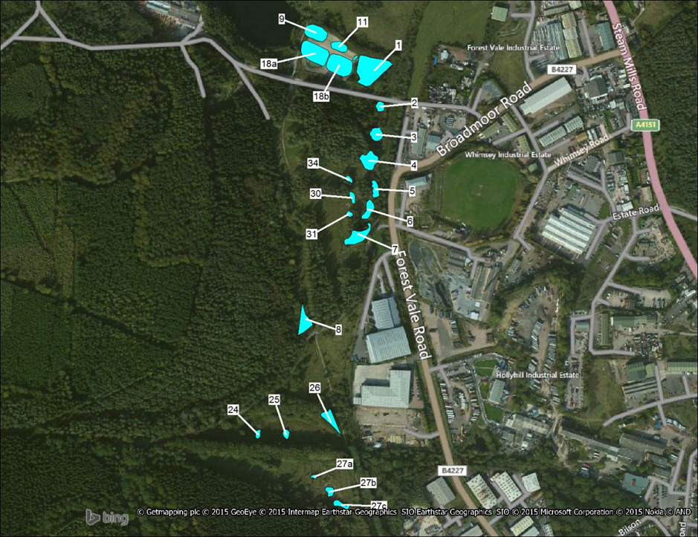

Surveys to comprise egg searches, torching and bottle trapping with six visits required to each pond between mid-March and mid-June, with a minimum of three between mid-April and mid-May.

Species, age and sex of all animals caught are to be recorded along with weather conditions, together with the precise location/pond reference.

Following each of the six survey sets a report setting out the results is to be prepared and provided to the Homes & Communities Agency (the client) and Natural England.

Based on previous 2013 surveys the estimated bottle trap numbers are as follows:

Pond Number | No’s of bottle traps | Pond Number | No’s of bottle traps
1 | 30 | 18B | 40
2 | 15 | 24 | 20
3 | 30 | 25 | 20
4 | 15 | 26 | 20
5 | 40 | 27A | 30
6 | 40 | 27B | 20
7 | 40 | 27C | 30
8 | 40 | 30 | 10
9 | 25 | 31 | 10
11 | 25 | 34 | 10
18A | 40

BACKGROUND

Cinderford and in particular the area of the town referred to as the Northern Quarter is a strategic project for the HCA in the South & South West Operating Area and is recognised within the top three priorities of the Gloucestershire LIP.

The area bounded by the red line on the cover of this consultant brief is the subject of a planning decision notice (reference P0663/14/OUT) for the delivery of a mixed use regeneration development in Cinderford’s Northern Quarter. The purpose of this consultant commission will provide detailed records of GCN’s potentially impacted by the development, and will be used to inform the requirement for ongoing and future EPS licence applications necessary to deliver the project.

The area of the planning consent can be accessed from the north directly from the A4136 (grid reference 363780 215550), and from Newtown Road to the south. The site falls within the Forest of Dean and is entirely surrounded by mixed woodland.

SUPPORTING INFORMATION

Planning information

Background information on the relevant local planning documents can be found at:

http://www.fdean.gov.uk/nqcontent.cfm?a_id=6567&tt=graphic

http://publicaccess.fdean.gov.uk/online-applications/simpleSearchResults.do;jsessionid=C4DED671E7FC2D461A40FC63369DCA9E?action=firstPage

Baseline information

The following information related to the Core Strategy and Area Action Plan can be found at:

http://www.fdean.gov.uk/nqcontent.cfm?a_id=7025&tt=graphic

Your attention is drawn to the “Cinderford Area Action Plan – Evidence Base” pages on the website.

SKILLS REQUIRED/ OUTPUTS
Skills required

The consultant will be expected to undertake the survey using an appropriately qualified and licensed team of specialist ecology professionals, working in a diligent and methodical manner. It is imperative that the consultant team has a full understanding of the ecological issues surrounding the commission, in particular, seasonal restrictions. If the consultant team has any doubts of what is required of it to meet this criteria, this is to be identified to the HCA upon receipt of this consultants brief.

PROGRAMME

- Tender return – 30th March 2015
- Consultant appointment – 1st April 2015
- Latest date for commencing first round of surveys – 13th April 2015
- Completion of final surveys – 19th June 2015
- Final reports completed and submitted to HCA/NE – 1st July 2015

FINANCE

6.1 Consultant’s fees will be paid at monthly intervals during the project.

PROJECT MANAGEMENT
Governance

The client for this project is HCA.

The consultants will report to the HCA Project Manager (Greg Morgan), on a day-to-day basis, with structured meetings held as deemed necessary, subject to reasonable notice. The consultant team will be expected to liaise and exchange information with the HCA’s incumbent consultant team, led by Parsons Brinkerhoff, and also the HCA’s partners, Forest of Dean District Council, the Forestry Commission, Gloucestershire County Council and Natural England. However, all initial correspondence and authority to divulge information (which is acknowledged may be of a sensitive nature) must be addressed through the HCA in the first instance. Allowance for attending these meetings and for reasonable attendance at other ad-hoc meetings must be made in the tender proposal.

SUBMISSION REQUIREMENTS

Format for submission

One hard copy of your proposal should be submitted by 12 noon on 1st April to:

Tendering Opening Panel
Homes and Communities Agency
St. George’s House
Kingsway
Team Valley
Gateshead
TYNE AND WEAR
NE11 0NA

A tender reference number will follow in a separate email w/c 23rd March 2015.

A Please mark it with the reference “Tender for Consultant Services – Great Crested Newt Pond Surveys, Cinderford Northern Quarter” and include the following information within your submission:

- Confirmation of lead consultant;
- Approach to project management;
- Project team structure;
- Details of any sub-consultants that may be required;
- Pen portraits and a description of each key member’s role within the project;
- Methodology for undertaking the commission;
- Details of the proposed individuals experience related to the work required under this commission;
- Anticipated programme for delivering the commission, including key milestones and incorporating the specific outputs detailed within this brief;
- Resource Plan, providing daily fee rates for each team member, allocation of the time of each team member across the work programme and total fee, including all expenses and travel costs.

If you have any queries relating to this brief, please email (redacted)

Fees

Please quote a fixed, lump sum fee for producing this commission, excluding VAT. Please include for the cost of producing the specific outputs required, as described in this brief. This is to include all printed material. We will require 4 hard copies of the final masterplan, along with an electronic copy of all material produced as part of the commission.

Travel costs and other expenses should also be included within your fixed fee proposal and will not be chargeable separately.

Evaluation Criteria

The selection of consultants will be made on price, once HCA is satisfied the consultant is capable of undertaking the commission on the strength of the tender submission.

It acknowledged that bidders are likely to engage sub-consultants to fulfil the HCA requirements set out in this brief. Bidders should clearly set out in their submission the responsibilities of the lead consultant and their sub-consultants including time charging and fees. The HCA has the right to decline nominated sub-consultants and where appropriate seek clarification of alternative arrangements from bidders.

Selection procedures and timescales

Following the assessment of bids received, the successful consultant will be informed by Wednesday 1st April 2015.

