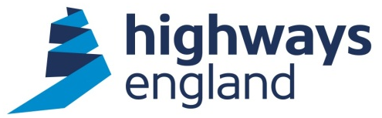  Our ref: CDF PC3b 0026  Your ref:  Garry Slater  Bid Director  Costain  Via Bravo Solutions | Sharon Cuff  Procurement Director  Highways England  Lateral  8 City Walk  Leeds  West Yorkshire  LS11 9AT  29 May 2018
CDF PC3b 0026 - Smart Motorways Programme-
Delivery Partner for M6 J21a-26

Dear Garry,

On behalf of Highways England, I am writing to accept your recent offer to carry out the above-mentioned Package Contract within the terms of the Collaborative Delivery Framework agreement.

The Package Contract is a Package order, awarded under Lot 3b of this Framework.

The Project Manager is Agnes Usciak.

This will form Order CDF PC3b 0026 to the Agreement.

You should note that we will not pay for any work unless it has been specifically authorised in writing within the terms of the Agreement.

Category Management

CDF Delivery Partners are required to utilise any live category specific arrangements Highways England has in place. Early engagement and appointment of a specialist subcontractor is required to drive efficiency during the scheme development through supply chain input. Highways England will arrange to discuss these requirements further and agree a joint action plan shortly following award. Current live category arrangements are:

- Traffic Management Technology
- Pavements

Collaborative Performance Framework

The CPF toolkit has now been tailored to suit individual types of task orders/contracts and as a result of this the Project Manager will liaise with Highways England’s Commercial Team to identify and issue the CPF toolkit that is relevant to this specific contract. A CPF will be required in accordance with the CPF guidance and FAQ documents. The CPF may be considered by the Company when allocating future work and other contractual mechanisms.

Project Bank Account

A project bank account will need to be created for this scheme. Please provide contact details, name, number and email address of your commercial manager and account manager so that this can be arranged.

Please note you must not make any public announcements and all media enquiries should be directed to the Highways England Press Office.

Please acknowledge receipt of this letter by return.

Yours sincerely,

Sharon Cuff
Procurement Director

