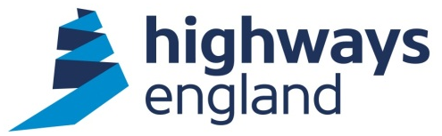  Our ref: CDF PC1 0053  Your ref:  MMS JV  Mott MacDonald House, 8-10 Sydenham Road Croydon, CR0 2EE  Sweco UK Limited, Grove House, Mansion Gate Drive, Leeds, LS7 4DN  Via Bravo | xxxxxxxxxxxxxxx  Procurement Delivery Officer  2nd Floor  Woodlands  Manton Lane  Bedford MK41 7LW  Direct Line: 0300 470 xxxx  13 December 2016
CDF PC1 0053
M49 AVONMOUTH JUNCTION PCF STAGE 3

Dear Sir

On behalf of Highways England, I am writing to accept your recent offer to carry out the above-mentioned Package Contract within the terms of the Collaborative Delivery Framework agreement.

The Package Contract is a Time Charge order, awarded under Lot 1.

The commencement date will be authorised by the Project Manager, (xxxxxxxx). The value of this Package Contract is £321,000.00 and the end date specified in the Package Order is 31 March 2017. This will form CDF PC1 0053 to the Agreement.

You should note that we will not pay for any work unless it has been specifically authorised in writing within the terms of the Agreement.

This award is subject to confirmation by return that the Key People you have offered in your tender will be available to start the project.

The CPF toolkit has now been tailored to suit individual types of task orders/contracts and as a result of this the Project Manager will liaise with Highways England’s Commercial Team to identify and issue the CPF toolkit that is relevant to this specific contract. A CPF will be required in accordance with the CPF guidance and FAQ documents. The CPF may be considered by the Company when allocating future work and other contractual mechanisms.

Invoices should be sent to FS Payments at Highways England, The Cube, 199 Wharfside Street, Birmingham, B1 1RN, quoting the Project Manager’s
name, Blanket Purchase Agreement number and release number, both obtainable from the Project Manager.

Please note you must not make any public announcements and all media enquiries should be directed to the Highways England Press Office.

Please acknowledge receipt of this letter by return.

Yours faithfully,

xxxxxxxxxxxx
Procurement Delivery Officer
Highways England Commercial & Procurement
Procurement Delivery (RIP)
Email: cdf@highwaysengland.co.uk

