NHS West London Clinical Commissioning Group
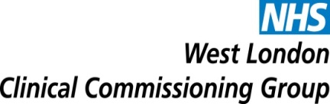
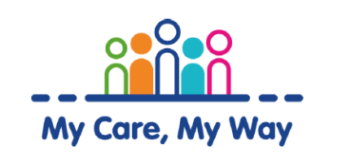

Organisational Development – Rapid Learning for My Care My Way Programme

Memorandum of Information (MOI)
08 March 2017

NHS West London
Clinical Commissioning Group (WL CCG)

Contents
1. Introduction and Overview 1
1.1 Purpose of this document 1
1.2 Introduction 1
2. Strategic and Local Context 1
3. OD Approach 3
4. West London CCG Membership 3
5. Governance and Administration 5

Introduction and Overview

Purpose of this document
The purpose of this Memorandum of Information (MOI) is to provide potential providers with an overview on NHS West London (WL) CCG’s considerations with regards to the rapid learning and organisational development process to guide the refinement and attain further improvements in the model of care of the CCG’s My Care, My Way (MCMW) programme of integrated care for the 65 and over.

The MOI is intended only as a preliminary background explanation of the MCMW Programme. It is in no way intended to form the basis of any decision on the terms upon which WL CCG will enter in to any contractual relationship. This MOI is supported by further details provided in the draft service specification.

Introduction
My Care My Way (MCMW) builds on the CCG Programme around a whole systems model of care working with people aged 65 and over with complex needs and conditions. The person is at the centre of holistic care planning across organisations such as health, social care and the voluntary sector. This way of working is a better, more coordinated way of providing care for the elderly population with long term conditions in West London and requires people with commitment and passion for working with older people.
MCMW was developed in response to a number of key national and local drivers including patient feedback, the NHS 5 Year Forward View, increasing demand and the changing health and social care landscape in NW London. It was developed over a 2 year period and has been operational for over 15 months. The service aims to deliver an accessible, efficient, service managing the health and care needs of the frail and elderly population of West London.
My Care My Way (MCMW) is an holistic approach to providing care to people and comprises the following key functions:
- Risk Stratification and selection of appropriate service users for active care planning.
- Holistic assessment for both health, social and wellbeing needs
- Person centred care planning
- Care Coordination.
- Patient centred multidisciplinary team working, supporting appropriate urgent care responses

Strategic and Local Context

The CCG has taken into consideration national, regional and local strategies and frameworks in the development of its commissioning intentions. There are strong and robust strategic drivers for change and key related strategies have been highlighted in this section of the MOI.

Over recent years, the NHS has been increasing its focus on improving the provision, access and quality of care provided outside of an acute hospital setting. The key drivers for the development of this service are to provide a local, more accessible, clinical and cost effective service for patients, as set out in ‘Equity and excellence: Liberating the NHS’

The recent NHS England Guidance (2013) highlights that in order to meet the needs of our population; it is not possible to maintain the current duplication and fragmentation of care. The guidance states that; ‘without transformational change in how services are delivered, a high quality, yet free at the point of use health service will not be available to future generations.’

The NHS Five Year Forward View further emphasises the need to break down barriers in how care is provided; with far more care delivered locally, supported by specialist centres for more complex needs. The provision of integrated services in the community is a step towards meeting this objective of care closer to patients and primary care. This has significant benefits; providing a more convenient service to patients and helping to relieve the pressure on secondary care services, focusing on patients with the most complex health and care needs. Patient & carer feedback, along with staff surveys indicate high levels of satisfaction by both the service users and providers.
2.1 Local Drivers for Change
The local drivers underpinning the need to transform clinical services in the borough of West London include:
- West London CCG and its Partners have a vision for health and care, Putting Patients First (PPF) is WLCCG’s key vehicle for delivering integrated services.
- PPF is an integrated approach to managing frail and vulnerable patients through the principles of care planning, case management and multi-disciplinary team working.
- It ensures that care provided for patients is seamless with joined up working between all professionals, involving clear communication to ensure that patients understand their condition, treatment plan and options for self-management, where appropriate.
- It enables patients to be stepped up and down seamlessly between any episodes of urgent care and planned or proactive managed care. These same principles form the basis of MCMW Programme which is an Integrated Care model of care which focusses on those over the age of 65.

2.2 MCMW Model of Care
The MCMW model of care is a new way of working that brings together multi-agencies across health, social care and the 3rd sector. The key is to provide seamless services to people 65 and over living within the West London area, enabling them to remain as independent for as long as possible whilst achieving outcomes that are important to them. Through single assessment, central support/care planning and co-ordination, people will be able to access their own support/care plan and actively contribute to shaping the services that will be delivered to enable them to manage their health and care needs.

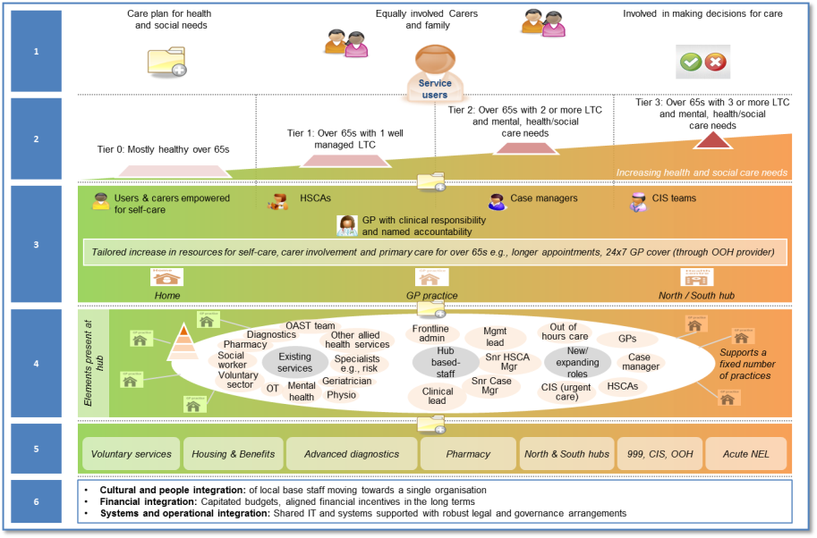
In order for the programme to function in an integrated way it is necessary for teams to be co-located which will encourage services to work together through day to day interaction and multi-disciplinary team meetings. St Charles is ideally located given the services that are already operating out of the building e.g. X ray, cardiology, respiratory, diabetes, phlebotomy, podiatry, voluntary services and older peoples’ day activities to name but a few. Similar range of services is also available at the other ICC hub at Violet Melchett health centre.

3. OD Approach

The overarching objectives of the OD approach are:

- To create and open and honest culture which supports people to be courageous in delivering better health outcomes
- Every individual member of the My Care My Way team and the wider community partners to understand their role and work towards a common purpose
- The organisational structure of the My Care My Way programme is clear and meets the highest standards of governance and enables WLCCG to achieve its strategic vision.
- This programme will assist in the refinement of the Model od Care, developing partnership working with the knowledge, skills, behaviours and qualities required to deliver the transformational changes required to meet future needs.

Service Specification sets out the detailed requirements for the Rapid Learning and Development Process – Refinement of the Model of Care service.

4. West London CCG Membership
West London CCG is composed of 47 member GP practices divided into two localities (North and South). The practices are further divided into 5 Commissioning Learning Sets (CLS), which are geographical groupings of GP practices that have been formed for the purposes of fostering collaboration and learning amongst members, sharing and benchmarking data, improving performance, spreading good practice, and generating ideas for service improvement.

The five CLSs are South West (Kensington & Chelsea), South East (Kensington & Chelsea), North West (Kensington & Chelsea), North Central (Kensington & Chelsea and Queens Park and Paddington) and North East (Kensington & Chelsea and Queens Park and Paddington).
4.1 Population demographics
West London CCG covers the Royal Borough of Kensington and Chelsea and also the Queen’s Park and Paddington area of Westminster. We commission services for our registered population of 229,700 of which 28,005 are 65 years or over. The population has a large proportion of older working age residents and very few children. Half the area’s population were born abroad and nearly one third are from BME groups.
In Kensington and Chelsea there are more females (50.7%) than males (49.3%) whereas the opposite is true for Westminster (49.2% female; 50.8% male). Overall, there are more men than women living across the West London.
Table 1: Gender profile of Central and West London CCG residents

The age profile of Kensington and Chelsea shows an aging population, with 12% of the population aged over 65, and 11% in Westminster. In neighbouring Hammersmith and Fulham, only 9% of the population is over 65.

Figure 1: Proportion of population by broad age group
Kensington & Chelsea and Westminster both have higher proportions (73% and 75% respectively) of population aged 15-64 than both London (70.2%) and England as a whole (65.9%). An estimated 11-12% of both Boroughs’ populations are in their retirement age.
Based on the usual residents’ population, Kensington & Chelsea is the country’s second most densely populated area with density of 13,087 per square km; Westminster is the country’s 7th most densely populated area with density of 10,211 per square km.
Half the area’s population were born abroad. Four in 10 (38%) of the population in Westminster and nearly a third (29%) of the population in Kensington and Chelsea is from Black, Asian and minority ethnic (BAME) groups. Over a quarter of people in K&C and just under a third of people in Westminster state that English is not their main language

4.3 Health Profile
Cancer is the highest cause of death followed by cardiovascular disease. In Kensington and Chelsea, the average life expectancy is 85.1 years for men and 89.8 for women, the highest in the country. Life Expectancy in Kensington and Chelsea was the fastest improving in the country over the last decade, with an increase of 7.8 years for men and 7.5 years for women. Westminster closely follows Kensington and Chelsea, having the second highest average life expectancy of all London boroughs at 84.3 years.

The rate of death from all causes in under 75s is lower in both Kensington and Chelsea (67.9) and Westminster (79.2) than in England (100). However there is discrepancy across the boroughs, with some areas have higher than expected rates of death (142.7 in Westminster and 131.3 in K&C) and some having very low rates of death (32.2 in Westminster; 25.9 in K&C).

Life expectancy for men and women living in the area covered by West London CCG is higher than London and England averages. However, the north of the area covered by West London CCG has correspondingly worse health outcomes. The wards falling into the worst 20% in London for self-reported bad/very bad health, self-reported limiting long-term illness (LLTI) and self-reported working age LLTI are Golborne, St Charles, Notting Barns and Cremorne.

For further information about West London CCG and population profile please visit:
WLCCG Website: www.westlondonccg.nh.uk

Joint Strategic Needs Assessment (JSNA) for Westminster, Kensington & Chelsea and Hammersmith & Fulham 2013/14 http://www.jsna.info/document/highlight-reports-2013-14

5. Governance and Administration

5.1 Freedom of Information
NHS West London CCG is committed to open government and meeting legal responsibilities under the Freedom of Information Act (FOIA). Accordingly, any information created by or submitted to the Commissioners (including, but not limited to, the information contained in the application and the submissions, and clarification answers received from potential bidder and bidders) may need to be disclosed by the Commissioners in response to a request for information under FOIA.

In making a submission or application or corresponding with the CCG at any stage of the Procurement, each potential bidder, and each Relevant Organisation acknowledges and accepts that the Commissioner may be obliged under the FOIA to disclose any information provided to it:

- Without consulting the potential bidder or bidders or
- Following consultation with the potential bidders or bidders and having taken its views into account.

Potential bidder and bidders must clearly identify any information supplied in their response to the application that they consider to be confidential or commercially sensitive and attach a brief statement of the reasons why such information should be so treated and for what period.

Where it is considered that disclosing information in response to a FOIA request could cause a risk to the Procurement process or prejudice the commercial interests of any potential bidder or bidders, the Commissioners may wish to withhold such information under the relevant FOIA exemption.

However, potential bidders should be aware that NHS West London CCG is responsible for determining at their absolute discretion whether the information requested falls within an exemption to disclosure, or whether it must be disclosed.

Potential bidders should therefore note that the receipt by the Commissioners of any information marked “confidential” or equivalent does not mean that the Commissioners accept any duty of confidence by virtue of that marking, and that the Commissioner has the final decision regarding the disclosure of any such information in response to a request for information under the FOIA.

5.2 Disclaimer
The information contained in this MOI is presented in good faith and does not purport to be comprehensive or to have been independently verified.

Neither the CCGs, nor any of their advisers accept any responsibility or liability in relation to its accuracy or completeness or any other information which has been, or which is subsequently, made available to any potential Bidder, Provider, Bidder Member, Clinical Services Supplier, financiers or any of their advisers, orally or in writing or in whatever media.

Interested parties and their advisers must therefore take their own steps to verify the accuracy of any information that they consider relevant. They must not, and are not entitled to, rely on any statement or representation made by the Commissioners or any of their advisers.

This MOI is intended only as a preliminary background explanation of NHS Central London and NHS West London CCGs’ activities and plans and is not intended to form the basis of any decision on whether to enter into any contractual relationship.

The Commissioners reserve the right to change the basis of, or the procedures (including the timetable) relating to, the Procurement process, to reject any, or all, of the submissions and applications, not to invite a potential bidder to proceed further, not to furnish a potential bidder with additional information nor otherwise to negotiate with a potential bidder in respect of the Procurement, subject to compliance with general EU principles on equal treatment, non- discrimination and transparency and procurement law.

The CCGs shall not be obliged to appoint any of the bidders and reserves the right not to proceed with the Procurement, or any part thereof, at any time.

Nothing in this MOI is, nor shall be relied upon as, a promise or representation as to any decision by NHS Central London and NHS West London CCGs in relation to this Procurement. No person has been authorised by the Commissioners or their advisers or consultants to give any information or make any representation not contained in this MOI and, if given or made, any such information or representation shall not be relied upon as having been so authorised.

Nothing in this MOI or any other pre-contractual documentation shall constitute the basis of an express or implied contract that may be concluded in relation to the Procurement, nor shall such documentation/information be used in construing any such contract. Each bidder must rely on the terms and conditions contained in any contract when, and if, finally executed, subject to such limitations and restrictions that may be specified in such contract. No such contract will contain any representation or warranty in respect of the MOI or other pre-contract documentation.

In this section, references to this MOI include all information contained in it and any other information (whether written, oral or in machine-readable form) or opinions made available by or on behalf of the Commissioners, or any of their advisers or consultants in connection with this MOI or any other

Equity and excellence: Liberating the NHS, DH (2010).
NHS England (2013) Planning and Delivering Service changes for Patients
http://www.england.nhs.uk/wp-content/uploads/2014/10/5yfv-web.pdf
JSNA, 2012.
Office for National Statistics, Neighbourhood Statistics, 2006-2008.

