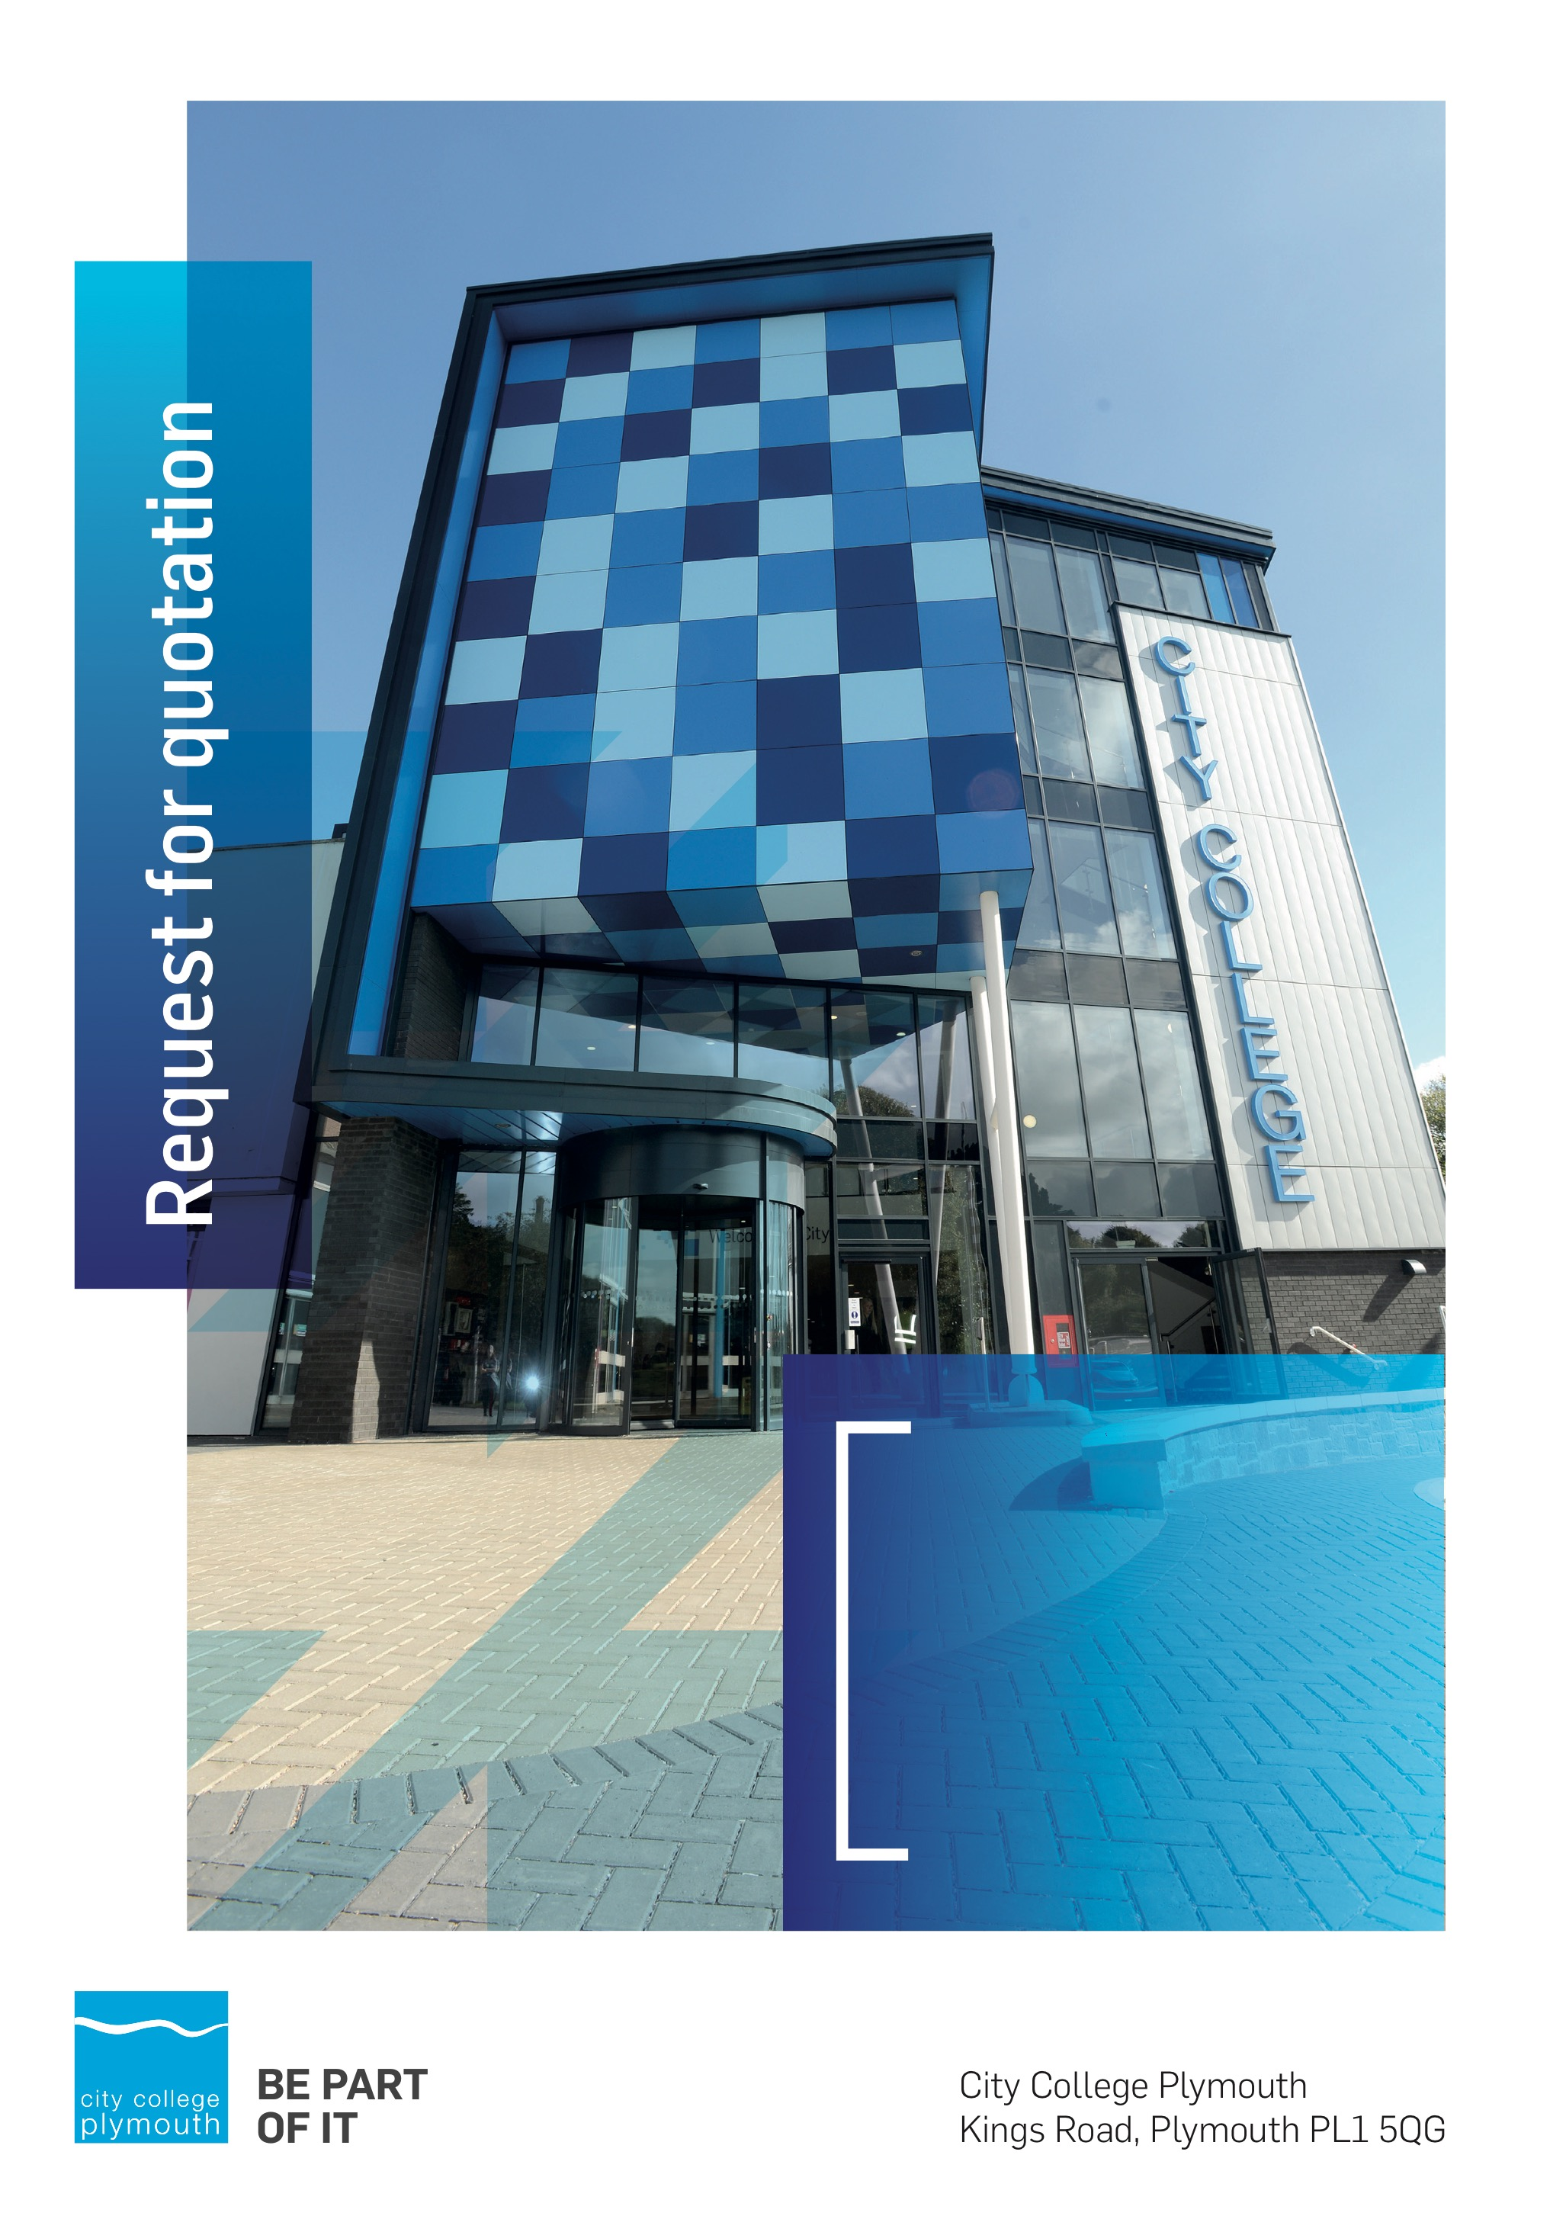

**Request for Quotation**

**RF174**

**Online Store**

**Issued 2nd July 2021**

# Table of Contents

Table of Contents 2

Confidentiality Statement 3

Open Procedure 4

Submission Details 4

Submission Deadlines 4

Submission Questions and Clarifications 4

Electronic Submissions 5

Introduction and Executive Summary 5

Business Overview & Background 6

Our guiding principle 6

Our Vision 7

Our Core values 7

Our Culture 7

The Way Forward - our Priorities 7

Detailed Requirement 7

Timescales 8

Written Submission 9

Pricing 9

Safeguarding 9

Terms and Conditions 10

Validity 10

Selection Criteria 10

Award Price 11

Written submission 11

Assessment of Quotations 11

Freedom of Information Act 2000 12

General Data Protection Regulation (GDPR) 2018 12

Agreement Conditions Acceptance and Declaration 12

Supporting Documentation 12

# Confidentiality Statement

This document, and any attachments thereto, regardless of form or medium, is intended only for use by the addressee(s) and may contain legally privileged and/or confidential, copyrighted, trademarked, patented or otherwise restricted information viewable by the intended recipient only. If you are not the intended recipient of this document (or the person responsible for delivering this document to the intended recipient), you are hereby notified that any dissemination, distribution, printing or copying of this document, and any attachment thereto, is strictly prohibited and violation of this condition may infringe upon copyright, trademark, patent, or other laws protecting proprietary and, or, intellectual property. In no event shall this document be delivered to anyone other than the intended recipient or original sender and violation may be considered a breach of law fully punishable by various domestic and international courts. If you have received this document in error, please respond to the originator of this message or email him/her at the address below and permanently delete and/or shred the original and any copies and any electronic form this document, and any attachments thereto and do not disseminate further.

Thank you for your consideration, City College Plymouth.

Where no notice is given, all information contained herein is Copyright 2021 City College Plymouth.

# Open Procedure

The College fully adheres to the requirements of the Public Contracts Regulations 2015, including for opportunities which are under threshold amounts.

Any Contractor who directly or indirectly canvasses any Member or Officer of the Institution, or advisor concerning the award of the contract for the provision of the services, or who directly or indirectly obtains or attempts to obtain information from any such member or Officer concerning any Tender or proposed Tender for the service will be disqualified from having his/her Tender considered.

# Submission Details

## Submission Deadlines

All submissions for responding to this Request for Quote must be submitted via email as stated below, no later than:

**Friday 23rd July 2021**

**12:00 Noon**

Any submissions received after this date will not be considered.

## Submission Questions and Clarifications

You may contact the following person if you have any questions or require clarification on any topics covered in this Request for Quotation: by 9th July 2021

**Adam Baker**

Procurement Officer

Phone: 01752 305313

Email: tenders@cityplym.ac.uk

All correspondence during the Tender should be channeled via the Procurement Officer using the above details only. Bidders found to have gained an unfair advantage shall be disqualified from the current opportunity and future opportunities with the College for a minimum of four (4) years.

## Electronic Submissions

Electronic submissions in response to this Request for Quotation are required and must meet the following criteria:

Sent via email to: [tenders@cityplym.ac.uk](mailto:tenders@cityplym.ac.uk)

Document standards:

* Text must be in Microsoft Word format;
* Price tables must be in Microsoft Excel format (using pricing schedule in Appendix A);
* Supportive evidence may additionally be submitted in PDF format;
* Images, Designs, and other supporting evidence may be in either JPEG or PDF format
* Completed Appendix C Suitability Assessment & Selection Questionnaire (Including Mandatory & Discretionary Exclusions) Parts 1, 2 and 3. - *Please note this suitability assessment will not be viewed unless you are the winning tenderer. Failure at this stage may prevent the contract from being awarded.*
* Signed Agreement Acceptance and Declaration.

*Please note that the College is able to accept submissions sent in a compressed or “.zip” file format, so long as the files contained meet the standards described above.*

**WARRANTY**:

By submitting your tender bid, you are warrantying to the College that you have not breached our canvassing or soliciting clause.

If any successful tenderer awarded a contract is found to have provided an inaccurate warranty, then the College reserves the right to terminate the awarded contract with immediate effect and re-tender the contract from which the successful tenderer will be excluded from re-bidding and shall be disqualified from any future opportunities for a period of four years.

# Introduction and Executive Summary

The College is undergoing major changes under its digital transformation agenda and is seeking quotations for a modern online store and payment facility. The system must be able to provide both an online shop and also provide a gateway for taking payments for tuition fees, including providing an RCP facility for instalment arrangements. The contract is expected to be in place for a minimum 3 years with an option to extend by a further 2 years.

The anticipated value of the supply contract will exceed £25,000. Therefore, as per the Public contracts Regulations 2015 the opportunity will be advertised on the government portal ‘Contracts Finder’.

# Business Overview & Background

City College Plymouth has a learning environment and organisational culture that impacts positively on the health, wellbeing and sustainability of our community and enables all of our students and staff to achieve their full potential.

City College Plymouth is one of the largest providers of innovative, technical and professional, education in the South West with a national reputation for promoting enterprise, employability and science, technology, engineering and mathematics (STEM). The College plays a central role in the educational, cultural and economic life of the region and works with strategic partners to facilitate growth, raise aspirations and foster wealth creation.

The College was awarded the Teaching Excellence Framework (TEF) Gold award for its university-level provision and its most recent Ofsted inspection confirmed that the College continues to be ‘Good’ with many outstanding features. The College was rated first in the South West and second nationally for student satisfaction in the latest FE Choices student satisfaction survey.

City College Plymouth is also one of the first Institutes of technology in the UK Working in collaboration with education providers and employers across the South West to improve the training in science, technology, engineering and maths in order to address skills gaps within these industries and support regional growth.

City College supports the region’s employers with their award-winning Apprenticeship provision, as well as providing a range of courses and bespoke training programmes which enable employees to upskill or retrain to better support their business’ requirements.

The College operates on two main sites within the city, serving 12,500 students and employing over 650 staff. The College operates year round, with opening times from 0800-2100 on some days.

## Our guiding principle

City College Plymouth has a learning environment and organisational culture that impacts positively on the health, wellbeing and sustainability of our community and enables all of our students and staff to achieve their full potential.

## Our Vision

To be the learning destination of choice

## Our Core values

Respect, ownership, integrity for all

## Our Culture

Nurturing a passion for teaching and learning

Enriching our community through knowledge, experience and skills

Enabling every student to be the best that they can be

## The Way Forward - our Priorities

• Staff - our most important investment

• Students - our purpose

• Community - making a difference

• Achievement - reputation for success

• Wellbeing - infusing health into every day

# Detailed Requirement

The approximate value of transactions through the facility is just over £200k per annum.

The College is undergoing major changes under its digital transformation agenda and is seeking quotations for a modern online store and payment facility. The system must be able to provide both an online shop and also provide a gateway for taking payments for tuition fees, including providing a Recurring Card Payment (RCP) facility for instalment arrangements.

The online payment facility and online shop must be viewable in multiple browsers and accessible from mobile devices. The facility must be able to link to the College Barclaycard smartpay account or EPDQ facility, as well as be compatible with College systems including Pro-achieve student record system and Microsoft GP finance system.

Online shop:

The College would like the online shop to be capable of selling a variety of items to include Room hire, merchandise, uniforms, bus passes and teaching equipment, bookings, through to paying for trips and miscellaneous items such as parking permits and taking bookings for events and student shows. We would also require the store to take payment of nursery fees.

The shop must be flexible and enable discounts to be offered for multiple items and purchase of multiple tickets for events. It should be simple and intuitive for end users, be fully mobile friendly, with a responsive design which means it renders correctly for all types of device (e.g. desktop, tablet, smartphone). It should provide flexible reporting and generation of management information.

A full list of required features is provided at Appendix E. For clarity the College does not require a Short Course module.

Online payments

We also require an online payment gateway to be able to take payments from students on enrolment with a pay now facility as well as providing a recurring card payment (RCP) option for instalment arrangements where applicable. Payments will need to be able to link into our student record system – ProAchieve by Advance and into our finance system; Microsoft GP.

The College would envisage having the new system up and running by the early December due to the expiry of the current contact in January.

## Timescales

|  |  |
| --- | --- |
| **Action** | **Date** |
| Tender Issued | 02/07/2021 |
| Deadline for Queries | 09/07/2021 |
| Tender Response Date | 23/07/2021 |
| Award Date | w/c 03/08/2021 |
| Go live date | 05/12/2021 |

## Written Submission

You should provide a written document which details your company offer, clearly outlining how you can meet the detailed requirements in Appendix E. Your document should therefore cover:

* The functionality of your proposed online store and payments facility, including the capability of your system to take Recurring Card Payments (RCP) for tuition fees. Where you cannot fully meet the specification please outline timescales for any planned development. To assist you are requested to completed Appendix F ‘eshop functionality’ spreadsheet
* How your proposed solution will link to the Colleges existing software
* How you will project manage the implementation and what ongoing support will be available following go live, to include a named customer/account manager
* Your experience of delivering similar facilities for other FE Colleges together with 2 reference sites
* Please indicate how the award of any resulting contract to your organisation would support City College Plymouth students in their development and learning and indicate any added value you could offer throughout the duration of the contract. (social value)

This submitted document will be scored as per the table on page 10.

## Pricing

Bidders should provide their pricing for any implementation costs as well as ongoing transaction fees or annual hosting fee in Appendix A.

Prices should be firm and valid for at least the initial contract period (12 months) and not subject to increase or escalation of any kind throughout the contract.

## Safeguarding

The College requires that all contractors, prior to undertaking work on the College site, will have been subject to a (DBS) English Disclosure Barring and Services check. You will be required to provide evidence of compliance before commencing work. This requirement may be suspended where works are undertaken during the college holiday breaks or outside of the main school week, providing the College is satisfied any risk to students who may be on site for revision or taster sessions is adequately managed.

All staff on site will be required to comply with health and safety requirements at all times and to wear appropriate identification.

All staff will be required to sign in and sign out when on College premises.

# Terms and Conditions

The College’s normal business terms are 30 days from the date of invoice. Payment will become due subject to the above upon the College’s full acceptance of the goods/services. This Request for Quotation and any resulting purchase order will be subject to the College’s General Terms and Conditions of Purchase of Goods/Services – see Appendix B.

# Validity

Bidder’s offers should be open and valid for acceptance for a period of no less than ninety [90] days from the date of submission.

# Selection Criteria

The successful supplier will have provided the Most Economically Advantageous Tender (MEAT) to the college. It should be noted that the bidder with the lowest submitted prices will not necessarily be down-selected. All bidders will be notified via email of the results of the outcome no later than 90 days from the date of submission. The date of contract award will be provided within that email.

The marking criteria follows:

|  |  |
| --- | --- |
| Category | Weight |
| Price | 50% |
| Quality and Functionality of online store | 20% |
| Online Payment Gateway | 10% |
| Compatibility with existing college systems | 5% |
| Contract management arrangements | 5% |
| Previous experience in FE colleges | 5% |
| Social Value | 5% |

Please see table below for more details on the scoring method.

## Award Price

Lowest quote price divided by quote price multiplied by 100

## Written submission

|  |  |  |
| --- | --- | --- |
| **Assessment** | **Score** | **Interpretation** |
| **Excellent** | 4 | *Comprehensive response supported by examples*  *Description fully supported by details that demonstrate the applicant’s ability to provide the required services.* |
| **Good** | 3 | *Broad response supported by relevant examples.*  *Description well supported by details that demonstrate the applicant’s ability to provide the required services.* |
| **Satisfactory** | 2 | *Reasonable response supported by some evidence.*  *Description adequately supported by details that demonstrate the applicant’s ability to provide the required services.* |
| **Poor** | 1 | *Limited response not well supported by evidence.*  *Description inadequately supported by details that demonstrate the applicant’s ability to provide the required services.* |
| **Unacceptable** | 0 | *No response or insufficient information provided.* |

# Assessment of Quotations

Bidders must ensure that their quotation fully addresses all information requested within this RFQ document. Bidders must ensure that any quotation fully meets the specification required. The College reserves the right to discount any quotation which does not fully meet the specification.

The College reserves the right to seek clarification with bidders upon receipt of quotations.

# Freedom of Information Act 2000

Under the Freedom of Information Act 2000 the College cannot guarantee that information provided by bidders during the course of this RFQ procedure or any resulting contract will be held a confidential. The College will not routinely release information to interested parties unless required to do so in order to meet our statutory obligations.

# General Data Protection Regulation (GDPR) 2018

All bidders must comply with the General Data Protection Regulation (GDPR) 2018 in respect of using and processing personal information. Bidders must have in place technical and organisational safeguards to protect personal data from unauthorised use, disclosure or loss.

The College reserves the right to request a copy of your privacy statement if you are the successful bidder.

# Agreement Conditions Acceptance and Declaration

Bidders are required to sign and return the attached Agreement Conditions Acceptance and Declaration. Appendix D

# Supporting Documentation

Appendix A: Pricing Schedule

Appendix B: City College Plymouth Standard Terms & Conditions

Appendix C: Suitability Assessment & Selection Questionnaire

Appendix D: Agreement Conditions Acceptance and Declaration

Appendix E: Detailed Specification

Appendix F: eshop functionality scoring sheet