Replica Rocket roadshow
Imagery and diagrams shown for illustrative purposes only
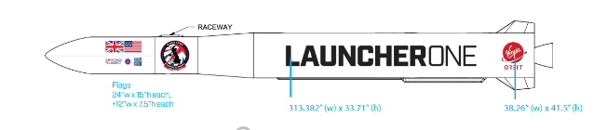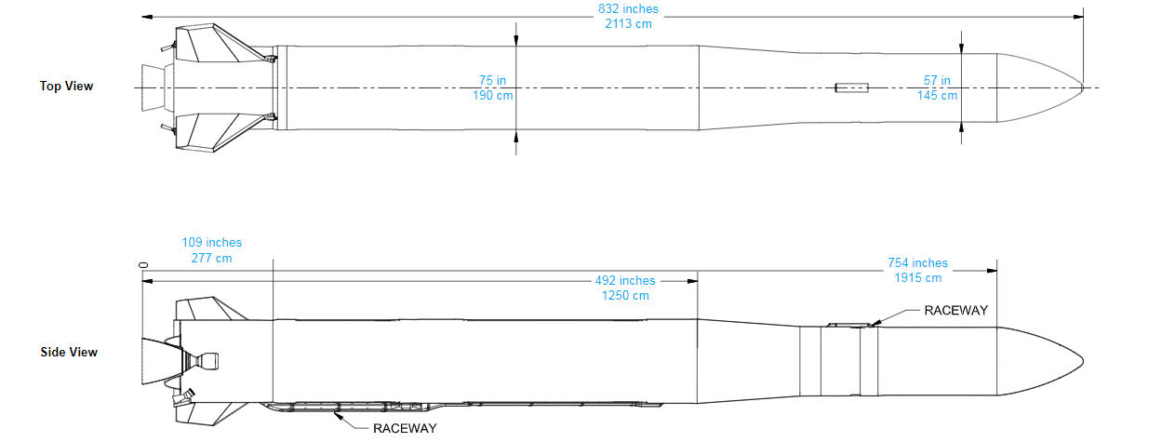
Illustrative diagrams showing rocket and livery (above)
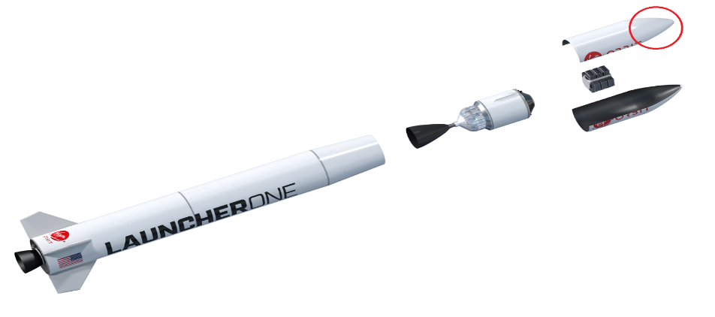

Illustration showing rocket with faring that opens (illustrative) –

Image taken from LauncherOne rocket installation in Times Square, New York (illustrative purposes only)
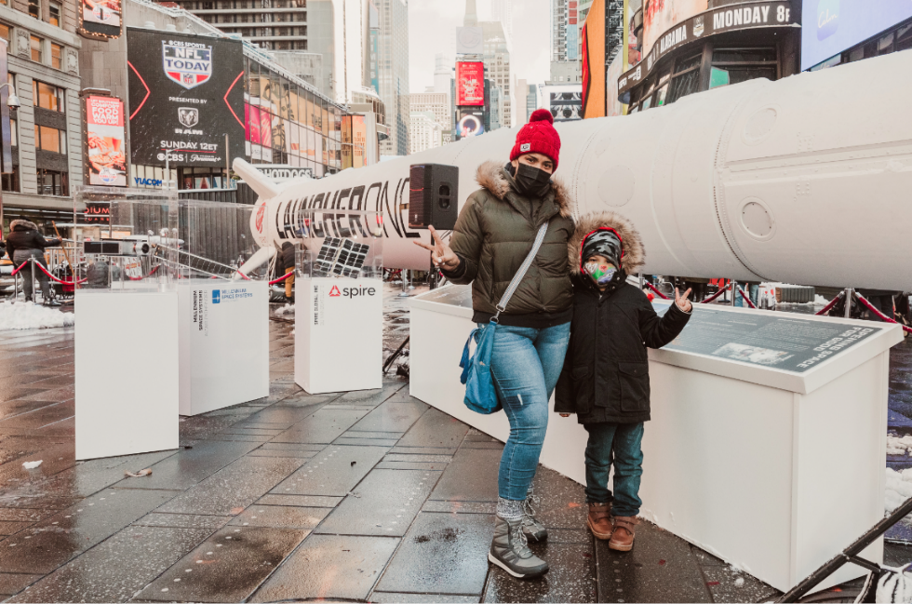

Images of LauncherOne rocket taken from Spaceport Cornwall’s ‘Story of a satellite’ STEM exhibition (360 degree tour here)


