Gauging Strategy – A Vision for Great Britain

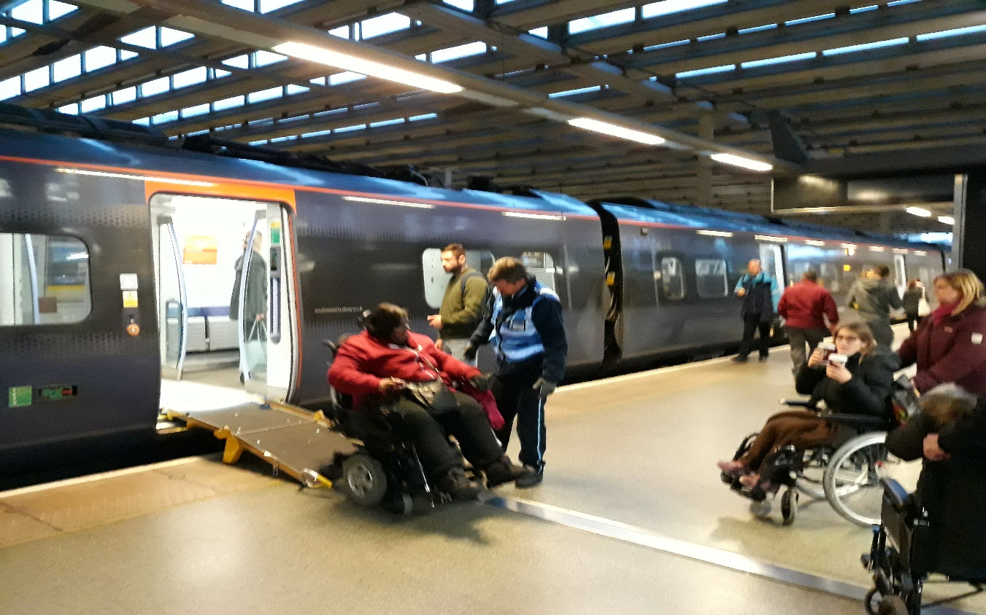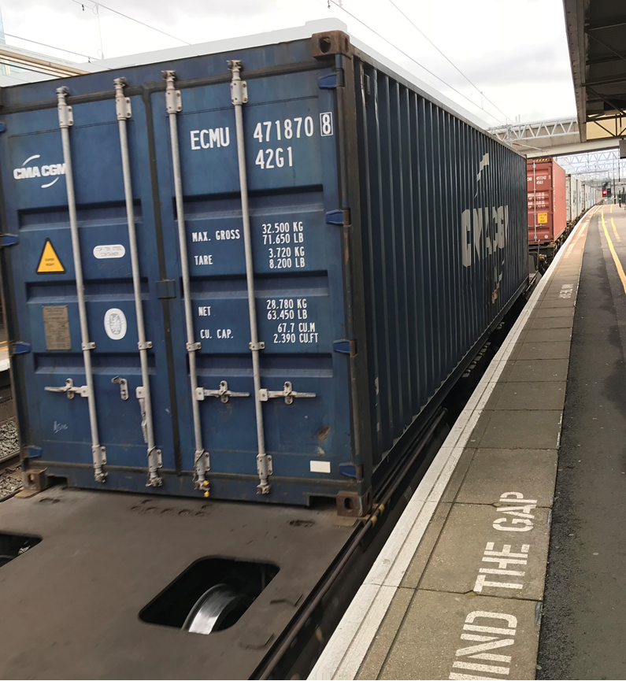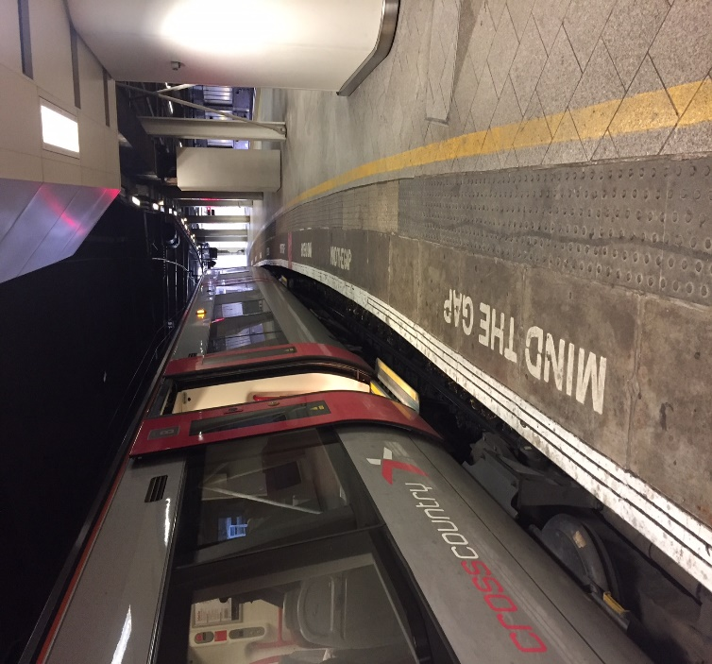

Vehicle / Structures System Interface Committee 2017

Foreword
“As Chair of the cross-industry Vehicle / Structures System Interface Committee I am pleased to present this ‘Gauging Strategy – A Vision for Great Britain’ which has been developed by the V/S SIC on behalf of the rail industry over the past couple of years.

Until now, the lack of a coherent gauging strategy has resulted in additional cost burdens to the industry over many years. The ever-present pressure to minimise initial project costs has led to a culture of minimum infrastructure work. Whilst this is economical over the very Short Term, it sub-optimises full route capability which would occur should a standard infrastructure gauge be adopted. In some cases, a relatively small cost increase now would avoid the need for structures to be revisited for future upgrades and would therefore reduce overall costs in the long term.

This Gauging Strategy specifies what the target gauges for parts of the network should be and also makes use of the standard vehicle gauges developed by V/S SIC and published by the Rail Safety and Standards Board (RSSB) thereby making the process of new vehicle introductions considerably more efficient. This Strategy also addresses the aspiration to improve the platform / train interface and provide standard platforms across more of the network. The provision of ‘level access’ is also considered.

I look forward to engaging with the wider industry to make the implementation of this Gauging Strategy a reality which it should be noted contributes significantly to delivering the aspirations of the Railway Technical Strategy in terms of improving Capacity and Customer experience and reducing Costs and the Carbon footprint of UK Plc.”

Mark Hicks – Chair of V/S SIC

Endorsement
- Technical Leadership Group (TLG)

and

- Planning Oversight Group (POG)

Gauging Strategy – A Vision for Great Britain

Contents

1. Introduction 4
2. Vision 5
3. Vision Explained 5
4. Background – Today’s Railway 7
5. Strategy 9
6. Implementation 11
7. Definitions 15

- Introduction
This document is the Vehicle / Structures System Interface Committee’s (V/S SIC’s) long term technical Gauging Strategy. A vision for the future is proposed alongside a description of the current issues and perceptions that are holding the industry back.
It should be noted that this is a strategic document setting out a vision for the industry. Network Rail is not presently funded to deliver this strategy which will need to be supported by additional funding from the Department for Transport or other sources.
For simplicity, the strategy section has been split into three key elements:
- Size of Infrastructure
- Size of Vehicles
- Interface Considerations
Within these elements aspirational targets for new build and various levels of upgrade projects have been set out along with an explanation of the research topics that will be required to help deliver the vision.
It is imperative that the industry starts to address the implementation of this gauging strategy, since in the agreement with Network Rail for Control Period 5 (from April 2014) there was no funding agreed to start to address any of the issues raised in this document. Engagement with the Planning Oversight Group in order to feed into the formal industry planning processes is seen as the most effective way to start to make real progress.

- Vision
Great Britain’s Rail Industry aspires to:
- Maximise Capacity on Great Britain’s Rail Network by adopting the largest cost-effective gauge over a core, nationwide network;
- Define and implement standard infrastructure and vehicle gauges and provide an optimised Customer experience at the Platform / Train Interface;
- Lower Costs of gauging to the industry;
- Contribute to Great Britain’s reduction in Carbon emissions through modal shift.

- Vision Explained
This section looks at the vision statements and provides the rationale and potential benefits behind them.
Vision a) Maximise Capacity on Great Britain’s Rail Network by adopting the largest cost-effective gauge over a core, nationwide network;

A rail system that provides larger trains over a high proportion of the network would yield significant benefits.
Rationale and potential benefits:
- Increased Passenger Capacity (larger rolling stock vehicles therefore more passengers per train path)
- Improved customer satisfaction (more seats, roomier trains)
- Reduced rolling stock cost (may no longer be bespoke vehicles for Great Britain only)
- Increased opportunity for freight flows (larger vehicles within Great Britain)
- Improved access to Great Britain’s rail network from Continental Europe (generating new passenger and freight flows)

This would also require development and incorporation of:
- New dynamic vehicle gauges for larger (e.g. European sized) vehicles using gauging methods developed in Great Britain
- Generation of dynamic infrastructure gauges which provide ‘normal’ clearances to those dynamic vehicle gauges
- Redefinition of the standard track interval (six-foot)
- Redefinition of the rules for the position of curved platforms (for example for longer vehicles)

Vision b) Define and implement standard infrastructure and vehicle gauges and provide an optimised Customer experience at the Platform / Train Interface.
Where no whole industry business case can be derived to support European sized gauges on the network, Great Britain specific standard infrastructure gauges should be used and consistently implemented on a whole route basis. The standard infrastructure gauges would enable the development of a suite of Standard Vehicle Gauges that all new build vehicles would be built to. This would serve to simplify the gauging process and steadily reduce the number of ‘tight’ locations across the network as the Infrastructure Manager commits to clearing and maintaining the gauge.
This would also incorporate:
- Use of ‘dynamic gauges’ to maximise the gauge capability of the infrastructure
- Platform works in order to bring all platforms to ‘standard’ prioritising the ‘tight and high’ platforms
- Aspiration for ‘level access’ (in accordance with PRM TSI)
- Addressing sub-standard ‘tight six-foots’
- Addressing significant historical infrastructure constraints
- Use of fixed track form through platforms
- Phase out legacy vehicles that are not compliant with standard vehicle gauges.

Rationale and potential benefits:
- Specific frequent measurements at the ‘tight’ structures significantly reduced
- Specific comparisons between locations and rolling stock types significantly reduced – since the majority of measurements required would be to ensure structures and track remain compliant with the ‘Standard Infrastructure Gauge’
- Rolling Stock compatibility checks significantly simplified
- Freight operators presented with a homogenous network significantly simplifying the introduction of ‘new freight flows’
- Standard Rolling Stock ‘step position’ lowered (since there will no longer be a need for rolling stock to be clear to ‘high’ and ‘tight’ platforms)
- Significantly reduced variability presented to passengers at the Platform / Train Interface
- Building on the ‘Access for All’ Project to make the Platform / Train interface truly accessible for Persons with Reduced Mobility (This project has so far excluded the Platform / Train Interface).

The PTI Strategy Group is developing the ‘optimised’ stepping arrangement and once this research is concluded the implications of this will need to be addressed.
Vision c) Lower Costs of gauging to the industry
This is a key objective as there is a perception that the cost of the gauging process for both the train operators (via vehicle manufacturers) and the Infrastructure Manager could be significantly reduced.

Rationale and potential benefits:
- Move to using standard vehicle gauges rather than absolute gauging to reduce costs
  - Train Operators
    - Reduction in costs of cascade including 23m to replace 20m (routes compatible with standard gauges)
  - Vehicle manufacturers:
    - Reduction in design and analysis time (simplified process)
    - Reduction in project risk (liability for infrastructure modification)
  - Infrastructure Manager:
    - Reduction in design and assessment time (simplified process)
    - Reduction in modification costs (commitment to an agreed gauge)
    - Reduction in inspection and maintenance costs (Normal clearances provided)

Vision d) Contribute to Great Britain’s reduction in Carbon emissions through modal shift
By continual progress in achieving the vision, transport by rail will become increasingly attractive to both the passenger and freight industry. With rail travel being significantly more efficient than road on a ‘per person’ or ‘per tonne of cargo’ basis, a substantial reduction in Great Britain’s overall Carbon emissions could be achieved.

Rationale and potential benefits:
- Increased Capacity enabling more passengers and freight to be carried
- Reduced use of less efficient transport as a result of improved Customer experience
- Reduced Costs ultimately passed on to customers (improved business case)

Background – Today’s Railway

  - Wide variation of infrastructure
There is currently much variation across Great Britain’s mainline rail network in relation to the size of the infrastructure and its gauge capability as a result of being built by disparate companies to different standards. This has led to wide variations in the profiles of structures, tunnels, bridges and platform heights etc. Consequently, this has resulted in a wide variation in the profiles and particularly footstep positions of rolling stock currently in operation.
The variation in the network has also led to a gradual trend in higher step positions in order for new vehicles to be compatible with ‘tight and high’ platforms and hence to ensure that they are not constrained to a specific part of the network, even if they are not initially intended to operate over the routes where these extreme platforms exist.
4.2 Modifications at minimal costs
The pressure to minimise initial costs of projects and modifications has led to a culture of minimum infrastructure work. Whilst this is economical in the short term, it sub-optimises full route capability which would occur with the adoption of a standard infrastructure gauge. In some cases, a relatively modest increase in cost now would avoid the need to rebuild structures for future upgrades and would deliver reduced overall costs in the long term. This strategy aims to change this current culture.
4.3 Management of tight clearance
Network Rail undertakes specific measurement checks at tight locations (less than Normal clearances) to ensure vehicles in operation remain able to pass the infrastructure. The profiles (of the specific vehicle types permitted to operate adjacent to these tight locations) are then compared against the latest infrastructure measurements to ensure they will remain clear and gauge capability is therefore maintained.
This is replicated at thousands of sites across the network. Consequently, these measurements are logistically challenging to obtain (especially at platforms) from the point of view of accessing the network to take physical measurements and also from the point of maintaining data accuracy.
This situation is further complicated by the fact that track does not remain fixed relative to surrounding structures both as a result of train operation and track maintenance activities and also ground movements. The continual movement of the track and repetitive requirement to measure and maintain its position is what drives up the cost.
A further complication is that the separation between the tracks (colloquially known as ‘the six-foot’ or ‘track interval’) also represents a constraint on the network since the resultant ‘passing clearances’ between trains on adjacent tracks is often the limiting case for the physical width of vehicles.
4.4 Absolute gauging
The use of absolute gauging for the introduction or cascade of vehicles and the design or modification of infrastructure leads to a bespoke solution for compatibility on any given route. This results in high costs in either case. For both vehicle and infrastructure changes there is significant effort in assessing the compatibility and for the vehicle introduction there is significant potential cost to modify the infrastructure. At the bid stage, this translates into a risk that must be priced into commercial agreements and raises costs for the sector.
4.5 Current perceptions
There are many perceived issues related to gauging within the rail industry and these will be considered for future research projects to be investigated and then confirmed or dispelled.
There are perceptions that:
- Freight and passenger gauging requirements are incompatible
- Gauging practice in Europe is cheaper than in Great Britain
- The Platform / Train interface could be improved
- ‘Level access’ is the best solution (in accordance with the PRM TSI)
- Double deck trains provide more capacity
- European trains can accommodate more seats / passengers
- Standard European trains are cheaper
- Deployable footsteps are expensive and introduce a level of unreliability which is incompatible with the high intensity mixed traffic network
- A standard infrastructure gauge would be beneficial
- Passenger vehicle floor heights have to be at least 1 metre in height
- A standard platform height and offset is beneficial
- It would be too expensive to modify existing infrastructure to be compatible with a standard infrastructure gauge
- Train seats need to be wider due to increasing passenger size
- The current process of managing the position of the track creates uncertainty of its relationship to structures
- The track interval constrains vehicle width in Great Britain
- European gauging practices do not make the most effective use of infrastructure space
- The aggregation of tolerances used in gauging practice is too conservative
- Fixed track forms would enable larger trains to run.
This strategy proposes research to address these perceptions.

- Strategy
This strategy addresses the Railway Technical Strategy ‘Capacity, Cost, Customer and Carbon’ aspects in the context of vehicle and infrastructure gauge provision, and also the Platform / Train Interface Strategy.
  - Size of Infrastructure
For Interoperability, the ultimate target is for a core part of the network to be compatible with the largest common European gauge as used for the Channel Tunnel and High Speed 1 (GC). For non-core passenger and freight networks, the ultimate target is to be compatible with the standard gauges listed below.
- Passenger gauges – PG1 (20m), PG2 (23m) and PG3(26m)
- Lower Sector Vehicle Gauge – LSVG
- Freight gauges – W12 and W6a upper gauges
Future specification and cascade of rolling stock will need to recognise existing infrastructure constraints and propose upgrades which are reflected in a beneficial whole industry business case. Key issues that will need to be addressed are platforms, track intervals, electrification and the majority of existing tunnels and bridges. However, it is thought that British gauging methods could facilitate compatible vehicles to operate on infrastructure that is actually smaller than that required by European gauging methods.
It is accepted that achieving the ultimate target will take many years, so it is proposed that the standard gauges be used to progressively increase Capacity towards the target. Table 1 shows how this might be implemented.
Table 1: Proposed network compatibility
Network Classification | Upgrade Classification | Target Size
Core Network | New infrastructure and major upgrades on new and existing lines. | Minimum – GB compatible* (EU)  Ideal – GC compliant (EU)
Core Network | Minor upgrades and infrastructure works on existing lines | PG1, PG2, PG3, Loco, W12,  W6a (upper) and LSVG
Non-Core Passenger Network | New infrastructure and all upgrades on new and existing lines. | PG1, PG2, PG3,  Loco, W6a (upper) and LSVG
Non-Core Freight Network | New infrastructure and all upgrades on new and existing lines. | Loco, W12, W6a (upper) and LSVG
*Vehicles with declared compliance to the European gauge are compatible with the infrastructure but the infrastructure does not satisfy EN 15273 requirements for the defined GB gauge.
Note: GB refers not to Great Britain but to the European GB reference gauge as specified in European gauging standards.

  - Size of Vehicles
Future passenger vehicles should be specified to be compliant with LSVG and PG1, PG2 or PG3 as appropriate, unless they are intended for use on the Core Network. Where the routes concerned are compatible or compliant with European gauges, new vehicles intended for use on these routes should be designed to be compatible with these European gauges. Eventually, where the routes concerned are part of the Core Network and mostly compatible or compliant with European gauges, new vehicles should be designed to be compliant with larger dynamic vehicle gauges and the infrastructure modified.
It is anticipated that standard European size vehicles and double deck vehicles could improve efficiency in terms of passengers carried and reduce Costs of the gauging acceptance process.
Current trends indicate that container freight vehicle design will focus on the development of vehicles designed to transport individual 40’ containers.
  - Interface Considerations
The key interface issues include electrification and the Platform / Train Interface (PTI).
Consideration also needs to be given to the height provision for overhead lines for European sized vehicles.
Upgrading the network would provide an excellent opportunity to improve the Customer experience at the PTI. Stepping distances could be improved in line with the PTI Strategy Group findings by optimising the platform height and offset with practical floor heights and step positions of the vehicle. The question of whether ‘level access’ is the optimal solution also needs to be answered.
The transition period as the network is upgraded may require platforms to be constructed to facilitate passive provision for future compatibility with the developed GC vehicle gauge or have gap fillers added. Vehicles compatible with the suite of PG gauges may also require to be fitted with deployable footsteps.

- Implementation
It is noted that this multi-faceted problem cannot be tackled in isolation and that research related purely to gauging represents a subset of a much bigger picture.
To define the timescale classification, the following timelines have been assigned as Short, Medium or Long Term. The classification is the period it is envisaged the objectives would be achieved, not when the necessary research and any construction work would be started.
  - Short Term = Network Rail - Control Period 5, 2014-2019
  - Medium Term = Network Rail - Control Period 6 & 7, 2019-2029
  - Long Term = Network Rail - Control Period 8+, 2029 onwards
The following section is split into four categories: Business, Infrastructure, Vehicles and Interface to group the required research by subject. Several questions are posed which need to be answered and could lead to further research to support the implementation of this Gauging Strategy for Great Britain. In isolation the V/S SIC cannot answer all of these questions completely, however, V/S SIC is suggesting several areas of research.
  - Business
    - Questions
- Where is the network currently at full capacity (both passenger and freight)?
  - Where on the network can no more train paths or longer trains be accommodated?
  - Where on the network do these locations coexist with the foreseeable need to provide more capacity in the next twenty-five to fifty years?
  - What are the implications in terms of platform provision to accommodate increased capacity? i.e. can existing platform space cater for the proposed increases in passengers and changes to the platform offset due to gauge enhancement?
- What are the implications for the plans to implement the ‘TEN-T’ Regulations?
- What are the implications of Great Britain’s respective TSI Implementation Plan(s) and the EU Referendum result?
- What are the Freight business needs for the provision of improved gauge capability?
- What are the implications in terms of capacity (including an assessment in terms of dwell time) of the operation of double deck vehicles?
- Are there any implications for the proposed High Speed 2 integration with existing routes?
    - Research
- Define in relation to 50-year business needs, an aspirational ‘Core Network’, ‘Non-Core Passenger Network’ and ‘Non-Core Freight Network’: (Medium Term)
- Determine the cost / benefit analysis for introducing double deck trains in relation to the cost of infrastructure modification and capacity benefits: (Medium Term)

  - Infrastructure
    - Questions
- What are the benefits of providing infrastructure that is compliant with Lower Sector Infrastructure Gauge (LSIG)?
- What are the benefits of providing infrastructure that is compatible with the standard freight and passenger vehicle gauges?
- To what extent can the current network provide gauge capability for Continental European GB and GC gauges (using UIC principles)?
  - Where are the restrictions as a result of clearances to structures?
  - Where are the restrictions as a result of the track interval?
  - What would be the cost estimates to address the restrictions identified?
- To what extent can the current network provide gauge capability for Continental European sized vehicles (gauged to the Absolute or Swedish method)?
  - Where are the restrictions as a result of clearances to structures?
  - Where are the restrictions as a result of the track interval?
  - What would be the cost estimates to address the restrictions identified?
- To what extent could improved track fixity alleviate the need for NR to manage tight clearances and is there a business case to address?
- To what extent are the current gauge clearance activities for example track lowering generating problems / costs for the future?

    - Research
  - Progress the use of probabilistic analysis in the gauging process: (Short Term)
- Infrastructure fixity
- Vehicle tolerances
- System tolerances
- The components of clearance
- Determine an optimum method for gauging which maximises the use of infrastructure space and define a GC gauge using the absolute gauging process: (Medium Term)
  - Map the current extent of the network that provides GC capability using both the optimal method and UIC principles (including track interval study) in order to compare and contrast network capability: (Medium Term)
      - Assessment of network gauge potential
      - Publishing exception structures
      - Route enhancement planning
  - Identify the costs of delivering increased gauge capability through a study of tight structures: (Medium Term)
  - Track interval optimisation to improve width of PG1 & PG2: (Medium Term)

  - Vehicle
    - Questions
- What is the benefit of gauging Continental European sized vehicles using Absolute Gauging or the ‘Swedish Method’ Techniques? i.e. how much space is saved by each?
- Are Continental European vehicles cheaper (and by how much) than an equivalent vehicle designed for use in Great Britain?
- What are the benefits of Continental European sized vehicles in terms of both the seating capacity and the ultimate capacity provided by a typical single deck and a double deck train consist?
- What are the reliability implications of the use of deployable footsteps?

    - Research
- Developing PG3 (26m): (Short Term):
- Developing a 3rd generation Locomotive gauge: (Short Term)
- Provide background information and support the implementation of: (Short Term)
- Passenger gauges (PG1, PG2 and PG3)
- Lower Sector Vehicle Gauge (LSVG)
- 3rd generation Freight gauges
- Pantograph sway standard
- Freight gauge research and capacity enhancements: (Short Term)
- Optimised wagon length
- Trends in container sizes
- Emerging suspension types
- Enhanced freight speeds
  - Progress the use of probabilistic analysis in the gauging process: (Short Term)
  - Introduce new gauging methods aligned with (past) research: (Medium Term)
  - Review gauges in light of T1062 Lower Sector recommendations
  - Review of Passenger gauges, are they working or not? Do they need revision?
  - Determine the benefits of European sized vehicles in terms of both the seating Capacity and the ultimate capacity provided by a typical single deck and a double deck consist including overall passenger flow rate: (Medium Term)
  - Develop dynamic vehicle gauges for European sized trains: (Medium Term)
  - Determine the extent of operability of 20m, 23m and 26m Passenger gauges and develop a 50-year rolling stock strategy based upon existing rolling stock and future rolling stock requirements: (Medium Term)
  - European vehicle research into the use of continental freight vehicles: (Medium Term)
  - Develop new container gauges and associated (European compatible) freight wagons to provide an optimised interface for emerging freight flat wagon design (40’ with eco bogies) and aspirational 50-year containerised freight needs: (Medium Term)
  - Investigate European container sizes for use in Great Britain: (Medium Term)
  - Investigate increasing capacity through improved freight bogie types: (Medium Term)

  - Interface
    - Questions
- Is there any benefit (and of what magnitude is it) of providing platforms at a standard height and offset?
- What are the implications on the operation of Continental European sized vehicles on the Platform / Train interface?
- What are the implications for the provision of ‘level access’?

    - Research
  - Analysis of PTI strategy: (Short – Medium Term)
  - Human factors stepping distance research
  - Determine if ‘level access’ is the optimal solution
  - Platform offset and height
  - Stepping distance calculation
  - Train footstep width
  - Vehicle floor height
  - Gap fillers / Deployable footsteps
  - Understand implications for platform compatibility with European gauge size vehicles
  - Pantograph gauging – implementing new methods from T942: (Short Term)
  - Determine compatibility of European sized vehicles with existing contact wire heights in Great Britain: (Medium Term)
  - Develop methods of passive provision for conversion of platform edge position for compatibility with GC size vehicles: (Medium Term)
  - Identify gauging constraints to planned electrification: (Medium Term)
  - Standardised platforms / PTI planned: (Long Term)

- Definitions
- European size gauges – This refers to gauges used in mainland Europe, such as GB, GB1 and GC. They are typically taller and wider than the gauges used in Great Britain particularly at platform level.

- Level access – The PRM TSI defines level access as when the footstep and platform are level with no more than a 50 mm vertical difference and up to a 75 mm lateral gap.

- Tight locations – The definition of a tight location is one that has less than ‘normal’ clearance as defined in the railway group standards between the vehicle and the infrastructure.

- 3rd generation (dynamic) gauges – These are gauges that are dynamic in nature in that the size of the gauge changes with cant deficiency and in some cases speed.

- Loco – New 3rd generation locomotive gauge being developed under the T995 Research project

PG3 is under development under RSSB research project T1092
T1062 – RSSB Research Project – Platform Recess – Review of Requirements
T942 - RSSB Research Project - Pantograph sway acceptance requirements and methodology

