
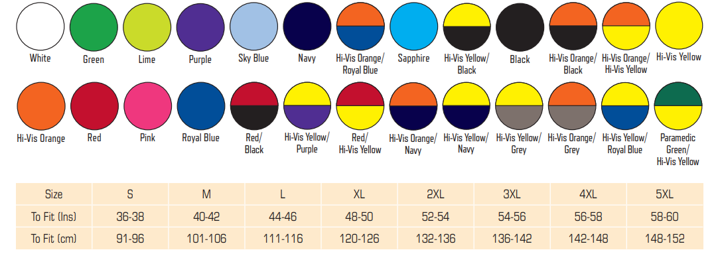

London Stadium Crowd Safety Uniform
Yoko HVW801 Multi-functional Executive Waistcoat has been used for reference only- any Equivalent product will be accepted


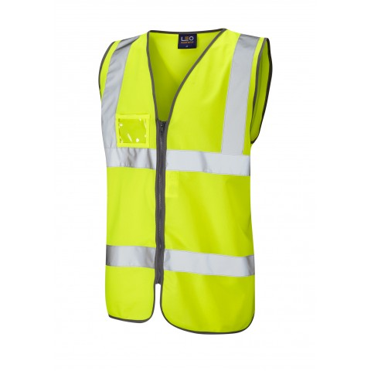
SI00
17
Yellow
Safety
ZIP Fastening
LB Screen Print LS Logo - Black
RB Screen Print Number-Black
Back Upper: Screen Print LS Logo - Black
Back Upper: Screen Print – SAFETY- Black
Back Upper Screen Print – Number - Black

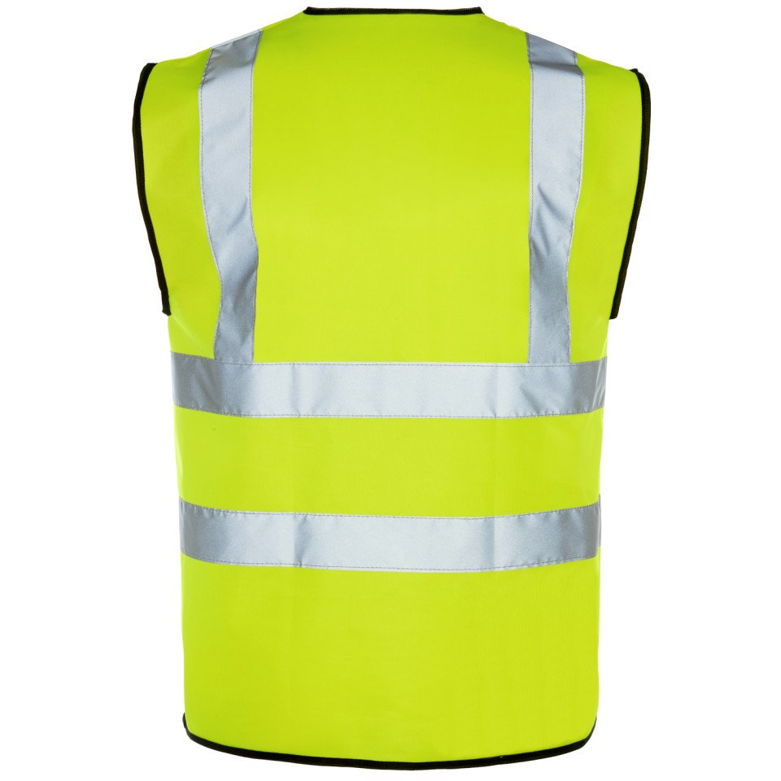
SAFETY
SI00


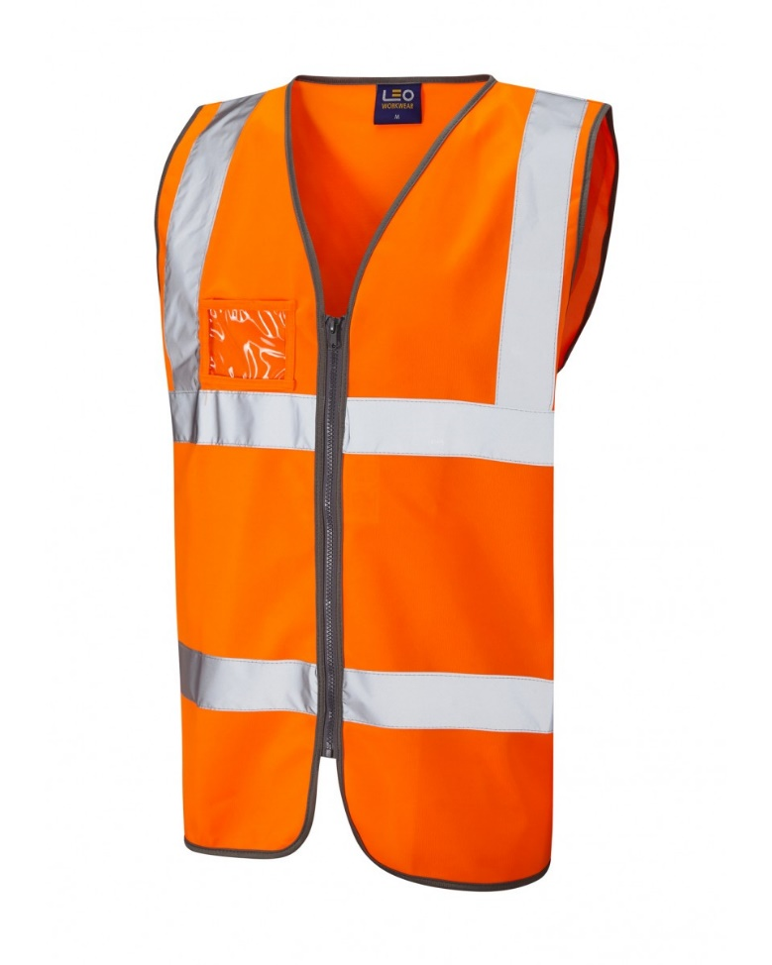
10
Orange
Steward
ZIP Fastening
ID Pocket
LB Screen Print LS Logo - Black
RB Screen Print Number-Black
Back Upper: Screen Print LS Logo - Black
Back Upper: Screen Print – STEWARD- Black
Back Upper Screen Print – Number - Black

LS00
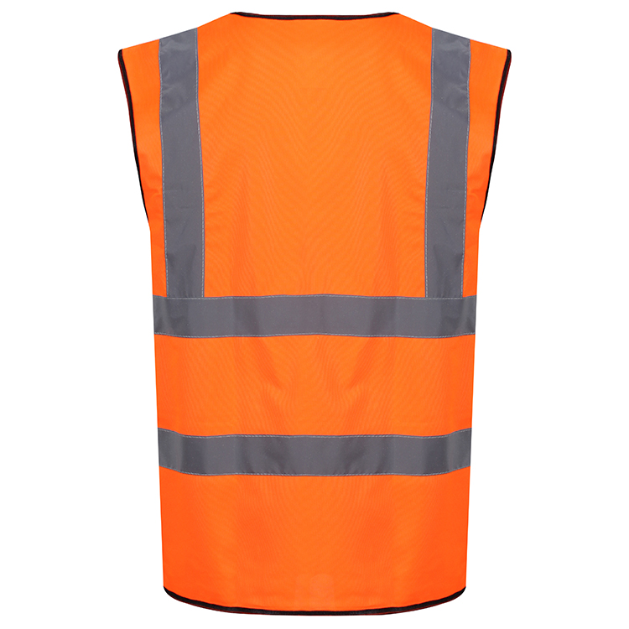
LS00
STEWARD

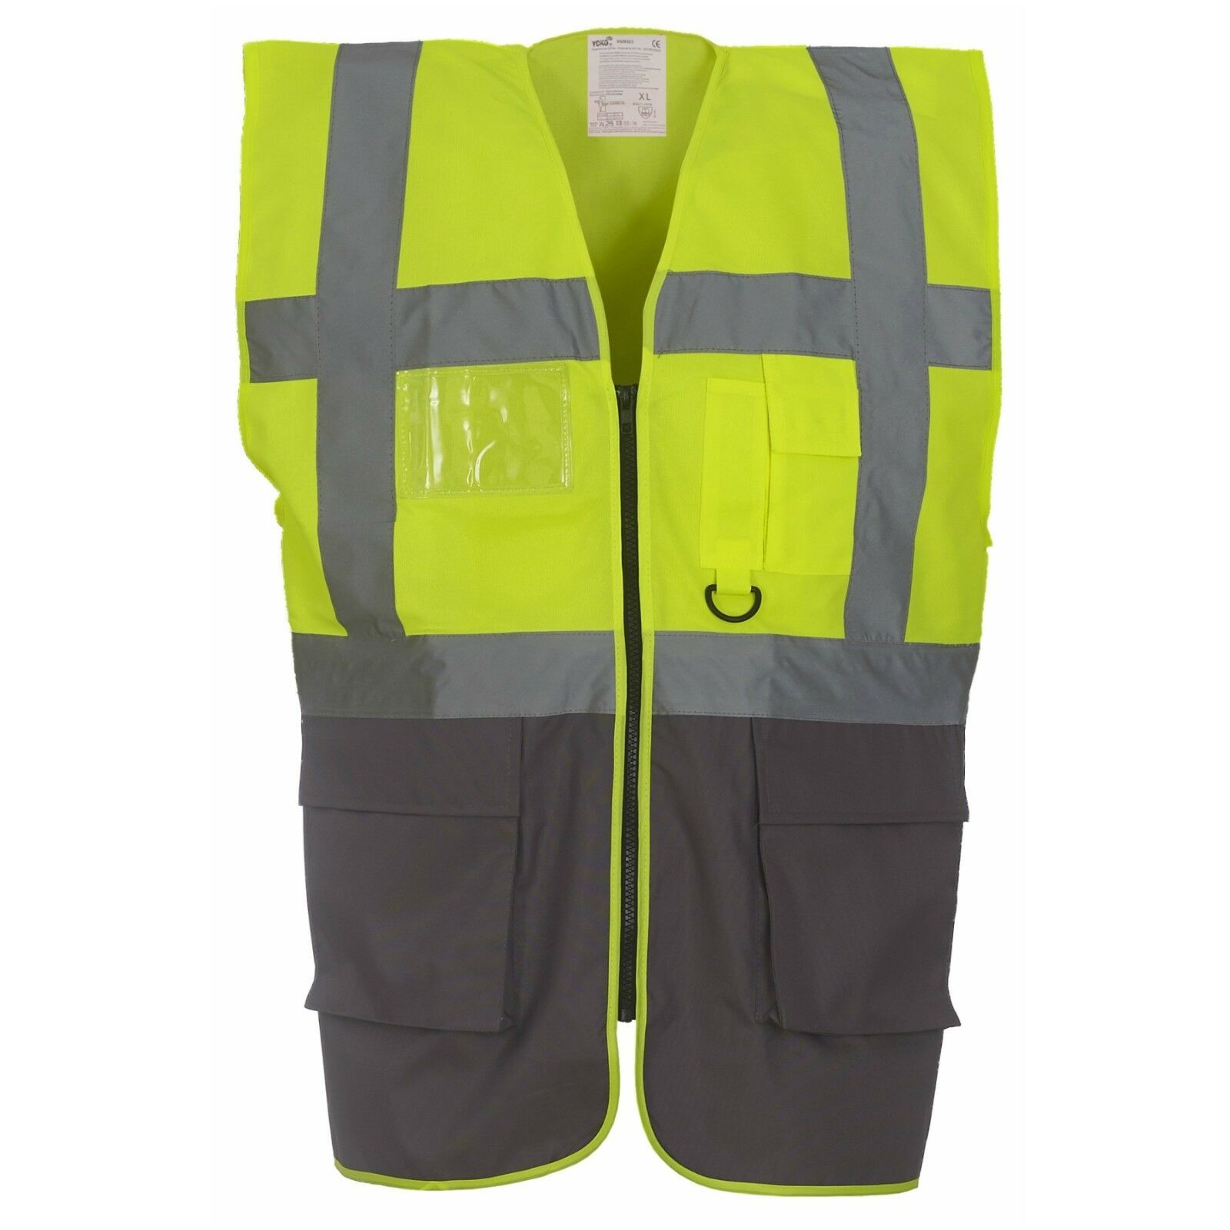
Yellow / Grey
Senior Supervisor
LB Screen Print LS Logo - Black
RB Screen Print Number-Black
Back Upper: Screen Print LS Logo - Black
Back Upper: Screen Print – SENIOR SUPERVISOR- Black
Back Upper Screen Print – Number - Black

20
SS01
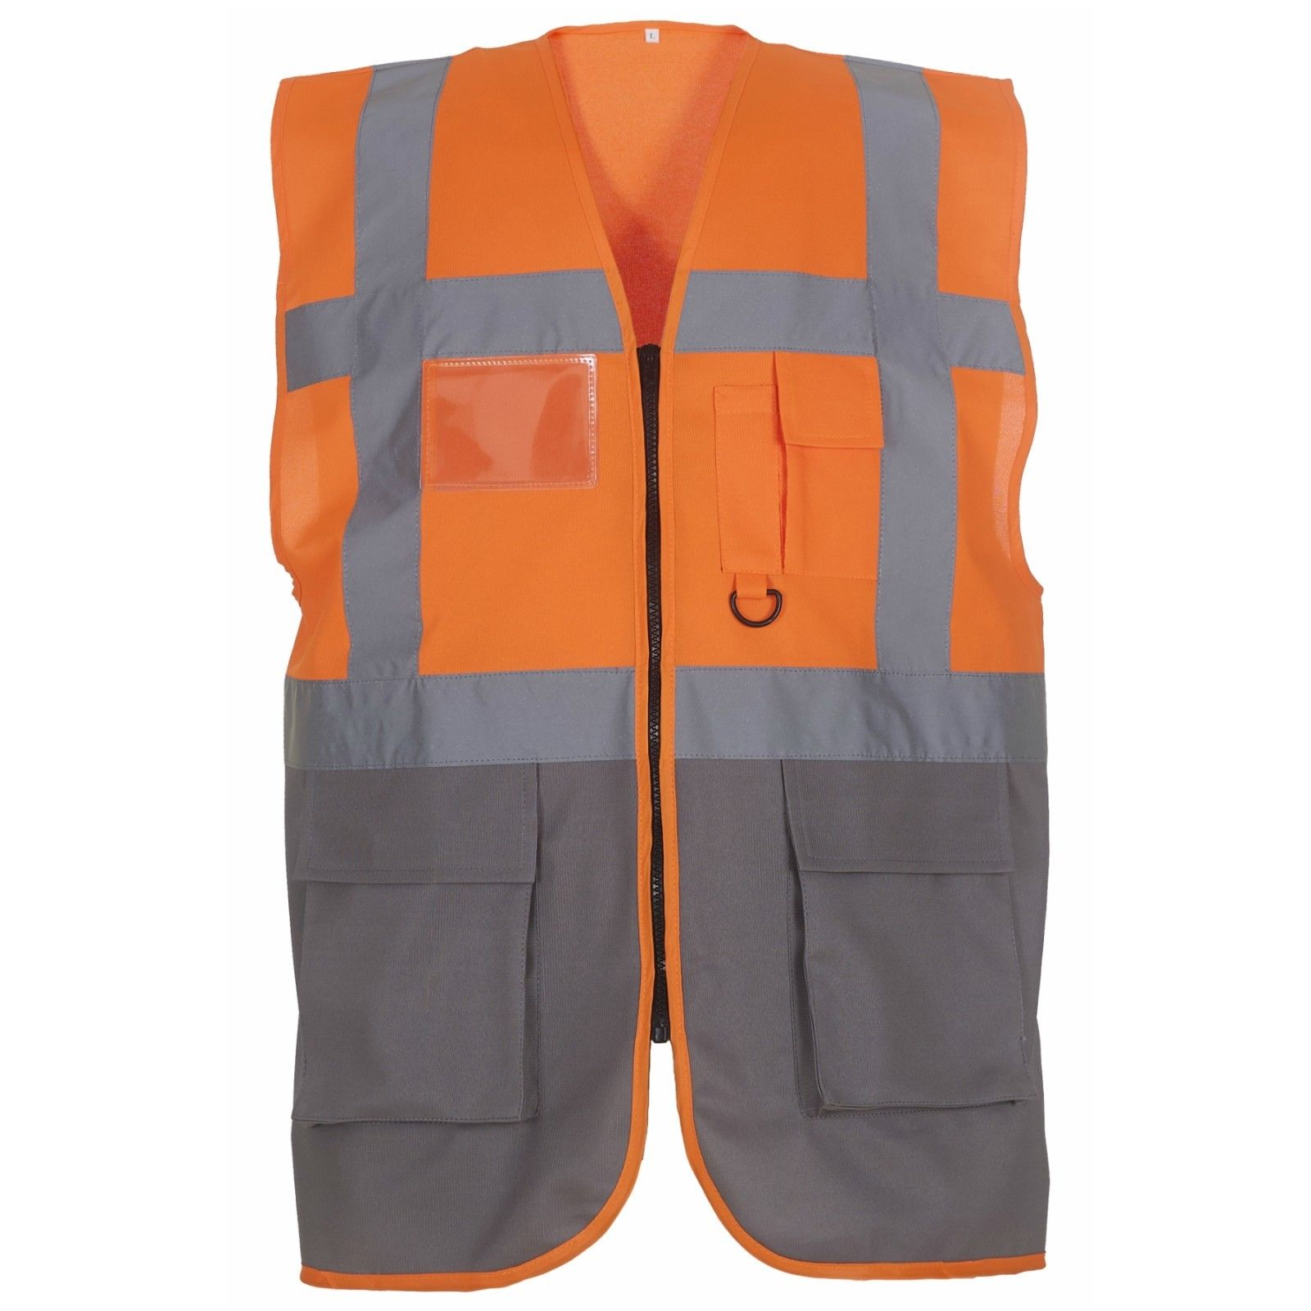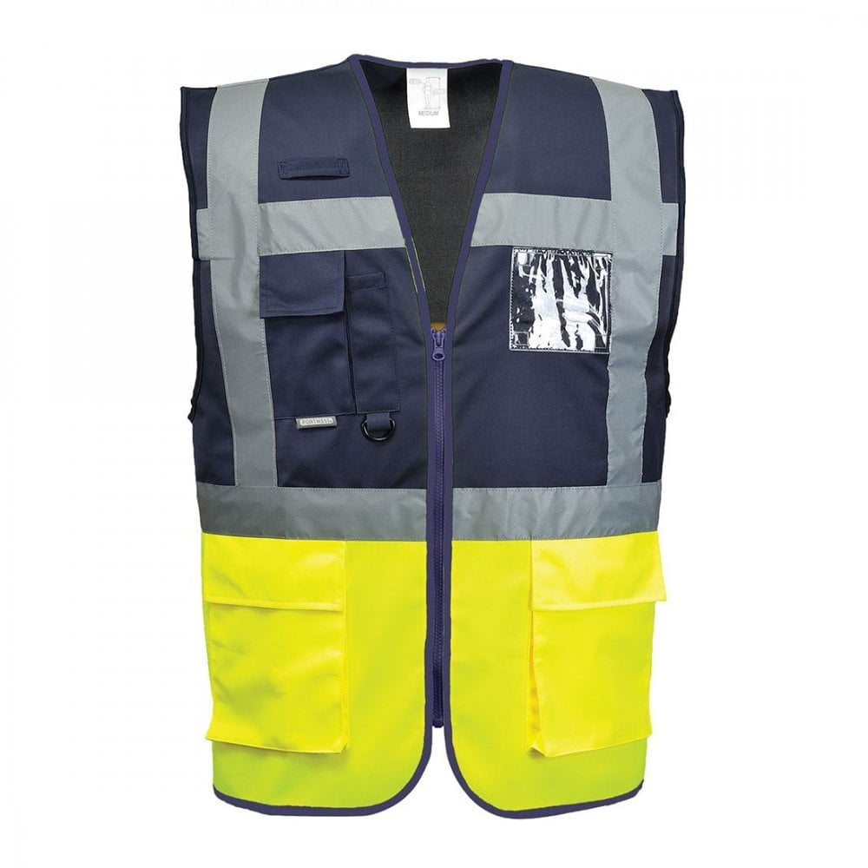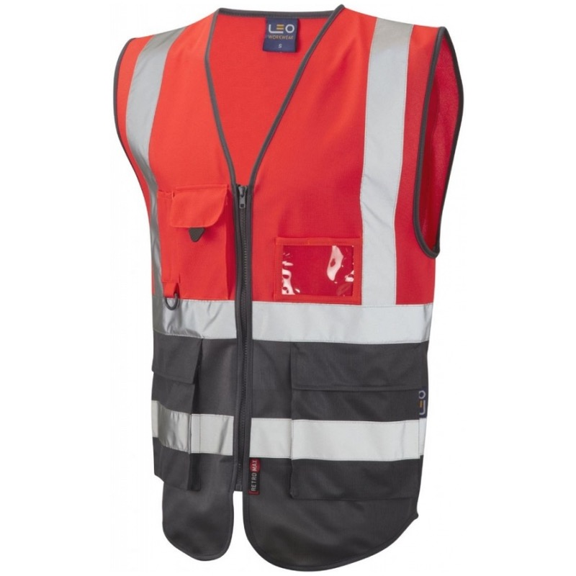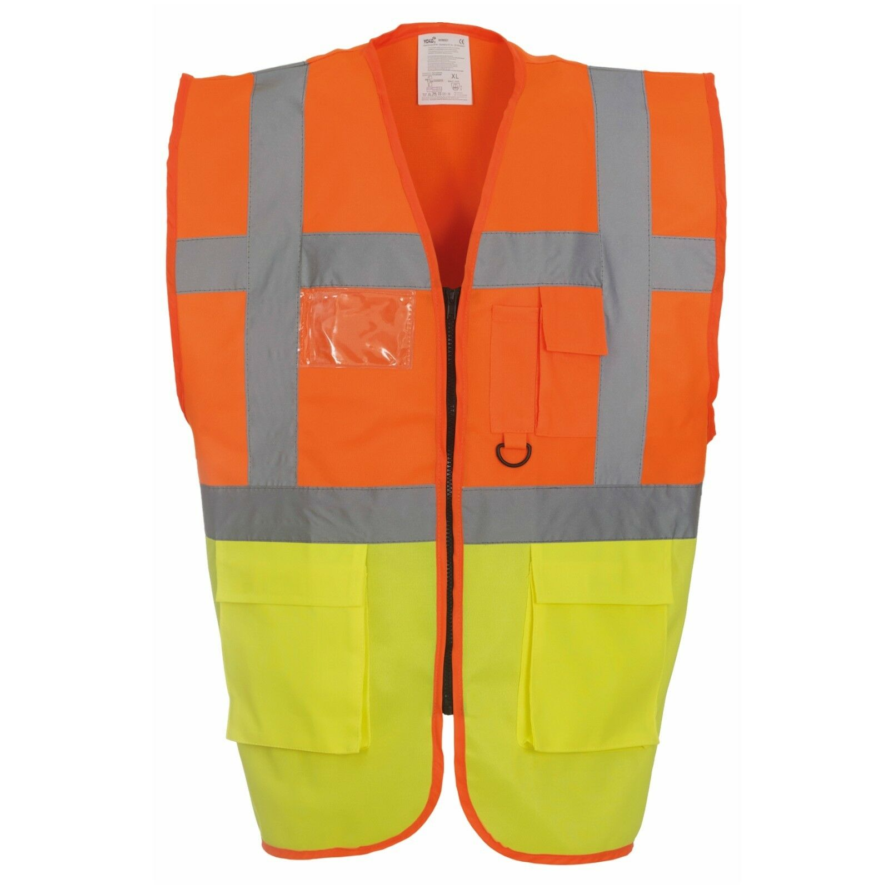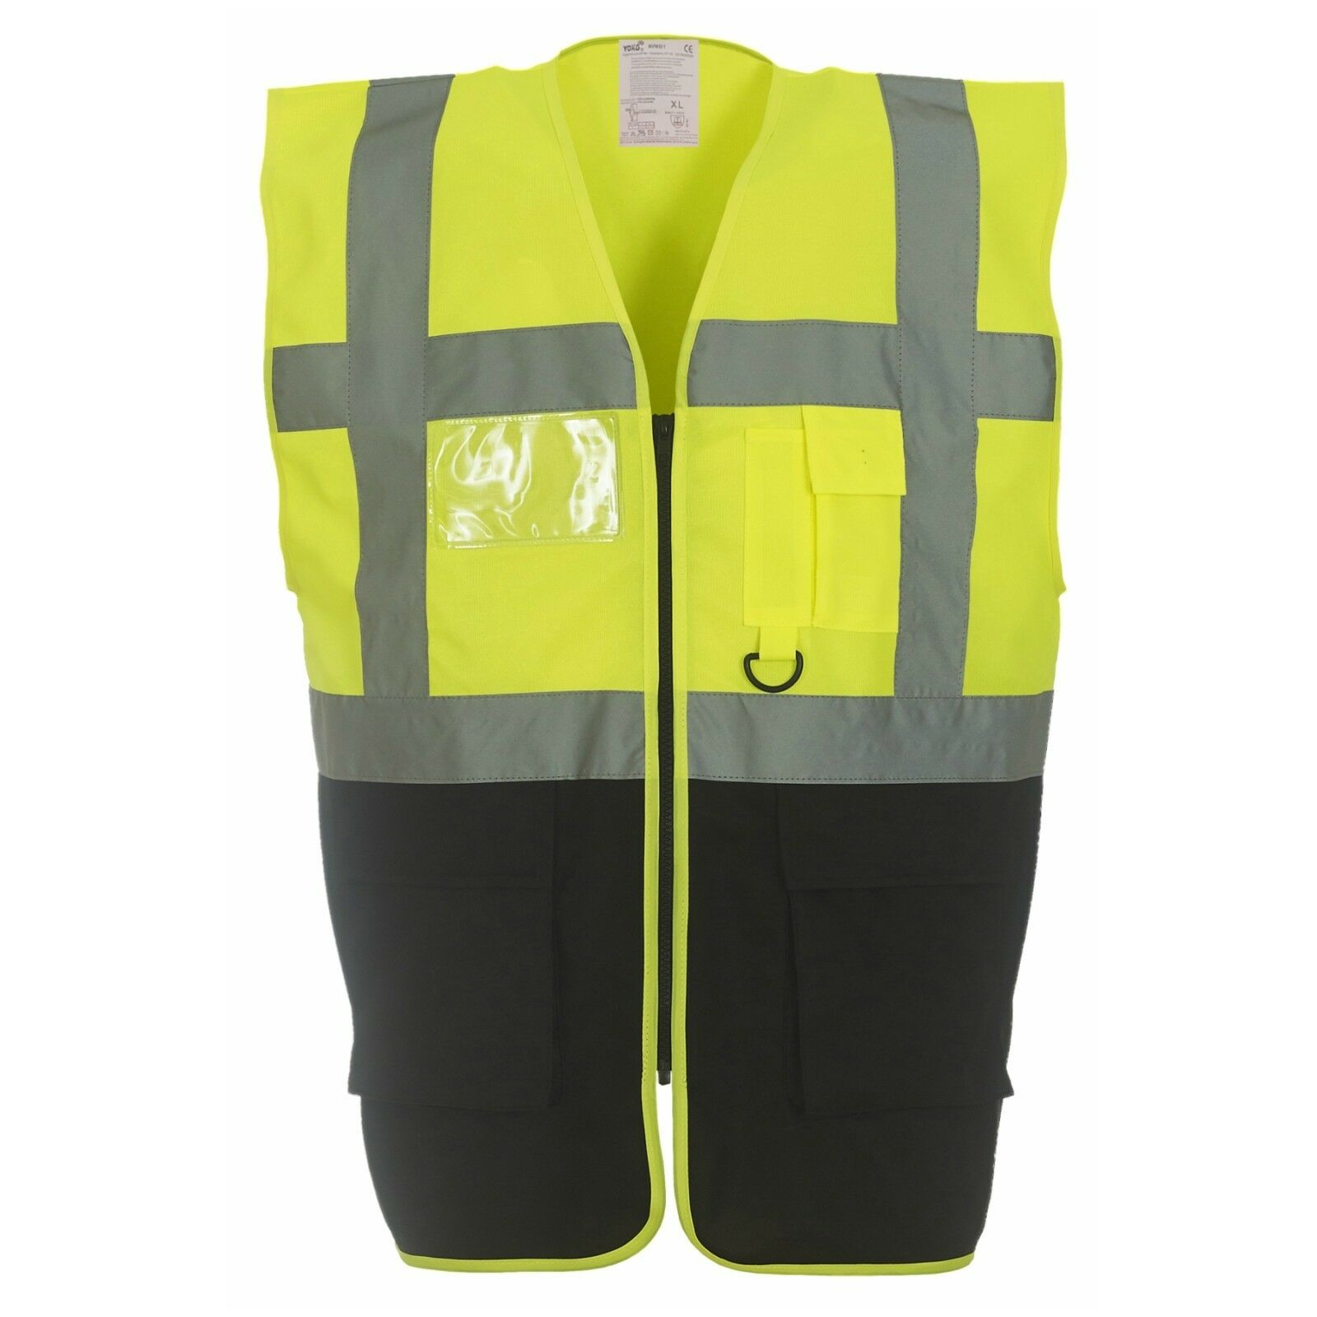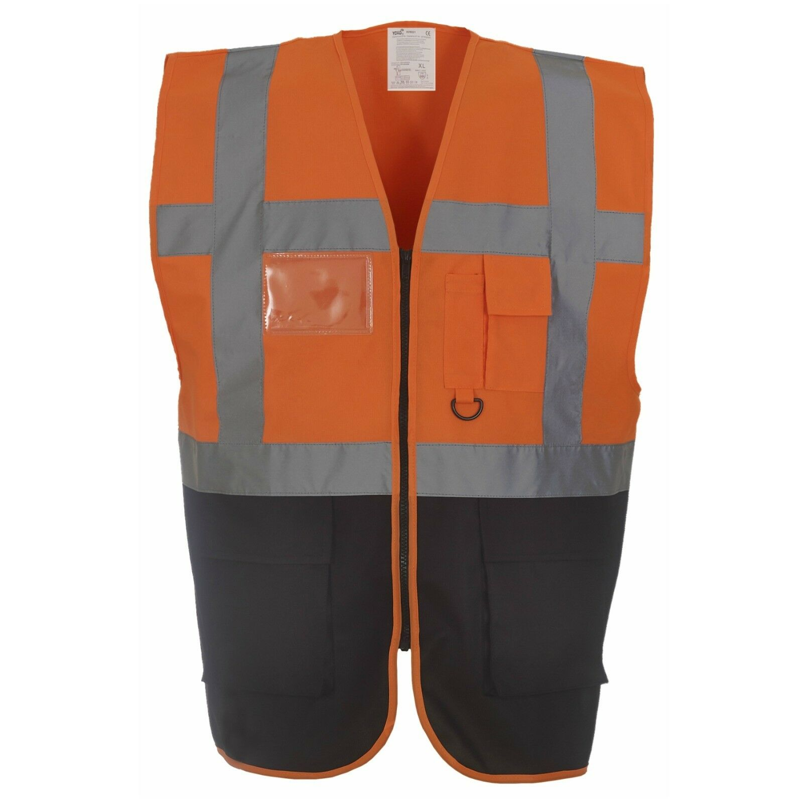
Orange/Grey
Senior Manager
LB Screen Print LS Logo - Black
RB Screen Print Number-Black
Back Upper: Screen Print LS Logo - Black
Back Upper: Screen Print – SENIOR MANAGER - Black
Back Upper Screen Print – Number - Black

001
SM01
1
JE
5
SAFETY
Navy – Yellow
Safety
Front left under pocket – SAFETY - Screen Print - White
LS logo upper left – Screen Print White
TOP LEFT Screen Print – JE – GH - White

Fire Team

Red / Grey
LB Screen Print LS Logo – White
LB Screen Print Fire– White
RB Screen Print Number- White
Back Upper: Screen Print LS Logo - White
Back Upper: Screen Print - FIRE TEAM - White
Back Upper Screen Print – Number - White

9
FIRE
001
11
Orange/Yellow
Supervisor
LB Screen Print LS Logo - Black
RB Screen Print Number- Black
Back Upper: Screen Print LS Logo - Black
Back Upper: Screen Print - SUPERVISOR - Black
Back Upper Screen Print – Number - Black

S001
SEG LINE SIA
Yellow/Black
LB Screen Print LS Logo - Black
RB Screen Print Number- Black
Back Upper: Screen Print LS LARGE LOGO - Black
Back Upper Screen Print – Number - Black

SEG1
18
Senior Manager
Orange/Grey
LB Screen Print LS Logo - Black
RB Screen Print Number- Black
Back Upper: Screen Print LS Logo - Black
Back Upper: Screen Print – SENIOR MANAGER - Black
Back Upper Screen Print – Number - Black

SM01
2

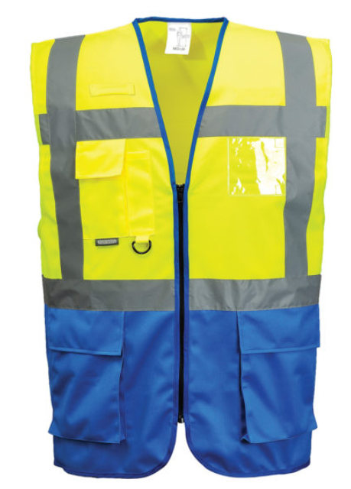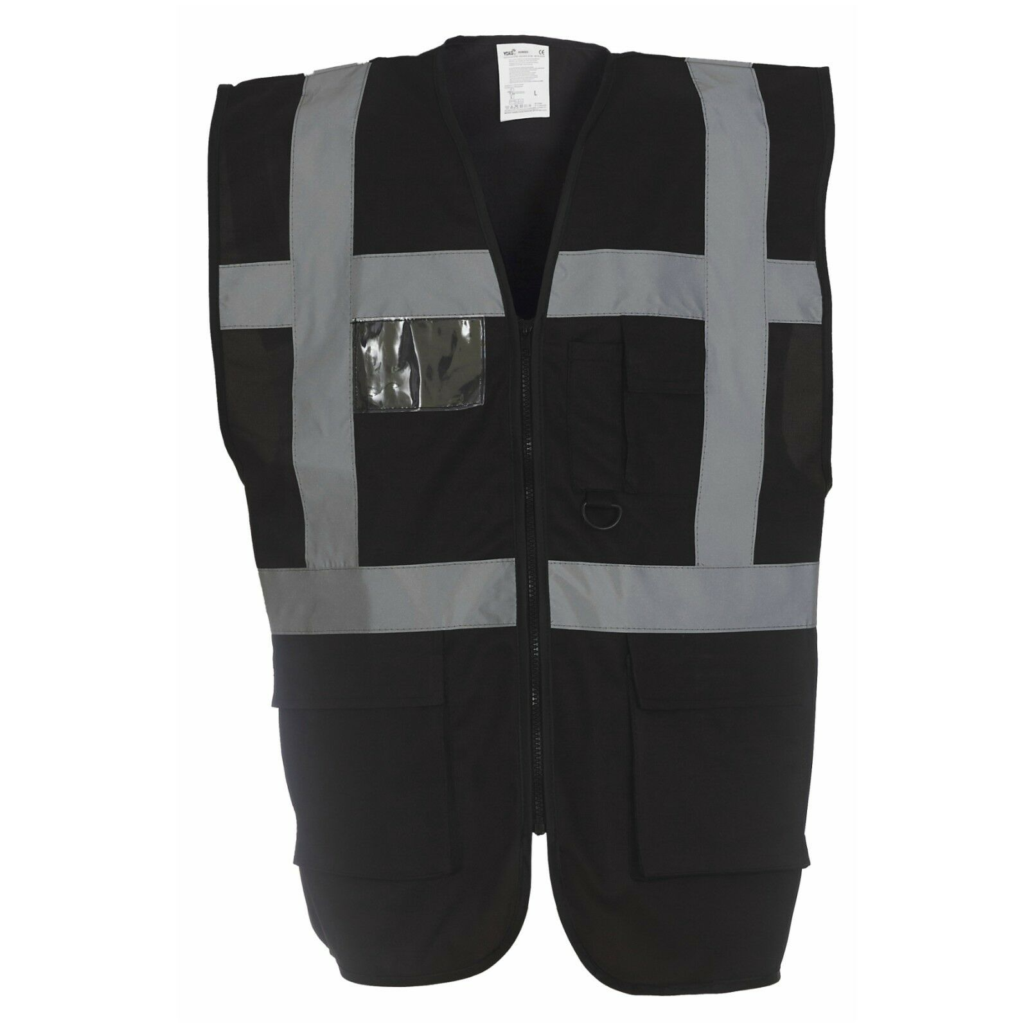
R001
Yellow and Royal Blue Executive Hi-Vis
Response Coordinator / Response Team Leader / Response
LB: Screen Print LS Logo -Black
RB: Screen Print Number- Black
Back Upper: Screen Print LS Logo - Black
Back Upper: Screen Print – RESPONSE TEAM LEADER or RESPONSE- Black
Back Upper Screen Print – Number - Black
RESPONSEE
TEAM
R001
14
IT1
Red/Yellow Executive Hi-Vis
Response Supervisor
LB: Screen Print LS Logo -White
RB: Screen Print Number- White
Back Upper: Screen Print LS Logo - White
Back Upper: Screen Print - SUPERVISOR - White
Back Upper Screen Print – Number - White

25

Black Executive Hi-Vis
IT
LB: Screen Print LS Logo -White
RB: Screen Print Number- White
Back Upper: Screen Print LARGE LS LOGO - White
Back Upper Screen Print – Number - White

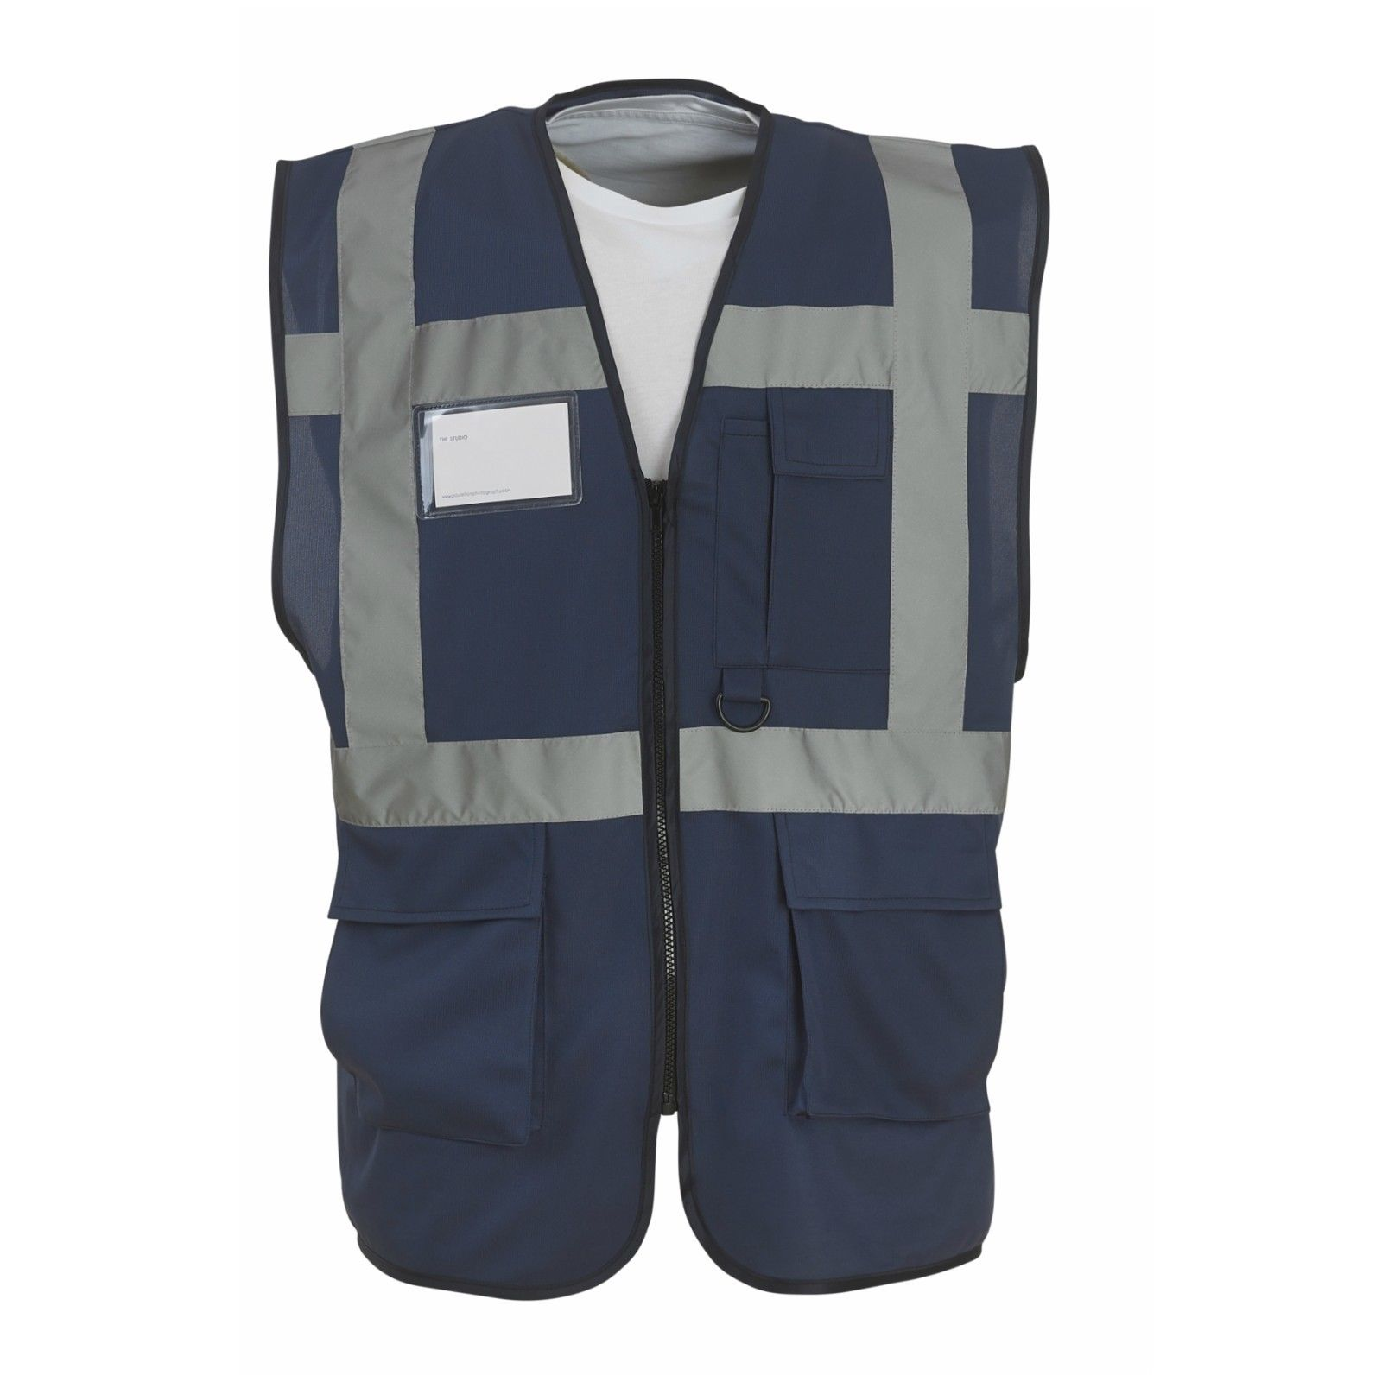
L01
8

Navy - Executive Hi-Vis
LB: Screen Print LS Logo -White
RB: Screen Print Number- White
Back Upper: Screen Print Small LS Logo – White
Back Upper: Screen Print - LOGISTICS – White
Back Upper Screen Print – Number - White

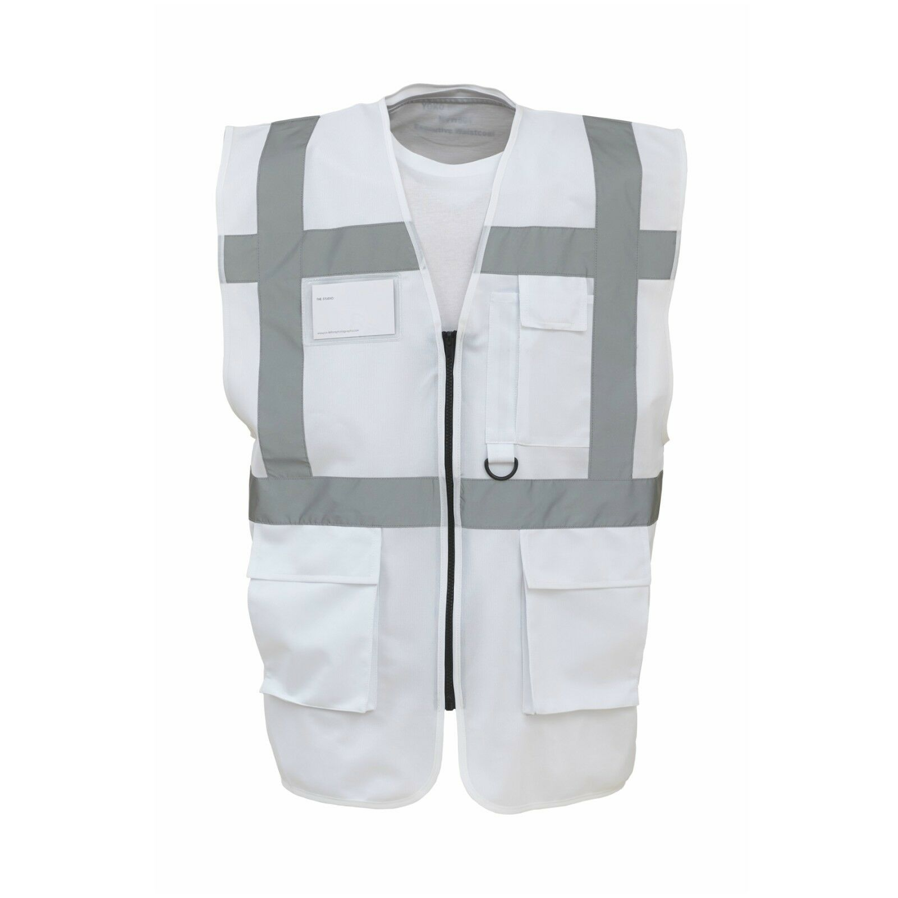
M01
6

White - Executive Hi-Vis
LB: Screen Print LS Logo -Black
RB: Screen Print Number- Black
Back Upper: Screen Print LS Logo - Black
Back Upper: Screen Print - MANAGER - Black
Back Upper Screen Print – Number - Black

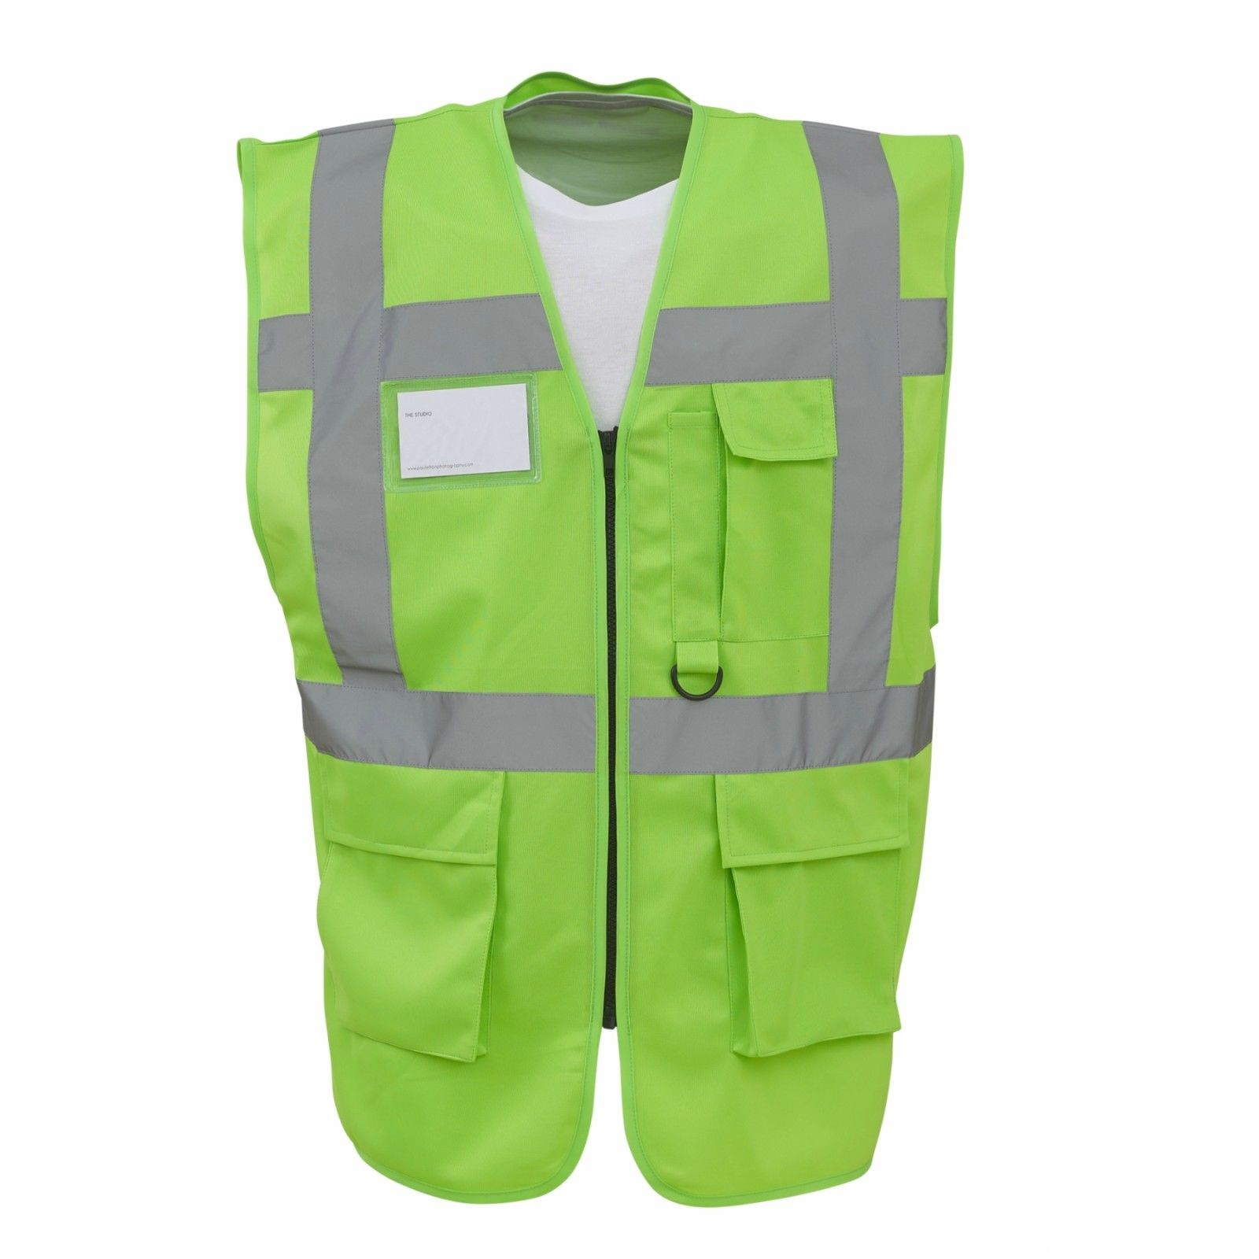
OB01
24

Lime Green - Executive Hi-Vis
Observer
LB: Screen Print LS Logo - White
RB: Screen Print Number- White
Back Upper: Screen Print LS Logo - White
Back Upper: Screen Print - OBSERVER - White
Back Upper Screen Print – Number - White

D001
001
001

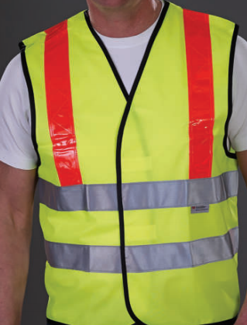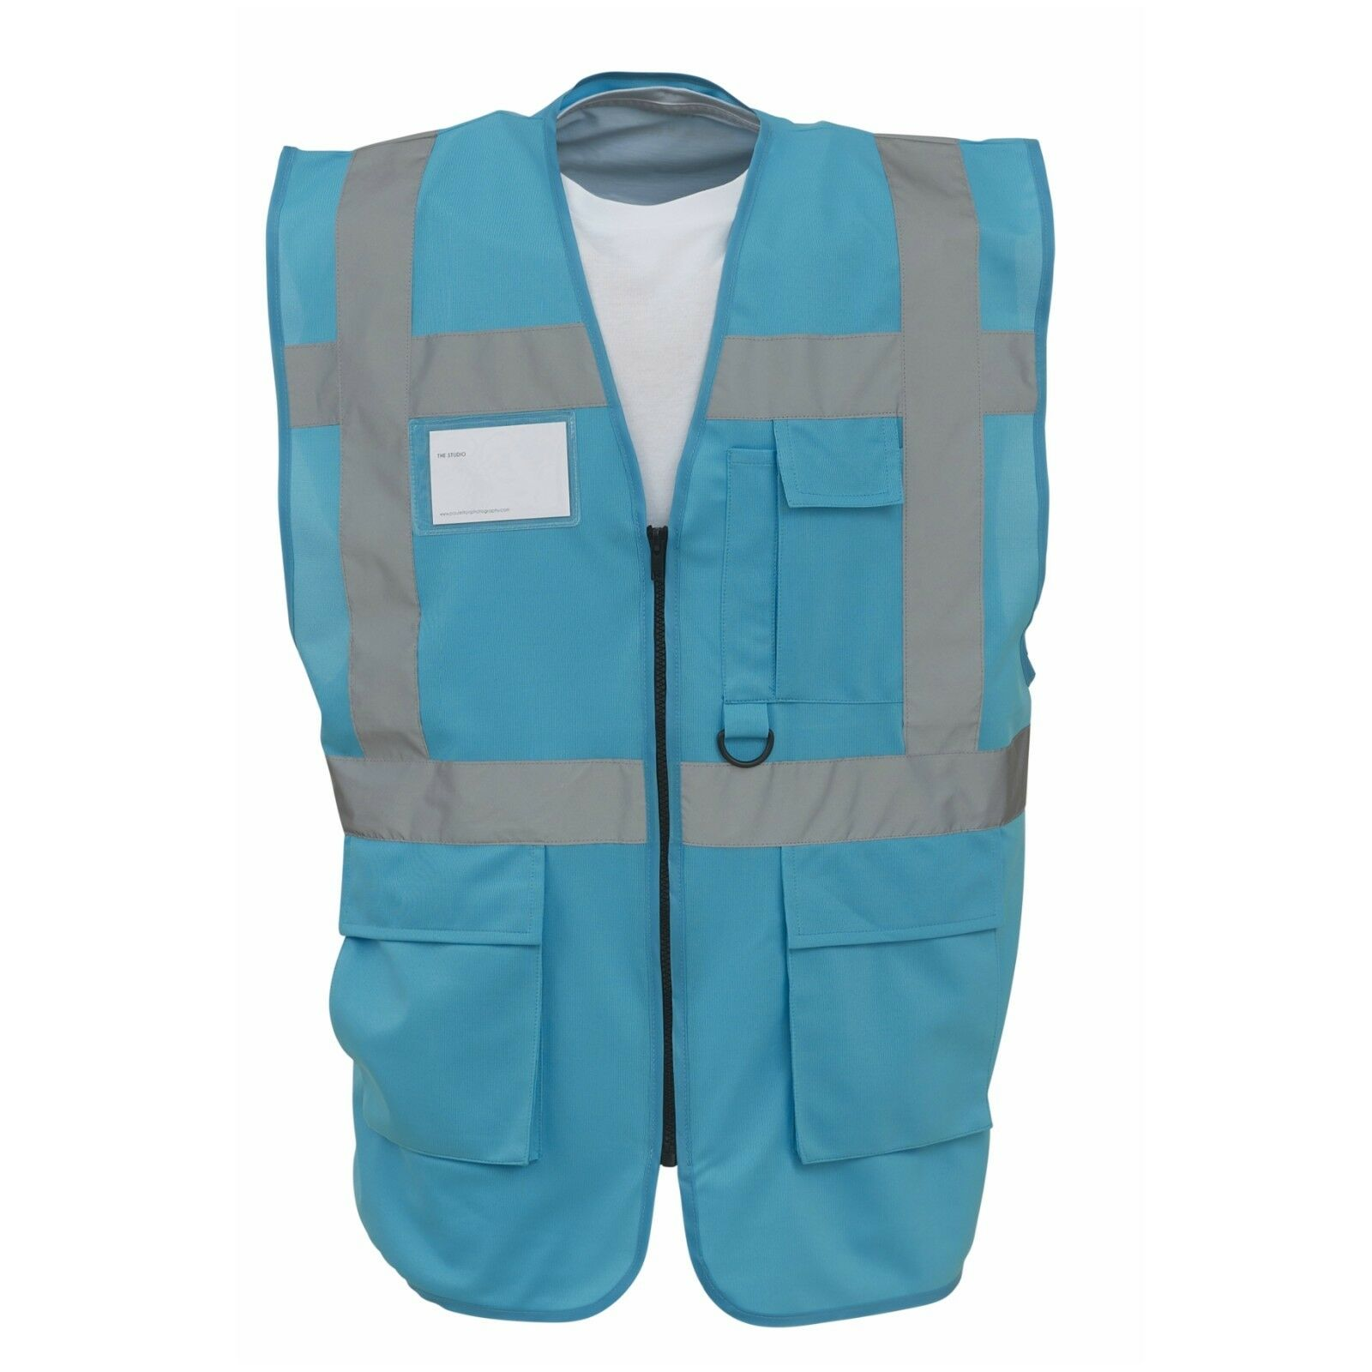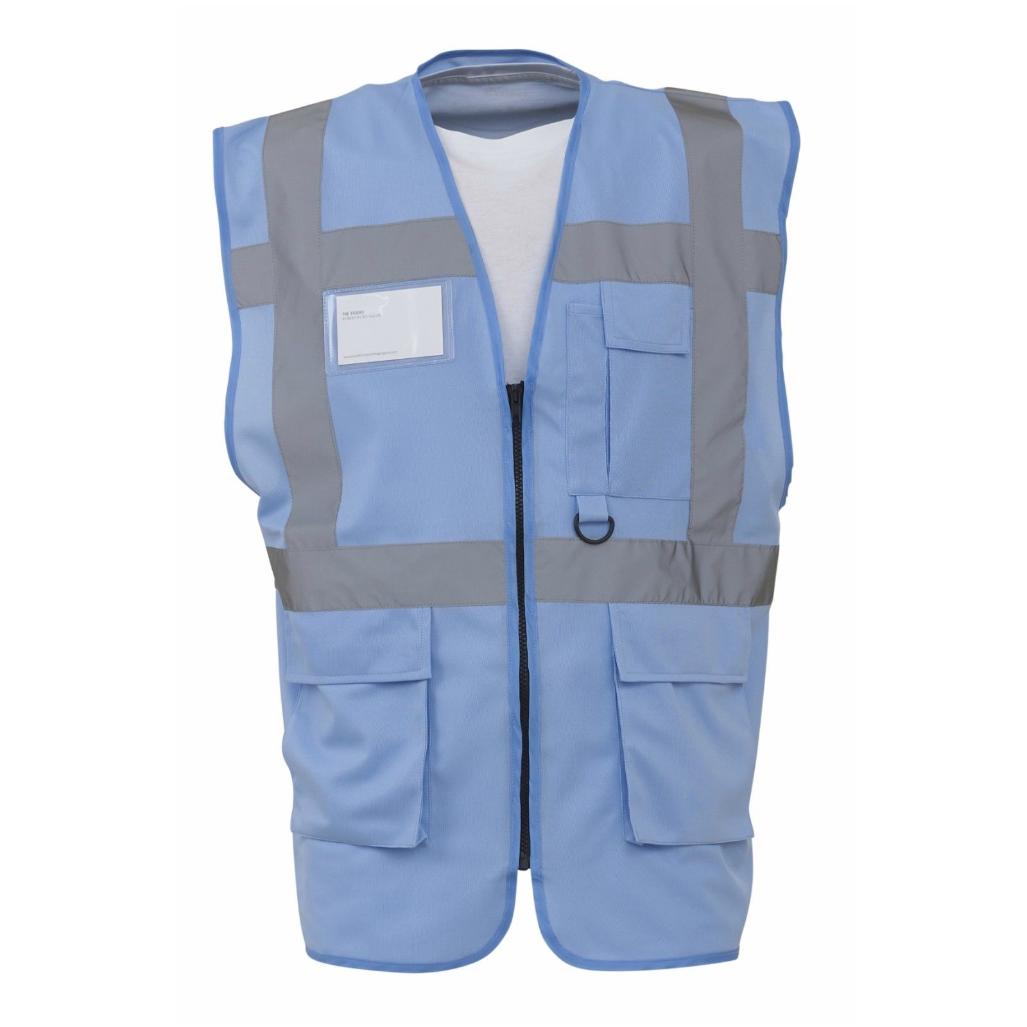
Yellow – With Orange Stripe- Chapter 8
Taxi Marshal
LB: Screen Print LS Logo - Black
RB: Screen Print Number- Black
Back Upper: Screen Print LS Logo - Black
Back Upper: Screen Print – TAXI MARSHAL - Black
Back Upper Screen Print – Number - Black

TM01
26
Sapphire Executive Hi-Vis
Wristbanding
LB: Screen Print LS Logo - White
RB: Screen Print Number- White
Back Upper: Screen Print LS Logo - White
Back Upper: Screen Print – LARGE LONDON STADIUM LOGO -White
Back Upper Screen Print – Number - White

W001
22
X001
21

SKY BLUE Executive Hi-Vis
Ticket Scanning
LB: Screen Print LS Logo - White
RB: Screen Print Number- White
Back Upper: Screen Print LS Logo - White
Back Upper: Screen Print – LARGE LONDON STADIUM LOGO -White
Back Upper Screen Print – Number - White

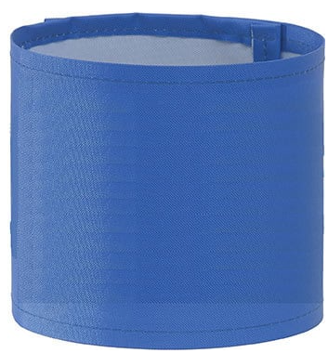
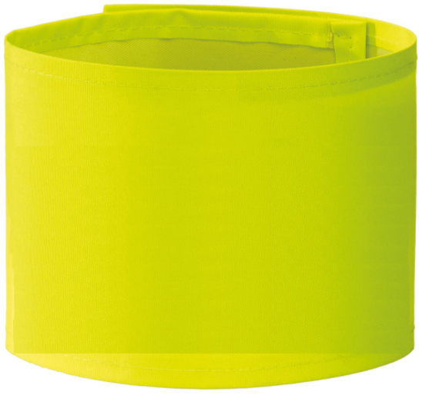
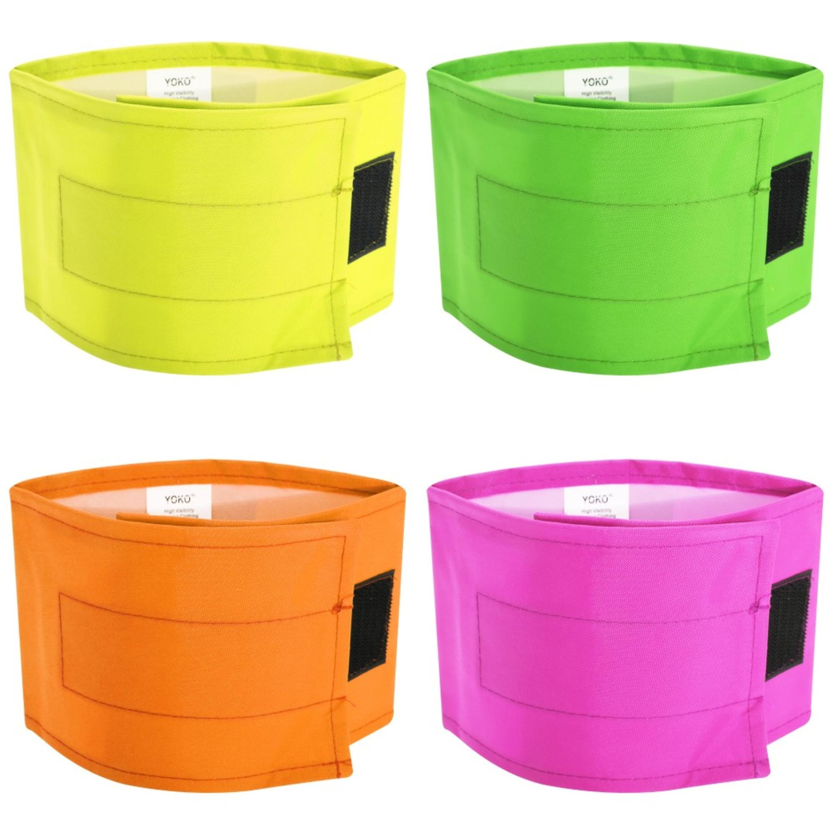
46+
45
MANAGER
INCIDENT COMAND
CCTV
44

Arm Bands
Yellow –Small LS Logo - Screen Print – cctv – Black
Blue – Small LS Logo - Screen Print – Incident Command – White
Pink – Small LS Logo - Screen Print – Manager - Black

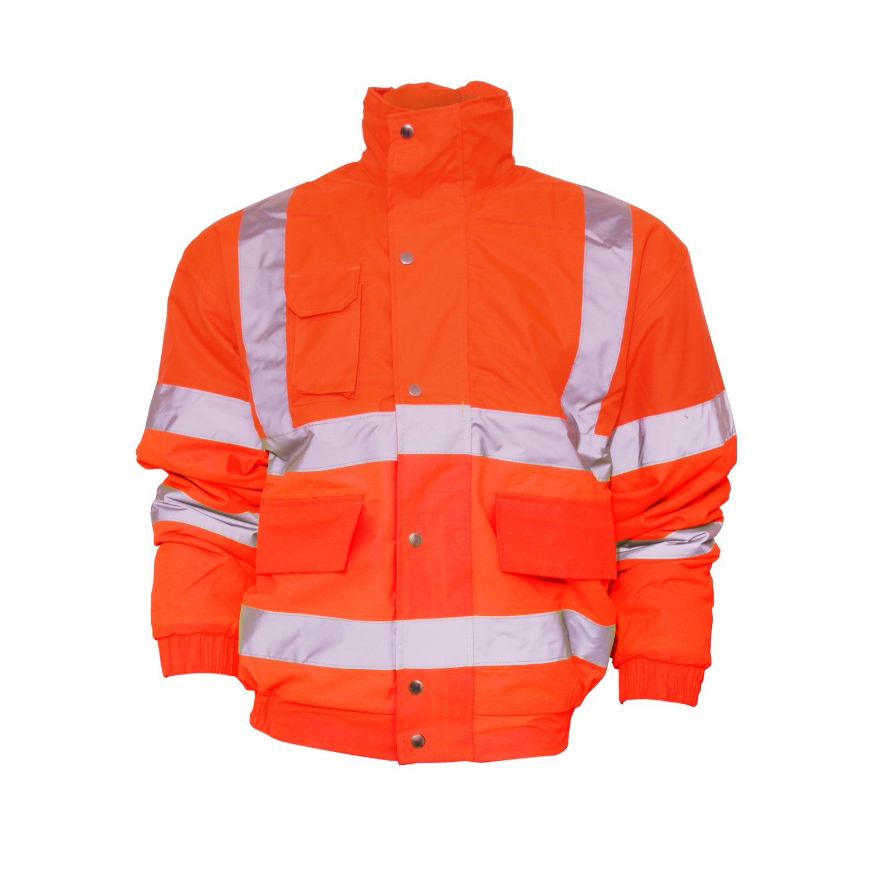
R001

Reb Bomber Jacket

Response Team
LB: Screen Print LS Logo - White
RB: Screen Print Number- White
Back Upper: Screen Print LS Logo - White
Back Upper: Screen Print – RESPONS TEAM -White
Back Upper Screen Print – Number - White

29
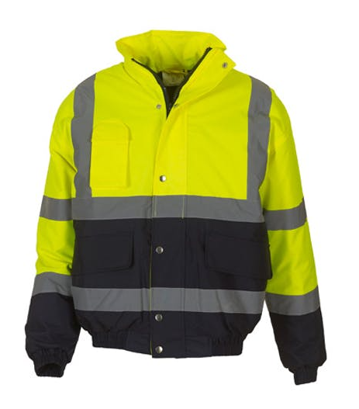

Yellow /Grey Bomber Jacket
London Stadium Senior Supervisor
LB: Screen Print LS Logo - Black
RB: Screen Print Number- Black
Back Upper: Screen Print LS Logo - Black
Back Upper: Screen Print – SENIOR SUPERVISOR -Black
Back Upper Screen Print – Number - Black

SS001
33
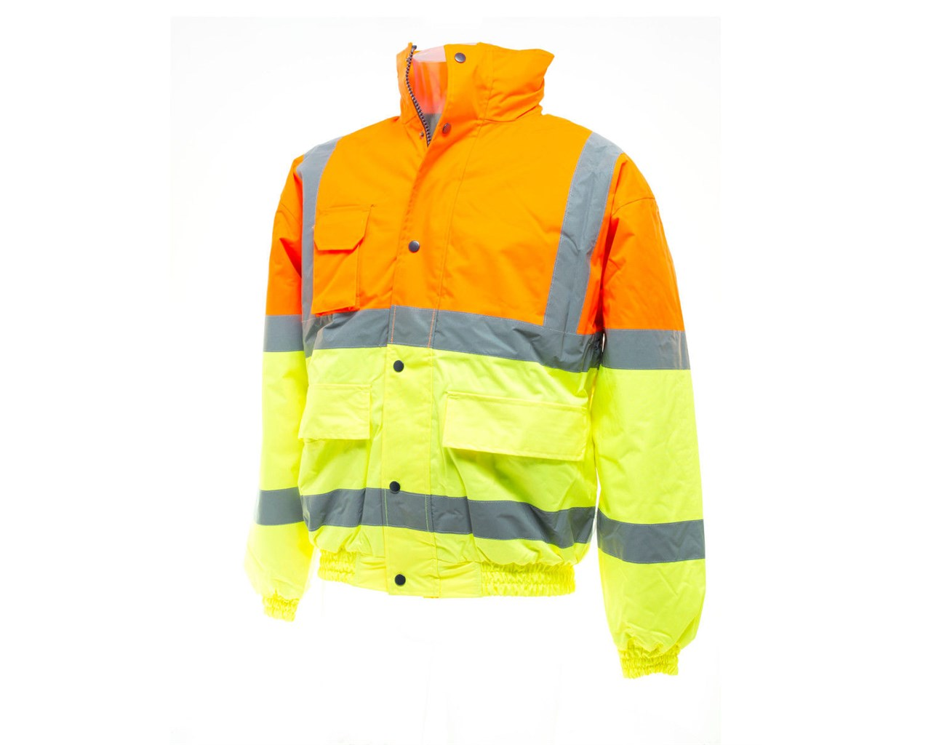
001

Yellow/Orange Bomber Jacket

Stadium Supervisor

Supervisor
LB: Screen Print LS Logo - Black
RB: Screen Print Number- Black
Back Upper: Screen Print LS Logo - Black
Back Upper: Screen Print – SUPERVISOR - Black
Back Upper Screen Print – Number - Black

32
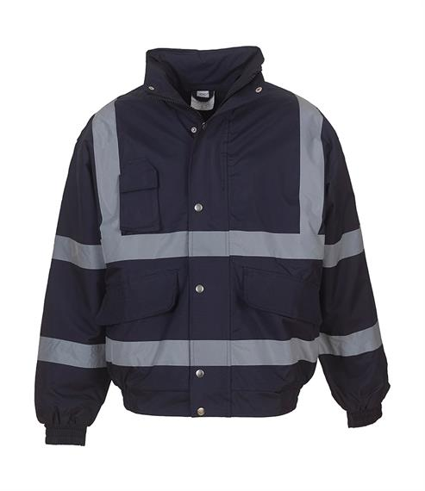
001

Navy Bomber Jacket
Logistics & Support Staff
LB: Screen Print LS Logo - White
RB: Screen Print Number- White
Back Upper: Screen Print LS Logo - White
Back Upper: Screen Print – LARGE London Stadium LOGO -White
Back Upper Screen Print – Number - White

36
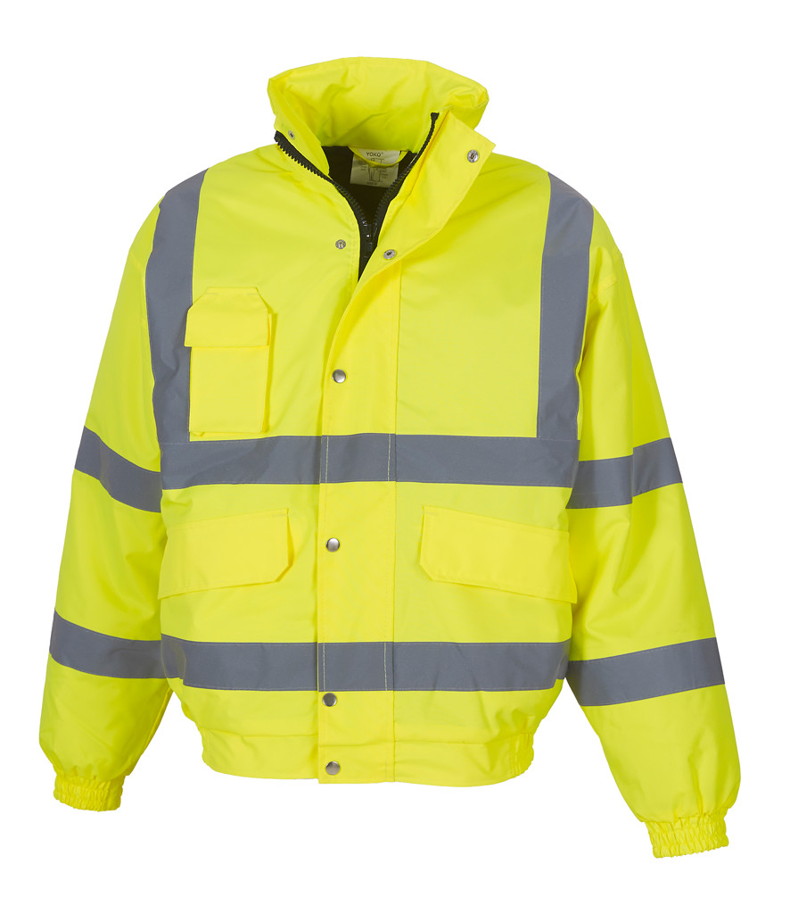
310
B001

Yellow Bomber Jacket

Safety

Supervisor
LB: Screen Print LS Logo - Black
RB: Screen Print Number- Black
Back Upper: Screen Print LS Logo - Black
Back Upper: Screen Print – SAFETY- Black
Back Upper Screen Print – Number - Black

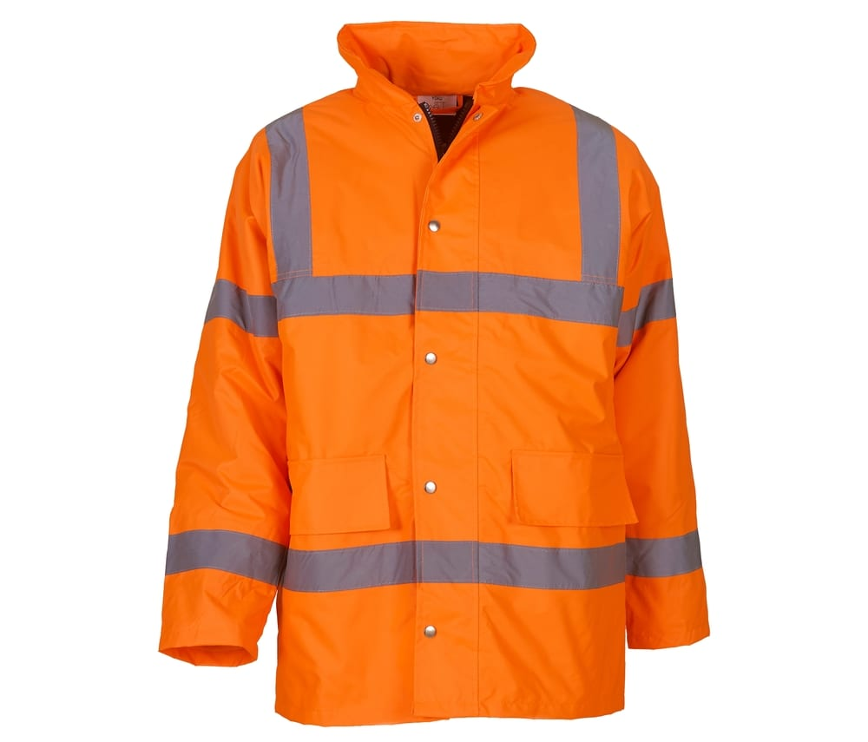
001
28

Orange High Visibility Padded Parka

Steward

Supervisor
LB: Screen Print LS Logo - Black
RB: Screen Print Number- Black
Back Upper: Screen Print LS Logo - Black
Back Upper: Screen Print – STEWARD- Black
Back Upper Screen Print – Number - Black

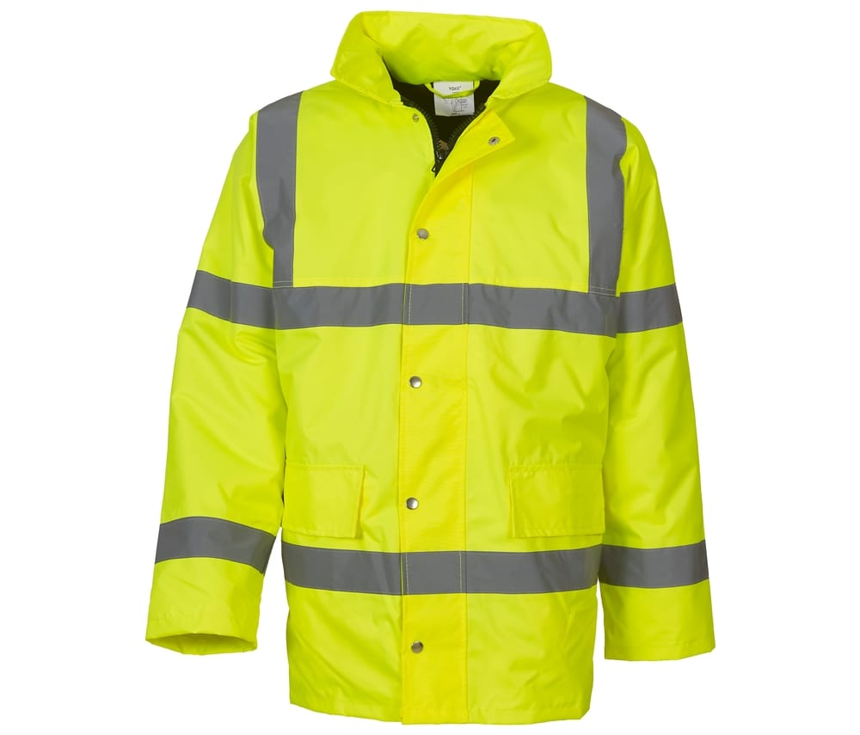
001
30

Yellow High Visibility Padded Parka

Safety

Supervisor
LB: Screen Print LS Logo - Black
RB: Screen Print Number- Black
Back Upper: Screen Print LS Logo - Black
Back Upper: Screen Print –LARGE LONDON STADIUM LOGO- Black
Back Upper Screen Print – Number - Black

#

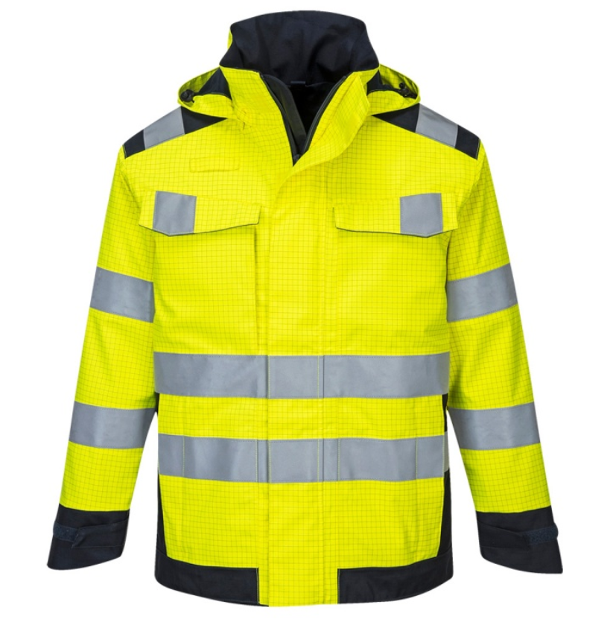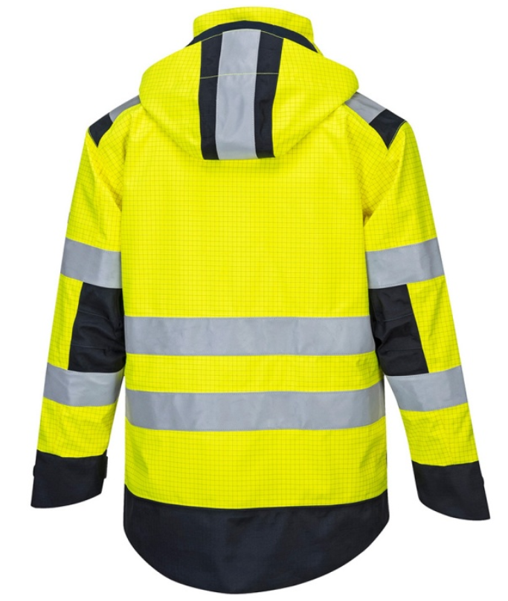
SAFETY
35

SAFETY

safety Officer

PORTWEST MV70 YELLOW MODAFLAME RAIN PPE ARC JACKET
LB: Screen Print LS Logo – Black
RB: Screen Print – SAFETY- Black
Back Upper: Screen Print LS Logo - Black
Back Upper: Screen Print – SAFETY- Black

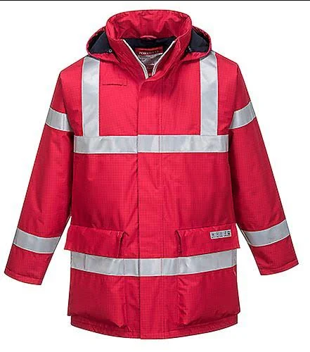
27

F001
FIRE

Portwest - Red Bizflame Rain Anti-Static FR Jacket - Conforms to EN 14058 Class 3, EN ISO 14116 Index 3, EN 13034 Type 6 - PW-S785RER
Optimum protection is offered from this anti-static jacket. Flame resistance coupled with superb breathable and water-resistant properties ensures this garment is suitable for multi-risk environments.
- H I G H P E R F O R M A N C E W A T E R P R O O F , F R P R O T E C T I O N
- Portwest Workwear
- Breathable garment
- CE certified
- Flame resistant reflective tape
- Internal chest pocket
- Phone pocket
- Radio loop
- Storm flap front
- Two-way front plastic moulded zip
- Anti-static
- Pack away hood
- Ribbed cuffs
- Lined
- Chemical
- 4 pockets
- Flame resistant treated waterproof fabric
- Fully lined and padded
- Waterproof with taped seams

Safety Standards: EN 1149 -5 || EN 13034 Type 6 || EN 343 Class 3:1 || EN 14058 Class 3 || EN ISO 14116 Index 3
Fabric/Material: Shell Fabric: Bizflame Rain 250g Lining Fabric: 100% Cotton Flame Resistant Lining 170g Filling Fabric: 100% Polyester Flame Resistant Filling.100g


F001
FIRE

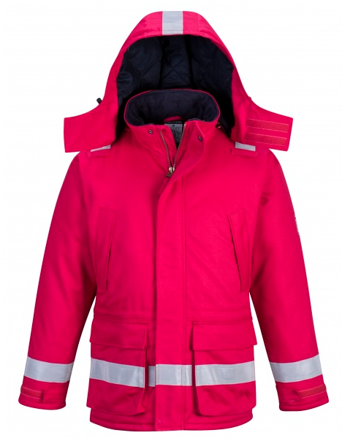
F001

Portwest Bizflame Anti Static Flame Retardant Jacket

optimum protection is offered from this anti-static jacket. Flame resistance coupled with superb breathable and water resistant properties ensures this garment is suitable for multi-risk environments.
- Flame resistant treated waterproof fabric prevents water penetration
- Premium sew on flame resistant reflective tape
- Anti-static
- Waterproof with taped seams preventing water penetration
- Fully lined and padded to trap the heat and increase warmth
- Internal chest pocket
- Storm flap front to protect against the elements
- Pack away hood for added functionality
- Radio loop for easy clipping of a radio
Fabric
Shell fabric Bizflame Rain>Lining fabric 100% cotton flame resistant lining>Filling fabric 100% Polyester flame resistant filling
Standards EN ISO 14116 Index 3 EN 1149 -5 EN 13034 Type 6 EN 343:2019 Class 3:1 X EN 14058 Class 3

FIRE
27

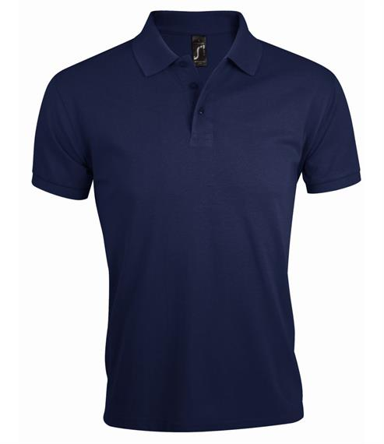
50

nAVY –cOTTON/pOLY pOLO

CROWD safety

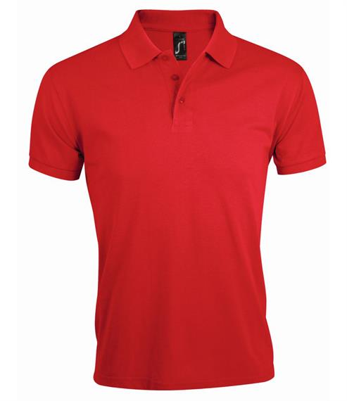
49

lONDON sTADIUM fIRE tEAM POLO

red – 100% cOTTON


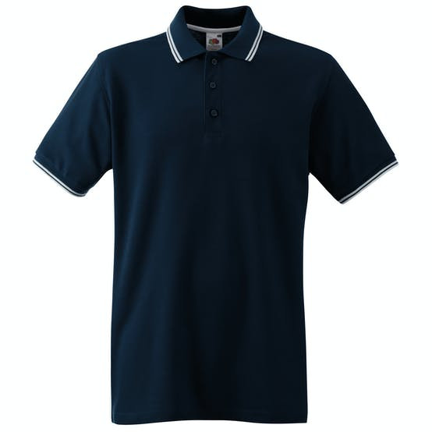
59

LONDON STADIUM FULL TIME STAFF

NAVY Tipped Polo Shirt

100% Cotton

LB: Embroidered London Stadium Logo – White


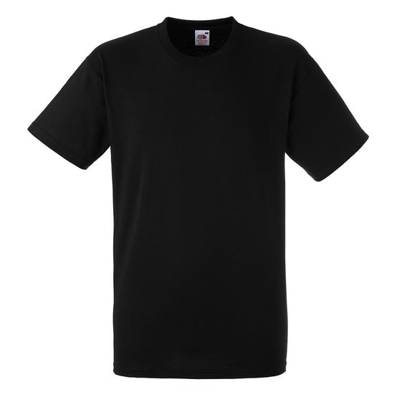
62

LONDON STADIUM

NAVY T SHIRT

100% COTTON

LB. Embroidered London Stadium Logo - White


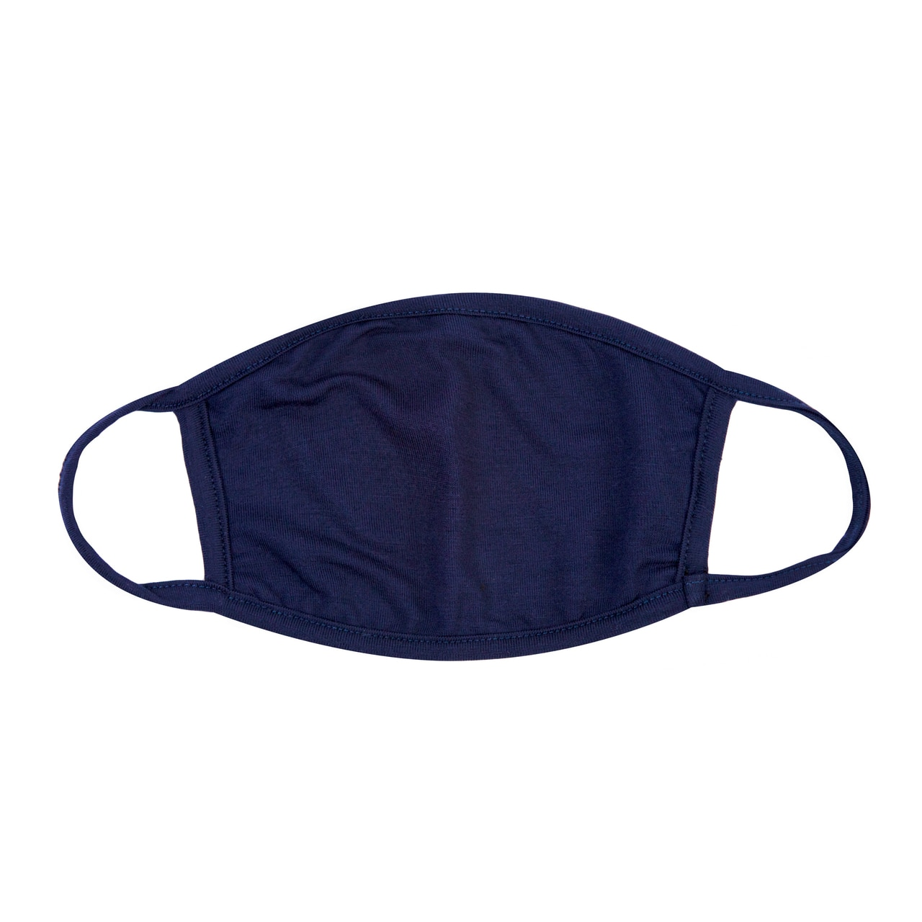
47

MACHINE WASHABLE FACE MASK

Navy

100% Cotton

Left – Screen Print LS logo – White



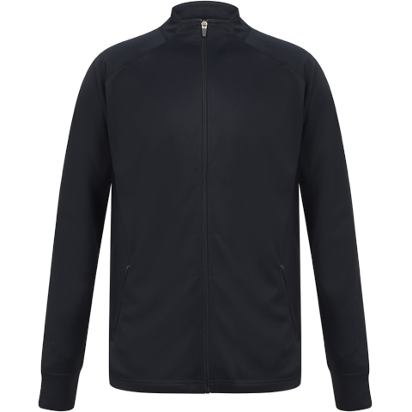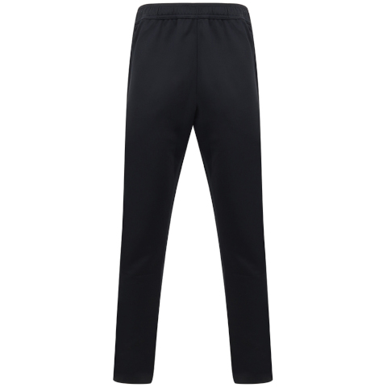
Pitch Runner Tracksuit
Navy/Royal
Top
LB: Embroidered London Stadium – Logo- White
RB: Screen Print RB -Number -White
LV881
Bottoms
LB. Embroidered London Stadium Logo - White
RB: Screen Print -Number -White

36

PR001
PR001


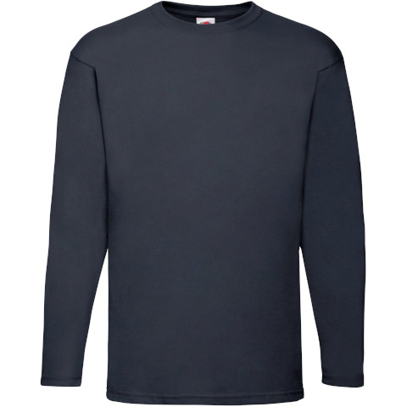
37

Long Sleeve T shirt
LB: Embroidered London Stadium Logo - White



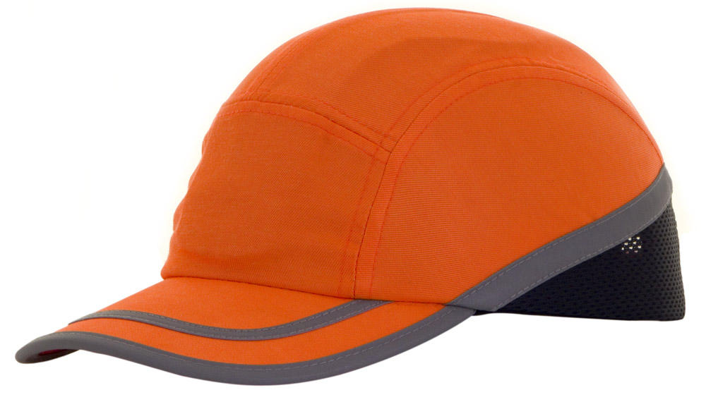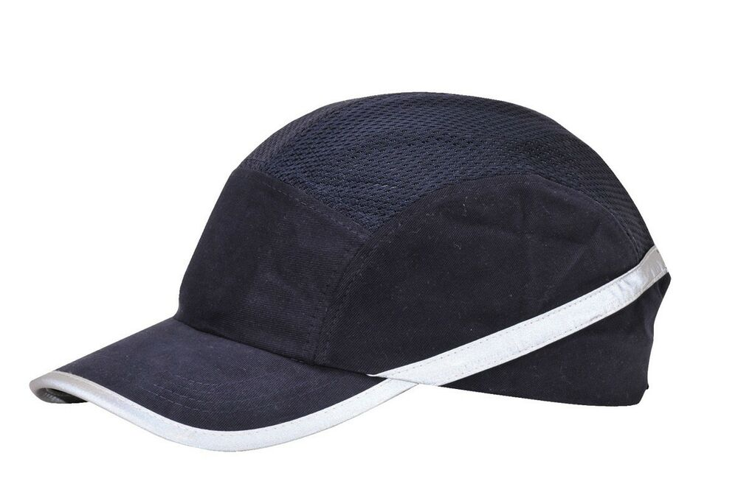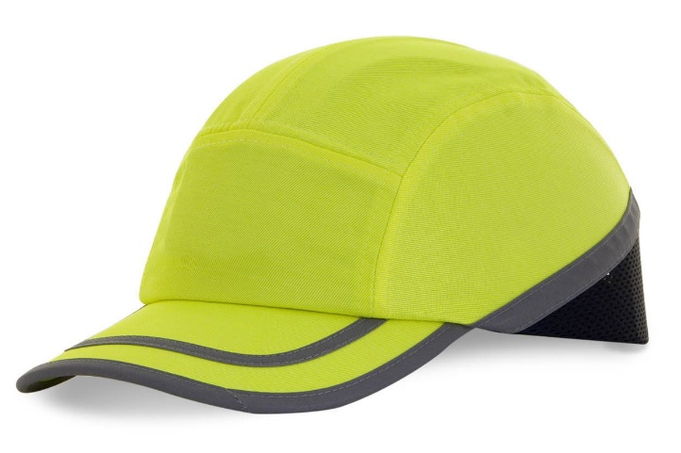
Blue Safety Bump Cap
Side: Manager side – Screen Print White
LOGO – Screen Print - White
Yellow Safety Bump Cap
Numbering – Screen Print White
LOGO – Screen Print - Black
52

51

Orange Safety Bump Cap
Side: Numbering – Screen Print Black
LOGO – Screen Print - Black
53

MANAGER
001
001
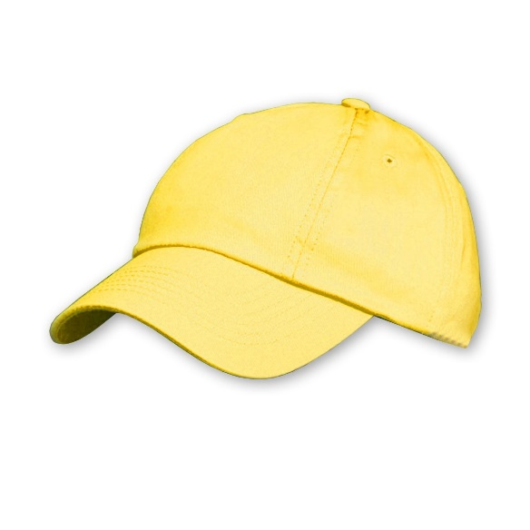
54

Yellow London Stadium Soft Cap
LOGO – Screen Print Black
Numbering Screen Print - Black

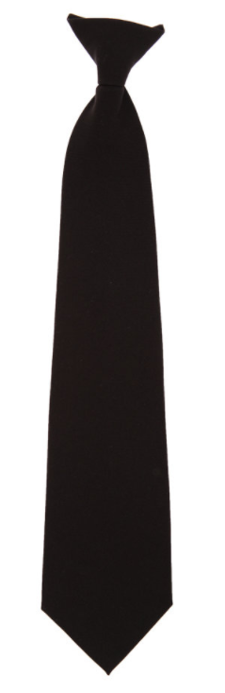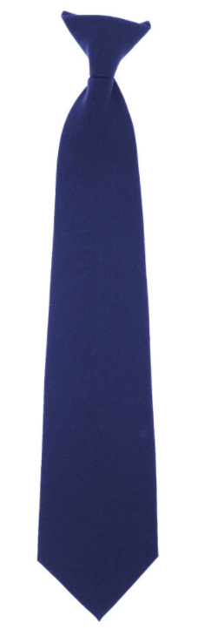
Navy Clip-on Tie –
Managers
LOGO – Screen Print -White
Black Clip-on Tie
Hospitality
LOGO – Screen Print - White
56

55

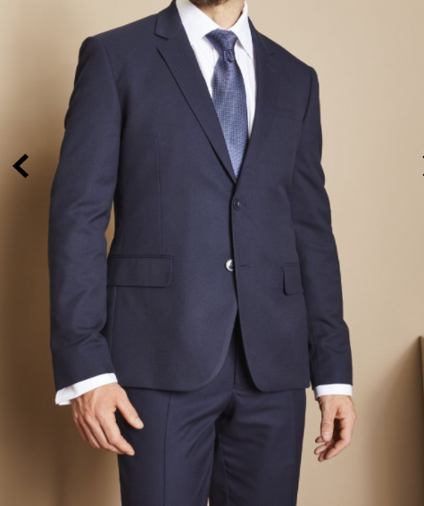
39

Navy Men’s Suit
Jacket
Size 34 to 52
Regular/Long
Navy
Tax Tag logo
Trousers
Waist 28 -50
Leg – Short (29)– Regular(31)-long (33)
Embroidery – London Stadium Logo or Tax Tag logo

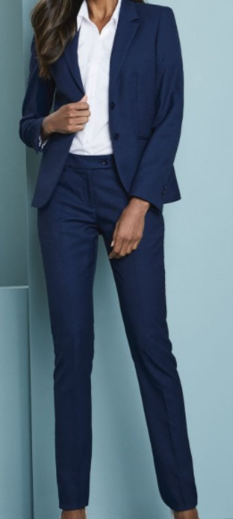
40

Navy Women’s Suit
Jacket Size 6 to 26
Tax Tag logo
Trousers
Embroidery – London Stadium Logo or Tax Tag logo

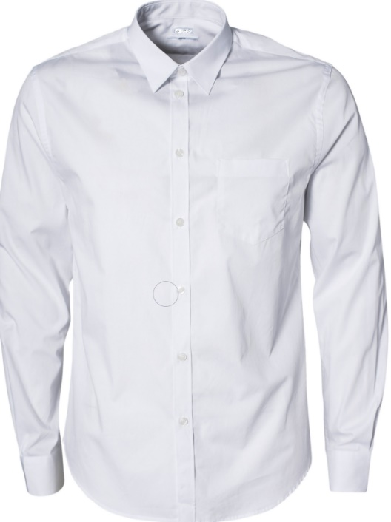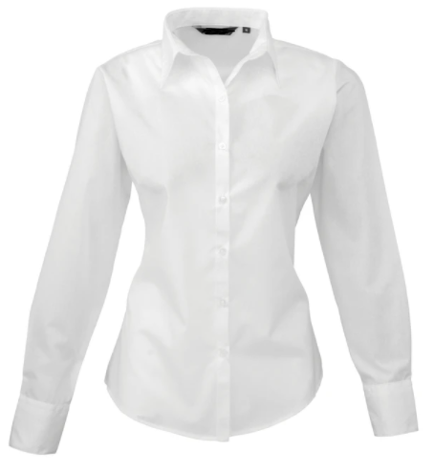
Men’s Long Sleeve Shirt
White
Tax Tag Logo

Women’s Long Sleeve Shirt
White
Tax Tag Logo

42

41

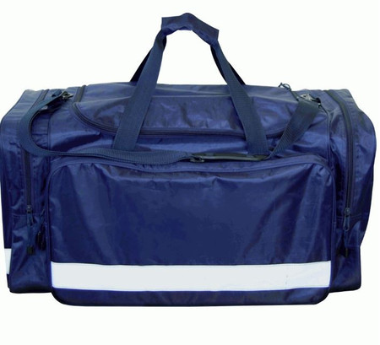
ZONE 1
ZONE BAG Large Holdall with reflective stripe
Navy
Numbering and Logo - Screen Print – White

43

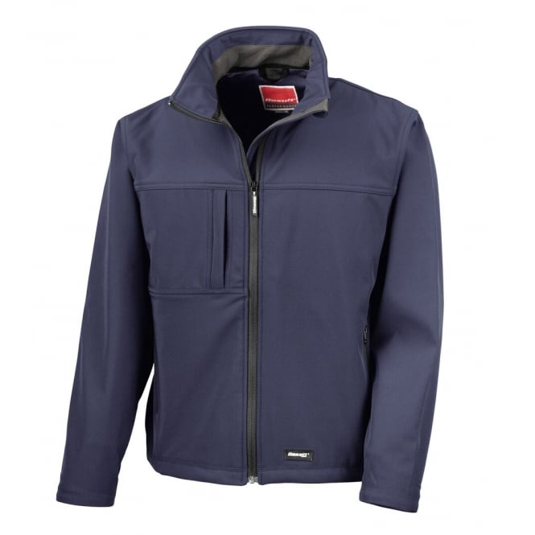
Soft Shell Jacket
Size – Small – 4X Large
Fabric:
Outer Layer: 93% Polyester, 7% Elastane. Mid-Layer: TPU waterproof, breathable and windproof membrane. Inner: Microfleece for extra warmth
Weight:
320gsm
LB: LOGO – Embroidered London Stadium Logo - White
57

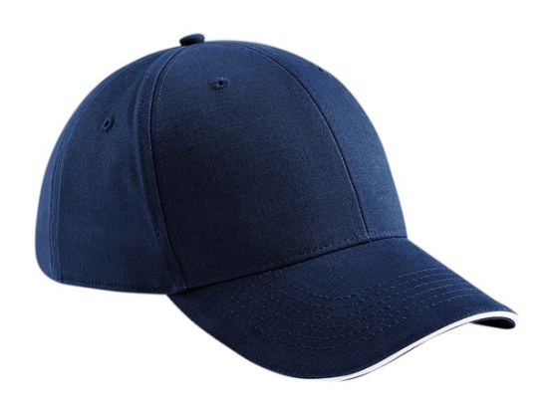
58

London Stadium Baseball Cap
Navy
LOGO – Embroidered London Stadium Logo - White

61

60

Chino Trousers
Colour Khaki
Women’s
Men’s
Tax tag

63

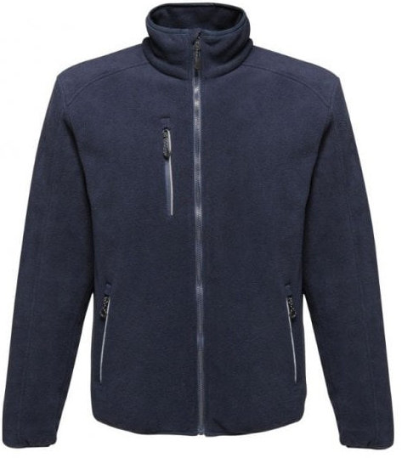
London Stadium full time Fleece Jacket
Navy
LB. LOGO – Embroidered London Stadium Logo - White

Fleece Beni Hat
Unisex
Embroidered London Stadium Logo - White

64

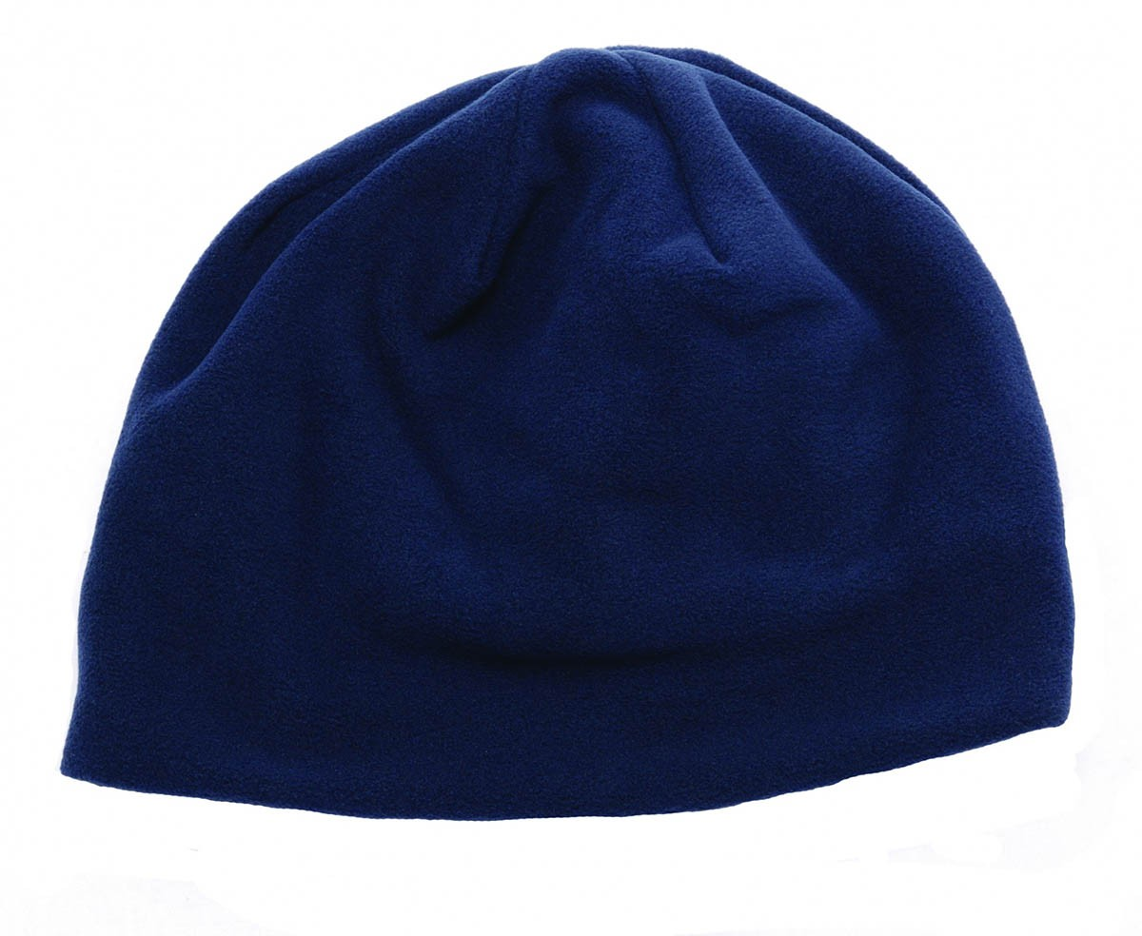

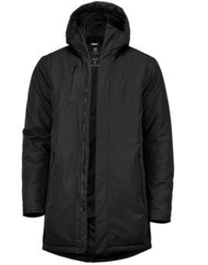
45

NB77M: Mapleton urban tech parka
Black
LB: London Stadium Logo – Screen Print – White



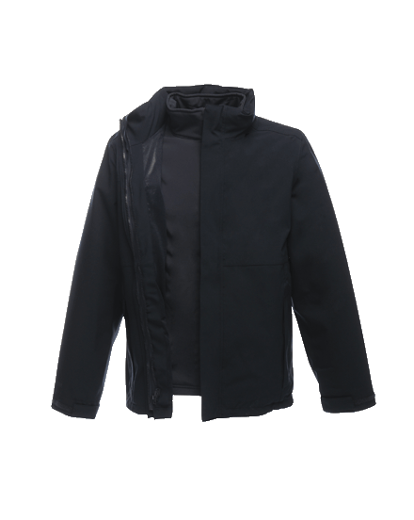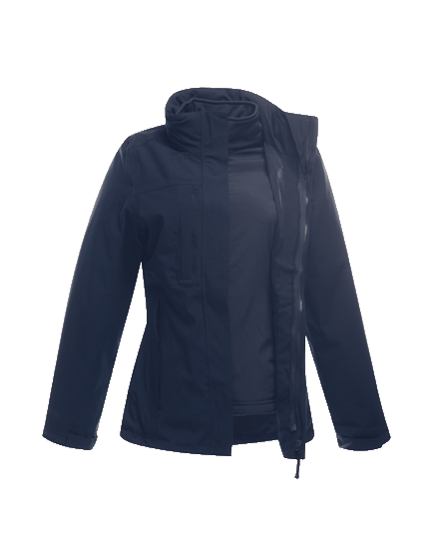
38

London Stadium Crowd Safety Manager Jacket

oPTION 1
LB: London Stadium Logo – Screen Print – White

KINGSLEY
STRETCH 3-IN-1 JACKET

272 - Navy
Men'sTRA143
Women'sTRA144
Fabric Information
Waterproof and breathable Isotex 10000 100% polyester stretch fabric
Durable water repellent finish
Part mesh, part polyester taffeta lining
Taped seams
Softshell Inner
Warm backed woven stretch Softshell fabric

Special Features
Concealed hood with adjusters
2 zipped lower pockets and 1 zipped chest pocket
Double stormflap with hook and loop fastening
Adjustable cuffs
Adjustable shockcord hem
Concealed zip entrance in lining for embroidery access
Shaped fit (women's only)
2 zipped lower pockets
Men's TRA143
Sizes: S – XXXL (EU 48–62)
Quantity Per Carton: 8
EN343 Declaration of compliance
Women's TRA144
Sizes: 10-20 (EU 36-46)

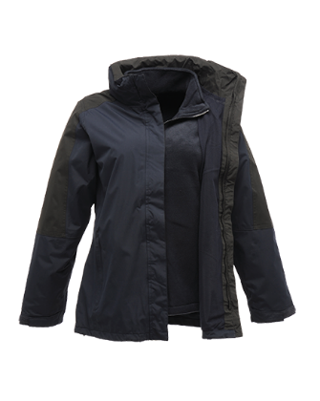
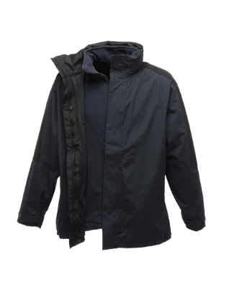
LB: London Stadium Logo – Screen Print – White

38
London Stadium Crowd Safety Manager Jacket
oPTION 1

DEFENDER III
WATERPROOF 3-IN-1 JACKET

58F NAVY/BLACK

Men'sTRA130
Women'sTRA132
Fabric Information
Waterproof Hydrafort peached polyester fabric
Mesh lined body
Windproof fabric
Taped seams
Inner
200 series anti-pill Symmetry fleece

Special Features
Concealed hood with adjusters
Stormflap with hook and loop fastening
Adjustable cuffs
2 zipped lower pockets
Adjustable shockcord hem
Concealed zip entrance in lining for embroidery access
Shaped fit (women's only)
Men's TRA130
Sizes: S - XXXL (EU 48-62)
Quantity Per Carton: 8
Women's TRA132
Sizes: 10-20 (36-46)
Quantity Per Carton: 8

