HAMBLE LE RICE PARISH COUNCIL
INFORMATION AND INSTRUCTIONS FOR TENDERING

INVITATION TO TENDER – replacement of benches at the Southern Quay Hamble.

Tenders must be submitted in accordance with the following instructions. Tenders not complying with these instructions, in any particular way, may be rejected by the Council, whose decision on the matter is final.

Invitation to Tender

Hamble Parish Council (HPC) is seeking to invite tenders for the design and replacement of public seating and public waste and dog bins.

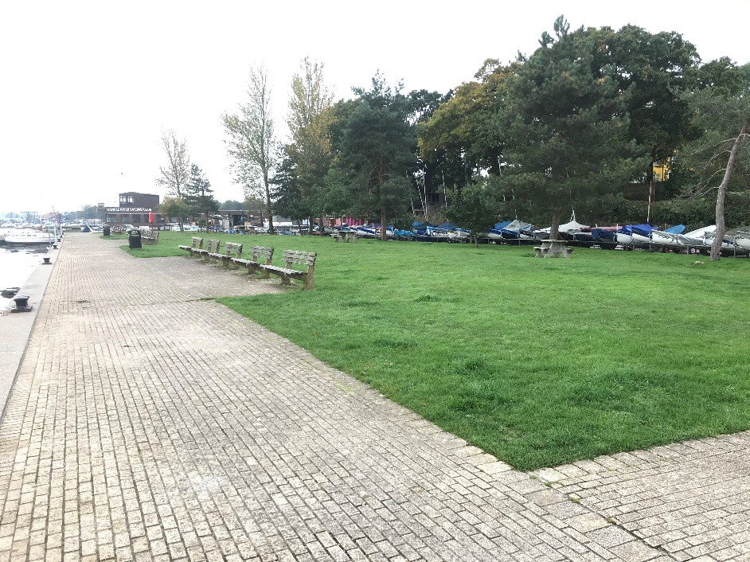
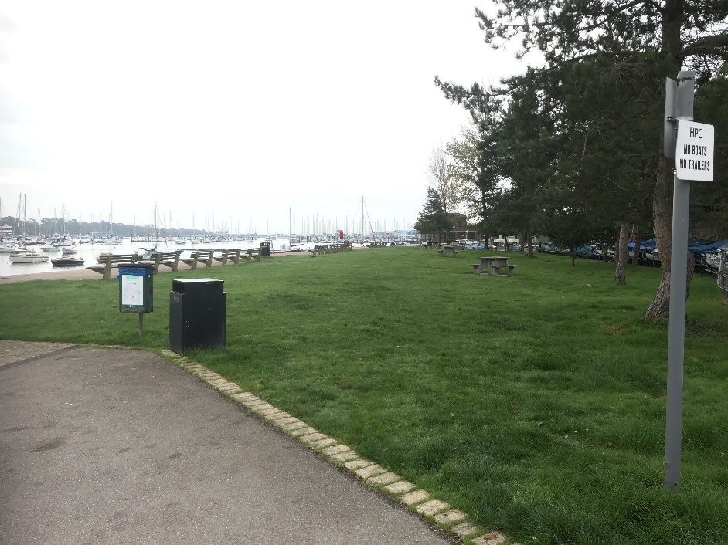

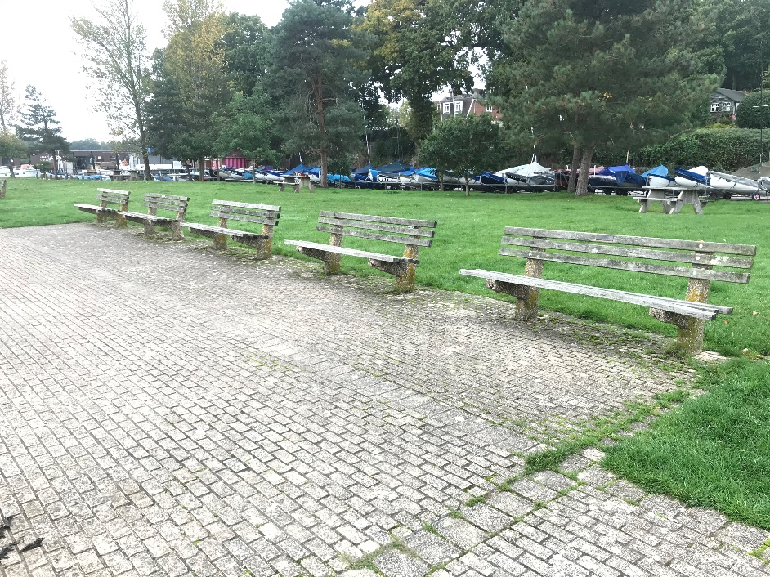
Location: https://www.google.com/maps/place/50%C2%B051'23.5%22N+1%C2%B018'45.5%22W/@50.85653,-1.3132106,184m/data=!3m2!1e3!4b1!4m6!3m5!1s0x0:0x0!7e2!8m2!3d50.8565299!4d-1.3126289

OVERVIEW OF PROJECT
The Foreshore at Hamble is owned by Hamble Parish Council and is zoned as a conservation area. The area comprises of a number of discrete areas including:
- Foreshore seating area and Quay
- Car Park
- Mid seating area
- Lifeboat Station and public facilities
- Dinghy storage park
- Southern Quay Green and quayside
- Beach Hut Cafe.

HPC is hoping to undertake a wider improvement programme that embraces the whole site, but ahead of that wants to kick start the programme by replacing the current 16 benches, the 3 picnic benches, along with 3 general waste bins and a dog waste bin. Adjoining the Southern Quay are a further 3 benches which will also be included but will be subject to available resources.

The Council has set aside £37,000 for seating and other furniture across the Southern Quay and another site elsewhere in the Village. In addition, sponsorship is being sought from local businesses. Value for money an important component of the bid although we will also want to ensure that there is a warranty arrangement in place and that the seating can be maintained. The site is exposed both in terms of physical conditions as well as vandalism and anti-social behaviour so the product must be robust and any tenders must be supported by 3 reference sites and contact details that demonstrate the performance of the product.

Officers will be available on the 4th December to facilitate a site visit and to address any queries. All queries will be recorded and shared with other tenderers. Tenders are actively encouraged to attend site to ensure familiarity with the location and the setting.

Design
The Foreshore is loved by residents and visitors alike. It has an international reputation within the sailing community and punches above its weight as a day trip destination. It is recognised as a friendly and traditional setting in which people can enjoy a range of pastimes throughout the whole year.

The Southern Quay sits at the most southernly point of the foreshore and is accessible only by foot. The area comprises of a grassed area backed by the Councils Dinghy Park and fringed at the front by a promenade which currently houses the 16 benches. The grassed area accommodates a number of wooden picnic benches which will be removed as part of the contract.

Historically the focus has been on river views which has meant that the grassed area is underutilised. Although river views remain important we are keen to encourage families to use the space more, to relieve pressure on space at the main Foreshore. With the removal of the existing picnic benches designs must include options for this activity. The grassed area nearest to the slipway is infrequently used for boat storage and must be avoided at a seating location.

Although we do not have a detailed design specification, we are looking for the following features:
- Seating that is variable in length and design
- Sections with and without back rests to enable people to sit and look at the river or the grassed area
- Use of curved sections to add interest and echo site features
- Provide sociable spaces that aid interaction between different users of the Foreshore, including cross-generational
- The use of some arm or end stops to prevent or deter running or skateboard/bmx use as well as providing support for those that need it.
- Consideration should be given to the seating design on the main Foreshore. Seats in this area are cast iron Baltimore wooden slatted seats. Although we want to see a different and unique design in this area, it is important that there is a common theme across the whole space. A design statement should support the bid.

Materials
For comfort the seating element will not be metallic and bidders must avoid single use plastics. Where metal is used it will be galvanised and powder coated and fixing will be bolted into the concrete pad. Use of recycled materials is encouraged.

Materials should be specifically suitable for use in a marine environment. A description of how the materials are treated to be resistant to corrosion should be given and their expected life span. Where protection can be reapplied this should be highlighted along with the method of repair and replacement as needed. Materials and the design must be resistant to vandalism and abuse

We will be looking for a minimum warranty of 15 years. Tenders should included in their statements how their product can be recycled or reused at the end of life to avoid materials going to land fill.

Removals
All existing benches must be removed from site and the price will include the additional 3 benches on the adjoining site. Where benches are removed and not replaced bids must include a cost for breaking up the remaining concrete pad and making good the surface. A decision will be made based on the design as to whether or not redundant concrete pads will be removed.
Surfacing
Currently all the seating sits on a concrete pad flush with the ground level. New locations for benches/seating will also be on concrete flush pads. Construction details and materials of new surfaces must be stated.

Additional street furniture
There are currently three waste bins and one dog bin. Replacement bins must match the design of the bench/seats but will, if possible, enable waste to be separated into general waste, recycled and glass. Bins must not be located in a position that would interrupt views of the river from the grassed area. If bins are post mounted the cost of the posts and installing them must be included in the bid.
Memorials and dedications

Plaques and Memorials
The current benches were purchased and donated to the Parish in return for a plaque. These plaques should be retained and be included and reaffixed in the new scheme. If the design of the seats are such that plaques cannot be attached to them, the tender should suggest how plaques can be accommodated in the new scheme. The Council will wish to allow further memorials as a source of income so this should also be considered.

Concepts
There will inevitably be a mix of views about what is an appropriate replacement for the existing site furniture. The shortlist of 3 will be subject to a public consultation exercise. The final decision will be taken by the Council but regard will be given to the views and preferences expressed as part of the consultation. Bids will be supported by a minimum of two A1 presentation boards showing both the layout in plan form and a concept representation of the finished scheme.

Value Added
The council encourages any additional value-added options within the proposal. These will be set out and costed separately in the tender proposals.

Working safely
The council will require a specific risk assessment for the site and method statement about how the project will be managed to keep people safe. This should be included as a specific section in the tender documents.

Storage
A requirement for site compound, vehicle access, parking and welfare facilities should be clearly identified. The security of plant, tools and materials will be the sole responsibility of the contractor and HPC will not be liable for any loss or damage.

Disposal of materials
All waste ad surplus materials removed from the site should ideally be recycled. Tenders should include arrangements for waste disposal and reuse. All areas should be restored prior to the end of the contract.

Restrictions
The area is not directly served by vehicles although access can be arranged via a footpath. Any method statements will need to address the safe movement of vehicles in a pedestrian environment. Given the proximity to property and businesses the hours of operation will be restricted within the range 0800-1700hrs although hours of daylight may restrict safe working further. This should be considered.

CONTRACT ISSUES AND TENDER PROCESS

Performance of contract and after Sales and Service Level Agreements
Suppliers must be able to respond quickly and effectively to any post installation maintenance requirements. Tenderers will confirm that they are able to meet the conditions and the penalties set out in the table below:

Requirement | Details | Penalty
Completion of project on  time | Other than delays due to aspects not within the control of the contractor, completion of 2 weeks beyond stated completion date | 2% of value of Project  (£740.00)  Longer than 2 weeks - 3% of value of Project (£1,110.00)
Resolution of Warranty  related defects | Beyond 4 weeks of notified defect if item is not safe to be used | 5% listed value of equipment in question
Retention | Any defects or quality issues within 12 months of installation | 5% of the value of the project to be withheld until 12 months following completion of the project

Project Completion
The project will not be deemed complete until all snagging issues are resolved and the Post Installation Inspection is complete and satisfactory.

Financial Assessment
The Council will carry out an independent appraisal of the 3 shortlisted tenders to assess their financial strength.

Tender Evaluation
Tenders will be evaluated in-line with the table below. Each category has a total number of points available which reflect the importance of the activity. Tenderers will therefore identify within their tender how they meet each of the categories.

Item | Score | Detail
Overall Design | 45% | Meeting the brief, design layout, aesthetics of equipment and surfacing
Quality of Materials and environmental sustainability | 30% | Maintenance, expected longevity of equipment and materials that are recycled or repurposed
Warranties | 10% | What is covered in the warranty, length of warranty for each type of material
Health and Safety | 5%
Presentation | 5% | Quotation, quality of the visuals, general information included and format of response
Time Table and  Service Levels | 5% | Can you meet the time frames and agree to the services levels detailed in this document

Scoring System

Quality | Points | Criteria
Superior | 4 | Exceptional demonstration of the relevant ability, understanding, Experience, skills, resources & quality measures required to meet the projects aims or requirement. Response highly relevant with comparable contract value.
Good | 3 | A comprehensive response submitted in terms of detail and relevance and clearly meets most of the project aims or requirement with no negative indications or inconsistencies.
Below  Expectations | 2 | Minimal achievement of the requirements specified in the tender offer & presentation for that criterion. Several errors, risks, weaknesses or omissions, which are possible, but difficult to correct/overcome and make acceptable.
Poor to  deficient | 1 | Limited response provided, or a response that is inadequate, substantially irrelevant, inaccurate or misleading
Unacceptable | 0 | Totally deficient and non-compliant for that criterion.

The Questionnaire will be assessed on a Pass/Fail basis, and only those organisations that pass this stage will be considered for the project.

This evaluation exercise will be used to select no more than three tenders. These will go forward to a decision-making stage involving a public consultation and then onto a Council Meeting. The Council will then confirm the successful bidder having considered the community feedback.

Project timeline

Below is the project timeline. Suppliers will need to provide confirmation (or Programme of Works) that these dates for starting and finishing the project can be met within their tender response:

Action: | Date Due By:
Invitation to tender | 18.11.19
Tender Site Meeting – time to be confirmed | 04.12.19
Deadline for submission of Invitation to Tender  Acknowledgement Form (Appendix 1) | 29.11.19
Deadline for submission of tender clarification questions | 06.12.19
HPC to answer outstanding questions | 13.12.19
Tender Response Due | 17.12.19
Shortlist confirmation | 08.01.20
Consultation Event over 1 week | w/c 13.01.20
Tender selected and decision notified | 12.02.20
Order Date and Contract signed | 24.02.20
Completion Date | 30.04.20
All snagging / ROSPA issues resolved, fencing and storage removed. | TBA
Invoice for Payment (5% retention till the end of defects period) | TBA

Preparation of Tender and Tender Duties.

Tenderers will be asked to complete 3 key documents as part of their tender submission. These are attached in the appendices. They are as follows:
- Invitation to Tender Acknowledgement – Appendix A
- Form of Tender – Appendix B
- Qualification Questionnaire (plus associated documents (Appendix C)

The Tender must be made in ink on the Form of Tender enclosed.

The Form of Tender must be signed where the Tenderer is an individual, by that individual. Where the Tenderer is a partnership, by two duly authorised partners. Where the Tenderer is a company, by two directors or by a director and company secretary, such persons to be duly authorised for the purpose.

Qualification Questionnaire will be completed and the following attached:
- Health & Safety Policy, Risk Assessments and Safe Working Procedures
- Proof of public liability, professional liability, product liability and employer’s liability
- Insurance, all of which must identify the level of indemnity
- Proposals for undertaking the replacement of the Southern Quay Benches
- Organisation and method of working
- Analysis of resources
- Details of any part of the replacement programme of the new play/recreation space to be sub-contracted
- A scale drawing of the proposed scheme 1:100
- Two A1 Colour presentations of the proposed scheme
- An outline schedule of works detailing the anticipated delivery and installation period
- Copies of the company’s certificates in relation to BSEN1176 & 1177
- Details of any proposed sub-contractors
- Details of any added value the proposals and how they might impact on whole life costs.

Total cost and detailed breakdown of prices showing:
- Unit price per item of equipment
- Detailed costs of all sundry items, including surfacing, bins, signage and fixings
- Installation costs per item of equipment and of sundry items
- Details of any additional items /costs such as security, delivery and storage

Site Visit
Before submitting a tender for the service, bidders are advised to visit the site to ascertain all relevant conditions and means of access and to thoroughly acquaint themselves with the extent and nature of the project.

Tender Questions, Clarifications and Site Visit
Tenderers are advised to study the Conditions of Contract and Specification. Tenderers will seek to clarify any points of doubt or difficulty (including any apparent ambiguities, errors and omissions in the tender documents) with the Council prior to submitting a tender. A site visit will be arranged for the 04.12.19.

Any Questions or matters of clarification regarding the ITT procedure, contract documentation, Specification or requests for further information will be submitted by e-mail to office@hamblepc.org.uk. The deadline for submission of tender clarification questions is 06.12.19.

The week beginning the 13.12.19, all questions raised and the Council’s responses will be circulated to all Tenderers who confirm their intention to submit a bid via completion and submission of the form enclosed at Appendix 1.
Except in response to a query as set out above, no-one has any authority to make any representation or explanation to Tenderers as to the meaning of any aspect of this ITT pack or of anything to be done or not to be done by the successful Contractor.

Tenderers must be deemed to have satisfied themselves before submitting their Tender as to the accuracy and sufficiency of the rates and prices stated by them in their proposal, which must, (except in so far as it is otherwise provided for in the Contract), cover all their obligations under the Contract, and must be deemed to have obtained for themselves all necessary information as to risks, contingencies and any other circumstances which might reasonably influence or affect their proposal.

Period of Validity
Tenderers are required to keep Tenders valid for acceptance for a period of 60 days from the closing date for receipt of tenders.

Submission of Tender
Tenders must be submitted in a plain sealed envelope/package clearly marked “Tender for Southern Quay Bench Replacement Programme”, in large bold print, by registered post, recorded delivery service or delivered by hand to:
Amanda Jobling
Clerk
Hamble Le Rice Parish Council Parish Office
Hamble Memorial hall
2 High Street
Hamble
Hants
SO31 4JE

The envelope must not bear any name or mark indicating the identity of the Tenderer.
Tenders must be received by no later than 12.00 noon on 17.12.19.
No Tender will be considered if it is received after this date and time specified, unless the Council at its sole discretion extends the closing date and time specified in writing.

Information supplied by Tenderers will be treated as contractually binding subject to the conditions and requirements laid down in this Invitation to Tender. The Council reserves the right to engage in a tender clarification process with one or more of the organisations who submit a proposal.

All unit rates and prices must be quoted in £ Sterling, exclusive of VAT and inclusive of all costs associated with the service.

The prices/fees to be inserted in the Form of Tender must be the full inclusive value of the goods, works and services described (The Services). They must represent all costs and expenses which may be incurred in order to provide the Services in accordance with the Conditions and Specification and to assume all express and implied risks, liabilities and obligations imposed by the Conditions, the Specification and all other documents forming part of the contract.

Tenderers must note that the council reserves the right to exchange certain priced items after receipt of tenders and may agree the same with the preferred bidder.

Bidders must be deemed to have satisfied themselves before submitting their Tender as to the accuracy and sufficiency of the rates and prices stated by them in their Tender, which, must (except in so far as it is otherwise provided for in the contract), cover all their obligations under the contract, and must be deemed to have obtained for themselves all necessary information as to risks, contingencies and any other circumstances which might reasonably influence or affect their tender. The Council is not bound to accept the lowest or any tender.

Scope of Tender
Tenders are being invited on the basis of undertaking the whole of the Services.

Contract Period
Tenders are invited for Services which are to be completed by 30.04.20. There maybe some discretion on the completion of the contract for an exceptional scheme. Inability to complete by the deadline should be identified in the bid.

Tender Acknowledgement & Confirmation of Intention to Submit a Tender
Please acknowledge receipt of this ITT Pack and confirm your intention or otherwise to submit a Tender by returning the form enclosed as Appendix 1

If you decide not to submit a proposal please complete and return the form enclosed as Appendix 1 stating your reasons for not submitting a proposal in the space provided or on a separate letter.

Please note that only those companies who confirm their intention to bid as above by 29.11.19 will be sent any future correspondence relating to this tender including clarification information.

Tender Costs
The Council will not be liable in respect of any costs, expenses or losses incurred (of whatever nature) by Tenderers in the preparation of Tenders or any associated work effort in connection with this tender process.

Inducements
Offering an inducement of any kind in relation to obtaining this or any other contract with the Councils will disqualify your proposal from being considered and may constitute a criminal offence.

Payments
Payments will be made within 28 days of receipt of an invoice subject to all Services being completed to the satisfaction of the Clerk for Hamble Le Rice Parish Council.

Sub-contracting
When submitting its Tender, the Tenderer must notify the Council of any parts of the services which it proposes to sub-contract. Failure to do so will invalidate any such tender.
The Council’s prior written approval must be obtained before any part of the services is sub-contracted.
The Council reserves the right to refuse such approval as its absolute discretion.

An approved sub-contractor must give a direct warranty and undertaking to the Council but the Contractor will nonetheless remain primarily liable for the provision of the Services.
Award of Contract
The Council expect to award the Contract on or about 12.02.20.
The successful Tenderer will be required to execute a formal contract and until such execution the successful Tender together with the Council’s written acceptance must constitute the contract.

Health and Safety
Tenderers will be required to comply with the Health and Safety at Work etc Act 1974 and all other regulation made under the Act.

Accuracy
Information supplied to Tenderers by the Council (whether in these tender documents or otherwise) is supplied for general guidance in the preparation of the tenders. Tenderers must satisfy themselves by their own investigations with regard to accuracy of any such information and no responsibility is accepted by the Council for any inaccurate information obtained by Tenderers.

Confidentiality
All information supplied by the Council in connection with this invitation to tender must be regarded as confidential by the Tenderer except that such information may be disclosed for the purpose of obtaining sureties and quotations necessary for the preparation of the Tender. Any data provided by the Council may only be used for the purposes of providing the Services and may not be used for any other purpose without the prior written consent of the Council

Freedom of Information
The Council is a public authority within the meaning of the Freedom of Information Act 2000. Information in relation to this Tender and all correspondence received may be made available on demand in accordance with the Freedom of Information Act 2000. Tenderers will state if and why any of the information supplied by them in response to this Tender is confidential or commercially sensitive or exempt from disclosure under the aforementioned Act. Notwithstanding the foregoing, unless an exemption under the aforementioned Act or a duty of confidence applies, information must be disclosed in accordance with the Freedom of Information Act 2000 in response to a freedom of information request where the public interest in favour of disclosure outweighs a Tenderer’s commercial interests in maintaining non-disclosure.

Publication of Successful Tender
The Council may publish the amount of the successful tender and the name of the successful Tenderer.

Appendix A

INVITATION TO TENDER ACKNOWLEDGEMENT

TENDER FOR BENCH REPLACEMENT AT SOUTHERN QUAY HAMBLE

*I/ We intend to submit a tender by the required date and confirm that all of the information required, will be enclosed with our formal submission.

* I/We are unable / do not wish to submit a tender and our reasons for this are set out below.

Please insert here your reasons for not submitting a tender, or include in a separate letter:

We confirm that we will treat all information supplied by the Councils as confidential and will not communicate any of that information to any other party or make use of that information for any purpose other than preparation of a response to the Invitation to Tender.

Signed: Date:

On behalf of:

Address:

Name (Block Capitals)

Position:

E-mail address for further Correspondence:

*Delete as appropriate

This form must be returned by no later than XXX to ensure receipt of any further correspondence including clarification responses.

To be returned by e-mail to:
clerk@hamblepc.org.uk
Or by post to:
Amanda Jobling
Clerk
Hamble Le Rice Parish Council
Parish Office
Hamble Memorial hall
2 High Street
Hamble Hants SO31 4JE

Appendix B
FORM OF TENDER
TO:
Amanda Jobling
Clerk
Hamble Le Rice Parish Council
Parish Office
Hamble Memorial hall
2 High Street
Hamble
SO31 4JE

I/We, ..............................................................................................................................
(insert full legal name of tenderer including ‘Ltd’ or ‘plc’ or as the case may be – please note: if the legal name is a business name not followed by ‘Ltd’ or ‘plc’ or a similar expression, please state the legal nature of the tenderer, e.g. partnership or incorporated unlimited company) hereby offer to provide the works, services and goods (‘the Services’) in accordance with the Conditions of
Contract and Specification Brief for the Fixed Sum of £………………..

1. I/We hereby warrant and represent to, and undertake with the Council that:-

a) I/We have not directly or indirectly canvassed any Member or Official of the Council with a view to gaining more favourable consideration of my/our Tender;

b) All information, representations and other matters of fact communicated (whether in writing or otherwise) to the Council by myself/ourselves my/our employees or agents in connection with the Form of Tender (and without prejudice to the generality hereof) are true, complete and accurate in all respects;

c) I/We have not submitted the Form of Tender or entered into the Contract in reliance upon any representations or statement (whether made orally or in writing) which may have been made by the Council or on the Council’s behalf;

d) I/We have full power and authority to enter into the Contract and to provide the Service;

e) I/We have sound financial standing and have sufficient working capital available to perform the contract in accordance with the conditions for the entire duration of the contract period;

2. I/We agree that:

a) This tender must be kept open for 60 days from 17th December 2019
b) The Contract must become binding upon the Council’s written acceptance of the Tender
c) The Council is under no obligation to accept this or any other Tender

Dated this day of 20__ __

(1) Signature: Name: Authority:
(2) Signature: Name: Authority:
Please complete this form in full and return it with all other items referred to in the Instructions to Tenderers. (Words defined in the Conditions of Contract and Specification must have the same meaning in this Form of Tender)

Appendix c
QUALIFICATION QUESTIONNAIRE

Suppliers will provide the following information to determine their financial and technical competence/suitability to supply the tendered Service. Please note the Council may obtain an independent appraisal of financial strength.

1. Trading Name of Contractor:

2. Full Name of Contractor:

3. Address of Registered Office:

4. Address and telephone number of office from where the Council’s work would be carried out:

5. Person applying on behalf of the Contractor:

Position in Company:

Tel No:

e-mail:

6. Date of Formation of Company:

7. Registration Number where a limited Company:

8. Health & Safety

Hamble Le Rice Parish Council firmly believes that successful Health & Safety management is integral to the efficiency and effectiveness of any organisation. It is therefore essential that the following questions are fully completed.

(i) Number of people employed by your organisation:

(ii) Name and designation of person responsible for Health & Safety within your organisation:

(iii) Do you have a Health & Safety Policy? If yes please enclose. YES/NO

(iv) Do you have risk assessments for the Services to be provided to Hamble Le Rice Parish Council? If yes, please enclose YES/NO

(v) Do you have Safe Working Procedures for the Service to be provided to Hamble Le Rice Parish Council? If yes please enclose YES/NO
.
(vi) Please provide the name and qualifications of the person used for competent health & safety advice to your organisation.

(vii) Please list any improvement notices, prohibition notices or prosecutions served on your organisation within the last 5 years.

(viii) How many accidents or near misses (if any) have been reported to you, by members of your staff in the last 12 months? Please detail below:

(viiii) How many RIDDOR reportable accidents (if any) have there been in the last 12 months? Please detail below:

11. Insurance

(i) Name and address of Insurance Broker

(ii) Employers Liability Insurance - Please enclose a copy of your current policy.

Limit of Cover

Insurer

Policy No

Expiry Date

(iii) Public Liability (Third Party) Insurance - Please enclose a copy of your current policy.

Limit of cover

Insurer

Policy No

Expiry Date
(iv) If your Public and Employers Liability Insurance cover is for less than £5 million, please confirm that you would be prepared to make cover of this amount available in the event of your being awarded a contract.
YES/NO

(v) Professional Liability Insurance – Please enclose a copy of your current policy

Limit of Cover:
Insurer:
Policy Number:
Expiry Date:

(vi) Product Liability Insurance – Please enclose a copy of your current policy

Limit of Cover:
Insurer:
Policy Number:
Expiry Date:

12. Previous Experience
Please give details of three of your most recent or current contracts that we can contact, preferably with the public sector in the South East area. By giving these details you consent to us contacting them.

Organisation and Address | Contact Name Telephone No  & e-mail | Date | Contract  Value | Contract  Description
Name: Tel:
e-mail:
Name: Tel:
e-mail:
Name: Tel:
e-mail
13. Has your company had a contract terminated or its employment determined within the last three years?
If yes, please give details below:

KEY CONTACTS

Richard Clarke, Head of Grounds and Assets
Technical aspects and site visit
HeadGroundsman@hamblepc.org.uk / 07949 160 885

Amanda Jobling, Clerk
Contract and specification issues
clerk@hamblepc.org.uk / 023 8045 3422

Jack Emerson-Heaney, Admin Assistant
Day-today contact, including management of the tender process
office@hamblepc.org.uk / 023 8045 3422

In addition there is a small project team who will make recommendations to the Parish Council’s Asset Management Committee and Full Council

