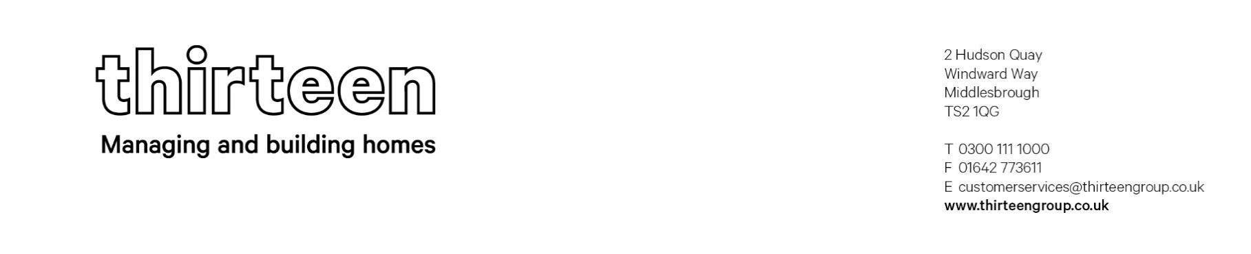

FORM OF TENDER

To: Thirteen Housing Group Ltd
2 Hudson Quay
Windward Way
Middlesbrough
TS2 1QG

For the Attention of: Procurement
Date:
Dear Sir/Madam,
Having carefully examined the Tender documents detailed therein; we confirm that we have fully satisfied ourselves as to the nature of the requirements of Thirteen Housing Group Ltd.

We hereby offer to supply the goods, services/related works in accordance with the Invitation to tender and all associated documents supplied through the procurement portal, which include but is not limited to the following below:

- Questionnaires
- Specification / Project Brief
- Form of Tender
- Certificate of non-collusion and non-canvassing
- Any terms and conditions stipulated within the brief
- Declaration
- Social Value response via Impact

In the event that our Tender is accepted we undertake to execute a formal contract with Thirteen Housing Group Ltd embodying all of the terms and conditions of this offer.

We agree to abide by our Tender for a period of 90 days (unless stated otherwise in the Project Brief) fixed from the submission date, and it shall be binding upon us at any time before expiration of that period.

We understand that Thirteen Housing Group Ltd is not bound to accept the lowest or any tender received. We also understand that any costs incurred in the preparation of our response are for our own account.

We confirm that the person whose signature is below that they are a duly authorised signatory of our company and they have full and formal legal authority to sign this document on behalf of our company.

Signed by

Name(s)

Position

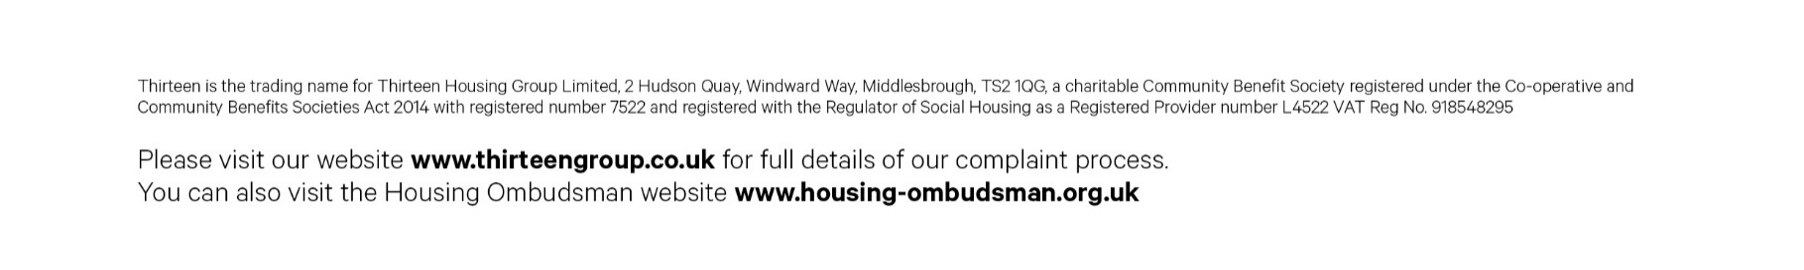
for and on behalf of [Tenderer]

