ROSSENDALE BOROUGH COUNCIL

Capital Works Contract No. 14
Various Sites within
Rossendale

SPECIFICATION of WORKS

Spring and Company Limited
213 Chestergate
Stockport
Sk3 0AN

JK0100 April 2020
SPECIFICATION
FOR

works at VARIOUS SITES IN ROSSENDALE

Capital works contract no. 14

CONTENTS

PART 1. CONTRACT DETAILS AND PRELIMINARIES

PART 2 . STANDARD CONDITIONS OF CONTRACT

PART 3 . SCHEDULE OF WORKS

PART 4. FORM OF TENDER

PART 5. CERTIFICATE OF NON-COLLUSION AND NON CONVASSING

APPENDIX NO. I REPORT AND SITE PLAN AND PICTURES ROCK VIEW CULVER HEAD

ROSSENDALE BOROUGH COUNCIL

PART 1

PROJECT AND CONTRACT DETAILS AND PRELIMINARIES

CAPITAL WORKS CONTRACT NO. 14

April 2020

A10 PROJECT PARTICULARS

110 THE PROJECT:
Name: Capital Works Contract No. 14

Nature:

120 EMPLOYER (CLIENT):
Rossendale Borough Council
Property & Facilities Management
The Business Centre
Futures Park
OL13 0BB
Tel: 01706 252527

123 EMPLOYER’S AGENT:
Spring & Co
213 Chestergate
Stockport
Cheshire
SK3 0AN
Tel : 0161 476 4456

130 PRINCIPAL CONTRACTOR: T.B.C.

140 ARCHITECT:

N/A

160 CDMC: Spring PCC to be ‘Principal Designer’ for purposes of Health and Safety regulations.

160 CONSULTING ENGINEER: N/A

170 MECHANICAL & ELECTRICAL DESIGN: N/A

197 BUILDING REGULATIONS SUBMISSION:
The submission for approval and associated fees will be the responsibility of the Contractor.

210 DESIGN REGULATIONS:
The works must be designed and executed strictly in accordance with all Local authority Regulations, Statutory Obligations, Regional Water Authority’s requirements, Fire Officer’s requirements and recommendations and the like.

The works must be designed and executed in accordance with the requirements of the current British Standards, Codes of Practice and good building practice.

A12 THE SITE

- POSSESSION OF SITE
The sites will be handed to the Contractor on commencement of the works.

140 EXISTING MAINS/SERVICES:
Prior to construction, ascertain and locate all services which are in the vicinity of the works or which are likely to be affected in any way by the execution of the works. Include for all associated works required including the diversion of existing services as is required, the provision of temporary works, temporary installations and the like to enable uninterrupted use of services.

Any damage to existing services or live drains or water courses is to be made good and in the event of any services being found in the way of the new work, the Contractor must make arrangements for and include all costs for them to be lowered, diverted or removed.

171 SITE CONDITIONS: The contractor is deemed to understand fully the precise nature of the site. No claim in respect of lack of knowledge in this regard will be considered.

195 ACCESS TO THE SITE:
The access to the site for construction traffic will agreed as required with the Employers Agent.

The Contractor must allow for keeping all surrounding roads and pavings including site accesses clean and tidy and provide for wheel wash facilities, where appropriate.

210 PARKING of the Contractors and employees' vehicles: to be off-site parking and agreed with the client for each site.

220 Do not use the site for any purpose other than carrying out the Works. The Employer reserves to himself the sole right to advertise on the Site. The Contractor shall not display or permit to be displayed advertisements on the Site without the written permission of the Employer.

230 SURROUNDING LAND/BUILDING USES:
The Contractor’s tender will be deemed to have allowed for fully complying with any reasonable request from existing and adjoining owners with regard to nuisance caused by noise, dust, etc.; and for complying with all legal restrictions placed upon him by all authorised bodies.

A13 DESCRIPTION OF THE WORKS

120 THE WORKS
- As described in section A10.

130 ACCESS FOR EMPLOYER:
The Employer and his authorised representatives shall have access to the site at all times during the execution of the Works.

190 SCHEDULE OF CONDITION:
A Schedule of Condition including a fully comprehensive photographic record or video survey relating to the adjacent features, adjacent ownerships, roads, pavements and the like which might be affected by the Works are to be prepared by the Contractor prior to taking possession of the Site and agreed with the EA and Local Authority as is appropriate.

On completion of the works any damage to the roads, pavements, etc. caused by the execution of the works shall be made good by the Contractor at his own expense to the satisfaction of the EA and relevant authorities as appropriate.

A30 TENDERING/SUBLETTING/SUPPLY

610 FEES AND CHARGES
The Contractor will be responsible for the payment of all public utility (e.g. electricity, gas, water and telecom.) charges together with any fuel charges up to practical completion, including those required for commissioning and testing of Contractor’s and Employer’s plant, equipment of installations.

A31 PROVISION, CONTENT AND USE OF DOCUMENTS

DOCUMENTS PROVIDED ON BEHALF OF EMPLOYER

470 DIVERGENCE FROM THE STATUTORY REQUIREMENTS
- Divergence: Between the drawings or specification and the requirements of the Building Regulations, other Statutes, statutory undertakers and other regulatory authorities.
- Action: Inform immediately.

DOCUMENTS PROVIDED BY CONTRACTOR/ SUBCONTRACTORS/ SUPPLIERS

620 AS BUILT DRAWINGS AND INFORMATION
- General: Provide the following Drawings/ information:
- Described elsewhere
- Submit: no later than 14 days after date of Practical Completion.

640 MAINTENANCE INSTRUCTION AND GUARANTEES
- Components and equipment: Obtain or retain copies, register with manufacturer and hand over on or before completion of the Works. Provide written evidence that component guarantees have been registered with manufacturers.

A32 MANAGEMENT OF THE WORKS

GENERALLY

110 SUPERVISION
- General: Accept responsibility for coordination, supervision and administration of the Works, including subcontracts.
- Coordination: Arrange and monitor a programme with each subcontractor, supplier, local authority and statutory undertaker, and obtain and supply information as necessary for coordination of the work.

115 LIAISON WITH ADJOINING OWNERS:
The Contractor shall liaise with all adjoining owners and tenants that may be affected by the works as necessary, to make them aware of the duration and progress of works affecting their buildings and rectify justified complaints, to attend meetings as required and to collaborate with the EA in this respect.

120 INSURANCE
- Documentary evidence: Before starting work on site submit details, and/ or policies and receipts for the insurances required by the Conditions of Contract.

130 INSURANCE CLAIMS
- Notice: If any event occurs which may give rise to any claim or proceeding in respect of loss or damage to the Works or injury or damage to persons or property arising out of the Works, immediately give notice to the Employer, the person named in clause A10/140, A10/123 and the Insurers.
- Failure to notify: Indemnify the Employer against any loss, which may be caused by failure to give such notice.

140 CLIMATIC CONDITIONS
- Information: Record accurately and retain:
- Daily maximum and minimum air temperatures (including overnight).
- Delays due to adverse weather, including description of the weather, types of work affected and number of hours lost.

150 OWNERSHIP
- Alteration/ clearance work: Materials arising become the property of the Contractor except where otherwise stated. Remove from site as work proceeds.

PROGRAMME/ PROGRESS

210 PROGRAMME
- Master programme: When requested and before starting work on site, submit in an approved form a master programme for the Works, which must include details of:
- Design, production information and proposals provided by the Contractor/ Subcontractors/ Suppliers, including inspection and checking.
- Planning and mobilization by the Contractor.
- Earliest and latest start and finish dates for each activity and identification of all critical activities.
- Running in, adjustment, commissioning and testing of all engineering services and installations
- Work resulting from instructions issued in regard to the expenditure of provisional sums

- Work by or on behalf of the Employer and concurrent with the Contract. The nature and scope of which, the relationship with preceding and following work and any relevant limitations are suitably defined in the Contract Documents.

- Exclusions: Where and to the extent that the programme implications for work which is not so defined are impossible to assess, the Contractor should exclude it and confirm this when submitting the programme.

230 SUBMISSION OF PROGRAMME
- Further information: Submission of the programme will not relieve the Contractor of the responsibility to advice of the need for further drawings or details or instructions in accordance with the Contract.

240 COMMENCEMENT OF WORK
- Notice: Before the proposed date for commencement of work on site give minimum notice of 10 working days.

250 MONITORING
- Progress: Record on a copy of the programme kept on site.
- Avoiding delays: If any circumstances arise which may affect the progress of the Works submit proposals or take other action as appropriate to minimize any delay and to recover any lost time.

255 NOTIFICATION OF COMPENSATION EVENT
- Content: Notwithstanding the Contractor's obligations under the Contract written notice must also be given of all other causes which apply concurrently.

260 SITE MEETINGS
- General: Site meetings will be held to review progress and other matters arising from administration of the Contract.
- Frequency: As agreed at pre-contract meeting
- Location: On Site.
- Accommodation: Ensure availability of accommodation for 10people (minimum) at the time of such meetings if required.
- Attendees: Attend meetings and inform subcontractors and suppliers when their presence is required.
- Chairperson (who will also take and distribute minutes): EA.

264 CONTRACTOR'S PROGRESS REPORT: Submit a progress report to the EA and Employer at the site meeting. Provide paper copies at the meeting. Notwithstanding the Contractor's obligations under the Contract the report must include:
- A progress statement confirming the contract completion date will be met (or not as appropriate)
- An updated the master programme indicating the present progress.
- A revised target programme to mitigate delays (as appropriate)
- ‘Labour on site’ records
- Proposed sub-contractors ‘for approval’ including evidence of PII etc.
- Details of any matters materially affecting or likely to affect the regular progress of the Works.
- Any requirements for comments on drawings or details or instructions to enable the EA to fulfil his obligations under the Conditions of Contract
- Any information required from the Employer and the latest date for its issue
- A health and safety report
- A report on conditions outstanding for the approval of building control
- A report on the approval of the design and construction of the highway works

- The status of collateral warranties to be provided by consultants and sub-contractors as required by the EA.
- A written (but brief) monthly report from the Architect and Engineer covering the design progress, quality matters raised by site inspections and the like.
- The current drawing list for all drawings.

270 CONTRACTOR'S SITE MEETINGS
- General: Hold meetings with appropriate subcontractors and suppliers shortly before main site meetings to facilitate accurate reporting of progress.

282 VISITORS BOOK:
- A Visitors Book shall be kept on site and should be signed by all visitors.

300 ADVERSE WEATHER:
Use all reasonable and suitable building aids and methods to prevent or minimise delays during adverse weather conditions.

CONTROL OF COST

430 PROPOSED INSTRUCTIONS
- Estimates: If a proposed instruction requires an estimate of cost, submit without delay and in any case within seven days.
- Include:
- A detailed breakdown of the cost, including any allowance for direct loss and expense.
- Details of any additional resources required.
- Details of any adjustments to be made to the programme for the Works.
- Any other information as is reasonably necessary to fully assess the implications of issuing such an instruction.
- Inability to comply: Inform immediately if it is not possible to comply with any of the above requirements.

440 MEASUREMENT
- Covered work: Give notice before covering work required to be measured.

462 INTERIM PAYMENTS: At least two days before the date arranged for each valuation submit to the Employer’s Agent (in the required detail and format in paper and in an electronic form) details of amounts due under the Contract together with all necessary supporting information (e.g. invoices to support applications for materials on site).

472 UNFIXED MATERIALS: At the time of each valuation disclose to the CA which of the unfixed materials and goods on site are free from, and which are subject to, any reservation of title inconsistent with passing of property as required by the Conditions of Contract, together with their respective values. When requested provide evidence of freedom from reservation of title.
A33 QUALITY STANDARDS/ CONTROL

STANDARDS OF PRODUCTS AND EXECUTIONS

SAMPLES/ APPROVALS

210 SAMPLES
- Products or executions: Comply with all other specification requirements and in respect of the stated or implied characteristics either:
- To an express approval.
- To match a sample expressly approved as a standard for the purpose.

220 APPROVAL OF PRODUCTS
- Submissions, samples, inspections and tests: Undertake or arrange to suit the Works programme.
- Approval: Relates to a sample of the product and not to the product as used in the Works. Do not confirm orders or use the product until approval of the sample has been obtained.
- Complying sample: Retain in good, clean condition on site. Remove when no longer required.

- REQUIRED SAMPLES: provide prior to construction samples of all materials for approval by the EA and the Employer.

SERVICES GENERALLY

410 SERVICES REGULATIONS: Any work carried out to or which affects new or existing services must be in accordance with the Bye Laws or Regulations of the relevant Statutory Authority.

420 SERVICE RUNS: Allow sufficient time for all legal approvals and permissions. Make adequate provision for services, including unobstructed routes and fixings. Wherever possible ducts, chases and holes are to be formed during construction rather than cut.

440 MECHANICAL AND ELECTRICAL SERVICES must have final tests and commissioning carried out with the evidence of all paperwork so that they have been properly demonstrated and are in full working order to achieve Practical Completion.

SUPERVISION/ INSPECTION/ DEFECTIVE WORK

510 SUPERVISION
- General: In addition to the constant management and supervision of the Works provided by the Contractor's person in charge, all significant types of work must be under the close control of competent trade supervisors to ensure maintenance of satisfactory quality and progress.
- Replacement: Give maximum possible notice before changing person in charge or site agent.

530 OVERTIME WORKING
- Notice: Prior to overtime being worked, submit details of times, types and locations of work to be done.
- Minimum period of notice: two working days
- Concealed work: If executed during overtime for which notice has not been given, it may be required to be opened up for inspection and reinstated at the Contractor's expense.

555 ACCESS FOR INSPECTION: Give EA not less than 5 working days notice before removing scaffolding or other facilities for access. Provide safe access by scaffold, cherry picker or the like at various times to enable inspections by the EA, Architect and Employer to take place during the works, prior to Practical Completion and at the end of the Defects Period.

560 TIMING OF TESTS AND INSPECTIONS: Agree dates and times of tests and inspections with EA 5 working days in advance, to enable the EA and other affected parties to be present. On the previous working day to each such test or inspection confirm that the work or sample in question will be ready or, if not ready, agree a new date and time. The advance notice to the EA for any PC Inspection and any Making Good Defects Inspection, shall be 10 working days.

- CCTV DRAIN SURVEYS: The contractor is to undertake CCTV drainage surveys in respect of all drains located within or at the perimeter of the site that may be affected by the works.

A survey is to be carried out no later than 4 weeks prior to Practical Completion to establish whether any remedial works are required which shall be rectified at the Contractor’s own expense. The visual record and written report shall be presented to the EA and the Engineer no later than 2 weeks before Practical Completion.

Obtain the Engineer’s approval to the proposed remedial measures. Re-survey after the remedial works are undertaken.

610 PROPOSALS FOR RECTIFICATION OF DEFECTIVE PRODUCTS/ EXECUTIONS
- Proposals: Immediately any execution or product is known, or appears, to be not in accordance with the Contract, submit proposals for opening up, inspection, testing, making good, adjustment of the Contract Sum, or removal and re-execution.
- Acceptability: Such proposals may be unacceptable and contrary instructions may be issued.

620 MEASURES TO ESTABLISH ACCEPTABILITY
- General: Wherever inspection or testing shows that the work, materials or goods are not in accordance with the contract and measures (e.g. testing, opening up, experimental making good) are taken to help in establishing whether or not the work is acceptable, such measures:
- Will be at the expense of the Contractor.
- Will not be considered as grounds for extension of time.

630 QUALITY CONTROL
- Procedures: Establish and maintain to ensure that the Works, including the work of subcontractors, comply with specified requirements.
- Records: Maintain full records, keep copies on site for inspection, and submit copies on request.
- Content of records:
- Identification of the element, item, batch or lot including location in the Works.
- Nature and dates of inspections, tests and approvals.
- Nature and extent of nonconforming work found.
- Details of corrective action.

WORK AT OR AFTER COMPLETION

710 WORK BEFORE COMPLETION
- General: Make good all damage consequent upon the Works.
- Temporary markings, coverings and protective wrappings: Remove unless otherwise instructed.
- Cleaning: Clean the Works thoroughly inside and out, including all accessible ducts and voids. Remove all splashes, deposits, efflorescence, rubbish and surplus materials.
- Cleaning materials and methods: As recommended by manufacturers of products being cleaned, and must not damage or disfigure other materials or construction.
- COSHH dated data sheets: Obtain for all materials used for cleaning and ensure they are used only as recommended by their manufacturers.
- Minor faults: Touch up in newly painted work, carefully matching colour and brushing out edges. Repaint badly marked areas back to suitable breaks or junctions.
- Moving parts of new work: Adjust, ease and lubricate as necessary to ensure easy and efficient operation, including doors, windows, drawers, ironmongery, appliances, valves and controls.

715 SNAGGING OPERATIONS PRIOR TO PRACTICAL COMPLETION: the contractor is required to undertake his own snagging inspections and remedial works prior to a formal inspection by the EA and Employer. The latter EA inspection will only take place when the works are substantially complete. The contractor must have a senior member of staff present throughout when this inspection(s) take(s) place.

720 SECURITY AT COMPLETION
- General: Leave the Works secure with, where appropriate, all accesses closed and locked.
- Keys: Account for and adequately label all keys and hand over to Employer with itemized schedule, retaining duplicate schedule signed by Employer as a receipt.

730 MAKING GOOD DEFECTS
- Remedial work: Arrange access with the Employer’s Agent (10 working days in advance)
- Rectification: Give reasonable notice for access to the various parts of the Works.
- Completion: Notify when remedial works have been completed.

750 MAKING GOOD DEFECTS: Make arrangements with the EA and give reasonable notice of the precise dates for access to the Works for purposes of making good defects. Inform EA when remedial works to the various parts of the Works are completed.
The repairs fall into the following categories:-

1. Emergency Repairs - items of repair to be executed within 48 hours.

2. Urgent repairs - items of repair to be executed within 7 days.

3. Non Emergency Repairs - items of repair to be undertaken within 14 days.

A notice of defect will be issued which will specify the defect classification time limit.

If any of the remedial works required are not carried out within this stipulated period they may at the discretion of the Employer’s Agent be carried out by others and the costs deducted from any monies including retention monies which may be outstanding or recovered as a debt from the Contractor. Allow for undertaking the defects in a time and sequence in order not to interfere with or disrupt the tenant’s operations and this will inevitably mean working out of ‘normal hours’.

A34 SECURITY/ SAFETY/ PROTECTION

SECURITY, HEALTH AND SAFETY

PLEASE NOTE THAT THE TIMING OF THIS PROJECT WILL REQUIRE THE IMPLEMENTATION OF HEALTH AND SAFETY PROCEDURES IN ACCORDANCE WITH THE CONSTRUCCTION (DESIGN AND MANAGEMENT) REGULATIONS 2105)

121 THE CONSTRUCTION PHASE HEALTH AND SAFETY PLAN, developed from the Pre-tender Health and Safety Plan, a plan must be submitted to the CDMC not less than 2 weeks before the proposed date for start of construction work. Do not start construction work until the Employer has confirmed in writing that in his view the Construction Phase Health and Safety Plan includes the procedures and arrangements required by CDM Regulation 15(4).
The plan must include:
- Detailed proposals for managing health and safety during the construction phase together with site rules and emergency procedures.
- Method statements related to the hazards identified in the pre-tender health and safety plan and/or statements on how the hazards will be addressed and other significant hazards identified by the contractor.

125 HSE APPROVED CODES OF PRACTICE: Comply with the following:
- Management of health and safety at work.
- Managing construction for health and safety.

150 SECURITY
- Protection: Safeguard the site, the Works, products, materials, and any existing buildings affected by the Works from damage and theft.
- Access: Take all reasonable precautions to prevent unauthorized access to the site, the Works and adjoining property.
- Special requirements: form bunds to prevent unauthorised vehicle access to the site and the adjoining land.

160 STABILITY
- Responsibility: Maintain the stability and structural integrity of the Works during the Contract.
- Design loads: Obtain details, support as necessary and prevent overloading.

210 EMPLOYER'S REPRESENTATIVES SITE VISITS
- Safety: Submit details in advance, to the Employer or the person identified in A10, of safety provisions and procedures (including those relating to materials, which may be deleterious), which will require their compliance when visiting the site.
- Protective clothing and/ or equipment: Provide and maintain on site for the Employer and other visitors to the site.

PROTECT AGAINST THE FOLLOWING

340 POLLUTION
- Prevention: Protect the site, the Works and the New Landscape Area and new fencing, general environment including streams and waterways against pollution.
- Contamination: If pollution occurs inform immediately, including to the appropriate Authorities and provide relevant information.

360 NUISANCE
- Duty: Prevent nuisance from smoke, dust, rubbish, vermin and other causes.
- Surface water: Prevent hazardous build-up on site, in excavations and to surrounding areas and roads.

390 SMOKING ON SITE
- Smoking on site: Not permitted.

400 BURNING ON SITE
- Burning on site: strictly not permitted.

410 MOISTURE
- Wetness or dampness: Prevent, where this may cause damage to the Works.
- Drying out: Control humidity and the application of heat to prevent:
- Blistering and failure of adhesion.
- Damage due to trapped moisture.
- Excessive movement.

430 WASTE
- Includes: Rubbish, debris, spoil, containers and surplus material.
- Minimize: Keep the site and Works clean and tidy.
- Remove: Frequently and dispose off site in a safe and competent manner:
- Non-hazardous material: In a manner approved by the Waste Regulation Authority.
- Hazardous material: As directed by the Waste Regulation Authority and in accordance with relevant regulations.
- Voids and cavities in the construction: Remove rubbish, dirt and residues before closing in.
- Waste transfer documentation: Retain on site.

PROTECT THE FOLLOWING

410 NEW WORKS: Adequately protect all types of work throughout the Contract. Wherever work is of an especially vulnerable nature or is exposed to abnormal risks provide special protection to ensure that damage does not occur e.g. protect the floor slab of the building, the face of brickwork and blockwork from other operations, provide temporary rainwater pipes, protect the finished bitmac from mortar or concrete spills, protect the external concrete hardstandings until curing.

510 EXISTING SERVICES
- Confirmation: Notify all service authorities, statutory undertakers and/ or adjacent owners of proposed works not less than one week before commencing site operations.
- Identification: Before starting work, check and mark positions of mains/ services. Where positions are not shown on drawings obtain relevant details from service authorities, statutory undertakers or other owners.
- Work adjacent to services:
- Comply with service authority's/ statutory undertaker's recommendations.
- Adequately protect, and prevent damage to services: Do not interfere with their operation without consent of service authorities/ statutory undertakers or other owners.
- Identifying services:
- Below ground: Use signboards, giving type and depth;
- Overhead: Use headroom markers.
- Damage to services: If any results from execution of the Works:
- Immediately give notice and notify appropriate service authority/ statutory undertaker.
- Make arrangements for the work to be made good without delay to the satisfaction of service authority/ statutory undertaker or other owner as appropriate.
- Any measures taken to deal with an emergency will not affect the extent of the Contractor's liability.
- Marker tapes or protective covers: Replace, if disturbed during site operations, to service authority's/ statutory undertaker's recommendations.

520 ROADS AND FOOTPATHS
- Duty: Maintain roads and footpaths within and adjacent to the site and keep clear of mud and debris.
- Damage caused by site traffic or otherwise consequent upon the Works: Make good to the satisfaction of the Employer, Local Authority or other owner.

560 EXISTING FEATURES
- Protection: Prevent damage to existing buildings, fences, gates, walls, roads, paved areas and other site features, which are to remain in position during execution of the Works.

481 ADJOINING PROPERTY: Prevent trespass of workpeople. Take all reasonable precautions to prevent damage to adjoining property. Obtain permission as necessary from the owners if requiring to erect scaffolding on or otherwise use adjoining property, and pay all charges. Remove and make good on completion or when directed. Bear the cost of repairing any damage arising from execution of the Works.

483 ADJOINING PROPERTY: prior to carrying out the works undertake due consideration of the position, proximity, structures and levels of existing land and property and reflect this in the design of the new works. As appropriate submit proposals to the EA / employer for approval.

A35 SPECIFIC LIMITATIONS ON METHOD/ SEQUENCE/ TIMING

190 WORKING HOURS
- Normal working hours shall be deemed to be as follows:-
a) Weekdays 8.00am to 6.00pm
b) Weekends on request.
c) Note all workings in the office at Henrietta St must be undertaken after the office is closed , so either at night during the week or at weekends .

The site is available for work 7 days per week and outside normal working hours for the contractor to complete the works in the required time period.

The premium cost of any works required to be undertaken out of normal working hours will be the responsibility of the Contractor.

A36 FACILITIES/ TEMPORARY WORK/ SERVICES

GENERALLY

110 SPOIL HEAPS, TEMPORARY WORKS AND SERVICES
- Location: Give notice of intended siting.
- Maintenance: Alter, adapt and move as necessary. Remove when no longer required and make good.

ACCOMMODATION

330 TEMPORARY HOARDING(S) & SCREEN(S)
Provide, maintain, adapt and move as required to suit the progress of the Works all necessary temporary fencing to the perimeter of the site.

The contractor may use ‘heras’ type fencing to an alternative to a fixed timber hoarding.

TEMPORARY WORKS

363 CONTRACTOR’S SIGN BOARD:
The Contractor shall provide a temporary ‘name board’ to an approved location incorporating the Contractor and sub-contractor’s names and allowing space for sign boards provided by all the Consultants. The size, nature and content of the nameboard shall be agreed with the EA. The Contractor shall obtain the necessary planning permission and pay all fees.

SERVICES AND FACILITIES

410 LIGHTING & POWER
- Finishing work and inspection: Provide temporary lighting, the intensity and direction of which closely resembles that delivered by the permanent installation.

440 TELEPHONES
- Temporary on site telephone: Provide as soon as practicable after the Date of Possession for joint use by the Contractor and Subcontractors and pay all charges.
- Responses: Make arrangements to ensure that incoming calls are answered promptly.

440 MOBILE TELEPHONES
- Direct communication: As soon as practicable after the Date of Possession provide the Contractor's person in charge with a mobile telephone.

460 FAX INSTALLATION
- General: As soon as practicable after the Date of Possession provide a suitable on site fax installation, with a separate dedicated telephone line, for use by the Contractor, Subcontractors and those acting on behalf of the Employer.
- Employer's call charges: Allow for the cost of a reasonable number of transmissions made by those acting on behalf of the Employer.
465 THERMOMETERS
- General: Provide on site and maintain in accurate condition a maximum and minimum thermometer for measuring atmospheric shade temperature, in an approved location.

490 BENEFICIAL USE OF INSTALLED SYSTEMS: Unless specific permission is given by the Employer and installer, the permanent supply, disposal, mechanical, electrical, communications, transport and access systems may not be used for any purpose other than running, in, testing and commissioning. Where permission is given for any other use of a system before practical completion of the works it must be subject to a separate written agreement between the parties and in accordance with the recommended procedures given in NJCC Guidance Note 10.

541 FACILITIES FOR INSPECTIONS OF THE WORKS: provide safe access to the roof for inspections during the works, prior to practical completion, at practical completion, inspection at the end of the defects liability period and for sign off of the Making Good of Defects. Provide an appropriate level of lighting to inspect internal works during construction, prior to P.C. and at P.C.
A37 OPERATION/ MAINTENANCE OF THE FINISHED BUILDING

GENERALLY

105 O & M MANUALS / HEALTH AND SAFETY FILE / AS-BUILT DRAWINGS:
Provide two paper copies each for the tenant and Purchaser. The Employer will be entitled to retain the sum of £1,000 due to the Contractor, in addition to the retention, should these documents not be ready at Practical Completion, until the final approved and complete versions are issued.

220 TRAINING OF BUILDING MANAGEMENT STAFF: By prior arrangement, explain and demonstrate the purpose, function and operation of the various installations including all items and procedures listed in the Building Manual. This may require a presentation after Practical Completion. Set heating on frost protection as required by the time of year and set the appropriate timing of the external lighting. Highlight the need for the various maintenance agreements.

ROSSENDALE BOROUGH COUNCIL

PART 2

CAPITAL WORKS CONTRACT NO. 14

STANDARD CONDITIONS OF THE CONTRACT

1 LOCATION OF THE WORKS

The works are required to be carried out on the various properties as noted on the title page.

2 DATE FOR COMMENCEMENT

The date for commencement of the works by the Contractor shall be agreed in writing. Commencement shall not usually be more than one month after acceptance of the tender by the Employer except where mutually agreed otherwise in writing by both parties , the overall contract must be completed by the agreed date at the time the contract is awarded.

3 REMOVAL OF RUBBISH, MATERIALS, ETC

The Contractor is to allow for removing all rubbish, surplus materials, etc. as the work proceeds.

4 PROTECTION OF PLANT

The Contractor is to ensure that all items of plant, tools, and any materials stored on site are to be securely protected and rendered safe from children.

5 DEFINITION OF PERSONS

The term "Employer" used throughout shall be deemed to mean Rossendale Borough Council.

The term "Surveyor" shall mean Spring and Company Limited

The term "Contractor" shall be deemed to mean the firm or company whose tender is accepted by the Employer.

6 TENDERS

The Contractor is to submit a tender for the works on a fixed price basis open for acceptance without alteration for a period of not exceeding 90 days. Each page of the specification must be initialed by the Contractor and returned by the tender date.

7 ACCEPTANCE OF TENDERS

The Employers do not bind themselves to accept the lowest or any tender and the contract will not be entered upon until the scheme has been approved.

8 CONDITIONS OF CONTRACT

The form of contract shall be the latest edition of the J.C.T. Form of Agreement of Minor Building Works 2011 and will include the amendments and choices between alternatives as set out below.

CLAUSE NO

2.1 Contractors obligation
2.2 Commencement and completion. The commencement date is to be inserted when the contract is let. The completion date shall be (to be agreed) days after the agreed commencement date.
2.3 Architect (surveyor) supervising officer's duties.
2.7 Extension of contract period
2.8 Damages for non-completion. The liquidated damages for non-completion to be inserted in the clause will be £500.00 per week.
2.10 Defects Liability - delete "three months" and insert "twelve months for the building works and twelve months for the mechanical and electrical plant"
3.1 Assignment
3.3 Sub-contracting
3.4 Architects (surveyors)/supervising officer's instructions
3.6 Variations
3.7 Provisional Sums
3.8 Exclusion from the works
4.1 VAT
4.2 Construction Industry Scheme (CIS)
4.4 Progress payments and retention
4.8 Final Certificate
4.11 Contribution levy and tax charges.
5.1 Liability of the Contractor, personal injury or death insurance.
5.2 Liability of the Contractor, injury or damage to property.
5.4 Insurance of the works
5.5 Evidence of Insurance
7.1 Settlement of Disputes – mediation.

When the contract is let, two copies of the above Agreement will be prepared which the Employer and the Contractor will sign and retain one each.

9 EQUAL OPPORTUNITIES

Rossendale Borough Council operates an Equal Opportunities policy, and expects everyone that it does business with to encourage equality of opportunity themselves.

Specifically, all contractors are required to observe the provisions of the:

* Race Relations Act
* Sex Discrimination Act 1975
* Equal Pay Act 1970 (as amended in 1983 and 1986
* Disabled Persons (Employment) Acts 1944 and 1958

and the provisions of the relevant Codes of Practice where possible.

In hiring sub-contractors and other agencies to work for it, the contractor should ensure that they meet the same standards with regard to ensuring Equality of Opportunity.

Where instances of discrimination, harassment or victimisation are alleged by employees, volunteers or users of the Council’s services, against the Contractor, its staff or sub-contractors, the Council will investigate rigorously to establish if there has been a breach of our Equal Opportunities Policy. As an example, racist and sexist remarks constitute harassment.

A breach of any of the above provisions may lead to the termination of a contract, and/or the severing of all links between the Council and the Contractor.

The contractor is required to disclose if at any time they are being investigated by CRE or EOC or if action is being taken against them with regards to Equal Opportunities.

10 SCAFFOLDING AND LADDERS

Where appropriate, the work will be carried out from scaffolding and ladders erected in accordance with all relevant Health and Safety legislation. The contractor must allow for the price of all scaffolding within the contract sum

At the end of each working day, the Contractor shall render any scaffolding as inaccessible to unauthorised personnel as is reasonably practicable. Ladders are to be removed to a separate place of store, or, if left standing, must be lined front and back with boards securely tied on and padlocked.

11 PEDESTRIAN ACCESS

12 DEBRIS

All debris and waste materials are to be removed from the site by skip or other means and shall not be allowed to accumulate. Removal must be completed each day from the site. It is the Contractors responsibility to ensure that any statutory permission for removing debris is obtained.

No access for any works is to be allowed through the main entrance.

13 ACCOMMODATION

The Contractor will be required to provide and erect suitable facilities for the storage of materials and for the protection or workmen in positions to be agreed with the Surveyor, and to clear same away on completion and make good all damage caused.

14 GARDENS AND PAVING

The Contractor will be responsible for all damage caused in the execution of the works to the existing facility etc. and any damage is to be made good to the approval of the surveyor at the Contractor's expense.

15 WATCHING AND LIGHTING

Where required, the Contractor shall provide proper and sufficient lighting and watching to guard the works during their progress as necessary.

16 WEATHER PENETRATION

The Contractor must take adequate steps to prevent damage to the property being caused by weather penetration as a result of the works. The Contractor will be held responsible for any damage to the property resulting from failure to comply with this clause.

17 CONTINUITY OF WORK

Once the work has commenced, it must be completed without interruption except with the permission of the Surveyor. The Contractor must not begin work on a property unless all labour and materials are available to complete it.

18 COMPLIANCE WITH REGULATIONS

All work carried out must comply in every respect with the current Building Regulations and must be carried out in accordance with EEC Construction Regulations.

19 WORKING IN OCCUPIED PREMISES

The Contractor is to make adequate allowance in his/her tender for executing the work around occupied premises and for making all arrangements necessary to carry out and complete the works with a minimum of inconvenience to occupants. The Contractor shall give at least five clear days notice in writing to each occupier and the surveyor of his/her intention to commence work in any such property.

Any noisy work is to be undertaken outside of core working times and suitable allowance is deemed to be included in the tender price to cover this.

20 WORKING HOURS

Normal working hours are to be 8.00 am to 6.00 pm or such other times as agreed with the Surveyor who will liaise with the occupants of the premises as necessary.

21 SUPERVISION

The Contractor shall give all necessary and proper superintendence during the execution of the works and shall constantly employ thereon a competent foreman and such foreman shall on behalf of the contractor carry out all such instructions as may be given by the Surveyor. The contractor shall in addition nominate a safety officer who may be the foreman as instructed above. This individual will be responsible for implementation of the requirements of the ECC Construction Regulations and will be responsible for monitoring the application of the Contractors health and safety policy.

22 NOISE AND DISTURBANCE

The Contractor is to take all reasonable steps to ensure that no undue noise or disturbance is caused to occupiers, neighbours or members of the public.

23 CONTINGENCY SUM

Where indicated in the Specification and tender, the Contractor is to include in his tender price the sum as shown in respect of contingencies. This sum is to be used as directed by the Surveyor and will be deducted in whole or part if not so used.

24 ELECTRICITY SUPPLY

The Contractor is to allow for making his own arrangements for providing/using electricity for the works unless alternative arrangements have been previously agreed.

25 VISITING OF THE PROPERTY FOR TENDER PURPOSES

The Contractor is advised to visit the property/site prior to tendering to obtain any necessary quantities/conditions relative to the proposed contract as no claims will be entertained for additional monies as a result of failure to allow for inaccurate quantities or conditions.

26 FITTINGS ETC

The Contractor is to take all due care and attention when working around or removing furniture, carpets, fixtures or other fittings. The Contractor will be held responsible for any claims for damage arising from the work. All debris is to be cleared away as it occurs and the property is to be left in a clean and tidy condition at the end of each working day.

27 MANUFACTURER'S GUARANTEES

None of the conditions contained in Part A of the contract shall invalidate any manufacturer's guarantees.

28 PREVENTION OF POLLUTION

The Contractor will have regard to the Control of Substances Hazardous to Health Regulations 1988 (1988 No. 1657) in relation to risk assessments (Reg 6) and to the prevention and control of exposure to substances hazardous to health (Regs 7 to 10) and to health surveillance and information/training of staff (Regs 11 and 12). The cost of rendering harmless or removing any offensive discharge or deposit caused by the Contractor or his/her workpeople will be borne by the Contractor.

The Contractor will have regard to his/her responsibilities for Waste Management Duty of Care as producers of controlled waste and as carriers of controlled waste under the provisions of the Control of Pollution (Amendment) Act 1989 and Sections 33 and 34 of the Environmental Protection Act 1990. Contractors undertaking work for the Society will be obliged to demonstrate proof of registration under the Act by showing their Certificate of Registration or an authorised copy thereof to the surveyor in charge.

The Contractor's attention is drawn to precautions to be taken when working with asbestos as referred to in guidance note EH40 "Work with Asbestos" published by the Health and Safety Executive. The Contractor is to instruct all workers involved in the methods of work with asbestos and the precautions to be taken to prevent or minimise dust generation.

PART 2 continued - SPECIAL CONDITIONS OF CONTRACT

1 CONTINUITY OF SERVICES

The Contractor must allow, where applicable, for any temporary measures which may be necessary to ensure that the occupier is not at any time without proper utilities. This requirement includes the provision where necessary of temporary apparatus and appropriate fuel supply.

2 ADDITIONS AND DEDUCTIONS

Rossendale Borough Council reserves the right to vary the quantity of work to be carried out under the contract should circumstance arise which make such variations necessary.

3 VARIATIONS

The Contractor shall insert in the Schedule of Rates the rates he/she has used in preparing his/her tender and such rates will be used to price any variation. All variations together with the cost implications will be summarised for the surveyor on a weekly basis. Failure to meet this condition may result in the withholding of payment for claims for extra work.

4 INSTRUCTIONS TO USERS

On completion of work, the Contractor shall instruct the occupier on the proper use of all appliances fitted all as per manufacturer's recommendations.

5 PIPE/CABLE RUNS

All new or amended pipe/cable runs shall be approved before work is put in hand. Where possible existing notches, ducts and conduits shall be utilised. On completion of the works, detailed dimensioned drawings indicating the position of all service runs shall be supplied to the surveyor for inclusion in the health and safety file.

7 COSHH REGULATIONS 1988

Due consideration and care will be taken by the Contractor in the selection and use of materials for the completion of the works in accordance with the regulations. Any material likely to prove hazardous to the health of Contractor's employees or users of the building or project will not be acceptable and an alternative material must be found.

The Contractor shall consider the long term exposure of users when selecting materials and carrying out the works. Care should be taken to ensure not only that the original substance does not cause harm, but that this also applies to any combination of substances.

2.00 SPECIAL PREAMBLES

Site inspection is essential to ascertain prevailing conditions for the operational site. In some instances the works will require a degree of preparation in terms of removal of fittings and equipment. However, the Contractor must include in the tender for any liaison with the Employers operatives at site level.

Notwithstanding the above, the Contractor will still be responsible for all temporary works including removal and refitting of fixtures in order to undertake the works.

If any work is required to be completed outside normal working hours, the bid cost musts include for this.

For all areas to be decorated these should all be suitably prepared and repaired prior to painting work being undertaken.

Specific scaffolding will be required for access to the Mechanics Institute at Bacup and these must be fully secured at all times.

3.00 BUILDING SPECIFICATION

General and Specific Building Specification

General Statement
This particular section of the specification shall be read in conjunction with Contract Particulars and Preliminaries and all other sections of the specification and Schedule of Works.

Standards
Building work shall be carried out in strict accordance with the National Building Specification, Building Regulations and current Codes of Good Practice including BS8000.

Scope of Works
The contractor shall supply and install all materials and provide all plant, equipment, and safe means of access, scaffolding, platforms and labour necessary to carry out the works as detailed in the schedule of works:

Contingency Sum
The Contractor is to include in his tender price the sum as shown in respect of contingencies. This sum is to be used as directed by the Project Surveyor and will be deducted in whole or part if not so used.

PART 3 - SCHEDULE OF WORKS

1. GENERAL

1.1. Design Criteria

The refurbishment work will as a minimum be designed and constructed to conform to the following:-

A. The requirements of the Local Planning Authority including the DDA requirements. _____

B. The requirements of the Building Regulations, current at the date of submission. , including the requirements of the Fire Service _____

C. British Standards Specifications and Codes of Practice as they are current at the date of submission. _____

D. Health and Safety Regulations including CDM Regulations as they are current at the date of submission. _____

E All new public and staff areas to be DDA compatible and to the minimum standards of Part M of the building regulations. _____

2. FUTURES PARK CAR PARK £

2.1. Retain the existing statue in the centre of the car park and suitably protect during the following works.

2.2. Remove all chippings and make good and pave the area to match the existing paving.

2.3 Lift and relay the existing paving and remove the trip hazards that exist between paving and roadway edgings adjacent to the statue .

2.4 The car park has 2 No. speed ramps. One adjacent to the entrance into the offices, and one adjacent to the statue. Both have suffered from settlement of the brick pavers that require lifting and, compacting and resetting. In addition, the gully located near to the existing statue is proud and requires reducing in height to remove the ponding which occurs when it rains. Works required for each speed ramp are:

2.4.1 Lift all pavers for 2m on either side of the ramp, make good and relay with a dry mix, and re-set to match existing pavers. Compact the mix before relaying.

2.4.2 As in 2.4.1, undertake the same exercise for the paver areas to the upper level of the speed ramp.

2.5 Include a PC sum for providing 5 No. vehicle re-charging points at £10k. This is to include all necessary connections to a supply point in Future Park office .

2.6 Include for replacing 50 No. cracked paving stones in the car park area. Final number to be agreed on site.

2.7 Provide for remarking the car park lining throughout the car park.

2.8 Work to the car park must be undertaken at weekends only .

_____

3. FUTURES PARK RECEPTION AREA

The existing main reception area is no longer used and the intention is to remove the revolving door and make good and refurbish the area to provide an open meeting area. Making good includes existing external paving area after the revolving door removal .

3.1 Remove and dispose of:-

  - Existing revolving entrance door and mechanisms.

  - Existing barrier mat of the revolving door.

  - Existing ceramic tile floor and carpeting and edging.

  - Existing reception desk.

  - All existing electric service to the desk and entrance door (note the existing single personnel door is to be retained) and make safe and good.

  - Existing plastered and suspended ceiling and lighting.

3.2 Make good floor as required prior to providing any new flooring.

3.3 Provide 4. No. separate costings for:-

3.3.1 Suitably prepare the surface and provide Heckmondwike Array carpet tile. Colour to be agreed.

3.3.2 As in 3.3.1, but in Polyflor Vinyl plank flooring, light oak colour.

3.3.3 As in 3.3.1, but Engineered wood board with a minimum of 2.5mm light oak veneer.

3.3.4 Provide a ceramic floor tile to the whole area and include for at £30m2 , to include all fixing and wastage .

NOTE YOUR TENDER SHOULD BE BASED ON THE TIMBER ENGINEERED SOLUTION ONLY . 3.3.1.2&3 ARE CLIENT OPTIONS AT THIS STAGE

3.4 For the area of the current revolving door replace with glazed paneling to match in dimension and colour of the existing windows and glazing. System used is made by Schuco. A complete replacement of the lower level “Bri Solaire “ to be included to match that at first floor level .

3.5 Replace the present ceiling with a suspended ceiling Armstrong Dune suspended and incorporate low energy lighting flush fitting 600m m x 600 mm to achieve 350 lux at 1m above the finished floor. Model to be Thorn 1Q Wave or similar, Lighting scheme to include emergency lighting and connected to the main building system.

3.6 Generally remove all vinyl and redecorate all walls with vinyl, colour to be agreed. Product to be Muraspec Crest.

All painted/varnished woodwork to be repainted to match existing.

Make good any damage to walls prior to applying new wall coverings.

3.7 In the area of the existing reception desk provide minimum of 3 No. twin 13 amp sockets to the wall.

3.8 All switches for the lighting to be based on timing switches and switch bank to be located as agreed.

3.9 Include for relocating the existing door entry system by Atlas Alarms.
Include a PC sum of £1,200

3.10 Include a p.c.sum of £2,500 to be spent as directed by the EA
______

4. MADEN RECREATION GROUND PAVILLION

4.1 Remove the existing CX boiler in the rear plant room and make good/isolate

4.2 Provide A rated new boiler, Valliant Ecotec 48KW in the existing changing room . Location to be agreed. All fixing, testing and 12 months warranty to be included.

4.3 Works to include:-

- Remove and isolate the existing boiler
- Flushing and commissioning
- Removing all old flues pipes, electrics etc.
- Disconnect the existing H.W cylinder, pump, zone controls, valves
- Relocate HW cylinder etc. to new location
- Include for a new heat plate exchanger
- Include for new autofill unit &expansion vessel for the boiler
- Include for all pipework and electrics and fittings
- Include for a new flu and all work to the roof for it

4.4 Include a p.c. sum of £2500 for repairs as directed by the EA
______

5. MARL PITTS PAVILLION

5.1 All the floors in the changing rooms require repainting in colours to match the existing.

5.2 A hard wearing “Twin Pack” Epoxy resin is to be used such as Marl coatings floor master. Floor to be non-slip.

5.3 All floors to be suitably prepared as set out in the paint manufacturers specifications.

5.4 Product to be finally agreed with EA before use.

5.5 Include a PC sum of £2,500 for repairs to be sent at the EA’s discretion.

______

6. DANIEL STREET INDUSTRIAL UNITS

6.1 The intention is to decorate the external elevation of all units at Daniel Street.

6.2 Suitably prepare in accordance with manufacturers guidelines, cladding, blockwork walls, roller shutter and personal doors, windows. Include for removing and replacing all signs.

6.3 In accordance with manufacturers recommendations paint all surfaces using the following products, colours to match existing.

  - Blockwork walls – Sandtex Masonry Paint.

  - Roller shutter doors – Sandtex 10 year exterior gloss

  - Personnel doors – Santex 10 year exterior gloss

  - Cladding – Sandtex 10 year exterior gloss.

All surfaces to be suitably prepared and minimum 1 No. undercoat to be applied.

6.4 Include a p.c sum of £5000 for repairs, to be spent at the direction of the EA

______

7. ROCK VIEW, CULVER HEAD REMODLING of CATCHPIT

7.1 The existing culvert arrangement has caused flooding during the winter, partly caused by collapse. The intention is to remodel as set out in the report and recommendations in Appendix A.

7.2 Undertake a CCTV survey of the Culvert from the Catch pit, down stream to the manhole adjacent to No.1 Rock View to identify if there are any restrictions .

7.3 Access has to be agreed with the farmer and the Cattery, and any cost should be included. In the absence include a PC sum of £5,000

7.4 Include a p.c. sum of £5,000 to be spent at the direction of the EA

8. TOLL BAR W.C AND BUS STOP

8.1 Remove all existing slates, and flashings dispose.

8.2 Replace the existing felt and battens if required after inspection

8.3 Provide TAPCO Classic slate effect tiles in Black and include for all flashings

8.4 Remove and replace all guttering, and paint any exposed woodwork to match the existing colours

______

Collection:

Item 1 £

Item 2 £

Item 3 £

Item 4 £

Item 5 £

Item 6 £

Item 7 £

Item 8 £_________

Contingency £15,000.00

Total £_________

Appendix I
Report and Site Plan and Pictures Rock View Culver Head

FLOOD PROTECTION SURVEY REPORT
Location
Rock View, Whitworth, OL12 8JD
Date of Inspection
8th April 2020
Purpose of the report
To investigate the flooding incidents and recommend resistance and/or resilience measures to reduce damage from flooding.

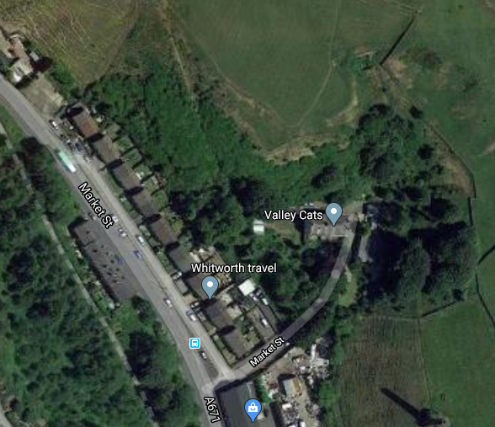

Contents
Investigation
Recommendations
Photographs
Investigation
Access to the area is from the Valley Cat’s carpark, unfortunately there is no vehicle access from this point. You will need to walk to the left hand side of the main cattery outbuilding through the gate and up the footpath keeping the boundary fence to your right hand side. At the top of the path the site can be accessed over a small sheep netted fence.
The main culvert head wall (marked A) over the outfall has collapsed and the remaining wall is showing signs of deterioration. The existing trash screen is made up of old gates and fencing panels which are not secured and has a heavy covering of spoil that is reducing the flow in heavy rain.
The wall to the left of the outfall (marked B) has also partially collapsed due to an exposed field drain above running through and over the catch pit wall.
The base of the pit is mainly exposed rock. This is covered in areas with vegetation and built up spoil over the years.
Plan veiw A

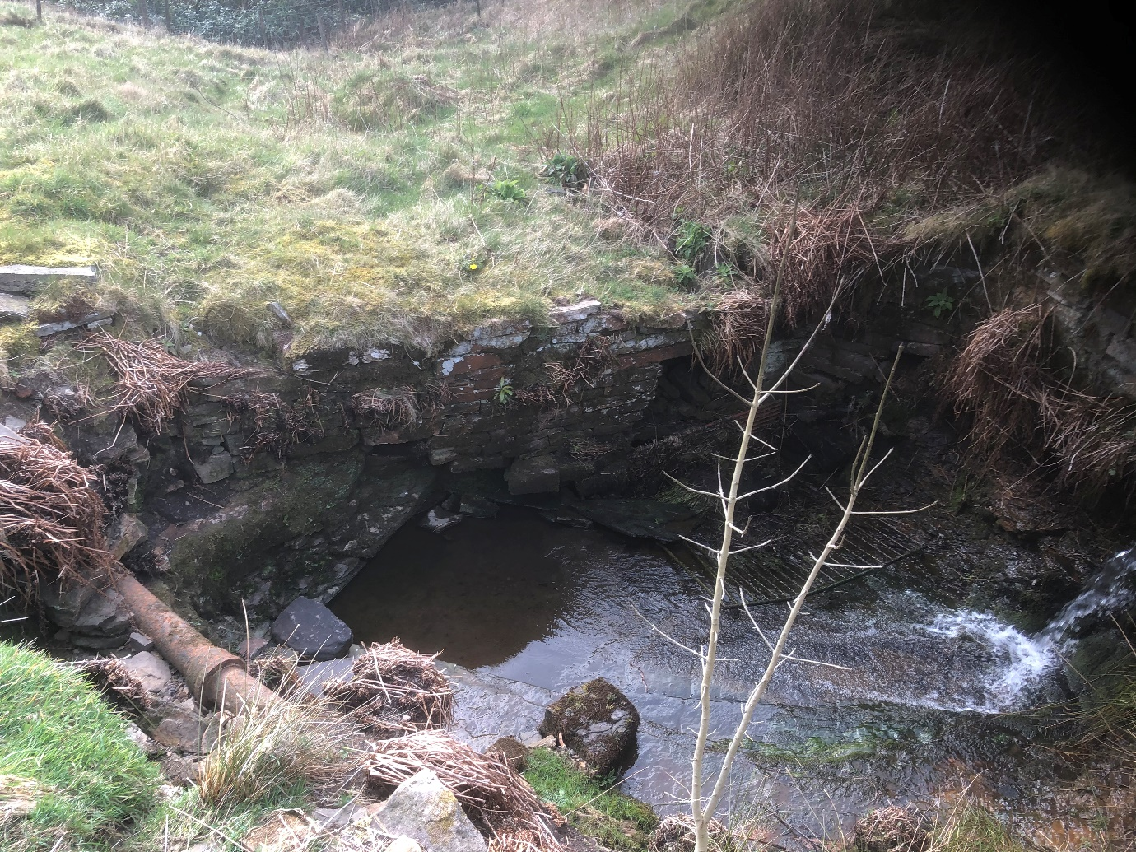

Plan Veiw (B)

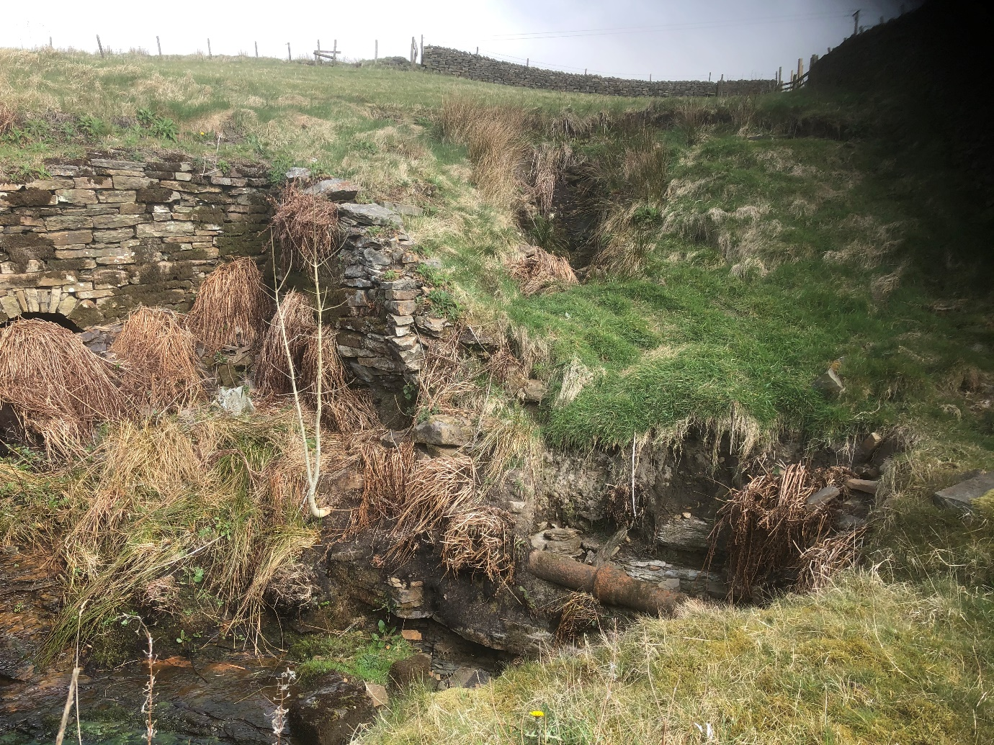

Recommendations
Vehicle access to the work area will need to be arranged with the land owner and will need to be left in good order.
- To carefully take down the existing culvert head wall (marked A) and store stone for re-use. Install fixings/starter bars, drilled and resin bound into the exposed rock bed and construct a new retaining wall using existing stone, importing new to match as required. New stonework is to be flush pointed and void being backfilled as required.

- Take down and rebuild wall (marked B) and replace as per wall (A).

- To supply and install a new 300mm twin wall pipe from the exposed field drain through wall (B) and discharge into the catch pit at high level. Back fill above the drain to restore the land to its original levels.

- Clean out all loose spoil and vegetation from the catch pit and remove from site/use as back fill if suitable.

- Supply and install a new trash screen securely fixed to the existing rock sub-base and head wall. The new trash screen is to be made from 18mm round bar and be fully galvanised.

- Make good as required and leave area tidy.

Additional Photos
