Invitation to Quote (NFNPA – 0048)

The New Forest – Special by design

- Summary

This invitation to quote is for design recommendations on the look and feel of the physical infrastructure in and around the New Forest National Park, to reinforce its special sense of place. The New Forest is mostly characterised by its special landscape of natural and cultural features but there is a real opportunity for physical infrastructure, especially signage, to reflect and compliment this. These man-made elements of the area need to fit together in the setting of the New Forest towns and villages as well with the natural environment and support the experience of the New Forest as unique and special.

We would like to know how existing man-made features, particularly signage at this time, compliment the New Forest’s special features and how their design could be improved to convey sense of place more coherently. We are also interested in recommendations on how this approach could be extended to the digital environment to assist with legibility as a special place to be cared for.

Although some of the bigger opportunities may be within the National Park area (and especially in the central areas of open Forest), the work should consider how physical infrastructures reads across to neighbouring villages and countryside in close proximity to it.

- Key drivers and opportunities

The New Forest is a unique jewel in our landscape – a world capital for natural and cultural heritage in the busy south. It conveys a sense of ‘wildness’ but due to its proximity to large areas of population and easy accessibility its fragility can be underestimated by those visiting it and living in it. Much of it is designated as being of international importance for nature. Its special systems of management, including the free ranging animals that graze the landscape, create the sense of place that people find so attractive. Because of this, it is an excellent place for people to reconnect with the natural world, to improve their health through outdoor activities and boost their wellbeing. Over 15.2 million recreational visitor days are taken in the National Park each year.
With so many people in such a special place, it is important that infrastructure design plays its part in conveying how we can all avoid impacting negatively on the things that make it special. This is particularly important within the open grazed parts of the New Forest where the potential for harm is greatest. However, it is equally important that structures such as signs do not detract from the natural surroundings and that any design or messaging is seen in the context of wider communication about place.
There are a number of events and projects which have come together over the past few months representing an opportunity to shape the legibility of the New Forest as a special place for years to come:
- 2019 marks the 70th anniversary of National Parks in the UK and a review of England’s protected landscapes is underway which is expected to call for a step change in care for National Parks and to recommend ways of reinforcing their unique and special qualities to inspire future generations.
- The Forestry Commission, managing approximately half the New Forest National Park, is 100 years old: it is rebranding as Forestry England and overhauling its extensive signage across its New Forest estate (134 car parks, plus ‘threshold’ signs where roads cross into the Crown land).
- Within the next two years the England Coast Path will be established in the New Forest, and new landowners such as the RSPB are establishing themselves in the area, alongside existing land managers such as Hampshire County Council and the National Trust.
- A Green Halo Partnership has been established drawing in multiple cross-sectoral partners from the wider region, sharing a vision to be ‘a global exemplar of how our most precious landscapes can work in harmony with a thriving, economically successful community’. This recognises the benefits of having such high-quality natural greenspace (or ‘natural capital’).
- Significant housing development is planned on the fringes of the New Forest, creating opportunities and likely demands for natural capital benefits by design and ‘sense of place’.
- The Landscape Institute is 90 years old in 2019 and is focussing on the theme of transformation and there are opportunities to link with the landscape design community on this project.

Visiting, living in or living close to the New Forest is a unique experience, and one which can be reinforced and augmented by clear and complimentary design, associated messaging and orientation, both physical and virtual.

We require an innovative and experienced place-making and design consultancy to give recommendations on how the design of our physical infrastructure can convey what is special about the National Park and surrounding area and encourage stewardship of all who live and work in it or visit it.

- Background

The New Forest dates back 900 years to when William the Conqueror first claimed it as his royal hunting ground. Today, there are different layers or zones that a visitor would experience as they travel to and through the Forest. A typical journey towards the ‘core’ could pass through neighbouring towns and cities (with their own clear identity), through communities that at least in part identify themselves as New Forest residents, into the New Forest District Council area, into the National Park itself, perhaps through estates with distinctive signage and lastly into the open heathlands managed by Forestry England and grazed by ponies and cattle.

Different organisations work both individually and together to protect and manage the area and serve the local communities. A list of the types of organisations and interested parties involved are in Annex 1. These organisations have many different roles and interests, many of which are complementary and some of the joint aspirations and plans are detailed in the statutory document for the National Park: the Partnership Plan. This is being reviewed this year with a new iteration to be published next year for the period 2020-2025.

Traditions, business, communities and organisations together help to create the identity of an area and many organisations and individuals carry out activities which help maintain and create a unique sense of place in the New Forest. Often this will be through regulation, such as how a planning authority implements its planning policies, or how the practice of grazing the open landscapes of the Forest has created a patchwork of wildlife-rich habitats across the area. Individual residents and visitors are also part of this story. Sense of place is defined by many things and suitable, sensitively designed and coherent infrastructure can assist and reinforce how people relate to and respond to a particular place.

As in other national parks we use the term ‘special qualities’ to describe the things that help make up the sense of place of the New Forest. These are the things which above all help create the look and feel of the landscape; other elements added to the landscape need to work in harmony with these special qualities.

How do the special qualities work together to affect design? How does the resultant sense of place affect behaviour and pride in place? What is the sense of arrival like? Where and how is awareness raised about the special qualities and how this might affect the way people should respond? How does it feel when you are close to, but not within, the National Park; is there a ‘porosity’ of sense of place in living close to a protected area (meaning are the benefits of the National Park shared to areas outside of its boundary)? When people are in the National Park, how do they know this? These are some of the questions we look to answer with this work.

- National Park identity

Whilst the work is really about the New Forest as a whole and the things that make it special, it inevitably needs to address questions around the National Park identity. When the National Park was established a logo and corporate identity guidelines were developed. Changes to the look and feel of both the built and natural environment are also informed by a National Park planning design guide and Landscape Action Plan which provide useful context although these do not directly address physical infrastructure.

The logo and guidelines apply to the work and publications of the National Park Authority (as an organisation), but there is overlap with the National Park (as a place). We would be happy to discuss with the chosen consultant the fact that the organisation and the place share branding because other National Parks have created a different brand identity for the organisation and the place. The initial assumption is that the logo itself will not change as it is still fit for purpose, but it may need to evolve to take account of multiple applications, potentially with new versions, and an extended visual language for use in a variety of ways.

- Governance

The work will be guided by a project steering group drawn from the following partners.

New Forest National Park Authority (NPA)
Forestry England (Forestry Commission)
Verderers of the New Forest
Commoners Defence Association
Hampshire County Council
New Forest District Council
Wiltshire Council

Ordnance Survey and the Landscape Institute will also be asked to advise and we plan to engage with some private land owners.

- Content of the recommendations

The recommendations produced will enable partners to implement creative and appropriate approaches to influencing sense of place through man-made structures and signage. We are not seeking a set of inflexible rules or parameters, but flexible and suitable approaches for different situations that add up to more than the sum of their parts.

The recommendations should:

- Coordinate approach to signage without constraining self-expression of partners
- Consider the benefits of a strong National Park identity to the area
- Consider how sense of place can be reinforced outside of the National Park
- Include consideration of digital tools for signage and digital presence
- Incorporate visually attractive and practical approaches
- Consider the need for signage reduction and the risk of signage clutter
- Give examples of possible expressions of the design including in all of the uses listed in Annex 2
- Costed implications of the various examples, for example in production, maintenance, lifespan and eventual replacement
- Take into account feedback from two workshops which will be run in partnership with the NPA (for budgeting purposes assume two workshops of 25 people, with venue costs covered by the NPA).

In addition to the guidelines we would like all design files of any graphical elements to be supplied in an agreed format.

The development of the recommendations will be an iterative process with feedback on concepts and options given by the key partners. The NPA has officers who can help and advise on many aspects of the guidelines including communication, interpretation, landscape and access. We suggest this is a three-stage process (see timescale below).

For clarity, the work is not intended to address highways signage because this is largely constrained by regulations, although the posts that support the signs could be included (there is already a commitment by the Hampshire highways authority to minimise the impacts of necessary signage on the landscape).

Similarly, the work should not prescribe specific behavioural messages but should consider where and how any such messages could be allowed for in sign design.

- Skills and experience required

The successful consultancy will need to demonstrate the following blend of skills and experience:

    - ability to create realistic and attractive mock-up examples of the identity
    - understanding of the challenges of place branding across a wide area with multiple stakeholders
    - understanding of the ways in which destination visual identity is conveyed
    - understanding of how signage and associated messaging influences people’s attitudes and behaviour
    - experience of undertaking similar projects in rural destinations / protected landscapes
    - understanding of the importance of local distinctiveness in rural communities
    - ability to complete the brief within the allocated time and agreed budget
    - environmental and sustainability awareness.

- Budget and Timescale

There is a budget of up to £20k (exc. VAT) for this contract, of which £15k is identified and we are seeking additional funding of £5k.

The proposed timescale is as follows:

- Preferred contractor invited to meeting - end June
- Work commences July
- Initial concepts August (Stage 1 feedback)
- Draft options early September (Stage 2 feedback)
- Final draft guidelines early October (Stage 3 feedback)
- Work completed end October (sign off)

- Submission

Prospective suppliers should:

- Outline your approach to delivering this brief, in consideration of the skills and experience for the requirements listed above, demonstrating how you can add value to the tasks listed
- Outline your experience of delivering briefs of a similar nature, through ideally three examples of prior similar work
- Outline the key personal involved in the project and who would be the lead contact throughout
- Detail the budget required for this work including a day rate.

The Authority proposes to pay 25% of the budget upon commencement of the project, with further equal stage payments being made at suitable agreed points in the delivery of the project. Tenderers should outline if they wish to propose a different payment schedule to this, noting that any proposed amendments will be subject to the evaluation process.

A copy of our Standard Conditions of Contract for Services can be found below:

Any imagery/logos provided to the successful contractor may only be used for the sole purposes of the contract and strictly for its duration.

Please note that we will not be liable for any costs incurred in the preparation of proposals or any associated work effort.

As stated above, the Authority holds a budget of £15k for this work, which may rise to £20k if additional funding is secured. In this light, we would like potential bidders to demonstrate exactly what services/output they could provide for both of these figures (i.e. making it clear what the additional £5k could offer in terms of output), noting that bids will be solely assessed by the quality of submissions and the stated deliverables, using the scoring system below:

Evaluation

- Understanding of our operating environment and place (20 marks)
- Project plan to include details of engagement/consultation, resourcing, timescales, milestones and reporting (30 marks)
- Evidence of constant pursuit of creativity and innovation in design (30 marks)
- Relevant experience / track record of working on projects with multiple stakeholders (20 marks)

All submissions can be made via our e-Procurement portal In-tend and must be submitted by 12noon on Friday 7 June 2019.

Please note that a shortlist of suppliers may be invited for interview in advance of a final decision being made.

Any queries must be made via the In-tend portal and any subsequent clarifications will be notified likewise (you will receive email notification from the In-tend system should this be the case).

The Authority reserves the right to withdraw this contract opportunity without notice and will not be liable for any costs incurred by suppliers during any stage of the process.

For queries relating to the procurement process, please contact:

Chris Pathmadeva
Finance and Procurement Officer
New Forest National Park Authority
chris.pathmadeva@newforestnpa.gov.uk
Direct Line: 01590 646678

Annex 1 - Types of organisations and interested parties to be considered.

National Park and local government authorities - New Forest National Park Authority, New Forest District Council, Hampshire County Council, Wiltshire Council, Test Valley Borough Council, Dorset Council, Bournemouth, Christchurch and Poole Council

Town and Parish Councils, local communities - many in the area including Totton and Eling, Lymington and Pennington, Ringwood and local parish and villages.

Major land managers and landowners - Forestry Commission (Forestry England from 1 April 2019), National Trust, RSPB, Hampshire County Council, Hampshire and the Isle of Wight Wildlife Trust, large estates (such as Beaulieu estate).

Statutory organisations – Natural England, Verderers of the New Forest, Environment Agency, Historic England

Other interested organisations - Green Halo Partnership, Railway and station operators, bus operators, Go New Forest, New Forest Marque, Commoners Defence Association.

Local businesses – Holiday parks, accommodation providers, visitor attractions, activity providers, restaurants and pubs, crafts, farming, forestry, other retail.

Annex 2 - Types of existing infrastructure to be considered

Type of signage | Description / opportunity | Picture of existing
Forestry Commission / England signs | New threshold and car park signs are planned by Forestry England. Potential to accommodate ‘key messages’
Waymarkers and Rights of Way signage | Plans to improve information provided (e.g. destination and distance) – mean that other aspects can also be reviewed | 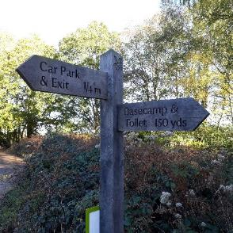
National Park Boundary Markers | These mark most entry points and could be upgraded / replaced to increase visibility and identity awareness. | 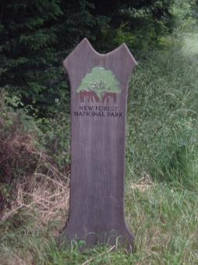
Cycling directional signs | Some directional signs carry the National Park logo. Potential to draw stronger links between settlements and transport hubs and walking, cycling and horse riding routes | 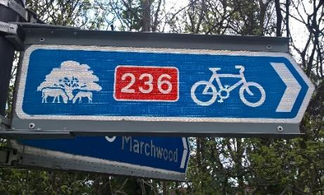
Station signs | Welcome to the National Park signage is in place at train stations. Potential to develop this and expand to bus stations | 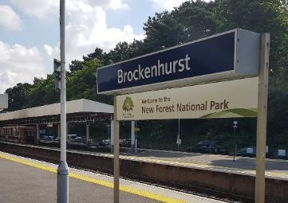
Village signs | Some parish councils have chosen to include the National Park logo on village entrance signs | 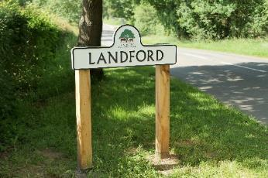
Road signage giving key messages | Some highways signs carry distinctive, additional changing messages about animal accidents
Traditional directional signage | Potential for new focus to replacing and upgrading finial signage and to review traditional directional signs for pedestrians | 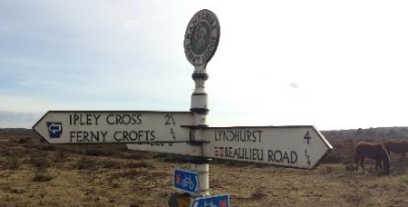
Information Point signage | External signage on all 10 local Information points, and on gateway information points (Ringwood, St Barbe, Fordingbridge) could be reviewed / improved | 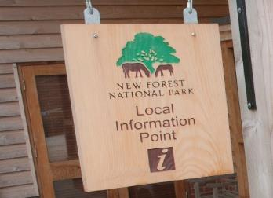
Perambulation (grazed area) entrances near cattle grids | Some ‘gateways’ to the perambulation have distinctive timber structures that support signs, but some are in poor repair. They often coincide with FE threshold locations but not always | 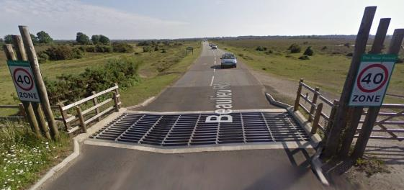
Other partner site signage, interpretation and information signs | A range of organisations with sites and signage manage may be receptive to design suggestions, e.g. Hampshire County Council, National Trust, Private Estates, Go New Forest | 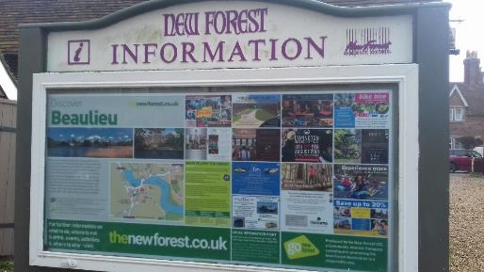  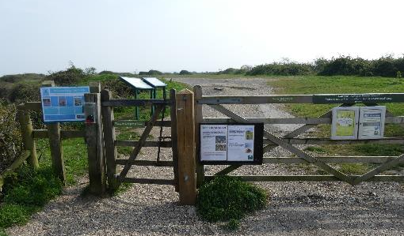
Locally distinctive highways infrastructure | Some highways infrastructure could be considered E.g. bollards and pinch points, hard surfacing, kerbs, drainage infrastructure, barriers, bridge railings, dragon’s teeth, posts that support highway signs, bus stops | Multiple examples
Countryside infrastructure | Potential to review gates, bridges, handrails, stiles, steps where this links to signage | 