**Appendix B – Quality Submission**

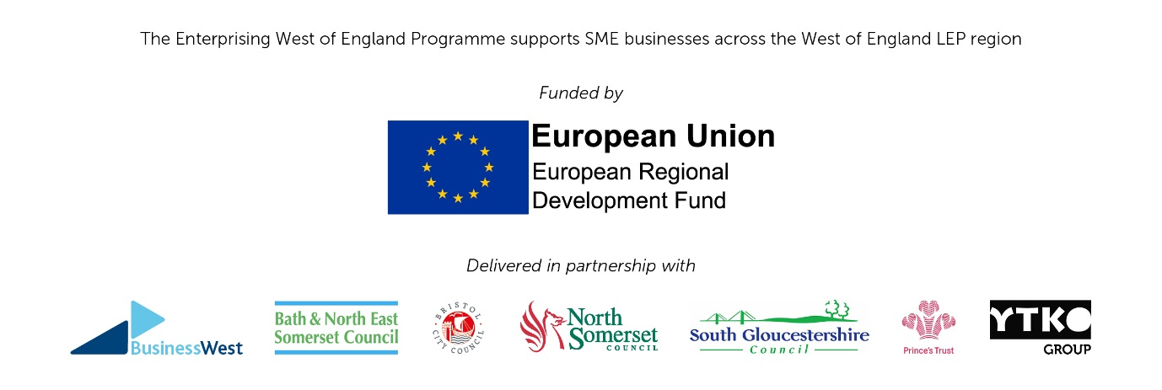

|  |  |  |
| --- | --- | --- |
|  | **Pass/Fail Question**   * Please confirm you will be delivering the service from a specific location within North Somerset and this will be staffed through the week? Please provide an address. |  |
|  |  |  |
| 1 | **Delivery**  Describe how you will develop and deliver the service as outlined in the Service Specification, including:   * Identifying the key topics that will be covered by the service to different stages of service user. * How you would work with other support available through Council Services, EWOE Partners and West of England Growth Hub to develop and deliver the service. * The techniques you will use to promote and market the service, including any particular approaches you will use to reach different audiences. * Identify any alternative methods you will use to meet, but particularly exceed the target indicators identified, both for ERDF and NSC outputs. * Detailing your Start in Business Course, including duration, how delivered and topics that will be covered.   The following bullets provide an indication of the range of areas that should form part of the advice and guidance that will be available to start up and early stage business development.   * Strategy and Business planning * Financial management * Communications and marketing * E-commerce and cyber security * Employment related matters   Information on how advice and support in other areas such as Equalities and Diversity, IP, property and tax should also be provided. Demonstrating expertise in each subject or at least demonstrating appropriate signposting and contacts.  The above bullets are not an exhaustive list of support, a more comprehensive range of topics that will be covered at different business stages, including the Start in Business Course, should be identified. | 50 |
| 2 | **Experience and knowledge**  Please can you detail your knowledge/experience of the following:   * Delivering a European Regional Development Fund (ERDF) funded project or service. * Working with the range of business support across North Somerset and the West of England.   Please outline staffing and their relevant qualifications and work experience.   * Any business advice needs to be provided by consultants who are is SFEDI accredited or similar agreed quality standards. | 20 |
| 3 | **Performance and Monitoring**  Describe how you will monitor and report on the progress of the service and outputs. You should confirm the system (s) that will be in place and maintained to record all required information on clients using the service and the services accessed. This will include effective monitoring of the delivery of the service against the required outputs and outcomes as detailed in Section 9, Table 1 of the Specification (Appendix A).  Please can you confirm that you are able to collect, record, store and provide to North Somerset Council all relevant information needed as described in 9.1 of the Specification (Appendix A). | 20 |
| 4 | **Business Plan**   * Provide a plan of how you will use the total funding covering activity including * All costs of running workshops and Start in Business Course * All costs of running clinics and 1-1 sessions * Promotions and marketing * Management costs including monitoring and reporting * Any overheads | 10 |